Personal Development Plan
Reflection
Within the last year, I have taken on the new role of Family Worker for Wellbeing. I have played a part in defining and developing the role to support Families with their individual and collective wellbeing for them to make positive change. I have completed training on new interventions such as Drawing and Talking and am using this therapeutic tool to support children to process their internal emotions. I have completed Halcyon and Intensive Interaction training which developed my knowledge and ability to support children and their families with additional needs such as autism spectrum disorder. As part of my personal wellbeing and development, I have also completed the STEPS programme which helps to build self-esteem and confidence to achieve set goals. I am a Local Authority Governor for a primary school and serve as their Governor for Attendance alongside sitting on various panels.
Goals & Actions
My immediate goal is to continue to engage with and complete the BA in Early Years with Practitioner status within the two years. To do this, I feel it is important for me to consistently attend the Monday evening lectures and complete the required independent study. With all of my personal and professional commitments, it is essential that I am organised and a timetable of when I study will be beneficial to complete the adequate reading and assignments with continuous reviewing of this. With knowledge gained from the first two assignments and the time taken for them, I would like to develop the personal timetable during reading week. I will also need ongoing support from my employers and in particular my line manager and the families I support to be able to facilitate the required observations for the Practitioner Status. I will know if I am successful with each assignment that I complete.
Another goal is to complete the Advanced Drawing and Talking course which will allow me to offer this therapeutic intervention to groups of people, including families as a whole. It also provides training for Sand Play which is also a Therapeutic Intervention but for younger children. I have requested this of my workplace via my line manager who is awaiting financial approval prior to booking. Ideally, I would like to complete this by February as the reduced cost afforded by my membership runs out at this time. I know I am successful at this when I am able to offer this additional Therapeutic Intervention to the families I support.
A longer-term goal is to complete the MA in Play Therapy offered by The University of South Wales. To do this, I firstly need to complete the BA in Early Years. In the meantime, I am able to explore the options for this course including booking an open day and conversing with the course staff to ensure I meet the entry criteria prior to applying. Continuing clinical supervisions with a Child Psychotherapist as part of my Wellbeing role as well as providing therapeutic play interventions such as sand play will also give me a good grounding and experience in the Play Therapy field. The time frame for this is fluid based on the entry criteria, but the course is completed part time over a three-year period. Ideally, I would like to apply for the 2025 intake and with acceptance, consider the goal met.
Reflective Practise
What is reflection and reflective practise?  Reflection is the ability to look back and think over a situation or conversation. This, according to Schon (1983) can be done in the moment (reflection-in-action) or at a later date (reflection-on-action). Finlay (2008) states that the point of reflective practise ‘is to recapture practice experiences and mull them over critically in order to gain new understandings and so improve future practice.’ In other words, it refers to looking back to analyse situations, looking at what went well, what did not go so well, what needs to be changed and what needs to continue. This provides opportunity for practitioners to develop their practice and continue learning as individuals, collective professionals and with children. It can be a tool to inform and improve professional practise as well as supporting children to develop this skill. | Why is reflective practise important to EY practise?  Reflective practise in Early Years helps to inform ongoing practice, allowing for continual learning to provide the service users with a proficient setting, service or educational establishment. Welsh Government (2023) have developed a toolkit to support Early Years Practitioners to reflect over their practise and they state that reflective practise ‘draws together the various requirements for delivering the type of high-quality care, education and play provision needed in Wales’. Reflecting over practise will enhance a practitioner’s confidence as they establish what went well as well as develop their analytical and critical thinking skills. Becoming a reflective practitioner and involving children or service users in this will also provide a valuable insight as well as address the United Nations Convention on the Rights of the Child’s (UNCRC) Article 12 that children have the right to have a say in what affects them.
The theory of reflective practise: Philosopher John Dewey was one of the first to look at Reflection as a tool in developing education. In his book How We Think (1933), Dewey states ‘Reflective thinking, in short, means judgement suspended during further inquiry.’ Dewey argued that reflective thinking allows people to alter their routine thoughts or actions and turn them into reflective actions.
Following Dewey’s works, Schon (1983) developed the theory further which as stated above included two sides of reflective thought which helped to inform the basis for the theory of reflective practise. He argued that reflection-on-action refers to thinking over past events with a view to making positive changes where needed for the future. With reflection-in-action referring to in the moment reflection to make those changes on the spot. Schon also argued that a novice practitioner would need to build their experiences to be able to reflect-in-action and would need to take their time to think through situations prior to action. An experienced practitioner, however, would have built knowledge of situations and reactions to be able to act immediately.
Grushka, Hinde-McLeod and Reynolds (2005) take Schons theory further and add reflection-for-action for practitioners which offers technical, practical and critical questions to address their ongoing practise and support lesson planning.

In Welsh Governments Reflective Toolkit, they have provided the below model of reflection, which concentrates on continuous reflection at each stage to encourage quality improvement as per their set national standards.  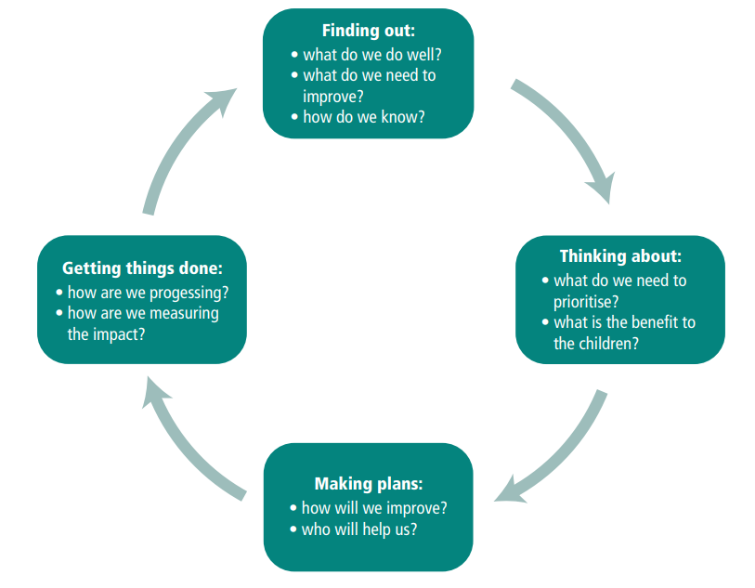 | The 5R Framework for Reflection developed by Bain, et al (2002) can be a useful tool for reflective accounts or reports which can keep the practitioner on track to structure their writing in order to strategize and develop future actions for situations.  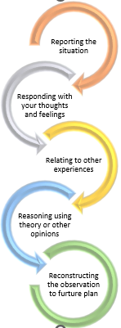
Analysis of models – compare/contrast/pros/cons:
There are pros and cons for each model of reflection and not all are suitable for any given situation. The 5R Framework for Reflection provides a basic list to support the practitioner to think about each stage in a methodical way, however, it may also over-simplify the process and not allow for flexibility in the thinking or the methodology, implying that you start at the top and work your way down. In practical terms, depending on the situation that is being reflected over, you can start anywhere on the list and do not have to include all of the steps.
Welsh Governments reflective toolkit cycle allows for reflection over each stage to address a situation. Again, it is implied that the model needs to be started at the top and followed around answering each question in turn without room for further exploration of the situation.
Both of the models detailed can be used for lone or team reflection either in written form or through conversation. They can both be used to keep the practitioners focussed to elicit an end goal and inform future practise. Team or peer reflection can be hugely beneficial as it allows for additional eyes on a situation and differing points of view. All models also provide a start and end point although following them to the letter may be time consuming and not always beneficial to the situation.
As with all models of reflection, the possibility for change of process often ultimately resides with management, however, change of practise and opportunity for continuous learning does reside with each practitioner. Reflective practise is a learnt skill, that needs to be honed to be completely effective in a learning journey, with the models providing a good starting point for less experienced practitioners and even those who are seasoned workers can benefit from continually using reflective practise through the models.
Conclusion: There are many different models of reflection, and they are often developed for specific purposes and professions as well as directed at group or lone reflections. Each model is subjective, however, based on the situation, the end goal, and the practitioner, who will use their own preferred model based on the situation in order to inform their future practice and provide service users with continued quality.

Recognise and analyse the significance of different aspects of professional practise and why these are important in meeting the individual and inclusive needs of children - including professional values, communication, multiagency work, observations, planning and the UNCRC.

