Greenpower Group Project

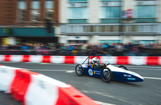

University of Wales Trinity Saint David
School of Engineering
Motorsport engineering
Oliver Gordon, Richard Osborne & Davis Watkins
P150782, 1704921 & P150289
2019
Group Project & CAE
Andrew Gibson

Abstract
Ollie

In short, this report will look into the green power kit car project. Each member of the team will research into their subject area’s and provide a good level of understanding and knowledge into the chosen subject/field. With Richard looking into batteries, motor and gearing subjects. Ollie looking into chassis design and redesigning the original kit car and some material choices. Davis shall be looking at the suspension set up for the kit car and deciding whether or not the kit car should be fitted with a damper or not. Jakub shall be submitting his part to the group report at a later date. Pages have been labelled in the top right hand corner so you know who has completed what pages.

Table of Contents
1.0 Abstract 2
2.0 Introduction 5
3.0 Timing 3
4.0 Research & Literature 4
4.1 Batteries 4
4.2 Motor 6
4.3 Gearing 9
4.4 Chassis 11
4.5 Materials 13
4.6 Suspension 15
4.7 Wheels & Tyres 18
5.0 Methodology 20
5.1 Dyno Testing 20
5.2 Cad analysis validating 22
6.0 Computer aided design work 24
6.1 Current design 24
6.2 Adapted design 25
6.3 Starting new design for chassis 27
7.0 Analysis 28
7.1 Dyno Testing 28
7.2 Gearing 30
7.3 Calculations with a damper fitted 33
8.0 Conclusion 37
9.0 References 39
9.1 Richard’s References 39
9.2 Ollie’s references. 40
9.3 Davis’s Reference’s 41

List of Figures
Figure 1 Jaguar Land Rover Greenpower Car 2
Figure 2 Greenpower 24+ Kit Car Complete 2
Figure 3 Battery Discharge Rig 4
Figure 4 Halogen Bulbs for Battery Test Rig Load 5
Figure 5 Motor Bracket Design by Coulden-Smith 7
Figure 6 Fitted Motor by Coulden-Smith 7
Figure 7 Motor Adjusters by Coulden-Smith 8
Figure 8 Return Email from Steve Newman Regarding Motor Temp 9
Figure 9 Return Email from Steve Newman Regarding Gearing 10
Figure 10-Colin chapman's lotus 25 11
Figure 11- Greenpower Regs, driver position 12
Figure 12- basic frame design 12
Figure 13-chassis inspiration 13
Figure 14-simple suspension set up like Greenpower kit car 13
Figure 15 Suspension Layout, Watkins (2019) 15
Figure 16 Shock Absorbers, Ingham (2005) 16
Figure 17 Spring Price, Protech 17
Figure 18 Shock Absorber Price, Protech 17
Figure 19 Tyre Size, Watkins 18
Figure 20 Mark Fall Data Collection Table 21
Figure 21 Mark Fall Data Collection Graph 21
Figure 22 completed kit car model 24
Figure 23 adapted front chassis 25
Figure 24 adapted rear chassis 25
Figure 25 simple assembly of adapted chassis 26
Figure 26 chassis frame strength idea's 27
Figure 27 Gear Shifter Idea 32
Figure 28 Suspension Simulation, drtuned 34
Figure 29 Sprung Mass Formula, Moodle 35
Figure 30 Sprung Mass Values, Watkins 35
Figure 31 Body Roll Formula, Moodle (2019) 36
Figure 32 Image 9 – Body Roll Values, Watkins 36
Figure 33 Weight Transfer Formula, Moodle 36
Figure 34 Weight Transfer Values, Moodle 36

Introduction
Ollie, Davis and Rich

For this project, the class was split into 3 groups of 5. This report will look at group 2’s efforts to investigate and put forward improvement recommendations for the Greenpower Formula 24+ Kit Car. The Greenpower Project is an event where small lightweight electrically powered vehicles compete in an endurance race to cover the largest distance on track in a 90-minute period, many teams will compete with multiple different modifications to make their vehicle be more efficient on the battery life with the given battery capacity. The teams can make many modifications to their vehicle whilst following the regulations enforced by the organisers of the project. Whilst many areas are to remain untouched, popular changes can include the seating position of the driver, the wheel sizes and the body shape. These teams will try every little adjustment to give them an edge in the event, this is due to the regulations preventing any changes to the main component being the battery, so instead the teams need to get the best efficiency from this battery.
The team members for this group were Richard Osborne, Oliver Gordon, Davis Watkins, Jakub Kot and Daniel Blackmore. Unfortunately, Daniel Blackmore decided to drop-out of University over the Christmas break and Jakub Kot, due to unforeseen circumstances, decided to leave the group project with the potential opportunity of completing at a later date.
Richard Osborne will be looking into, Batteries, Motor and Gearing, Oliver Gordon will be looking into Chassis design and development, and Davis Watkins will be investigating the need for suspension.
  - Richard
For this report I will be investigating Batteries, Motor, Motor Control, Motor Cooling (alongside Jakub Kot), Gearing systems and also an Energy Recovery System. I will carry out research into all subject areas, assess the capabilities of the facilities at UWTSD Swansea for practical use, arrange any group testing and produce ideas to improve each of my selected sectors. I will also produce some parts in CAD to be assembled in the model of the current, standard chassis design, and assist with the physical building of the vehicle. Any queries of regulations, or any other aspect, will be confirmed via email/phone calls to Greenpower Education Trust.
  - Ollie

With my part of the group project I had the job of design/redesigning the chassis for the green power kit car. I shall be going through why a completely new design would have been preferred but wasn’t ideal for the situation. I shall be talking through some inspiration for chassis design and idea’s I’ve had. Will be discussing some materials I want to use with and without a theoretical budget. There’s an insight into who did what for our group cad model for the kit car and a who did what and how much each person did. Then there will be an image of an adapted version of the chassis model after I’ve done some weight saving, during my part of the work I mention that there is further work being conducted by myself for certain topics. At the end in my conclusion will be a small insight into how I think each person performed within the group as a whole.
Ollie, Davis and Rich
  - Davis
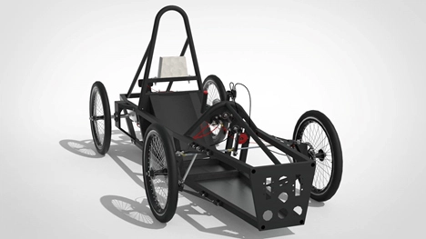
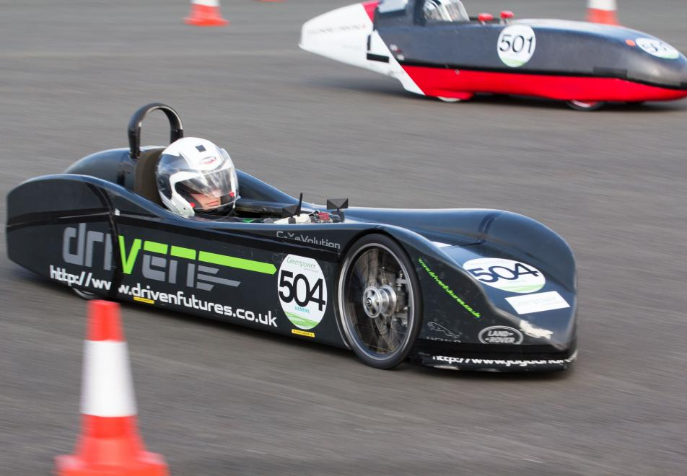
Some big areas that the teams will focus on include weight reduction, aerodynamics and lowering the rolling resistance as much as possible to lower the strain on the battery making it drain the power a bit slower than it would otherwise.
Figure 1 Jaguar Land Rover Greenpower Car
Figure 2 Greenpower 24+ Kit Car Complete
In regard to the suspension and steering system, there isn’t really a big area of improvement. But tests can be done for a comparison on the performance with different tyre sizes, and possibly the addition of a damping system for the Greenpower car and whether or not this would be a worthy modification. Using a different sized tyre would change the rolling radius and either increase or reduce the rolling resistance of the vehicle, so a few tests would be required to find the ideal tyre size needed to maximise the battery efficiency. Also, the steering system is very basic and consists of many unnecessary parts, so this could be modified to a more efficient layout that would reduce the weight or there could just be a method used of simplifying the current layout to remove some of the excess parts.
Teams that compete in the Greenpower endurance race would modify every little area of the vehicle down to the smallest components just to ensure they improve it as much as they can, because as this is an endurance race every small modification can make a big difference to the vehicle.

Timing
Jakub
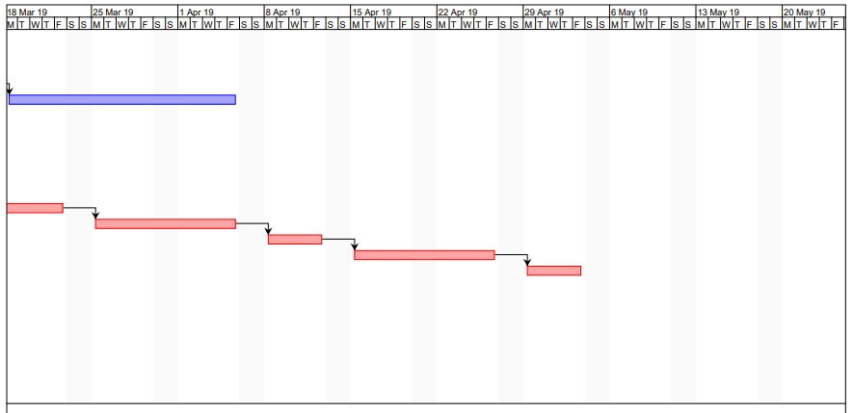
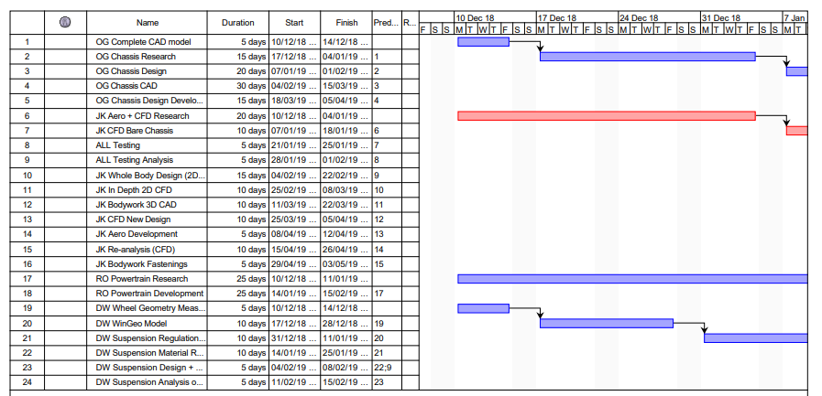
Below is a Gantt chart that was completed by Jakub Kot.

Research & Literature
Rich

Batteries

The Greenpower branded REC36 battery is manufactured by Yuasa. These batteries are compliant with all current regulations for all Greenpower categories. All batteries used by participating teams must be as supplied by Greenpower. Each battery weighs approximately 11kg, are 12v and 36Ah capacity. These batteries are fully rechargeable and usable in any orientation except up-side-down.
The batteries must be stored in temperatures no lower than 5 degrees C. This is because the batteries capacity will reduce at lower temperatures meaning that a fully charged battery below 5 degrees, will not hold the same charge as a fully charged battery above 5 degrees C.
“Greenpower regulations allow batteries to be at a maximum of 25C, you should aim to be close to this limit as a battery's capacity will be reduced when discharged at low temperature. If your batteries have been in a cold trailer overnight before the Final in October they could well be lower than 5C and have 15% less capacity than they would at 25C. Teams use all sorts of things to keep batteries warm, reptile heating mats, Peltier effect hot/cool boxes, electric blankets, there are lots of options.” As found by Coulden-Smith (2017).
It is also found that time of inactivity can reduce a batteries capacity. A reduction of 5-10% in capacity can be found over a matter of weeks but can be partially regained by carrying out a charge and discharge cycle. This is demonstrated by Coulden-Smith (2017) below.
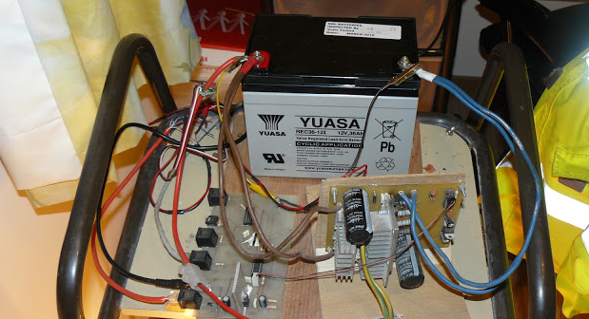
Figure 3 Battery Discharge Rig

“Bench cycling of batteries needn't be complicated, all you need is a load, a switch, a Multi-meter and a stopwatch. Four or five 12V 50W halogen bulbs in parallel make a suitable load of about 17A or 21A respectively, so connect the battery to the bulbs and with the stopwatch time how long it takes for the battery voltage to fall to 11V then switch off immediately. Whoever is watching this test needs to be extremely vigilant to ensure the voltage doesn't drop too low and damage the battery, however if you have any electronics knowledge it is quite feasible to automate the discharging process.”
Rich

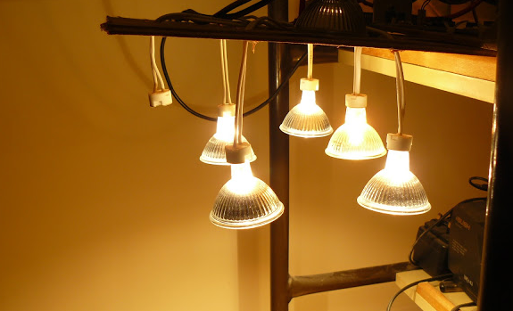
Figure 4 Halogen Bulbs for Battery Test Rig Load

The Greenpower Regulations state that two unmodified 12v batteries are to be used on each vehicle. Only one pair of main batteries will be used in a race. No external energy sources may be used and energy recovery systems are permitted. Auxiliary batteries for powering devices on the car must not exceed one PP3 or six AA batteries per car. Coin or button batteries are permitted as a power source for brake lights but also to allow control systems to retain settings whilst main batteries are changed. Also, proprietary unmodified electronics with self-contained batteries, for example, speedometers, watches, radios are permitted so long as they’re not connected to any of the car control systems. All other devices including motor controllers must be powered off the main batteries.

Motor
Rich

The motor used in all Greenpower cars is produced by a company called Framco and is manufactured exclusively for Greenpower. The motor is a sealed unit and must not be tampered with in any way, any sign of modification and the vehicle will not pass scrutineering. The motor is rated as 24V DC 240W and 2000rpm. Replacement parts are available directly from Greenpower. The regulations say nothing about relocation of the motor but only that it must be visible for inspection by the scrutineers on race days. Mounting the motor in a different position to standard is something that a few teams in the past have carried out, the example below is provided by Coulden-Smith (2017) on the Greenpower website.
“Mounting the motor is one of the more difficult parts of the car and how we choose to install it depends very much on the sort of transmission we'll be using. In order to keep things as simple as possible, we would recommend using single speed, fixed gear, chain drive with 3/8" industrial chain, exactly the same as the Greenpower kit.”
Using a single speed gearing setup means there is only one gear attached to the motor, known as the driver gear, and one gear attached to the axle, known as the driven gear. There is no gear changing ability. These gears are connected via a chain and are fixed meaning there is no freewheel option as standard. The chain used by Gary Coulden-Smith is an oversized industrial chain, chosen to be durable and reliable. He is also using an adjustable mounting setup for chain tension adjustment.
“The motor mount is a simple, aluminium angle and channel bolted and riveted together, overall it's about 350mm long. At the left-hand side is the top of the mount, the long bolt will pass through a pivot on the chassis allowing the whole mount to swing vertically. The two ball joints at the right-hand side are part of the tensioning system.” As stated by Coulden-Smith (2017) and is shown in the image below.
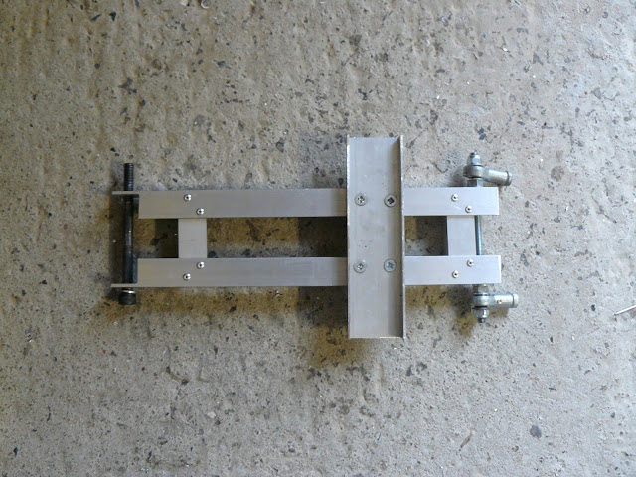​
Rich
Figure 5 Motor Bracket Design by Coulden-Smith

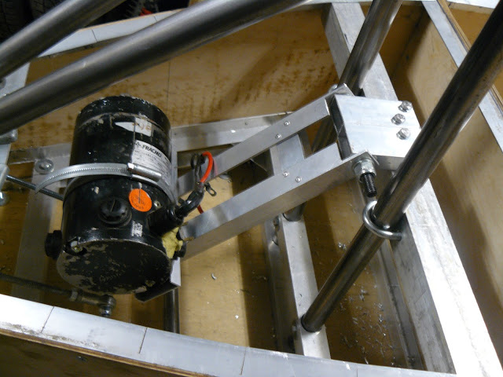
Figure 6 Fitted Motor by Coulden-Smith
As it can be seen, to the left, in the image above, the ball joints are adjusted via threaded bar, thus increasing and decreasing tension to the suitable motor location. This is shown in the following image and can be adjusted externally of the vehicle.
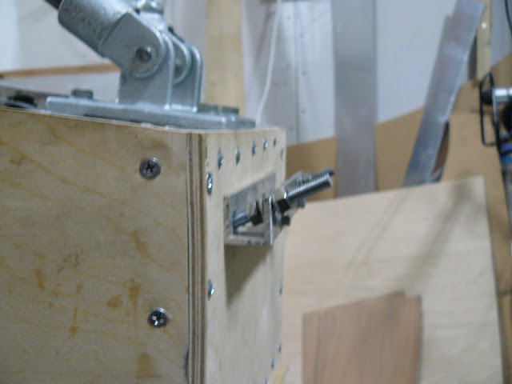
Rich
Figure 7 Motor Adjusters by Coulden-Smith

“M8 threaded rod is screwed into the ball joints and locked with nuts. The other end of the threaded rod passes through the rear bulkhead. The aluminium channel has been used only to allow adjustment to be made from the outside of the car as access to the motor compartment will be difficult. The nuts are tightened against each other to lock the adjuster. It's not particularly elegant having the threaded rod at an angle but it works well enough and the angle introduces an element of triangulation which prevents the motor mount twisting under load.”
According to the regulations, motor cooling is only allowed via the use of passive or forced air. The forced air option is only usable via power sourced from the main batteries, which is a downside due to the fact that the main batteries power should ideally, only be used to propel the vehicle. The passive air, through bodywork ducting, is a more beneficial route to take (This area was to be covered by Jakub Kot and his aerodynamics section). The reason for the inquiry into motor cooling was un-earthed during testing as temperature at the motor casing increased rapidly (see section 5.1).
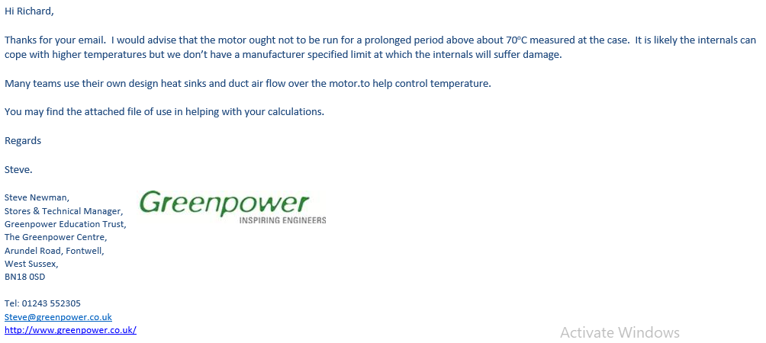
Rich
Figure 8 Return Email from Steve Newman Regarding Motor Temp

Gearing

There are multiple designs throughout the automotive industry for different gearing applications. The key to understanding what gearing system will be required is the vehicle to which it will be applied. For a small engine city car, such as, a Volkswagen Up, the gearbox overall design maybe a compact unit with a weaker gear set than would be fitted to say, a Mercedes ML. The factors for consideration here are the type of vehicle owners, vehicle weight, towing capacity and general usage of the vehicle. It can be surmised that a Volkswagen Up would not necessarily be used to tow a trailer or go off road, this may not be entirely correct for some owners but in the majority of cases, this scenario is unlikely.
The list below are a few examples of gearing systems used in the automotive sector.

- Manual
- Automatic
- CVT (Continuously Variable Transmission)
- DSG (Direct-Shift Gearbox)
- DCT (Dual Clutch Transmission)
- Tiptronic Transmission
Rich
The list continues. For the Greenpower F24 Kit Car, a much less robust form of gearing is required due to the vehicle being small, light and only having one purpose, slow paced racing with a low power motor.
The regulations are unclear as to what can be used for the gearing system on the F24, therefore Richard Osborne sent an email to Greenpower regarding this and the reply can be seen below.
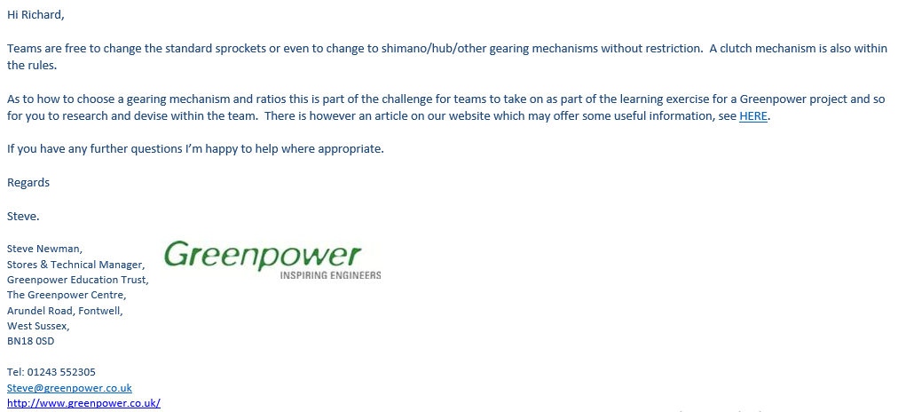
Figure 9 Return Email from Steve Newman Regarding Gearing
With the information supplied from Steve Newman at Greenpower, the idea of using bicycle gearing sounded most appealing and cost effective.

Chassis
Ollie

With the limited time and guidelines with the direction wanted on this project we’ve decided as a group that the easier option is to adapt the current chassis using some analysis to show where weight can be saved to lower the centre of gravity of the kit car, if the modifications I make in cad were to be used on the real kit car it wold no longer be allowed in the kit car series. Having to change the original design isn’t feasible because of time and money. Ideally would like to redesign the Greenpower car from scratch but time limit and zero budget limit this from happening. Another reason for cad not being further developed is due to a corrupt hard drive and a loss in all cad work which had to be start from scratch.

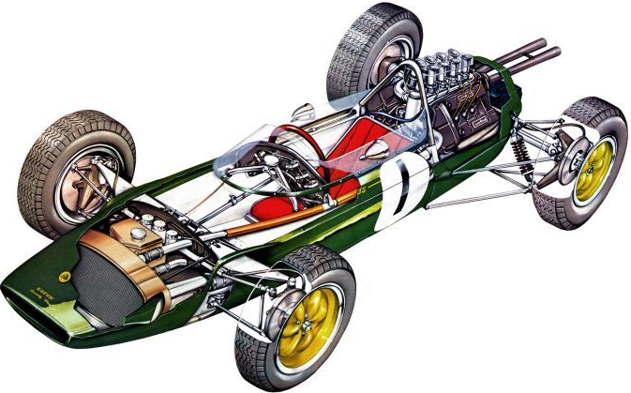
Originally I was going to be taking inspiration from Colin Chapman’s design of the lotus 25 chassis, this is because he designed the first Monocoque chassis to be used in formula one and it was one of the major factors for Jim Clarke’s success in the car, although you can’t take away how brilliant and gifted Jim Clarke was as a driver before his passing.
Figure 10-Colin chapman's lotus 25
This chassis was the first in formula one to have a chassis with the body built in which adds strength whilst also saving weight because you don’t need to add as much reinforcement to it. This gave me a few ideas for what could be done with chassis, but after some discussions with the group we decided this wasn’t the right direction to go down.

When it comes to the regulations, the vehicle must not exceed 2800mm in length, 1200mm in width and 1200mm in height. Minimum ride height of 30mm. The base of the batteries and the base of the driver’s seat (including padding) must be at or below 100mm from ground level. The drivers head, with a helmet, must be 50mm below line A B (Greenpower, 2018).
Ollie
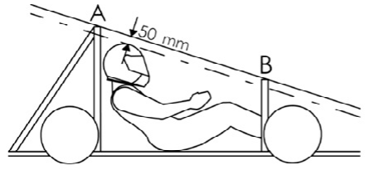

Figure 11- Greenpower Regs, driver position
A quote from a book I’ve been reading that has stuck with me when it comes to designing a chassis was, “Designing a rigid frame with or without a roll cage structure requires the application of a few basic elements. A maze of steel tubing might look impressive visually but unless arranged correctly and secured properly, they will not produce a rigid structure”, (chassis engineering by herb Adams).

When looking to design a new chassis, Pinterest was the first place I went to for some initial ideas, which I quickly found this simple chassis design for what could be a soup box racer. It’s a simple box section chassis similar to the original to the kit car, I wanted to use this to give me an idea of what to design for the new chassis or what to adapt to the original kit car for example simplifying it and cut weight off.
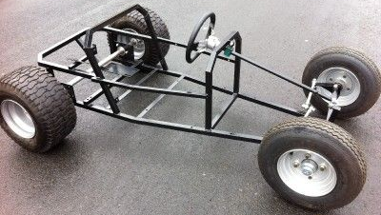

Figure 12- basic frame design

Ollie
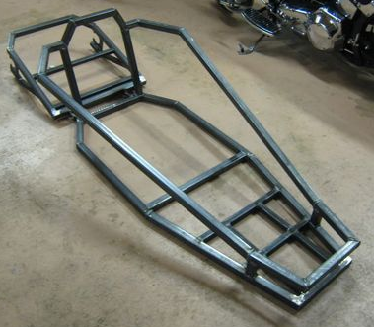
With this box section chassis, we have to the left, it is a good example of a strong basic chassis with some reinforcements on the underside, this was used as further inspiration for a new design and a redesign.

Figure 13-chassis inspiration

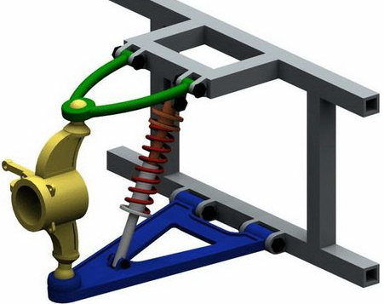
This is a basic suspension set up that’s very similar to the Greenpower kit car that we have in the work shop. But with a spring. From the original design I’ve been using the wheel hub to do some stress analysis, but before I do that I need to do some validating of the stress analysis in the workshop and the cad system so what was suggested to me was that I get a piece of box section scrape in the workshop and copy the set up in cad and see if I get the same/ similar results.
Figure 14-simple suspension set up like Greenpower kit car

Materials

With materials I’ve decided to give my-self a theoretical budget which can give me a limit on the cost of material so I can keep it at a realistic level. But also going to look at what could be done if money wasn’t an object and there was zero limit to the budget but still not going overboard with the materials that shall be chosen. Now with a limit of around £15,000 to build to whole car and giving £3,000 of it being allocated into the chassis side of the build. This gives me limits to what quality of material I can purchase for the build and the fabricating cost of having some build it. My initial idea was to look into other types of steel and look into the cost of aluminium, carbon fibre would be ideal but if money from the total budget needing to go to body work and not just chassis carbon fibre doesn’t seem to be a smart move with a theoretical budget.
Ollie
10 tubes at 25mm x 25mm x 3.62mm at 2000mm in length aluminium box section costs a total £159.72 including vat. Plus, some steel tubing taken from the kit car so that’s free, the rest of the £3,000 allocated to chassis design and build would go to paying the students to design and build or to an outsourced designer and manufacture. Also factoring in costs for using equipment such as welder etc.
Without a theoretical budget: money is not an object, and this allows me to look at all kinds of materials and experiment with different ways to join multiple materials together or different types of welding maybe, and other joining methods. After doing some research into carbon fibre Monocoque chassis I came across a race team where they spent a total $7000 us dollars on a single seater chassis with roll bars and all the regs met for the chassis side of things, as quoted below. With this in mind, our green power car would possible cost around three quarters of that price to make a Monocoque chassis for the green power car. Then any amount of money could be spent on getting the best possible steering and suspension set up as chosen by Davis and the best gearing and motor control as chosen by Rich and full carbon fibre bodywork or fibre glass depending on what is chosen by Jakub.
“Initial calculations give an approximate cost of $1650 for the carbon fibre and epoxy resin. The honeycomb purchased for this project was sourced for $1815, majority of was shipping cost. As the desired material was not available in Australia, core cost alone was $1100. If the material needs to be sourced from the USA, as was required for this project, it will cost $3300 for one sheet which will cover the conceptual design proposed within this project. With an approximate cost of $700 for the cost of the film adhesive, the Monocoque materials alone could cost a minimum of $4200 to a maximum of $7000.” (School of Engineering and Information Technology, UNSW Canberra at ADFA).

Suspension
Davis
The current suspension setup for the Greenpower car is very stiff and uncomfortable for the driver, this is because there is currently no method of damping being used. As there is no damper being used, this means that the bumps and forces coming from the floor surface are being transferred straight from the wheels through to the chassis.
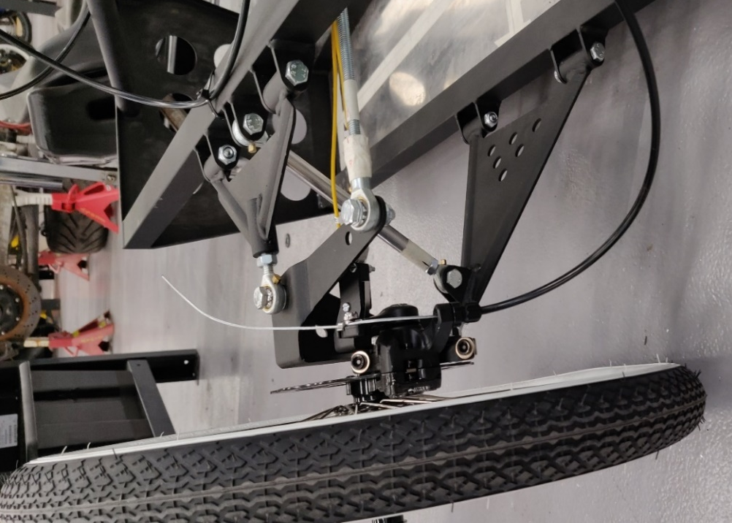
The lack of components used for dampening the shock from any bumps can often lead to a very uncomfortable ride for the driver of the Greenpower car. This means that if the driver needs to be sat in the car for prolonged periods of driving, it can create a lot of discomfort for the driver and in some cases maybe cause a small injury to the driver if introduced to a bump or dip in the road surface due to the entire shock being sent straight to the driver.
As shown in the image above, the only suspension components being used are solid metal. This could easily be replaced with a compact and lightweight damper to improve the comfort for the driver, reducing the fatigue of the driver and lowering the chances of developing an injury.
Figure 15 Suspension Layout, Watkins (2019)
However, adding suspension to the system can introduce a few problems such as body roll. This is where the weight is transferred to the outside wheels when turning, and therefore the suspension on the outside wheels get compressed further and the vehicle body begins to lean because of this. This can adjust the centre of gravity on the vehicle and make the handling more unpredictable due to the weight shift pushing the vehicle outwards. This can be controlled by adjusting the spring stiffness and lowering the ride height to drop the centre of gravity.

An example of a replacement suspension system includes:
Davis
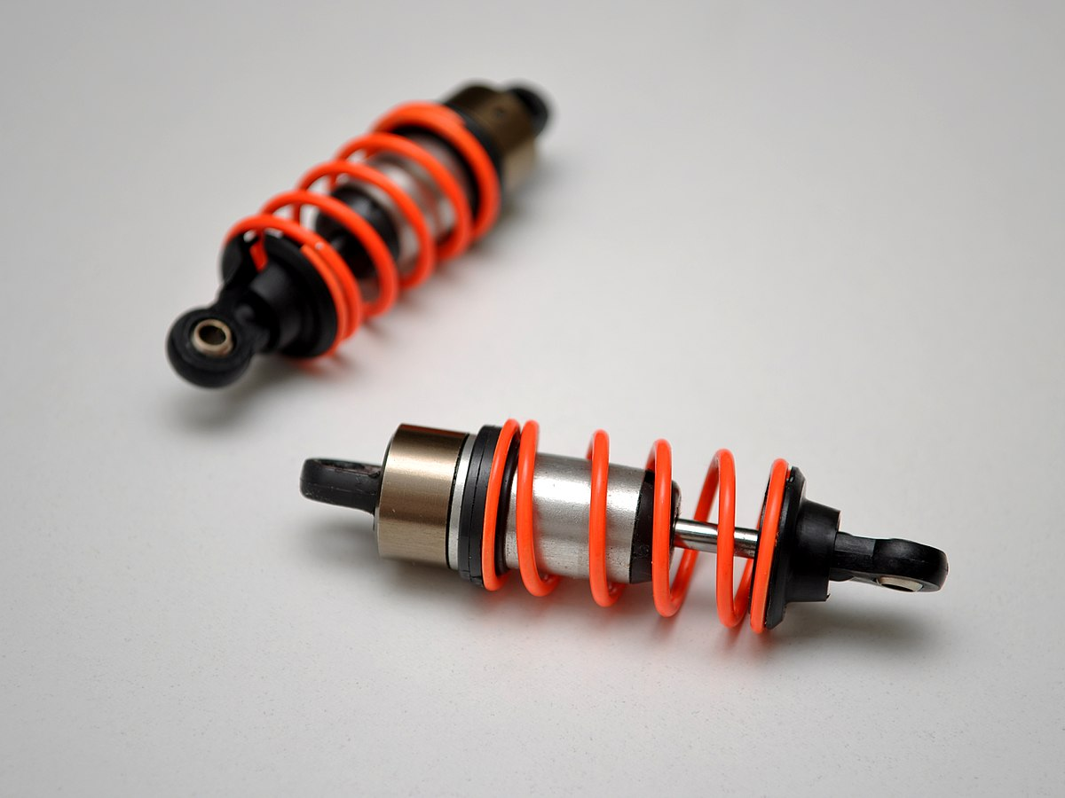
Small Shock Absorbers
Figure 16 Shock Absorbers, Ingham (2005)

A shock absorber can be compact and lightweight, making it a good option to be fitted onto the Greenpower car. A shock absorber will improve the drivers comfort by dampening a lot of the forces produced by the road surface, meaning the forces won’t be sent straight to the driver, but is instead being suppressed to lower the forces felt by the driver.
This is useful especially in the Greenpower project as it’s an endurance race, putting the driver through long durations of racing that can slowly cause fatigue to the driver.
Adjusting the ride height and stiffness of these shock absorbers can be easy, and through live testing an ideal suspension setup can be achieved. This setup needs to take into consideration the many adjustments to the vehicle such as the ride quality, the ride height and the handling capabilities. Adjusting any of these can affect the others in many ways, so there needs to be a correct point in the setup to compensate for the differences and still manage to improve the system.
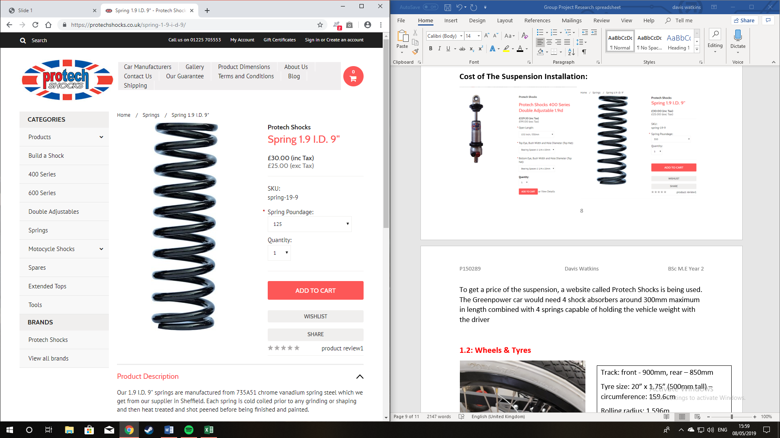
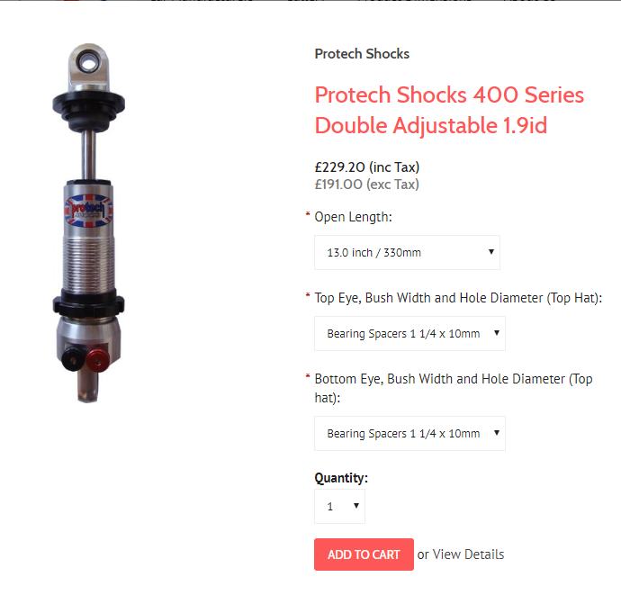
Cost of the Suspension Installation:
Davis
Figure 17 Spring Price, Protech
Figure 18 Shock Absorber Price, Protech
To get a price of the suspension, a website called Protech Shocks is being used. The Greenpower car would need 4 shock absorbers around 300mm maximum in length, combined with 4 springs capable of holding the vehicle weight with the driver.
The dampers shown above in figure 17 are set to a maximum length of 330mm, this provides plenty of height adjustment for the car to set the ride height at the ideal setup.
The springs to partner with the shock absorbers are shown above in figure 17, as the weight will be distributed between four springs it will only need to hold a ¼ of the total vehicle weight plus extra for the weight transfer so 125lbs will be enough to support the weight.
The total cost of these modifications would cost:
Shock absorbers: £229 x 4 = £916
Plus, the springs: 30 x 4 = 120
Total cost: 916 + 120 = £1036
Using a similar sized shock absorber from www.Amazon.com, a weight reference for the shock absorbers were found to be 3.8kg each.
To install four of these shock absorbers onto the Greenpower car, this would increase the total weight by 15.2kg, giving an increase to the total weight of 154.2kg.

Wheels & Tyres
Davis

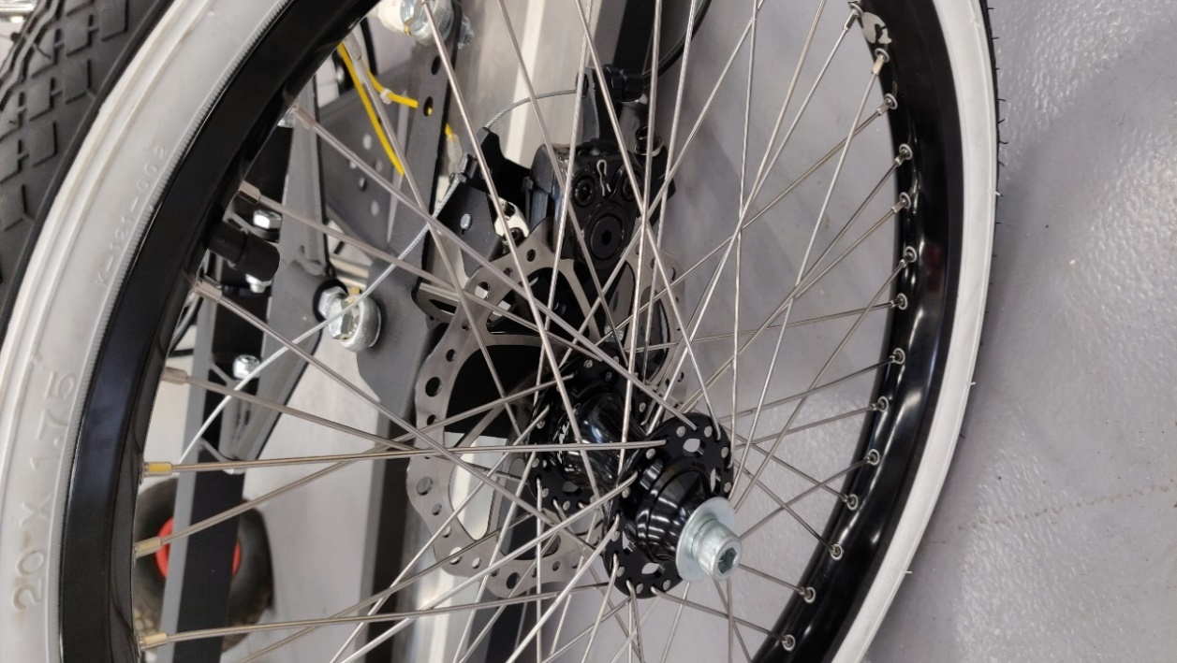
Figure 19 Tyre Size, Watkins
Track: front - 900mm, rear – 850mm

Tyre size: 20” x 1.75” (500mm tall) – circumference: 159.6cm
Rolling radius: 1.596m

Alternative: 18” x 1.75” (400mm tall) – circumference: 143.63cm
Rolling radius: 1.436m

Or 16” x 1.75” (300mm tall) – circumference: 127.7cm
Rolling radius: 1.277m

Top speed: 30.62 km/h (19.03mph)
Changing the tyre size can have an effect on many areas of a normal vehicle. This can include bringing up faults in the system and producing an inaccurate reading from the speedometer due to a different rolling radius of the tyre.
There are however some advantages and disadvantages to adjusting the tyre sizes on a track.
Advantages can include an increase in handling performance and producing less tyre roll to improve the stability in the corners, easier to take a corner at a higher speed, and opens the possibility to install slightly bigger brakes.
However, there are also many disadvantages. Firstly, it is more expensive, it can produce a higher rolling resistance, a reduction in ride comfort and it can be at a slightly higher risk of aquaplaning in wet conditions.

The regulations are fairly strict when it comes to the tyres, it states that “Tyres must not be less than 300 mm nor greater than 520 mm in diameter” (Greenpower, 2019). This means that a tyre diameter of 18” and 16” are usable instead of the 20” wheels currently fitted to the Greenpower car as their sizes are within the regulation as shown above next to Figure 19.
Davis
Changing the width of the tyres is also allowed but making them a different width comes with disadvantages. A narrower tyre can reduce the vehicles handling performance, this is due to there being less contact between the tyre and the floor surface, potentially increasing the chance of oversteering or understeering in a corner. However, a wider tyre would increase the available traction with the floor surface but at the same time it would increase the rolling resistance and therefore slow the vehicle down at a lower speed. So, a tyre width of 1.75 inches is a good point between decent handling and low rolling resistance.
The regulations also state that “The track of the vehicle must not be less than 500 mm front or rear”.
Another regulation includes “The track is deemed as the measured width between centres of tyres where they contact the ground. The track may vary front to rear” (Greenpower, 2019).
A regulation for the Alloys themselves says that “Plastic spoked wheels are not permitted” (Greenpower, 2019). This means that the alloys must not include plastic spokes, this can be for safety of the vehicle as the metal spokes are stronger and less likely to buckle under stress.

Methodology
Rich

Dyno Testing

Richard Osborne organised all dyno testing and each group was notified of dates and times to attend. Before the commencement of any testing, health and safety precautions had to be adhered to. All students participating in live testing activities had to be wearing appropriate PPE (personal protective equipment). This consisted of a pair of safety boots with steel toe caps.
The plan for testing was to obtain data of the motor temperature rise over a time period and also to understand how much voltage was drawn from the batteries over this time. Other groups had the idea to understand the current draw via the use of an amp’s clamp, unfortunately this proved unsuccessful due to a faulty amp’s clamp therefore the data for this was not collected.
The testing was carried out 3 times on different days to obtain an average. The first dyno run data was unusable as the batteries were not fully charged in preparation for testing. This dyno run was still carried out, nonetheless, for learning purposes. The 2nd and 3rd dyno runs were successful but ran slightly differently. The 2nd run was carried out with the dyno on and creating a theoretical road resistance, and the 3rd run was carried out with the dyno off and solely collecting data via measuring apparatus (Temperature probe and Multi-meter). A 4th run was carried out by Mark Fall, staff member in charge of the Dynamometer at UWTSD Swansea, with the dyno on and a printout of data obtained. This data shows the maximum speed of the vehicle, power output, motor rpm etc. in standard form. This data is shown below.
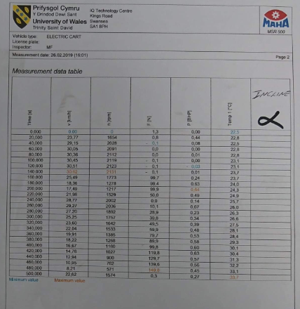
Rich
Figure 20 Mark Fall Data Collection Table
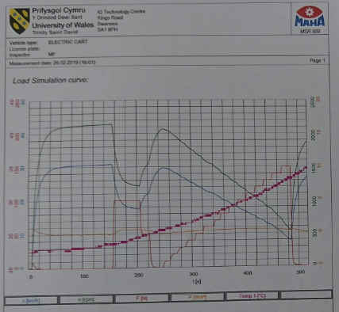
Figure 21 Mark Fall Data Collection Graph
Ollie

Cad analysis validating

Workshop validating steps.
- Step one, choose some scrap box section steel pipe.
- Using different grain of sandpaper, sand the contact patch till it’s smooth and shiny.
- Glue the sensor patch to the contact patch on the metal.
- Solder the wires to the strain Vr sensor.
- Using insolation tape, stop the wire from touching each other.
- Take the metal to a vice on the worktop. Clamp level and tight.
- Making sure the sensor is close to the vice, measure from the vice to the centre of the sensor, 42mm, from the vice to the end of the metal, 1245mm, and from the vice to the hanging position of the of the weights being used.
- Now plugging in all the sensor gauges.
- Take a reading of the gauge with 0 kg attached.
- Then attach the 0.5kg hanging weight and taking a second reading, and after that going up to 7.5 kg in 1 kg increments.
- Jotting the readings down on each increment.
- Then using a formula given to convert the Vr reading into strain.
- Now that the strain has been found I can use that to find stress.
- Once this is done I can then mock it up in solid work’s and use as a validation of the simulation system.
- The box section being 25mm by 25mm and material thickness of 3mm.
$$\frac{4Vr}{GF(1+2Vr)}$$
Above being the conversion formula needed to convert Vr into strain.

Ollie
Load (kg) | Vr | strain
0 | 0.03 | 52.9x10-3
0.5 | 0.04 | 69.23x10-3
1.5 | 0.05 | 84.96x10-3
2.5 | 0.06 | 100.13x10-3
3.5 | 0.07 | 114.77x10-3
4.5 | 0.08 | 128.91x10-3
5.5 | 0.09 | 142.56x10-3
6.5 | 0.12 | 180.89x10-3
7.5 | 0.15 | 215.67x10-3

Now that the strain the next step is to also mock the set up in cad and validate the system with cad. This will be show in the viva, along with final cad design of current kit car and an adaptation of the current chassis and a possible new design of a chassis which is had ideas for as previously stated before in my work.

Computer aided design work
Ollie

Current design

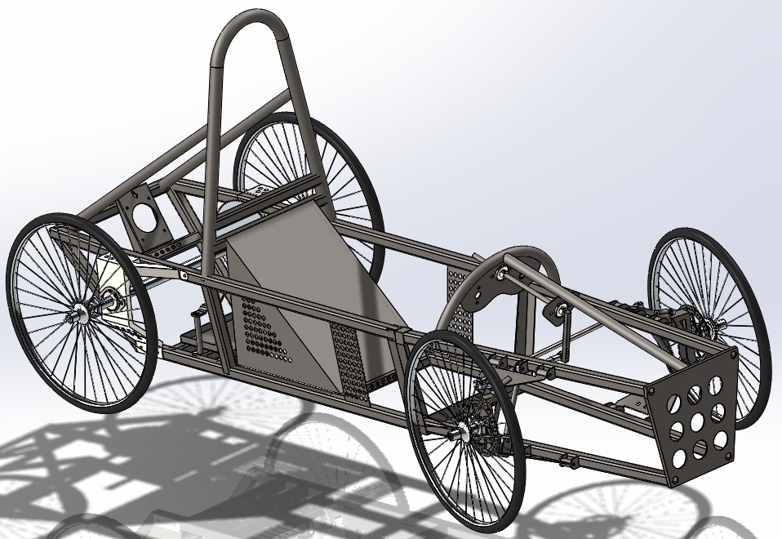
The current design of the cad model was made up of 4 individuals doing different parts to the kit car and myself putting them together. Me doing the front chassis and suspension components and all the rose joints and some steering components. This was because Daniel was doing the steering and suspension components but they were incorrectly measured and he unfortunately hasn’t returned after Christmas break so I took on this role. Jakub created the rear axle and all the components for that in CAD, Davis did the frame for the rear section of the chassis which needed to be adapted by myself to work because of some errors and he also did the wheel and brake disc’s. Rich did the seat and reinforcement components for rear chassis and steering components with me, after some difficulties that occurred at the start of the second semester with cad being lost, which was unfortunate, I had to redesign my side of all the cad and re assemble the components. Whilst this was happening, Jakub assembled his rear axle, and rich went to measure any extra components that I required measurements for. After adapting any mistakes and extra stuff like sprocket and motor mounting bracket and plate. I then assembled the whole kit car.

Figure 22 completed kit car model
This design is actually very good but for a car that doesn’t produce a lot of speed and weighs a lot without a driver let alone with a driver, with one of the lightest students from our class in the car the total weight was 143.5kg with the weight distribution being 45% at the front and 55% at the rear. And with the motor being mounted off centre to the left meaning the weight transfer was offset to the left, 51.22% to the left and 48.78% to the right. So for this report I went into change the current design with the goal of saving weight and it still looking like a driver could sit in it. Below is a first initial step to cutting out some weight from the front chassis.
Ollie

Adapted design

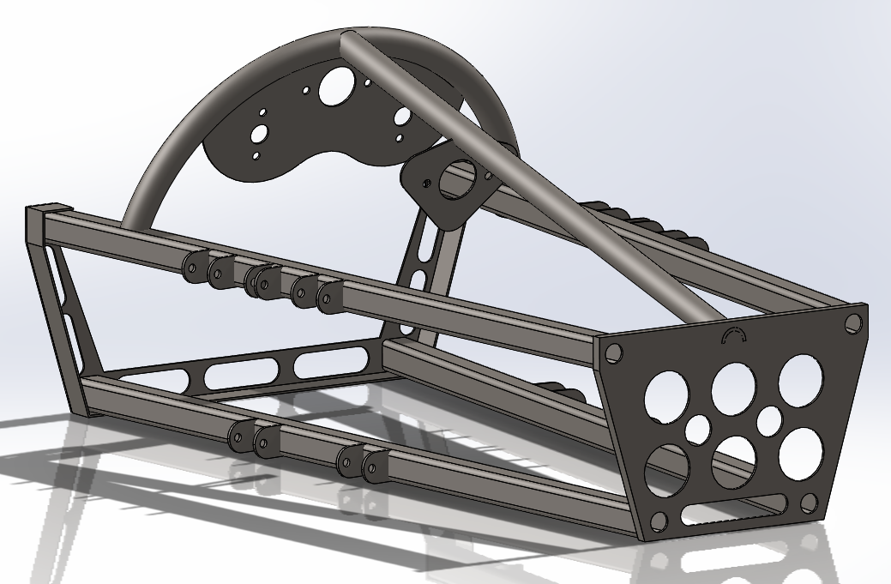
With the redesign of the front chassis component I’ve trimmed the height by 100mm front and back and trimmed the width by 100mm by top and bottom. And removing three cut outs from the front plate. With multiple cut outs in the rear plate and front plate because they both have unnecessary material being on the component.

Figure 23 adapted front chassis
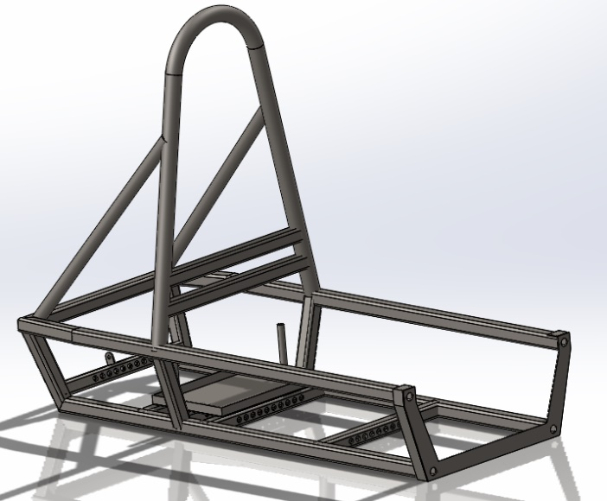
With the rear chassis to the same thing with the height as I had done to the front section of the chassis this was by 100mm, and I made it shorter length ways by 100mm. also moved the battery tray to be more under the seat so that the centre of gravity is more centralised, theoretically I could make the front and rear roll bars shorter in height. Further adaptation shall be done to see if it would be better to adapt the old or redesign from scratch.
Figure 24 adapted rear chassis
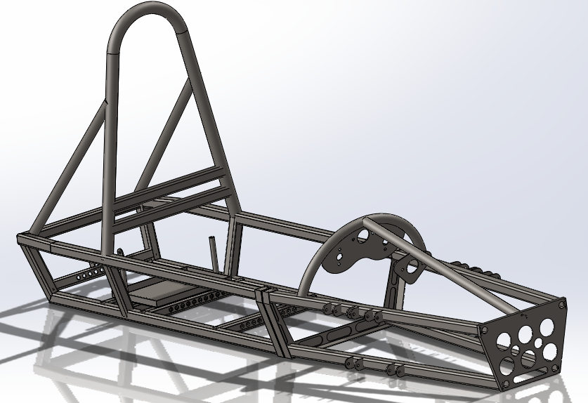
Ollie
Figure 25 simple assembly of adapted chassis
Here’s a view of the adapted assembly of the chassis without any other components like wheels and axles and steering, this was redesigned by my-self.

Starting new design for chassis
Ollie
With a new design I needed to do some research into strong shapes and came across a chassis engineering book in the library, in the book it explained how triangles were a good solid shape and can deal with a high load of stress, there was also the angled four sided frame which looks good but isn’t great under load. So, to counter this you would make it a square with a reinforcement beam going across to add stability and make sit incredibly strong when under load. Then there was a square with a plated back which again is strong but weighs a lot more which in the scenario that the group is working in adding more weight is a hindrance.
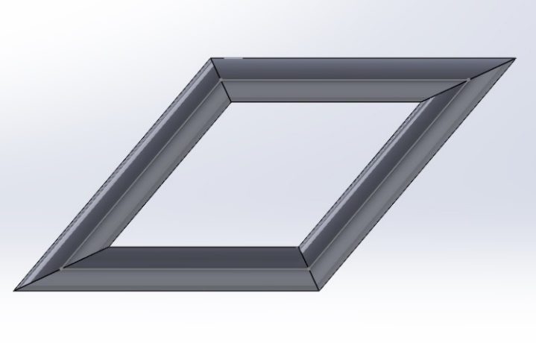
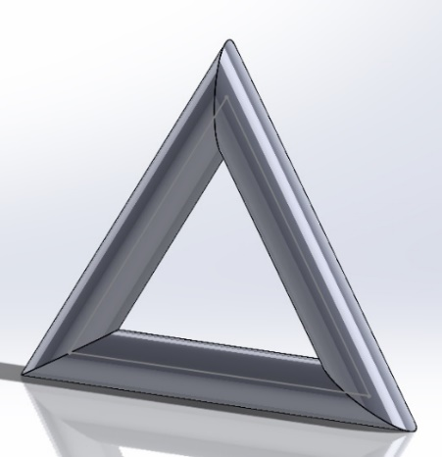

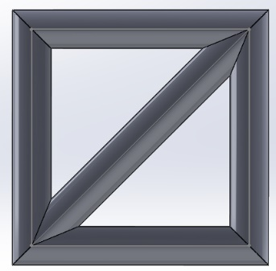
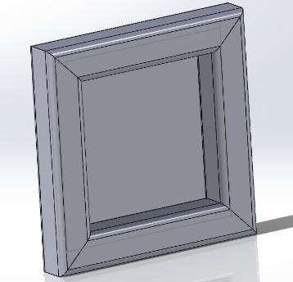

Figure 26 chassis frame strength idea's
Once the analysis work on the cad modals is done, I shall be showing which shapes are strong and which aren’t to support the theory I have about these four simple framework modals I have mad in solid works. When doing the analysis, I’ll do it with the conditions on each part, fix the bottom pipe or square box section and apply a load of 1000N to the left-hand side and wait for the results and compare them to each other to see which deals with the load and see which type of frame shapes I should use for a new design. My initial thought would be the triangle shaped framework and the square with reinforced bar framework, but with the analysis I shall be carrying out this will prove or disprove my initial thought.

Analysis
Rich

Dyno Testing

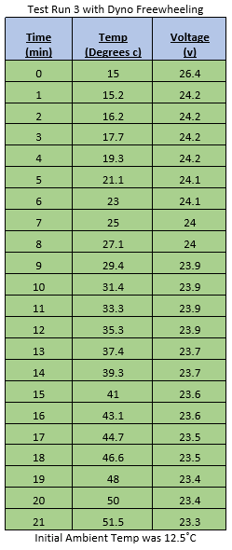
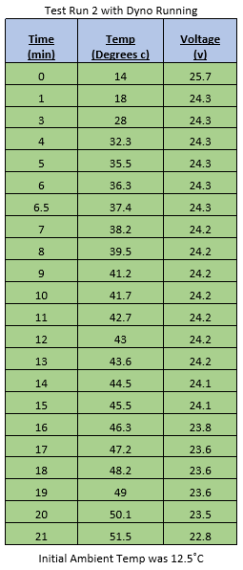
The Greenpower vehicle was tested on the dynamometer at UWTSD Swansea. It was tested on three separate occasions, the first of which is unrecorded due to the batteries being under charged. The tests were carried out to understand voltage drain against temperature rise over time.
Rich
It can be seen in the tables above that, over a time period of 21 minutes, the voltage doesn’t decrease that much from fully charged (total drop of 2.9v in run 2 and 3.1v in run 3). The Motor Temperature, measured at the case, however, increases rapidly throughout. Testing was ended on both occasions when the motor temperature exceeded 51 degrees. This temperature was deemed too hot by the students and Mark Fall. At this point in time the information from Steve Newman at Greenpower regarding Motor Temperature was unknown (See Figure 6). Unfortunately, another dyno testing session was not carried out due to lack of interest.

Gearing
Rich

The Greenpower F24 Kit Car in original state is fitted with fixed gearing. This fixed gearing means that there is no freewheel/clutch mechanism and there is 1 driving gear (mounted to the motor) and 1 driven gear (fitted to the axle). The standard driving gear has 12 teeth and the driven gear has 72 teeth, giving a gear ratio of 6:1. The higher a gear ratio, e.g. 8:1, 10:1 etc., allows for less torque/power to be needed from the motor to get the vehicle moving. The downside to this is that the top speed is limited, and therefore, some calculations are required to understand a happy medium between top speed and less battery drain.
After an email to Steve at Greenpower, gearing possibilities were confirmed (see Figure 7) and the idea to use bicycle gearing was enabled. A theoretical budget for gearing was set at £500 and parts required were investigated.
  - Parts Required
Firstly, a rear cassette of gears was looked into, to understand availability and cost. The Cassette decided on was the Hope 11 speed cassette – 10-48T, this cassette has a 48 tooth 1st gear (largest available off the shelf) and a 10 tooth 11th gear (smallest available off the shelf), this tooth arrangement is the reason for its selection due to the wide range and higher 11th gear for top speed. The Gear Cassette will be mounted to the axle in place of the original 72 tooth driven gear. The cost of this was £157.50

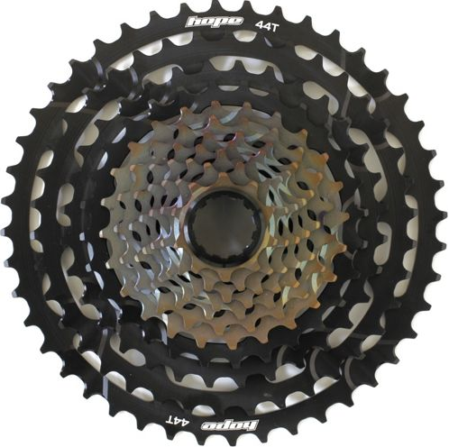

Next on the list was a durable and reliable derailleur. A derailleur is used to change gears by directing the drive chain to the gear selected by the driver. This will be fitted to a custom bracket and mounted above the cassette. Alignment of the derailleur to cassette chain routing is carried out on the derailleur itself. Along with companies like Hope (Cassette Manufacturer), Shimano is another top brand in mountain biking so a Shimano derailleur was found. The Shimano SLX M7000 11 Speed Rear Derailleur was chosen because of their long-time success in aggressive mountain biking components, such as components fitted to downhill mountain bikes. The cost of this component was £44.99
Rich

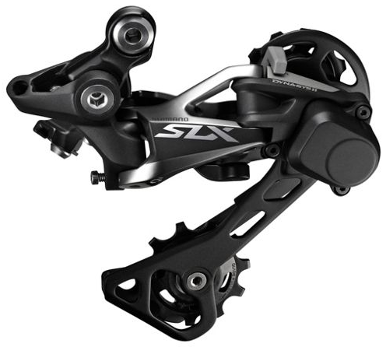
A Gear Cable Set will also be required and can be made at a custom length dependant on the application. This has a cost of £4.99
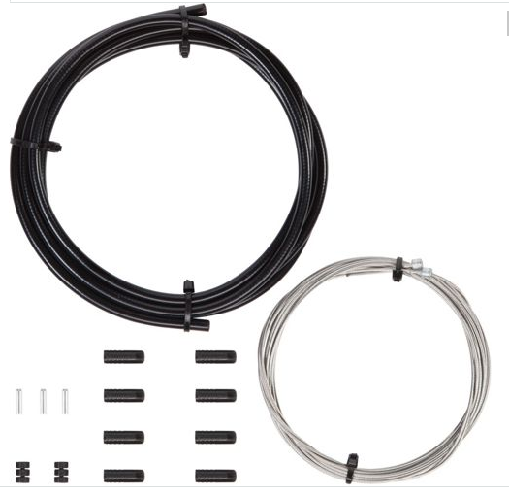

These components combined cost a total of £207.48 leaving £292.52 for development of the gear shifter and ratcheting mechanism that follows.
The need for a gear selector/shifter was required next. Inspiration was taken from sequential gear shifters found in race cars, as shown below.
Rich
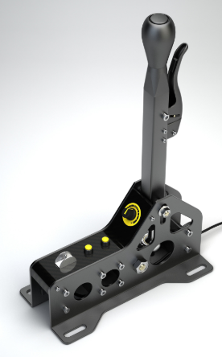
Figure 27 Gear Shifter Idea
This would need to be designed and produced in house as it would be a custom setup, unfortunately a design was not produced. The idea is that a shifter lever would be mounted on a pivot on the side of the chassis within driver reach, this would have a ratcheting mechanism locked and unlocked via the small lever attached at the front of the gear lever. A gear cable would run from the bottom of the lever to the derailleur and as the lever is pulled and pushed, the derailleur would change up and down gears at each increment of the ratcheting mechanism. As shown similarly in the video link provided https://www.youtube.com/watch?v=V0_1DzVTiPc
  - Gear Ratios
As it is known that the standard Gear Ratio is 6:1, an equivalent or better first gear ratio should be used. Once the vehicle is in motion and gear changes are enabled, this shouldn’t cause further battery drain but maintain a normal voltage discharge. Gear selection however will have to be monitored closely by the driver to attempt to maintain as little battery drain as possible.
With the Hope cassette having 48 teeth on first gear, the motor sprocket must be reduced to obtain the standard or better gear ratio for pulling off from the starting line. If the motor sprocket were to have 8 teeth instead of the original 12, the
Rich and Davis

gear ratio would hit the target of 6:1 as 48 teeth (First Gear) ÷ 8 teeth (Motor) = 6, therefore the Gear Ratio is 6:1
With this knowledge obtained the gear ratios can be worked out for every gear, as displayed in the table below.
Gear | Teeth | Ratio
1st | 48 | 6:1
2nd | 40 | 5:1
3rd | 33 | 4.125:1
4th | 28 | 3.5:1
5th | 24 | 3:1
6th | 21 | 2.625:1
7th | 18 | 2.25:1
8th | 16 | 2:1
9th | 14 | 1.75:1
10th | 12 | 1.5:1
11th | 10 | 1.25:1

Calculations with a damper fitted

The height of the dampers would be around 300mm tall as this is the distance of the suspension mounts on the Greenpower car, but the dampers would compress under load and therefore lower the vehicle ride height.
This means that the damper could be a bit longer than 300mm tall and the ride height can then be set with the weight applied to it.
The floor of the Greenpower car currently sits at around 50mm off the floor and the regulations state that it must be at or below 100mm, which this means the car is within the limit and complying with the regulations.
“The driver’s seat and base of the main batteries must be at or below 100mm from ground level, a 6 mm hole should be drilled through the base of the seat to allow height measurement.” (Greenpower, 2019).
This shows that there is a maximum ride height of 100mm, so the springs would need to be adjusted to ensure that the ride height follows these regulations.
Adding a damper would increase the body roll and weight transfer, so to find the amount of weight transfer the first step is to find the total weight on the front and back.
Davis
Without a driver the vehicle has a front weight of 24.5kg and a rear weight of 53kg, whereas having a driver sit in the car this went up to a front weight of 63.5kg and a rear weight of 75.5kg
This means that with a driver there is a total weight of 139kg split slightly lower on the front of the car.
This equates to 45.7% of the weight being applied on the front of the car and then 54.3% of the weight being applied to the rear of the car.
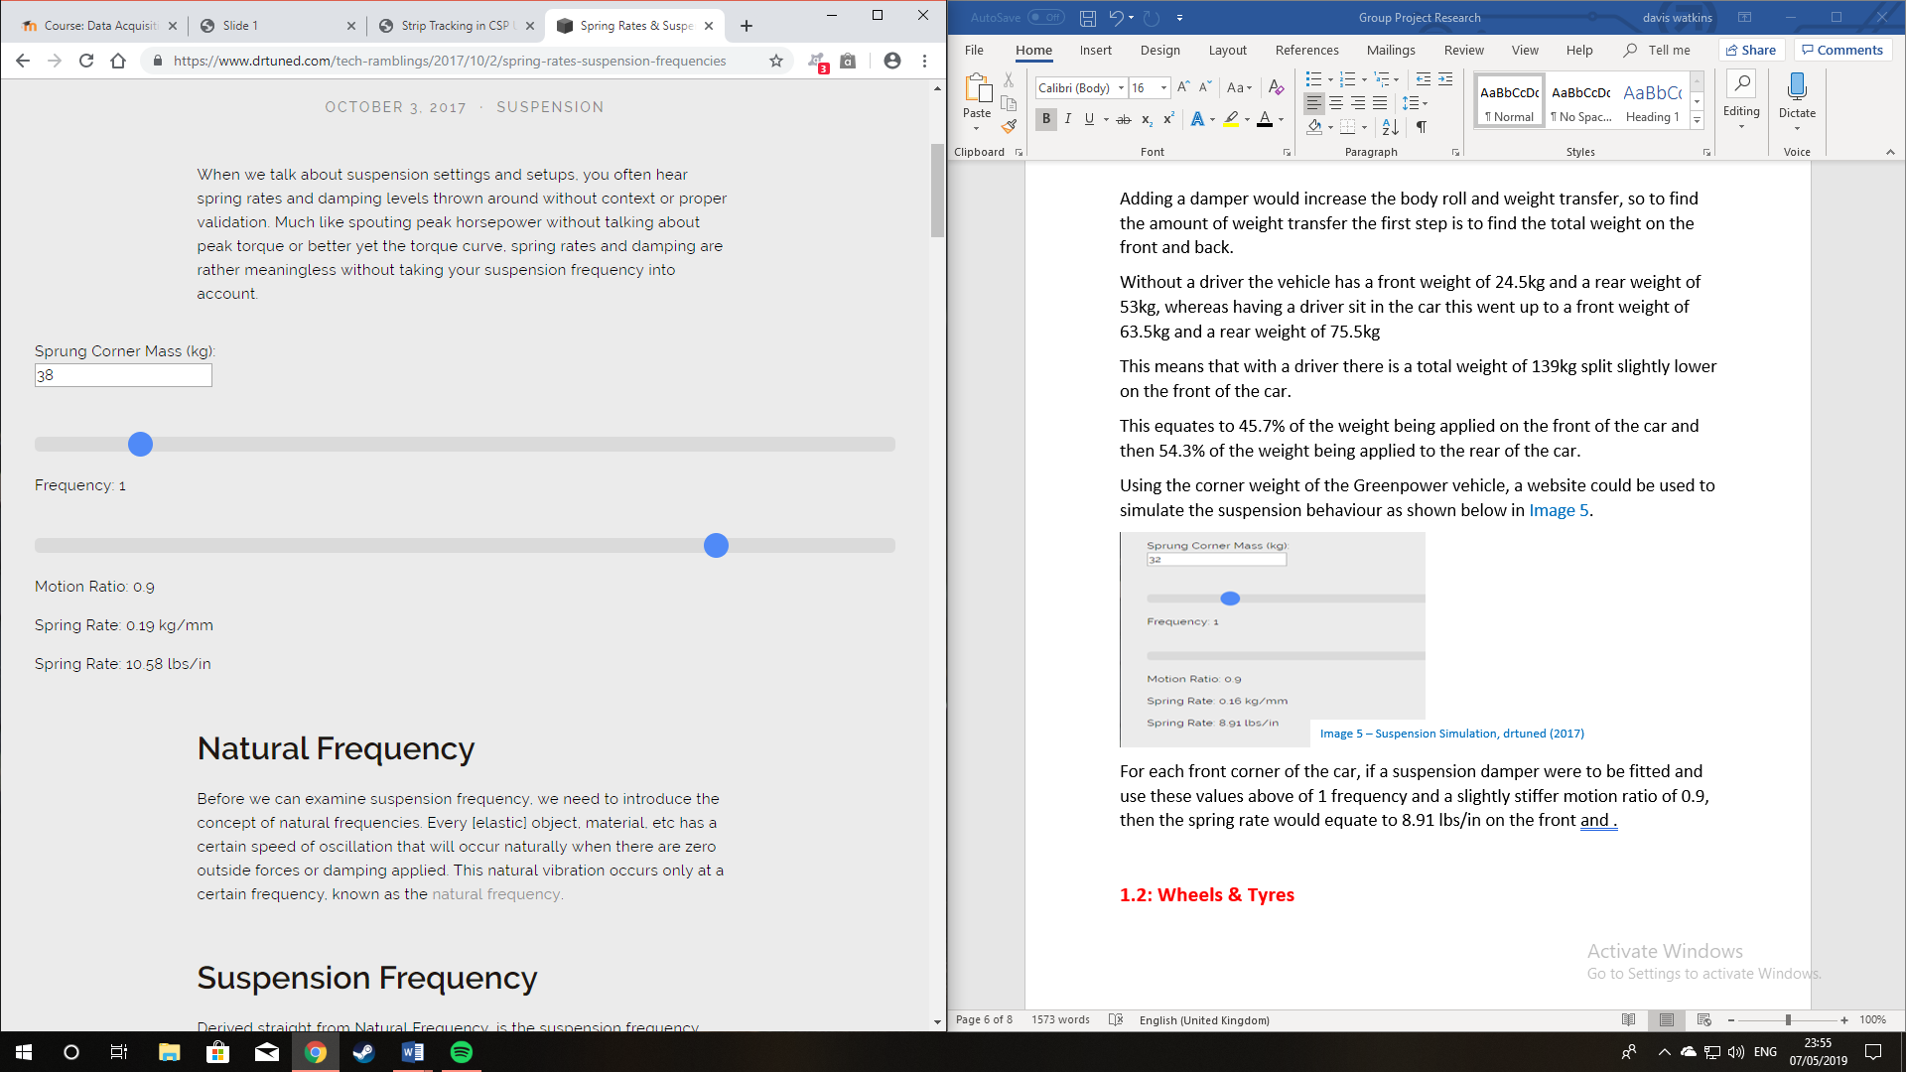
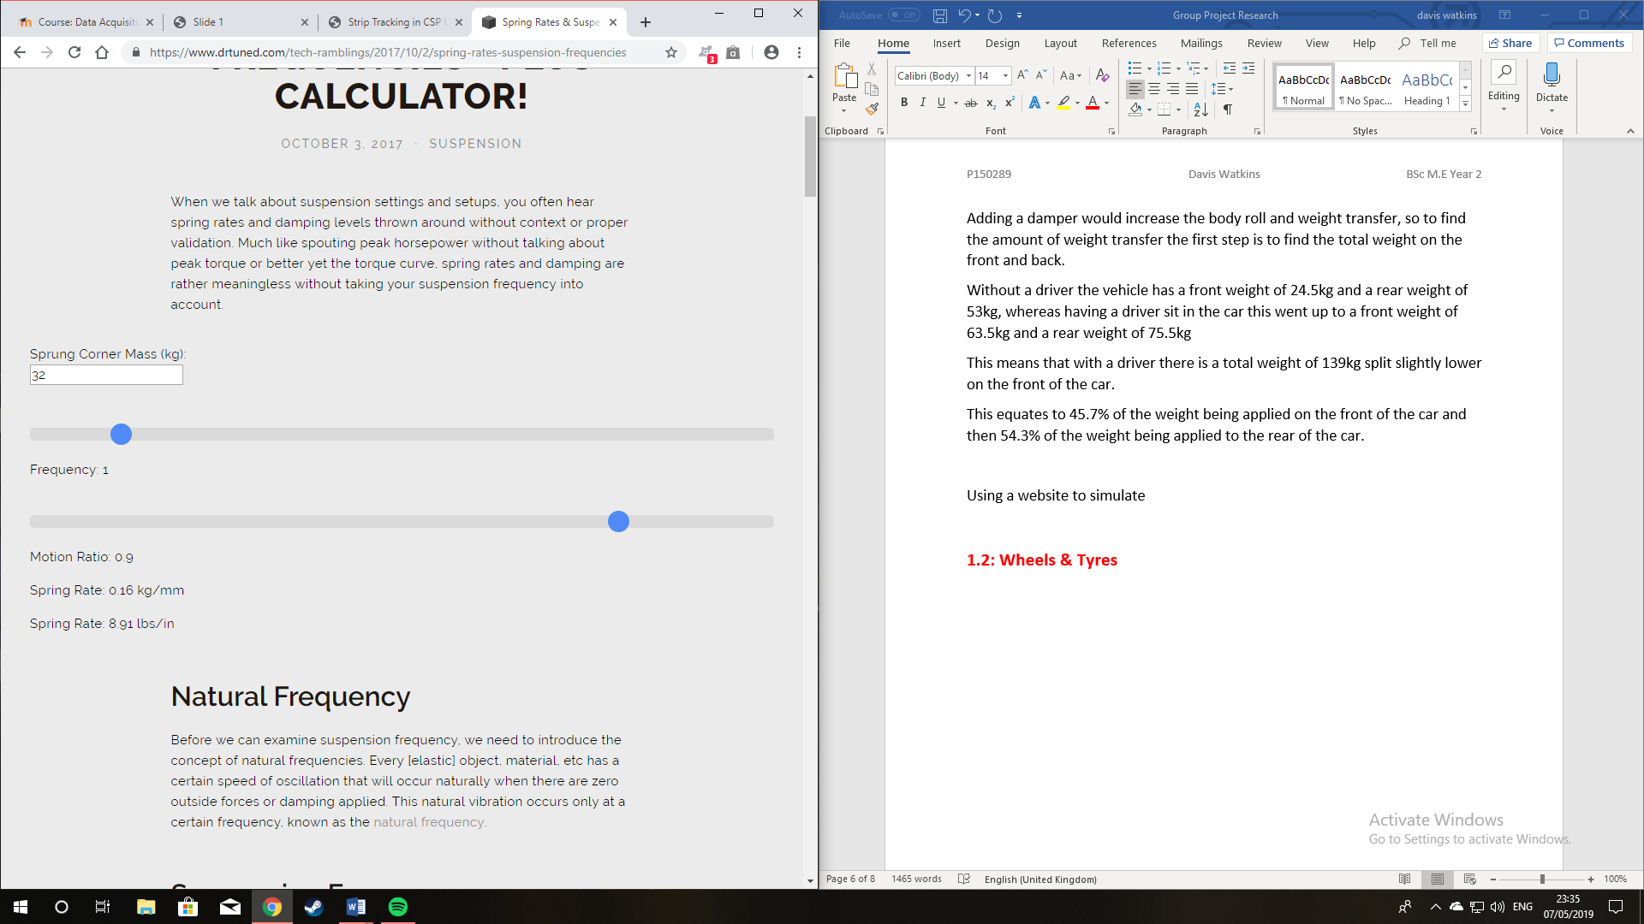
Using the corner weight of the Greenpower vehicle, a website could be used to simulate the suspension behaviour for an example as shown below in figure 25.
Figure 28 Suspension Simulation, drtuned
For each corner of the car, if a suspension damper were to be fitted and use these values above of 1 frequency and a slightly stiffer motion ratio of 0.9, then the spring rate would equate to 8.91 lbs/in on the front and 1.58 lbs/in on the rear.
Let’s use an example un-sprung mass of 20kg from 5kg each corner, leaving the sprung mass on the suspension of 119kg. The formula below calculates the height of the sprung mass: 958.24
Davis
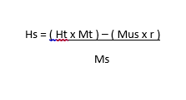
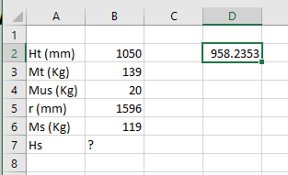

Figure 29 Sprung Mass Formula, Moodle
Figure 30 Sprung Mass Values, Watkins

Using the above formula, the vehicle values can be inserted into an excel spreadsheet to find the overall centre of gravity height of the sprung mass.
The rear sprung mass would be 54.3% of the 119kg of sprung mass, this equates to 64.6kg. The front sprung mass would be 45.7% of the 119kg of sprung mass, this equates to 54.4kg.
This overall height of the centre of gravity height of the sprung mass comes out as 958.2mm from the floor.
To find the distance of the centre of gravity from the front of the vehicle, the formula below needs to be used:
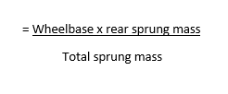
This means that to find the distance, it would be (1380*64.4)/119. This equates to 749.14mm from the front of the car, and 958.2mm from the floor.
Due to there currently being no suspension on the Greenpower car, to calculate the roll angle (φ) there needs to be a value for the deflection.
For theoretical purposes an estimated value will be used of 20mm total deflection to calculate the roll angle with suspension fitted, then using the formula shown below it is possible to develop an understanding of the amount of body roll produced by the suspension:
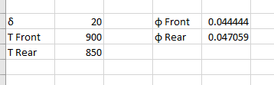
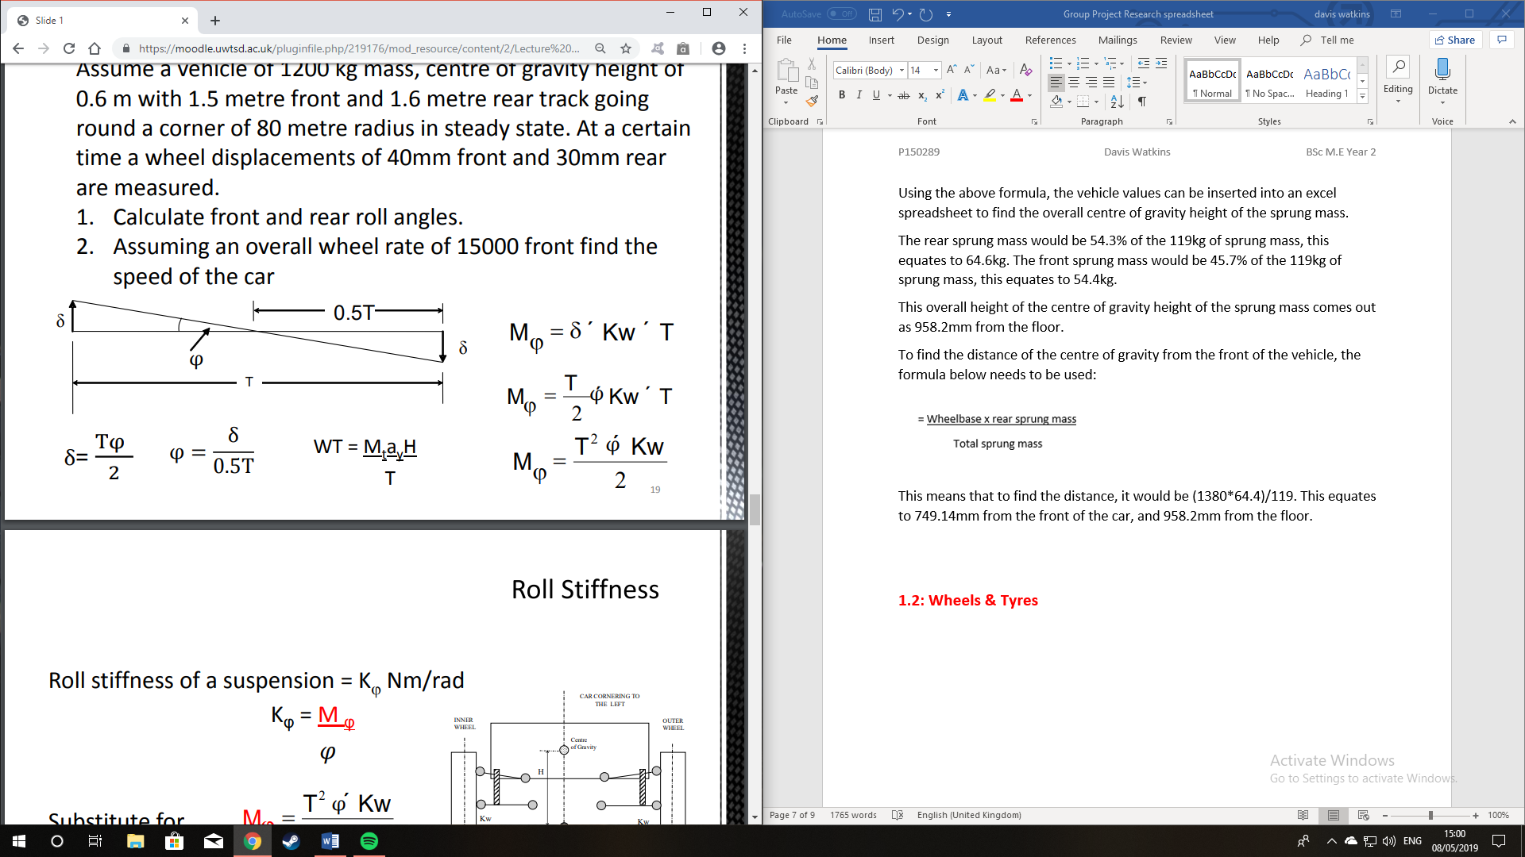
Davis
Figure 31 Body Roll Formula, Moodle (2019)
Figure 32 Image 9 – Body Roll Values, Watkins

As shown in the images above, using the formula and estimated values a result of the front and rear body roll can be calculated. Being shown in figure 29 are a front body roll value (φ Front) of 0.044 ͦand a rear body roll (φ Rear) value of 0.047 ͦ.
In order to calculate the amount of weight transfer in the Greenpower car, the formula below is needed. This value can differ based on the ride height and the suspension stiffness as setting the suspension to be stiffer can reduce the amount of weight transfer, this is because the suspension would help to keep the vehicle body steady when turning so less weight will be thrown outwards as it’s shared more equally by the suspension. The lateral acceleration will be using the value of the maximum speed of the vehicle to understand the maximum amount of weight transfer, this maximum speed would be 19mph:
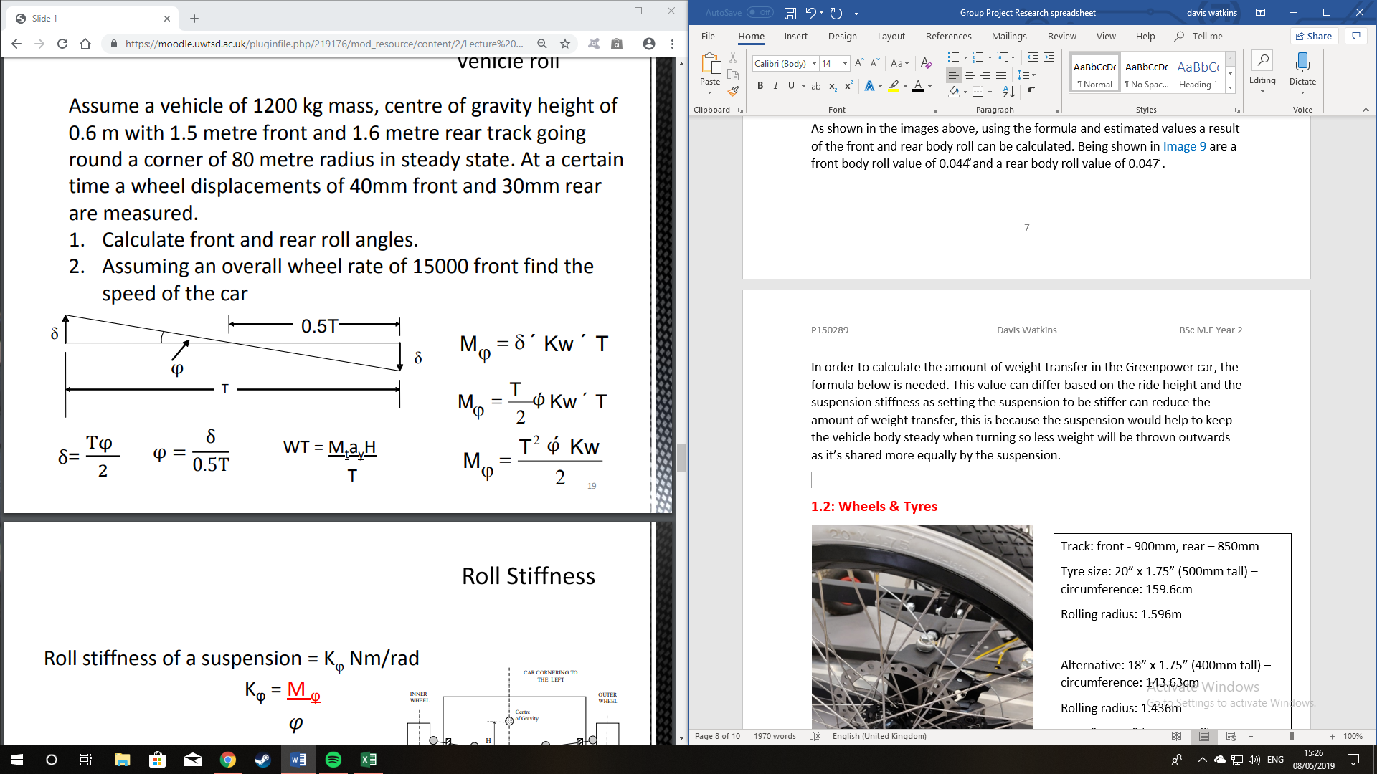
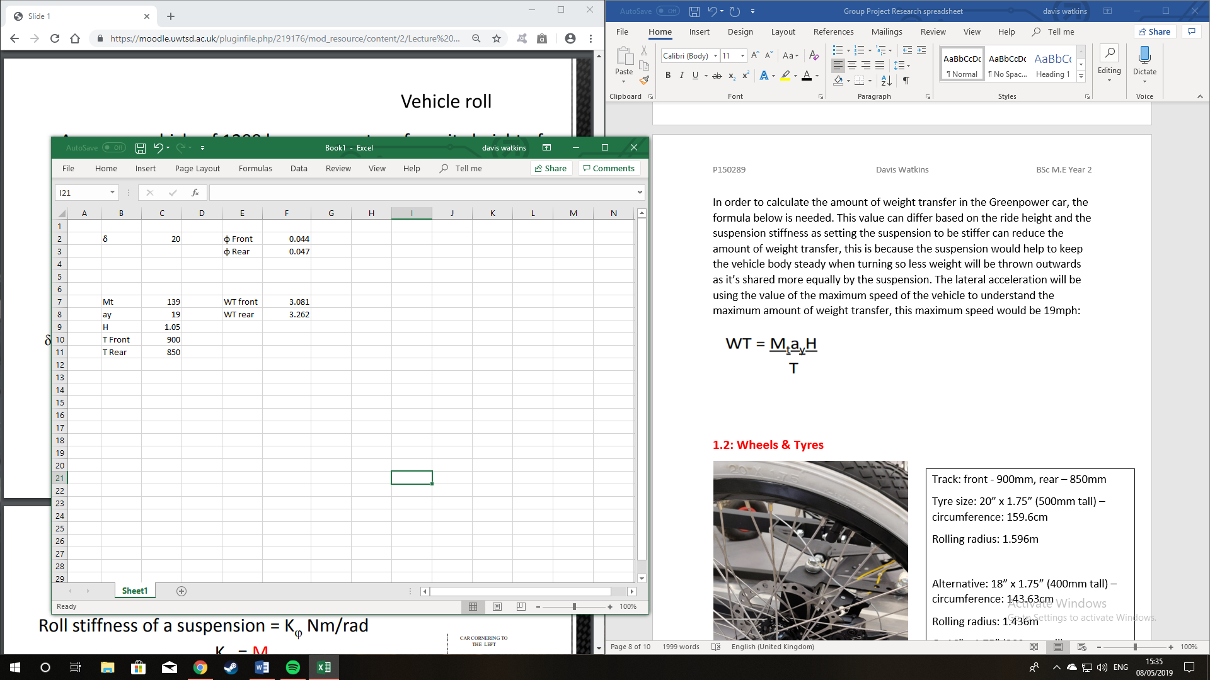
Figure 33 Weight Transfer Formula, Moodle
Figure 34 Weight Transfer Values, Moodle
As shown in the images above, the weight transfer can be calculated using the formula in figure 30 and this calculates the values which are shown in figure 31. The front weight transfer (WT Front) is shown as 3.08kg at 19mph, the rear weight transfer (WT Rear) is shown as 3.26kg at 19mph. as mentioned these values would differ based on the suspension setup, as stiffer suspension would reduce the amount of weight transfer and softer suspension would increase the amount of weight transfer.

Conclusion
Rich and Ollie

  - Richard
It was my original intention to cover a number of sectors for this project, unfortunately, not only was the number of areas selected a bit ambitious, but with Jakub (Aero Package) leaving the group the motor cooling was not carried out. I only covered Batteries, Motor and a look into a Gearing System. This is due to poor time management on my behalf and a lack of general effort and interest. It is my personal opinion that my choice of area was poor and my reason for choice was simply that I believed the other team members would not have wanted to cover the electronic side of the project. If I had the chance again, given the knowledge I have obtained of vehicle dynamics this year, this would have been my area of choice as I find this interesting.
Due to my lack of interest I feel I have left this report too late to complete to a good standard. That being said, when I did finally commence my work, the Gearing System sparked my interest. With this, I was immediately met with regret and wish I had put in the effort and started at the times specified in the Gantt chart (Section 3.0), this way I am confident that I could have handed in a better report and could have obtain a much broader knowledge of the subject.
My general overview of the project as a team effort is poor and after conversing with other team’s members, the effort put into the group projects as a class has also been poor. This may not be entirely true for the groups but it is what I have been told.
  - Ollie
To conclude on my section of the project. This would be the dream option as a group in my opinion because it would be a great learning opportunity and we’d have a lot more interest in the project as a whole rather than having zero to no chance to do anything to or with the current kit car in the workshop. Because of a lack of interest, it meant that as a group we didn’t really progress the project along till a few weeks before the deadline which isn’t the correct or professional way to conduct a group project such as this one. But on a personal side of things I think out of all the student in my group I showed a good level of cad skills, but I didn’t like the fact that I had to change other students in my group cad work considering we were working together on the cad for the first part, but after having to spend more time fixing and changing the components on cad I wasn’t able to advance through the analysis by this point as I would have liked too and I wanted a new chassis with maybe a steering and suspension set-up completed for it as well but loosing members of the team on the way was a big factor to this. I can’t speak for the whole group but I think if we had all motivated ourselves at the beginning to get on with this project it would have been progressed a lot further and would have been at a top level of work. I should have applied myself more when it came to do the analysis work in solid works because it’s a great skill to have and it would’ve been good to show a good level of analysis work in the report.
Ollie and Davis
Davis
The ride quality of the Greenpower car is tough and uncomfortable, so a great modification to improve the ride quality would be to install a set of small shock absorbers.
This would increase the weight a little bit as found online, a set of shock absorbers could increase the weight by around 15kg but there may be lighter alternatives available to use.
In order to install a full set of shock absorbers to the Greenpower car, a suitable set of shock absorbers with compatible springs were found online with a total price around £1000. This price could vary based on the different sizes, brands, and materials used, all with different characteristics to benefit from.
Installing a suspension system would improve the ride quality, but it would introduce the possibilities of body roll and weight transfer affecting the handling of the car.
There are however ways to combat this by using methods such as lowering the ride height of the car. This improves the stability of the car in the corners and can improve the aerodynamics, this is due to less air travelling underneath the car to reduce the drag.
The advantage with using a suspension system is the fact that it’s very easy to adjust the ride height, and the spring stiffness can be adjusted in small increments to reduce the amount of body roll when cornering. This adjustment can allow the driver to find the suitable point between decent ride comfort and better handling capabilities.

However, due to many calculations and research to support it, there doesn’t appear to be much of an argument to install any means of damping to the Greenpower car. This is because the Greenpower race is based on endurance where the cars will compete for a very long duration, so a minimum weight and the lowest resistance is crucial for every team to provide the best advantage. Installing a suspension system would cost a lot of money and add a lot of weight to the car, whilst the advantages that are received from the damping are not great enough to outweigh the advantages of not having a suspension system, due to it being used on a flat and smooth track surface.

References
Rich

Richard’s References

Bike.shimano.com. (2018). CS-5700. [online] Available at: https://bike.shimano.com/en-EU/product/component/zee-m640/CS-5700.html [Accessed 8 May 2019].
Burkett, C. (2016). Greenpower Gearing. [video] Available at: https://www.youtube.com/watch?v=V0_1DzVTiPc [Accessed 8 May 2019].
Chainreactioncycles.com. (2019). Chain Reaction Cycles | MTB | Road | TRI | Run. [online] Available at: https://www.chainreactioncycles.com/shimano-acera-hg200-9-speed-mtb-cassette/rp-prod120023 [Accessed 8 May 2019].
Chainreactioncycles.com. (2019). Hope 11 Speed Cassette - 10-48t | Chain Reaction Cycles. [online] Available at: https://www.chainreactioncycles.com/hope-11-speed-cassette-10-48t/rp-prod161749 [Accessed 8 May 2019].
Coulden-Smith, G. (2017). Battery Care | Greenpower. [online] Greenpower.co.uk. Available at: https://www.greenpower.co.uk/node/406 [Accessed 27 Nov. 2018].
Park Tool. (2017). How A Rear Derailleur Works. [online] Available at: https://www.parktool.com/blog/repair-help/how-a-rear-derailleur-works [Accessed 8 May 2019].
Yuasa.co.uk. (2014). REC36-12I - REC - VRLA - Cyclic Use - Industrial - Batteries. [online] Available at: https://www.yuasa.co.uk/batteries/industrial/rec-vrla-cyclic-use/rec36-12.html [Accessed 25 Nov. 2018].

Ollie’s references.
Ollie

3.26mm), 1. (2019). 1" x 1" x 10swg (25.4mm x 25.4mm x 3.26mm) - 1st Choice Metals. [online] 1st Choice Metals. Available at: https://www.1stchoicemetals.co.uk/product/1-x-1-x-10swg25-4mm-x-25-4mm-x-3-26mm/ [Accessed 9 May 2019]. : budget aluminium
Ojs.unsw.adfa.edu.au. (2019). [online] Available at: http://ojs.unsw.adfa.edu.au/index.php/juer/article/viewFile/1125/748 [Accessed 9 May 2019].: carbon fibre costing
Pinterest. (2019). Arachnid Build in NOLA - Page 2 - DIY Go Kart Forum | Cars I like | DIY go kart, go kart, Go kart frame. [online] Available at: https://www.pinterest.co.uk/pin/488148047101639751 [Accessed 9 May 2019].: figure four.
Pinterest. (2019). Double Wish Bone Suspension | wanting to build an off road buggy | Kit cars, Pedal cars, Go kart plans. [online] Available at: https://www.pinterest.co.uk/pin/380624605989048120/ [Accessed 9 May 2019].: figure three.
Pinterest. (2019). Totrod Tot Rod Chassis Go-kart Go Kart Buggy Petrol Car | | Go Karts | Go kart buggy, go kart, DIY go kart. [online] Available at: https://www.pinterest.co.uk/pin/816347869925168440 [Accessed 9 May 2019].: figure two.
The Hybrid Blog. (2019). F1 Dominators – Lotus 25 Climax. [Online] Available at: https://aaronlloydcollins.wordpress.com/2017/05/03/f1-dominators-lotus-25-climax/ [Accessed 7 May 2019].: figure one.

Davis’s Reference’s
Davis

Greenpower Regulations – Greenpower Regulations 2019, Technical & Sporting Regulations 2019, https://www.greenpower.co.uk/sites/default/files/uploads/Technical%20and%20Sporting%20Regulations%202019%20V1.pdf [Online] (Accessed 03/05/2019).
Greenpower Wheel & Track Regulations (2019), Technical and Sporting Regulations 2019, greenpower.co.uk, https://www.greenpower.co.uk/sites/default/files/uploads/Technical%20and%20Sporting%20Regulations%202019%20V1.pdf [Online] (Accessed 05/05/2019).
Image 1 – Greenpower (2017), Greenpowersg.com, Formula 24 (F24I) Intermediate, https://greenpowersg.com/categories/formula-24-f24i-intermediate-3/ [Online] (Accessed 03/05/2019).
Image 11 – Davis Watkins (2019), Weight Transfer Values, Microsoft Excel Spreadsheet, (Created 05/05/19)
Image 12 – Protech Shocks (2019), Shock Absorbers, protechshocks.co.uk, https://protechshocks.co.uk/protech-shocks-400-series-double-adjustable-1-9id/ [Online] (Accessed 05/05/2019).
Image 13 – Protech Shocks (2019), Shock Absorber Springs, protechshocks.co.uk, https://protechshocks.co.uk/spring-1-9-i-d-7/ [Online] (Accessed 05/05/2019).
Image 14 – Davis Watkins, Tyre Sizes, Personal Photograph (2019).
Image 2 – Lets Build One, letsbuildone.wordpress.com, Greenpower F24+, https://letsbuildone.wordpress.com/greenpower-f24/ [Online] (Accessed 03/05/2019).
Image 3 – Davis Watkins, Suspension Layout, Personal Photograph (2019).
Image 4 – David R, Ingham (2005), Wikipedia.org, Shock Absorber, https://en.wikipedia.org/wiki/Shock_absorber [Online] (Accessed 03/05/2019).
Image 5 – drtunedracing (2017), drtuned.com, SPRING RATES & SUSPENSION FREQUENCIES - PLUS CALCULATOR!, https://www.drtuned.com/tech-ramblings/2017/10/2/spring-rates-suspension-frequencies [Online] (Accessed 04/05/2019).

Davis
Image 6 – Finding Hsra (2019), Moodle.uwtsd.ac.uk, https://moodle.uwtsd.ac.uk/pluginfile.php/83262/mod_resource/content/3/2.%20Assignment%202%20Guidance%20%20-%20Finding%20Hs%20and%20Hsra%20%20from%20Ht.pdf [Online] (Accessed 04/05/2019).
Image 7 – Davis Watkins (2019), Sprung Mass Values, Microsoft Excel Spreadsheet, (Created 04/05/19)
Image 8 – Dynamic Wheel Loads (2019), Moodle.uwtsd.ac.uk, https://moodle.uwtsd.ac.uk/pluginfile.php/219176/mod_resource/content/2/Lecture%20on%20%20Roll%20Stiffness%20Distribution.pdf [Online] (Accessed 04/05/2019).
Image 9 – Davis Watkins (2019), Body Roll Values, Microsoft Excel Spreadsheet, (Created 05/05/19)
Image10 – Dynamic Wheel Loads (2019), Moodle.uwtsd.ac.uk, https://moodle.uwtsd.ac.uk/pluginfile.php/219176/mod_resource/content/2/Lecture%20on%20%20Roll%20Stiffness%20Distribution.pdf [Online] (Accessed 04/05/2019).
Shock Absorber Weight – Amazon Seller (2019), Amazon.com, GZYF Motorcycle 13.5" 340mm 2PCS L&R Shock Absorbers For Honda Suzuki Yamaha Kawasaki Rear Suspension, https://www.amazon.com/GZYF-Motorcycle-Absorber-Suspension-Clevis/dp/B075TXMN4Y/ref=sr_1_26?qid=1557328807&s=industrial&sr=1-26 [Online] (Accessed 05/05/2019).

