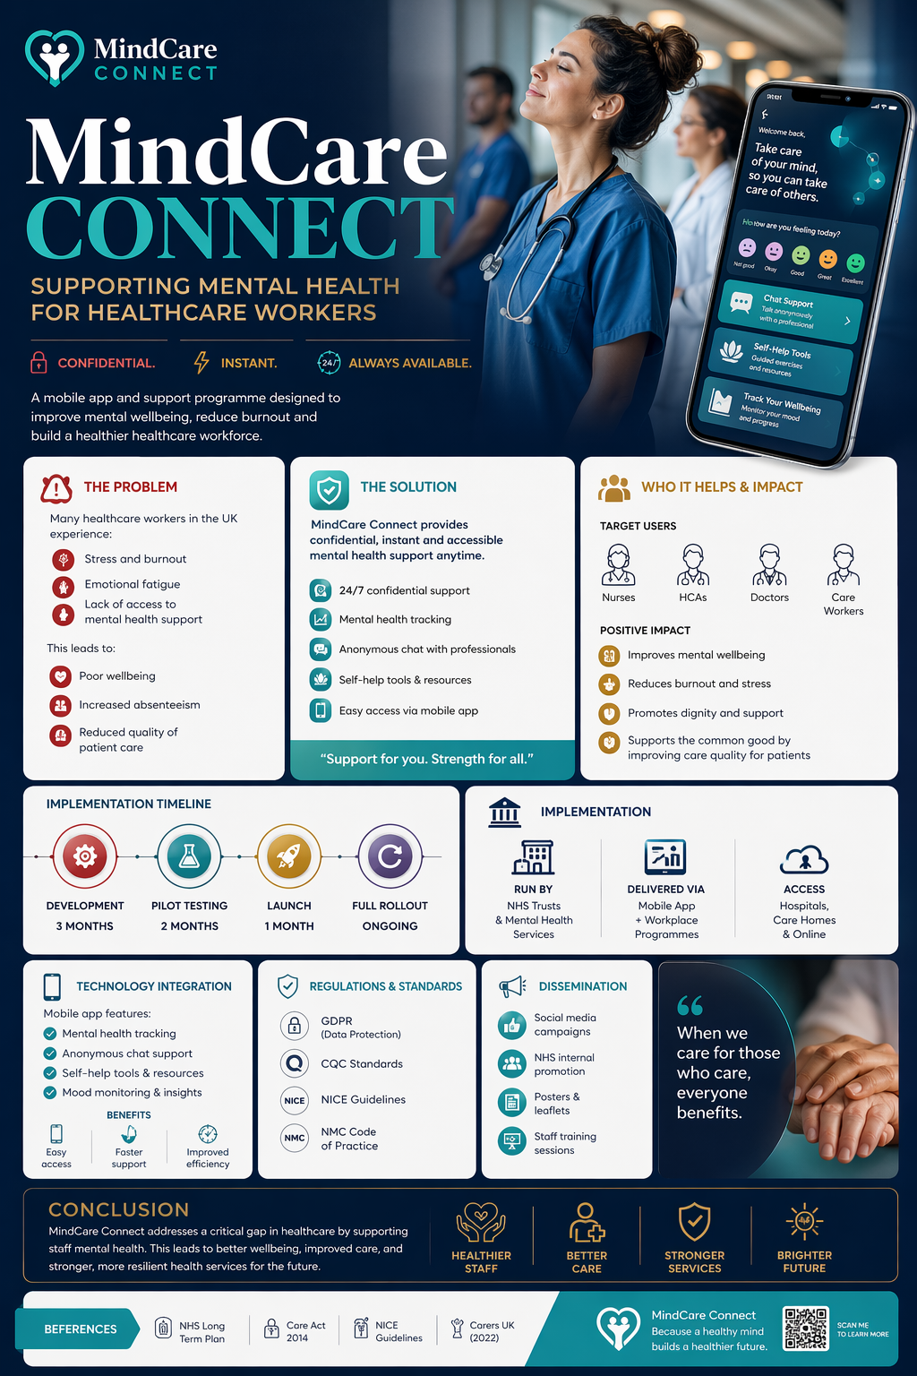

Student name:Margarida Ferreira
Student ID:2415797

Module name: Creativity in Healthcare
Module code:BMHP5014
Lecturer name:Caroline Salami

Introduction
MindCare Connect is an innovative digital solution designed to address the increasing mental health challenges faced by healthcare workers in the United Kingdom. It combines a mobile application with workplace-based support programmes to provide confidential, accessible, and immediate mental health support. This innovation responds to a significant gap in current healthcare systems, where staff wellbeing is often overlooked despite growing pressures. Healthcare professionals such as nurses, healthcare assistants, doctors, and care workers are the primary beneficiaries, and their wellbeing is essential for maintaining safe and effective patient care. Supporting the mental health of healthcare workers is therefore not only important at an individual level but also critical for sustaining a resilient healthcare system.

Background
Mental health problems among healthcare workers have become an increasing concern across the UK. High workloads, staff shortages, emotional pressure, and long working hours all contribute to stress, anxiety, burnout, and emotional exhaustion. According to the Health and Safety Executive (2021), work-related stress, anxiety, and depression remain some of the most common causes of work-related illness in the UK. In health and social care settings, these pressures are often even greater because staff regularly deal with complex patient needs, emergencies, and emotionally difficult situations.
In addition, caring roles often involve both physical and emotional demands, which can negatively affect wellbeing over time. Carers UK (2022) highlights that people in caring roles frequently experience poor mental health and struggle to access the support they need. This is especially important in healthcare, where staff are expected to continue providing compassionate and safe care even when they are under considerable strain themselves.
The NHS Long Term Plan recognises that staff wellbeing is essential for improving patient care and maintaining an effective workforce (Department of Health and Social Care, 2019). However, despite policy recognition, many healthcare workers still face barriers to support, including stigma, lack of time, and limited access to confidential services. This demonstrates a clear need for innovative and accessible mental health support such as MindCare Connect.

Innovation Description
MindCare Connect is a digital mental health support solution designed specifically for healthcare workers. It combines a mobile application with workplace-based wellbeing initiatives to provide immediate, confidential, and accessible support. The platform includes key features such as mental health tracking, anonymous chat with trained professionals, and personalised self-help resources tailored to individual needs. These tools allow users to monitor their emotional wellbeing and seek support at any time, without fear of judgement or stigma.
What makes MindCare Connect innovative is its integration of technology with existing healthcare systems. Unlike traditional mental health services, which often involve long waiting times or limited availability, this platform offers instant access to support. The anonymous nature of the service helps to reduce stigma, encouraging more healthcare workers to engage with mental health resources.
In addition, the platform uses real-time data tracking to help users recognise patterns in their mental health, promoting early intervention and prevention. This proactive approach is particularly important in high-pressure healthcare environments, where issues can escalate quickly if left unaddressed.
By embedding MindCare Connect within NHS Trusts and care organisations, the innovation becomes part of everyday workplace support. This ensures it is not only accessible but also sustainable, making it a practical and effective solution for improving staff wellbeing.

Impact on Health and Social Care
MindCare Connect has the potential to significantly improve both staff wellbeing and the overall quality of health and social care services. Healthcare workers, including nurses, healthcare assistants, doctors, and care staff, would benefit directly from having immediate and confidential access to mental health support. By reducing stress, anxiety, and burnout, the platform can improve emotional resilience, job satisfaction, and staff retention.
Improved staff wellbeing has a direct impact on patient care. Healthcare professionals who feel supported are more likely to deliver safe, compassionate, and person-centered care. This can lead to better patient outcomes, improved communication, and a reduction in clinical errors. In addition, lower levels of burnout can reduce absenteeism and staff turnover, helping to maintain continuity of care and reduce pressure on already stretched healthcare services.
The innovation also contributes to the wider concept of the common good by promoting equality, dignity, and access to support for all healthcare workers, regardless of their role or background. Providing accessible mental health support ensures that staff are better equipped to meet the needs of diverse patient populations.
Overall, MindCare Connect supports a healthier workforce, which is essential for building a more sustainable and effective healthcare system.

Public and Stakeholder Involvement
The successful development and implementation of MindCare Connect would require active involvement from key stakeholders, including healthcare workers, NHS organisations, mental health professionals, and policymakers. Co-production is particularly important, as involving users in the design process ensures that the platform reflects their real needs and experiences.
Feedback from staff would be gathered through surveys, pilot programmes, and ongoing evaluation to improve the system over time. In addition, public awareness campaigns and staff training sessions would help reduce stigma and encourage engagement with the platform.
By involving stakeholders at every stage, the innovation is more likely to be accepted, trusted, and effectively integrated into existing healthcare environments.

Policies, Services, and Professional Links
MindCare Connect aligns closely with key UK policies and professional standards. The Care Act 2014 emphasises the importance of wellbeing and preventative approaches in health and social care (Care Act 2014). Similarly, the Equality Act 2010 supports equal access to services and highlights the need to address inequalities in healthcare provision.
The innovation also supports the NHS Long Term Plan’s commitment to improving staff wellbeing and strengthening workforce resilience (Department of Health and Social Care, 2019). It complements existing services such as occupational health support, GP services, and mental health teams by providing an additional, easily accessible layer of support.
Furthermore, professional standards such as the NMC Code highlight that healthcare professionals have a responsibility to maintain their own health and wellbeing in order to practise safely and effectively (Nursing and Midwifery Council, 2018). MindCare Connect directly supports this expectation by enabling staff to prioritise their mental health.

Conclusion
MindCare Connect addresses a critical gap within the healthcare system by providing accessible, confidential, and immediate mental health support for healthcare workers. By improving staff wellbeing, reducing burnout, and enhancing patient care, the innovation offers clear benefits at both individual and system levels. Its integration within existing healthcare structures ensures that it is both practical and sustainable. Ultimately, supporting the mental health of those who care for others is essential, and MindCare Connect represents a meaningful step towards a healthier, more resilient healthcare workforce.

References
Carers UK (2022) State of Caring 2022. Available at: https://www.carersuk.org (Accessed: 20 April 2026).
Care Act 2014. Care Act 2014. London: UK Government. Available at: https://www.legislation.gov.uk (Accessed: 23 April 2026).
Department of Health and Social Care (2019) The NHS Long Term Plan. London: Department of Health and Social Care. Available at: https://www.longtermplan.nhs.uk (Accessed: 20 April 2026).
NHS England (2023) NHS Workforce Statistics. Available at: https://www.england.nhs.uk (Accessed: 22 April 2026).
National Institute for Health and Care Excellence (2022) Mental wellbeing at work (NG212). Available at: https://www.nice.org.uk (Accessed: 23 April 2026).
Nursing and Midwifery Council (2018) The Code: Professional standards of practice and behaviour for nurses, midwives and nursing associates. London: NMC. Available at: https://www.nmc.org.uk (Accessed: 20 April 2026).
Health and Safety Executive (2021) Work-related stress, anxiety or depression statistics in Great Britain. Available at: https://www.hse.gov.uk (Accessed: 23 April 2026).
World Health Organization (2022) Mental health and wellbeing at work. Available at: https://www.who.int (Accessed: 23 April 2026).

