

Programme: MSc Computing portfolio
Course Name: MSc data and AI
Module: Research Proposal

Topic: An Experimental Evaluation of an AI-Based Alcohol Detection System with the Internet of Things

Student Name: Hajee Muzahir Sheikdawood
Student ID: 2518747

Abstract
Overview: The research proposal focuses on using Artificial Intelligence (AI) based alcohol detection in the Internet of Things (IoT) to improve alcohol detection and prevention systems. It will show the relevance of connected technologies in the performance of modern vehicle safety systems.
Purpose: The key purpose of the research is to develop and design real-time alcohol detection units to reduce accident events related to drink and drive. The study focuses on secondary quantitative methods using an experimental research design.
Methods: A quantitative experimental research design/approach in the research will test the alcohol detection system through controlled experiments. Sensors measure alcohol levels and collect numerical data like detection accuracy, response time, and blood alcohol concentration (BAC). The research will consider a systematic review of existing literature leveraging quantitative methods using an experimental research design, with the selection of reliable studies that support the research aims and objectives.
Expected results: The anticipated result of the research is expected to show the improvement of detection accuracy using IoT sensors, enhancing the parameters of cloud connectivity with graduated safety intervention.
Conclusion: In designing and developing further research investigations on alcohol detection systems using the IoT, the proposal serves as a blueprint in offering comprehensive insights into safe, scalable and practical solutions.

1.0 Introduction

1.1 Background
Globally, alcohol-impaired driving remains a leading cause of road traffic crashes. The report of the World Health Organisation (WHO) shows that approximately 1.16 million deaths occur annually due to road traffic crashes, and 92% of fatalities on the roads occur in low- and middle-income countries (WHO, 2023). In this regard, the implementation of electronic solutions as an alternative alcohol detection approach can be significant for reducing incidents related to impaired driving. An automated alcohol sensing system, combined with the Internet of Things (IoT), is a smart way to measure breath alcohol and automatically restrict vehicle use under unsafe conditions (Preethi et al., 2026). The research focuses on proposing IoT-oriented alcohol detection frameworks, showing the role of connected technologies in the performance of modern vehicle safety systems through continuous monitoring, remote notification, and ignition control.

1.2 Research Problem
The core research problem can be determined in response to automated, continuous, real-time and connected systems for the detection of alcohol. The enforcement of traditional legislation on blood alcohol concentration (BAC) is undermined due to inadequate roadside testing equipment and limited access to emergency medical care (Leonardo et al., 2026). Also, the existing detection systems for measuring individual alcohol concentration are inconvenient, as air pollution or indoor ventilation makes it difficult to accurately measure concentration. Additionally, the breathalyser-based ignition interlock devices also show a drawback in difficulty identifying driver faces, leading to potential measurement errors (Choi et al., 2026). This highlights a gap in response to detection and prevention, showing the necessity of introducing an intelligent, IoT-enabled system to detect alcohol accurately, while initiating automated preventive action in real time.

1.3 Motivation / Need for Research
The motivation and need for developing research on an alcohol detection system using the IoT is driven by factors, such as safety, accountability, and technological opportunity. There is an urgent need to reduce preventable deaths, as 35% of all road deaths are estimated to result from drunk driving globally (Kassym et al., 2023). Besides, a high level of accountability is also required in both organisational and personal driving parameters by fostering and ensuring a safer and more effective public transportation system, with the assurance that adequate financial resources and regulatory frameworks are in place (Qi et al., 2025). Also, the rapid advancement of microcontrollers. The global market value of microcontrollers is estimated to grow to $52.43 billion and $151.25 billion by 3034, at a growth rate of 14.16% [Refer to Figure 1] (Fortune Business Insights, 2026). The growth is driven towards the use of connected IoT devices and high-sensitivity edge computing, including low-power microcontrollers such as STM32U5 (Fortune Business Insights, 2026). Thus, the motivation behind developing research reflects the transformation of passive detection devices into active ones, fostering a connected and safer ecosystem.
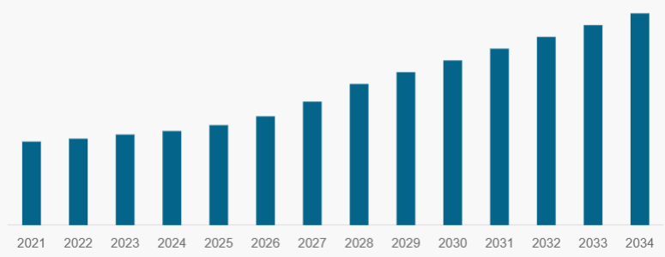
Figure 1: Microcontrollers market growth
(Source: Fortune Business Insights, 2026)

1.4 Shortcomings in Literature
The existing literature on alcohol detection systems using the IoT highlights significant drawbacks. The study by Abu Al-Haija and Krichen (2022) emphasises only allowable threshold-based detection using an MQ-3 alcohol sensor. Conversely, Almirah et al. (2025) have shown IoT-based detection in the context of the fermentation process, failing to offer a portable solution for initial screening of alcohol relevant to alcohol-impaired driving. This shows that existing studies fail to show IoT integration for remote monitoring, where its effectiveness on alcohol detection systems has remained unexplored. Thus, in terms of addressing these gaps, the research will be significant to offer investigation into experimentally validated and fully integrated IoT-based alcohol detection systems.

2.0 Objectives
- To design and develop a real-time alcohol detection unit interfaced with a low-cost microcontroller to improve detection accuracy above BAC equivalent
- To encourage the implementation of an automated prevention mechanism for disabling vehicle ignition and sending alerts through an AI model into an IoT-based alcohol detection system
- To highlight the necessity of a cloud-based dashboard for real-time monitoring for authorised users
- To quantitatively evaluate the performance of the AI-driven IoT system in terms of response time, positive rate and connectivity reliability in reducing the impact of alcohol-impaired driving

3.0 Research Importance
Scientifically, the research will contribute to the process of embedding AI sensor-based systems, such as IoT, by showing a validated architecture in an alcohol detection system through edge computing and cloud communication. As a result, the research will add value in the enhancement of knowledge concerning sensor calibration techniques to eliminate errors and improve measurement accuracy.
Practically, the research shows several social implications. The knowledge of the study can be used directly in the optimisation of commercial and private vehicles for timely crash detection and enhancement of driver safety and convenience. Additionally, it will help to improve the process of law enforcement, enabling remote monitoring and reducing the limitations of inadequate roadside testing equipment.

4.0 Literature Review

4.1 Alcohol Detection Systems and Sensor Technology
According to Wang et al. (2026), in response to the increasing likelihood of accidents, alcohol detection technologies in the current phase primarily include breath analysis. The study has found that recent advancements, such as metal oxide semiconductor (MOS) gas sensors, have been significant in improving ethanol selectivity through microstructure design. On the other hand, Liu et al. (2022) show the importance of multi-sensor fusion technology, stating the credibility of data fusion algorithms as an intelligent detection system for determining drunk driving. As per Liu et al. (2022), multi-sensor fusion technology is being developed to compensate for the rising impact of alcohol-impaired driving due to a lack of reliability and measurement precision, with measurement accuracy despite poor environments or equipment failure.
Kumar and Kumar (2022) compared the alcohol sensor-based detection system iMQ-3 with the alcohol concentration detector MQ-135 sensor. The study states that the MQ-3 alcohol sensor and BAC are used to determine the presence of alcohol in the driver. This can be demonstrated through a direct current (DC) motor and an LCD (Liquid Crystal Display) screen with an alcohol sensor and an Arduino Uno microcontroller. The MQ-135 is used as a concentration detector and has a higher cross-sensitivity to harmful gases and benzene. This highlights a clear evolution of alcohol detection systems from warning to prevention beyond permissible limits.

4.2 IoT-Enabled Alcohol Detection Systems
In securing connected monitoring systems, IoT is a significant standalone detector transformation. In this context, Prashanth et al. (2023) cited the significance of IoT-enabled alcohol detection systems in the pursuit of road transportation safety. The central checking framework is empowered by IoT, emitting a notification and sending advice through a light sign when a BAC-equivalent level is reached. As Carbon monoxide (CO) is a dry and odourless gas with the signs of drowsiness, disorder and inconvenience, the integration of IoT-powered monitoring of covellar carbon monoxide detection abruptly eliminates road traffic crashes. On the other hand, the studies argue that accuracy enhancement, calibration and interface handling of the alcohol detection system using IoT in the real world are hindered by significant limitations. The findings of Abu Al-Haija and Krichen (2022) reveal that the MQ-3 gas sensor shows higher sensitivity to alcohol and is easily disturbed by other gases such as gasoline, smoke, and vapour. This shows a difficulty in integrating IoT sensors in vehicles, comprising MQ-3 sensors and a memory unit connected through an ARM Cortex M4 Microcontroller.
Sandhiya et al. (2026) cite that an IoT-enabled smart safety system is effective for continuously monitoring the driver’s breath alcohol concentration by immobilising the vehicle engine, thereby preventing operation under unsafe conditions. On a similar note Sri et al. (2026) proposed an IoT-based detection system in the context of real-time alcohol detection, based on the driver's breath, leveraging an MQ-3 sensor. However, Shasikala et al. (2026) suggest that IoT driven through an MQ-3 sensor leads to real-time data processing by raising an alarm towards unsafe levels of alcohol, enabling early detection and alerting, while preventing alcohol-related accidents. Conversely, the study of Mobaraki and Turmo (2024) found that several IoT prototypes are categorised in terms of functional and non-functional requirements. The study found that prototypes highly rely on functional requirements, while neglecting non-functional requirements (NFRs), with the failure of end-users to directly observe performance, security, reliability, and scalability. This shows drawbacks of IoT in alcohol detection, as the majority of prototypes focus only on simple binary classification, failing to meet criteria in response to quantitative metrics. Preethi et al. (2026) also found that detecting levels of alcohol consumption is hindered by response and recovery delays. This hinders the practical integration of real-time vehicle control, leading to delays and susceptibility to environmental variation.
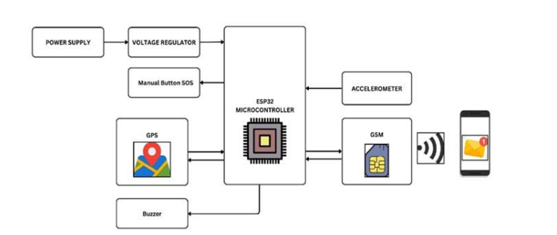
Figure 2: Functioning process of GPS modules
(Source: Kumar and Marwaha, 2026)
However, Kumar and Marwaha (2026) provided the most robust IoT approach in terms of integrating Arduino and Global Positioning System (GPS) modules to eliminate factors that lead to injuries and deaths resulting from delayed emergency services and driver conditions [Refer to Figure 2]. Rani B et al. (2026) show that automation of the monitoring system using an Arduino microcontroller wirelessly controls vehicles using real-time facial analysis, Arduino Uno and IoT connectivity via GSM that enables emergency alert transmission for testing purposes, minimising delays and reducing vehicle accidents [Refer to Figure 3]. The studies prove that IoT is feasible in real-time detection of alcohol concentration; however, it fails to provide insights into speed, security and efficiency of deployment.
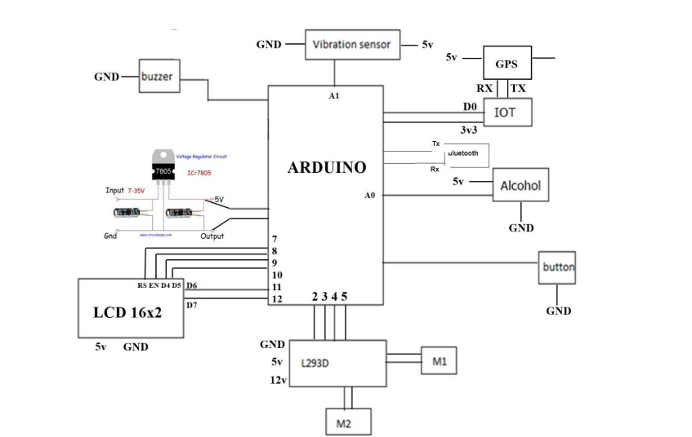
Figure 3: Functioning of Arduino controller
(Source: Kumar and Marwaha, 2026)

4.3 Improvising Automated Intervention and Smart Mobility Integration
In terms of improving automated intervention, the current approach of simply cutting the ignition must evolve in response to a multi-layered smart mobility solution. Liu et al. (2022) suggest that a multi-sensor data fusion model can help to compensate for concerns about reliability and measurement precision. The embedding of IoT in a multi-layered smart mobility solution enables the obtaining of multi-source information with reliable judgment and accuracy, thereby improving the accuracy of fault diagnosis, with real-time data detection in real time and improved precision of drunk driving detection. In addressing the gap in traditional alcohol detection systems, the theoretical lens of Cyber-Physical Systems (CPS) Theory can effectively combine algorithms with physical processes. In this regard, Kocsis et al. (2025) state that the application of ‘‘Cyber-Physical Systems’’ in the real-world environment is effective for deploying cyber-physical computing, equipped with the capability of reasoning, learning, adapting, and evolving, in support of system performance specifications. In theb research, the theoretical perspective will be significant to justify the gap pertaining to threshold alert insufficiency and show why automated physical intervention is required to close the loop.
Ruiz-Ocampo et al. (2026), in relevance to campus safety and ongoing threats such as substance-related incidents including alcohol consumption, suggests to inmprove safety by implementing mobile and IoT-enabled systems for real-time intoxication monitoring. Conversely, from the study of Fairbairn et al. (2025), the significance of wearable sensors theorises the need for higher accuracy in contemporaneous alcohol use detection through biosensors, regardless of variable environmental conditions. Apart from this, the study by Mohammed et al. (2025) cited an improvement in response to cloud-linked intervention. VSLCloud offers an online, LoRa-compatible cloud-based intoxication detector, supporting the assessment of alcohol level quantity through MQ-3 and the utilisation of an Arduino-equipped sensor. Thus, the improvisation proves the need for creating a low-cost, tamper-proof, safe, and IoT-enabled intervention ecosystem with a timely alcohol detection process.

5.0 Research Question
RQ1: How can a low-cost AI-based IoT alcohol detection unit be designed to achieve high detection accuracy despite environmental interferences?
RQ2: To what extent can an automated ignition interlock and AI model in an IoT-based alcohol detection system alert mechanism prevent vehicle operation when intoxication is detected?
RQ3: How effective is a cloud-based dashboard in enabling real-time monitoring and evidence-based intervention for authorised users?
RQ4: What is the quantitative performance of the integrated AI-driven IoT system in terms of response time, false positive rate, and connectivity reliability compared to standalone detectors?

6.0 Research Design and Methodology
The study will adopt the philosophy of pragmatism as it is suitable for solving practical problems related to the rising concern of alcohol-impaired driving, leading to a rise in mortality rates. According to Hameed (2024), the pragmatism philosophy focuses on determining truth, enhancing efficacy, and generating ideas to guide action. It supports experimentation, adaptation, and resolution of problems from real-world contexts. This means that, in future research, pragmatism is significant for objective measurement and subjective evaluation of both sensor data and system usability, while solving gaps in relevance to detection and prevention. The research further adopts a deductive approach in terms of testing theories against observations, such as an alcohol detection system using the IoT. Barroga et al. (2023) cite that, in quantitative research, the approach of deductive enables to prove hypotheses/answer research questions by making observations based on the theory surrounding specific observations. In the pursuit of investigating an alcohol detection system using the IoT, the approach will be leveraged for establishing theories in response to IoT architectures and systematically examining existing studies to answer research questions.
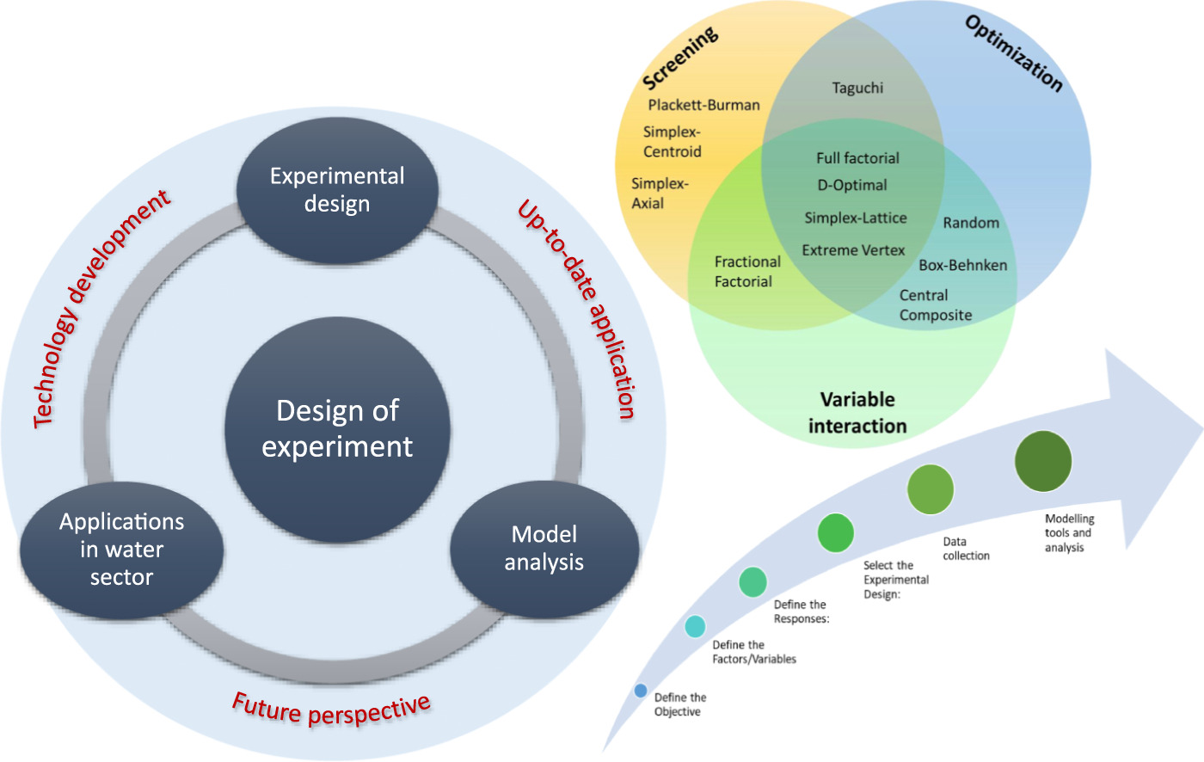
Figure 4: Experimental research design
(Source: Lee et al., 2022)
The study will employ a quantitative experimental research design to measure the cause and effect of variables [Refer to Figure 4]. Zubair (2022) proposes that experimental research design is significant in establishing cause-and-effect relationships between the variables, with the manipulation of factors and controlling other influences. The data are then analysed statistically to prove system effectiveness and reliability. For future research, the design will be highly appropriate to measure outcomes in regard to IoT detection accuracy, response time, and false positive rate. As a result, the researcher will leverage studies that were conducted in a controlled lab environment simulating vehicle conditions, thereby enabling research to extract quantitative performance metrics. Besides, the research will adopt five procedural research strategies in response to identifying the topic and reporting results. The steps include selecting the research subject, determining the nature of the research, determining the transparency of the research purpose, selecting the method and determining the size of selected studies (Dźwigoł, 2020).
For the collection of data, the research will use a secondary quantitative data collection method, focusing on a systematic review of quantitative experimental studies. Ahn and Kang (2018) state that a systematic review is a transparent data collection process in supporting the outcomes of secondary methods. In this aspect, the research will use secondary quantitative data, supported by a systematic literature review guided by the PRISMA (Preferred Reporting Items for Systematic Reviews and Meta-Analyses) protocol, with a focus on the inclusion criteria to use quantitative experimental studies between 2020 and 2026 on IoT alcohol detection prototypes. The research will undertake preprocessing, exploratory data analysis and feature selection prior to the application of IoT classification models, such as Logistic Regression, Decision Tree, Random Forest and Support Vector Machine (SVM). In the security intrusion prevention of the alcohol detection gap with IoT, the research will evaluate models using accuracy, precision, recall, F1-score and a confusion matrix. As a result, through the findings, the research will show the credibility of applying an AI model to an IoT-based alcohol detection system to enhance the process of real-time detection and alert generation.
Further, the study will identify datasets from https://data.mendeley.com/datasets/kvcfp5y95z/1. This will allow the researcher to concentrate on variables such as MQ3 Alcohol, MQ2 Smoke, and MQ135 Air Quality, including temperature, humidity and air quality. The study will focus on mean, median, range and standard deviation pertaining to IoT performance metrics, the evolution of performance from 2020 to 2026 and directly contrast and compare standalone vs IoT-enabled systems. In further research, the method will allow suitable identification of quantitative results from published experimental studies relevant to IoT alcohol prototypes, BAC levels tested, and others. The method will directly support quantitative objective evaluation by establishing benchmarks for comparison. The collected data will be analysed via descriptive statistics, trend analysis and comparative analysis (Kaliyadan and Kulkarni, 2020). Thus, the upcoming research will concentrate on quantitative methods using an experimental research design.

7.0 Research Limitations
The findings of the upcoming research will be limited in regard to design and the choice of data collection methods. The higher reliance of the study on a secondary systematic review can impact the accuracy of findings to generalise data on sensor accuracy, response time and power consumption, as existing studies are developed with a concentration on diverse environmental conditions, lacking focus on a specific environment, thereby impacting the long-term reliability of the research. Besides, the study is also limited by quantitative experimental studies as there are presence of limited studies published between 2020-2026. Additionally, this can be interpreted as publication bias, as studies with negative results mostly remain underrepresented.

8.0 Timeline with Professional Practice
The research will be completed through self-directed planning, adhering to a structured timeline for literature review, system design, testing, and documentation. In this regard, autonomy will be shown in terms of selecting IoT components, designing experimental setups, and troubleshooting sensor calibration independently. Besides, the researcher will maintain personal responsibility by meeting deadlines, ensuring data accuracy, following ethical research practices, and managing resources effectively. Overall, the researcher will ensure regular self-evaluation and time management for successful completion and delivery of the research, demonstrating professional competence and accountability.
Task | Week 1 | Week 2 | Week 3 | Week 4 | Week 5 | Week 6 | Week 7 | Week 8
Selection of the subject
Research on the
background
Proposing research
questions
Development of research aim and
objectives
Reviewing existing
literature
Selection of
methodological tools
Systematic Literature Search & PRISMA Screening
Data Extraction & Descriptive Analysis
Quantitative Evaluation
Trend & Comparative Analysis and Report Writing
Final Review, Limitations & Submission
Table 1: Research Timeline
(Source: Self-developed)

9.0 Expected Findings
In relevance to the objective of designing and developing a real-time alcohol detection unit interfaced with a low-cost microcontroller to improve detection accuracy above BAC equivalent, the research expects findings in relevance to the MQ-3 sensor interfaced with IoT for understanding alcohol detection in real-time and obtaining BAC equivalent values. In this regard, the study expects to meet these objectives through a secondary quantitative data collection method to address the gap by testing, collecting and converting BAC equivalent values and filtering them with repeated trials, despite the variance in environmental factors where alcohol detection systems using the IoT were initiated. Besides, the research will meet objectives pertaining to encouraging implementation of an automated prevention mechanism for disabling vehicle ignition and sending alerts through IoT based on findings from experimental testing. They are expected to demonstrate a safe, graduated intervention by collecting authentic data on BAC and locking the ignition. As a result, the research is expected to prove the objective by showing that automation, such as IoT, can prevent vehicle start-up without manual intervention.
The research is expected to highlight the necessity of a cloud-based dashboard for real-time monitoring for authorised users by collecting reliable data on popular IoT platforms, such as ThingSpeak and Blynk. Through the data collection and analysis, the research is expected to highlight its importance in the real-world context concerning an alcohol detection system using IoT sensors. In addition, through trend analysis, the research expects to link cloud data towards continuous monitoring capability, while addressing the limitations of traditional governance and monitoring on road safety. Further, the research expects to meet the objective of quantitatively evaluating the performance of the IoT system in terms of response time, positive rate and connectivity reliability in reducing the impact of alcohol-impaired driving. In this regard, the study will ensure to leverage quantitative data analysis to yield positive results on the research problem, thereby effectively answering key questions. The research will test existing studies by considering both positive and false rates, while gaining accuracy of findings by using relevant and meaningful secondary sources. Through the secondary findings, the research will evaluate the performance of IoT, showing the reliability of data transmission to reduce road crashes and, most appropriately, the impact of alcohol-impaired driving. Hence, from the overall findings, the research expects to demonstrate positive outcomes of IoT in improving alcohol detection systems, highlighting its suitability in diverse real-world contexts to improve the feasibility of public transportation, across both commercial and domestic functions.

References
Abu Al-Haija, Q. and Krichen, M. (2022). A lightweight in-vehicle alcohol detection using smart sensing and supervised learning. Computers, [online] 11(8), p.121.
Ahn, E. and Kang, H. (2018). Introduction to systematic review and meta-analysis. Korean Journal of Anesthesiology, [online] 71(2), pp.103–112.
Almirah, N.T., Taqwa, A. and Salamah, I. (2025). IoT-Based alcohol presence detection in soy sauce using MQ-3 and ESP32. bit-Tech, [online] 8(1), pp.1018–1027.
Barroga, E., Matanguihan, G.J., Furuta, A., Arima, M., Tsuchiya, S., Kawahara, C., Takamiya, Y. and Izumi, M. (2023). Conducting and writing quantitative and qualitative research. Journal of Korean Medical Science, [online] 38(37), pp.1–16.
Choi, J.Y., Kim, K. and Eom, J.B. (2026). Non-contact alcohol detection in mice using an imaging photoplethysmography (IPPG) system. Scientific reports, [online] 16(1), p.22617.
Dźwigoł, H. (2020). DEVELOPING A RESEARCH PROCESS PROCEDURE.
Fairbairn, C.E., Han, J., Caumiant, E.P., Benjamin, A.S. and Bosch, N. (2025). A wearable alcohol biosensor: Exploring the accuracy of transdermal drinking detection. Drug and alcohol dependence, [online] 266, p.112519.
Fortune Business Insights (2026). Microcontroller market size & share report [2021-2028]. [online] www.fortunebusinessinsights.com.
Hameed, U. (2024). Pragmatism: The practical philosophy that values action.
Kaliyadan, F. and Kulkarni, V. (2020). Types of variables, descriptive statistics, and sample size. Indian Dermatology Online Journal, [online] 10(1), pp.82–86.
Kassym, L., Kussainova, A., Semenova, Y., Kussainov, A., Marapov, D., Zhanaspayev, M., Urazalina, Z., Akhmetova, A., Tokanov, M., Smail, Y. and Bjørklund, G. (2023). Worldwide prevalence of alcohol use in non-fatally injured motor vehicle drivers: A systematic review and meta-analysis. Healthcare, [online] 11(5), p.758.
Kocsis, I., Burján-Mosoni, B. and Balajti, I. (2025). A comprehensive review of key cyber-physical systems, and assessment of their education challenges. IEEE Access, [online] pp.1–1.
Kumar, A. and Kumar, A. (2022). A literature survey of drunk driving detection approaches. Proceedings of the 2022 Fourteenth International Conference on Contemporary Computing, [online] pp.342–349.
Kumar, A. and Marwaha, N. (2026). IoT-Based smart vehicle accident detection and alcohol monitoring system using Arduino. Journal of Electrical and Electronic Engineering, [online] 14(2), pp.110–118.
Lee, B.C.Y., Mahtab, M.S., Neo, T.H., Farooqi, I.H. and Khursheed, A. (2022). A comprehensive review of design of experiment (DOE) for water and wastewater treatment application - key concepts, methodology and contextualized application. Journal of Water Process Engineering, [online] 47, p.102673.
Leonardo, J.C.C., Peltier, M.R., Mokwuah, A.A., Bin-Mahfouz, A., Verplaetse, T.L., Zakiniaeiz, Y., Kohler, R., Garcia-Rivas, V., Banini, B.A., Raval, N.R., Pittman, B. and McKee, S.A. (2026). Legal blood alcohol concentration limits and alcohol-attributable traffic mortality rates: An analysis across 165 countries. eClinicalMedicine, [online] 93, p.103794.
Liu, J., Luo, Y., Ge, L., Zeng, W., Rao, Z. and Xiao, X. (2022). An intelligent online drunk driving detection system based on multi-sensor fusion technology. Sensors, [online] 22(21), p.8460.
Mobaraki , B. and Turmo, J. (2024). Advances in Intelligent Sensors and IoT Solutions.
Mohammed, T.L., Ahmed, S.S., Khaleel , M.I. and Rashid, Z.N. (2025). VSLCloud: A LoRa-Enabled Cloud for Real-Time Alcohol Detection and Safer Driving.
Prashanth, J., Poojitha, B., Priyanka, M., Evangiline, S. and Nikhila, Y. (2023). IoT enabled alcohol and accident detection system.
Preethi, B.M., K, P. and R, U. (2026). Alcohol detection system using IOT. [online] 14(1), pp.2320–2882.
Qi, X., Huang, X. and Zhu, W. (2025). Evaluation for the operational risk factors of public transportation process based on entropy weighted- DEMATEL method. PLOS One, [online] 20(5), p.e0323417.
Rani B, U., Imran, M., Nishanth, S., Naik, V. and P, A. (2026). IOT-enabled real-time driver monitoring system for drowsiness and alcohol detection using Arduino and OpenCV. EPJ Web of Conferences, 363, p.02002.
Ruiz-Ocampo, J., A. Fernandez, G., T. Jamero, E.M., C. Ruiz, J., C. Lumontod, J. and M. Tumilid, A. (2026). Integrating IoT and mobile technologies for real-time incident reporting and alcohol detection in campus environments. Mediterranean Journal of Basic and Applied Sciences, [online] 10(01), pp.183–201.
Sandhiya, J.A., Thanappan, G., Thamotharan, k. and Veeraragavan, R. (2026). Design of an IoT -Enabled Smart Safety System for Alcohol Detection and Automatic Engine Immobilization.
Shasikala, G., Muthukumar, S. and Saravanan, R. (2026). BAC based Alcohol Detection System. International Journal of Engineering & Extended Technologies Research, 08(02).
Sri, V., Srikanth, K., Ch, M. and Lakshmi Kumari (2026). An IOT-enabled breath alcohol detection system for real-time driver monitoring and accident prevention. International Research Journal of Modernization in Engineering Technology and Science @International Research Journal of Modernization in Engineering, [online] pp.2582–5208.
Wang, X., Jiang, H., Zhang, X., Si, R., Li, G., Hong, Z. and Zhang, S. (2026). Development of intelligent drinking detection system for vehicles. Sensors and Actuators B: Chemical, [online] 446, p.138732.
WHO (2023). Road traffic injuries. [online] World Health Organization.
Yerrapalem, R., Ravuri, N., Seelam, B.V.A. and Pallala, R.S. (2023). The IoT based health monitoring with alcohol detection and control system. International Journal of Engineering and Computer Science, [online] 12(03), pp.25669–25676.
Zubair, A.M. (2022). Experimental research design-types & process. [online] ResearchGate.

