

A report focussing on :

Programme control

Prepared for:

Dr. Deborah Hughes

Created by:

Rhydian Preece

Word Count – 2,220

Date Completed:
January 21st, 2022
Table of Contents
Page Number
- Introduction 3

- Site-Specific Reports 3
  - Cost Report 3
  - Resource/Cost Report 5
  - Resource/Time Report 7
  - Time Report 8
  - Tracking Gantt 11

- Incentivisation 12
  - Introduction for incentivisation 12
  - What is incentivisation? 12
  - Motivation 12
  - How can we incentivise people? – Client’s perspective 13
  - How can we incentivise people? – Contractor’s perspective 13

- Scenario – Local concrete company strike 15
  - Introduction to scenario 15
  - Delay 15
  - Extensions of time 15
  - Tracking Gantt 16

- Conclusion 17

- Figures 18

- References 19

1. Introduction
In this assignment, one will be producing a Gantt chart to show the development of a new student accommodation in the SA1 area. From completing this chart, site-specific reports for time, cost, and resources of the work activities will be made. As this assignment will focus on the basement / underground car park construction, costs will be made relevant to this element of the construction process. After the completion of the Gantt chart and site-specific reports, possible ways of addressing performance issues in terms of productivity and incentivisation to the client will be developed in a report.
The final stage of this assignment will be scenario-based and will require one to address a problem and mainly how it will be dealt with on a contractual level.
2. Site-Specific Reports
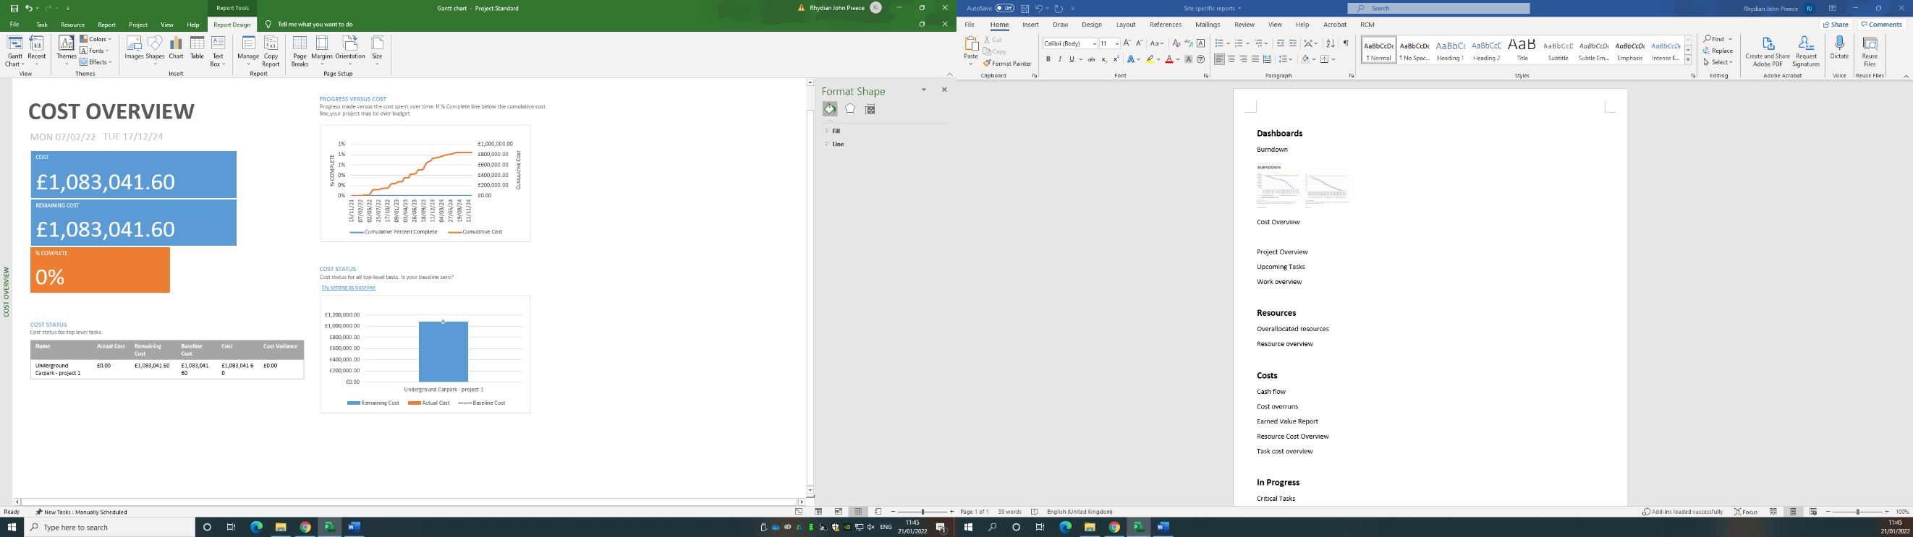
  - Cost Report
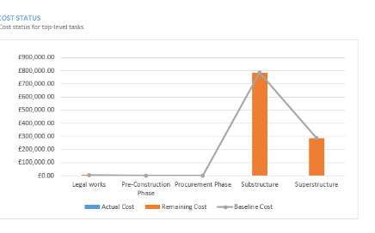
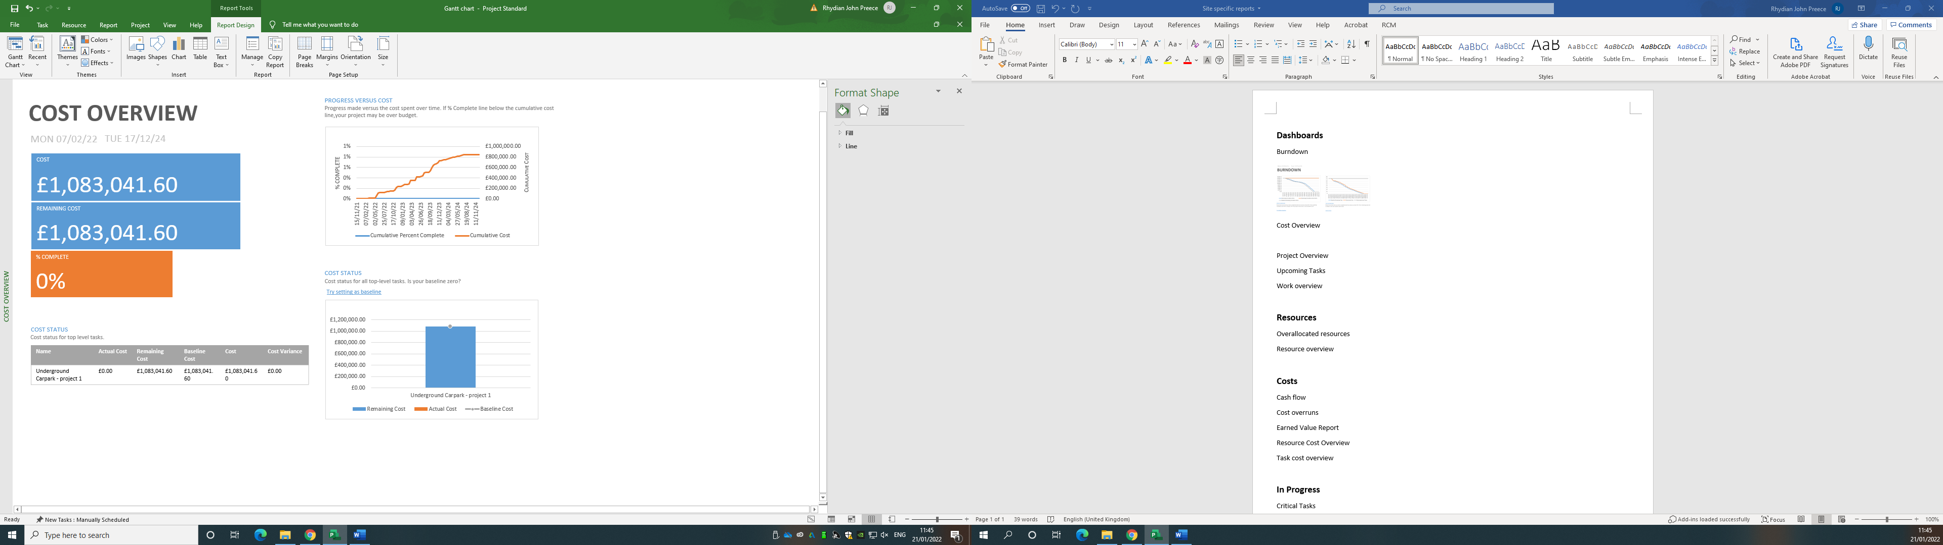Figure 1 – Cost overview, progress versus cost, and task cost overview
The cost overview above shows the overall cost of the project and how much each top-level task will cost. It can be shown that site setup is the least expensive, whereas the groundworks for the piled foundations are the most expensive. The substructure work is the most expensive as it requires a lot of different materials and skilled workers to construct. As I am focussing mainly on the substructure in this Gantt chart, the substructure costs will be more expensive. The other graph shown at the top right is the progress versus cost. This shows the progress made versus the cost spent over time. If % complete line is below the cumulative cost line, the project may be over budget. The table below shows a breakdown of the costs for each stage of the project and then the costs for the workers.
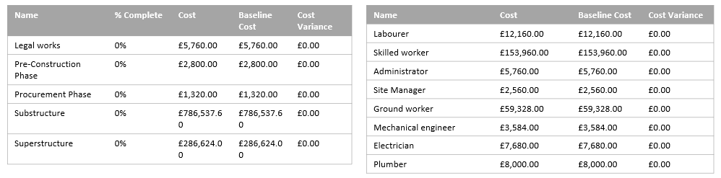Figure 2 – Baseline cost tables for stages of work and workers

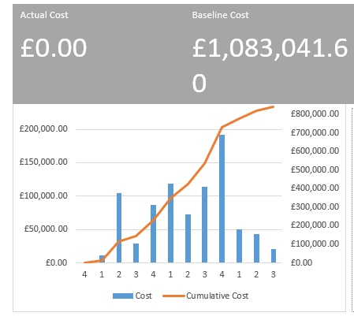 Figure 3 – Cash Flow chart
The chart above shows the project's cumulative cost and the cost per quarter.

  - Resource/Cost Report
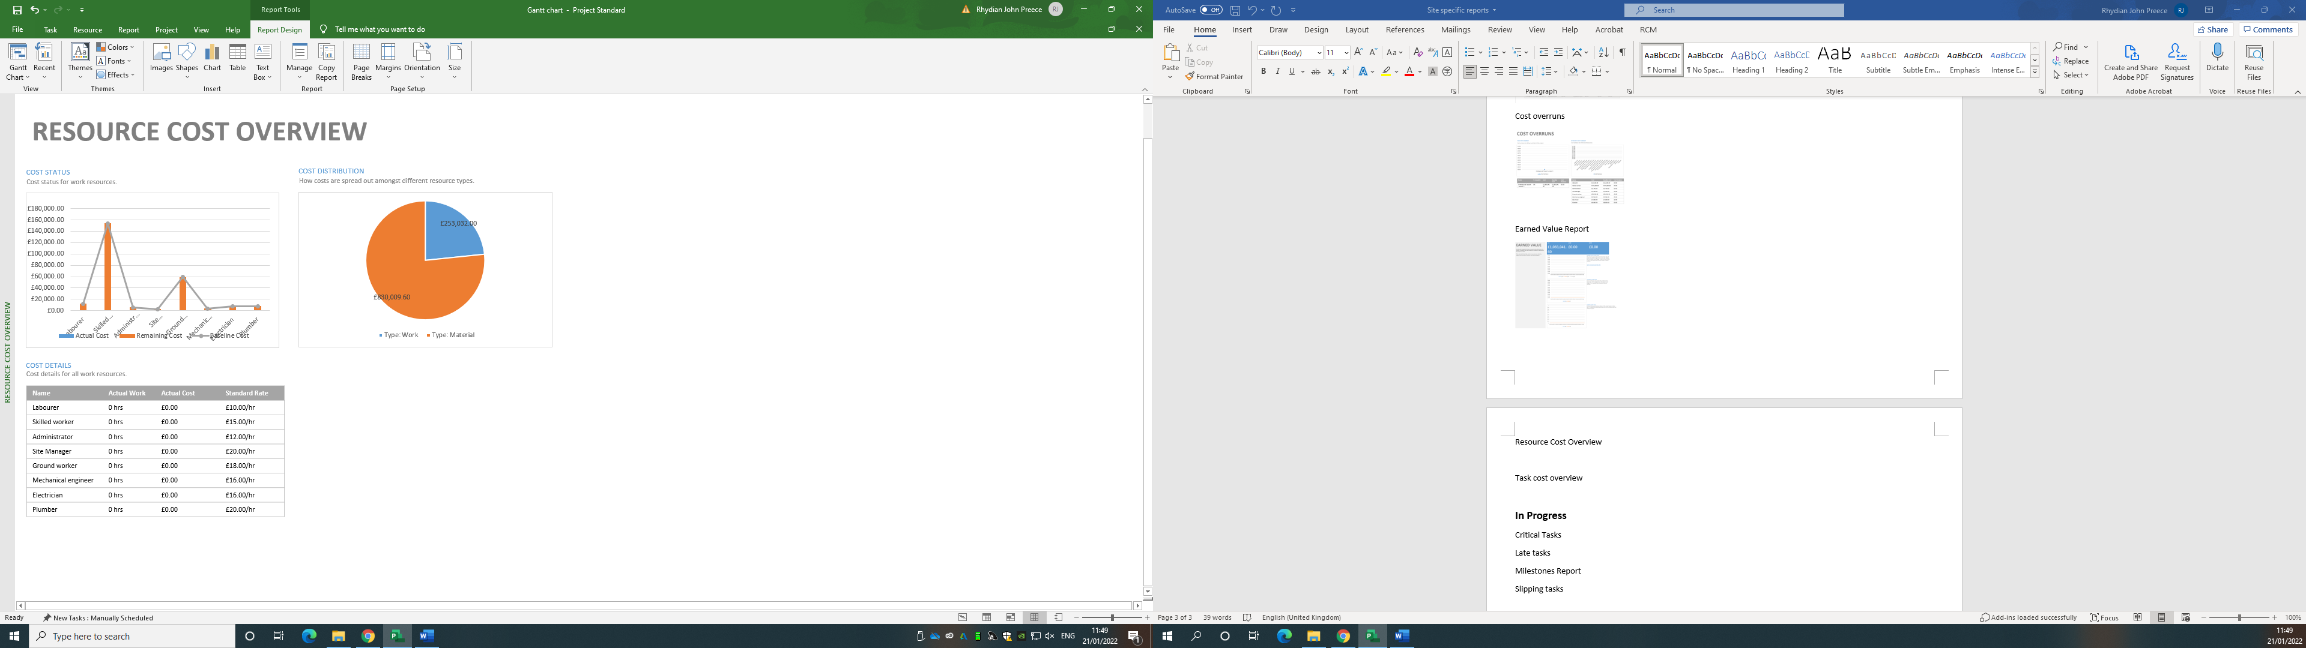Figure 4 – Resource Cost Overview
The graph above shows the different work resources that have been used throughout this project and how they compare in price. The pie chart compares the price of work to the price of materials. Materials have summed up to £830,009.60 and work is £253,032.00. As this is such a big project, a lot of materials will be needed compared to workers. This is shown through the pie chart where materials are worth more than 75% of the overall project.
Figure 5 – Cost Details
The table above shows the different resources and how much their standard rate is.

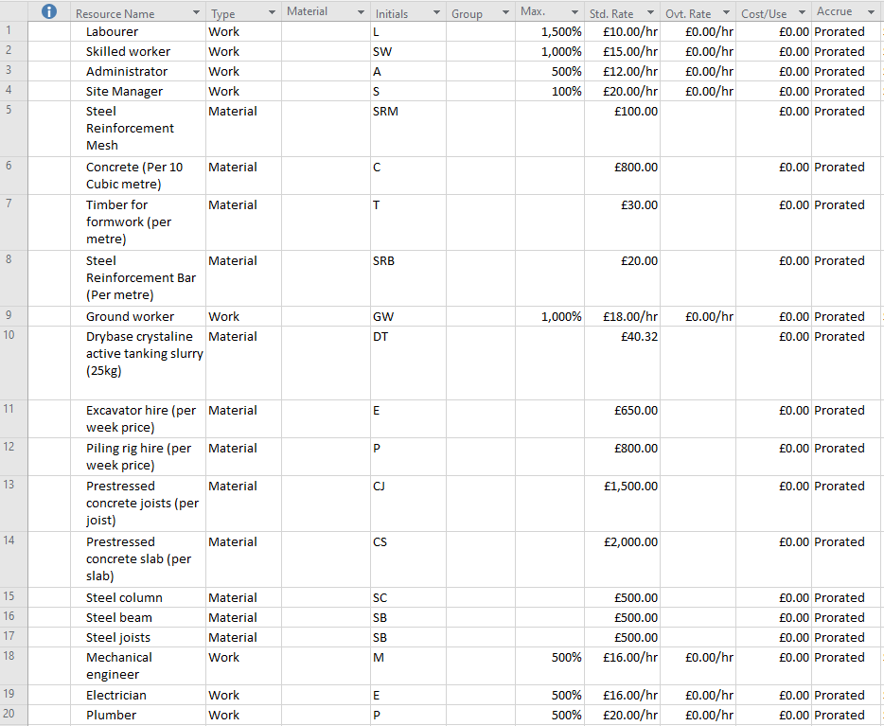
Figure 6 – Resource sheet
Shown above is the resource sheet for this project. It shows different types of materials that will be used and different types of workers that will be on this project. All of the resources stated in the Gantt chart will be directly related to this sheet. This sheet will be used for reference of workers' standard rates and material costs.

  - Resource/Time Report
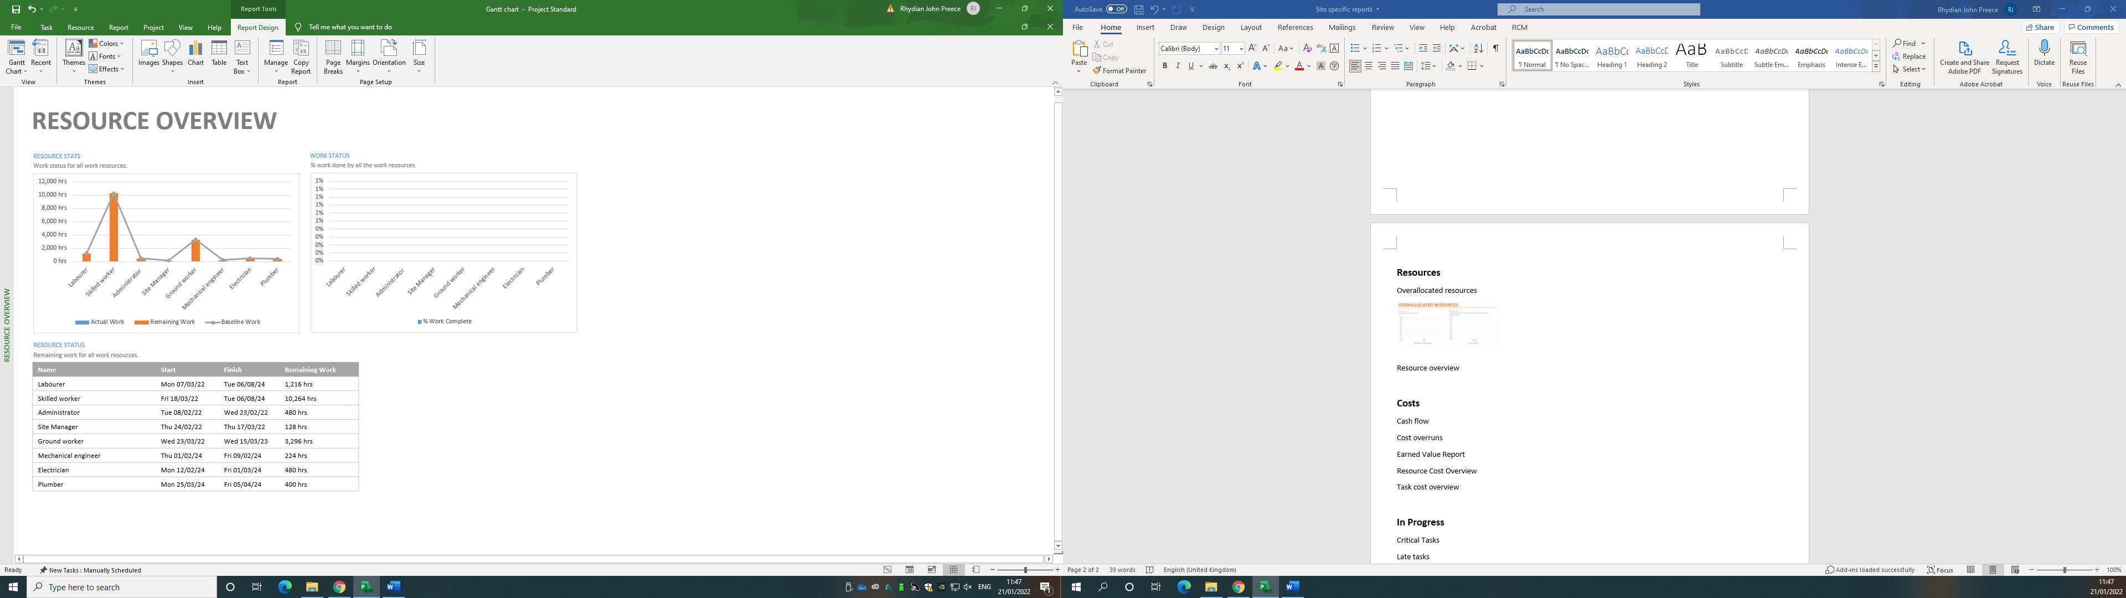 Figure 7 – Resource stats
The graph above shows the different work resources and how many hours each one will have during the project. There is a big need for skilled workers on this job, as the substructure will be mainly piled foundations which are very expensive. The superstructure also uses steel columns, beams, and joists which would require workers specialised in that field.
Figure 8 – Resource status
The table above shows the number of hours each worker will take on during the project. As stated above, the skilled workers, ground workers, and labourers will take on the most hours on this project as they will be around from the start till the finish. Whereas the electrician, plumber, and mechanical engineer will be used more towards the end of the project.
  - Time Report
The next few screenshots will show my final Gantt chart for this project. It can be shown that the project will begin on the 7th of February 2022 and finish on the 8th of August 2024.
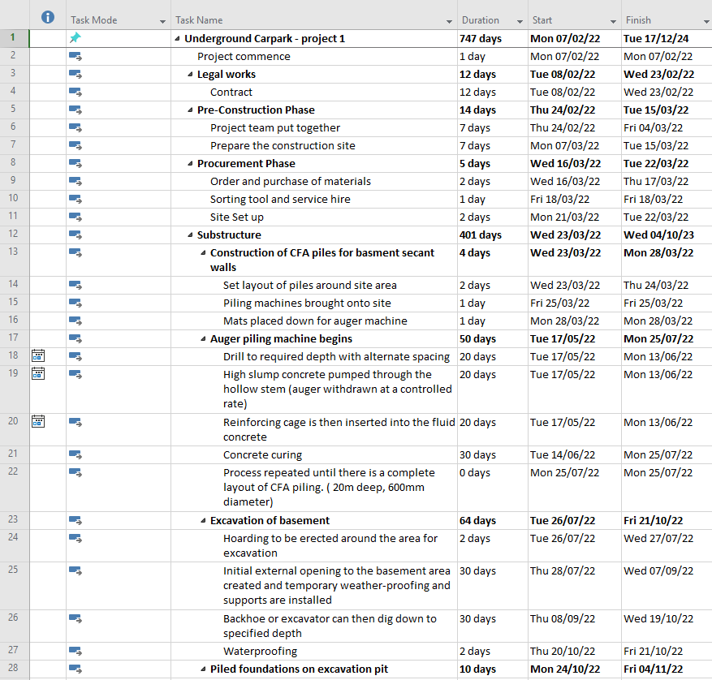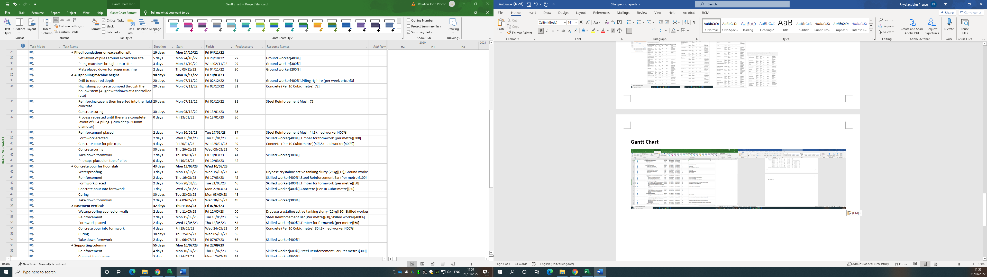

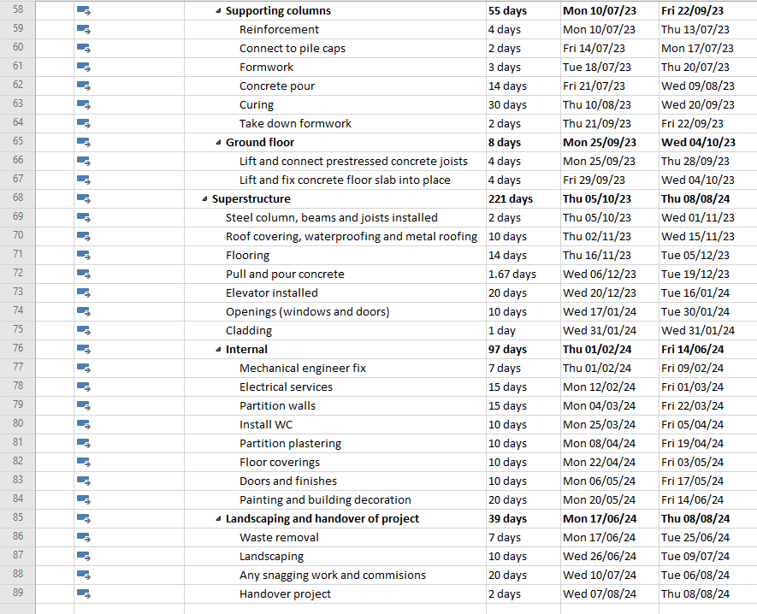Figure 9 – Gantt Chart

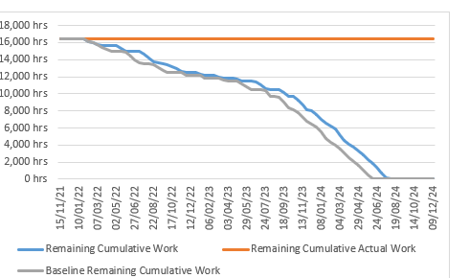
Figure 10 - Burndown
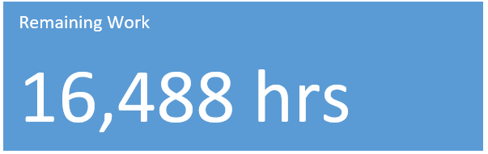
The graph above shows the amount of work that should be done by each date. When the project starts, the manager can start to compare the lines to ensure that they are keeping on track with the work completed. The overall amount of time that the project will take can be indicated above in the blue box.

  - Tracking Gantt
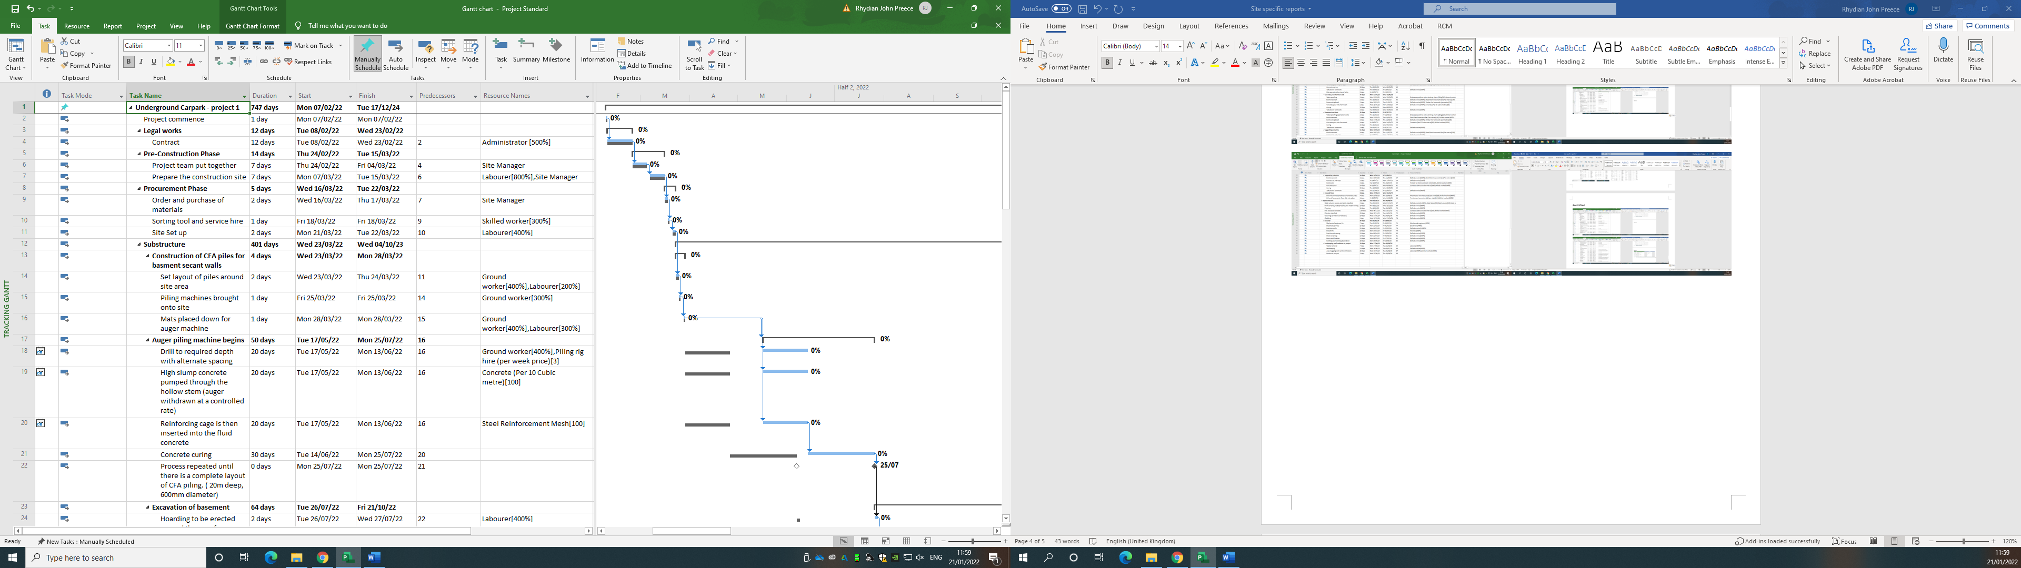
Figure 11 – Tracking Gantt
It can be shown above that just before the drilling and concrete pour of the CFA piles begin, there is a 5-week delay. This delay was caused by the concrete company going on strike, which would push the whole project back by 5 weeks. Even though it shows the project finishing on the 8th of August 2024 on the Gantt chart, it should have been handed over on the 4th of July 2024.

3. Incentivisation
3.1 Introduction for incentivisation
This part of the assignment will explore incentivisation and how it can be used to address performance issues in terms of productivity in the workplace. Coming from the client’s perspective, we need to understand how to incentivise the contractor and also how to motivate a team while working on the project.
3.2 What is incentivisation?
Incentivisation according to Parry (2019), “incentivisation is incorporating incentives into an arrangement in order to motivate the parties to it. Incentives can be either financial or non-financial”. Before an employer or client can decide on how they want to incentivise, it is important for them to fully understand the objectives of the project. After this, the behaviours and performance necessary to achieve those objectives can be established. Once these are understood, an appropriate incentive regime can be developed in order to motivate the behaviours and performance necessary to achieve those objectives.
3.3 Motivation
When incentivising workers, it is important to understand the two different types of motivation which are extrinsic and intrinsic. Cherry (2020) describes extrinsic motivation as when we are motivated “to perform a behaviour or engage in an activity because we want to earn a reward or avoid punishment”. These types of people will engage in behaviour not because they enjoy it or find it satisfying, but because they expect to earn a reward or avoid punishment. Whereas someone who is intrinsically motivated will engage in a behaviour because they find it rewarding. This person will perform an activity for their own sake rather than desiring an external reward. So, before incentives can be handed out, employers/clients must understand the person they are incentivising.
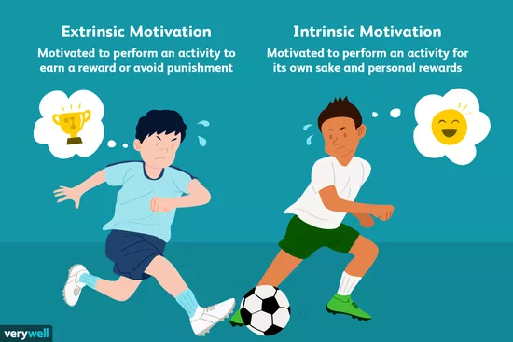
Figure 12 – Image showing the different types of motivation.

Extrinsic Motivation | Intrinsic Motivation
- Participating in a sport to win awards | - Participating in a sport because you find the activity enjoyable
- Cleaning your room to avoid being reprimanded by your parents | - Cleaning your room because you like tidying up
- Competing in a contest to win a scholarship | - Solving a word puzzle because you find the challenge fun and exciting
- Studying because you want to get a good grade | - Studying a subject, you find fascinating

Figure 13 – Examples of extrinsic and intrinsic motivation
3.4 How can we incentivise people? – Client’s perspective
The main types of incentives that people may think of are pay rises, promotion, bonuses, but again the incentives that are given must be related to people that are extrinsically and intrinsically motivated. For example, someone who is extrinsically motivated would work harder to gain a bonus but someone who is intrinsically motivated would not be bothered by a bonus but work because they enjoy what they are doing.
As a client, you will need to encourage or motivate your contractors. A client will want to incentivise to reduce overall costs, time and improve quality. People are starting to move away from the traditional contracting relationship to a more collaborative contracting model Parry (2019). For example, the client could state in the contract that they will be providing training for x number of staff as part of the project. The client can also encourage workers of the contractors by awarding “employee of the month” awards.
3.5 How can we incentivise people? – Contractor’s perspective
From a contractor’s point of view, it is essential to keep your employees happy for their well-being and to ensure work is being done to a high quality. Your employees must not be simply going through the motions but ensuring that they want to get the job done well. There are many ways in which we can motivate a team such as:
- Celebrating Big (And Small) Wins – it is very important to honour your team when they accomplish a job well done. Some companies will celebrate this by handing out MVP rewards to employees, financial incentives, and even a small email to certain employees to recognize that they are doing a good job.
- Rewards after a day of hard work – some employees may become demotivated after working in the bitter cold or the blazing heat, so something small such as treating your employees to a meal, or a drink can go a long way and also show them that you recognize their contributions.
- Staying engaged with your team – knowing what your team is working on and why they are doing it. From this knowledge, you can offer guidance and answer questions at each step of the process. Even when you cannot keep an eye on your team, you can stay in contact through a collaboration platform.
- Allow your team to grow – as a leader, you should take advantage of the skills that your employees have and allow them to grow these abilities. Giving your team more challenging projects will give them more responsibility and will keep their interest up in the field while ensuring they don’t become bored when working.
Incentives to a team were provided by Kala (2022)

4. Scenario – Local concrete company strike
4.1 Introduction to scenario
During the lifespan of the project, there will be difficulties to cope with and there are ways in which the client and contractor can deal with this. In this situation, the local concrete company that will be the main supplier for the contractor will be going on a strike due to last 5 weeks. The strike is set to begin on the first day we require concrete so this will affect the project on many levels. According to the Gantt chart, the pile locations will have been set out, the piling rigs would have been brought on to the site and nothing else can be done on-site without the concrete.

Something put in place to ensure the project is completed before or on the set date is something called the contract master programme. This will be signed by both the client and contractor before the project starts. The contractor has a contractual duty to complete the work on or before the date of completion and if not, he/she may suffer the deduction of liquidated and ascertained damages from his/her contract payment.

4.2 Delay
Projects may suffer disruptions that are concerned with loss of efficiency due to lower productivity than expected or some interference with normal progress. The 5-week strike held by the local concrete company will be known as a non-culpable delay, which means the contractor is delayed through no fault of their own (excusable delay or employer delay).

4.3 Extensions of Time
Delay and disruption are dealt with extensions of time. These are expressly dealt with within standard construction contracts through specific clauses:
- Extensions of time for specific events beyond the contractor’s control.
- Procedures for the contractor to follow when making an application for an extension of time.
- Procedures for the contract administrator to follow when considering the contractor´s application.
Information on delay and extension was provided by the slides on Moodle.

4.4 Tracking Gantt
Figure 11 – Tracking Gantt
Shown already from part 2 of the assignment is the Tracking Gantt. This is to show how the 5-week delay will affect the project. The full Gantt chart and tracking Gantt can be found in the Gantt chart submission. As shown in the tracking Gantt, the grey line shows the baseline at which date the task should’ve been completed. The blue line shows the new date at which the set task will be completed.
Though this may affect the project, no one was at fault in the contracting parties, so the contractor can apply for an extension of time in the contract which will allow the project to be completed by a new set date. This new set date will be agreed with the client in the contract.

5. Conclusion
To conclude, this assignment has explored the subject of programme control. During this piece of work, a Gantt chart has been created alongside site-specific reports for cost, resources, and time. After completing the Gantt chart for an underground car park, one explained the different ways in which we can incentivise people from the client encouraging the contractor, to the contractor motivating their employees.
When these tasks were completed, we were tasked with a scenario-based question that involved a local concrete company going on strike for 5 weeks. One had to show how this would affect the project and also understand how this would be dealt with from a contractual point of view.
This assignment has provided me with excellent knowledge on how to manage a project and also understand how we can incentivise people to increase productivity in the workplace.

6. Figures
- Figure 1 – Cost overview, progress versus cost, and task cost overview (page 3)
- Figure 2 – Baseline cost tables for stages of work and workers (page 4)
- Figure 3 – Cash Flow chart (page 4)
- Figure 4 – Resource Cost Overview (page 5)
- Figure 5 – Cost Details (page 5)
- Figure 6 – Resource sheet (page 6)
- Figure 7 – Resource stats (page 7)
- Figure 8 – Resource status (page 7)
- Figure 9 – Gantt Chart (page 9)
- Figure 10 – Burndown (page 10)
- Figure 11 – Tracking Gantt (page 11)
- Figure 12 – Image showing the different types of motivation (page 12) [Online]. [Accessed 10 January 2022]. Available from: https://www.verywellmind.com/differences-between-extrinsic-and-intrinsic-motivation-2795384
- Figure 13 – Examples of extrinsic and intrinsic motivation (page 13)

7. References
- Parry, R. (2019) – Using incentives to drive contractor behaviour. Pinsent Masons.
- Cherry, K. (2020) – Differences of Extrinsic and Intrinsic Motivation
- Kala, T. (2022) – 8 Tips to Motivate Your Construction Team. Priority Matrix.
- Moodle (2022)

