Programme: BA (Hons) Business Management
Module: Principles of Human Resource Management
Module code: LCBB5012
Student Name: Kiren Nisar
Student ID: 2220781

Table of Contents
Introduction 3
Internal and External Environment 4
Organisation Application 7
Application of Model: PESTLE analysis 9
Conclusion 14
References 15

Introduction
The human resource department plays a crucial role within the organisational premises as they are fulfilling the responsibilities of hiring, training, employee management and more aspects. Hiring suitable employees leads to an increase in organisational effectiveness and achieve greater competitive advantage within the business market. Recruitment and selection, performance management, training and development, as well as employee relations, are the major HR functions (J.D. & Holznienkemper, 2024). These functions are essential for business aspects as they help to acquire the relevant talent from the company's perspective and enhance overall productivity. The role of performance management is to keenly measure the effectiveness of the actions as per the stipulated goals of the organisation. This leads to enhanced engagement of the employees with the organisational premises. In addition, the HR department of a firm is to protect it from any types of regulatory issues while incorporating the relevant legislation within the organisational processes. This report will emphasise the internal and external environment of an organisation and its influence on the HR practices. The PESTLE analysis framework will be undertaken here to understand the influence of the external factors on the HR practices in Vodafone Group Plc. Application of this model will be introduced here in a detailed manner, followed by future implications.

Internal and External Environment
Business environment model
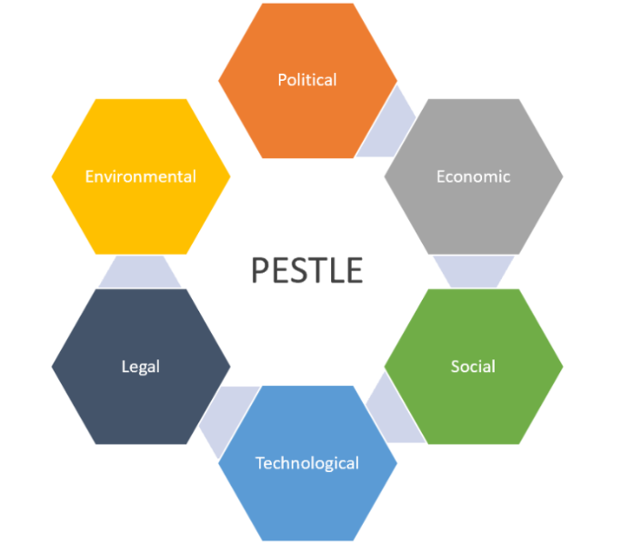
Figure: The framework of the PESTLE model
Source: (Madsen, 2024)
Definition of the PESTLE Model
The PESTLE model refers to a strategic framework that is used for analysis and further monitoring the external macro-environmental factors of a specific organisation. This model is particularly designed to assist the employees of a company in identifying the risks and opportunities for the strategic planning and decision-making initiatives of their fellow employees (Madsen, 2024). The explanation of the effectiveness of the elements of the PESTLE model on the network of a specific entity is as follows:
Importance of Political Factors: The political factors refer to the impact of the government policies, stability, trade restrictions and the tax policies on the functions of an entity. However, the working professionals often find this model, which is limited to the adaptation of the latest trends and the lack of capability for adapting to the current changes.
Effectiveness of the Economic Factors: This factor refers to the inflation rate, exchange rates and the disposable income of the consumers in the network of a company. This element acts as an important factor for the company in calculating its operational costs and other rising costs. There is a high chance that the employees will be prone to mistakes, as these rates are highly volatile and unpredictable (Crimmins, 2025).
Importance of the Social factors: Different cultural trends, demographics and the behaviour of the customers towards the business fall under the category of the social factors. It is quite important for the senior working members of a company to get an understanding of the latest trends in the industry. These factors help the employees to provide the specific product that satisfies the needs of the targeted audience.
Impact of technological factors on a business: Currently, the majority of the emerging companies are using the latest digital and innovative tools for manufacturing products and services for consumers. Therefore, this factor is quite important for a company to emerge in a region.
Effectiveness of the Legal Factors: It stands quite mandatory for a company to adhere to the latest laws and regulations of a region to exist. Laws like employment laws, consumer protection laws and other regulations fall under this category (Madsen, 2024).
The importance of Environmental factors: This factor helps the enterprise to promote the specific services and products that create a positive impact on the environment (Crimmins, 2025). Components like climate, sustainability and carbon footprints are considered by a particular company through this factor.
Linking to HR Function
Internal and external factors influencing the HR practices
The internal factors help the HR manager to manage the capacity of the organisation. The latest trends of the industry help the HR of the business to recruit skilled and potential candidates in the business network. The external factor influences the HR practices of a company by guiding them through the processes that are required to be followed for engaging the workforce of an enterprise. Employees are considered to be the important components for a business to reach the goals of the company (Vin, 2023). Hence, these factors also significantly influence the leadership style and the management approach of a company.

Organisation Application

Figure: The brand logo of the Vodafone Group Plc
Source: (Vodafone.com, 2026)
Brief Overview of the Vodafone Group Plc’s operations and its global presence
Vodafone Group Plc is a major British multinational telecommunications company that is headquartered in Newbury, the United Kingdom. The primary services which are provided by this business are voice, data, broadband and other Internet services. Vodafone Group Plc is the largest mobile network operator from a global perspective. The recent data suggests that this business serves over 330 million consumers globally, having a huge and significant presence worldwide (Vodafone.com, 2026). Being a multinational enterprise, Vodafone Group Plc shares hold a strong presence in the regions of Africa and Europe. For future purposes, this firm is also committed to making investments in cloud services and the Internet of Things.

HR practices followed by Vodafone Group Plc
This telecommunication service provider focuses on building a future-ready, digital-first workforce by integrating the latest digital tools. In terms of managing the global workforce, the senior managers use a particular way termed the Vodafone Way for managing the skilled employees, including the engineers and team members. A thorough evaluation also suggests that a particular CSR strategy is being embedded that helps them to provide appraisals and rewards to the chief executive officers (Vodafone.com, 2021). To motivate the existing working members, the company have provided the appropriate rewards and recognition based on the performance of the different individuals.

Application of Model: PESTLE analysis
Impact on Vodafone Group Plc
Political factors
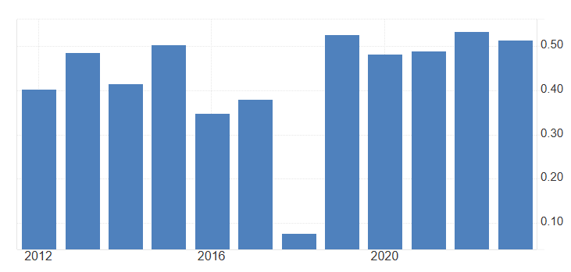
Figure: Political stability of the United Kingdom
Source: (Tradingeconomics, 2023)
The political stability of the United Kingdom has been maintained with limited violence, which signifies that the political scenario has been stable in recent times. As per statistics, the level of political stability has been measured as 0.51494 in 2023 (Tradingeconomics, 2023). This is favourable for Vodafone Group Plc to foster long-term infrastructure development in the United Kingdom. In recent times, the firm has merged with Three and formed a new entity named VodafoneThree. This is considered the UK's largest mobile operator and offers services to nearly 27 million customers (Rudolph, 2025).
Economic factors
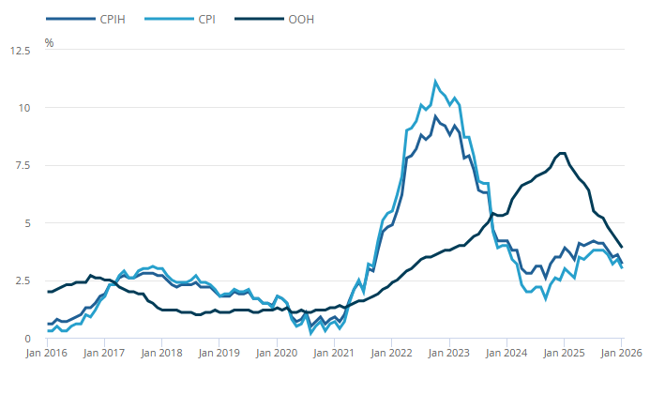
Figure: Inflation rate in the United Kingdom
Source: (ONS.GOV, 2026)
The people in the United Kingdom have a high disposable income level, and this suggests wider acceptance of the 5G network offered by Vodafone Group Plc. On the other hand, the current inflation rate in the United Kingdom has been recorded as 3.2% in January 2026, which is perceived as high by the citizens (ONS.GOV, 2026). However, it was down from the level of inflation from the previous month. For this reason, people are more consciously investing in the companies in terms of availing the services. To deal with the current inflationary situation, the company is moving towards a skill-based hiring process by its HR department.
Social factors
There are only 28% of the population of the United Kingdom is using the 5G network in recent times (Tomás, 2025). The demand for smoother connectivity in terms of using the 5G network has increased here. This is favourable for the firm to attract a diverse level of customers through providing them extensive quality of services. £11 billion is the current investment made by this firm in terms of enhancing its digital infrastructure in the United Kingdom (Rudolph, 2025).
Technological factors
The current network business is moving forward rapidly while boosting its network and providing quality services to the customers. Statistics reveal that nearly 39% of the network companies are eagerly moving towards the 5G investment in the United Kingdom, and among them, 14% of the companies have invested (Davison, 2025). The recently approved merger with Three UK has smoothed the pathway for Vodafone Group Plc to attract potential employees through the HR department.
Legal factors
There are strict guidelines followed by the telephone companies in the United Kingdom for preserving the rights of the users. Wireless Telegraphy Act 2006, Telecommunications (Security) Act 2021 (TSA), Security Regulations & Code of Practice (2022), and more legislation are helpful to avoid the legal consequences. Corporate security and following the legal terms are the main focus of the firm; this is helpful for the HR department of the firm to maintain all the business processes (Vodafone, 2025).
Environmental factors
Environmental factors, such as sustainability, carbon emission and more, are addressed as significant in the current scenario of the United Kingdom. Various companies are committed towards the net-zero aspects and the complex business landscape. In this manner, the company is moving actively to reduce the level of carbon emissions and reach net-zero levels by 2027 and use 100% renewable electricity (Vodafone, 2026). The HR department of the firm has aligned its employee hiring and handling process and enhanced overall effectiveness as per the current environmental aspects of the firm.
Country differences
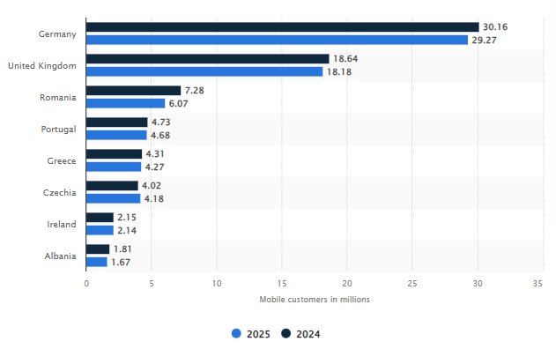
Figure: Mobile users of Vodafone in the UK and Europe
Source: (Elagina, 2025)
Focusing on the presence of Vodafone Group Plc in diverse locations, this section will provide a discussion about the United Kingdom and European locations. In the UK, the company is widely accepted, and its new digital infrastructure is smoothly aligned with the current digital preferences of the local citizens. On the other hand, the company is facing diverse cultural preferences in the European locations, though there is also present the high-performing tech adoption. Additionally, the current regulatory infrastructure of the United Kingdom is offering flexibility to companies after Brexit. This is helpful for the firm to understand the regulations and integrate them within the business framework of Vodafone Group Plc. Contrary to that, the European legislation at times is strict and often influences the revenue generation of the firm. Considering the economic factors, the United Kingdom has experienced a high level of inflation of 3.2% in 2026 (ONS.GOV, 2026). Alternatively, Europe has increased the inflation rate from 1.7% to 1.9% in February 2026 (Tradingeconomics, 2026). Though the rate of inflation is low in Europe compared to the level of inflation in the UK. This suggests that the company is currently having a better economic scenario in Europe compared to the UK. Statistics also revealed that Vodafone Group Plc. has a user base of 18.64 million in the UK and 30.16 million in Europe in 2024 (Elagina, 2025).

Conclusion
The report has critically evaluated the component of human resources management in the network of a particular company. This aspect has been discussed for the company of the entity of Vodafone Group Plc. The PESTLE model has been used to explain the overall activities of the HR manager in this telecommunications business. The effectiveness of each element and its effectiveness on the different operations of this entity have also been thoroughly discussed. An overview of the Vodafone Group Plc has also been highlighted in this report. Different data and figures have been presented for analysing the external conduction of this telecommunications company in the international market. The processes and the strategies that are followed by the HR Manager of this multinational enterprise have also been thoroughly evaluated. Based on the future implications, it can be stated that global organisations are undergoing a technological transformation that drives business value. This transformation is characterised by the use of the digital tools like the Artificial Intelligence and the use of the Big Data Analytics. The predictive analytics helps the employees to analyse the turnover rates of the employees in the business network. Getting an idea beforehand helps the senior managers and the workers to implement the strategy that is necessary for the employees to keep them motivated and encouraged. The overall market situation is quite dynamic and competitive, and therefore, it is quite important for the HR manager to enhance skills and proficiencies over time.

References
Crimmins, C., (2025). PESTEL Analysis: What It Is and How to Use It for Strategic Planning. [Online] Available at: https://www.spiderstrategies.com/blog/pestel-analysis/ [Accessed 27 February 2026].
Davison, M., (2025). Why digital infrastructure could be the next Great British success story. [Online] Available at: https://www.vodafone.co.uk/newscentre/features/digital-infrastructure-next-great-british-success-story/ [Accessed 28 February 2026].
Elagina, D., (2025). Number of Vodafone mobile customers in Europe as of end of 2024/25 financial year, by country. [Online] Available at: https://www.statista.com/statistics/714550/number-of-vodafone-mobile-customers-by-markets/?srsltid=AfmBOoroOTkPKiPb-44j8Htu_aCPY7wouq4S0LaIp0fFjeIcvXmgMN2J [Accessed 28 February 2026].
J.D., D. O. & Holznienkemper, L., (2024). What Is Human Resources? The Ultimate Guide. [Online] Available at: https://www.forbes.com/advisor/business/what-is-human-resources/ [Accessed 27 February 2026].
Madsen, T., (2024). Get Expansion Right The First Time: Considerations For International Companies When Analysing Local Environments. [Online] Available at: https://www.forbes.com/councils/forbesbusinesscouncil/2024/08/27/get-expansion-right-the-first-time-considerations-for-international-companies-when-analyzing-local-environments/ [Accessed 27 February 2026].
ONS.GOV, (2026). Consumer price inflation, UK: January 2026. [Online] Available at: https://www.ons.gov.uk/economy/inflationandpriceindices/bulletins/consumerpriceinflation/january2026 [Accessed 28 February 2026].
Rudolph, A., (2025). ​Vodafone-Three merger: what next after the creation of the UK's largest mobile operator?. [Online] Available at: https://www.ig.com/en/news-and-trade-ideas/vodafone-three-merger--what-next-after-the-creation-of-the-uk-s--250611 [Accessed 28 February 2026].
Tomás, J. P., (2025). Ofcom: 5G accounts for 28% of UK connections. [Online] Available at: https://www.rcrwireless.com/20250718/5g/5g-uk-ofcom [Accessed 28 February 2026].
Tradingeconomics, (2023). United Kingdom - Political Stability And Absence Of Violence/Terrorism: Estimate. [Online] Available at: https://tradingeconomics.com/united-kingdom/political-stability-and-absence-of-violence-terrorism-estimate-wb-data.html [Accessed 28 February 2026].
Tradingeconomics, (2026). Euro Area Inflation Rate. [Online] Available at: https://tradingeconomics.com/euro-area/inflation-cpi [Accessed 28 February 2026].
Vin, (2023). External and Internal factors affecting HRM Decision making.. [Online] Available at: https://elms.org.uk/external-and-internal-factors-affecting-hrm-decision-making/ [Accessed 28 February 2026].
Vodafone, (2025). Our Code of Conduct. [Online] Available at: https://binaries.vodafone.co.uk/gbnnsauqav4t/675k1XGZolsuBGFQgYjkpH/a810e5c4e2803ef74a7d19c5c7c2a7ef/vodafone-uk-code-of-conduct.pdf [Accessed 28 February 2026].
Vodafone, (2026). Protecting the Planet. [Online] Available at: https://www.vodafone.co.uk/mobile/sustainable-business/planet [Accessed 28 February 2026].
Vodafone.com, (2021). Our future ready ways of working. [Online] Available at: https://www.vodafone.com/news/newsroom/digital-society/our-future-ready-ways-working [Accessed 28 February 2026].
Vodafone.com, (2026). OUR COMPANY. [Online] Available at: https://www.vodafone.com/our-company [Accessed 28 February 2026].

