Introduction
This study aims to understand how soil/water at ‘Quakers pond’ on Kilvey Hill is affected by the waste metal contamination from past nearby copper smelting processes.

Kilvey hill, a 3km² area, situated on the east side of Swansea between the river Tawe to the west and Crymlyn Bog National Nature Reserve to the east, incorporates young woodland, heathland, wetland and meadow. It is a haven for wildlife including the skylark, night jar, linnet, peregrine, redwing, song thrush, fieldfare, raven and whitethroat. There have also been sightings of the rare small blue butterfly recorded at this site. (Swansea Council, 2021)
Powered by access to coal, Swansea was world-renowned for copper smelting during the Industrial Revolution. The waste from White Rock copperworks was tipped as copper slag on Kilvey hill leading to metal-contaminated land. Also, part of the hill would receive over 180 tons of sulphuric acid with copper smoke every day for at least 150 years (between the 1760s and 1890). (Robins, 2023)
‘By 1802, the hill (Kilvey) above White Rock was lifeless’ and remained similar for over 150 years; in the 1960s, the soil on Kilvey was regarded as ‘severely degraded’ and would only support a little vegetation including isolated stands of Purple Moor-grass (Molinia caerulea). During subsequent years, the Forestry Commission and Swansea Council planted pines across Kilvey including Scots, Lodgepole, Corsican and Monterey. This was the first time in over two centuries that trees had been planted on the hill; the choice of coniferous trees was due to the pollution causing little else to grow. Many of these pioneer trees are still there (when searched for in spring 2022) with the Monterey Pines doing especially well. (Robins, 2023)
Today (2024), there is a large amount of native trees regenerating in the clearings, including Birch, Alder and Oak.
The reclaimed land on Kilvey hill comprises of ecosystems supporting a variety of ecosystem services for humans. The forest itself will be providing atmospheric oxygen and other nourishments to help support all life on this planet. There are numerous more physical as well as mental health and wellbeing benefits that the different ecosystems provide. Considerable time and money has been invested by people in developing Kilvey for recreational uses such as walking, cycling and horse riding. (Nantel, 2011) Simply visiting greenspaces reduces mental health problems in people in general, but the more conscious of nature a person is, the more wellbeing benefit that person receives. (Chang, 2024)

Quaker’s pond (Martin’s pond) is located on ditch runs near to the bottom west side of Kilvey hill, and would have been near to the original location of the early chimneys of the White Rock copperworks. (Robins, 2023)
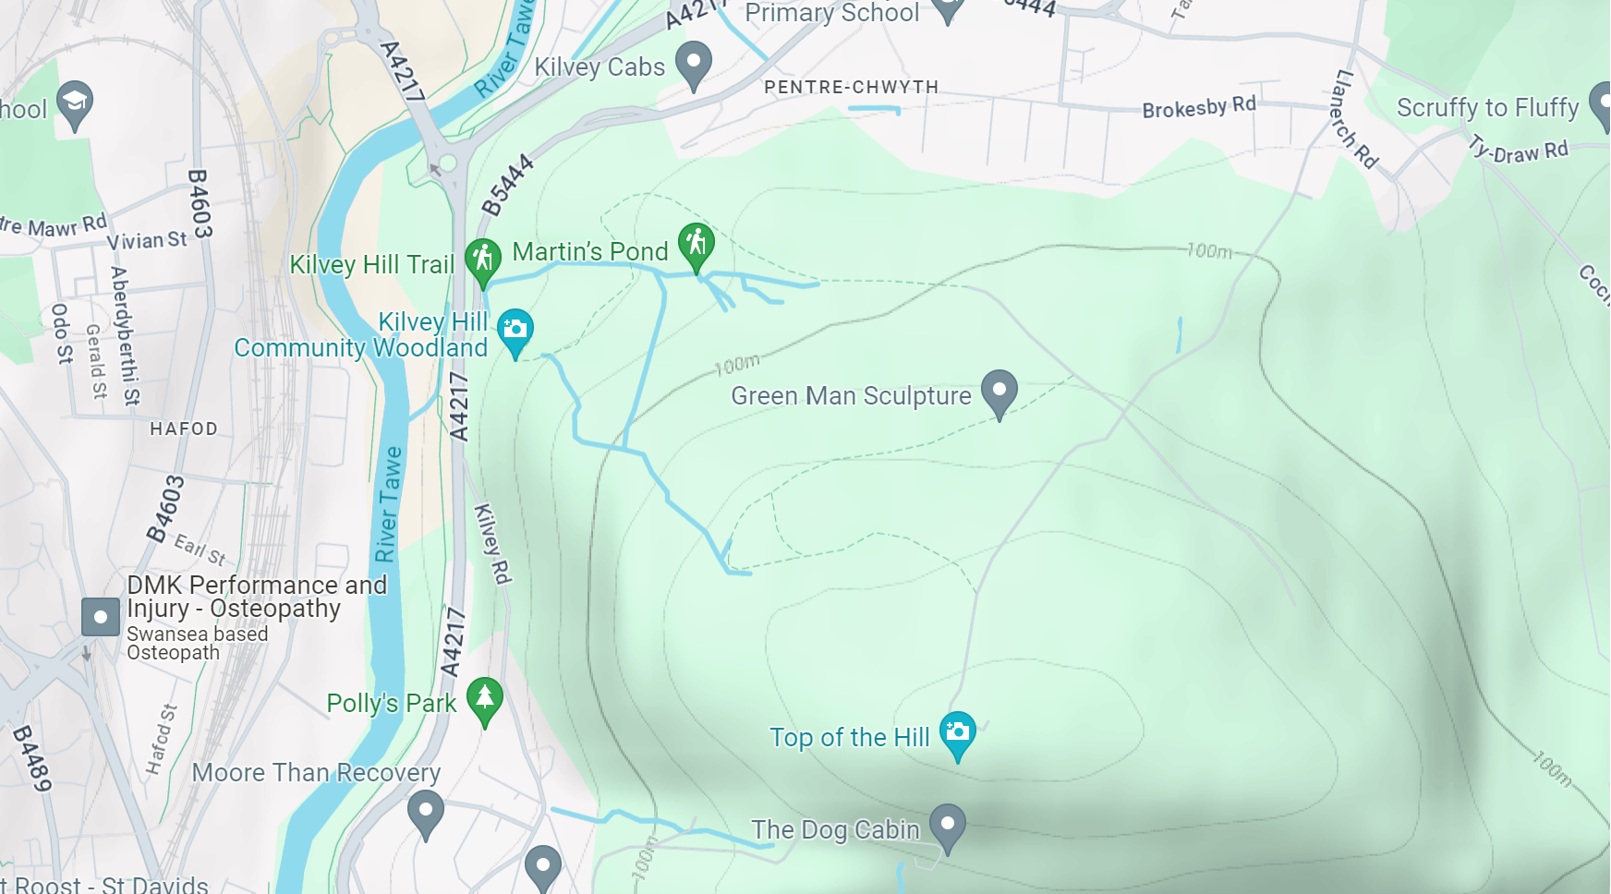
Figure 1. Kilvey hill to the east of river Tawe. Quaker's pond (Martin's pond) near to bottom west side of Kilvey hill (Google maps, 2024)
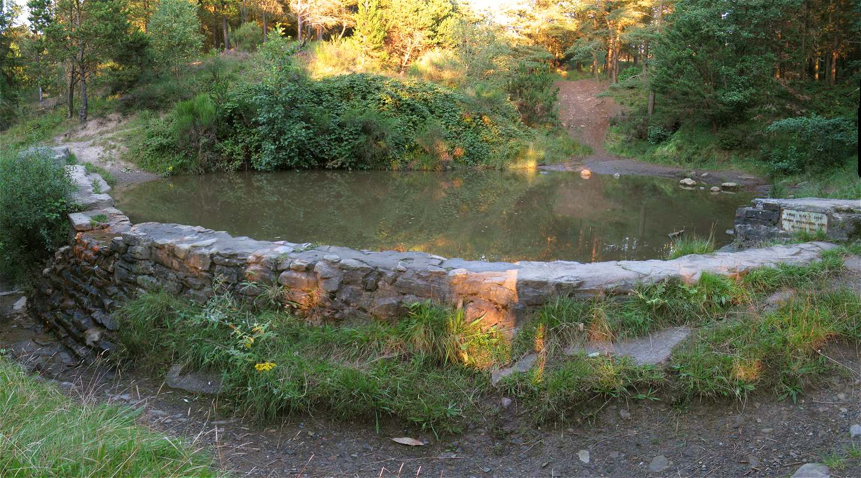
Figure 2. Quaker's pond behind a dam in Kilvey hill Community woodland (Davies, 2012)

Despite the work that has been done to reclaim Kilvey hill, there is resistance in biodiversity development at Quaker’s pond where there is slag and other mining waste just beneath the soil surface. (University of Wales Trinity St Davids, 2024)
Due to the poor soil and afforestation with pines, there are few ground cover species that are able to be found in the woodland areas. (Yet, today (2024), there is Hart’s tongue fern an ‘ancient-woodland-indicator’ plant, which has a wide variety of medicinal uses. (Woodland Trust, n.d.)) There are areas on the lower slopes and upper heathlands, which have grasses and heather, where wild plants are freely propagating. There is scrub with Hazel, hawthorn and blackthorn on the lower slopes and groundcover here, as well as in the upper heathlands, include those found in heath and marsh-meadow such as Dog’s mercury, wild garlic, wood Anemone, Speedwell and Sorrell. (Nantel, 2011)

There is a Site of Special Scientific Interest (SSSI) which is partly located at the now demolished White Rock works in Hafod near to Quaker’s pond.
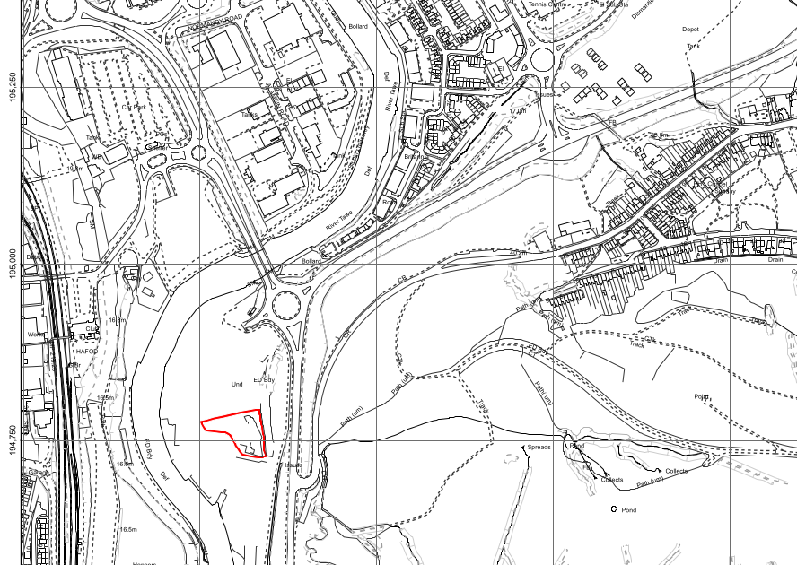
Figure 3. SSSI partly located at former White Rock copperworks marked in red adjacent to river Tawe (Martin's pond located just to the east of the site) (Natural Resources Wales, 2024)

The SSSI is now the only remaining fragment of habitat from the bygone copper-smelting era, and is of special interest for its calaminarian grassland, including the vascular plant spring sandwort Minuartia verna. Spring sandwort is usually seen on metal-rich rock strata and mine spoil in North Wales and the Pennines so it is particularly interesting that it is also seen at this SSSI, which is one of its most southerly locations in Britain. Metal-tolerating mosses, liverworts (bryophytes) and lichens are also prominent in the calaminarian grassland. (Natural Resources Wales, 2024)

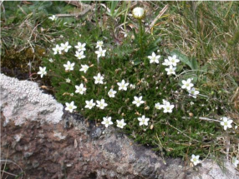
Figure 4. Spring sandwort Minuartia verna (Natural Resources Wales, 2024)
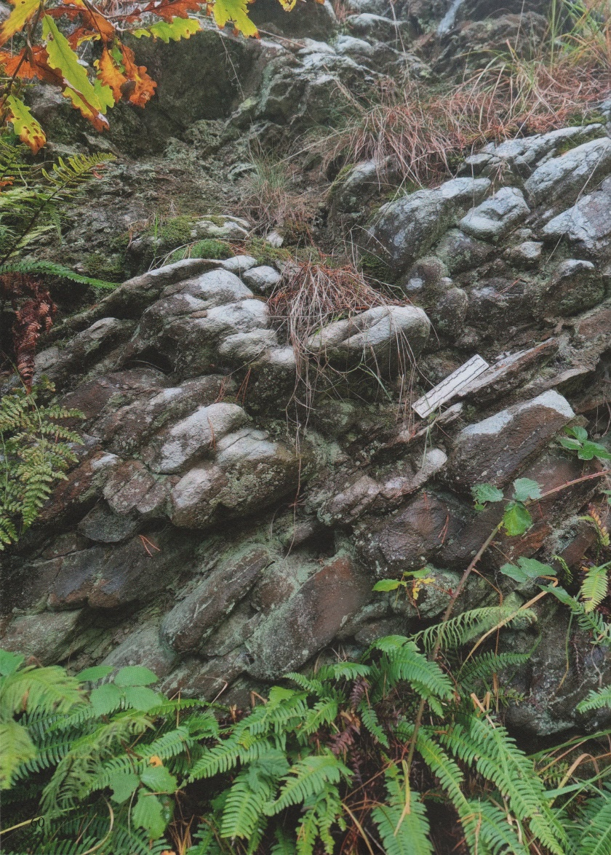
Figure 5. Sandstone bed rock at Quaker's pond showing effects of two centuries of weathering and decomposition by acid rain and copper smoke from the White Rock works. As the rock face softens, vegetation gets a hold with many small mosses and moulds finding a home on the rocks. (Robins, 2023)

Methodology and Equipment
In February 2024, after walking around the woodland paths of Kilvey and spotting some different species of plants, animals and fungi, water samples were taken from near the bank of Quakers pond.
Test strips were used to obtain readings for the pH, chlorine and iron levels of the samples of water.
Electronic meter (e.g. spectrometer) readings were obtained for more accurate results (pH, Copper and Iron).
The results were tabled and compared to environmental standards set to protect wildlife.
This survey method was simple, easy to use and produced fast results. There may have been more accurate methods (equipment) that could have been used in laboratory analyses, but these may not have been as practical in obtaining field data.

Results
All results are in mg l⁻¹.
Specific pollutants (Test type) | Environmental standard  (mg l⁻¹) | Results (mg/l)
Specific pollutants (Test type) | Environmental standard  (mg l⁻¹) | Sample number |  |  |  | Sample Mean average
Specific pollutants (Test type) | Environmental standard  (mg l⁻¹) | 1 | 2 | 3
Copper (Spectrometer) | 0.001 | 0.49 (2dp)
Iron (Spectrometer) | 0.73 | 0.26(2dp)
Iron test (strips - using method B) | 0.73 | 0.005 | 0.005 | 0.005 | 0.005
Nitrate | 1-2 | 10 | 0 | 0 | 3.33 (2dp)
Phosphate | 0.03 - 3 | 0 | 0 | 0 | 0
Sulphate | 0-250 | 0 | 0 | 0 | 0
Ammonia | 0.022 | 0.25 | 1 | 0.25 | 0.5
Chlorine (strip) | 0.02-0.05 | 1
Chlorine | 0.05 | 0.5 | 0.5 | 0.5 | 0.5
pH (strip) | <6.0 | <6.2
pH (meter) | <6.0 | 6.2 | 6.2 | 6.2 | 6.2
Table 1. Student’s results from water sampling at Quaker’s pond. These results reveal that Quaker’s pond is highly contaminated with copper, nitrate, ammonia and chlorine. It is also too acidic.

The environmental standard for copper in freshwater lakes is an annual mean concentration 0.001 mg l⁻¹ of dissolved copper. (UK Technical Advisory Group Water Framework Directive (WFD), 2013). The results in table 1 indicate that the copper concentration in this survey is at least 490 times greater than this standard.
The good/moderate threshold for iron in freshwater lakes is 0.73 mg l⁻¹ for the protection of sensitive taxa. (UK Technical Advisory Group Water Framework Directive, 2012) The results in table 1 indicate that the iron concentration in this survey is below this threshold.
1–2 mg l⁻¹ of winter-nitrate may correspond with ‘good’ ecological quality under the
terms of the European Water Framework Directive. (James, 2005). The nitrate concentration in this winter survey is up to 10 times higher than this standard.
The standards for good annual mean total phosphorus may range from less than 0.01 mg l⁻¹ up to around 1 mg l⁻¹ (or for total phosphate from 0.03 mg l⁻¹ up to around 3 mg l⁻¹ ). (UK Technical Advisory Group Water Framework Group , 2012) The phosphate concentration in this survey was negligible.
Sulphate concentrations in freshwater lakes typically range from 0 to 250 mg l⁻¹. (Dominik, 2021) The sulphate concentration in this survey was negligible.
For freshwater, the lowest concentration of ammonia that was found to have detrimental effects on aquatic life was 0.022 mg l⁻¹. (Environment Agency, 2007) The concentration of ammonia in this survey was almost 23 times higher than this standard.
The guideline for the proposed standard of chlorine concentration is no greater than 0.05 mg l⁻¹. (DEFRA, 2014) The concentration of chlorine in this survey was at least 10 times greater than this standard.
A pH below 6.0 increasingly affects the physiology and growth of freshwater organisms. (Forestry Commission, Scottish Forestry, Natural Resources Wales and Forest Service, 2023) The pH in this survey was just above this standard.

Discussion
The results reveal that Quaker’s pond is highly contaminated with copper, nitrate, ammonia and chlorine.
The copper contamination is likely a result of the waste from the White Rock copperworks or other nearby copperworks, either as dumped slag or copper smoke or both. Whilst some plants and lichens are able to resist copper toxicity, heavy metals like copper are able to accumulate in food chains and have serious impacts on aquatic organisms health, especially fish, as well as on the environment and human health.
There are various technologies which can be used to remove heavy metals from wastewater including membrane separation, ion exchange, chemical precipitation, electrochemistry, adsorption and biotechnology. However, perhaps a more ecological and cheaper alternative to these technologies would be phytoextraction using ‘hyperaccumulator’ plants which are fast growing, and are able to store heavy metals in above ground organs, such as poplars or willows. (Saladin, 2015) (Liu, 2023) (Emon, 2023)
Nitrogen (nitrate and ammonia) may be generated by natural processes such as the breakdown of plants and animals, nitrogen fixation by legumes, the transformation of nitrogen in the soil and deposition from atmospheric nitrogen. Nitrogen is primarily produced by humans, for example, in fertilisers used in farming, from livestock manure, by wastewater from housing/roads development, and sewage. It is also transported through atmospheric transport. (ADAS report to DEFRA, 2007) (Beauchamp, 2022) (WWT, 2024) However, due to the lack of farmland and housing on Kilvey, it is unlikely that Nitrogen would have been introduced directly through fertilisers, manure and sewage.
Excess of nutrients (nitrogen and phosphorus) in water also causes pollution (eutrophication) due to excess photosynthesis (e.g. ‘algal blooms’) leading to decreased availability of oxygen and sunlight for some aquatic life. Methods for reducing nutrients in water may include the use of over-winter plants, which can reduce nitrate leaching, and building wetlands, which have a natural capacity to clean and filter water. (ADAS report to DEFRA, 2007) (Chislock, 2013) (WWT, 2024) Riparian woodland can also intercept nutrients draining from adjacent land. However, closed canopies of trees, especially conifers, can shade out lower levels of vegetation and increase bank erosion. Conifers also increase capture of acid pollutants in the atmosphere and consequently reduce pH of waters, so careful management of excessive conifer regeneration is required (Forestry Commission, Scottish Forestry, Natural Resources Wales and Forest Service, 2023)
The chlorine level in this survey would be likely to be toxic to freshwater organisms. (Water Framework Directive UK, 2007) Chlorine is commonly used in industry and found in household products. As Quaker’s pond is located on ditch runs with flowing water the source of chlorine is likely to be leachate from the soil. Atacamite imported into Swansea was a ‘hydrated oxychloride of copper’ and Chilean copper ore used in Swansea furnaces ‘contained oxychloride copper’ and released vast quantities of chlorine. (Percy, 1892) By extrapolation, it is likely that this chlorine is the source of the present day chlorine found in Quaker’s pond. Further research is required to understand how chlorine levels are regulated in the environment and how methods of dechlorination would affect long-term chlorine cycling. (Svensson, 2021)
The samples taken in this survey may not reflect the true environment of Quaker’s pond and more sampling, for example, closer to the centre of the pond, rather than near to the bank, may be necessary. The test kits used in obtaining the field data may be less sensitive and/or specific and therefore less reliable than those used in laboratory analyses.

Conclusion
There is much work to be done on Kilvey to reduce contamination by pollutants in Quaker’s pond. Clearly in the short timeframe since trees have been planted there has been great improvement on Kilvey. However, there is an argument for a need for further site management strategies, which could include transitioning from coniferous to more native broadleaf trees to help reduce the pollutants and improve biodiversity of ecosystems.

References
ADAS report to DEFRA, 2007. Diffuse nitrate pollution from agriculture – strategies for reducing nitrate leaching. [Online]
Available at: https://www.gov.wales/sites/default/files/publications/2021-03/atisn14824doc7.pdf
[Accessed 27 March 2024].
Beauchamp, K. e. a., 2022. National Forest in Wales Evidence Review- Annex 5, Bangor: Bangor University.
Chang, C. L. B. F. X. e. a., 2024. A lower connection to nature is related to lower mental health benefits from nature contact.. Scientific Reports, 20 March.
Chislock, M. e. a., 2013. Eutrophication Causes, Consequences, and Controls in Aquatic Ecosystems. [Online]
Available at: https://www.nature.com/scitable/knowledge/library/eutrophication-causes-consequences-and-controls-in-aquatic-102364466/
[Accessed 27 March 2024].
Davies, N., 2012. Wikimedia Commons. [Online]
Available at: https://commons.wikimedia.org/wiki/File:Pond_behind_dam_in_Kilvey_Hill_Community_Woodland_-_geograph.org.uk_-_3134099.jpg
[Accessed 22 March 2024].
DEFRA, 2014. Water Framework Directive implementation in England and Wales: new and updated standards to protect the water environment. [Online]
Available at: https://assets.publishing.service.gov.uk/media/5a7f00e740f0b62305b84861/river-basin-planning-standards.pdf
[Accessed 27 March 2024].
Dominik, Z. e. a., 2021. Sulphate in freshwater ecosystems: A review of sources, biogeochemical cycles, ecotoxicological effects and bioremediation. Earth-Science Reviews, Volume 212.
Emon, F. e. a., 2023. Bioaccumulation and Bioremediation of Heavy Metals in Fishes—A Review. Toxics, 11(6), p. 510.
Environment Agency, 2007. Using Science to Create a Better Place. [Online]
Available at: https://www.wfduk.org/sites/default/files/Media/ammonia.pdf
[Accessed 27 March 2024].
Environment Agency, 2019. Phosphorus and Freshwater Eutrophication Pressure. [Online]
Available at: https://consult.environment-agency.gov.uk/++preview++/environment-and-business/challenges-and-choices/user_uploads/phosphorus-pressure-rbmp-2021.pdf
[Accessed 25 March 2024].
EPA (US), 2023. Causes and Effects of Pollutants on Fish. [Online]
Available at: https://www.fao.org/fishery/docs/CDrom/aquaculture/a0844t/docrep/009/T1623E/T1623E03.htm
[Accessed 27 March 2024].
Forestry Commission, Scottish Forestry, Natural Resources Wales and Forest Service, 2023. The UK Forestry Standard. [Online]
Available at: https://cdn.forestresearch.gov.uk/2023/10/The-UK-Forestry-Standard.pdf
[Accessed 29 March 2024].
Google maps, 2024. Google maps. [Online]
Available at: https://www.google.com/maps/@51.6345967,-3.9301024,15z/data=!5m1!1e4?entry=ttu
[Accessed 22 March 2024].
James, C., 2005. Nitrate availability and hydrophyte species richness in shallow lakes. Freshwater Biology.
Liu, Y. e. a., 2023. Removal of Copper Ions from Wastewater: A Review. Int J Environ Res Public Health, 20(5).
Nantel, A., 2011. Leisure in natural balance : harmony or harm? : establishing a numerical matrix to evaluate the impact of recreational use upon woodland., Swansea: Swansea Metropolitan University.
Natural Resources Wales, 2024. Natural Resources Wales. [Online]
Available at: https://naturalresources.wales/media/682586/sssi_4200_citation_en001.pdf
[Accessed 22 March 2024].
Natural Resources Wales, 2024. Natural Resources Wales. [Online]
Available at: https://naturalresources.wales/media/682587/sssi_4200_map001.pdf
[Accessed 22 March 2024].
Percy, J. E. ,. M. .., 1892. Catalogue of the Collection of Metallurgical Specimens. London: Eyre and Spottiswoode.
Robins, N. A., 2023. Historical Geography on Kilvey Hill. 1st ed. Swansea: Nyddfwch Publishing.
Saladin, G., 2015. Phytoextraction of Heavy Metals: The Potential Efficiency of Conifers. Limoges: Springer.
Svensson, T. e. a., 2021. Chlorine cycling and the fate of Cl in terrestrial environments. Environ Sci Pollut Res Int., 28(7), p. 7691–7709.
Swansea Council, 2021. Kilvey hill. [Online]
Available at: https://www.swansea.gov.uk/kilveyhill
[Accessed 20 March 2024].
UK Technical Advisory Group Water Framework Directive (WFD), 2013. Water Framework Directive. [Online]
Available at: https://www.wfduk.org/sites/default/files/Media/Environmental%20standards/UKTAG%20Environmental%20Standards%20Phase%203%20Final%20Report%2004112013.pdf
[Accessed 25 March 2024].
UK Technical Advisory Group Water Framework Directive, 2012. Phosphorus Standards in Rivers. [Online]
Available at: https://wfduk.org/sites/default/files/Media/Iron%20-%20UKTAG.pdf
[Accessed 25 March 2024].
UK Technical Advisory Group Water Framework Group , 2012. Phosphorus Standards for Rivers. [Online]
Available at: https://www.wfduk.org/sites/default/files/Media/Phosphorus%20standards%20for%20rivers.pdf
[Accessed 25 March 2024].
University of Wales Trinity St Davids, 2024. Assignment brief. [Online]
Available at: https://moodle.uwtsd.ac.uk/course/view.php?id=9986&section=4
[Accessed 22 March 2024].
Water Framework Directive UK, 2007. Proposed EQS for Water Framework Directive Annex VIII substances: chlorine (free available). [Online]
Available at: https://www.wfduk.org/sites/default/files/Media/chlorine.pdf
[Accessed 29 March 2024].
Woodland Trust, n.d. Woodland Trust. [Online]
Available at: https://www.woodlandtrust.org.uk/trees-woods-and-wildlife/plants/ferns/harts-tongue-fern/
[Accessed 22 March 2024].
WWT, 2024. Natures Way to Cleaner Water. WaterLife, Issue 224, pp. 13-17.

