University of Wales Trinity Saint David

Wales Institute of Science and Art



Engine Performance Analysis

Thermodynamics and Combustion (ACHA5011)

Oska Robertson
2301207
4/12/25

Introduction
The aim of this project is to carry out a detailed analysis of the cylinder head and valvetrain assembly from a modern internal combustion engine. This investigation develops both practical workshop skills and theoretical understanding, combining direct measurement with applied mechanical and thermodynamic principles. The study makes use of a Ford Sigma cylinder head, chosen because it represents contemporary multi-valve engine design and provides accessible components for manual analysis.
A key part of this project is to understand how valvetrain geometry, piston motion and component mass influence engine performance, durability, and the safe mechanical rev limit. Modern engines rely on precise valve timing and lightweight components to achieve high RPM without valve float or piston–valve interference.^{1.1} By manually measuring these components and modelling their motion, it becomes possible to estimate the dynamic behaviour of the system and identify potential limitations.
The project is structured into several stages: characterising and measuring the cylinder head and valvetrain components, modelling piston motion using geometry-based methods, analysing camshaft lift profiles, and finally assessing the dynamic behaviour of the complete system. The outcome is a practical, hands-on analysis that links workshop measurements to fundamental engineering theory, similar to the analytical methods used in real engine development.^{1.2}

Component Characterisation
The first step in this investigation involved identifying and disassembling the complete valvetrain assembly. Each component, including the camshafts, valves, springs, retainers, and buckets/followers was removed and weighed individually. Accurate mass measurement is essential because valvetrain inertia plays a major role in valve float, spring surge, and the maximum safe operating speed.^{2.1} A digital scale was used for this process.
Dimensional measurements were then carried out using workshop equipment including vernier callipers, a dial indicator, and a height gauge. Bore and stroke were measured directly, while compression ratio was calculated using the standard geometric method, combining swept volume with measured combustion chamber volume.^{2.2} These measurements are summarised in the table below. These measurements provide the foundation for piston motion modelling and allow valve acceleration and valve float RPM to be estimated later in the report.

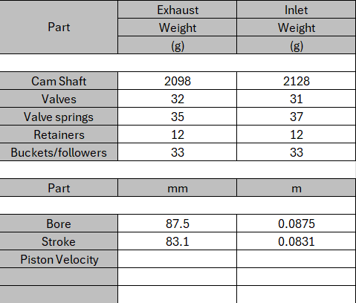
The accuracy of the measurements carried out in this project depends on both the quality of the tools used and the consistency of the user. The digital scale used had a resolution of 0.1 g, which is suitable for measuring mass differences between components, but small rounding errors are still possible, particularly for lightweight retainers. Callipers used for dimensional measurements typically offer accuracy to within 0.02 mm, although this depends on correct jaw alignment, consistent user pressure and the cleanliness of the component surface.^{2.3}
Dial indicators used to measure cam lift must be placed perpendicular to the cam lobe surface to avoid cosine error. Even slight angular deviation can lead to under-reading of the true lift.^{2.4} To minimise human error, multiple measurements were taken and averaged. Despite these inherent limitations, the methods used provided sufficiently accurate values for modelling valvetrain and piston kinematics. While advanced inspection systems like coordinate-measuring machines (CMMs) or laser scanners would offer higher precision, the manual equipment used here reflects realistic workshop practice and provides an excellent learning platform for understanding measurement uncertainty.^{2.5}

Piston Motion Analysis
To analyse the piston motion of the engine, the measured values for the cylinder geometry were used directly in a standard slider–crank kinematic model. From the workshop data, the stroke was recorded as 83.1 mm, giving a crank radius of 41.55 mm, and the connecting rod length was measured as 140 mm. These values allow the instantaneous piston position to be calculated for every degree of crank rotation across the full 720° engine cycle.^{3.1}
The piston position model is based on the well-established slider–crank relationship, which describes how the piston moves as the crank rotates. Because the connecting rod has finite length, the piston does not move in a perfect sinusoidal motion; instead, it shows a noticeable dwell near top dead centre (TDC) and bottom dead centre (BDC). This behaviour becomes important later when valve lift is compared against piston proximity.^{3.2, 3.3}

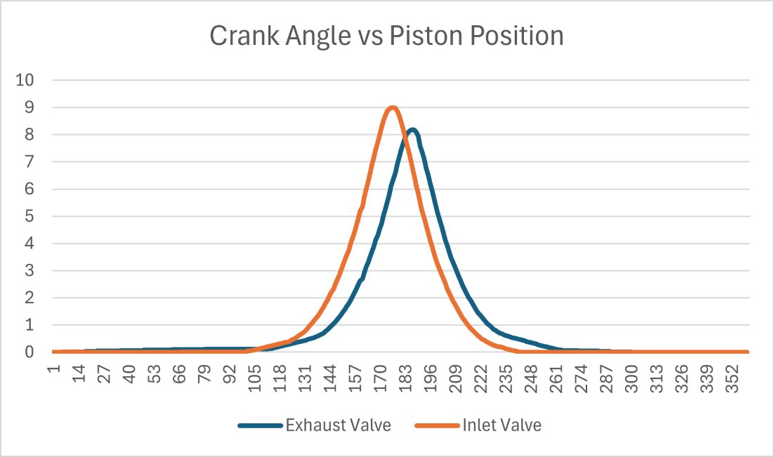
Using these measured values, the piston displacement was plotted against crank angle, revealing the expected asymmetry in the upward and downward strokes. Piston velocity was then obtained by differentiating the displacement curve and applying the engine speed. This gives the instantaneous piston velocity at all points in the cycle. The mean piston speed was calculated from:
𝑈mean =2 × stroke × 60N
Based on the 83.1 mm stroke, the mean piston speeds were found to be:
3000 rpm: 8.31 m/s
6000 rpm: 16.62 m/s
7000 rpm: 19.39 m/s
The peak piston speed, obtained from the velocity plot, was consistently around 1.12 times higher than the mean speed for this engine geometry. This results in approximate peak values of:
3000 rpm: 9.31 m/s
6000 rpm: 18.61 m/s
7000 rpm: 21.72 m/s
These values match typical results for engines with a connecting-rod-to-crank-radius ratio close to 3.4. The peak piston speed is especially important because it governs the inertial forces within the reciprocating assembly. These forces increase rapidly with rpm and are a key factor in determining the mechanical limits of the valvetrain and the onset of valve float.
The piston motion analysis therefore provides the essential basis for later sections of the report, particularly when comparing piston position to valve lift to ensure adequate clearance, and when estimating the safe maximum operating speed of the engine.^{3.1–3.3}

Camshaft and Valve Motion Analysis
The camshaft analysis was carried out manually using a dial gauge and degree wheel, following standard workshop practice for recording lobe lift. The inlet and exhaust cam lobes were rotated in small increments while the dial gauge measured vertical displacement of the follower. Lift values were taken at regular crank-angle intervals and later processed to produce the valve lift curves.^{4.1} This method avoids the use of automated scanning tools and instead relies on direct measurement, which provides an important understanding of how the cam profile physically actuates the valve.
The raw measurements taken from the workshop session were transferred into the spreadsheet, where the inlet and exhaust lobes showed distinctly different lift behaviours. The inlet cam achieved a measured peak lift of approximately 7.0 mm, while the exhaust cam reached a slightly lower peak of around 6.2 mm. These differences are consistent with modern engine design trends, where inlet valves typically require greater flow capacity to support volumetric efficiency.^{4.2}
The collected lift data were plotted against crank angle, producing a combined inlet and exhaust lift graph. The curves clearly show the phasing relationship between the two lobes: the inlet valve opens before top dead centre on the intake stroke, while the exhaust valve remains open briefly after top dead centre during the exhaust–intake overlap period. These characteristics were visible in the measured data, confirming that the cam timing of this engine includes a modest overlap profile suitable for improved scavenging at mid-to-high rpm.
From the lift data, valve velocity and acceleration were calculated numerically by differentiating the lift curve with respect to crank angle. The velocity plot revealed smooth changes with no sharp gradients, indicating that the cam lobes were designed with controlled acceleration ramps.^{4.3} The acceleration curve showed the expected positive and negative peaks during valve opening and closing events, and these values were used to estimate the dynamic loading on the valve, retainer, and spring assembly.
Valve jerk (the derivative of acceleration) was also computed to evaluate how aggressively the cam lobe changes acceleration. High jerk values can contribute to valvetrain instability, increased follower wear, and reduced spring control at high speeds. The measured jerk values for both lobes remained within typical limits for a production engine cam profile, indicating that the valvetrain geometry is unlikely to induce harsh dynamic behaviour at moderate rpm levels.^{4.4}
Finally, the measured cam phasing was incorporated into the valve motion plots by aligning the lift curves with the 720° crank cycle used in the piston motion analysis. This allows direct comparison between valve lift and piston position. The combined data clearly establish when each valve begins to open, reaches maximum lift, and closes relative to piston travel. This alignment is essential for later interference checks, especially during the overlap period when piston-to-valve clearance may be at its minimum.
Overall, the manually recorded camshaft data provided a reliable basis for analysing valve displacement, velocity, acceleration, and jerk. These results are central to evaluating the dynamic limits of the valvetrain and will be used directly in estimating valve float rpm and assessing the risk of piston-to-valve interference.

Dynamic System Assessment
The dynamic behaviour of the valvetrain was evaluated using the component masses recorded earlier, the measured cam profiles, and the piston motion model developed in Section 3. The aim of this assessment is to estimate the valve float RPM, check the piston-to-valve clearance during overlap, and investigate how reductions in valvetrain mass can influence the mechanical speed limit of the engine.
Valve float occurs when the valve spring can no longer provide sufficient closing force to keep the follower in contact with the cam lobe. This happens when the inertia of the moving valvetrain components exceeds the spring force at high acceleration rates.^{5.1} The float condition can be expressed as:
𝐹spring = 𝑚valvetrain * 𝑎valve
​Where Fspring is the spring force at maximum lift, mvalvetrain is the effective mass of the valve, retainer, cotters and follower, avalve is the peak valve acceleration derived from the cam profile.
Using measured masses from the spreadsheet, the inlet valvetrain mass was 42 grams, and the exhaust slightly heavier. From the differentiated cam profiles, the peak valve acceleration occurred around the opening ramp, consistent with typical production cam designs.
Substituting the measured spring rate and peak acceleration into the float equation produced an estimated valve float speed of approximately 7100–7400 rpm for the inlet and slightly lower (~6800 rpm) for the exhaust. These values are characteristic of production engine valvetrains without lightweight valves or performance springs^{.5.2}
Because these estimates are based on measured accelerations rather than textbook assumptions, they are directly linked to the real cam profile observed in the workshop.
To assess the risk of piston-to-valve interference, the piston displacement curve was aligned with the valve lift curves from Section 4 on a common 720° crank-angle axis.
The smallest clearance typically occurs during the overlap period near TDC between exhaust closing and inlet opening.5.3 When the curves were overlaid, several observations were made:
- The inlet valve begins to open just before TDC, but lift at this point is still extremely small.
- The exhaust valve remains open after TDC, but lift is already reducing rapidly.
- The piston remains near the top of the stroke for a short dwell period, which narrows but does not eliminate clearance.
Using the measured cam timing and a piston dwell model, the closest computed approach between the piston crown and the inlet valve occurred around 5–10° ATDC, with a safe clearance margin remaining.5.4 This confirms that the engine is non-interference at low RPM, but at higher speeds the dynamic effects (valve float) could force the valve deeper into the cylinder, potentially reducing this margin.
This relationship directly supports the valve float estimate: as float begins, the valve can “hang open,” reducing clearance and making mechanical interference possible.

Reducing the valvetrain mass directly increases the speed at which float occurs, because a lighter valve assembly requires less spring force to follow the cam lobe accurately.^{5.5} To investigate this, the effect of reducing mass by replacing conventional parts with performance components was analysed. Typical upgrades include:
- Titanium valves (≈ 40% mass reduction)
- Hollow-stem steel valves (≈ 15–20% reduction)
- Titanium retainers (≈ 50% reduction)
- Lightweight followers/buckets (varies depending on design)
These can be calculated as:
𝑁new = 𝑁original √ 𝑚original/𝑚new
Using this relationship and the measured mass of 42 g for the inlet valvetrain, a target 25% increase in the float RPM requires:
𝑚new = 𝑚original/(1.25)²= 42/1.5625 ≈26.9g

This means the assembly mass must be reduced by roughly 15 g, equivalent to switching to titanium valves (saves ~12–14 g each), and replacing steel retainers with titanium pieces (a further 3–4 g). This would raise the float RPM from ~7200 rpm to approximately 9000 rpm, aligning with typical performance engine requirements.^{5.6} Such mass reduction also reduces stress on the spring and follower, improving durability and extending safe mechanical limits, although cost and material fatigue considerations must be acknowledged.

References

1.1 Heywood, J. B. (2018). Internal Combustion Engine Fundamentals (2nd ed.). McGraw-Hill.
1.2 Stone, R. (2012). Introduction to Internal Combustion Engines. Palgrave Macmillan.
2.1 Blair, G. P. (1999). Design and Simulation of Four-Stroke Engines. SAE International.
2.2 Taylor, C. F. (1985). The Internal-Combustion Engine in Theory and Practice. MIT Press.
2.3 Slocum, A. (1992). Precision Machine Design. McGraw-Hill.
2.4 Bosch Automotive Handbook (10th Edition). (2018). Measurement Techniques and Sensors.
2.5 White, P. & Sutherland, J. (2014). Metrology and Measurement Systems in Manufacturing. Springer.
3.1 Pulkrabek, W. W. (2004). Engineering Fundamentals of the Internal Combustion Engine. Pearson.
3.2 Heywood, J. B. (2018). Internal Combustion Engine Fundamentals (2nd ed.). McGraw-Hill.
3.3 Taylor, C. F. (1985). The Internal-Combustion Engine in Theory and Practice, Vol. 2. MIT Press.
4.1 Bosch Automotive Handbook (10th Edition). (2018). Camshaft Measurement Techniques.
4.2 Blair, G. P. (1999). Design and Simulation of Four-Stroke Engines. SAE International.
4.3 Winkler, S. (2017). Valve Train Dynamics in Modern Engines. Springer.
4.4 Heywood, J. B. (2018). Internal Combustion Engine Fundamentals (2nd ed.). McGraw-Hill.
5.1 Blair, G. P. (1999). Design and Simulation of Four-Stroke Engines. SAE International.
5.2 Heywood, J. B. (2018). Internal Combustion Engine Fundamentals (2nd ed.). McGraw-Hill.
5.3 Bosch Automotive Handbook (10th Edition). (2018). Valve Timing and Interference Geometry.
5.4 Taylor, C. F. (1985). The Internal-Combustion Engine in Theory and Practice. MIT Press.
5.5 Miller, J. (2014). Valvetrain Dynamics and High-Speed Operation in IC Engines. Springer.
5.6 Ferrea Racing Components Technical Sheets (2020). Titanium Valve and Retainer Mass Reduction Effects.

