Analysing Industry Trends and Marketing Strategies

By Sean Ferris
Trinity St David’s University

Contents

Business Description Page 3

Demographic Page 3

Prototype Page 6

Localisation Page 6

Milestones & Deliverables Page 7

Competition Page 8

Advertising Page 9

Merchandise Page 9

Expandability Page 9

References Page 10 - 12

Business Description
The product is a 3D animated short film, piloting for a series called “Cellus”. The series is about redemption story of two main characters the father, Ted. To rebuild the relationship with his son, Max. The two face unstoppable odds against a military experiment. The genre is science fiction and creature horror.

The Pilot logline:
A young man returns to his ancestral home in search of a father he left behind, only to discover a monster.

Synopsis:
After years apart, Max returns to his old home in search of his father, only to find the place a mess and disarray. He finds a mysterious hatch that he hasn’t seen before. Leading to an underground a laboratory.

Aim:
To produce a series of 10 episodes, 20 minutes each episode. The series is about a father, a mad scientist who focused solely on his work. He injected himself with an experimental drug, where he is transitioning into a creature. The son, Max returns to his old home, looking for him.

Demographic
The demographical area is focused on the primary audience, age from 15-24 and the secondary audience are from 25 – 35. The primary age consists of young people aged 15-24 who may be growing up with complicated relationships within their families. As an example, they may be dealing with divorce, workaholic parent or loss of a parent, lack of communication, arguing or abuse. Young people may be feeling rebellious, resentful and neglected. The narrative reflects upon the audience, showing how the main character, Max deals with his disconnection with his father.
The secondary audience are aged 25 – 35, who may be parents that may have a complicated relationship with their son or daughter. The story will encourage this demographic to sympathise and understand the affects, which can reflect on the primary demographic. In the pilot, the second main character who is the father portrays a sense of monstrosity. Which is the sons’ conceptual perception between his father and himself.
Source: filmhubscotland.com
Gender by Age, Horror Genre
Figure 1
According to figure 4, the data shows there was an audience of females under 35 have 44% watch horror films. However, it also shows that females under 35, has a bigger audience compared to males under 35 by 8%. This also, shows that as age increases for both female and male, the less they watch horror films. As an overall, Great Britain has 32% watch horror films.
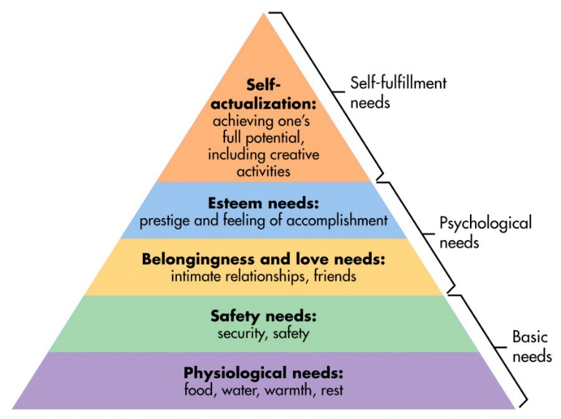
Maslow’s Theory
Figure 2
This is the Maslow's Hierarchy of Needs theory, the pyramid is a motivational theory in psychology which explains five different tiers of human needs, which explains in hierarchy explaining each level within the pyramid.
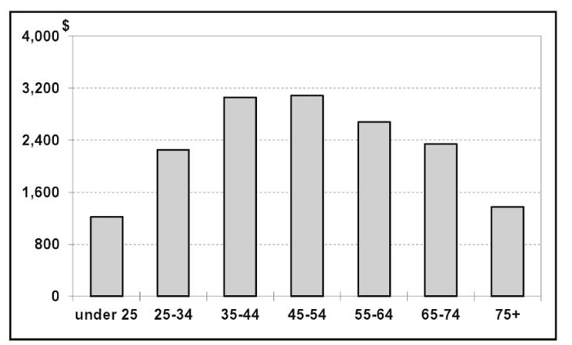
Spending on entertainment classified by age groups
Figure 3
To focus on the demographics, figure 3 shows the spending on entertainment classified by age groups, “young people usually have more time and less income than the middle-aged, who are in the prime of their career and family-raising years and have the income but not the time.” (Harold L. Vogel) It also shows that young people are usually have less money than older generations. This is because younger people under 25 tend to have less psychological needs. Whereas older generations focus more on their basic needs, but also have psychological needs when spending on entertainment.
Source: Boxofficemojo.com, BusinessInsider.com.
Top Grossing Horror Films
Figure 4
In figure 4, these top grossing horror films were released in various different years. The top grossing horror films from 1970-2018. The first top grossing horror film is IT in 2017. Bringing its popularity over the decades, a remake of its original, 1986 was remade making 700.2 million dollars. Over the past few decades, evidence shows that there has been an increase of films in the two years in horror. As it shows in this graph, IT 2017 shows that there was a fan base from its previous film in 1986, which was remade making $700.4 million.
Source: Boxofficemojo.com
Horror Films Increasing
Figure 5
This graph explains that since 2017 and 2018, there has been increase of horror films and having success in the film industry. However, it also shows that there were films that were unsuccessful like Annihilation and successful films, from 2017 the increase has shown that the horror genre have been increasing in popularity.

Prototype
The process of developing the pilot is to release a prototype, in a pre-production stage of a 2D animatic. This will be showing the storytelling, camera movements and characters animations. The risks of producing the prototype is the release of it not becoming popular enough and will not produce enough of an audience. The precautions to make sure this will not happen is to advertise via social media and build an audience who have an interest for the type of genre.

Localisation
To approach localisation, video marketing will be used for to promote the product, it will be advertised through YouTube, Facebook and Twitter. Also, it is available for mobile users and tablet users. Why video marketing? Video marketing is a quick way to share the pilot, which will be released through YouTube, letting Facebook and Twitter to be able to share the video. Although, to focus on promoting the video, language localisation is important to reach other audiences in other countries.
To localise the product, the countries that are marketed to, are U.S.A, U.K, Turkey, Spain and Japan. As per country, the place where the series is held, is in America, Ohio. The series will be marketed to U.S.A and the U.K. in the English language. However, translations to Turkish, Spanish and Japanese will be used to market to. By marketing to these countries, it is necessary to translations of the title series to the country and subtitles into the languages will be used. The pilot has an advantage, as it can appeal to many different types of audiences, as the pilot does not have that much dialogue. However, if the series is presented, it will include translations in the specific language.

Milestones & Deliverables
The marketing trend will be focused mainly of demographics. However, the content will be advertised across multi-platforms such as Amazon Prime, Netflix and YouTube. To focus on the primary and secondary demographic, these platforms are available to young people and parents. To build an audience for the series, advertising will be distributed through multi-platforms, releasing the pilot, which will reach both primary and secondary audiences.
The deliverables of the product will be disturbed across multi-platforms such as YouTube, Vimeo and Netflix releasing the pilot during the summer 2019. A 1-year plan, devising into 4 months of pre-production and 8 months of production before releasing the content through Netflix. The release date of the product will be released by Halloween in October 2019, where the horror theme becomes a reoccurring theme in October.

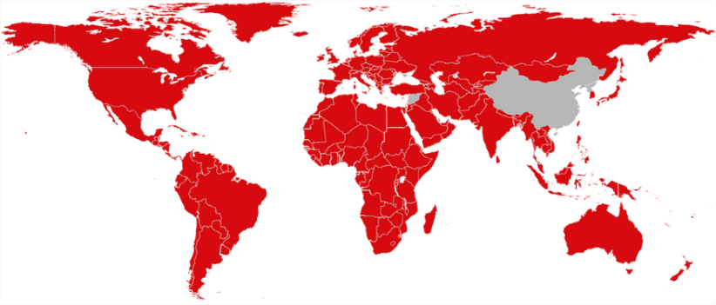Source: Netflix.com | 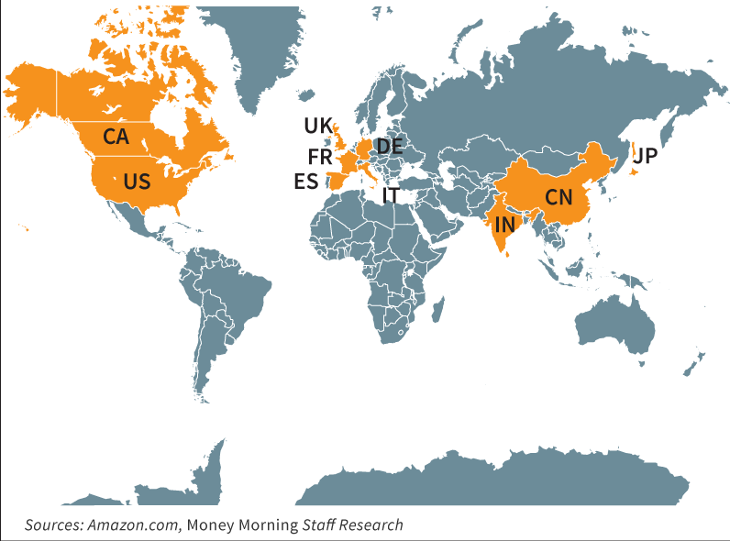
Netflix vs Amazon 2018
Figure 6
To focus on distributing the product will be released through Netflix. Netflix worldwide gives many different people access to films, series and etc. In comparison to its second competitor, Amazon Prime has less of an audience. The popularity of Netflix has been rising since 2012. In 2017, Netflix was the top video streaming content, spending 6 billion. Their international growth has tapped into foreign markets, aiming towards other areas of the world such as Korea, Japan, U.S.A, U.K, etc. Netflix is one of the largest video streaming content services, offering three different deals. It is £5.99 per month for standard definition and download videos. The second offer is HD and downloads for £7.99 per month. They also offer £9.99 per month for ultra HD and download videos.
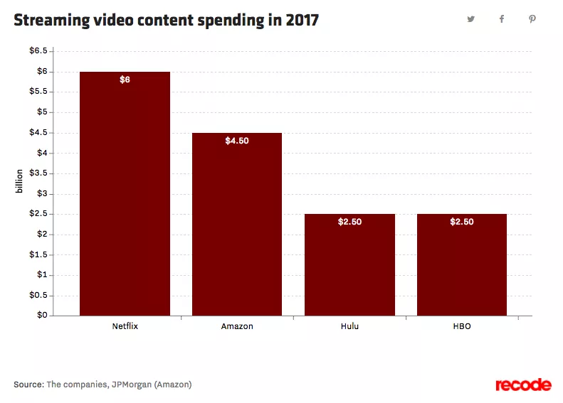
Netflix, Amazon, Hulu and HBO video streaming content services
Figure 7
The largest competitor against Netflix is Amazon Prime, with roughly 30% total market share. Amazon Prime is a feature where a subscriber can have one day delivery service. With an extra feature, Amazon Prime’s subscription service offers video streaming content. Amazon gained a market share through video streaming quickly, offering a feature to Prime subscribers with no extra cost. This means it costs less in comparison to Netflix, at £79.00 a year or £7.99 a month. Amazon is also beginning to produce original content.
In this graph it shows that Hulu is Netflix’s third largest competitor, roughly having 15% market share for video content streaming. Hulu costs $8 per month for subscription, with commercials. They also offer $12 per month for no commercials. However, Hulu only streams video content on one screen at a time, also mainly focuses on content that they already own by parented companies and it is blocked everywhere outside U.S. HBO is also a competitor in video content streaming service, offering $14.99 per month. They have access to all its video streams, current and past HBO content. HBO is also available through Sky Atlantic.

Competition
The Stranger Things Season 3 trailer is set in a 1980s mall, capturing the essence of the times by including specific products, food, clothes, style, books, etc. However, in the trailer it shows a common character from the previous seasons, which would suggest to the following audience that the mall may be the centre of the new season. Stranger Things has released a promotional trailer for releasing a new season in the summer of 2019. Essentially their publicity will raise interest in the genre and potential target audience. It is important therefore to exploit this opportunity by releasing the pilot of “Cellus”, before the new season of Stranger Things starts.
A common setting between Stranger Things and Cellus is the genre, however the culture and time period is set in the early 1990s, instead of the 1980s. The pilot will set a tone between two characters who have a complicated relationship between each other. The father and the son. The series is a based upon rebuilding the relationship, making a character development for both characters.

Advertising
To advertise the product, social media can be used for advertising the series. The plan is to use YouTube adverts to promote the product, however to share the product it can be uploaded into Facebook and Twitter as a pilot. For example, in figure 8, it shows that a recent film called “Halloween” was released as a trailer, where they shared their content on Facebook and Twitter. The Twitter page consists of many different contents regarding the film, voice actors, concept art, merchandise and events.
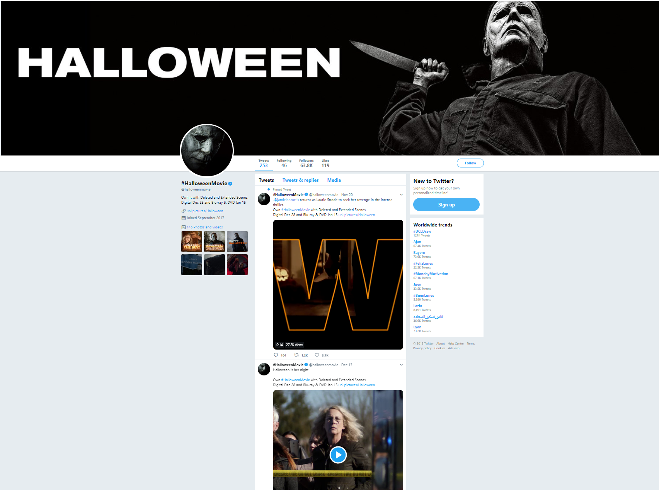 | 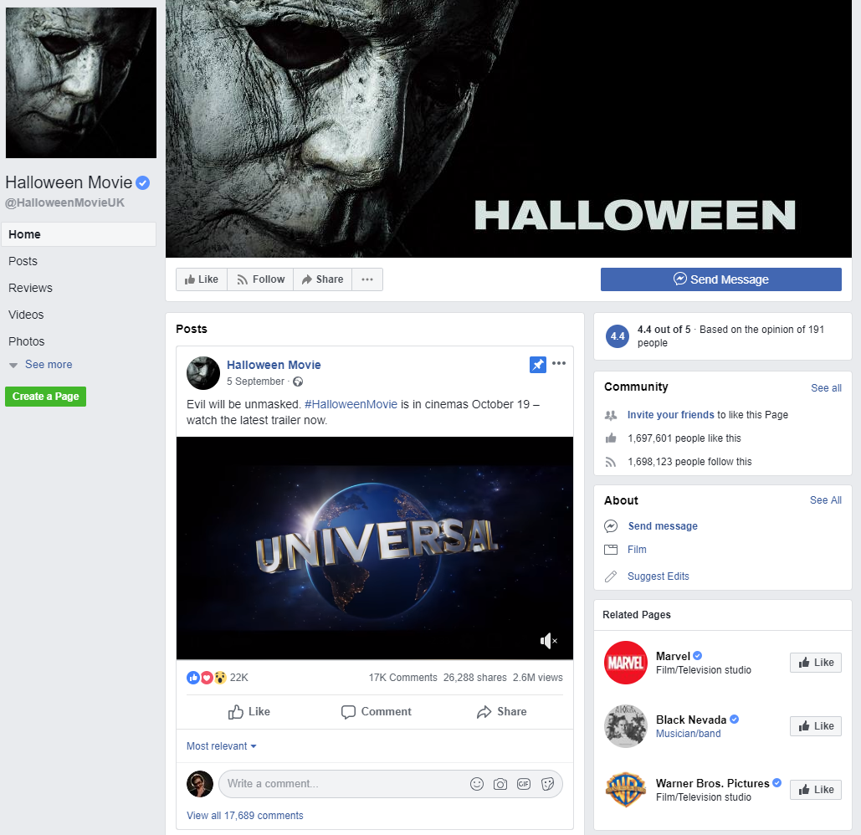
Twitter | Facebook
Figure 8
This is not necessarily advertising; however, it lets the audience access to inspect the content, regarding the film or series. For example, the pilot will be released through YouTube, but shared into the Facebook page and Twitter Page. This is to attract an audience from social media, where they can access it by phone, tablet, laptops and desktop. Advertising the merchandise using social media, Facebook page, Twitter page and YouTube video description sharing the link to the merchandise.

Merchandise
The merchandising is used for the market area to sustain the target audience and generate revenue. Releasing merchandise will include marketing T-shirts, Hoodies, Comic Books, Art book, Figurines, Vinyl toys and Posters as Concept Art. Collective items will include max’s bag, a figurine and comic book.

Expandability
To expand this product, comic books will be released based on the character development. As a foundation, this can build an audience and create story arcs for the characters. Which will make the scale of the project bigger. The business will depend based upon the development of the script and duration of the series. However, the scale of the project expands when the headcount increases, expanding the project and the business.
By analysing Blizzards’ content, a game called “Overwatch”, was first released in 2016. They built their content and their audience through 3D animated short films, showing different character arcs, showing their background story. To set a similar root, making a game on the character arcs and the narrative. Which is then put into 3D animated short film, showing their character development and their background story.

References
Books
Harold L. Vogel. 2015. Entertainment Industry Economics: A Guide for Financial Analysis, Ninth Edition. Cambridge University Printing Press, 2015. [Page 17]
Websites
An investigation of diverse and mainstream UK film audiences. 2011. “A research report commissioned by the UK Film Council”. [Online]. Available at: http://www.filmhubscotland.com/media/36425/uk-film-council-portrayal-vs-betrayal-case-study.pdf [Accessed 27th November 2019].
BFI Research and Statistics, 2017. “Audiences”. September 2017. [Online]. Available at: https://www.bfi.org.uk/sites/bfi.org.uk/files/downloads/bfi-statistical-yearbook-audiences-2016-2017-09-27.pdf [Accessed 29th November 2019].
BFI Research and Statistics, 2017. “Genre and Classification”. September 2017. [Online]. Available at: https://www.bfi.org.uk/sites/bfi.org.uk/files/downloads/bfi-genre-and-classification-2017-06-16.pdf [Accessed 29th November 2019].
Bhana. Y. 2015. TranslateMedia. 11th August 2015. “Localisation in the Film and TV Industries”. [Online]. Available at: https://www.translatemedia.com/translation-blog/localisation-in-the-film-and-tv-industries/ [Accessed 27th November 2019].
Clarke. T. Money Morning. 2014. “New Amazon HQ (Nasdaq: AMZN) Aims to Profit from China's Massive E-Commerce Market”. 22nd August 2014. [Online]. Available at: https://moneymorning.com/2014/08/22/new-amazon-hq-nasdaq-amzn-aims-to-profit-from-chinas-massive-e-commerce-market/ [Accessed 23rd November 2019].
Cunha. M. D. 2018. WordStream. 23rd March 2018. “Video Marketing Ideas: 9 Ways to Promote Video Content”. [Online]. Available at: https://www.wordstream.com/blog/ws/2016/08/03/video-marketing-ideas [Accessed 27th November 2019].
D'Onfro. J. 2014. Business Insiders 25th April 2014. “Amazon Prime Versus Netflix Versus Hulu Plus: Which Should You Pay For?” [Online]. Available at: https://www.businessinsider.com/amazon-prime-versus-netflix-versus-hulu-plus-2014-4?r=US&IR=T [Accessed 23rd November 2019].
Film L.A. 2017. Pilot Production Report. [Online]. Available at: https://www.filmla.com/wp-content/uploads/2017/08/2017_TV_Production_Study_v5_WEB.pdf [Accessed 25th November 2019].
Facebook, 2018. Halloween Movie, 11th January 2018. [Online]. Available at: https://www.facebook.com/HalloweenMovieUK/ [Accessed 27th November 2019].
Hulu.com. 2018. “HBO® on Hulu” [Online]. Available at: https://www.hulu.com/hbo [Accessed 21st November 2019].
Horror Audience Research, Saraevening. 2012. “Official Statistics.” 9th October 2012. [Online]. Available at: https://saraeveninga2media.wordpress.com/2012/10/09/audience-research/ [Accessed 27th November 2019].
Kallas. P. 2018. Dreamgrow. 10th July 2018. “8 Powerful Reasons You Need to Use Video Marketing [TRENDS]” [Online]. Available at: https://www.dreamgrow.com/8-reasons-why-your-business-should-use-video-marketing/ [Accessed 27th November 2019].
Lynch. J, 2018. “The 20 top-earning horror movies of all time”. 14th January 2018. [Online]. Available at: http://uk.businessinsider.com/highest-grossing-horror-movies-all-time-2017-9/#20-the-ring-2002-2493-million-1 [Accessed 29th November 2019].
Miyamoto. K. 2017. Screencraft. 26th October 2017 “How to Sell Your TV Series the Stranger Things Way”. [Online]. Available at: https://screencraft.org/2017/10/26/how-to-sell-your-tv-series-the-stranger-things-way/ [Accessed 25th November 2019].
Marketing-Schools.org. 2012. “Web marketing: Explore the Strategy of Web Marketing”. [Online]. Available at: http://www.marketing-schools.org/types-of-marketing/web-marketing.html [Accessed 25th November 2019].
Maslow, McLeod, S. A. 2018. “Simply Psychology: Maslow's Hierarchy of Needs”. 21st May 2018. [Online]. Available at: https://www.simplypsychology.org/maslow.html [Accessed 27th November 2019].
Netflix.com. 2018. “Help Center: Where is Netflix Available?” [Online]. Available at: https://help.netflix.com/en/node/14164 [Accessed 25th November 2019].
Pitney bowes. 1996-2018. “What is localization strategy?” [Online]. Available at: https://www.pitneybowes.com/us/global-ecommerce/case-studies/what-is-localization-strategy.html [Accessed 27th November 2019].
Twitter, 2018. Halloween Movie, 13th September 2017. [Online]. Available at: https://twitter.com/halloweenmovie [Accessed 27th November 2019].
TalkPoint: a PGI Company, 2018. “Stats You Need To Know About Live-Streaming Video In 2018”. 9th January 2018. [Online]. Available at: https://www.talkpoint.com/stats-you-need-to-know-about-live-streaming-video-in-2018/ [Accessed 5th November 2019].
Unblock Websites. 2014. “Smart DNS Proxy: News – Unblock Hulu in UK – because it’s worth it”. 26th November 2014. [Online]. Available at: https://www.smartdnsproxy.com/news/unblock-websites/unblock-hulu-in-uk-because-it-s-worth-it-34.aspx [Accessed 27th November 2019].
Universal Studios, 2018. Halloween [Online]. Available at: http://www.universalpictures.co.uk/micro/halloween [Accessed 27th November 2019].
Where’s the Jump? 2018. “The Highest Grossing Horror Movies At The Box Office” [Online]. Available at: https://wheresthejump.com/highest-grossing-horror-movies-at-the-box-office/ [Accessed 25th November 2019].
Wakisaka. P, 2017. “An Analysis of Blizzard’s use of Social Media for “Overwatch”. [Online]. Available at: https://medium.com/rta902/an-analysis-of-blizzards-use-of-social-media-for-overwatch-68c984b054aa [Accessed 27th November 2019].
Online Videos
CGMeetup, 2016. CGI 3D Animated Short Film “Giest” by Giant Studios | CGMeetup, [Online Video], Available at: https://www.youtube.com/watch?v=VCs7BFdltyU [Accessed by 15th November 2019].
CGMeetup, 2016. CGI 3D Animated Short Film “Horror” by Riff and Alternate Studio | CGMeetup, [Online Video], Available at: https://www.youtube.com/watch?v=GNWRr2nUmvg [Accessed by 15th November 2019].
CGMeetup, 2017. CGI 3D Animated Short Film “The Return of The Monster” by MegaComputeur | CGMeetup, [Online Video], Available at: https://www.youtube.com/watch?v=TfI6JWgw4OE [Accessed by 15th November 2019].
Blue Corona, Inc. 2017. How Much Does YouTube Advertising Cost? | YouTube Video Ads & Marketing, [Online Video], Available at: https://www.youtube.com/watch?v=LsKDLGaof-A [Accessed by 29th November 2019].
Kingpinning, 2016. Facebook Ad Budgets & Bidding - LIKE A Boss Facebook Training, [Online Video], Available at: https://www.youtube.com/watch?v=THpiaTwLtJ8 [Accessed by 29th November 2019].
Netflix, 2018. Stranger Things: Season 3 | Title Tease [HD] | Netflix, [Online Video], Available at: https://www.youtube.com/watch?v=PH3kBCSfL-4 [Accessed by 9th December 2019].
ONE Media, 2018. STRANGER THINGS Season 3 Trailer TEASER (2018) Netflix TV Show HD, [Online Video], Available at: https://www.youtube.com/watch?v=QdMZgCTeFRM [Accessed by 29th November 2019].
PlayOverwatch, 2014. Overwatch Cinematic Trailer. [Online Video], Available at: https://www.youtube.com/watch?v=FqnKB22pOC0&feature=youtu.be [Accessed by 3rd December 2019].
PlayOverwatch, 2016. Overwatch Animated Short | “The Last Bastion” [Online Video], Available at: https://www.youtube.com/watch?v=to8yh83jlXg&feature=youtu.be [Accessed by 3rd December 2019].

