Characteristics of Effective Teams

An effective team is a team in which people cooperate, using individual skills to achieve the common goal, overcoming any personal conflict.

Characteristics

1.A Common Goal

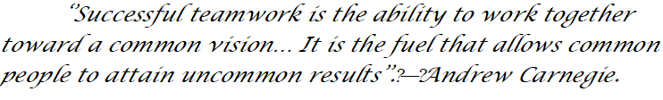

This common goal must be clearly understood and known by all team members. Once the goal is clear and known to all team members, the common goal becomes motivating and the way to reach will flow in the right direction.

2. Open Communication

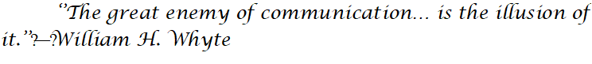

The establishment of compelling cooperation is great communication. Similarly, as with the shared objective, all communication ought to be unambiguous and imparted to all colleagues. With no communication, the objective will never be accomplished. With terrible communication, the objective might be accomplished in the end, however, the procedure will include duplication of undertakings, disappointment and perplexity. Good communication involves sharing learning. A team in which colleagues can freely express their thoughts, feelings and trust is an effective team

3. Team Roles

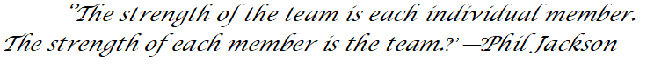
Building up characterized team roles, with a regard for every job's part in accomplishing the shared objective, is a basic piece of powerful cooperation. An effective team can be separated into 3 group jobs: leaders, strategists, and workers.
Workers will focus on the tasks required to progress, finding obstacles along the way.
Strategies look for the best strategies to remove obstacles, focusing on the goal to be achieved.
The leader will choose the right strategy and delegate the tasks back to the workers considering the common goal.

4. Time Management

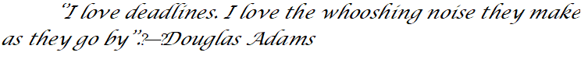Effective teams know the importance of time and use how much precious time they have. When they have to accomplish a new task, they concentrate on this task until they are completed. The importance or necessity of a task is taken by the leader, who makes the decisions quickly and definitively.

5.Problem Solving

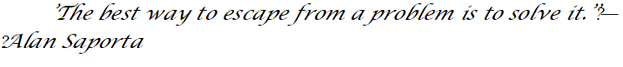
Along the way to the common goal many problems can arise. A powerful team that encounters these issues uses critical thinking to accurately distinguish the issue.

Strong groups resolve issues as they appear. Problems are not something to be overlooked in expectations that will disappear. Another problem is seen as another chance to move forward on the path to the common goal.

6. Bonding

A happy team is an efficient team. Mutual trust among team members is essential for achieving the goal and also rebounds when they fail. Teams will thrive with a mutual realization mentality and mutual defeats - A victory is a team victory; A loss is a team loss.



