UNIVERSITY OF WALES TRINITY SAINT DAVIS

Programme: CertHE Skills for the Workplace
Module: Effective Team Work and Communication
Module code: BMSW4002
Assignment Title: Effective Team Work and Communication Assignment 1 (Report)
Module Leader: Soban Sadiq
Student: Valentin-Gabriel Farcas 2132525

Table of Contents

1.0 Introduction 3
2.0 Models of Communication 3
2.1 Shannon and Weaver Model of Communication 3
2.2 Schramm (1954) Model of Communication 4
2.3 Berlo (1964) Model of Communication: 7
3.0 Communication Skills: 8
3.1 Verbal Communication Skills: 8
3.2 Non-Verbal Communication Skills: 9
Listening: 9
The Advantages and disadvantages of technology in communication 10
Conclusion: 11
Reference 13

1.0 Introduction
Communication is the act of exchanging information between two or more people through verbal, non-verbal, or written means. It is the process of understanding and sharing ideas, thoughts, and feelings. It enables individuals to interact and build relationships with one another. This report provides an overview of the models of communication and communication skills. It explains the various types of communication models, such as the linear, interactive, and transactional models. It also provides an overview of communication skills, including listening, questioning, nonverbal communication, and problem-solving. The report provides an analysis of the various models of communication and their application in various contexts. The role of good communication in fostering healthy relationships is also explored. Finally, the paper concludes with suggestions for further research into and practice with respect to communication models and communication abilities.

2.0 Models of Communication

2.1 Shannon and Weaver Model of Communication
Claude Shannon and Warren Weaver created a linear model of communication in 1949; they called it the "action model of communication." This model views communication as a process that consists of five steps: sender, message, channel, receiver, and response (Businesstopia, 2022).
In the first step, the sender encodes a message in an appropriate form, such as language, images, or symbols. The sender then transmits the message through a channel, such as radio waves, the internet, or telephone lines. The channel is responsible for the message's transmission and transmission rate.
In the third step, the receiver obtains the message and interprets it. The receiver interprets the message and makes sense of it.
In the fourth step, the receiver answers the sender's message. This response can be verbal or nonverbal and can be positive, negative, or neutral (Roberts, 2018).
In the fifth and final step, the sender interprets the receiver's response and adjusts their message accordingly. This step is important in making sure that the message has been accurately received and comprehended by the receiver.
The Shannon and Weaver model of communication is widely used in communication studies and is considered by many to be the foundation of communication theory.

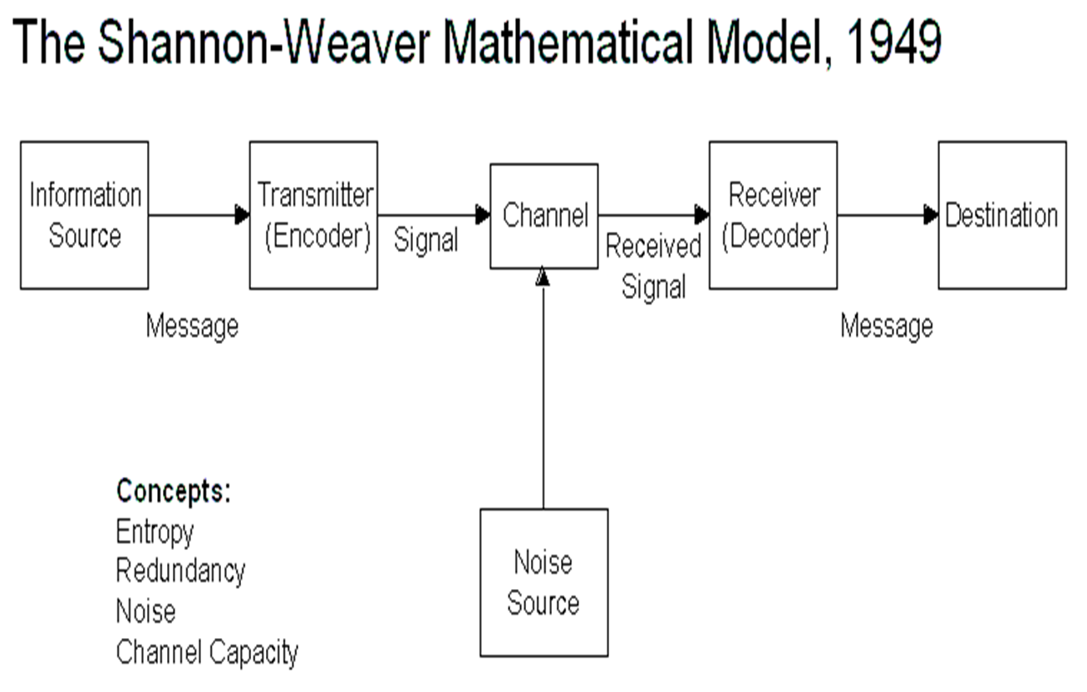
Figure: Shannon and Weaver Model of Communication
(Source: Businesstopia, 2022)

Case Study
How could any misunderstanding be avoided?
The situation was obviously a bit suspicious. Pedro should have felt doubt about the conversation. After all, why would Maria call him to tell him that she will meet him in the Kitchen? Thus he should have asked Maria again. Also, Maria could have just texted Pedro about bringing the chicken. In this way, there would not be any confusion.
A similar example from my workplace
Yes In my workplace, one day, my co-worker called me and asked me if I could bring some extra wafers. I said yes I have it. Thus I bought it alone, I thought she might wanna have it. But when I reached the office, she told me she asked me to bring some extra paper that she needed for writing an application.

2.2 Schramm (1954) Model of Communication
The Schramm (1954) Model of Communication is a linear model of communication that views the transmission of messages as a one-way process. This model is composed of five elements: sender, message, encoding, channel, and receiver. The sender is the source of the message and is responsible for selecting and encoding the content of the message. The message is the actual content of the communication and is encoded by the sender according to the message they wish to convey (LTSS, 2022). The encoding refers to the form in which the message is conveyed, such as through verbal language, body language, or written language. The channel is the medium through which the message is transmitted, such as through a telephone call, email, or face-to-face conversation. The receiver is the person or people receiving the message, who must decode the message in order to interpret it (Kastberg, 2022). The Schramm (1954) Model of Communication suggests that the effectiveness of communication depends on the accuracy of the encoding and decoding processes.
How does the Schramm (1954) Model of Communication differ from S & W model?

The Schramm (1954) Model of Communication differs from the S & W model in several ways. The Schramm model is a more circular approach to communication, while the S & W model is linear. The Schramm model emphasizes feedback and the role of the receiver in the communication process, as opposed to the S & W model which is more focused on the sender and their message (Kubota, 2019). The Schramm model also emphasizes the importance of the context in which communication takes place, while the S & W model does not. Finally, the Schramm model acknowledges that communication can be influenced by external factors, such as cultural norms and values, something which the S & W model does not take into account.

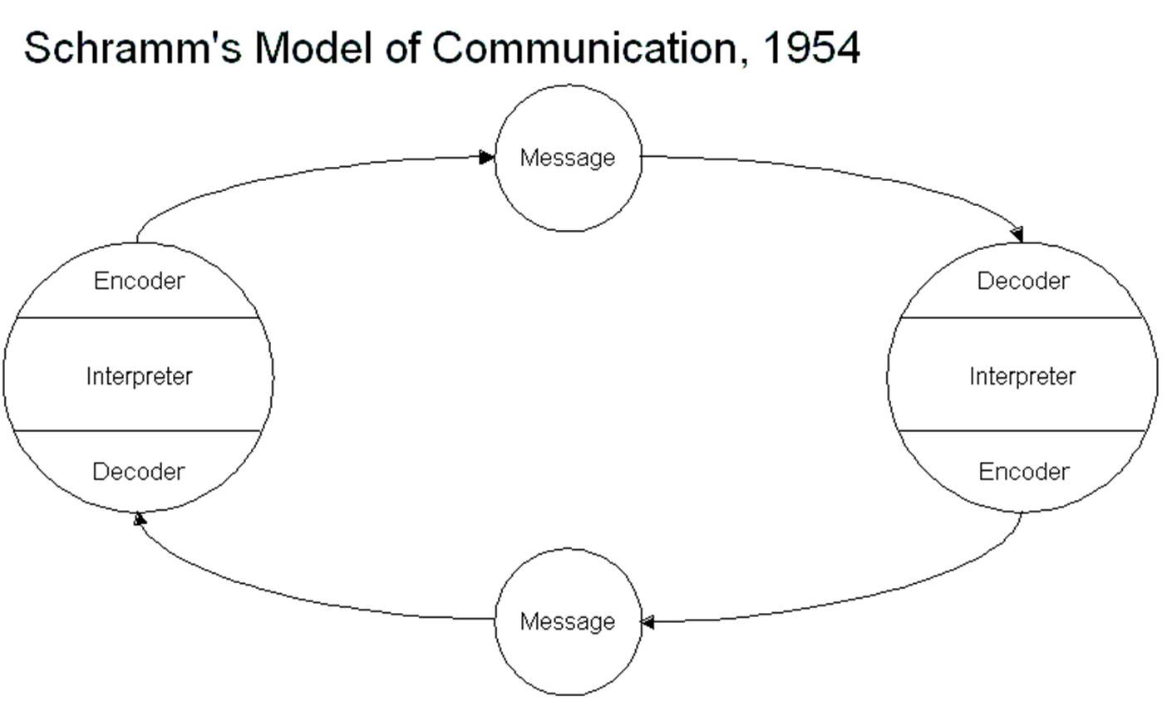
Figure:
(Source:

Case Study:
How any misunderstanding could be avoided?
It was evident that something wasn't quite right with the situation. It was reasonable for Pedro to have doubts regarding the validity of their dialogue. After all, Maria has no reason to phone him and tell him she can be found in the kitchen. Accordingly, he should have re-questioned Maria. Maria could have asked Pedro to fetch the chicken if she had just sent him a text message. This would ensure that there is no misunderstanding.
A similar example from your workplace
Yes, My coworker just called and asked if I could bring in some extra wafers for the workplace. When asked, "Why do you already have it?" I said that I did. That's why I packed it; I felt she'd appreciate having it. When I arrived, however, she informed me that she needed additional paper to finish an application, and I was subsequently asked to provide it.

2.3 Berlo (1964) Model of Communication:
Sender, Message, Encoding, Channel, and Recipient are the five individual parts that makeup Berlo's (1964) Linear Model of Communication. The sender creates the message and decides on its encoding and delivery method (Frijns, Schürer, & Koeszegi, 2021). The message is the information or content being communicated. Encoding is the process of transforming the message into a form that is suitable for transmission. The channel is the medium through which the message is sent, such as a telephone line or email. Finally, the receiver is the individual or group that interprets the message. The model emphasizes the importance of understanding the context in which the message is sent and received, as well as the importance of tailoring the message to the intended audience (Lee et al., 2020). The model also highlights the importance of feedback from the receiver to ensure that the message is received and understood as intended.
How is Berlo’s Model different from S/W’s and Schramm model of communication?
Berlo's Model is different from S/W's and Schramm's Models of Communication in that it includes several additional components: the message, the sender, the receiver, the channel, the encoder, the decoder, the context, and the feedback. Berlo's Model emphasizes that communication is a process involving both the sender and receiver, and that the message is encoded and decoded in order to be understood (Extension, 2022). It also takes into account the importance of context and feedback in the communication process. S/W's and Schramm's Models of Communication, on the other hand, emphasize the importance of the message and the sender and receiver, but do not include any of the other components of Berlo's Model.

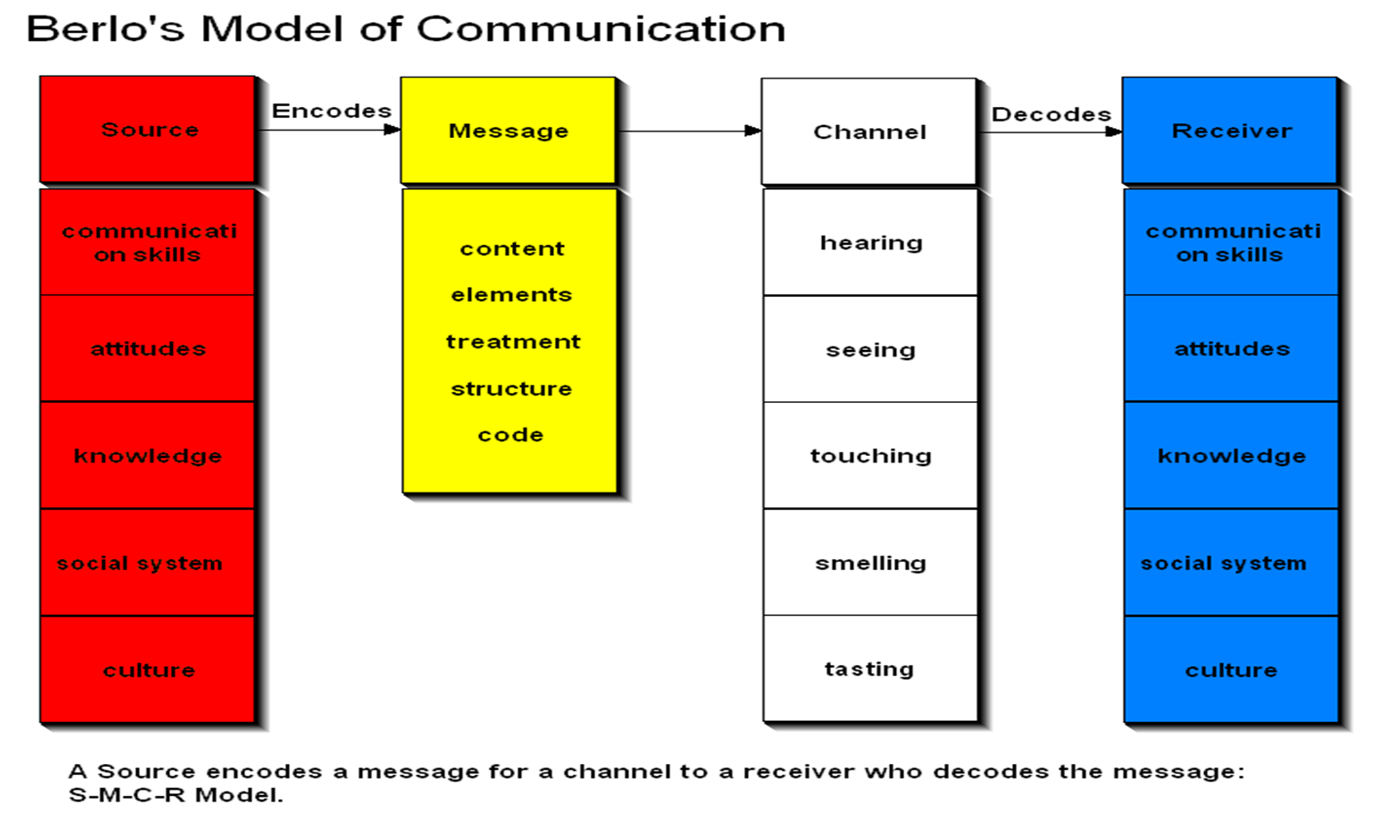

Case Study:
To avoid misunderstandings, all of these components must be taken into consideration. The sender must ensure that the message is clear and concise and that it is being sent through the appropriate channel. The receiver must be attentive and actively listen to the message, and the context should be taken into consideration to ensure the message is understood in its intended form (CT, 2022). Additionally, it is important to provide feedback to ensure that the message was received and interpreted correctly. By utilizing all of the components of Berlo's (1964) model of communication, misunderstandings can be avoided.

3.0 Communication Skills:

3.1 Verbal Communication Skills:
Verbal communication is the process of exchanging information through the use of spoken or written words. It involves two main components: choice of words and tone. The choice of words in verbal communication can have a significant impact on the message being conveyed and the reaction of the listener (Vogel, Meyer, and Harendza, 2018). The tone is the attitude or mood conveyed through the use of words and is generally determined by the speaker's inflexion, volume, and intonation. Pitch is the degree of high or low sound in the speaker's voice and can also be used to convey additional meaning or emphasis (San-Valero et al., 2019).

3.2 Non-Verbal Communication Skills:
Body language is a form of non-verbal communication that involves the use of physical movements, gestures, and posture to convey messages. Facial expressions involve the use of facial muscles to express a variety of emotions and are often used in combination with other non-verbal communication cues. Gestures are physical movements of the body, arms, or hands that are used to express intent or as part of a conversation (Ahmed, 2020). They can range from simple head nods and hand waves to more elaborate forms such as pointing and thumbs-up signs.
Case Study:
If I were in Mark’s position
If I were in Mark’s position, I would have attempted to make a more prominent impression on Mrs Brown by not stammering and by making better questions overall.
The flaw’s in Mark’s evaluation
I think Mark had evaluated the context in the wrong way. Probably Mrs Brown was being nice to Mark so that he can provide her with certain company-related information that can potentially make her take specific decisions. The information Markl provided can make Mrs Brown take some decisions which can adversely affect Mark’s company.
Communication factors that led to the change in CEO’s attitude
Probably, when she noticed Mark’s hesitant behaviour and nervousness, she decided to change her attitude so that she can make Mark feel more comfortable doing his job correctly.

Listening:
Active Listening
The skill of "active listening" entails giving one's undivided attention to another person's speech in order to fully comprehend it and intelligently reply to it. It requires a person to be present at the moment and to suspend judgment. Active listening involves listening with all senses to gain a full understanding of the speaker’s message (Jonsdottir and Fridriksdottir, K., 2020). It involves paying attention to the words being said, the tone of voice being used, and the body language of the speaker. The listener also focuses on understanding the feelings and needs of the speaker and uses verbal and non-verbal responses to demonstrate understanding (Cui, 2021). This may include restating what was said, summarizing what was said, and asking questions to clarify points.

Empathetic listening.
Empathetic listening is a communication technique that involves actively listening to another person without judgment or interruption. It involves being attentive to the words the person is saying, their body language, and their emotions. It also involves responding to the person with understanding and validation. Empathetic listening helps to create a safe space where the speaker can feel heard and understood (Jonsdottir and Kristinsson, 2020).

CASE STUDY
Max's chosen method of communication proved difficult. Since he failed to make a mental note of the new date schedule during the call, he missed it. It was terribly unlucky for him to lose such a longtime and devoted client. Of course, he should have replaced the management team with new faces. Hiring employees will likely cost me some money at first, but in the long run, his productivity will increase and he'll be able to take on more projects. That being the case, he ought to start thinking about getting some help sooner rather than later. If this trend continues, it will only get worse.
Despite the fact that Tamara's reaction was understandable, she would have been better served by giving Max's offer and choosing a different date for the celebration of her parent's anniversary. Both parties would gain from this arrangement.

The Advantages and disadvantages of technology in communication
Communication technology has had a massive influence on our lives in the past few decades. It has revolutionized the way people communicate, collaborate and do business. Technology has allowed us to communicate with anyone, anywhere, at any time. It has also made it easier to find information quickly and make better decisions (Sutiyatno, 2018).
Advantages
1. Easy and Fast Communication: Technology has made communication much easier and faster. People can communicate with anyone around the world in a matter of seconds. People can use emails, text messages, social media platforms, video conferencing and more to stay in touch with their friends, family, and colleagues (Gray et al., 2020).
2. Cost-effectiveness: Technology has made communication much more cost-effective. People can now communicate with anyone around the world without having to pay for expensive international calls or travel expenses (Sadeghi, 2019).
3. Improved Productivity: Technology has also helped to improve productivity in the workplace. By using technologies like video conferencing and instant messaging, businesses can save time and money by reducing the need for travel and face-to-face meetings.
4. Access to Information: Technology has made it easier for us to find information quickly. People can now access information from anywhere in the world with just a few clicks of the mouse (Kapur, 2018).

Disadvantages
1. Cost: Technology can be expensive to implement and maintain. Businesses need to invest in the necessary hardware and software to make use of the most up-to-date communication technology.
2. Security Risks: With the increase in technology, there are also increased security risks. Hackers and cybercriminals can access sensitive information if the necessary security measures are not taken (Sadeghi, 2019).
3. Distraction: Technology can also be a distraction. It's possible that people will rely too heavily on electronic devices and neglect the value of interpersonal interaction.
4. Social Isolation: Technology can also lead to social isolation. People may become too consumed with technology and neglect the importance of real-world relationships (Gray et al., 2020).
Overall, communication technology has had a massive impact on our lives. It has made communication much faster and easier, and it has allowed us to access information from anywhere in the world. However, there are also some drawbacks to using technology for communication, such as cost, security risks, and social isolation.

Conclusion:
In conclusion, understanding the models of communication and communication skills is a crucial part of being an effective communicator. By understanding the different models of communication, their purpose, and the various communication skills, one can be better equipped to reach their desired outcome when communicating. Communicating effectively is a skill that can be developed and improved over time with practice, patience, and a willingness to learn. With the right resources, anyone can learn to become a more effective communicator.

Reference
Ahmed, H.M., 2020. Role of verbal and non-verbal communication of health care providers in general satisfaction with birth care: a cross-sectional study in government health settings of Erbil City, Iraq. Reproductive Health, 17(1), pp.1-9.
Businesstopia, 2022 “Shannon and Weaver Model Of Communication”, Available at https://www.businesstopia.net/communication/shannon-and-weaver-model-communication [Accessed on 4th December 2022]
CT, 2022, “Shannon and Weaver Model of Communication”, Available at https://www.communicationtheory.org/shannon-and-weaver-model-of-communication/ [Accessed on 4th December 2022]
Cui, Y., 2021. The role of emotional intelligence in workplace transparency and open communication. Aggression and Violent Behavior, p.101602.
Extension, 2022, “Developing Effective Communications”, Available at https://extension.missouri.edu/publications/cm109 [Accessed on 4th December 2022]
Frijns, H.A., Schürer, O. and Koeszegi, S.T., 2021. Communication models in human–robot interaction: an asymmetric MODel of ALterity in human–robot interaction (AMODAL-HRI). International Journal of Social Robotics, pp.1-28.
Gray, L.M., Wong-Wylie, G., Rempel, G.R. and Cook, K., 2020. Expanding qualitative research interviewing strategies: Zoom video communications. The Qualitative Report, 25(5), pp.1292-1301.
Jonsdottir, I.J. and Fridriksdottir, K., 2020. Active listening: Is it the forgotten dimension in managerial communication?. International Journal of Listening, 34(3), pp.178-188.
Jonsdottir, I.J. and Kristinsson, K., 2020. Supervisors’ active-empathetic listening as an important antecedent of work engagement. International Journal of Environmental Research and Public Health, 17(21), p.7976.
Kapur, R., 2018. Barriers to effective communication. Delhi University.
Kastberg, P., 2022. Modelling Knowledge Communication as Co-Actional Communication. In Perspectives on Knowledge Communication: Concepts and Settings. Routledge.
Kubota, M., 2019. What is “Communication”?―Beyond the Shannon & Weaver’s Model―. International Journal, 13(1), pp.54-65.
Lee, S., Nah, S., Chung, D.S. and Kim, J., 2020. Predicting ai news credibility: communicative or social capital or both?. Communication Studies, 71(3), pp.428-447.
LTSS, 2022, “Models of Interpersonal Communication”, Available at https://socialsci.libretexts.org/Bookshelves/Communication/Interpersonal_Communication/Book%3A_Interpersonal_Communication_-_A_Mindful_Approach_to_Relationships_(Wrench_et_al.)/02%3A_Overview_of_Interpersonal_Communication/2.04%3A_Models_of_Interpersonal_Communication [Acessed on 4th December 2022]
Roberts, J., 2018. Multinational business service firms: The development of multinational organisational structures in the UK business services sector. Routledge.
Sadeghi, M., 2019. A shift from classroom to distance learning: Advantages and limitations. International Journal of Research in English Education, 4(1), pp.80-88.
San-Valero, P., Robles, A., Ruano, M.V., Martí, N., Cháfer, A. and Badia, J.D., 2019. Workshops of innovation in chemical engineering to train communication skills in science and technology. Education for Chemical Engineers, 26, pp.114-121.
Sutiyatno, S., 2018. The effect of teacher's verbal communication and non-verbal communication on students' English achievement. Journal of Language Teaching and Research, 9(2), pp.430-437.
Vogel, D., Meyer, M. and Harendza, S., 2018. Verbal and non-verbal communication skills including empathy during history taking of undergraduate medical students. BMC medical education, 18(1), pp.1-7.

