
  - Assignment 1
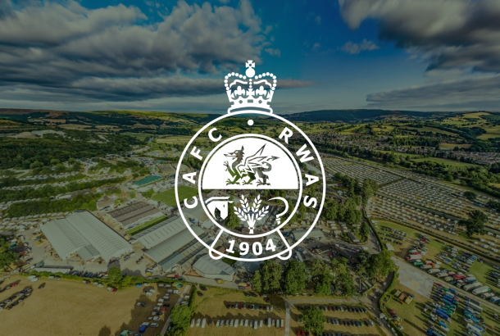
  - Report

Chelsea Renshaw | 2516848
BMTP4018 | Tourism, Events, and Leisure Industry | Deborah Jenkins
28th November 2025 | 1646 words

I acknowledge that the use of ChatGPT www.chatgpt.com on November 15 2025 to help find researchers backing up my assignment. I use the prompts:
- Can you find me 7 articles about the Royal Welsh show
- Can you find me 15 academic recourses linked with event & tourism management, tourism trends, rural tourism.

EXSECUTIVE SUMMARY
This report looks closely at the Royal Welsh Show, a major annual event held every July in Llanelwedd, Mid Wales. The report explores the event itself, the destination, how people get there, who visits, and how the show affects the local area. It also looks at modern tourism trends, current challenges, and ideas for future improvement.
The first part of the report explains the show’s location and what makes the Royal Welsh Show ground an important venue for Wales. It also reviews the transport options available, including car parks, shuttle buses, rail links, and accessibility features that help all visitors enjoy the event.
The report then examines tourism trends, especially the growing interest in hands-on, meaningful experiences. The Royal Welsh Show fits this trend well by offering activities such as livestock demonstrations, local food tasting, crafts, and cultural displays.
Impacts of the event are investigated. In the short term, the show brings money into the local economy and creates excitement in the community, although it can also cause traffic and waste. In the long term, the show helps preserve Welsh culture, supports rural businesses, and strengthens the area as a tourist destination.
The report looks at who attends the show and why. It shows different visitor types like families, tourists, farmers, and cultural explorers and uses theories such as Maslow, Plog, and Cohen to explain visitor motivations. Many visitors come for fun, learning, shopping, and hands-on activities, while others enjoy the traditional displays and competitions.
Finally, the report explores modern challenges such as sustainability, digital technology, accessibility, and competition from other events. These are key issues that could affect the show in the future.
The report ends with recommendations for how the Royal Welsh Show can continue to grow, stay appealing, and adapt to new visitor needs.
Overall, this report provides a clear overview of the Royal Welsh Show, showing its importance to tourism, culture, and the local economy in Mid Wales.

TABLE OF CONTENTS
INTRODUCTION……………………………………………………………………………………4
DESTINATION……………………………………………………………………………………….5
EVENT…………………………………………………………………………………………………5
TRANSPORT & ACCESSIBILITY………………………………………………………………..5
TOURISM TRENDS………………………………………………………………………………..6
SHORT TERM IMPACTS………………………………………………………………………….7
LONGTERM IMPACTS……………………………………………………………………………7
VISITOR TYPOLOGIES & EXPERIENCES……………………………………………………8
VISTOR BEHAVIOUR, PARTICIPATION &LEISURE NEEDS……………………………9
CONTEMPORARY TRENDS & CHALLENGES……………………………………………10
CONCLUSION & RECOMMENDATIONS………………………………………………….11
REFERENCES……………………………………………………………………………………..12

Introduction
This report will be reviewing The Royal Welsh Show an event held in LLanelwedd, Wales. The Royal Welsh Show is an annual Event that takes place in July Around the 21st until the 24th. The report will be looking into:
- Event, destination, transport & accessibility, tourism trends.
- Short- and long-term impact of the event
- Visitor profile
- Visitor behaviours, participation, and Leasure needs
- Contemporary trends and challenges and what impact they could have on the event
On conclusion there will also be recommendations for realistic future development.



Event & Destination Overview

DESTINATION
The Royal Welsh Show is one of the UK’s premier agricultural events, held every July at the Royal Welsh Show ground in Llanelwedd, a small village in mid-Wales. Across the river Wye, near Builth Wells. Best known as the home of the Royal Welsh Show ground. The surrounding area features rural landscapes scenic walking routes and easy access to roads connecting to North and South Wales.

EVENT
Organised by the Welsh Agricultural Society, which has supported rural development for over a century, the Show features livestock competitions, trade stands, food exhibits, forestry, horticulture, and traditional Welsh crafts. (Royal Welsh Agriculture Society)
As an event, the Royal Welsh Show is also an excellent example of large-scale event management in a rural context. The show ground itself hosts over 400 events a year, ranging from business conferences to concerts. making it a well-established venue beyond just the agricultural show. It plays a strategic role in promoting rural culture and community identity, while also delivering economic and social value: the Royal Welsh Agricultural Society explicitly tells that part of its mission is “to promote rural arts, culture and heritage.” (Royal Welsh agricultural society)

TRANSPORT & ACCESSIBILITY
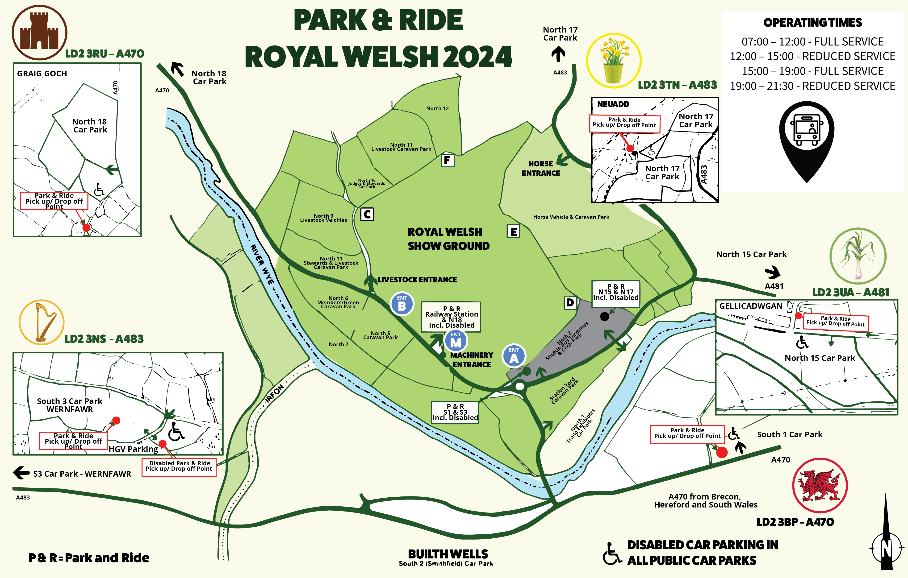
The Show offers several transport options to support visitor access including car travel with dedicated parking areas shuttle buses from nearby towns as well as busses, Park & Ride Routes, and Rail connections to mid wales stations. There is clear signage, traffic management systems and temporary road measures are put in place to ensure peak visitor traffic is managed. On-site accessibility features such as step-free routes, accessible parking bays, mobility scooter hire, and dedicated viewing or rest areas, all help to ensure the event is inclusive for visitors with added mobility needs or disabilities are catered for. (royal Welsh Agricultural Society)

TOURISM TRENDS
From a tourism perspective, the Royal Welsh Show is a major draw: according to Visit Wales, it attracts more than 200,000 visitors annually, many of the visitors travel from outside mid-Wales to attend.(Visit Wales) These visitors contribute significantly to the local and regional economy through spending on accommodation, food, transport, and other services and amenities within the area. The importance of the show within the tourism industry is reflected in the shows recognition at national awards: in 2025, the Show won the Best Event award at the National Tourism Awards for Wales. (MWT Cymru) (Brecon & Radnor express)
Experiential Tourism focuses on meaningful, immersive, and emotionally engaging visitor experiences. Events like the royal Welsh show creates these experiences by giving visitors direct interaction with Welsh culture, agriculture, food craft, and rural life. Goldblatt argues that “To provide more than just a passive viewing experience, the event designer must create an environment that allows the guests to participate, to be actors in the decorators’ dream world.” (Goldblatt, 2014, p.86). In this way, the show “stages” an authentic rural setting where visitors, learn, take part, and connect emotionally, enhancing the overall experiential value.

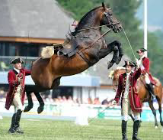
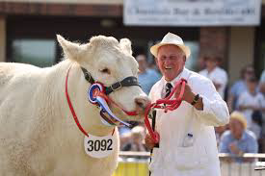
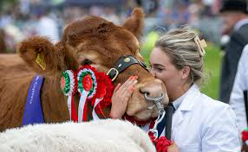
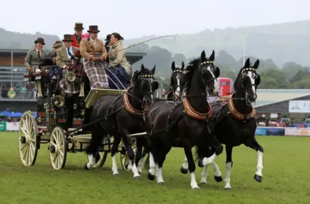
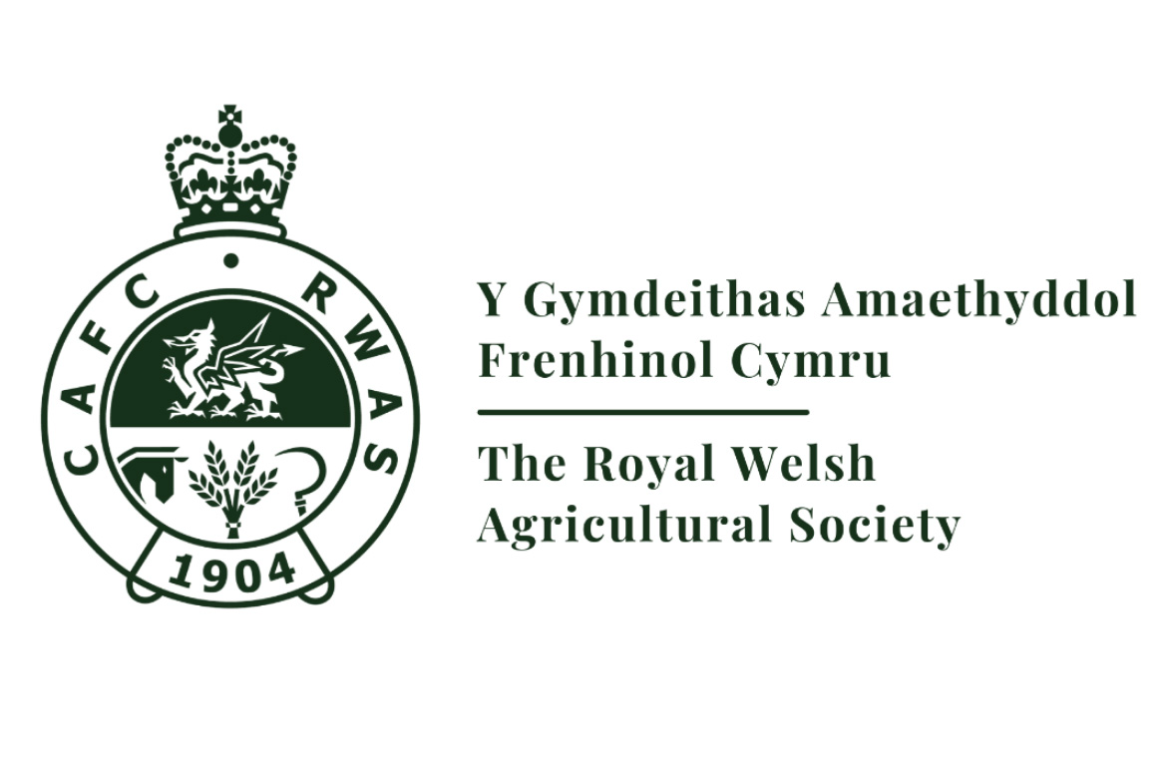
In summary, the Royal Welsh Show is not just a celebration of Welsh farming and tradition, it is a key pillar of rural tourism and a flagship event that supports both the local economy and Wales’s national tourism profile.

Impacts of Event

SHORT-TERM IMPACTS
ECONOMIC - the royal welsh show attracts over 200,000 visitors annually, which boosts local businesses like hotels, restaurants, and shops. Generating immediate revenue. It also creates temporary jobs for locals during the event (Getz, 2008).
SOCIAL & CULTURAL – Residents feel proud and enjoy the excitement, but large crowds can sometimes cause traffic and disruption.
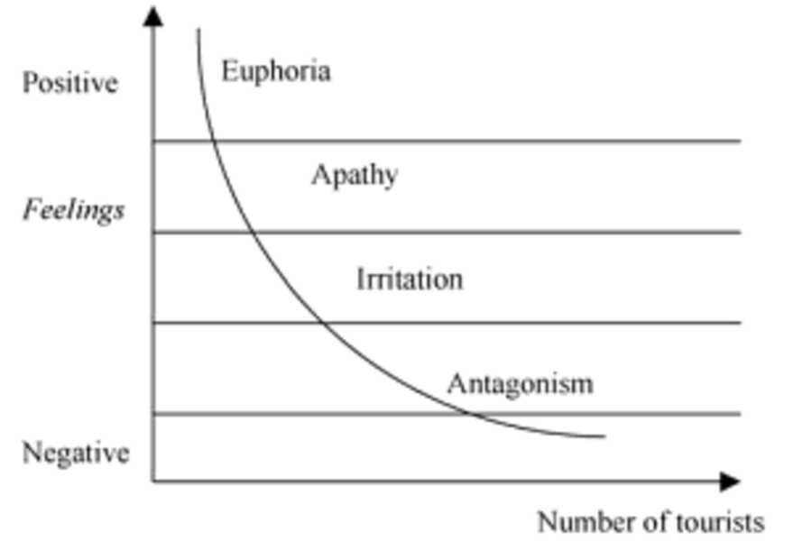
ENVIRONMENTAL – Traffic, litter, and land use increase temporarily, though organisers manage these with parking, signage, and waste systems
Doxey’s Irridex shows that residents’ attitudes can shift from excitement to mild annoyance when visitor numbers are too high, which often happens during the show (Doxey,1975).

LONG-TERM IMPACTS
ECONOMIC – The Royal Welsh Show helps mid-wales shine as a tourist hotspot, encouraging visitors to come back and keep businesses buzzing all year because the show ground is host for many events (Getz & Page, 2016).
SOCIAL & CULTURAL – It helps to preserve the welsh farming traditions, crafts, and local culture, while also creating a sense of pride and community.
ENVIRONMENTAL – Over time, organisers improve roads, facilities, and sustainable practices to keep the area looking beautiful and welcoming.
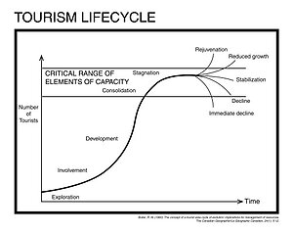
Butlers TALC shows that the show helps the destination grow and develop. More visitors, better infrastructure, and a stronger reputation keeping mid-wales a top spot for tourism (Butler,1980).
Visitor Typologies & Experiences
VISITOR PROFILE

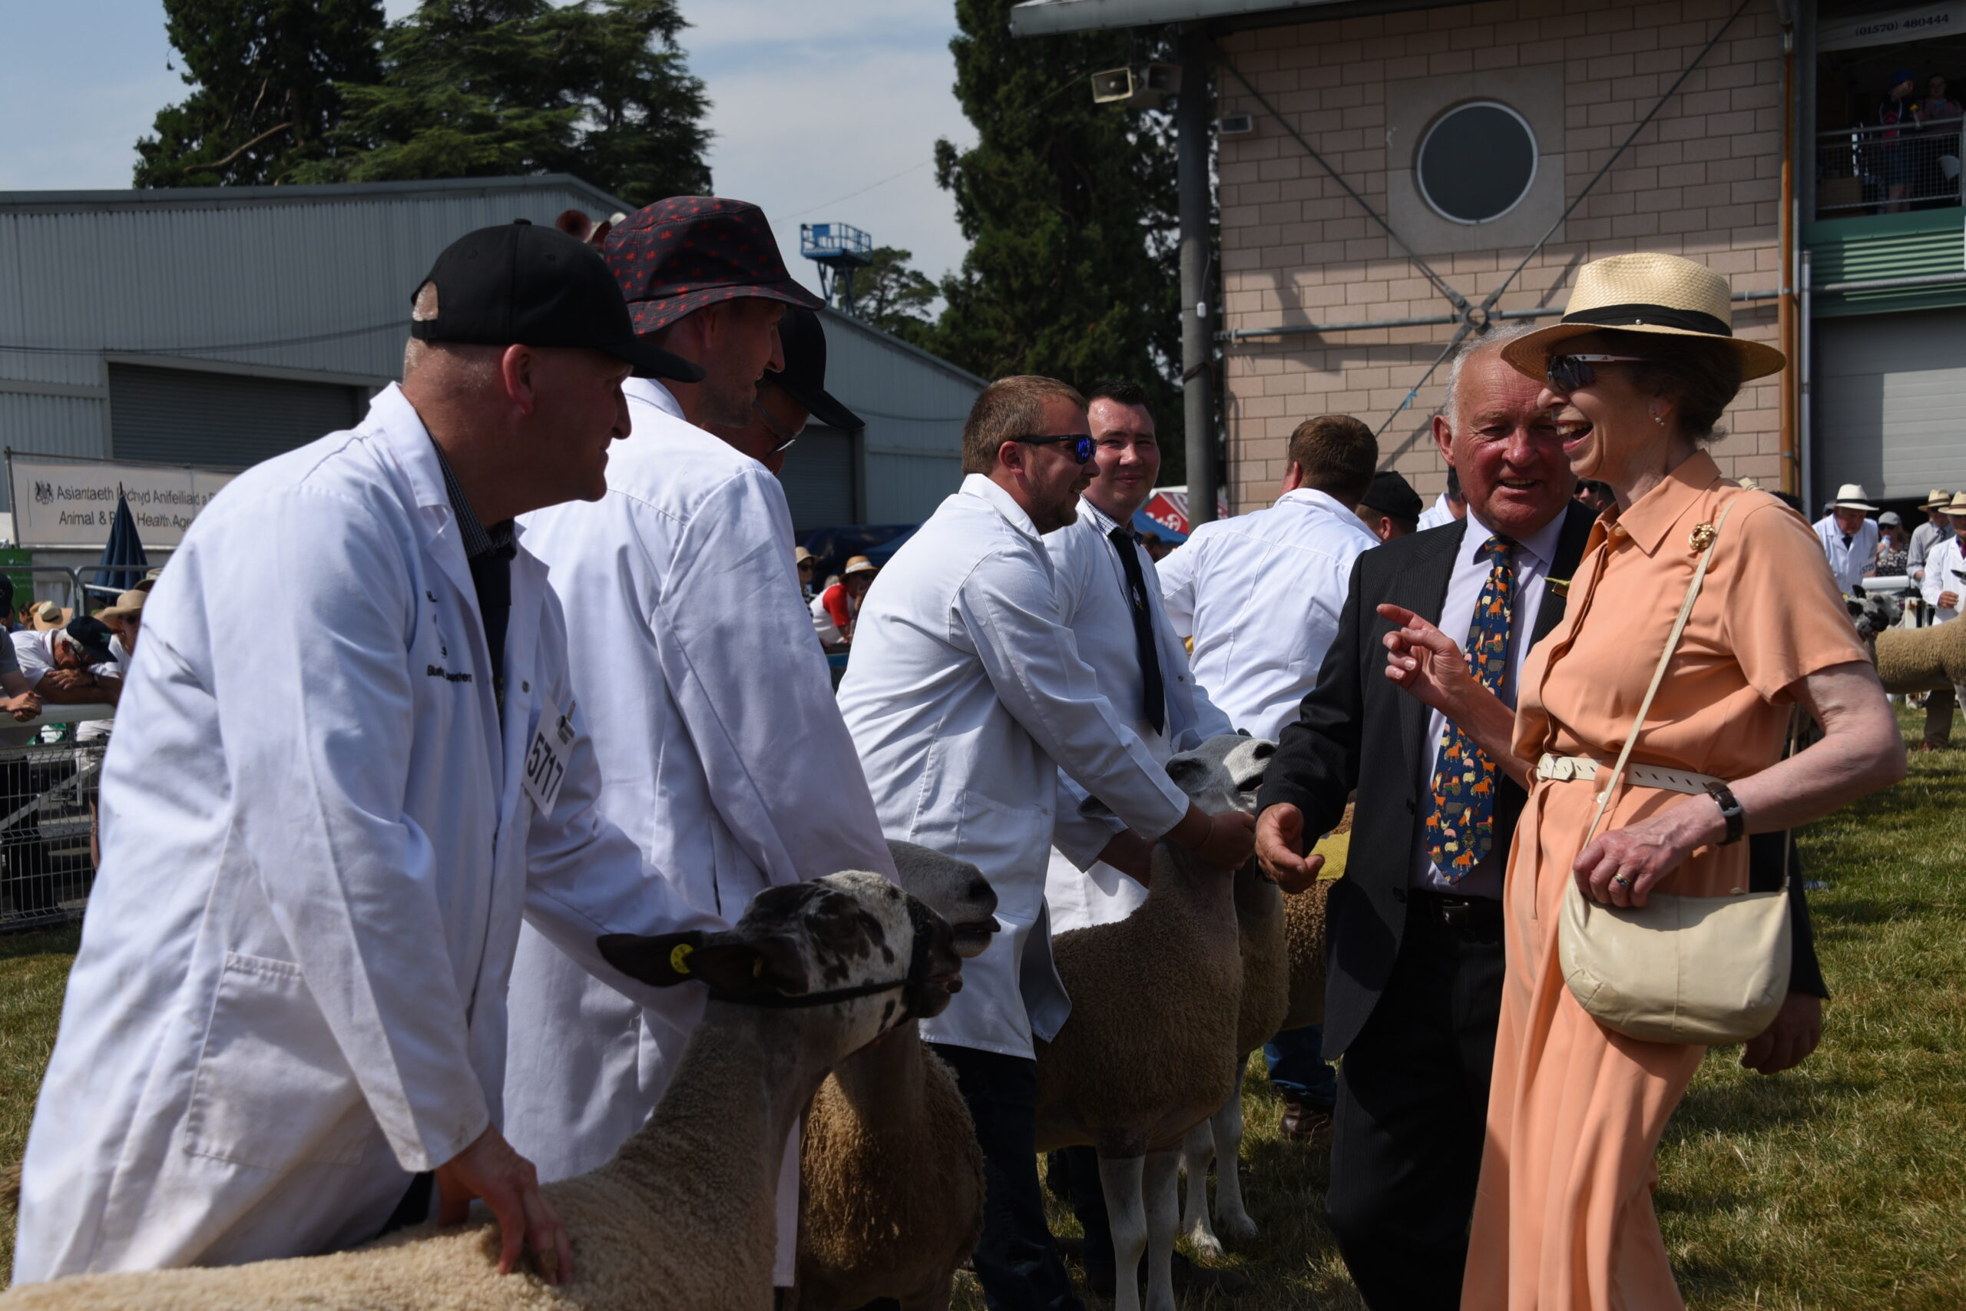
The royal welsh show attracts a broad range of visitors, including families, leisure tourists, and agricultural professionals. Many travel from across wales, especially rural communities, while others come from midlands and southwest English regions, reflecting the trend that rural-event visitors mainly travel within a 1-2 hour radius (Getz, 2008) Visitors range in age, though adults ages 25-55 form the largest group, consistent with rural event demographics (Hall and Page,2014).
Visitor interests include agriculture, Welsh culture, local food, crafts, and outdoor activities aligning with the rural and cultural tourism motivations. Many visitors attend for authentic experiences such as, interacting with livestock watching, demonstrations, and sampling local produce, reflecting experiential tourism trends (Pine and Gilmore, 1999).

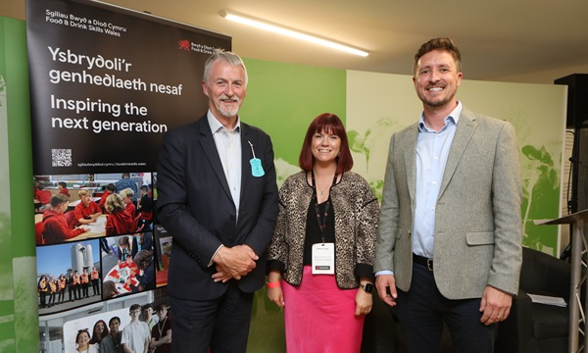
Most visitors attend as day-trippers, traveling by car due to the rural location, although some extend their visit into a short break, staying in local hotels, B&Bs, or campsites (Getz and Page, 2016). Spending is high, particularly on food, crafts, and agricultural goods. Repeat visitation is common, highlighting loyalty and attachment to the event. Overall, the profile shows a blend of cultural tourists, rural community members, and industry stakeholders drawn to the show’s immersive, authentic experiences (Getz, 2008).

VISITOR BEHAVIORS, PARTICIPATION & LEISURE NEEDS

Visitor behavior at the Royal Welsh show can be understood through motivational theories and typologies. Using Maslow's hierarchy of needs visitors look for basic social and self fulfillment experiences. Families may satisfy safety and social needs such as food, shelter, or family bonding. while craft workshops, cultural activities, and livestock demonstrations provides a steam and self actualization opportunities Maslow, 1943).

Cohen’s tourist typologies also apply. The show attracts organised mass tourists, individual mass tourists, and “explorers” – agricultural professionals or cultural tourists looking for “hands-on” interaction with welsh tradition (Cohen, 1972).

Plog’s (2001) model helps explain why people visit the royal welsh show.

Psychocentric visitors – Comfort Seekers
Those who prefer familiar and traditional experiences. usually drawn to well-known features like livestock displays, food stands, and family activities.

Allocentric visitors – Experience Seekers
Those who enjoy new and unique experiences. Usually drawn to specialist demonstrations, workshops, and cultural elements of rural welsh life.

By appealing to both groups, the Royal Welsh Show reflects Plog’s idea that popular destinations are more likely to succeed when they offer something for comfort-seekers and experience-seekers (Plog, 2001).
Participation at The Royal Welsh Show shows how visitors' motivations and leisure needs differ. Many people come for fun, shopping, and relaxation. While other more adventurous visitors join the hands-on activities such as workshops, livestock judging, and cultural demonstrations. The event is extremely popular: in 2015, 241,971 people attended and a typical year sees over 200,000 visitors (ITV News, 2015) (Visit Wales). On busy days attendances can be extremely high, in 2009 53,400 people came on the opening day (Farmers weekly,2009). This mix of casual leisure visitors and experience-seekers fits Plog’s 2001 model, showing that the show attracts both who like familiar, safe experiences and those looking for new immersive activities (Plog, 2001).

Contemporary Trends & Challenges

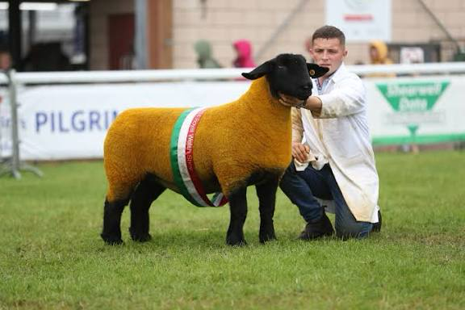
The royal welsh show reflects the growing trend of experiential tourism, offering visitors authentic and immersive experiences. Visitors can engage with welsh farming, livestock, crafts, and local food through workshops demonstrations and hands-on activities. Offering learning opportunities, enjoyment, and cultural connection. (Pine And Gilmore, 1999).

Technology is also shaping the event. The show. Uses online ticketing, and social media to improve convenience, guide visitors, and attract younger audiences (Getz bad Page, 2016). Accessibility is increasingly important, with measures such as mobility and family friendly facilities, ensuring the event meets modern expectations (Getz, 2008).

Sustainability is another challenge. Large visitor numbers create traffic, waste, and land-use pressures, to organisers implement recycling and responsible land management to reduce environmental impacts and meet eco-conscious visitor expectations (sharpley and sharpley, 1997).

Finally, the show faces marketing competition and changing demographics, requiring interactive, culturally engaging experiences to keep appeal and attract repeat visitors (hall and Page, 2014) by adapting to these trends and challenges, the royal welsh show continues to provide diverse and meaningful experiences that satisfy both leisure and experiential tourism needs.
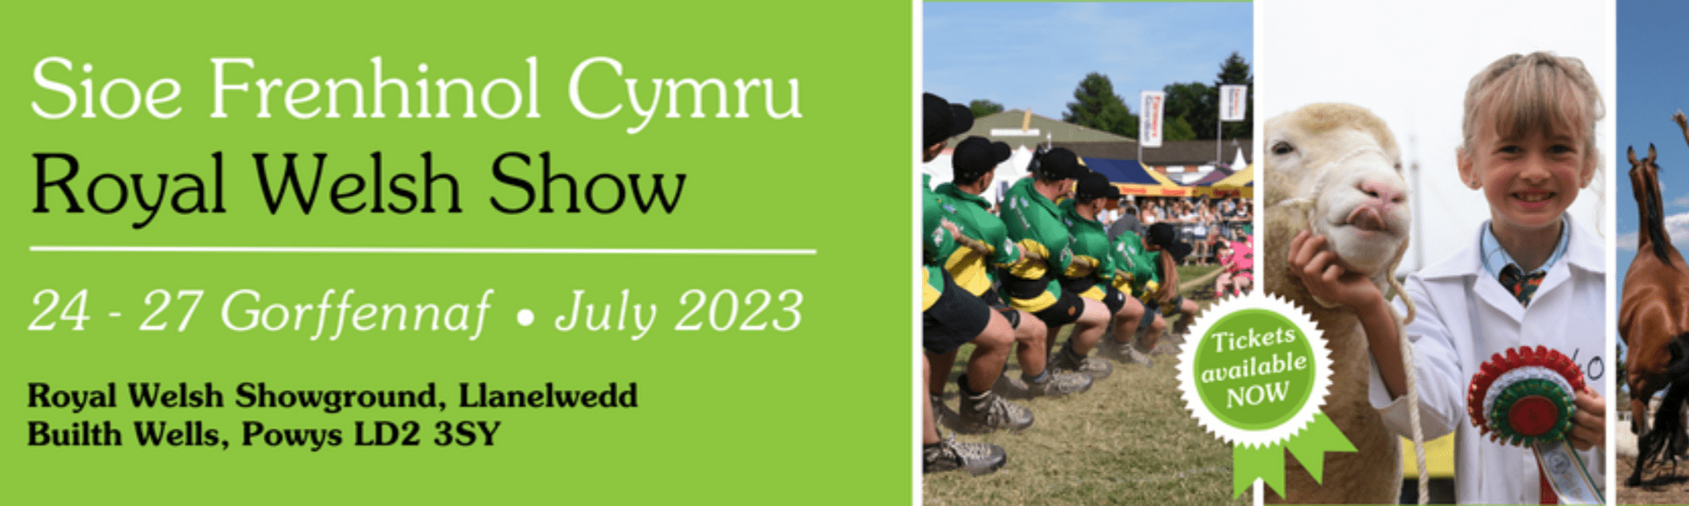

Conclusion & Recommendations

The royal welsh show is a major rural event that successfully attracts a diverse mix of visitors by combining leisure, cultural, and experiential tourism opportunities. It generates significant economic, social, and cultural benefits, while also presenting challenges in accessibility, environmental management, and meeting changing visitor expectations.

To enhance future success, organisers should:
- Expand experiential activities to carer to both casual and immersive visitors.
- Embrace technology with apps, interactive guides, and social media tools making navigation easier and attracting younger audiences.
- Go green by continuing recycling, waste reduction, and more responsible land management.
- Keep it accessible and inclusive so everyone can enjoy the show, from families to mobility-impaired visitors.

By focusing on these areas, the royal welsh show can stay a top cultural and rural event, keep visitors coming back year after year, and continue to shine as a must-visit attraction in mid-wales.

Reference page. Don’t add until checked for turn it in

