
To what extent can lessons from bespoke hospice architecture inform the design of NHS hospital environments to improve the psychological wellbeing of patients and staff?

School of Architecture, Built and Natural Environment
Course: BSc Architecture

Name: Dylan Longman
Student Number: 2317635
Module code: ACAA6003
Word count: 10199
Date: 03/04/2026


Author’s Declaration
I declare that the work in this dissertation was carried out in accordance with the regulations of the University of Wales, Trinity Saint David. The work is original except where indicated by special references in the text and no part of the dissertation has been submitted for any other degree.
Any views expressed in the dissertation are those of the author and in no way represent those of the University of Wales, Trinity Saint David.
The dissertation has not been presented to any other University for examination either in the United Kingdom or overseas.
I hereby give permission for my work, if accepted, to be available for photocopying and inter-library loan, and for the title and summary to be made available to outside organisations.

Signed:

Dylan Longman

Date: 19/03/26

Copyright statement

The copyright of this dissertation rests with the University of Wales, Trinity Saint David. No information derived from this dissertation shall be published without the prior written consent of the University.

Signed:

Dylan Longman

Date: 19/03/26

Abstract
The interest in this topic developed more seriously after spending time in Morriston Hospital during the summer. While the care delivered by staff was professional and committed, the environment of the building left a very different impression. Walking through the hospital, the author became very aware of how little the building offered in terms of orientation or relief from the internal environment. During that time, the author became increasingly aware of the environment they were moving through. Much of the interior felt repetitive and disorientating; corridors seemed to stretch on under constant artificial lighting, with very few moments where daylight or views outside broke up the journey through the building. After a while the author realised, they had completely lost their sense of where they were in the building, and even what time of day it was outside. That moment made the author stop and think about what it must feel like for someone who must spend long periods of time in that environment rather than just passing through it. If a short visit could feel this disorientating, it raised the question of how the building might feel for someone staying there for days or weeks. This experience raised a simple but important question: if healthcare environments are intended to support recovery and dignity, why do so many hospital interiors feel so psychologically indifferent?
Introduction
Hospitals are often discussed in terms of efficiency, clinical performance and operational capacity. These priorities are clearly necessary for delivering healthcare at scale, yet they can obscure a fundamental issue: hospitals are also environments where people experience fear, uncertainty, vulnerability and grief. The spaces where healthcare takes place, therefore matter more than they are often given credit for. Simple things such as daylight, noise levels, clear layouts, privacy and the ability to see outside can all influence how people feel when they are in a hospital. For most people, going to a hospital is not planned in a calm moment; it usually happens because something is wrong. Someone might be sick, hurt, or sitting there waiting to hear what is going to happen to someone they love. At times like that, the hospital itself can change how the moment feels, as the building, rooms, and atmosphere can either add to the strain or take a little of the weight off it (Bernhardt et al., 2022; Ulrich et al., 2008).

Yet in practice, many hospital buildings still feel overtly institutional. Corridors are long and difficult to navigate, materials are often hard and clinical, and environments can feel confusing or overwhelming at the very moment when people are least equipped to cope with them (Lawson, 2010; Ulrich et al., 2008). Within the UK, NHS hospitals are typically shaped by complex regulatory frameworks, financial constraints, and procurement systems that prioritise standardisation, risk management, and service delivery at scale (Welsh Government, 2021; Hamilton and Watkins, 2009).
Hospice architecture often takes a different approach. Hospices are usually smaller and focus more on comfort and dignity, trying to create spaces where people feel a bit more at ease. Things like natural light, views of gardens, and more homely layouts are used to soften the typical clinical feel. In a lot of cases, they’re designed to feel closer to a home than a hospital (Jencks, 2015; Gesler et al., 1992). Projects such as Maggie’s Centres have demonstrated how carefully considered architecture can create spaces that support not only physical treatment but also emotional wellbeing during extremely difficult periods of life (Jencks, 2015).
This contrast raises an important architectural question. If environments designed for end of life care can prioritise psychological wellbeing so effectively, why do many large hospital environments struggle to do the same? Part of the answer may lie in how these buildings come into being. Some are designed as entirely new projects, where ideas about light, layout, and atmosphere can be considered from the outset. Others are the result of refurbishment, where new functions are fitted into existing structures that were not originally designed with these concerns in mind.
Even so, the difference cannot really be justified by whether a building is new or adapted alone. It points to a deeper issue in how healthcare spaces are approached: the push for efficiency and repeatable systems on one side, and the need for places that still feel humane and supportive for patients on the other (Hamilton and Watkins, 2009; Ulrich et al., 2008).
This dissertation therefore examines whether lessons from bespoke hospice architecture could inform the design of NHS hospital environments. While hospices and hospitals operate under very different conditions, it is possible that some of the spatial principles found in hospice design, such as domestic scale, sensory calm, access to nature, and clearer spatial organisation, could be adapted in ways that improve the psychological experience of hospital environments (Jencks, 2015; Marcus and Sachs, 2014; Ulrich, 1991).

Using research, guidance, case studies, and conversations with architects, this study explores what from hospice design might carry over into larger NHS hospitals. At its core, it looks at how hospital environments might better respond to the emotional side of illness and care.
Many towns across South Wales are closely tied to their local hospitals. In valley communities especially, these buildings are more than places where treatment happens; they are often among the most significant pieces of public infrastructure a community has. The NHS in Wales is frequently described as an “anchor institution”, meaning that hospitals and health boards play a wider role within local communities through employment, economic activity, procurement, estate development, and the provision of essential public services (Welsh Government, 2018; NHS Confederation, 2022). Despite this, the quality of the environments inside them is rarely discussed beyond issues of staffing, funding, or clinical performance. They are not just places where treatment happens, but buildings that hold a wider social role, often acting as important anchors within towns where public infrastructure can be limited.
In many cases, hospitals are also one of the few public buildings that people will return to repeatedly over the course of their lives. Unlike other types of architecture, they are encountered at very different moments, from routine visits to emergencies, from birth to end-of-life care. Because of this, people build up a layered understanding of these environments over time (Gesler, 1992; Marcus and Sachs, 2014). The building is not experienced just once. People come back to hospitals at different points in their lives, often under very different circumstances, and those experiences start to build up over time. From personal experience, it becomes clear how quickly you notice the environment once you are there for more than a short visit. Things like not knowing where you are, not seeing outside, or feeling stuck in the same kind of space start to stay with you (Lawson, 2010; Ulrich et al., 2008). Because of that, the quality of these environments matters more than it might first seem. The building doesn’t just disappear once you leave; it shapes how you remember the experience and how you feel about coming back (Pallasmaa, 2012).
The intention of this research is not to criticise the NHS itself, but to examine how the architectural frameworks surrounding healthcare design might be improved. In Wales especially, where communities are often closely connected to their local hospitals, the spatial quality of these environments can carry wider social meaning. Policy now puts more emphasis on mental wellbeing, but in practice healthcare spaces are still shaped by efficiency, rules, and cost (Welsh Government, 2021).
At the same time, things like daylight, privacy, and access to nature can make a real difference to how these spaces feel. For example, patients with more natural light often recover quicker and may spend less time in hospital (Park et al., 2018). More generally, these conditions are linked to reduced stress and a better overall patient experience (Ulrich, 1984; Ulrich et al., 2008).
This research therefore looks at how light, privacy, views of the landscape, and the overall layout of a building shape how people feel inside healthcare environments. By looking at hospital interiors alongside hospice environments, it asks whether the qualities that make hospices feel calmer and more supportive could be brought into hospital design.

Aim and Objectives
Aim
The aim of this dissertation is to critically examine how architectural design influences psychological wellbeing in healthcare environments and to evaluate whether design principles commonly used in bespoke hospice architecture could inform improvements to standardised NHS hospital environments.
Objectives
To review existing literature on healing architecture, sensory environments, and evidence-based healthcare design to understand how architectural factors affect patient and staff wellbeing.
This part of the study looks at how hospice spaces are designed and experienced, and what makes them feel more supportive for patients.
It also looks at what shapes NHS hospital design in practice, from regulations and funding to the way hospitals run day to day. It also draws on the views of architects and designers working on healthcare projects. The main methods for this study will be questionnaires and interviews.
To compare hospice and hospital design approaches to identify transferable design principles that could improve psychological wellbeing in NHS healthcare settings.
To evaluate the feasibility of integrating these principles within the constraints of public-sector healthcare design.

Methodology
Research Approach
This study takes a qualitative approach to explore how healthcare design affects patients and staff, particularly around wellbeing and comfort. This makes sense here because it focuses on how spaces feel, rather than just looking at clinical data (Creswell and Poth, 2018).
It also uses case studies to compare different healthcare environments and understand how they work in real situations (Yin, 2018).
This study starts from the idea that hospitals are more than just places for treatment; they are environments where people experience stress, uncertainty, and vulnerability.
Therefore, understanding how people experience these spaces is just as important as understanding their practical use.
This study uses two main methods:
- A case study of healthcare infrastructure in Wales.
- An analysis of questionnaire data, which reflects personal experiences in healthcare settings.
These two methods are combined to allow for a comparison between intended design qualities and the practical realities of lived experience, an approach consistent with qualitative case study research (Yin, 2018).
Questionnaire
Literature Review
Case Studies
Comparative Analysis
Recommendations
Analytical Framework
Figure 1: Research Methodology Flowchart
Diagram illustrating the structure of the research process, showing the relationship between literature review, analytical framework, questionnaire data, case study analysis, and resulting findings. Source: Author (2026)

Findings

Case Study Selection
Three healthcare buildings in South Wales were selected:
- Ysbyty Ystrad Fawr, Caerphilly
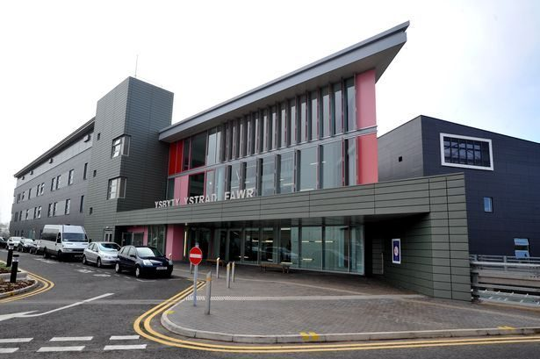
Figure 2: Ysbyty Ystrad Fawr Main Entrance
Source: Wales Online (2014)

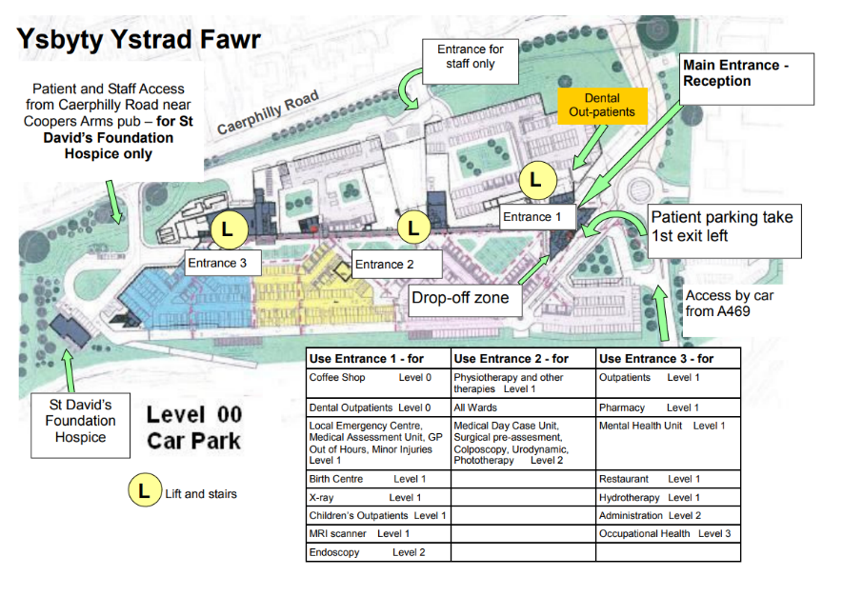
Figure 3: Ysbyty Ystrad Fawr Level 00 Plan
Source: NHS Wales (2023)

- St David’s Hospice Care, Newport
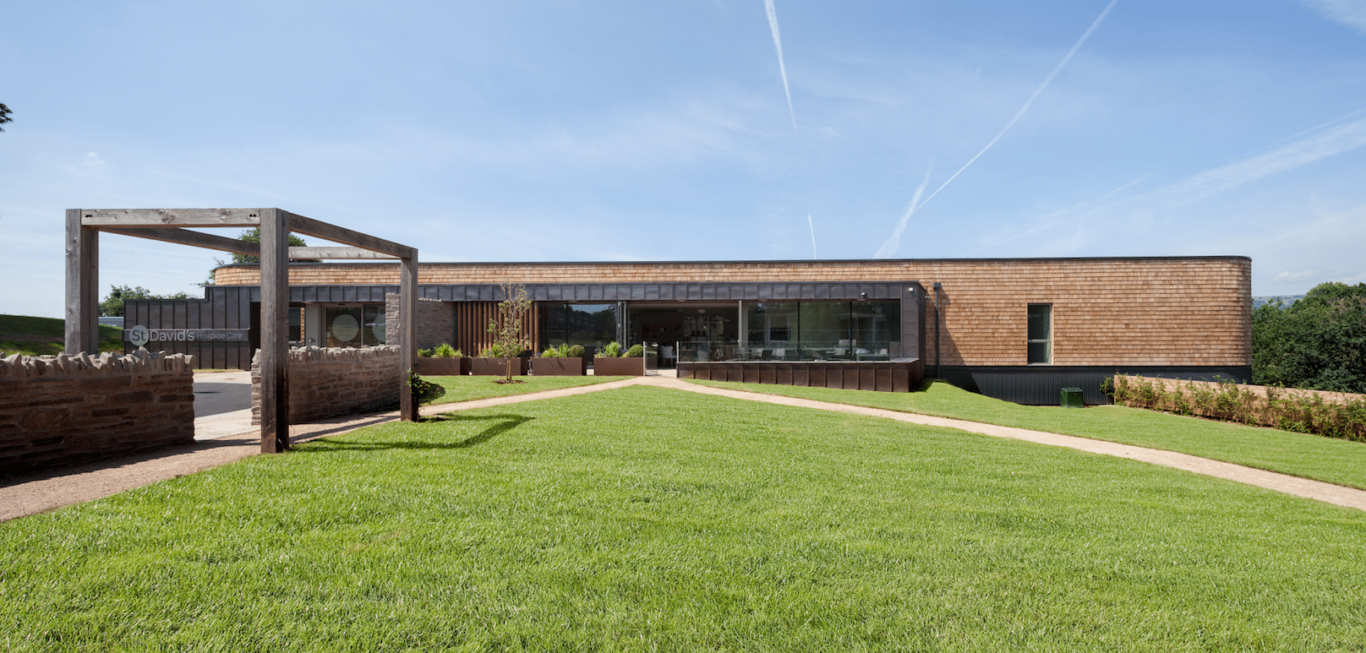
Figure 4: St Davids Hospice Care Exterior
Source: KKE Architects (2017)

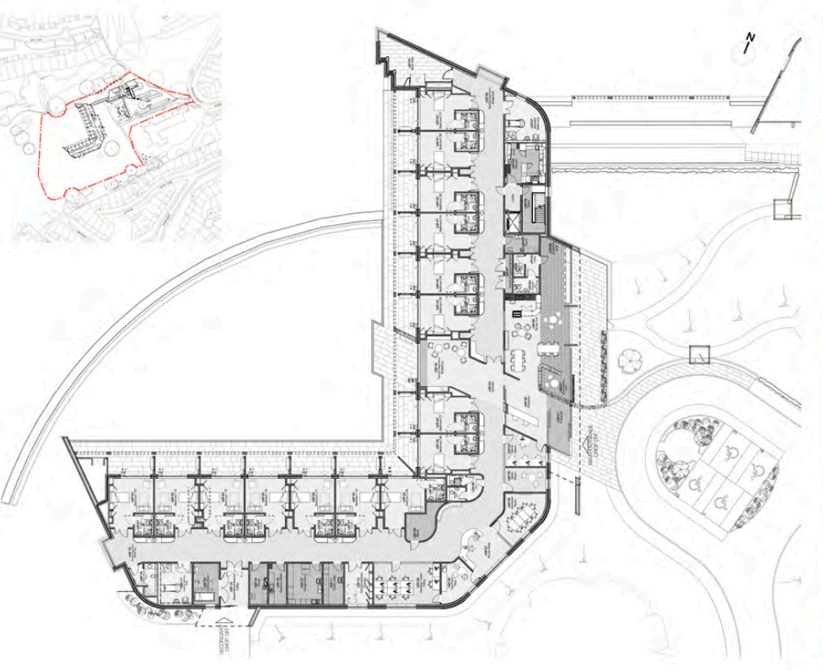
Figure 5: St Davids Hospice Care Floor Plan
Source: KKE Architects (2017)

- Ysbyty Cwm Cynon, Rhondda Cynon Taf
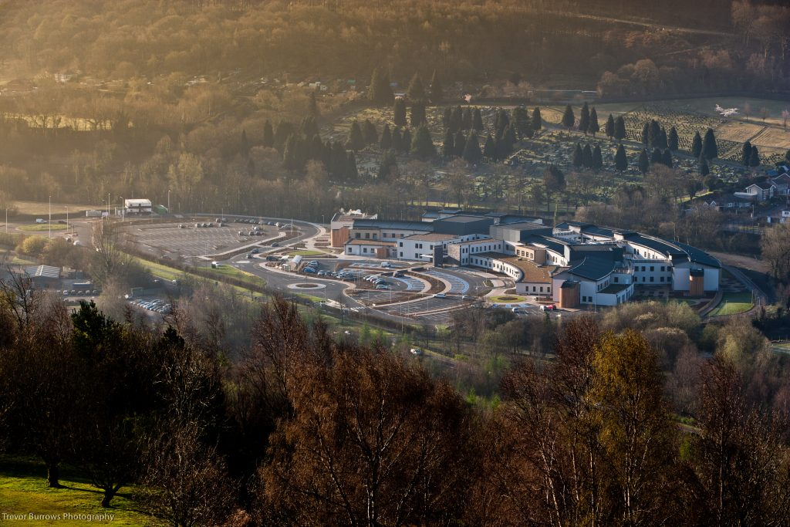
Figure 6: Ysbyty Cwm Cynon Hospital Exterior
Source: Architecture Vogue Magazine (2025)

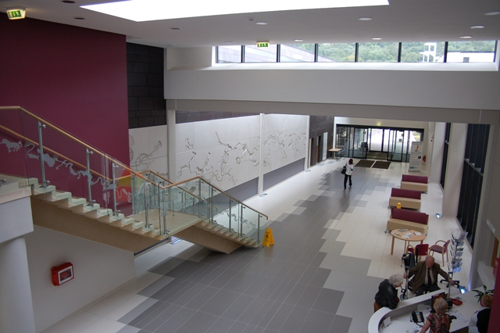
Figure 7: Ysbyty Cwm Cynon Hospital Interior
Source: Architects for Health (2012)

These were chosen because they represent different approaches to healthcare environments:
- A large NHS hospital (Ysbyty Ystrad Fawr)
- A hospice care setting (St David’s Hospice)
- A smaller community hospital (Ysbyty Cwm Cynon)
This range allows for comparison between institutional and more personal care environments, which is central to the research question.
The case studies are analysed through drawings, photographs, published material, and existing literature.
Building | Type | Location | Scale | Key Design Approach | Relevance
Ysbyty Ystrad Fawr | NHS Hospital | Caerphilly | Large | Healing environment, zigzag wards | Institutional baseline
St David’s Hospice | Hospice | Newport | Small | Domestic scale, garden focus | Human-centred benchmark
Ysbyty Cwm Cynon | Community hospital | Rhondda Cynon Taf | Medium | Hybrid model | Middle ground
Table 1: Overview of Selected Healthcare Case Studies.
Summary of the three case studies selected for comparative analysis, including building type, scale, and relevance to the research. Source: Author (2026)

Analytical Framework
To ensure consistency across the case studies, each building is analysed using the same set of themes:
- Privacy and dignity
- Access to daylight and views
- Relationship to landscape
- Circulation and wayfinding
- Noise and atmosphere
- Room layout and patient experience
These themes are not arbitrary; they are drawn directly from both:
- The literature review
- The questionnaire responses
This creates a framework that connects theory, real experience and architectural analysis.

Theme | Why it matters | Literature link | Seen in questionnaire
Wayfinding | Reduces stress, improves clarity | Lawson (2010) | “Felt lost”, “confusing layout”
Daylight & Views | Supports recovery, reduces stress | Ulrich (1984) | “Needed windows”, “felt trapped”
Privacy | Maintains dignity | Ulrich et al. (2008) | “No space”, “shared wards”
Noise | Affects rest and stress | Lawson (2010) | “Constant noise”
Atmosphere | Shapes emotional experience | Pallasmaa (2012) | “cold”, “clinical”
Landscape | Improves wellbeing | Marcus & Sachs (2014) | “Liked being outside”
Table 2: Analytical Framework for Healthcare Environment Evaluation
Framework used to assess each case study, derived from literature on healthcare design and informed by questionnaire responses. Source: Author (2026)

Questionnaire Approach
To gather information, a questionnaire was used to survey people with experience in healthcare settings. The main goal wasn't to collect a lot of statistical data.
The focus then shifted to understanding the shared emotional experiences of patients in hospitals.
The survey questions focused on:
- People's feelings in healthcare settings.
- The factors that made these environments feel either comfortable or uncomfortable.
- The influence of design on their experiences.
- Their suggestions for improvement.

The questionnaire used a combination of:
- Multiple-choice questions, which helped identify common patterns.
- Short written answers, which allowed for the collection of personal experiences.
Questionnaire as a Structural Basis
Rather than being treated as a separate part, the questionnaire served as the main framework for the entire analysis.
Key responses helped highlight recurring issues, such as:
- Feeling lost or disoriented in hospital layouts.
- Environments feeling clinical, cold, or impersonal.
- A strong preference for natural light and views outside.
- The importance of quiet spaces and privacy.
- A noticeable difference between hospice environments and hospitals.
These responses directly informed the analytical categories used in the case studies. Comments about getting lost relate to how people move around and find their way. Comments about feeling exposed or uncomfortable are connected to privacy and dignity. Preferences for windows and outdoor views are linked to natural light and the surrounding environment. This approach allows the dissertation to go beyond just theory and base its analysis on real user experiences.
Connecting Research and Design
This methodological approach seeks to establish a direct relationship among three essential elements:
- Empirical research findings concerning improvements in healthcare settings.
- The personal narratives offered by individuals.
- The practical considerations inherent in architectural design.
By comparing these three aspects, this study aims to identify both the successful and the less successful elements of healthcare design.

Limitations
This methodology is subject to certain constraints:
- The sample size of the questionnaire is comparatively small, thereby limiting the statistical representativeness of the results.
- These responses are subjective, reflecting the unique experiences of everyone.
- Case studies are contingent upon existing drawings and secondary sources, as opposed to direct site access.
Even with these limitations, the approach still gives useful insight by looking closely at case studies and how they’re interpreted (Creswell and Poth, 2018; Yin, 2018).
Summary
Overall, this methodology combines case studies with an understanding of user experience to explore not just how healthcare environments are designed, but how they are actually felt.
This dissertation, using the questionnaire as a framework, focuses on the people who use these spaces, rather than just looking at architecture as a technical or abstract idea.

Literature Review
The Evolution of Healthcare Architecture
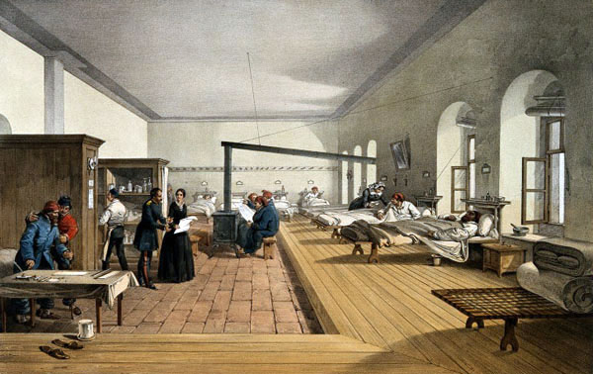
Figure 8: ‘Florence Nightingale assessing a ward at the military hospital in Scutari’. Coloured lithograph, c. 1856, by E. Walker after W. Simpson. Source: National Archives.
Healthcare architecture has traditionally focused on practical concerns such as cleanliness, safety, and the efficient organisation of medical services. In the nineteenth and early twentieth centuries, hospitals were often laid out so that patient wards were kept apart from one another. Separating hospital wards from one another helped bring more fresh air and daylight into patient areas, while also reducing the chances of illness spreading between different parts of the building (Verderber & Fine, 2000). These ideas came from Florence Nightingale, who believed that clean surroundings, daylight, and fresh air could help people recover (Nightingale, 1863). While this improved public health, hospitals were still mainly organised around how care was delivered, rather than how patients experienced them.
Over time, hospitals have just got bigger and more complicated as medicine has changed (Verderber and Fine, 2000; Lawson, 2010).

Noise and atmosphere
Daylight and Views

Connection to nature
Wayfinding
Healthcare Experience

Privacy and Dignity
Scale

Figure 9: Key Factors Influencing Healthcare Experience
Conceptual diagram identifying the primary environmental and spatial factors shaping user experience in healthcare settings, including daylight, privacy, wayfinding, noise, nature, and scale. Source: Author (2026)

This shift shows up clearly in the buildings. You can often tell when a hospital was built just from its layout or materials. Older ones tend to feel more broken up or ward based, while newer ones are usually larger, more standardised, and more focused on efficiency. As medicine advanced, hospitals had to accommodate more equipment, services, and specialist departments within the same buildings. While these changes supported more advanced medical treatment, they also led to hospitals that could feel overwhelming, impersonal, and hard for patients and visitors to find their way around (Lawson, 2010).
In recent decades, architectural discourse has increasingly recognised that hospital buildings influence not only clinical outcomes but also the psychological and emotional wellbeing of patients. Contemporary healthcare design therefore seeks to integrate clinical performance with human centred environments. According to Roger Ulrich et al. (2008), research has shown that the way healthcare spaces are designed can affect how stressed patients feel and how comfortable staff are while working. Because of this, designers have increasingly begun to draw on research when thinking about how hospitals should be planned and arranged (Hamilton & Watkins, 2009).
Evidence based design focuses on simple aspects of a space that can affect how people feel, such as daylight, quieter surroundings, clear layouts, and the ability to see outside. These features are now often seen as an important part of creating healthcare spaces that feel more comfortable and supportive for patients (Ulrich et al., 2008).

Environmental Psychology and Healing Environments
A lot of research has looked at how the spaces around us affect how we feel. Put simply, environmental psychology looks at how the places people spend time in can influence how they feel and behave. In hospitals and care settings, this thinking led to the idea that the environment itself can play a part in helping people feel calmer and more at ease while they are receiving treatment (Gesler et al., 1992).
One of the most influential studies in this field was conducted by Roger Ulrich (1984), who demonstrated that hospital patients recovering from surgery experienced shorter recovery times and required less pain medication when their rooms overlooked natural landscapes rather than brick walls. The study helped show that the spaces patients stay in can influence how well they recover.
Later, Roger Ulrich expanded on this work by arguing that certain qualities in a space such as natural light, views outside, or a sense of calm and order, helps reduce the stress people feel in hospitals (Ulrich, 1991). Since then, these ideas have become an important part of how designers and researchers think about healthcare environments.
In The Architecture of Hope, Charles Jencks (2015) describes Maggie’s Centres as a clear break from what most people expect a healthcare building to feel like. They’re not trying to feel like hospitals at all. Instead, they’re smaller, calmer, and much more personal, spaces that seem to focus on how people feel rather than how efficiently things run. A lot of that comes through in how they’re put together. There’s a stronger connection to the outside, the spaces feel more domestic than institutional, and you don’t get that same sense of being processed through a system. It’s a very different atmosphere to what most people associate with hospitals. What’s interesting is the contrast this creates. Hospitals might work well in terms of function, but that doesn’t always translate into a better experience for the people using them. The Maggie’s approach makes that gap obvious (Jencks, 2015). It also raises a bigger question. Are these kinds of environments only possible because they sit outside the main hospital system, or could some of those ideas realistically be brought into larger healthcare settings?
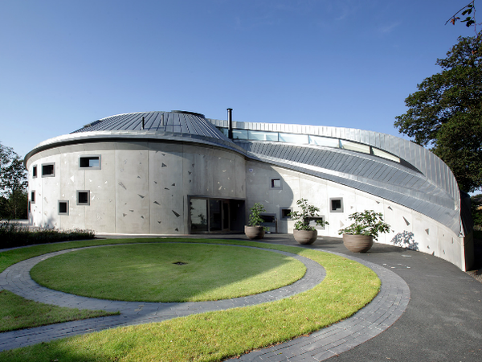
Figure 10: Maggies Swansea Exterior designed by Kisho Kurokawa. Source: Maggies.org
Subsequent research has reinforced the importance of nature, daylight, and sensory comfort in healthcare environments. Research has shown that being able to see outside, get daylight, or spend time near outdoor spaces can help patients feel calmer during their stay (Ulrich et al., 2008). Because of this, many hospitals now try to include elements such as courtyards, larger windows, and patient rooms that bring in more natural light as part of evidence-based design strategies (Ulrich et al., 2008; Hamilton and Watkins, 2009).
Researchers have also looked at how spending time around nature can help people mentally recover from stress and tiredness, suggesting that natural surroundings can help the mind feel more settled again (Kaplan & Kaplan, 1989).
Noise levels are another critical environmental factor. Hospitals are rarely quiet environments. The sounds of equipment, alarms, and people moving through the building can make it difficult for patients to properly rest, which can make the experience of being in hospital more tiring and stressful (Lawson, 2010). As a result, modern healthcare design increasingly incorporates acoustic strategies such as sound-absorbing materials and separated circulation routes.
Some architects have suggested that the experience of a building is about more than just how it looks. Juhani Pallasmaa writes about how the feeling of a place often comes from small, quiet qualities, such as the way light enters a room, the sound of a space, or the texture of materials, and how these subtle details can shape how people experience a building (Pallasmaa, 2012).
Privacy, Dignity and Spatial Experience
It’s not just about comfort. The way spaces are set out can either give you a bit of privacy or take it away. In older hospitals, being in a large, shared ward often meant you were never really on your own, which could feel quite exposing at times. Although this made it easier to manage care, it often meant people had very little privacy and were constantly surrounded by noise and activity (Curtis & Northcott, 2017).
Because of that, a lot of newer hospitals try to give patients their own rooms. It helps people feel more at ease and gives them a bit of privacy, which can make a tough situation slightly easier to deal with (Ulrich et al., 2008). Having a private space can help people feel more comfortable and makes it easier for them to rest, while also helping reduce the chances of illness spreading between patients (Ulrich et al., 2008).
Being able to easily understand where you are in a hospital, and how to get where you need to go, is an important part of how people experience the building. Hospitals can be difficult places to move around, especially for people who are unfamiliar with them. When buildings are hard to understand, people often end up wandering around trying to find the right place, which can make an already stressful visit feel even more overwhelming (Lawson, 2010). Things that might seem minor, like immediately knowing where the entrance is, or a corridor that naturally leads you where you need to go can quietly make the whole experience feel far less frustrating.
For many patients, hospitals are experienced during moments of vulnerability and uncertainty. Architectural design therefore plays a role in supporting dignity by reducing feelings of disorientation or institutional control.
Landscape, Nature and Therapeutic Space
Landscape and access to nature are increasingly recognised as important aspects of healthcare design. For many patients, being able to step outside into a garden can feel like a brief escape from the clinical atmosphere of the hospital. Sometimes it doesn’t take much. Stepping outside for a bit, getting some fresh air, or just seeing a bit of greenery can break up what otherwise feels like a long day stuck inside.
Research indicates that contact with nature can reduce stress, lower blood pressure, and improve emotional wellbeing (Marcus & Sachs, 2014). Because of this, gardens and outdoor areas in healthcare settings are often treated as more than just decoration. They are planned as places where patients and families can spend time, get some fresh air, and have a break from the atmosphere inside the hospital.
Wilbert Gesler (1992) wrote about how some places seem to have a positive effect on how people feel, especially when they include nature or a calm setting. Ideas like this have encouraged hospitals to bring more outdoor spaces, courtyards, and views of greenery into their buildings.
In hospice care, spaces outside can matter even more. When people are spending long stretches of time in the same building, being able to step out into a garden even briefly can give patients and their families a moment away from the ward and the routines of care.
In Wales, some newer healthcare buildings have tried to make more of their surroundings. For example, Ysbyty Ystrad Fawr was designed around a “healing environment” concept, with a zigzag ward plan intended to maximise sunlight and provide many rooms with views across the Rhymney Valley (Nightingale Associates, 2011), so that patients and staff are not always looking into corridors or blank walls.
Community, Place and Welsh Healthcare Infrastructure
Hospitals often play an important social role within towns and communities. In a lot of Welsh towns, hospitals aren’t just places you go for treatment, they’re a big part of the place itself, something people recognise and rely on. Recent Welsh Government guidance leans more towards healthcare that supports people beyond just treatment, with a bigger focus on community and overall wellbeing (Welsh Government, 2021).
Some architects also argue that buildings should reflect the places and communities they belong to. Kenneth Frampton describes this approach as critical regionalism, which emphasises architecture that responds to local landscape, culture, and identity rather than purely technological or globalised design approaches (Frampton, 1983).
This way of thinking is especially relevant in Wales, where hospitals often play an important role in smaller towns and local communities. Buildings such as St David’s Hospice take a different approach to care environments, using gardens, daylight, and a quieter domestic scale to create a calmer setting for patients and families (KKE Architects, 2017).

Hospice architecture often differs from traditional hospital design by prioritising comfort, intimacy, and emotional support rather than clinical efficiency alone. These environments aim to create spaces that feel welcoming and supportive for patients and families during difficult periods of care.
Implications for Contemporary Healthcare Design
Many writers on hospital design point out that a building can work perfectly well for doctors and equipment yet still feel difficult for the people staying in it. Long corridors, harsh lighting, constant noise, or not being able to see outside can all shape how patients experience their time in hospital. Things like daylight, quieter spaces, and being able to understand where you are in the building can make that experience feel very different.
Hospitals never really slow down. There’s a constant flow of people, equipment, and supplies moving through the building, and if the layout doesn’t keep up with that, things start to feel messy very quickly.
The difficult part is trying to balance all of this at once. Hospitals must run efficiently, but they also need to feel manageable for the people inside them. One way of approaching it is by paying attention to how spaces affect people, not just how they function on paper (Ulrich et al., 2008; Hamilton & Watkins, 2009).
A lot of the focus usually lands on patients, but staff deal with these spaces all day, every day. Hospitals are busy, pressured places, and if the layout makes simple things harder, moving around, finding people, getting between departments, it all starts to add up. Over time, that can make the job more tiring than it needs to be.
How a hospital is laid out matters. What you can see and how far you must walk also matter. These things don’t just affect how smoothly it runs; they affect the staff as well. Long walks, poor visibility, or awkward setups can wear staff down over a shift, and that inevitably shows in the care they’re able to give (Ulrich et al., 2008). It means the space must work for both sides, patients and staff, not just one or the other.
Together, these ideas help frame the way this dissertation looks at the design of several healthcare buildings in Wales, not just in terms of patient experience, but also how these spaces are used and worked in daily.

Findings
Across the case studies and responses, one thing came through quite clearly. Healthcare buildings might be designed to run efficiently, but that does not always match how they feel to the people using them. For patients and visitors, the experience can be very different from what the design seems to prioritise on paper, echoing wider research on the gap between operational performance and user experience in healthcare environments (Ulrich et al., 2008; Hamilton and Watkins, 2009). Across both the questionnaire responses and the case study analysis, similar issues appear repeatedly (See Appendix A).
When people talked about hospitals, it was usually in terms of how hard they are to deal with getting lost, constant noise, very little privacy, and an overall feeling that the space isn’t really set up with them in mind (See Appendix A).
At the same time, spaces that felt smaller, quieter, and more connected to the outside were consistently described in more positive terms (See Appendix A).
These findings are organised using the coding framework developed from the questionnaire (See Appendix A).
Disorientation and Wayfinding
Getting lost came up repeatedly in the responses. Not in a dramatic way, but in small, frustrating moments, people missing turns, doubling back on themselves, or standing still trying to work out where to go next. A few described arriving already stressed and then feeling that stress build simply because the building wasn’t easy to read. When the building does not ease that process, it quietly adds to the overall strain of being there (Lawson, 2010; Ulrich et al., 2008; See Appendix A).
Rather than moving naturally through the space, people often felt like they were navigating it step by step, relying on signs to get anywhere. Corridors felt similar, routes weren’t always obvious, and there wasn’t much to guide you instinctively. It wasn’t just about poor signage; it was more that the layout itself didn’t do much to help (See Appendix A).
What came through quite clearly is that most people aren’t experiencing these buildings in a calm or neutral state. They’re arriving worried, distracted, or under pressure, which makes even simple navigation feel harder. When the building doesn’t ease that process, it quietly adds to the overall strain of being there (See Appendix A).

In larger buildings like Ysbyty Ystrad Fawr, getting around can feel a bit stop-start. Long corridors stretch out in similar directions, departments branch off in ways that aren’t always obvious, and you end up relying on signs just to make basic decisions. It’s not so much that the building is confusing on purpose, more that it doesn’t give you much to go on unless you already know where you’re heading (See Appendix A).
That experience shifts quite noticeably in places like St David’s Hospice Day Hospice. The spaces are smaller, but more importantly, they’re easier to read. You can see where things lead, distances are shorter, and moving through the building feels more instinctive rather than somethi ng you must think your way through (See Appendix A).
What this points to isn’t just size on its own, but how that size is handled. When spaces repeat without much variation, people aren’t given much to hold onto in terms of direction. When spaces are more contained and visually clear, people seem to move with a bit more confidence, even if they’ve never been there before (See Appendix A).
Clinical and Impersonal Atmosphere
A lot of people didn’t struggle to describe how hospitals felt, the same words kept coming up: cold, clinical, a bit unwelcoming. It wasn’t said dramatically, more like a quiet acceptance of how those spaces tend to be (See Appendix A).
What seemed to shape that feeling were ordinary things. Bright artificial lighting that never really softens, long corridors that feel more like routes than places to pause, and materials that are easy to clean but not particularly comforting to be around. None of these on their own are unusual, but together they create an environment that can feel quite stripped back, almost indifferent (See Appendix A).
That tone came through much more strongly in larger settings, where everything feels geared toward keeping things running smoothly. You can sense the logic behind it, but it doesn’t always leave much room for warmth (See Appendix A).
The mood shifts in places like St David’s Hospice Day Hospice. People spoke about it differently, noticing softer finishes, quieter rooms, and an overall calmness that felt more considered. It’s not just that it looks nicer; it feels easier to be in (See Appendix A).
What comes through here is that atmosphere isn’t created by one big gesture. It builds up through small, repeated choices, how light is handled, how materials feel, how spaces are scaled, and those choices shape whether a place feels harsh or humane (Pallasmaa, 2012; Ulrich, 1991; See Appendix A).
Lack of Privacy
Privacy came up in a quieter way, but it clearly mattered. A few people described how hard it is to properly switch off in hospital when you’re never alone. It’s not just about being seen, it’s about constantly hearing other conversations, other patients, machines, footsteps. Even when you’re lying in bed, it can feel like you’re still part of everything going on around you.
Shared wards were frequently mentioned in the responses, especially the awkwardness of being so close to people you don’t know. A few described lying there trying to rest but picking up on everything, other conversations, movement, even small sounds, which made it hard to properly settle (See Appendix A).
In larger hospital settings, that lack of privacy seems to come from how much must be fitted into one place. Spaces are used efficiently, but that often means boundaries between people are quite thin, physically and acoustically (See Appendix A).
That experience shifts in hospice environments, where people tend to have a bit more space around them. Rooms feel quieter, more contained, and there’s more of a sense that you can control your own environment, even in small ways like closing a door or having a moment to yourself (See Appendix A).
What this really comes back to is how exposed people feel. Even if you’re technically “in a space of your own”, noise, layout, and lack of control can make it feel like you are still sharing it (Curtis and Northcott, 2017; Ulrich et al., 2008; See Appendix A).
Noise and Overstimulation
Noise was something people kept coming back to, often without even being prompted. Not just loud in an obvious sense, but constant, the kind of background activity that never really drops off. A few described it as hard to escape, even when nothing was happening.
It wasn’t usually one thing causing it. More a mix of sounds layered together, machines beeping, doors opening and closing, conversations carrying down corridors, people passing through at all hours. Individually, none of it is surprising, but over time it builds into something that’s difficult to ignore (See Appendix A).
That seemed to matter most when people were trying to rest. Some mentioned lying in bed and being aware of everything going on around them, even at night, which made it harder to properly switch off. It’s less about sudden noise and more about the lack of quiet (See Appendix A).

In larger hospital buildings, this feels harder to avoid. A lot of patient spaces sit right off main walkways, so you constantly hear movement nearby. Even if you’re not directly involved in that activity, you still hear it, and it becomes part of the experience of being there (See Appendix A).
In smaller settings, things tend to be kept a bit more apart. Areas where people are moving through don’t spill straight into spaces meant for resting, and that alone seems to make things feel quieter (See Appendix A).
Daylight and Connection to Outside
Access to daylight was discussed in noticeably more positive terms than most other aspects. People didn’t always describe it in technical terms, but it was clear that it mattered. Being near a window, catching a bit of sunlight, or just being able to look outside seemed to break up the feeling of being stuck inside (Ulrich, 1984; Park et al., 2018; See Appendix A).
A few responses mentioned simple things, watching the weather change, seeing trees move, or just having something to look at that wasn’t part of the hospital. It gave them a point of focus that felt separate from everything else going on (See Appendix A).
What stood out is how small those moments are, but how much they seem to help. Even briefly, they shift attention away from the immediate situation and make the space feel less closed in (See Appendix A).
Buildings such as Ysbyty Ystrad Fawr incorporate courtyards and windows that bring light deeper into the plan, but this is not always consistent across all areas.
In places where you can see outside, the mood shifts quite quickly. Even just a glimpse of daylight or weather breaking through gives you something else to focus on, instead of being stuck in the same interior all day. It’s a small thing, but it seems to make being there feel more manageable (See Appendix A).
Positive Perception of Smaller-Scale Environments
Across both the questionnaire and the case studies, smaller environments were almost always talked about more positively. Not in a dramatic way, but in how people described being there, things felt quieter, easier to understand, and generally less intense (See Appendix A).

It often came down to how manageable the space felt. People weren’t second-guessing where they were going, there was a bit more separation from others, and it was easier to find a moment of calm. Access to outdoor space came up here as well, especially where it felt close and easy to reach rather than something distant or hidden away (See Appendix A). This came through quite clearly in places like St David’s Hospice Day Hospice, where the building feels closer in scale to something domestic. Rooms don’t stretch on endlessly, routes are straightforward, and the overall atmosphere feels more considered (See Appendix A).
By contrast, larger hospitals were often described in terms of how much they demand from you, more to take in, more people around, and more going on at once. It’s not just that they’re bigger, but that they can feel harder to settle into (See Appendix A). What this seems to come back to is scale, but not just in terms of size. It’s about how much a space asks of you when you’re already dealing with everything else especially when you are already dealing with everything else (Gesler et al., 1992; Jencks, 2015; See Appendix A).
Summary of Findings
When considered collectively, the difference between environments is clear. Larger hospital buildings often came across as harder to deal with, not just because of their size, but because of how they feel to move through and spend time in. People described them as tiring, sometimes confusing, and a bit impersonal (See Appendix A). Smaller, more carefully designed places felt noticeably different. They were easier to understand, quieter, and generally more comfortable to be in. It wasn’t just one feature doing that, it was how everything worked together (See Appendix A).
What stands out is that a lot of the negative experiences people described weren’t really about the care itself. They were about the setting around it. Things like layout, lighting, noise, and privacy kept coming up as part of the experience, not something separate from it (See Appendix A).
It makes it quite hard to see healthcare buildings as neutral. The way they’re put together clearly shapes how people feel while they’re there, whether that’s adding to the stress of the situation or easing it slightly (See Appendix A).

Theme | Ysbyty Ystrad Fawr | St David’s Hospice | Ysbyty Cwm Cynon
Wayfinding | Complex, sign-dependent | Intuitive, visible routes | Moderate clarity
Daylight | Inconsistent | Strong, consistent | Moderate
Privacy | Limited in shared areas | High | Moderate
Noise | Constant background activity | Controlled, quieter | Mixed
Atmosphere | Clinical, impersonal | Calm, domestic | In-between
Scale | Large, overwhelming | Small, manageable | Medium
Table 3: Comparative Analysis of Case Study Findings
Comparison of key spatial and environmental themes across the three case studies, highlighting differences in user experience and design approach. Source: Author (2026)

Discussion
Overview
What comes through quite clearly from the findings is a gap between how these buildings are meant to work and how they feel to be in. From a clinical point of view, most hospitals do what they need to do. But that doesn’t really match how people experience these places. What keeps coming up is how disorientating they can feel, struggling to find your way, hearing everything around you, never quite being able to switch off. It’s usually not anything dramatic. It’s more that things just feel a bit off the whole time, and it wears you down after a while. The space isn’t just something you pass through, it gets to you. It can make things feel heavier than they already are, or every now and then, taking a bit of the pressure off (Ulrich, 1991; Bernhardt et al., 2022; See Appendix A).
This isn’t something new. Authors like Bryan Lawson (2010) and Roger Ulrich et al. (2008) have already pointed out that designing for efficiency doesn’t always mean designing for people. What’s interesting is how closely the questionnaire responses echo that, it’s not abstract, its exactly what people are still experiencing (See Appendix A).

Looking at the findings alongside the literature, there’s a bit of a disconnect. A lot of the issues people raised, getting lost, lack of privacy, constant noise, the importance of daylight, are already well understood (Ulrich et al., 2008; Marcus and Sachs, 2014). So, it’s not really a knowledge problem. It’s more that these ideas don’t seem to fully carry through into the buildings themselves, something D. Kirk Hamilton and David H. Watkins (2009) also touch on.
Wayfinding and Disorientation
“Feeling lost” came through strongly in the findings (See Appendix A), and not just in a practical sense. People weren’t just missing turns, they were second-guessing themselves, stopping to figure things out, or relying on signs for even simple routes.
That lines up quite closely with what Lawson (2010) talks about. When layouts get complicated, it’s not just inconvenient, it adds another layer of stress, especially if you’re already not in a great headspace. The responses here back that up. Getting around isn’t just about efficiency; it shapes how comfortable or uncomfortable people feel while they’re there.
In larger buildings like Ysbyty Ystrad Fawr, getting a sense of the place isn’t always straightforward. You tend to move through long corridors that all feel quite similar, with different departments branching off, so it’s easy to lose track of how everything connects. A lot of the time, you end up relying on signs just to get from one place to another. Research by Roger Ulrich et al. (2008) suggests that when buildings work like this, it can make things more mentally tiring, especially if you’re already stressed.
That experience feels quite different in places like St David’s Hospice Day Hospice. The smaller scale makes it easier to get your bearings, and you’re not constantly having to think about where you’re going next. Bryan Lawson (2010) links this kind of clarity to reduced stress, which lines up with what came through in the responses.
Atmosphere and Emotional Experience
The way people described hospital environments was consistent, such as being “clinical” or “cold” came up a lot, but usually in a quiet, matter of fact way rather than as strong complaints (See Appendix A).
What stood out wasn’t one obvious problem, but how everything adds up when you’re there. It’s the kind of thing you only really notice when you’ve spent time in those spaces yourself, the lighting that never quite softens, the materials that feel hard and unforgiving, the way rooms connect without much variation. None of it is extreme on its own, but together it creates a certain mood that’s hard to ignore (See Appendix A).
Juhani Pallasmaa (2012) writes about how architecture is felt as much as it is seen, and that idea feels quite accurate here. The responses weren’t picking apart design features, they were describing how the space made them feel overall, which is something that’s much harder to control once a building is already built.
It also links back to Roger Ulrich (1991), who suggests that environments can either ease stress or quietly make it worse. Some of the descriptions in the responses, feeling on edge, unable to settle, or just generally uncomfortable, point towards that second side. Not because anything is obviously wrong, but because the environment doesn’t do much to take that pressure off.
In contrast, hospice environments were described in calmer and more positive terms. Research into therapeutic environments has been pointing in this direction for a while. Wilbert Gesler et al. (1992) describe how smaller, less institutional spaces tend to feel more supportive, which lines up quite closely with what came through in the findings. It’s not just about how a space looks, it’s about whether it feels manageable to be in.
Privacy and Dignity
Privacy came through as something people were quite aware of, even if they didn’t always describe it directly. Shared wards seemed to make people feel exposed, not just visually, but in terms of sound and general awareness of others. Trying to rest while hearing conversations, movement, or other patients nearby made it harder to properly settle.
This is something that’s been picked up in research as well. S. Curtis and H. Northcott (2017) talk about how shared spaces can reduce a sense of dignity, which feels quite close to how people described it here (See Appendix A).
There’s also a noticeable difference when people have a bit more space to themselves. Studies by Roger Ulrich et al. (2008) suggest that single rooms can improve comfort and even outcomes, but what stands out in the findings is how simple it is, people just feel more at ease when they’re not constantly aware of others.
It ends up feeling like a bit of a trade off. Shared spaces might make sense from a practical point of view, but they don’t always work so well for the people in them (See Appendix A).
Noise and Sensory Experience
Noise was one of those things that people didn’t always describe in detail but clearly felt. It’s not just that hospitals are loud, it’s that they’re rarely quiet. The noise isn’t always loud, but it’s constant, bits of conversation, equipment, movement, all layering on top of each other (See Appendix A).
Bryan Lawson (2010) links this kind of environment to increased stress, which lines up with what people described. A few mentioned lying there trying to rest but never quite switching off, because something was always happening nearby.
It also ties back to what Juhani Pallasmaa (2012) writes about, that we experience buildings through all our senses, not just visually. The noise doesn’t just sit in the background, it kind of gets under your skin after a while and starts shaping the whole experience.
Daylight, Nature, and Recovery
Daylight and views outside were some of the few things people spoke about positively. Being able to sit near a window, see the sky, or just look at something beyond the hospital seemed to make a noticeable difference.
This lines up with Roger Ulrich’s (1984) work on views of nature and recovery, but what’s interesting is how simply people described it. It wasn’t about “design features”, it was about having something else to focus on, something that made the space feel less closed in.
What comes through quite clearly is that these things aren’t just nice additions. They seem to help people get through time in these environments, even in small ways.
Scale and the Experience of Care
Scale kept coming up, both in the findings and in the reading, but not in a technical sense, more in how the spaces feel to be in (See Appendix A). Smaller environments were almost always described in a more positive way. People found them easier to move through, quieter, and generally less draining (See Appendix A). In The Architecture of Hope, Charles Jencks (2015) talks about Maggie's Centres being designed closer to a domestic scale, and you can see why that matters. They don’t feel like large institutions, and that seems to make them easier to spend time in.
That idea comes up in other research too. Wilbert Gesler et al. (1992) link smaller, more human scale environments to better emotional wellbeing, which fits quite closely with what people described here. Larger hospital buildings might work efficiently, but that doesn’t stop them from feeling overwhelming when you’re in them.
What this seems to come down to is how much a place asks of you. Bigger environments tend to demand more, more to take in, more to figure out, whereas smaller ones feel a bit easier to settle into, especially when you’re already not at your best.

The Gap Between Research and Practice
One thing that’s hard to ignore is that none of this is particularly new. The issues people described, getting lost, lack of privacy, constant noise, and the importance of daylight, have been discussed for decades (See Appendix A), with early hospital design guidance already emphasising light, ventilation, and patient comfort in the early twentieth century (Nightingale, 1863; Verderber & Fine, 2000).
Writers like Bryan Lawson (2010) and Roger Ulrich (1984; 2008) have already shown how things like clear layouts, quieter environments, and access to light can make a real difference. Clare Cooper Marcus and Marni Barnes Sachs (2014) make similar points around nature and wellbeing. So, the knowledge is there.
What’s interesting is that people are still describing the same problems now (See Appendix A). It suggests that the issue isn’t about understanding what works, it’s more about what gets built. D. Kirk Hamilton and David H. Watkins (2009) touch on the gap between theory and practice, and it is quite visible in the findings.
There are probably a few reasons for that. Hospitals are under pressure to keep things moving, tight budgets, standard ways of doing things, not much room for slowing down. That kind of setup gets the job done, but it can feel like the more human side of it slips through the cracks a bit.

Hospice Qualities |  | NHS Constraints |  | Adaptation in Hospitals
Domestic scale |  | Large, complex systems |  | Break into smaller zones / clusters
Strong connection to nature |  | Deep-plan buildings |  | Courtyards, views, light wells
Calm, quiet atmosphere |  | High activity + noise |  | Acoustic buffering, zoning
Simple, intuitive layout |  | Complex departments |  | Clear circulation hierarchy
High privacy |  | High patient density |  | Better separation, single rooms where possible
Figure 10: Transfer of Hospice Design Principles into NHS Hospital Contexts
Diagram illustrating how key qualities of hospice environments can be adapted within the constraints of NHS hospital design to improve psychological wellbeing.
Source: Author (2026)

Summary
Looking back over the discussion, what stands out is how closely the findings match what’s already been written about, but also how little that seems to have changed in practice. The same issues keep coming up, and people are still experiencing them in very real ways.
What this really points to is that healthcare environments aren’t neutral at all. The way they’re designed has a direct impact on how people feel while they’re there, whether that’s adding to the stress of the situation or easing it slightly. That’s something Roger Ulrich (1991) and Juhani Pallasmaa (2012) both touch on, but it comes through just as clearly in the responses.
At the same time, there’s a bit of a disconnect. A lot of what’s known about better healthcare design doesn’t seem to fully show up in the buildings people are using. The result is environments that work from a clinical point of view, but don’t always support the experience of being there.
If anything, it suggests that healthcare design needs to be taken more seriously as part of the overall care experience, not just something that sits in the background, but something that actively shapes it.

Conclusion
This dissertation set out to explore how healthcare environments are experienced, and whether current hospital design reflects what is already understood about patient wellbeing. Looking across the literature, case studies, and questionnaire responses, the same issues keep coming up. Many hospitals work well in terms of treatment and day-to-day operation, but that doesn’t always mean they feel easy or comfortable to be in. Research has already shown that the spaces people move through can shape how they feel and cope while they are there (Ulrich, 1991; Ulrich et al., 2008), and the findings in this study echo that in a very direct way. What stands out is that people rarely talk about these environments in neutral terms. Instead, they describe how they feel in them, lost, exposed, overwhelmed, or, in better cases, calm and supported. These experiences don’t seem random. They tend to relate back to basic aspects of design: how the building is laid out, how big it feels, whether there is natural light, whether there are views outside, and how the space sounds and feels to be in. In that sense, the study reinforces something that is already well established in the literature but often overlooked in practice: healthcare environments are not just backgrounds to treatment. They are part of the experience itself.
The central question of this dissertation asked whether lessons from more bespoke healthcare environments could inform the design of standardised hospital settings.
The comparison between larger hospitals such as Ysbyty Ystrad Fawr and more intimate environments like St David’s Hospice Day Hospice suggests that they can. Across the findings, smaller and more carefully considered environments were consistently described in more positive ways. They were easier to understand, quieter, and felt more personal. People seemed more at ease in them, even when the context of care itself was difficult. This reflects the ideas put forward by Charles Jencks (2015), who argues that environments designed around human experience can support people in ways that go beyond clinical treatment. What is important here is that these qualities are not necessarily complex or expensive in themselves.

They often come down to relatively simple things:
- Being able to see outside.
- Having access to daylight.
- Understanding how to move through the building.
- Having some level of privacy.
- Not being constantly surrounded by noise.
At the same time, the study shows that these qualities are not completely absent from larger hospitals. They do appear, but not in a consistent way. You might move through a space that feels open, bright, and easy to understand, and then almost immediately enter an area that feels closed in, confusing, or overwhelming. This unevenness is important. It suggests that the issue is not whether these ideas can be applied in large-scale healthcare settings, but how consistently they are carried through the building.
Final Argument
The key argument that emerges from this study is that healthcare environments are not neutral. The way a hospital is put together doesn’t just affect how care is delivered, it changes how that care feels for the people going through it. Things like light, noise, privacy, and layout are not secondary concerns. They shape whether someone feels at ease or on edge, whether they can rest, and whether the experience feels manageable or overwhelming (Ulrich et al., 2008; Lawson, 2010). What becomes clear is that many of these effects are already well understood. Research has been pointing to the importance of these factors for decades. Yet the same issues still appear in real healthcare environments.
This points to a gap between what is known and what is built (Hamilton & Watkins, 2009). That gap is not simply a failure of design. Hospitals don’t have complete freedom in how they are designed. Buildings need to be efficient, repeatable, and cost-effective. They need to accommodate large numbers of patients, staff, and services, often within tight budgets and standardised systems. The focus often ends up on things that can be measured, like how many patients a space can handle or how efficiently it runs, while how the space feels is harder to factor in. Because of this, the way patients feel in these spaces can get overlooked, even though people know it matters. What you are left with is a building that works in a technical sense but does not always make things any easier for the people inside it.

Recommendations for NHS Design
Taking all of this into account, there are several areas where relatively small shifts in approach could improve how healthcare environments are experienced. These are not intended as radical changes, but as practical adjustments that could be applied within existing systems.
- Making buildings easier to understand
Hospitals are often laid out in a way that works for movement, but not always for people trying to find their way through them for the first time. You can end up following signs from one corridor to the next without ever really understanding where you are. In places where the layout is clearer, the experience feels very different. Being able to see where you’re going, recognising key spaces, or just having a sense of direction without constantly checking signs can take away a lot of that low-level stress (Lawson, 2010).
- Daylight and views
Access to daylight and views outside can change how a space feels more than expected. In some parts of hospitals, this works well you get a sense of openness, maybe a view out, and a bit of relief from being inside. Then in other areas, that disappears completely. Where these qualities are present, they seem to make time feel more manageable. Even something simple, like being able to see the sky or a bit of greenery, can break up what might otherwise feel like a long stretch indoors (Ulrich, 1984; Marcus & Sachs, 2014).
- Noise and atmosphere
Hospitals don’t have to be silent, but they don’t all have to feel constantly busy either. In many cases, the noise comes from how spaces are arranged corridors passing through patient areas, movement happening right outside rooms, or activity that never really stops. Where spaces are slightly more separated, or where there’s some buffer from that movement, it becomes easier to rest. Even small differences in sound seem to affect how tiring a space feels over time (Ulrich et al., 2008).

- Privacy
A lot of the discomfort people talk about seems to come down to privacy, or the lack of it. Being in a shared space, hearing everything going on around you, or not being able to control basic things like light or noise can make it hard to properly relax. It’s not always about big redesigns either. Even small changes, like a bit more separation between beds, softer boundaries between spaces, or giving people some say over their immediate surroundings, can take the edge off. They don’t fix everything, but they can make a place feel a bit more bearable when you’re already not at your best (Curtis & Northcott, 2017).
- Scale
Large hospitals are always going to be complex, but they don’t have to feel as overwhelming as they sometimes do. In smaller environments, or even in parts of larger buildings that are broken down into clearer sections, things tend to feel more manageable. You’re not dealing with the whole building at once, just the part you’re in. That sense of scale, whether a place feels big or not, seems to play a bigger role than expected in how people experience it. It’s something that comes through clearly in hospice settings and in projects like Maggie’s Centres (Jencks, 2015).
Closing Statement
What this study keeps coming back to is that hospitals are not just places where treatment happens. They are places people move through when something has already gone wrong, when they are worried, unwell, or waiting for news. In that situation, the building around them starts to matter more. Sometimes it adds to the strain, when spaces are confusing, noisy, or feel impersonal. Other times, even small things can take the edge off, light, quiet, a view outside, or simply knowing where you are. None of this is new. The research has been saying similar things for years. The issue is less about discovering new ideas, and more about how unevenly those ideas are applied in real buildings. If anything comes out of this, it’s that these details aren’t minor. They shape how people experience some of the most difficult moments of their lives. Because of that, they are worth taking seriously. For patients and their families, hospitals are not just places of care, they are places encountered at moments when something has already gone wrong. In those situations, the environment around them becomes more noticeable.

It can either add to the strain of the moment or make it slightly easier to cope. Because of this, design decisions carry weight.
Not in an abstract or theoretical sense, but in everyday experience:
- Whether someone feels lost or can find their way
- Whether they feel exposed or have some sense of privacy
- Whether the space adds to the stress or softens it slightly
The challenge moving forward is not discovering new ideas, but applying what is already understood in a more consistent way. If healthcare design begins to take experience as seriously as efficiency, then hospitals have the potential to become not just places where treatment happens, but places that genuinely support the people moving through them, not just in how they function, but in how they make people feel.

Reference List
Bernhardt, J., Lipson-Smith, R., Davis, A., White, M., Zeeman, H., Pitt, N., Shannon, M., Crotty, M., Churilov, L. and Elf, M. (2022) ‘Why hospital design matters: a narrative review of built environments research relevant to stroke care’, Journal of Cerebral Blood Flow & Metabolism, 42(6), pp. 873–894.
Creswell, J.W. and Poth, C.N. (2018) Qualitative Inquiry and Research Design: Choosing Among Five Approaches. 4th edn. Thousand Oaks, CA: SAGE.
Curtis, P. and Northcott, A. (2017) ‘The impact of single and shared rooms on family-centred care in children’s hospitals’, Journal of Clinical Nursing, 26(11–12), pp. 1584–1596.
Frampton, K. (1983) ‘Towards a Critical Regionalism: Six Points for an Architecture of Resistance’, in Foster, H. (ed.) The Anti-Aesthetic: Essays on Postmodern Culture. Port Townsend, WA: Bay Press, pp. 16–30.
Gesler, W.M. (1992) ‘Therapeutic landscapes: medical issues in light of the new cultural geography’, Social Science & Medicine, 34(7), pp. 735–746.
Hamilton, D.K. and Watkins, D.H. (2009) Evidence-Based Design for Multiple Building Types. Hoboken, NJ: John Wiley & Sons.
Jencks, C. and Heathcote, E. (2015) The Architecture of Hope: Maggie’s Cancer Caring Centres. London: Frances Lincoln.
Kaplan, R. and Kaplan, S. (1989) The Experience of Nature: A Psychological Perspective. Cambridge: Cambridge University Press.
KKE Architects (2017) St David’s Hospice – Day Hospice. Available at: KKE Architects website (Accessed: 3 April 2026).
Lawson, B. (2010) ‘Healing architecture’, Arts & Health, 2(2), pp. 95–108.
Marcus, C.C. and Sachs, N.A. (2014) Therapeutic Landscapes: An Evidence-Based Approach to Designing Healing Gardens and Restorative Outdoor Spaces. Hoboken, NJ: John Wiley & Sons.
Nightingale, F. (1863) Notes on Hospitals. 3rd edn. London: Longman, Green, Longman, Roberts, and Green.
Nightingale Associates (2011) Ysbyty Ystrad Fawr, Wales. Available at: e-architect / Nightingale Associates project page (Accessed: 3 April 2026).
NHS Confederation (2022) Role of Welsh Local Authorities in Delivering Public Services and Economic Development. London: NHS Confederation.
Pallasmaa, J. (2012) The Eyes of the Skin: Architecture and the Senses. 3rd edn. Chichester: Wiley.
Park, M.Y., Chai, C.G., Lee, H.K., Moon, H. and Noh, J.S. (2018) ‘The effects of natural daylight on length of hospital stay’, Environmental Health Insights, 12, pp. 1–7.
Ulrich, R.S. (1984) ‘View through a window may influence recovery from surgery’, Science, 224(4647), pp. 420–421.
Ulrich, R.S. (1991) ‘Effects of interior design on wellness: theory and recent scientific research’, Journal of Health Care Interior Design, 3, pp. 97–109.
Ulrich, R.S., Zimring, C., Zhu, X., DuBose, J., Seo, H.-B., Choi, Y.-S., Quan, X. and Joseph, A. (2008) ‘A review of the research literature on evidence-based healthcare design’, HERD: Health Environments Research & Design Journal, 1(3), pp. 61–125.
Verderber, S. and Fine, D.J. (2000) Healthcare Architecture in an Era of Radical Transformation. New Haven, CT: Yale University Press.
Welsh Government (2018) A Healthier Wales: Our Plan for Health and Social Care. Cardiff: Welsh Government.
Welsh Government (2021) NHS Wales Planning Framework 2022 to 2025. Cardiff: Welsh Government.
Yin, R.K. (2018) Case Study Research and Applications: Design and Methods. 6th edn. Thousand Oaks, CA: SAGE.

Figures
- Research Methodology Flowchart………………………………………………………..p8
- Ysbyty Ystrad Fawr Main Entrance………………………………………………………p9
- Ysbyty Ystrad Fawr Level 00 Plan………………………………………………………..p9
- St Davids Hospice Care Exterior………………………………………………………..p10
- St Davids Hospice Care Floor Plan…..…………………………………………………p10
- Ysbyty Cwm Cynon Exterior………………….………………………………………….p11
- Ysbyty Cwm Cynon Interior…………….…………………………………………….….p11
- Florence Nightingale assessing a ward at the military hospital in Scutari’………….p16
- Key Factors Influencing Healthcare Experience………………………………………p17
- Maggies Swansea Exterior designed by Kisho Kurokawa…………………………...p19
- Transfer of Hospice Design Principles into NHS Hospital Contexts…………….…..p33
Tables
- Overview of Selected Healthcare Case Studies……………………………………….p12
- Analytical Framework for Healthcare Environment Evaluation………………………p13
- Comparative Analysis of Case Study Findings………………………………….……..p28

Bibliography
Bell, S.L., Foley, R., Houghton, F., Maddrell, A. and Williams, A.M. (2018) ‘From therapeutic landscapes to healthy spaces, places and practices: a scoping review’, Social Science & Medicine, 196, pp. 123–130.
Bernhardt, J., Lipson-Smith, R., Davis, A., White, M., Zeeman, H., Pitt, N., Shannon, M., Crotty, M., Churilov, L. and Elf, M. (2022) ‘Why hospital design matters: a narrative review of built environments research relevant to stroke care’, Journal of Cerebral Blood Flow & Metabolism, 42(6), pp. 873–894.
Creswell, J.W. and Poth, C.N. (2018) Qualitative Inquiry and Research Design: Choosing Among Five Approaches. 4th edn. Thousand Oaks, CA: SAGE.
Curtis, P. and Northcott, A. (2017) ‘The impact of single and shared rooms on family-centred care in children’s hospitals’, Journal of Clinical Nursing, 26(11–12), pp. 1584–1596.
Donetto, S., Penfold, C., Anderson, J. and Robert, G. (2019) Patient experience and the built environment in hospitals. Available at: https://www.health.org.uk/publications/reports/patient-experience-and-the-built-environment-in-hospitals (Accessed: 3 April 2026).
Frampton, K. (1983) ‘Towards a Critical Regionalism: Six Points for an Architecture of Resistance’, in Foster, H. (ed.) The Anti-Aesthetic: Essays on Postmodern Culture. Port Townsend, WA: Bay Press, pp. 16–30.
Gastaldo, D., Andrews, G.J. and Khanlou, N. (2004) ‘Therapeutic landscapes of the mind: theorizing some intersections between health geography, health promotion and immigration studies’, Critical Public Health, 14(2), pp. 157–176.
Gesler, W.M. (1992) ‘Therapeutic landscapes: medical issues in light of the new cultural geography’, Social Science & Medicine, 34(7), pp. 735–746.
Hamilton, D.K. and Watkins, D.H. (2009) Evidence-Based Design for Multiple Building Types. Hoboken, NJ: John Wiley & Sons.
Jencks, C. and Heathcote, E. (2015) The Architecture of Hope: Maggie’s Cancer Caring Centres. London: Frances Lincoln.
Kaplan, R. and Kaplan, S. (1989) The Experience of Nature: A Psychological Perspective. Cambridge: Cambridge University Press.
KKE Architects (2017) St David’s Hospice – Day Hospice. Available at: https://kkearchitects.co.uk/project/st-davids-hospice (Accessed: 3 April 2026).
Lawson, B. (2010) ‘Healing architecture’, Arts & Health, 2(2), pp. 95–108.
Malkin, J. (2008) A Visual Reference for Evidence-Based Design. Concord, CA: The Center for Health Design.
Marcus, C.C. and Sachs, N.A. (2014) Therapeutic Landscapes: An Evidence-Based Approach to Designing Healing Gardens and Restorative Outdoor Spaces. Hoboken, NJ: John Wiley & Sons.
NHS Confederation (2022) The role of Welsh local authorities in delivering public services and economic development. Available at: https://www.nhsconfed.org/publications/role-welsh-local-authorities-delivering-public-services-and-economic-development (Accessed: 3 April 2026).
Nightingale, F. (1863) Notes on Hospitals. 3rd edn. London: Longman, Green, Longman, Roberts, and Green.
Nightingale Associates (2011) Ysbyty Ystrad Fawr, Wales. Available at: https://www.e-architect.com/wales/ysbyty-ystrad-fawr-hospital (Accessed: 3 April 2026).
Pallasmaa, J. (2012) The Eyes of the Skin: Architecture and the Senses. 3rd edn. Chichester: Wiley.
Park, M.Y., Chai, C.G., Lee, H.K., Moon, H. and Noh, J.S. (2018) ‘The effects of natural daylight on length of hospital stay’, Environmental Health Insights, 12, pp. 1–7.
RIBAJ (2018) ‘St David’s Hospice, New In-Patient Unit, Newport, by KKE Architects’, RIBA Journal. Available at: https://www.ribaj.com/buildings/regional-awards-2018-wales-kke-architects-st-davids-hospice-new-in-patient-unit-newport (Accessed: 3 April 2026).
Ulrich, R.S. (1984) ‘View through a window may influence recovery from surgery’, Science, 224(4647), pp. 420–421.
Ulrich, R.S. (1991) ‘Effects of interior design on wellness: theory and recent scientific research’, Journal of Health Care Interior Design, 3, pp. 97–109.
Ulrich, R.S., Zimring, C., Zhu, X., DuBose, J., Seo, H.-B., Choi, Y.-S., Quan, X. and Joseph, A. (2008) ‘A review of the research literature on evidence-based healthcare design’, HERD: Health Environments Research & Design Journal, 1(3), pp. 61–125.
van de Glind, I., de Roode, S. and Goossensen, A. (2007) ‘Do patients in hospitals benefit from single rooms? A literature review’, Health Policy, 84(2–3), pp. 153–161.
Verderber, S. and Fine, D.J. (2000) Healthcare Architecture in an Era of Radical Transformation. New Haven, CT: Yale University Press.
Walch, J.M., Rabin, B.S., Day, R., Williams, J.N., Choi, K. and Kang, J.D. (2005) ‘The effect of sunlight on postoperative analgesic medication use: a prospective study of patients undergoing spinal surgery’, Psychosomatic Medicine, 67(1), pp. 156–163.
Welsh Government (2018) A Healthier Wales: Our Plan for Health and Social Care. Available at: https://www.gov.wales/healthier-wales-long-term-plan-health-and-social-care (Accessed: 3 April 2026).
Welsh Government (2021) NHS Wales Planning Framework 2022–2025. Available at: https://www.gov.wales/nhs-planning-framework-2022-2025 (Accessed: 3 April 2026).
Yin, R.K. (2018) Case Study Research and Applications: Design and Methods. 6th edn. Thousand Oaks, CA: SAGE.

Appendices
Appendix A: Questionnaire Responses
Question 1: What were the core design principles or philosophies guiding your healthcare buildings?
Answer 1: My local healthcare building is relatively new, so it is more open, bright but still confusing to find my way around
Answer 2: Emergency care, Proceedural support and patient care, staff welfare, infection control, proceedural efficiency
Answer 3: My core design philosophy was rooted in dignity, autonomy, and emotional comfort. From the outset, the building was conceived not as a medical institution but as a place of living and care. Human scale, domestic familiarity, and calmness were prioritised to counteract the anxiety often associated with healthcare environments.
Answer 4: The primary design principles were safety, efficiency, compliance, and long-term operational functionality. The building needed to meet clinical requirements, infection control standards, and NHS guidance while remaining flexible enough to adapt to future healthcare needs. Patient well-being was considered, but always within these overriding constraints.
Answer 5: My core design philosophy is that human beings are biologically attuned to nature, and that healthcare environments should actively reconnect people with natural systems. The building was conceived as a restorative landscape rather than a purely clinical object, where light, air, vegetation, and material authenticity play a central role in healing.
Answer 6: The guiding principles were value for money, long-term operational resilience, and compliance with public-sector policy and standards. The aim was to deliver a safe, functional, and adaptable healthcare environment that performs reliably over decades, while still providing a reasonable level of comfort for users.
Answer 7: My core principle was to design a place that feels cared for, rather than simply functional. As a small practice, we place great value on human scale, emotional resonance, and the everyday experience of users. The building was approached almost as a piece of domestic architecture, where comfort, familiarity, and atmosphere take precedence over institutional expression.
Answer 8: My approach is grounded in evidence-based design and phenomenological theory. I am interested in how space is perceived, inhabited, and remembered, rather than how it merely functions. Healthcare architecture should support not only treatment but the lived experience of vulnerability, uncertainty, and care.
Answer 9: Our approach is driven by integration, efficiency, and deliverability. As a multidisciplinary practice, our priority is to create healthcare environments that function effectively as part of a wider system—clinically, operationally, and economically—while still delivering a positive experience for patients and staff.
Answer 10: My approach is rooted in the idea that healthcare buildings should act as civic anchors within wider regeneration strategies. The building was designed not only as a place of treatment, but as a contributor to neighbourhood identity, pride, and long-term social resilience.
Answer 11: At my level, the overarching design principles were set by the project leads and the client, usually focusing on compliance, efficiency, and deliverability. However, personally, I am strongly motivated by the idea that healthcare architecture should be humane, legible, and emotionally supportive, even within restrictive frameworks.
Answer 12: The core principles were dignity, calmness, and domestic familiarity. The hospice was designed as a place to live rather than a place to be treated, prioritising emotional comfort and human scale over institutional efficiency.
Answer 13: Patient and staff wellbeing, patient safety and compliance

Question 2: How did you aim to integrate concepts of well-being, comfort, and healing into the design?
Answer 1: Colours such as white and blue, which might symbolise cleanliness.
Answer 2: incororated diverse colour pallettes in staff welfare areas and also in patient areas where we also softened some wall lines where not in proceedural or infectin sensative areas
Answer 3: Well-being was embedded spatially rather than applied superficially. This included generous access to daylight, views to gardens, quiet retreat spaces, and flexible rooms that allowed patients to personalise their environment. Healing was understood as emotional as much as physical, so comfort, choice, and control were fundamental.
Answer 4: Well-being was addressed through compliance-led measures such as adequate daylight levels, clear circulation, single-patient rooms where possible, and access to external views. However, these considerations were balanced carefully against spatial efficiency, clinical workflows, and budgetary limitations.
Answer 5: Well-being was embedded through continuous access to daylight, framed views of greenery, and clear visual connections between interior and exterior spaces. Comfort and healing were addressed by reducing environmental stressors—noise, glare, visual clutter—and replacing them with sensory experiences associated with calm and safety.
Answer 6: Well-being was addressed through practical, evidence-based measures such as adequate daylight, clear circulation, single-room accommodation where feasible, and legible public spaces. The approach prioritised robustness and consistency over bespoke or highly expressive design solutions.
Answer 7: These concepts were integrated through material choice, proportion, light, and spatial sequencing. We focused on creating calm thresholds, warm interiors, and spaces that feel intuitive rather than intimidating. Healing was understood as something that happens through feeling safe and at ease, not just through medical treatment.
Answer 8: These concepts were embedded through spatial clarity, sensory moderation, and the creation of environments that support autonomy and orientation. Healing is understood as a psychological and social process as much as a clinical one, and architecture plays a mediating role in that process.
Answer 9: Well-being was addressed through evidence-based strategies such as optimising daylight, clear spatial zoning, reduction of travel distances, and provision of staff support spaces. These measures were embedded early in the design to ensure they aligned with clinical workflows and building performance targets.
Answer 10: Well-being was understood at both individual and community levels. Internally, this meant creating welcoming, legible, and calm environments. Externally, the building was designed to be open, accessible, and integrated with public routes, green spaces, and surrounding amenities to reduce stigma and isolation.
Answer 11: My contribution was often at the detail and spatial experience level—thinking about daylight penetration, proportions of rooms, material choices, and how spaces transition from public to private. While these are small moves, they can meaningfully affect how people feel in a space.
Answer 12: These concepts were embedded spatially through access to daylight, views of nature, quiet retreat spaces, and rooms that allow personalisation. Healing was understood as emotional and psychological, not solely clinical.
Answer 13: we have prioritised staff wellbeing at the core of our design. NHS is in crisis and staff absence is a huge factor in a struggling workforce - this has been paramount in our designs recently. Additionally, patient wellbeing has been fundamental as quick recovery means more patients can be seen quicker. We focus on aspects such as access to outdoor space for staff and patients (private outdoor space for staff), access to natural daylight, natural finishes wherever possible and strong focus on interior design schemes which compliment the service and provide relaxing and 'less clinical' atmospheres.

Question 3: Were there particular models or precedents (e.g., Maggie’s Centres, biophilic design, salutogenic design) that influenced your approach?
Answer 1: I have none of these locally, but it does intrigue me
Answer 2: Yes, we had to source and learn about infwction control and us antimicrobial mayterials and features (ie - brass knobs, HTM standard WHB's and layouts)
Answer 3: Yes, Maggie’s Centres were a significant influence, particularly their emphasis on domestic scale and emotional safety. Salutogenic and biophilic design principles also informed the approach, especially the integration of nature as a restorative element rather than an aesthetic afterthought.
Answer 4: We primarily referenced NHS best-practice precedents and Health Building Notes. While we are aware of projects like Maggie’s Centres and biophilic healthcare environments, these are difficult to translate directly into large-scale acute hospital settings.
Answer 5: Yes, biophilic design theory (Kellert), salutogenic design, and projects such as Maggie’s Centres were key influences. I also draw heavily on evidence-based research linking nature exposure to reduced stress, improved mood, and faster recovery.
Answer 6: NHS best-practice projects and guidance documents (HBNs/WHBNs) were the primary references. While we are aware of bespoke hospice projects, these are often seen as difficult to replicate within public-sector procurement and budget structures.
Answer 7: Yes, Maggie’s Centres were a major reference, but also small-scale residential and community buildings. We are less interested in replicating healthcare typologies and more in translating qualities from non-clinical architecture into care settings.
Answer 8: Yes. Maggie’s Centres, Scandinavian healthcare projects, and the work of Pallasmaa and Norberg-Schulz were influential. I am also guided by research linking spatial quality to stress reduction and cognitive ease.
Answer 9: We referenced a range of national and international hospital precedents, NHS best practice guidance, and internal post-occupancy data from previous projects. Bespoke hospice projects are inspirational but not always directly scalable to large acute facilities.
Answer 10: Yes, community health centres embedded within regeneration projects were key precedents, alongside hospices that successfully blur the boundary between healthcare, domestic, and civic architecture.
Answer 11: Yes, Maggie’s Centres, hospice projects, and biophilic design precedents were influential during my education. In practice, however, these references are often aspirational rather than directly applied.
Answer 12: Yes, Maggie’s Centres and Scandinavian hospice projects were key influences, particularly their emphasis on domestic scale, non-clinical atmospheres, and user autonomy
Answer 13: Maggie's centres are always great examples of prioritised wellbeing. Velindre Cancer centre in Cardiff is another. Additionally there are lots of great examples in scandinavia where nature/light/wellbeing is a fundamental factor in their designs

Question 4: How did you address psychological needs such as privacy, autonomy, stress reduction, and sensory comfort in your design?
Answer 1: The windows all face trees and fields with no footpaths, allowing me privacy and a calming view
Answer 2: Paid attention to how users integrated with space and ensured movement was controlled and efficient. Varied colour pallets on wards away from standard marigold. introduced curved walls where we could.
Answer 3: Privacy was achieved through single rooms and careful spatial zoning. Autonomy was supported by offering patients control over lighting, temperature, and views. Stress reduction was addressed through acoustic softness, warm materials, and clear visual connections to the outdoors.
Answer 4: Privacy was addressed through single-bed rooms or controlled multi-bed wards. Autonomy was more limited but supported through clear wayfinding and accessible layouts. Stress reduction was considered through neutral colour palettes, controlled lighting levels, and minimising visual clutter.
Answer 5: Privacy and autonomy were supported through single rooms with direct views to nature and the ability for patients to control light, ventilation, and shading. Stress reduction was achieved by incorporating natural materials, soft transitions between spaces, and planting that provides seasonal change and sensory richness.
Answer 6: Privacy was addressed through room layouts and separation of public and clinical zones. Autonomy was limited but supported through intuitive wayfinding and predictable environments. Stress reduction focused on reducing confusion and overcrowding rather than creating highly personalised spaces.
Answer 7: Privacy and autonomy were fundamental. We designed spaces that allow users to withdraw, pause, or engage on their own terms. Stress reduction came from minimising visual clutter, using natural materials, and creating quiet, legible layouts. Sensory comfort—particularly acoustics and tactility—was treated as essential, not secondary.
Answer 8: Privacy and autonomy were prioritised through spatial sequencing and room typologies that allow for choice. Stress reduction was addressed by minimising sensory overload—particularly noise, visual clutter, and excessive signage. Sensory comfort was treated as an ethical concern, not an aesthetic one.
Answer 9: Privacy was addressed through single-bed accommodation where possible and controlled separation of public and clinical zones. Autonomy was supported through legible layouts and predictable environments. Stress reduction focused on minimising congestion, noise, and confusion within high-pressure clinical areas.
Answer 10: Privacy and autonomy were addressed through clear zoning and choice—allowing users to engage with public or quieter spaces as they felt comfortable. Stress reduction was supported through access to daylight, views to public life, and familiar materials that reflect local character rather than institutional anonymity.
Answer 11: As an early-career architect, my role was largely supportive, but I tried to advocate for clearer layouts, reduced visual clutter, and better-quality patient and staff spaces. I became very aware of how even small design decisions can either increase or reduce stress.
Answer 12: Privacy was ensured through single rooms and careful zoning. Autonomy was supported by allowing users control over lighting, temperature, and views. Stress reduction was achieved through acoustic softness, natural materials, and visual calm.
Answer 13: Giving people a choice is always a great way to help facilitate a bespoke environment, in a way that they can control and move into different areas for rest and recovery. Our designs featured all single bedrooms, large enough for a small break out space and seat near a window for patients; a view out of a window direct from a bed for patients who are laying down and unable to remain seated; small social dining spaces so patients wishing for some interaction can gather and share a meal or cup of tea (designed in a domestic way like a big kitchen table at home); artwork and natural materials are key

Question 5: In your view, which design elements most significantly influence the emotional experience of patients (lighting, colour, spatial layout, materials, nature, etc.)?
Answer 1: Cool tones (white, blue) and natural lighting feels safer to me than warm tones (yellow, orange)
Answer 2: Ensured patient, ome to one / family rooms and staff welfare areas had windows (if possible) to provide views otherwise use colour. reduced doors and incorpotrated screen walls.
Answer 3: Natural light and views of nature are the most powerful contributors. Material tactility, scale, and acoustic calmness are also crucial. Patients respond positively to spaces that feel familiar and non-clinical rather than overtly medical.
Answer 4: From an NHS hospital perspective, legibility, clarity of movement, and predictability of spaces are critical. Confusion and disorientation significantly increase patient anxiety, so intuitive layouts and clear signage play a major role.
Answer 5: Access to natural light and nature views has the strongest impact, followed closely by acoustics and material texture. Patients consistently respond positively to environments that feel alive, dynamic, and connected to the outside world rather than static and sealed.
Answer 6: From a public-sector perspective, clarity, consistency, and predictability are key. Spaces that are easy to understand and navigate reduce anxiety, particularly for vulnerable users and older patients.
Answer 7: Scale and materiality are crucial. People respond immediately to whether a space feels too large, too hard, or too clinical. Light, texture, and acoustic softness often matter more than overt aesthetic gestures.
Answer 8: Research consistently shows that daylight, acoustic quality, spatial legibility, and access to nature have the greatest impact. However, it is the relationship between these elements that matters most, rather than any single feature.
Answer 9: From our experience, clarity of layout, intuitive wayfinding, access to daylight, and visual connection to the outside are the most impactful factors at scale. In large buildings, reducing cognitive load is critical to patient and visitor comfort.
Answer 10: Connection—to nature, to daylight, and to the surrounding community—is crucial. Patients often respond positively to spaces that feel part of everyday life rather than removed from it.
Answer 11: From what I’ve observed, daylight, wayfinding clarity, and noise control have the biggest impact. Patients and visitors often comment on whether a space feels confusing or calm, rather than on more formal design aspects.
Answer 12: Natural light, views of nature, material warmth, and acoustic comfort have the greatest impact. Patients respond most positively to spaces that feel familiar rather than clinical.
Answer 13: poor lighting, overly clinical and harsh finishes, lack of privacy/choice/autonomy

Question 6: How did you balance clinical requirements with creating a humane, non-institutional environment?
Answer 1
Answer 2: increasing levels of infection control thrugh movement, ie recovery, waiting, welfare areas on outside, wash rooms, prep areas etc then surgical and proceedural areas. The inner areas controlled with air locks
Answer 3: Clinical requirements were treated as necessary infrastructure, not defining characteristics. Services and medical equipment were carefully integrated or concealed to maintain a domestic atmosphere without compromising safety.
Answer 4: This balance is one of constant negotiation. Clinical requirements generally take precedence, but we aim to soften environments where possible through material choice, daylight, and careful spatial proportion.
Answer 5: Clinical requirements were integrated discreetly. Medical systems were carefully concealed or blended with architectural elements so that the dominant experience remained natural rather than technical.
Answer 6: Clinical requirements inevitably took priority. However, we sought to humanise spaces through proportion, daylight, and careful detailing within those constraints.
Answer 7: We worked closely with consultants to meet clinical requirements, but always questioned whether those requirements needed to be visually dominant. Wherever possible, services and equipment were integrated subtly to preserve a sense of normality.
Answer 8: This balance requires reframing clinical requirements as design parameters rather than design drivers. When architecture is reduced to compliance, emotional experience is lost. A humane environment emerges when regulation is interpreted critically, not applied mechanically.
Answer 9: This balance was achieved through close collaboration between architects, clinicians, engineers, and cost consultants. Humane design elements were introduced where they could coexist with performance, safety, and maintenance requirements.
Answer 10: Clinical requirements were integrated carefully, but never allowed to dominate the public-facing aspects of the building. The aim was to normalise the healthcare experience rather than isolate it behind clinical formality.
Answer 11: That balance was largely determined by senior staff, but I learned that questioning assumptions—such as whether a space really needs to feel overtly clinical—can sometimes open up opportunities for more humane solutions.
Answer 12: Clinical requirements were integrated discreetly, ensuring that medical equipment and services did not dominate the visual or emotional experience of the space.
Answer 13: this is a tricky one as infection and prevention control requirements are very stringent in the UK. There are a lot more products available now than there were ten years ago though. Closely working with hospital infection control teams will allow you to understand the limitations around this and what they would be happy for you to integrate into a design - it's all about collaboration and with good engagement you can often achieve more and push the design boundaries.

Question 7: To what extent were patients, staff, carers, or community groups involved in the design decision-making?
Answer 1: No information known, but most likely not involved
Answer 2: 'coal face' and infection control staff very influencial. Hoistorical feedback from patients reviewed
Answer 3: User involvement was central. We engaged patients, families, carers, and staff through workshops and informal conversations. Their experiences directly shaped room layouts, shared spaces, and circulation routes.
Answer 4: Staff engagement is a key part of the process, particularly clinical teams and facilities managers. Patient involvement is more limited due to ethical, time, and procurement constraints, though patient representatives may be consulted at briefing stages.
Answer 5: User engagement was an important part of the process. Patients and staff were consulted to understand how and where they most valued access to nature, daylight, and quiet retreat spaces.
Answer 6: Staff engagement is standard practice and heavily influences design outcomes. Patient involvement is more limited and usually mediated through representatives or consultation reports rather than direct co-design.
Answer 7: User engagement was extensive. As a small practice, we can work closely with clients, staff, and sometimes patients through workshops and informal conversations. This proximity allows us to respond quickly and sensitively to real needs.
Answer 8: User involvement is essential from both an ethical and methodological standpoint. While direct co-design is not always possible, qualitative research, post-occupancy data, and ethnographic studies can meaningfully inform design decisions.
Answer 9: User engagement was structured and formalised, involving clinical user groups, estates teams, and management stakeholders. Direct patient involvement was limited but informed by existing research and feedback data.
Answer 10: User and community engagement were central. We worked with local residents, patient groups, and community organisations to understand how the building could support wider regeneration goals as well as healthcare delivery.
Answer 11: User involvement was usually mediated through clinicians and project managers rather than direct engagement. I rarely experienced true co-design with patients, which felt like a missed opportunity.
Answer 12: User involvement was central. Patients, families, carers, and staff were engaged through workshops and informal conversations throughout the design process.
Answer 13: completely. We had a series of regular workshops to find out what users with lived experience and staff valued. collaboration is key for good design. they were consulted on all artwork and helped to define the brief for specific areas, even sitting on the interview panel for artists who were engaging with the project

Question 8: How did user involvement influence the final outcome?
Answer 1: Standard healthcare building, nothing unique about it
Answer 2: It was key. Inclusivity was key to success
Answer 3: It led to spaces that were more intuitive, emotionally supportive, and responsive. Many design decisions—such as the size of communal kitchens or placement of gardens—came directly from user feedback.
Answer 4: Staff input heavily influenced room layouts, adjacencies, and workflow efficiency. Where patient feedback was available, it tended to affect waiting areas and public-facing spaces rather than core clinical zones.
Answer 5: It reinforced the importance of outdoor access, gardens visible from beds, and informal social spaces. Many design decisions—such as placing seating in sunlit areas or orientating rooms toward green views—came directly from user feedback.
Answer 6: Staff input significantly improved operational efficiency and safety. Patient input, where available, tended to influence public areas such as entrances, waiting spaces, and signage rather than core clinical environments.
Answer 7: It significantly shaped the project. Many spatial decisions—such as where people naturally want to sit, gather, or retreat—came directly from listening to users rather than applying generic standards.
Answer 8: It shifted the focus from abstract efficiency to lived experience. Users consistently emphasise calmness, dignity, and clarity—qualities often undervalued in conventional healthcare briefs.
Answer 9: Staff input significantly shaped adjacencies, workflows, and room layouts. This ensured operational efficiency and safety, which indirectly contributes to a calmer environment for patients.
Answer 10: It directly informed the building’s openness, its relationship to public space, and the inclusion of shared facilities such as cafés, gardens, and community rooms that serve both patients and residents.
Answer 11: Staff input had a clear impact on layouts and workflows. Patient perspectives, when they were available, tended to influence public areas and wayfinding rather than core clinical spaces.
Answer 12: It led to more intuitive layouts, better social spaces, and stronger connections to outdoor areas. Many design decisions directly reflected user priorities rather than architectural assumptions.
Answer 13: user involvement set out the core values for the project. the client also bought into these and it resulted in a hugely successful design for the use type. the initial sketches and final sketches were very different as a result. regulations and guidance don't always balance human nature and wellbeing

Question 9: What planning, regulatory, or guideline constraints (e.g., WHBN/HBN standards, infection control, budget) most influenced your design options?
Answer 1: Covid things still existing
Answer 2: balance between patient welfare and hospital standardsm focussing on positive patient experience
Answer 3: While healthcare regulations were present, hospice projects allowed more flexibility than NHS hospitals. Budget was a constraint, but design decisions prioritised emotional value over unnecessary complexity.
Answer 4: Health Building Notes (HBNs), Welsh Health Building Notes (WHBNs), infection control, cost limits, and programme timescales were the most significant constraints. These largely determine room sizes, layouts, and material selections.
Answer 5: Infection control and maintenance requirements were the most significant constraints, particularly around planting and natural materials. However, with careful detailing and collaboration, these constraints can be addressed rather than avoided.
Answer 6: Budget caps, procurement routes, programme deadlines, and statutory compliance were the most significant constraints. These factors often limit the scope for bespoke or experimental design approaches.
Answer 7: Budget was the primary constraint, followed by regulatory requirements. However, smaller projects often allow more interpretive flexibility than large NHS schemes, particularly where clients are open to alternative approaches.
Answer 8: Regulatory frameworks, funding structures, and institutional risk aversion are the most significant constraints. These often prioritise measurable performance over experiential quality.
Answer 9: Programme, budget, procurement strategy, and compliance with HBN/WHBN standards were the primary constraints. These factors strongly influence spatial efficiency and material choices.
Answer 10: Public-sector procurement and planning policy were the main constraints. While these frameworks encourage social value, they can be slow to accommodate place-specific or community-led design approaches.
Answer 11: HBN/WHBN compliance, budget, and programme pressures were the dominant constraints. As a junior team member, these were often presented as non-negotiable.
Answer 12: While healthcare regulations applied, hospice projects allowed greater interpretive flexibility than NHS hospitals. Budget was the most significant constraint.
Answer 13: there was no guidance for this project (mother and baby perinatal mental health unit) so we had to collaborate with the college of physicians to understand what adult acute guidance must be followed and what could be subjective. Other standards however such as IPC, Sanitaryware, Acoustics etc. (core WHTM/WHBN's) all applied and were followed (sometimes flexed with IPC blessing!)

Question 10: Do you feel current NHS design guidelines support or restrict innovative, mental-health-focused design solutions? Why?
Answer 1: I feel as though they do, but it is a low priority, because all healthcare buildings I have been in look the same
Answer 2: Suppoortive as they evolve and are improved through use.
Answer 3: In my experience, NHS guidelines often restrict this approach. They prioritise risk management and standardisation, which can unintentionally undermine emotional well-being.
Answer 4: The guidelines ensure consistency and safety, but they can restrict innovation. Mental health and emotional well-being are acknowledged, but not prioritised to the same degree as operational efficiency and risk management.
Answer 5: Current NHS guidelines are largely neutral toward biophilic design—they do not prohibit it, but they rarely encourage it. This often results in missed opportunities rather than deliberate resistance.
Answer 6: The guidelines support safety and consistency but do restrict innovation. Mental health is acknowledged, but it is not embedded as a primary performance metric within public-sector design frameworks.
Answer 7: In my view, they largely restrict it. The guidelines are written for consistency and risk avoidance, which can discourage the kind of subtle, emotionally responsive design that small practices often excel at.
Answer 8: The guidelines are necessary but insufficient. They tend to codify minimum standards rather than encourage qualitative ambition. Mental health is referenced, but rarely operationalised in spatial terms.
Answer 9: The guidelines provide clarity and consistency, which is essential at scale, but they can limit experimentation. Innovation tends to occur incrementally rather than through radical departures from standard models.
Answer 10: They tend to prioritise internal clinical efficiency over external social impact. Mental health is often treated as an internal condition, rather than something influenced by neighbourhood context and social connection.
Answer 11: I understand their importance, but they can feel restrictive—particularly when mental health and emotional experience are treated as secondary considerations rather than core design drivers.
Answer 12: They largely restrict it. NHS guidelines prioritise standardisation and risk management, which can undermine emotionally sensitive and person-centred design approaches.
Answer 13: They do, however the balance of patient risk and life safety is also paramount. it's a really hard balance to find. close work with clinical teams to understand the patient group and their specific risks is key! for example, learning disabilities units need robustness (anti-ligature isn't typically the highest risk or need here), where as anti-ligature in an adult acute mental health setting will be more essential. Things can be risk assessed out if clinical groups can evidence it is not needed and document it accordingly.

Question 11: From a designer’s perspective, how do bespoke hospice environments differ from NHS hospital projects in terms of: creative freedom, material and spatial choices, client expectations and constraints
Answer 1: Hospices do a lot of more with nature and connecting patients with being outside, while this is restricted in hospitals
Answer 2: More scope to vear away from sterile colour palletts and sensible approach to appropriate use / user ergonomics
Answer 3: Hospice projects allow greater creative freedom, closer client collaboration, and a stronger focus on atmosphere and meaning. Hospital projects are more fragmented and constrained by operational systems.
Answer 4: Hospice projects allow greater flexibility, stronger client-designer relationships, and a focus on atmosphere and individuality. NHS hospital projects are highly standardised, involve multiple stakeholders, and are driven by systems and scale.
Answer 5: Hospice projects are far more receptive to biophilic thinking, as emotional well-being is central to the brief. Hospital projects tend to treat nature as an optional add-on rather than a core therapeutic resource.
Answer 6: Hospice projects benefit from smaller scale, charitable funding, and more flexible governance. Public hospitals must serve broader populations under tighter constraints, making bespoke solutions harder to justify.
Answer 7: Bespoke projects allow for intimacy, authorship, and emotional nuance. NHS hospital projects tend to dilute design intent through scale, procurement complexity, and competing priorities.
Answer 8: Hospice environments are conceptually aligned with emotional care, allowing architecture to engage directly with vulnerability and intimacy. Hospitals, by contrast, are structured around systems, flows, and risk mitigation, which can marginalise emotional considerations.
Answer 9: Hospice projects operate at a different scale, with fewer stakeholders and greater design flexibility. Large hospital projects must balance competing priorities across departments, making bespoke solutions more challenging.
Answer 10: Hospices often engage deeply with place and landscape, creating environments that feel rooted and personal. Hospitals, particularly large ones, are more inward-looking and less responsive to their urban context.
Answer 11: Hospice projects appear more values-driven, with a stronger emphasis on emotional care and individuality. NHS hospital projects are more system-driven, which can dilute design intent.
Answer 12: Hospice projects allow greater creative freedom, closer collaboration with users, and a stronger focus on atmosphere and emotional experience. Hospital projects are more system-driven and constrained.
Answer 13: hospice environments are very different. bay nature of the patient criteria they are often less able and are focused on comfort and end of life care. A lot of hospices can be different to the NHS as they are not actually clinical. For example, you could not compare a Marie Curie Hospice to a large acute hospital project. The guidelines and requirements are very different.

Question 12: Are there elements commonly found in hospice design (domestic scale, homeliness, sensory qualities) that you believe could be successfully incorporated into hospital settings?
Answer 1: Material quality such as timber and more garden spaces
Answer 2: Sensory requiremnets are key, full consideation has to be given to infection control
Answer 3: Yes, particularly at smaller scales—patient rooms, waiting areas, staff rest spaces. While full replication isn’t feasible, the underlying principles are transferable.
Answer 4: Yes, but selectively. Elements such as improved staff rest areas, better-quality waiting spaces, and access to nature can be introduced without compromising clinical efficiency.
Answer 5: Absolutely. Even small interventions—courtyards, planted waiting areas, green views from corridors, daylight optimisation—can have significant psychological benefits at hospital scale.
Answer 6: Some principles—such as improved waiting areas, better staff facilities, and enhanced access to daylight—can be incorporated, but wholesale adoption is unrealistic within current public-sector systems.
Answer 7: Yes, particularly through small, targeted interventions—family rooms, waiting areas, staff spaces—where emotional quality can be prioritised without disrupting the wider system.
Answer 8: Yes, but this requires a cultural shift as much as a design one. The principles—dignity, legibility, sensory calm—are transferable, even if the forms differ.
Answer 9: Yes, selectively. Lessons from hospice design can inform patient rooms, family areas, and staff wellbeing spaces, but must be adapted to suit large-scale operational demands.
Answer 10: Yes, particularly principles of openness, domestic scale, and integration with outdoor and community spaces. These are highly relevant to regeneration-led healthcare projects.
Answer 11: I believe they can, especially at the level of patient rooms, waiting areas, and staff spaces. Even small changes can improve the experience significantly.
Answer 12: Yes. Principles such as domestic scale, access to nature, quiet spaces, and family-centred areas could be incorporated at ward or departmental level.
Answer 13: Yes in appropriate places, such as paediatric wards, older adult wards etc. Not in areas which are highly clinical such as theatres of treatment areas.

Question 13: Has post-occupancy evaluation been conducted, and did it reveal anything about user emotional or psychological responses?
Answer 1:
Answer 2: We had positive feedback from staff and parients.Great learning experience
Answer 3: Yes, feedback consistently highlights reduced anxiety, increased comfort, and a stronger sense of dignity. Families often describe the environment as calming rather than intimidating.
Answer 4: Post-occupancy evaluation is not consistently undertaken. Where it is, findings tend to focus on operational performance rather than emotional response, though some data suggests that clearer layouts and better daylight reduce stress.
Answer 5: Yes. Post-occupancy studies consistently show reduced stress, improved mood, and higher satisfaction in spaces with strong biophilic qualities. Staff also report lower fatigue and improved concentration.
Answer 6: Post-occupancy evaluation is inconsistently applied. When undertaken, it focuses more on operational performance than emotional outcomes, though there is growing interest in linking environment to staff well-being.
Answer 7: Feedback is often informal rather than formal, but it is consistently emotional. Users talk about feeling calmer, more respected, and less anxious—responses that are rarely captured by standard performance metrics.
Answer 8: Where robust post-occupancy evaluation is undertaken, there is clear evidence linking spatial quality to reduced stress, improved staff well-being, and better patient experience. However, such evaluation is still not systematically embedded in NHS practice.
Answer 9: Post-occupancy evaluation is increasingly used within our practice, particularly to assess staff satisfaction and patient flow. Findings often highlight the importance of daylight, spatial clarity, and staff amenities.
Answer 10: Feedback often highlights reduced stigma, improved sense of belonging, and greater comfort when healthcare buildings feel part of everyday community life rather than isolated institutions.
Answer 11: POE is discussed a lot in theory but less often experienced in practice. Where I’ve seen feedback, it highlights issues like noise, lack of privacy, and poor staff facilities.
Answer 12: Yes. Feedback consistently highlights reduced anxiety, increased comfort, and a stronger sense of dignity for both patients and families.
Answer 13: It has not yet been conducted. Happy to report back once it has

Question 14: How do you personally measure a successful healthcare building beyond functional performance?
Answer 1: When patients and their visitors feel positive staying there
Answer 2: The staff feedbackover time improves
Answer 3: Success is measured through emotional response—whether the space feels safe, comforting, and supportive at difficult moments.
Answer 4: While functionality remains the primary measure, success is increasingly linked to patient satisfaction scores, staff retention, and reduced complaints related to environment and comfort.
Answer 5: Success is measured through emotional response, behavioural patterns, and long-term well-being indicators, not just clinical efficiency.
Answer 6: Success is measured through durability, adaptability, reduced maintenance costs, and user satisfaction metrics rather than qualitative emotional experience alone.
Answer 7: Success is measured by how people describe the space—whether they feel welcome, comfortable, and at ease. Those reactions matter more to us than quantitative benchmarks.
Answer 8: Success should be measured through qualitative indicators: emotional response, sense of dignity, and long-term adaptability. These are harder to quantify but more meaningful.
Answer 9: Success is measured through a combination of operational performance, user satisfaction surveys, staff retention metrics, and feedback from healthcare providers.
Answer 10: Success is measured by how the building is used beyond its clinical function—whether it becomes a positive presence in the neighbourhood and contributes to social cohesion.
Answer 11: Personally, I see success in how people talk about a space—whether they feel calmer, less lost, or more respected. These responses are not always captured in formal metrics.
Answer 12: Success is measured by how calm, supported, and respected users feel within the space, rather than purely by efficiency or throughput.
Answer 13: Feedback from patients and staff. We run a customer service feedback initiative so throughout the design process and the competed project (POE) we will discuss with them and review their experience of the process and resulting building, it's functionality and the way people feel in the space. The results of this inform our work on subsequent projects.

Question 15: Looking back, is there anything you would change in your approach to designing healing environments?
Answer 1: Privet locations, ground floor is the most preferred level and outdoor spaces other than a car park
Answer 2: Yes, thermal integrety of building elements, move to under floorheating and electric heating
Answer 3: I would advocate even more strongly for emotional well-being at early briefing stages, especially when working within more restrictive frameworks.
Answer 4: With greater flexibility, I would advocate earlier integration of mental well-being considerations, particularly in patient-facing and staff environments.
Answer 5: I would push harder for biophilic principles to be embedded at briefing and policy level rather than treated as aesthetic enhancements later in the process.
Answer 6: With more flexibility, I would advocate earlier integration of well-being objectives into public-sector briefs, supported by clearer evidence and policy backing.
Answer 7: I would push even harder to protect design intent throughout delivery, as small practices often see emotional qualities value-engineered out late in the process.
Answer 8: I would advocate more strongly for the translation of research into policy and practice. Too often, evidence remains academic rather than actionable.
Answer 9: With more flexibility in procurement and briefing, we would advocate for greater emphasis on staff well-being and patient experience as measurable outcomes.
Answer 10: I would push for stronger alignment between healthcare planning and regeneration policy, ensuring mental health and social value are embedded from the outset.
Answer 11: I would like to become more confident in advocating for mental well-being and user experience, even when working within rigid systems.
Answer 12: I would advocate even more strongly for emotional well-being to be prioritised early in the briefing stage, particularly when budgets become restrictive.
Answer 13: There can always be more done to push this. Unfortunately regulations and compliance sometimes prevents this from going as far as it can; less pragmatic infection prevention control teams etc. I would always push the client initially to see the value in pushing the boundaries, particularly to ensure that the good design is fostered from the outset and not an add on that could easily be Value Engineered out.

Question 16: How do you see healthcare design evolving to better support mental health and well-being in the future?
Answer 1: I can’t say I think it’s going to change much
Answer 2: beter use of colour and incororating more integration in being able to see the outside landscape / garden (plants not always a good odea within the building)
Answer 3: I believe healthcare design must move toward greater flexibility, user involvement, and recognition of mental health as integral—not secondary—to care.
Answer 4: I expect a gradual shift toward more evidence-based and psychologically informed design, supported by revised NHS guidance and stronger emphasis on post-occupancy evaluation.
Answer 5: I believe biophilic design will become increasingly evidence-driven and integral to healthcare standards, particularly as mental health and staff burnout gain greater recognition.
Answer 6: I expect gradual change rather than radical reform—incremental improvements in guidance, greater use of evidence-based design, and stronger recognition of staff well-being as a critical factor in service delivery.
Answer 7: I hope to see a shift toward valuing quality over uniformity, and greater recognition that small-scale, bespoke thinking can meaningfully improve mental well-being—even within larger systems.
Answer 8: I foresee a gradual move toward evidence-led, psychologically informed design, supported by mandatory post-occupancy evaluation and interdisciplinary collaboration between architects, clinicians, and researchers.
Answer 9: Healthcare design will continue to move toward integrated, data-driven solutions, with increasing attention to mental health, staff burnout, and adaptability—delivered through collaborative, multidisciplinary models.
Answer 10: I see healthcare buildings increasingly acting as catalysts for regeneration—integrated with housing, green infrastructure, and community services to support mental health at both individual and collective scales.
Answer 11: I’m hopeful that mental health, staff well-being, and post-occupancy feedback will become more central to healthcare design, and that younger architects will help push that shift forward.
Answer 12: Healthcare design must move toward greater flexibility, deeper user involvement, and recognition of mental health as a core architectural responsibility rather than a secondary consideration.
Answer 13: more privacy and independence for patients. small apartment style living with their own courtyard spaces, but also access to social spaces too. Choice is fundamental - but it requires more space and it''s not always possible.

