

Masters of Business Administration
Dissertation - Proposal
Module code: LCMB7035

Performance-Based Rewards and Employee Outcomes at Qatar Airways: The Role of Organisational Support and AI-Enabled HR Practices

Student Name: Fabiha Rahman
Student ID: 2506578
Submission Date: 17/07/2026
Supervisor Name: Amare Desta

Contents

1. INTRODUCTION 2
RATIONALE OF THE STUDY 2
2. AIM 2
3. OBJECTIVES 3
4. PROPOSED HYPOTHESES 3
5. RESEARCH QUESTIONS 3
6. LITERATURE REVIEW 4
7. RESEARCH GAP 5
8. PROPOSED CONCEPTUAL FRAMEWORK 5
Research Method 7
Research Onion 7
CHOICES 8
10. DATA COLLECTION AND ANALYSIS 8
11. RESEARCH ETHICS 10
11. RESOURCES AND PLANNING 10
REFERENCES 11

1. INTRODUCTION

In the modern business environment, effective employee management and motivation are essential for organisational success. This research investigates how performance-based reward systems influence employee outcomes in the airline industry, with a specific focus on Qatar Airways. In a highly competitive aviation sector, employee performance plays a vital role in improving service quality, maintaining safety standards, and achieving business objectives (Karatepe & Vatankhah, 2014). Reward systems can improve employee motivation, commitment, and support within organisations. As Artificial Intelligence (AI) becomes more common in HR practices, understanding the relationship between employees and technology is increasingly important (Anvari, 2024). AI is therefore considered one of the advanced digital technologies used within HR practices rather than a separate technology (Davenport & Ronanki, 2018). This study uses a quantitative survey approach to examine employee views on rewards, motivation, satisfaction, and commitment among 100 employees (Saunders et al., 2019). The research aims to provide insights into digital HR practices and offer recommendations for improving reward systems and AI adoption (Tambe et al., 2019).

RATIONALE OF THE STUDY

Qatar Airways, one of the world's leading airlines, provides an appropriate setting for examining the effectiveness of performance-based reward systems in a digitally evolving workplace. The airline is increasingly adopting digital Human Resource (HR) practices, including AI-enabled performance evaluation and decision-making, making it important to understand employees' perceptions of these systems. Previous studies show that performance-based rewards improve employee motivation, organisational support, and reduce turnover intentions (Vatankhah et al., 2017). However, limited research has explored these relationships in Middle Eastern airlines, particularly Qatar Airways. Therefore, this study will provide insights that can help improve reward systems, employee outcomes, and AI-enabled HR decision-making (Chen et al., 2025).

2. AIM

This research aims to investigate the relationship between performance-based reward systems and employee outcomes at Qatar Airways by examining employees' perceptions, perceived organisational support, and AI-enabled HR practices.

3. OBJECTIVES

The following objectives will guide this research:
- To critically evaluate Qatar Airways' current performance management and reward systems, including the use of AI in performance evaluation and reward allocation.

- To examine employees' perceptions of the fairness, transparency, and effectiveness of performance-based reward systems.

- To analyse the relationship between performance-based rewards and key employee outcomes, including motivation, job satisfaction, and organisational commitment, at Qatar Airways.

- To investigate whether AI-enabled HR practices moderate the relationship between performance-based rewards and employee outcomes.

4. PROPOSED HYPOTHESES
The following hypotheses are proposed for this research:
H1: Performance-based reward systems positively influence employee motivation, job satisfaction and organisational commitment.
H2: Perceived organisational support positively mediates the relationship between performance-based reward systems and employee outcomes.
H4: AI-enabled HR practices positively moderate the relationship between performance-based reward systems and employee outcomes.

5. RESEARCH QUESTIONS

The following research questions will be addressed:
- What performance management and performance-based reward systems are currently used at Qatar Airways, including AI-enabled digital HR practices?
- How do employees perceive the fairness, transparency, and effectiveness of performance-based reward systems?
- What is the relationship between performance-based reward systems and employee motivation, job satisfaction, and organisational commitment?
- How do AI-enabled HR practices moderate the relationship between performance-based rewards and employee outcomes?

6. LITERATURE REVIEW

Performance Management in Airlines
Performance management is an important part of organizations since it improves the performance of employees, improves service quality, and results in organizational success. Good performance systems assist employees in defining clear expectations, measuring performance, and continuously improving. Intellectual studies indicate that good performance of employees leads to improved service facility and efficiency in the organization (Chen et al., 2025). The use of technologies requires organizations to incorporate the use of Artificial Intelligence in assessing the performance of their employees (Davenport & Ronanki, 2018).
Reward Systems and Employee Motivation
One of the important human resource practices is reward system, which plays an essential role in motivating employees, increasing their job satisfaction and organisational commitment, as well as improving their performance. According to existing research, reward systems based on fairness and performance positively influence employees' perceptions about organisational support, making them more engaged in work and having positive attitude towards the organisation and decreasing turnover intentions (Karatepe & Vatankhah, 2014). Rewards also play an essential part in reducing employees' dissatisfaction in case of organisational changes and contribute to the improvement of their perceptions about the fairness of payments (Suthatorn & Charoensukmongkol, 2025).
The Relationship Between Performance and Rewards
Performance and reward have been extensively researched in various organizational settings. It has been found that employee satisfaction with rewards, which include compensation and other benefits, varies over time according to their individual expectations and experiences (Yao et al., 2026). A suitable reward system that is also fair contributes to increasing the level of employee satisfaction, while failure to meet their expectations results in low morale, and providing excessive rewards does not result in any added advantage (Han & Bi, 2024). Performance-based rewards also contribute towards increased employee perceptions of organizational support, commitment, and improved attitudes.
AI-Enabled Human Resource Practices and Performance Management
Artificial Intelligence (AI) has become an important component of digital Human Resource Management by supporting employee performance evaluation, workforce planning, performance feedback, and reward allocation. In this study, AI refers specifically to AI-enabled HR practices used to assist managers in performance appraisal and reward-related decision-making rather than replacing human judgement. Human managers continue to make final decisions while AI provides data-driven insights and recommendations. Employees' acceptance of AI depends on their trust in the system, perceived fairness, and transparency of AI-assisted decisions (Anvari, 2024; Davenport & Ronanki, 2018).

7. RESEARCH GAP

Although previous studies have demonstrated that performance-based reward systems improve employee motivation and organisational performance, most research has focused on Western and Asian organisations. Limited experimental research has examined these relationships within Middle Eastern airlines, particularly Qatar Airways. Furthermore, little is known about how AI-enabled HR practices influence employees' perceptions of performance evaluation and reward systems. Existing studies have also focused limited attention to the mediating role of perceived organisational support and the moderating role of AI-enabled HR practices in explaining the relationship between performance-based rewards and employee outcomes. Therefore, this study aims to address these gaps by examining these relationships within Qatar Airways.

8. PROPOSED CONCEPTUAL FRAMEWORK

The conceptual framework proposes that performance-based reward systems positively influence employee motivation, job satisfaction, and organisational commitment. Perceived organisational support is expected to mediate this relationship because employees who believe their organisation values and supports them are more likely to respond positively to reward systems. AI-enabled HR practices are proposed as a moderating variable because employees' trust and acceptance of AI-assisted performance evaluation may strengthen or weaken the effectiveness of performance-based rewards on employee outcomes.

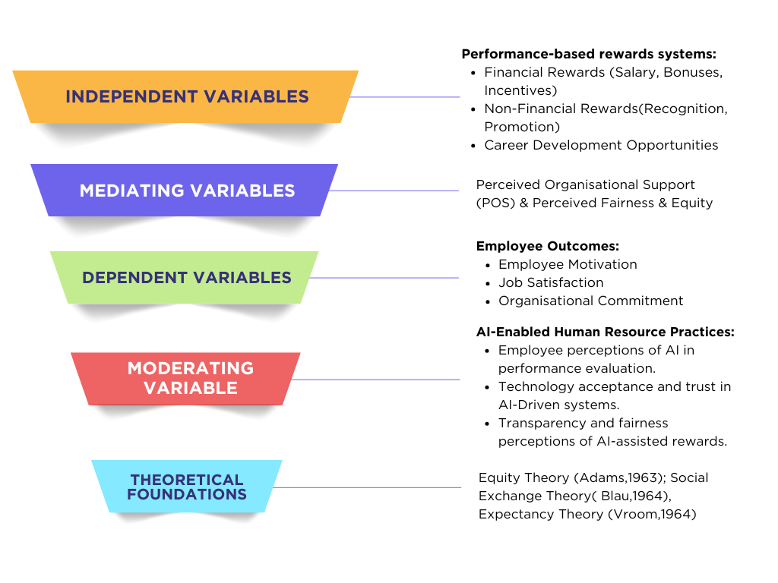

Fig: 01 Proposed Conceptual Framework (Self-Created)
Advantages of the framework:
1. Offers Clarity and Structure: This framework clearly defines all the variables used in the study and explains how they interact, ensuring that the researcher stays focussed and organises the research (Creswell, 2017; Moschis, 2024).
2. Enhances Theoretical Base: This framework relies on such well-known theories as Equity Theory, Social Exchange Theory, and Expectancy Theory, thus increasing reliability of the study (Saunders et al., 2019).
3. Assists Data Analysis: This framework aids in formulating hypotheses and using proper statistical analysis to analyse the interaction between rewards, organisational support, AI-Enabled HR practices, and employees' outcomes (Karatepe & Vatankhah, 2014; Vroom, 1964).
Disadvantages of Using the Conceptual Framework
1.May Over-Simplify Complex Relations: This model may not be able to incorporate various other factors like organizational culture, individual differences, working environment, which also affect employees’ behavior and attitudes (Wirtz et al., 2008).
2. May Limit Unforeseen Findings: As this model is based on previous theories, it may limit new discoveries made during research (Saunders et al., 2019).

9. METHODOLOGY

Research Method
Research methodology provides a systematic framework for selecting research design, data collection methods, and analytical techniques to ensure valid, reliable, and credible findings (Dawson, 2019). This study adopts a structured methodological approach to examine the relationship between performance-based rewards, employee perceptions, organisational support, and Human-AI synergy at Qatar Airways, ensuring that the findings are evidence-based, reliable, and aligned with the research objectives (Saunders et al., 2019).

Research Onion
The Research Onion model offers an organized way to conduct research (Saunders et al., 2009). Some of its main components include research philosophy, research approach, research strategy, data collection method, data analysis technique, and timeline (Saunders et al., 2019). This model is used in this study to present the effect of performance reward on the perceptions and organizational support and Human-AI synergy in Qatar Airways.
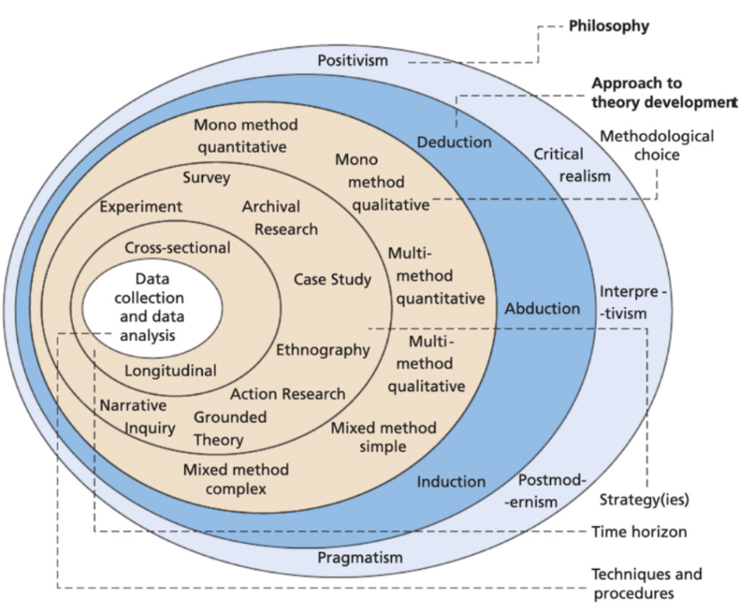

Fig: 02 The Research Onion (Saunders et al., 2009)

CHOICES
Quantitative Research
Quantitative research uses numerical data from primary and secondary sources to identify patterns, measure relationships, and produce objective findings through statistical analysis (Saunders et al., 2019). It is appropriate for examining the relationship between performance-based rewards and employee outcomes using observable evidence (Creswell, 2017).

Mono Method Quantitative Research
This study adopts a mono-method quantitative approach, relying on numerical data and statistical analysis to examine the impact of performance-based rewards on employee motivation, job satisfaction, organisational commitment, and perceived organisational support (Creswell, 2017). Data will be collected through surveys and analysed using statistical techniques to identify relationships between variables, providing reliable, objective, and evidence-based findings on employee outcomes at Qatar Airways (Saunders et al., 2019).
Time Horizons- Cross-Sectional
A cross-sectional time horizon examines individuals or groups at a single point in time to identify relationships, differences, and patterns (Creswell & Creswell, 2017). This approach enables researchers to collect and analyse data efficiently, providing insights into employee perceptions and organisational support (Saunders et al., 2019). It is appropriate for assessing current employee perceptions of performance-based rewards at Qatar Airways and their relationship with employee outcomes (Yao et al., 2026).

10. DATA COLLECTION AND ANALYSIS

Data Collection Method
Primary data will be collected through an online questionnaire administered using Microsoft Forms, with approximately 10-15 closed-ended questions expected to take 10-15 minutes to complete (Saunders et al., 2019). All responses will be measured using a five-point Likert scale ranging from "Strongly Disagree" to "Strongly Agree" to ensure consistency and facilitate quantitative analysis (Creswell, 2017).

Sampling Size
This research will involve a sample size of 100 participants employed across a range of departments at Qatar Airways, including flight operations, cabin crew, ground services, maintenance, and administrative functions (Saunders et al., 2019). This sample size allows for meaningful statistical analysis while remaining practical for data collection within the available timeframe.
Sample Type (Demographic & Geographic)
The study will include participants of both genders, aged between 20 and 60 years, with varying levels of occupation, job positions, and departmental backgrounds at Qatar Airways (Yao et al., 2026). Geographically, all individuals are from Qatar Airways’ operations based in Doha, Qatar, because the primary hub for this airline is located there. Using different demographic characteristics enables the researcher to find out if the connection between reward systems and employee performance differs among various groups of employees (Han & Bi, 2024).
Sampling Method
This study will use a non-probability convenience sampling method. Participants will be identified through professional networks, LinkedIn, WhatsApp groups, and personal contacts of the researcher. The online questionnaire will be distributed to Qatar Airways employees through the researcher's professional networks and online communication platforms. Convenience sampling is suitable because it enables efficient data collection within the available time and resource constraints (Saunders et al., 2019).
Data Collection Process
Primary data will be collected within a four-week timeframe upon approval from the University's Research Ethics Committee. The survey will be shared through email to the Qatar Airways employees who are employed in various departments such as cabin crew, ground services, administration, engineering, and customer services. This will be on voluntary and anonymous basis through the process of informed consent.
Analysis of Data
The quantitative approach, together with Microsoft Excel will assist in organizing, calculating, and interpreting the information obtained through analysis. It will also help in understanding the relationship that exists between the different variables. Analysis will further aid in identifying the differences that exist between different groups of participants (Creswell, 2017).

11. RESEARCH ETHICS

Research ethics refers to the ethics and rules that govern the ethics in the conduct of research with the intention of protecting the interests and well-being of those involved in the research. It involves a set of rules that the researcher is expected to adhere to in order to maintain the integrity and dignity of the research (Smith & Johnson, 2015). With regard to this particular research, the researcher will make sure that all primary data collected will be kept confidential.

11. RESOURCES AND PLANNING

The Gantt progress chart allows the researcher to maintain visibility on commitments, focus on overcoming challenges and preventing delays, and provide timely communication in cases where commitments cannot be met (Geraldi, 2012). To enhance the structure of the research concerning the relationship between performance-based rewards, employee perceptions, organisational support, and Human-AI synergy at Qatar Airways, a Gantt Chart has been developed to visually illustrate the project's timeline and facilitate effective task coordination.
The following Gantt Chart has been created for the timeline of 08th June 2026 – 18th September 2026.

Fig: 03 Personal Gantt Chart (Self-Created)

REFERENCES

Adams, J. S. (1963). Towards an understanding of inequity. Journal of Abnormal and Social Psychology, 67(5), 422-436.
Anvari, R., 2024, October. Enhancing Team Performance Through Emotional Intelligence Leadership: A Digital Management and Artificial Inteligence Perspective in Qatar Airways. In International Scientific-Practical Conference (pp. 302-309). Cham: Springer Nature Switzerland.
Blau, P. M. (1964). Exchange and power in social life. Transaction Publishers.
Creswell, J.W. and Creswell, J.D., 2017. Research design: Qualitative, quantitative, and mixed methods approaches. Sage publications.
Chen, F. R., Lu, M. Y., Ko, W. H., & Liu, C. H. (2025). Creating airlines' innovation: linking employees' perspective of service quality, intellectual capital and innovation performance. Technology Analysis & Strategic Management, 37(12), 3530-3546.
Davenport, T. H., & Ronanki, R. (2018). Artificial intelligence for the real world. Harvard Business Review, 96(1), 108–116.
Dawson, C. (2019). Introduction to research methods : a practical guide for anyone undertaking a research project (5th ed.).p.160. 1408711044, 9781408711040. https://books.google.co.uk/books?id=pu5MDwAAQBAJ
Gittell, J.H., Von Nordenflycht, A. and Kochan, T.A., 2004. Mutual gains or zero sum? Labor relations and firm performance in the airline industry. Ilr Review, 57(2), pp.163-180.
Geraldi, Joana & Lechter, Thomas. (2012). Gantt charts revisited: A critical analysis of its roots and implications to the management of projects today. International Journal of Managing Projects in Business. 5. 10.1108/17538371211268889.
Han, T. Y., & Bi, J. W. (2024). Exploring the asymmetric relationships between satisfaction factors and overall employee satisfaction in the airline industry. Current Issues in Tourism, 27(14), 2325-2344.
Kim, M. J., & Park, Y. J. (2025). Building sustainable organizational citizenship behavior in hospitality: Structural relationships of rapport, trust, and psychological capital among airline cabin crew. Sustainability, 17(23), 10804.
Karatepe, O. M., & Vatankhah, S. (2014). The effects of high-performance work practices on perceived organizational support and turnover intentions: Evidence from the airline industry. Journal of Human Resources in Hospitality & Tourism, 13(2), 103-119.
Moschis, George. (2024). Conceptual Framework and Theory Development. 10.1007/978-3-031-56548-9_5.
Mansour, S., Nogues, S., & Tremblay, D. G. (2022). Psychosocial safety climate as a mediator between high-performance work practices and service recovery performance: an international study in the airline industry. The International Journal of Human Resource Management, 33(21), 4215-4250.
Suthatorn, P., & Charoensukmongkol, P. (2025). Cabin crew members' experience with management's bottom-line mentality during airline restructuring: Moderating effects of self-sacrifice leadership and performance-based rewards. Asia Pacific Management Review, 100382.
Saunders, M., Lewis, P., & Thornhill, A. (2019). Research methods for business students (8th ed.). Pearson.
Saunders, M., Lewis, P. and Thornhill, A., 2009. Research methods for business students. Pearson education.
Smith, J., & Johnson, L. (2017). Secondary data analysis in educational research: A guide for researchers. Harvard University Press.
Smith, J., & Johnson, R. (2015). Understanding research ethics: A comprehensive guide. Harvard University Press.
Tambe, P., Cappelli, P., & Yakubovich, V. (2019). Artificial Intelligence in Human Resources Management: Challenges and a Path Forward. California Management Review, 61, 15-42. https://doi.org/10.1177/0008125619867910
Vatankhah, S., Javid, E., & Raoofi, A. (2017). Perceived organizational support as the mediator of the relationships between high-performance work practices and counterproductive work behavior. Journal of Air Transport Management, 59, 107-115.
Vroom, V. H. (1964). Work and motivation. Wiley.
Wirtz, Jochen, Heracleous, Loizos Th. and Pangarkar, Nitin (2008) Managing human resources for service excellence and cost effectiveness at Singapore Airlines. Managing Service Quality, Vol.18 (No.1). pp. 4-19. doi:10.1108/09604520810842812 ISSN 0960-4529.
Yin, R. K. (2018). Case study research and applications: Design and methods (6th ed.). Sage Publications.
Yao, Y., Han, T. Y., & Yang, Y. (2026). Dynamic asymmetry relationship between employee satisfaction and its influencing factors: Evidence from the airline industry. Journal of Quality Assurance in Hospitality & Tourism, 27(1), 133-151

