

BA BUSINESS MANAGEMENT
Assignment 1

Module: Introducing the Modern Workplace
Code: LCBB4003
Lecturer: Hoang Dang Nguyen
Name: Silvia Bounegru
Student ID: 2132530

SUBMITTED ON THE 6th January 2023

Assignment Title:
Organizational structure and culture in Airline Industry

Contents
Introduction 3
An overview of British Airways 3
Organization structure and culture 4
Impact of structure and culture on the performance of British Airways 4
SWOT analysis of British Airways 6
Impact of culture on employees' behaviour at British Airways 7
Impact of structure on employees' behaviour of British Airways 8
Impact of motivation on employee behaviour of British Airways 9
Conclusion 10
References 11

Introduction
In every organization, some factors can influence the overall performance of an organization. Organizational structure is one of them which includes the operational hierarchy. The behaviour of employees depends on the organization's structure (Buchanan and Huczynski, 2019). A combination of norms, ethics, and way of behaviour within an organization is known as organizational culture. It has a great influence on the overall performance of an organization. Motivational factors also impact employee behaviour. There is a strong relationship between structure, culture, people, and organizational performance. In this study, organizational structure and culture along with their impact on employees' performance are described. An overview of British Airways which is a UK-based company is included. SWOT analysis of British Airway is also a part of this paper. Three important factors influence the achievement of organizational goals. These are organizational structure, organizational culture, and individual motivation. The impact of these factors on employees' behaviour is also described in this paper.

An overview of British Airways
British Airways is one of the biggest and most successful airlines operating in the United Kingdom to date. It provides global services. The headquarters of British Airlines is located in London. It is the second large UK-based airline. They are extremely popular for their excellent service. The airline ensures customer comfort, loyalty programs, and diverse types of services to satisfy its customer (Jackson and Tozer, 2020). British Airways is part of the International Airlines Group, and it was founded in 1974, because of the merger of four companies. Serving people and the world is at the heart of everything they do. It flies over 200 destinations and sometimes has frequent flyer programs. In order to achieve its vision, the company aims to become an airline with the best reputation for responsibility. The company tries to ensure creativity and diversity in its performance. They are overly concerned about focus and differentiation. The company often practised an autocratic leadership style (Al-Ansari, 2017). Strong brand value is one of the strengths of British Airways. The company motivates its employees by ensuring a strong network within the organization. They offer many options for their employees to ensure flexibility. Sometimes they allow job sharing or work from home. Effective communication and organisation skills are needed to work at British Airways. The organizational culture of British Airways helps to motivate its employees.

Organization structure and culture
The organizational structure includes allocation, coordination, and supervision of activities in a systematic manner. It is a system that determines the operation of some moves within an organization to achieve its goal. An organisation's structure includes rules, roles, and obligations. It determines the flow of information in an organization. Organizational structure also helps businesses in the decision-making process. A business can make better decisions by ensuring the participation of lower-level employees. It also helps to improve relationships within an organization. Organizational structure has a great influence on the overall performance of an organization. Organizational culture is an important factor for business success. Organizational culture can be defined as the collection of values, practices, norms, and expectations practised in an organization. These cultures are known to all the personnel within an organization. If an organization's culture seems positive towards employees, it will lead to improved performance. Cultures practised in an organization are not written. Culture can be identified by observing how a CEO responds to a crisis, how an organization meets customer demand, how managers treat their employees, and how employees serve their customers. Organizational culture can influence all aspects of a business. Culture can ensure employee satisfaction. Alignment, appreciation, performance, trust, integrity, innovation, teamwork, and psychological safety are some qualities of a positive organizational culture.

Impact of structure and culture on the performance of British Airways
The organizational structure ensures clarity at all levels of a company. All the employees get better opportunities in an organization that has a good structure. Centralization makes complexity and can cause job dissatisfaction. Decentralization is a process that gives opportunities to the right people in right place. Specialization helps employees to adapt to changing situations. Clear job descriptions and organizational structure help employees to manage their work properly.
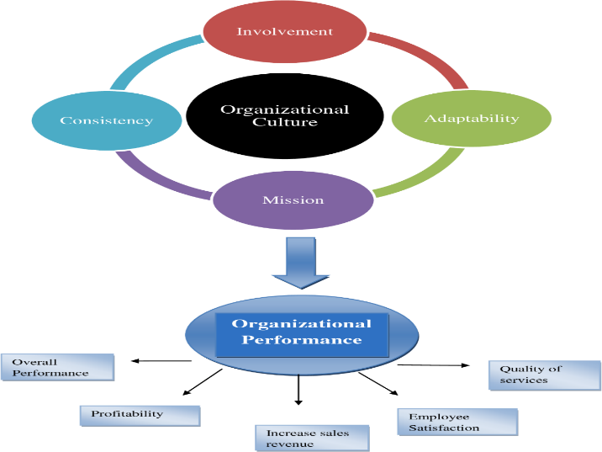
Figure 1: Impact of culture on employee behaviour at British Airways (Ogbeibu et al., 2018)

Organizational structure also influences employee performance through target sales, output, profit margin determination and the process of project management of British Airways Moreover, the organizational structure has an impact on communication regarding project decisions The employee performance of British Airways can be attributed to a variety of factors, including knowledge management, e-commerce, team empowerment, creative thinking, and organizational culture.
The distributions of Power among employees happen by following organizational structure. Organizational culture has a significant influence on employees' effectiveness at British Airways. All companies have their own organizational culture which may differ from other organizations. A positive and favourable organization can influence the overall performance of an organization.
It also ensures employee engagement and improves their experience. Organizational cultures improve their employees' commitment to the organization, they try to make their customers satisfied to earn profit. It is also helpful to increase sales revenue. They always try to ensure the quality of service. The better the organizational culture the higher the motivational level of employees. A positive organizational culture accomplishes and rewards its employees. It creates a positive impression of employees toward their organization. If the culture is hostile, it may lead to employee dissatisfaction. It can impact productivity levels. Besides, due to employee dissatisfaction, the turnover rate may increase. An unfavourable culture can disconnect employees from their workplace. So, organizational culture and structure have a direct and active role in the overall performance of an organization.

SWOT analysis of British Airways
SWOT analysis reflects an organisation's strengths, weaknesses, opportunities, and threats. Safety, sustainability, Brand name, technological strengths, international routes, and strong partnerships are some strengths of British Airways (Gupta et al., 2019). The company is trying to become a sustainable brand. The company is investing more in customer satisfaction. They have the plan to go zero carbon by 2050. They are trying to reduce carbon waste. That's why British Airways adding more planes that are fuel efficient.
The company needs to maintain these strengths to compete in the global market. Rolls Royce Engine, revenue dependency on the local market, and issues with human resources are some weaknesses of British Airways (Tan, 2019). Rolls-Royce engines generate many problems in the airline. Due to this engine, punctuality, and availability of British Airways are reduced. Though the company is very concerned about its employees, over time different problems arise. The company has to overcome its weaknesses regarding the engine, dependency on the local market, and human resources.
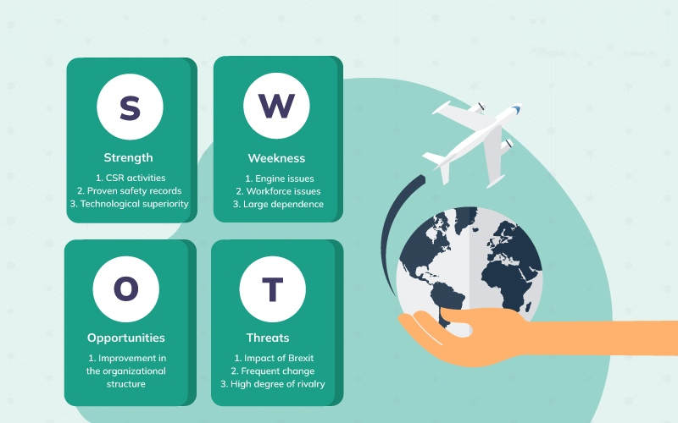
Figure: SWOT analysis of British Airways (Gupta et al., 2019)
There are a lot of opportunities for the organization. Expansion of service, technological advancement, and serving the international market are some of them. Due to the COVID-19 pandemic, the company has to face a lot of difficulties (Hamawandy et al., 2021). Competition in the market, regulatory factors, and Brexit are some threats facing British Airlines. The organization should grab these opportunities to achieve organizational goals.

Impact of culture on employees' behaviour at British Airways
Organizational culture includes the proper way of behaviour within an organization. Organizational culture has a great influence on organizational performance. Culture ensures involvement, consistency, mission, and adaptability which make an organization able to increase the overall performance of an organization. British Airways' rules, beliefs, and procedures of organizing themselves can be defined as their organizational culture. They follow a hierarchy system, passing information from top-level management to lower-level management. There are four types of culture according to Charles Handy.
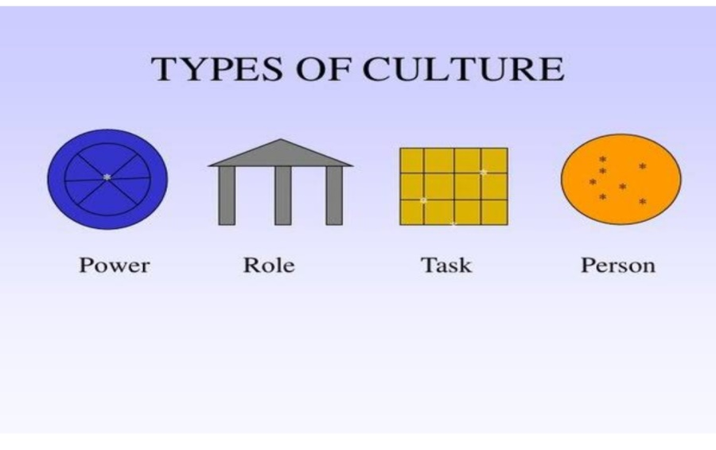
Figure: Charles Handys, types of culture (SILVA and SIMÕES, 2019)
These are power, task, role, and person. British Airways practice both role and task culture (O’Neill, 2018). Role culture is a culture that emphasizes following strict rules and procedures. Everyone knows about their position, duties, and responsibilities in the hierarchy. They follow this role culture within their organization. Task culture is a culture of forming a team for completing a special task. Task culture ensures employee satisfaction as they get the opportunity to lead others. People of different ages, sex, ethnicity, and religion work at British Airways. The company always tries to treat its employees without any discrimination. The health and safety of its employees are important factors maintained by British Airways (Gakhal, 2017). They are very concerned about their employees and customer. They make sure the safety of the flight by checking the plan twice before starting. These all things make their employees feel important.

Impact of structure on employees' behaviour at British Airways
British airways` organizational structure has a great influence on employee behaviour. Employee behaviour is the reflection of employees' perception of an organization. Organizational structure helps an organization achieve its goal. The British airline is a private limited company that is controlled by its shareholders, without any involvement by the government. There are different types of organizational structures practised all over the world. Functional, flat, matrix and multi-divisional structures are some of them. British Airways has a flat structure (Jarvis, 2014). There are a small number of management levels, but the span of control is wide. The company also follows a divisional structure mainly as their business is customer based. It helps to ensure efficiency. But the company faces problems as there is a lot of work under a few managers. Managers have a large number of subordinates which is tough to maintain. Subordinates have to report to their manager, increasing the workload of both manager and employee. Employees feel insecure regarding their job. It may decrease productivity. Organizational structure plays a vital role in ensuring employee satisfaction. In airways, it is also noticed. The employee who is not satisfied will not contribute properly. Autocratic leadership is practised in British airways. Employees will be satisfied if they get their expected chain of command in the organizational structure. The participation of employees can be ensured by practising a multi-divisional structure. So, it can be concluded that organizational structure works as a blueprint within an organization and greatly influences employees' behaviour.

Impact of motivation on employee behaviour of British Airways
Motivation is an effective tool to improve employees' performance. Without motivation, productivity cannot be increased. The motivational factor may vary from person to person. Maslow's hierarchy of needs and Herzberg's Tow factor theory are important for employees' motivation for British Airways (Pinder, 2014). Every organization strives to create an environment in which employees can work in a relaxed atmosphere. Therefore, an organization should determine its organizational structure to reduce workplace tension. As part of the management of the work environment, health and safety issues are also critical factors to consider. If British Airways formulate the proper job design and ensure job security, the overall performance of employees will be increased. Satisfied employees are more productive. As British Airways follows flat culture, they should encourage teamwork to ensure strong relationships and communication skills. British Airways should focus on recognition and rewards to motivate their employees. It will increase healthy competition among workers. Management in British Airways can engage their employees in decision-making. Though it's lengthy, it will ensure employees' job satisfaction. The employee will be loyal. Absenteeism and turnover rate of employees will be reduced. The proper implication of motivating tools can ensure employee involvement and job satisfaction. So, the motivation factor has a great influence on employee behaviour.

Conclusion
As organizational structure and culture affect its performance, an organization should be careful about these factors. A suitable organizational structure should be determined. Cultural issues should be managed properly. Without a strong organizational structure and culture, no company can succeed in this competitive business world. Employees are the driving force of a company. Companies should value them. Motivation is an important tool to ensure job satisfaction. Evaluating the nature and position of employees’ motivation should be given. British Airways should give more focus to their employees. Employees are the driving force of a company. Organizational structure, culture, and motivation influence the behaviour of employees. Organizations should properly manage these factors to achieve its goal.

References
Al-Ansari, S., 2017. Impact of Leadership Style on Motivational Level among Employees with Multi-ethnic Working Environment (Doctoral dissertation, Anglia Ruskin University).
Buchanan, D.A. and Huczynski, A.A., 2019. Organizational behaviour. Pearson UK.
Gakhal, R., 2017. British Airways: Drug and alcohol policy. In Addiction at Work (pp. 267-270). Routledge.
Gupta, A., Gupta, N. and Gupta, M., 2019. British Airways-A SWOT and PESTLE Analysis-The impact of Europe 2020 policy. NOLEGEIN-Journal of Corporate & Business Laws, 1(1), pp.1-11.
Hamawandy, N.M., Ali, R., Bewani, H.A.W.A., bdulmajeed Jamil, D., Rahman, S.K. and Othman, B.J., 2021. The financial Impacts of (COVID-19) on financial reporting quality Airlines Companies: British Airlines. Journal of Contemporary Issues in Business and Government Vol, 27(2).
Jackson, S. and Tozer, J., 2020. A vision for data science at British Airways. Impact, 2020(1), pp.15-19.
Jarvis, P., 2014. British Airways: An Illustrated History. Amberley Publishing Limited.
O’Neill, B., 2018. Developing future leaders at British Airways. In The Photofit Manager (pp. 72-89). Routledge.
Ogbeibu, S., Senadjki, A. and Gaskin, J., 2018. The moderating effect of benevolence on the impact of organisational culture on employee creativity. Journal of Business Research, 90, pp.334-346.
Pinder, C. C., 2014. Work motivation in organizational behaviour. New York: Psychology Press.
SILVA, M.D.C. and SIMÕES GOMES, C.F., 2019. ALIGNED PROJECT MANAGEMENT PRACTICES TO ORGANIZATIONAL CULTURE TYPOLOGIES. Annals of the Faculty of Engineering Hunedoara-International Journal of Engineering, 17(3).
Tan, L., 2019. CorporateMetrics Methodology Application for the Market Risk Quantification in British Airways Company.

