

Industrial Vehicle Pedestrian Detection
Major Project 2019
Major Project
M6X00417
Supervisor: Dr Rachel Alexander

B.Eng (Hons) Manufacturing Systems Engineering
Ashley Bishop
P151990

I. Statement of Authenticity

"This thesis is the result of the author’s original research. It has been composed by the author and has not been previously submitted for examination which has led to the award of a degree."

Signed: Date: 3rd May 2019
Print: A. Bishop Student Number: P151990

II. Acknowledgements

Throughout the writing of this dissertation, I have called upon the support and guidance multiple times from many technical specialists, colleagues and friends. Firstly, I would like to acknowledge and thank the project team, all of whom have helped with gathering technical data, research and helping with general project advancement.
I would also like to thank my supervisor, Dr Rachel Alexander for her support and guidance throughout the entirety of the project.
Finally, I would like to thank my partner Mikaela for being an immense support throughout the whole of the degree and most recently being so encouraging and motivational throughout the dissertation.

III. Abstract

Following an accident involving an industrial vehicle and a pedestrian in 2018, a rising number of near misses between pedestrians and vehicles was identified at Ford Motor Company’s Bridgend Engine Plant. The cause of the rise was found to be due to a number of reasons however the aim of this project was to eliminate the scenario of vehicles and pedestrians coming into contact with each other by designing an innovative detection system.
The project focuses on designing a new detection system, developing software and hardware which can be combined so that it is capable of detecting pedestrians and obstructions that could be retrofitted to existing industrial vehicles within the Engine Plant.
A literature review was carried out to fill any existing gaps and lack of in the authors current knowledge. Data was collected from a variety of sources and the main problem attributed to the near misses was the associated blind spots on modern industrial vehicles.
Following data analysis, it was decided that an innovative cutting-edge solution would be developed with the intention of eliminating the blind spots on industrial vehicles. Many new and older technologies were explored, from which three were amalgamated into a brand-new product.
A prototype was developed; however, it did not have the ability to be fitted to a vehicle at the time of writing due to unforeseen problems. More development would be needed however the system did work as intended albeit a simplified version of the project teams’ vision.
Although the projects main objective was to make the plant a safer workplace, it also has the ability of saving over £4,000,000 in costs that could potentially be lost due to an accident occurring if full implementation was carried out.

V. Table of Contents
I. Statement of Authenticity 1
II. Acknowledgements 2
III. Abstract 3
VI. Table of Figures 7
VII. Table of Tables 9
1.0 Introduction to the Project and Bridgend Engine Plant 10
1.1 Introduction to the Problem 11
1.2 Bridgend Engine Plant (BEP) 11
1.3 The Project Team 12
1.4 Timing Plan 13
2.0 Define: Evidence of the Problem 15
2.1 Industrial Vehicles in Operation at BEP 16
2.2 February 2018 Accident 17
2.3 Vehicle Damage 17
2.4 Plant Damage 18
2.5 Consequences of the Problem 18
2.6 Aims and Objectives of the Project 19
2.7 Voice of the Customer 20
2.7.1 Internal Customer 20
2.7.2 External Customers 20
2.7.3 Voice of Customer (VOC) Statement 20
3.0 Literature Review 21
3.1 Purpose of Literature Review 22
3.2 Health and Safety at Work 23
3.3 Levels of Automation 24
3.4 Autonomous Industrial Vehicles 25
3.4.1 Automated Guided Vehicles (AGV’s) 25
3.4.2 Vision Guided Vehicles (VGV’s) 26
3.5 Six Sigma Methodologies and Tools 27
3.5.1 DMAIC 27
3.5.2 DMEDI 27
3.5.3 Quality Function Deployment (QFD) 29
3.5.4 Failure Mode and Effects Analysis (FMEA) 30
3.5.5 The 5S’s 31
3.5.6 Critical to Quality (CTQ) 34
3.5.7 Root Cause - 5 Why’s Analysis and Cause and Effect Diagrams 35
3.5 Management of Change Culture 36
4.0 Measure: Data Collection 37
4.1 Cause and Effect Diagram 38
4.2 Data Collection Plan 39
4.2.1 What data will be collected? 39
4.2.2 Why is the data needed? 40
4.2.3 Who is responsible for the data collection? 41
4.2.4 How will the data be collected? 41
4.2.5 When will the data be collected by? 42
4.2.6 Where will the data be collected from? 42
4.3 Data Collection Results 42
4.3.1 BEP Near Miss Data 42
4.3.2 BEP Collision Data 45
4.3.3 Data Collection Questionnaire 46
4.3.4 The Health and Safety Executive (HSE) Accident Data 51
4.3.5 Accident Cost Data 53
4.3.6 Collision Cost Data 55
5.0 Explore: Current Technologies 56
5.1 Data Impact 57
5.2 FMEA 58
5.3 Root Cause Analysis 59
5.3.1 Proposed Corrective Action 62
5.4 Current Detection Systems 64
5.4.1 You Only Look Once (YOLO) Real-Time Object Detection 64
5.4.2 Amazon DeepLens 66
5.4.3 Radio Frequency Identification (RFID) 67
5.4.4 Radio Detection and Ranging (RADAR) 68
5.4.5 Light Detection and Ranging (LIDAR) 69
5.4.6 Ultrasonic Sensing Systems 70
5.4.7 Arduino 72
5.5 Conclusion and Relevance 73
6.0 Develop: Detailed Design 74
6.1 Action Plan 75
6.2 Setting up the Arduino 75
6.3 Setting up of the YOLO 77
6.4 Training of the YOLO 78
6.5 Setting up of the Ultrasonic Sensor 82
6.6 Combining the Development 87
7.0 Implement: Final Design 88
7.1 Implementation of the Prototype 89
7.2 Monitoring Plan 90
7.3 Reaction Plan 91
7.4 Change Management and Culture Control 92
8.0 Conclusion and Recommendations 93
8.1 Potential Cost Savings of the Project 94
8.2 Project Conclusion 95
8.3 Recommendations 98
8.3.1 Short Term 98
8.3.1 Long Term 98
9.0 References 99

VI. Table of Figures
Figure 1 – The BEP Project Team 11
Figure 2 - Project Gantt Chart 13
Figure 3 - Selection of Industrial Vehicles within BEP 15
Figure 4 - Vehicles Showing Signs of Damage 16
Figure 5 - Pedestrian Barriers and Bollards Showing Signs of Damage 17
Figure 6 - Levels of Automation (Blain, 2017) 23
Figure 7 - Automatic Guided Vehicle (Turck Trucks, 1999) 25
Figure 8 - Five stages of the DMAIC Methodology (Lean Six Sigma Training Ireland, 2017) 26
Figure 9 - House of Quality Template (Master of Project Academy, 2018) 29
Figure 10 - FMEA Template (Six Sigma DSI, 2019) 30
Figure 11 - 5S Diagram (The Lean Accountants, 2011) 31
Figure 12 - Ford Pedestrian and Vehicle Safety Marking Program (John, 2019) 32
Figure 13 - The Kano Model (Mind Tools, 2018) 33
Figure 14 - Near Miss Occurrence Cause and Effect Diagram 37
Figure 15 - BEP Near Miss Report 41
Figure 16 - Graph Showing Increasing Near Misses 42
Figure 17 - MP&L Questionnaire 45
Figure 18 - Q1 Have You Ever Had A Near Miss with a Pedestrian Results 47
Figure 19 - Q1 Did You Enter Near Miss Report Results 48
Figure 20 - Q2 Reasons for Increase in Near Misses Results 49
Figure 21 - Q3 Ideas to Reduce Near Misses Results 50
Figure 22 - Main Kinds of Fatal Accidents for Workers 2017/18 (RIDDOR, 2018) 51
Figure 23 - Fatal Injuries to Workers by Accident Kind 2013/14-2017/18 (HSE, 2018) 51
Figure 24 - Total Estimated Cost of Fatal and Non-Fatal Injuries (HSE, 2018) 53
Figure 25 - Why Tree 60
Figure 26 - BEP Fork Truck 61
Figure 27 - Pedestrians Stood Around FLT in Blind Spots 62
Figure 28 - Drivers View of Pedestrians Hidden in Blind Spots 62
Figure 29 - Yolo Grid Detection (Ying, 2018) 63
Figure 30 - Yolo Logic Regression (Redmon & Ali, 2018) 64
Figure 31 - Amazon DeepLens Architecture (AWS, 2019) 65
Figure 32 - How RFID Works (Narayanan et al., 2005) 66
Figure 33 - How RADAR Works (Spanawave, 2015) 67
Figure 34 - Calculating the Distance of an Object Using LIDAR (Eckhardt Optics LLC , 2019) 68
Figure 35 - How an Ultrasonic Senor Works (ElectronicWings, 2019) 69
Figure 36 - Arduino IDE (Ardunio, 2019) 71
Figure 37 - Arduino PCB (Ardunio, 2019) 71
Figure 38 - Arduino UNO PCB bought by BEP 74
Figure 39 - Downloading Arduino IDE Software (Ardunio, 2019) 75
Figure 40 - Arduino PCB Powering Up 75
Figure 41 - CUDA GPU Dependency Installation Page 76
Figure 42 - Cloning the Darknet Git Repository 76
Figure 43 - Errors downloading Darknet to Arduino 77
Figure 44 - Downloading the OpenCV Weight Library 78
Figure 45 - Running the Weight Library Train Command 78
Figure 46 - Webcam to Arduino Wiring Diagram 78
Figure 47 - Webcam Being Wired to Arduino PCB 78
Figure 48 - Testing the YOLO Software 79
Figure 49 - Calibrating the Camera 79
Figure 50 - YOLO Software Test Showing Response 80
Figure 51 - Diagram showing Ultrasonic Sensors Required 81
Figure 52 - Pin Outs for Ultrasonic Sensor (Santos, 2019) 81
Figure 53 - Wiring Schematic of Ultrasonic Sensor (Santos, 2019) 82
Figure 54 - Setting up of the Ultrasonic Sensor 82
Figure 55 - Code for the Ultrasonic Sensor (Santos, 2019) 83
Figure 56 - Creating Variables for Trigger and Echo (Santos, 2019) 84
Figure 57 - Loop Sequence for the Ultrasonic Sensor (Santos, 2019) 84
Figure 58 - Converting Time into Distance (Santos, 2019) 85
Figure 59 - Final Combined Wiring Diagram 86
Figure 60 - Electronics Personnel Carrier 88
Figure 61 - Reaction Plan 90

VII. Table of Tables
Table 1 - Total Number of Vehicle Types Operating in BEP (Allen, 2019) 14
Table 2 - Number of Near Misses Per Year 41
Table 3 - Reasons for Near Misses 42
Table 4 - FactoryVision Collison Data 43
Table 5 - Statistically Significant Test 45
Table 6 - Number of Fatalities per Accident Kind 2013-2018 (HSE, 2018) 50
Table 7 - Number of Non-Fatal Injuries per Accident Kind 2017-2018 (HSE, 2018) 51
Table 8 - Total Lease Costs for Vehicles in BEP (Allen, 2019) 53
Table 9 - Total Estimated Vehicle Damage Charges 53
Table 10 - FMEA Table 56
Table 11 - Development Action Plan 73
Table 12 - Monitoring Plan 88

1
2
3
4
5
6
7
8
9
10
11

1.0 Introduction to the Project and Bridgend Engine Plant

1.1 Introduction to the Problem

All fatalities and certain non-fatal injuries which are serious within the UK must be reported by employers to the Enforcing Authorities under the Reporting of Injuries, Diseases and Dangerous Occurrences Regulations (RIDDOR) (HSE, 2018).
In the working year 2017/18 there were 71,062 such reported incidents. It is however known by the Health and Safety Executive (HSE) that RIDDOR defined non-fatal injuries to employees are substantially under-reported by employers, with current levels of reporting estimated at around a half. This means that statics for injuries caused by moving vehicles are often less accurate than it would seem. Despite long term reductions in the number of workers injured each year, the kinds of accidents remain similar year on year (HSE, 2018).
Within Ford Motor Company’s Bridgend Engine Plant (BEP) the problem is that there is an ever-increasing number of near misses between vehicles and pedestrians. It has also been noted by management that there has been an increase in damage to barriers and stanchions caused by vehicles in plant. This had led to a concern that someone could come into contact with and vehicle and could get seriously injured unless a root cause is found and a solution provided.
This project has been requested by the senior management of BEP with a goal to investigate why near misses are occurring and what can be done to combat this in order to protect employees from a potential accident.

1.2 Bridgend Engine Plant (BEP)

Bridgend Engine Plant (BEP) is an engine manufacturing plant, part of the manufacturing arm of Ford of Europe. The purpose-built manufacturing facility opened in 1980 at a cost of over £200m and it has since produced over 20 Million engines for a wide customer base including Aston Martin, Volvo and Mazda.
BEP currently employs just over 1600 personnel who are split between hourly and salaried, along with several hundred contractors. Working 365 days a year, the plant currently produces three different petrol engines, with each engine having its own machining and assembly lines which produce different small capacity variants of engines for Ford Motor Company and two different variants of larger capacity petrol engines for Jaguar Land Rover. Currently engines are sent world-wide. At its peak in 2014, BEP was producing over 750,000 engines annually.

1.3 The Project Team
The Project team is made up of six individuals and two departments, all working within BEP. The role of the Project Champion, the author of this report, will ultimately be to carry out the research, investigation and any subsequent development or recommendation aspects of the project. Mark Thomas and Hugh Davies, both level 5 leadership managers will hold managerial roles and will be ensuring timeframes and budgets are adhered to. Phil Morton and Simon Matthews, both engineers will be a source of vast amounts of information. They have copious amounts of experience in their respected fields and therefore will provide information and guidance to the Project Champion. Keith Allen, the current plant fleet engineer will again provide expertise and guidance where necessary. As fleet engineer, his day to day role involves working with plant vehicles. Any recommendations concluded by this report will then be cascaded down to the relevant departments including Health and Safety (H&S) and South Wales Fork Trucks (SWFT).
Mark Thomas
Non-Production Area Manager
Hugh Davies
Plant Safety Manager
Phil Morton
Future Technologies Engineer
Simon Matthews
Safety Engineer
Keith Allen
Plant Fleet Engineer
Ashley Bishop
Project Champion
Health and Safety
3 Members
South Wales Fork Trucks
2 Members
Figure 1 – The BEP Project Team

1.4 Timing Plan

The project will be undertaken during the 2018/2019 academic year. The timing frame is agreed with work Managers from the Project team and University Project Tutors in advance. The purpose of a Gantt Chart (See Figure 2) is to portray a high-level overview of the project schedule (ISIXSIGMA, 2018).

Due to the time pressured sensitiveness of the project, the Gantt Chart will be vitally important to ensure that tasks are completed on time so that the outcomes of the project can be achieved.
Figure 2 - Project Gantt Chart

1
2
3
4
5
6
7
8
9
10
11

2.0 Define: Evidence of the Problem

2.1 Industrial Vehicles in Operation at BEP

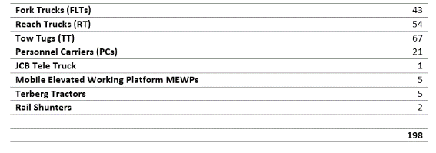
Within BEP there are up to a total of 198 industrial vehicles operating at any one time over an internal road network of nearly six miles and an external road surface of 3 miles. These vehicles also include Rail Shunters which are used to move rolling rail stock within the 1.5 miles of rail track within the BEP perimeter. These figures do not include contractor vehicles and it is estimated that there are 18 contractor vehicles within BEP.
Table 1 - Total Number of Vehicle Types Operating in BEP (Allen, 2019)
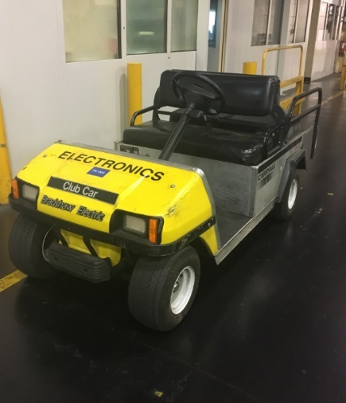
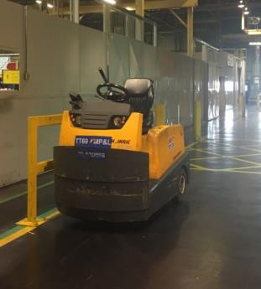
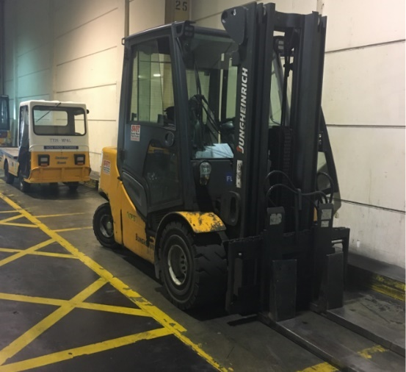
The majority of the vehicles used at BEP are FLT’s, RT’s and TT’s. These are used by the Market Place and Logistics (MP&L) employees for moving stock around the huge floor space at BEP. Terberg Tractors are used to transport 44-ton, curtain sided lorry trailers from the lorry park to inside the plant and vice versa. MEWPs, JCBs and some specially fitted FLT’s such as the Rhino (an FLT with a single beam lifting hook) are mainly used by maintenance personnel for a range of maintenance tasks. Personnel Carriers are used by a wide range of employees, usually ones that are required to travel long distances within the plant.
Figure 3 - Selection of Industrial Vehicles within BEP

2.2 February 2018 Accident

In February 2018, a contractor working as a banksman was run over by a MEWP within BEP. This caused a severe leg injury to the contractor and subsequently meant BEP was investigated by the HSE. The results of the investigation have not yet been concluded and BEP requested that a report and subsequent investigation was carried out to provide ways in which to further protect its employees.
This project has been launched to run simultaneously with the H&S investigation to attempt to find a solution to the problem of vehicle and pedestrian near misses. The investigation by BEP’s Health and Safety (H&S) Department was carried out and found a number of factors that could have been identified at an earlier opportunity that would show potential reasons/consequences of vehicles and pedestrians coming into contact with each other.

2.3 Vehicle Damage

The H&S Investigation noticed an increased amount of damage to the vehicles within BEP. Nearly all vehicles were showing signs of crash damage (see figure 4). There is a worry that this increase in damage could eventually lead to an accident as for whatever circumstances, vehicles should not be showing signs of crash damage. There is also a cost to repair damaged fork trucks that are leased and must be returned after the lease has expired.
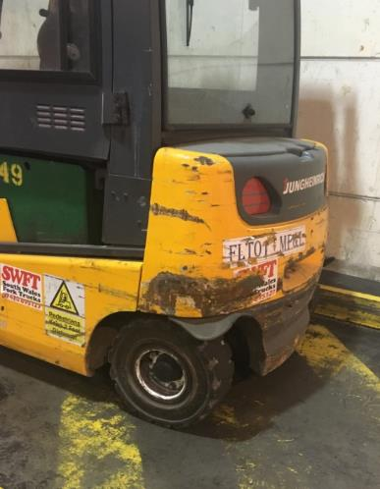
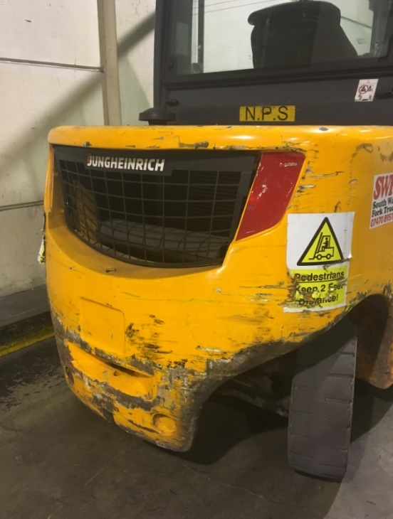
Figure 4 - Vehicles Showing Signs of Damage

2.4 Plant Damage

Along with the damage to the vehicles, barriers and bollards were also showing signs of damage (see figure 5). This again is causing management to find the root cause of the problem. The damage to the footpath barriers shows that vehicles are coming into contact with them and it is very possible that a person could be stood nearby and be harmed by these actions. The damage is also costly and defective/damaged barriers have to be repaired or replaced.
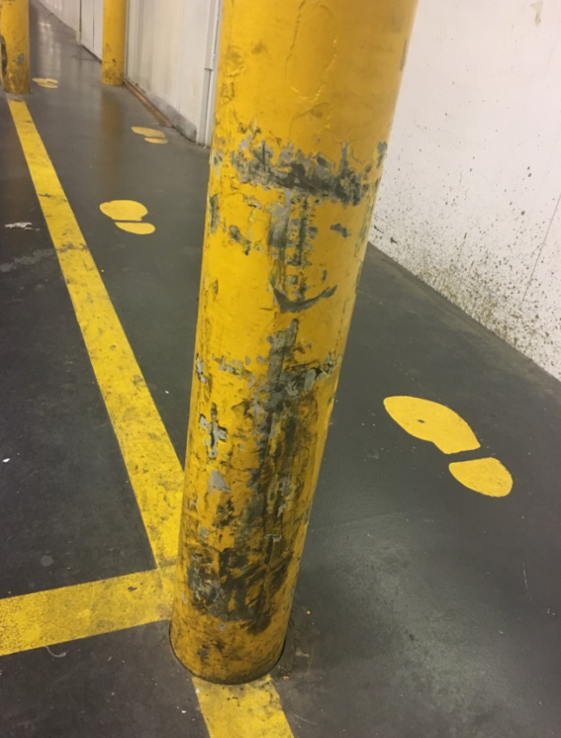
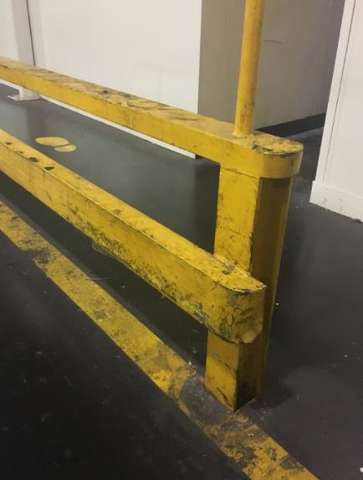
Figure 5 - Pedestrian Barriers and Bollards Showing Signs of Damage

2.5 Consequences of the Problem

The main consequence that affect a large company such as Ford is financial. Damage to barriers and vehicles will cost BEP a great deal of money to repair and replace, however the cost of an accident involving a vehicle and pedestrian would be considerably more.
This report will carry out research to calculate this cost and also look at the wider consequences of an accident. Data will be collected from with BEP and the HSE to make conclusions and decide upon a root cause. Once a root cause has been identified, further research will be carried out to explore ways in which to combat and counteract the problem. Finally, a design for a product or process will be developed and implemented with BEP to protect pedestrians from industrial vehicles and reduce near miss occurrences.

2.6 Aims and Objectives of the Project

After the scope of the project has been identified, it is important to set the project aims and objectives. The overall achievement of the project can be assessed during the conclusion by looking back on the original aims and objectives (Breach, 2009).
The Aim of the project:
To decrease the number of near miss occurrences and vehicle collisions within Bridgend Engine Plant.
In order to achieve the main aim, the following objectives have been set:
- Research lean six sigma project tools in order to discover potential opportunities to increase efficiency and safety though the project.
- Measure and collect current accident data and look for similarities within in order to find a ‘root cause’ in order to tackle the problem.
- Research and explore current detection methods within the automotive and other industries to see how these could be implemented within BEP.
- Research and develop an effective detection system that has the ability to be implemented within BEP in order to reduce near misses and vehicle collisions.

- Produce and implement a prototype to measure and collect data to see whether the system works correctly.

2.7 Voice of the Customer

Customers be it internal or external are the driving force behind any business. They have the ability to enforce changes to a process or a product and therefore it is vitally important to understand what the customer desires in order to satisfy them (Milosevic, 2003).

2.7.1 Internal Customer
Internal Customers are those within BEP, be it the next process or Bridgend Engine Plant as a whole. The management of BEP are the main driving force behind this project as they want to reduce near miss occurrences between vehicles and pedestrians whilst simultaneously reducing the amount of damage caused by vehicles within BEP as the cost of repairing and replacing vehicles and barriers is increasing. Therefore, Bridgend Engine Plant as a whole is the internal customer.

2.7.2 External Customers
External customers are individuals or organisations outside of BEP that have a vested interest within the plant. Usually the end user of a product, in this case the external customer is Ford Motor Company (FMC) (Europe) as a whole. If an accident were to occur within BEP and a fine given by a court of law, it would be FMC that would be fined and not BEP as a manufacturing facility.

2.7.3 Voice of Customer (VOC) Statement
The current level of near miss occurrences between vehicles and pedestrians is increasing. Damage is being recorded on more vehicles and barriers designed to protect pedestrians. If a vehicle were to come into contact with a pedestrian then the consequences could be a fatality or at best a very serious, life changing injury. A solution is needed for this problem and therefore the company wishes to explore and develop a new system that will aid drivers of vehicles within BEP to avoid pedestrians and obstacles in their path.

1
2
3
4
5
6
7
8
9
10
11

3.0 Literature Review

3.1 Purpose of Literature Review

Before commencing with the data collection, analysis and implementation of any project, it is necessary to gather and critically appraise the relevant literature associated with the project. It is important to critically appraise the literature in order to decide if the material is relevant to the project and also accepted by other professionals. The purpose of a literature review is to give the author a greater knowledge surrounding the prospective project area as well as a wider surrounding knowledge which may prove to be useful and offer insights that the author may not previously considered (Breach, 2009).
The literature review will be carried out with the aim and objective of the project in mind and therefore the main topics of research are as follow;
- Health and Safety at Work
- Levels of Automation
- Six Sigma Methodologies and Tools
- Autonomous Industrial Vehicles
- Change Culture and Management

3.2 Health and Safety at Work

Health and Safety regulations have been around since the early 1800’s when the factory act was introduced by Sir Robert Peel. (Billington, 2017). Since then there have been numerous acts and reforms introduced, the last major one being the Health and Safety at Work Act 1974.
The Health and Safety at Work Act 1974 is an Act of Parliament that sets out the framework for managing workplace health and safety in the UK. It was thought by many to be a revolutionary piece of legislation which forms the basis of all health and safety legislation across the world today (Billington, 2017).
The act defines the general duties of everyone from employers and employees to owners, managers and maintainers of work premises for maintaining health and safety within most workplaces.
The act itself is a primary piece of legislation set out by the government. Other regulations which complement the HASAWA 1974 are known as statutory instruments (essentially secondary pieces of legislation that may also be referred to as delegated legislation) (British Safety Council, 2019).
Industrial vehicles and the use and operation of, fit under a number of legislations. One such legislation is the Provision and Use of Work Equipment Regulations 1998 (PUWER). The regulations deal with the work equipment and machinery used every day in workplaces and aims to keep people safe wherever equipment and machinery is used at work (RoSPA, 2013). The PUWER regulations require that lift trucks which carry a seated ride-on operator should be fitted with a restraining system, such as a seat belt, if risk assessment indicates that there is a risk of the vehicle rolling over and the operator falling from the operating position and being crushed between the truck and the ground (HSE, 2018).
These legislations are important, especially to management. If there was an accident and someone was injured by a vehicle, the company and senior personnel could potentially be prosecuted under the Health and Safety at Work Act for failing to implement the legislation to its full effect within the workplace.
At BEP, as already explained there was an accident involving a pedestrian and an industrial vehicle from which this project was started. The management at BEP would like to take measures to reduce the risk of an accident ever happening again and if possible, completely eliminate this and as such this is the aim of the project team.

3.3 Levels of Automation

Automation is often seen as one of the most cost-effective ways to increase production whilst lowering operational costs. However, a human operator had the ability to sort situations and problems that an automated system may not be able to interpret (Frohm, 2008).
The same can be said for automation within the automotive industry. Car manufacturers are increasingly adding more and more automation to cars to eventually achieve the goal of a fully autonomous vehicle. This is due to a number of reasons but mainly due to wanting to remove driver error to reduce crashes. Going back to safety, globally, cars kill 1.2 million people a year. A driverless car builds an occupancy grid using sophisticated sensors. These include HD cameras, radar, sonar, GPS and LIDAR, a Light and Range Detection device that paints the scene ahead with laser light, which builds a 3D model. Deep learning artificial intelligence (AI) replaces inflexible symbolic AI as the preferred computing program for artificial perception in driverless cars (Lipson & Kurman, 2016).
Car manufacturers are investing heavily in the development of autonomous vehicle technology in the hopes of cashing in on a new segment of the auto market sometime in the next five to ten years. Tesla being the market leader currently, other companies such as Volvo are slowly closing the gap. There are however problems with existing semiautonomous technology which suggests that a fully autonomous vehicle could be some time away (Hirsh et al., 2016).
When it comes to industrial vehicles however, some have been fully autonomous since the 1950’s. (Savant, 2019). With this technology being over half a century old, it is only recently that the technology from the car manufacturers research and development is finding its way into industry.
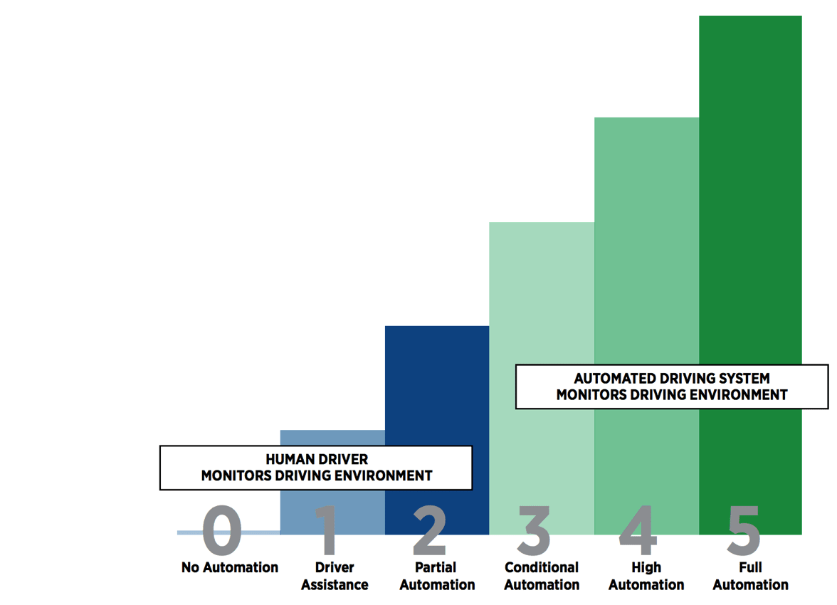
Figure 6 - Levels of Automation (Blain, 2017)

It is thought by some that automation is not reliable enough to completely take away responsibility from humans and therefore technology implementation should be slowed down (Hirsh et al., 2016). Some even state that the cars currently being designed are based on humans becoming lazy and useless (Simonite, 2014).
In the case of this project however, it is not something the project team are trying to do. The autonomy of any system that is designed will be there to aid a driver, not take away any responsibly or reduce the need for them to concentrate in any way. It will not provide any corrective action and will be a maximum of level 1 automation, purely assisting the driver to their surrounding that they should have already seen anyway.

3.4 Autonomous Industrial Vehicles

3.4.1 Automated Guided Vehicles (AGV’s)

As previously mentioned, Automated Guided Vehicles (AGV’s) have been around since the 1950s (Savant, 2019). Initially they were ‘tractor-trailers’ and worked by following a set ‘track’. The track, either a wire buried in the ground or marked tape lines. Modern day AVG’s have the ability to navigate using lasers, gyroscopes, geoguidance or the original tape method. They also have the ability to see what is in front of them using a range of sensors, most commonly Radar. Their main purpose is transporting inventory around the factory marketplace. They are extremely safe as they are slower moving and have a vast array of technologies to let them ‘see’ ahead for any obstructions (Ullrich, 2014).
The main problem with AGV’s is that they are rarely used where they may come into contact with pedestrians. This is due to the high costs of installing and maintaining sufficient control measures to stop collisions between AVG’s and people. Smaller, slower moving AVG’s are able to co-exist with humans as they cause less of a risk, however this then counter-acts the purpose of the AVG in the first place; greater cost and time efficiency (Sharda, 2017). This has led to the development of Vision Guided Vehicles.
For this project, the management have requested that any system developed must be retro fitted to the existing vehicles within BEP. In an ideal world, modern AVG’s could be used instead of the MP&L drivers, however this simply is not an option for this project.
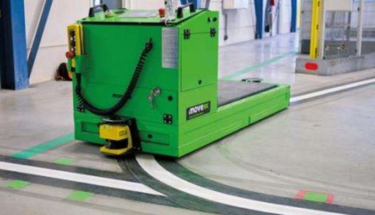
Figure 7 - Automatic Guided Vehicle (Turck Trucks, 1999)

3.4.2 Vision Guided Vehicles (VGV’s)

Vision Guided Vehicles (VGV’s) on occasions can be confused with AGV’s, however they are considered by many to be the future replacement of AGV’s (Gunn, 2017). VGV’s differ from AGV’s because VGVs do not require infrastructure such as wires, magnets, or tape, and they navigate without inflexible laser technology.
They use camera and vision technology which means the vehicle can ‘see’ in real-time and make decisions regarding routes or obstacles. This development has meant that the vehicle can work in a joint, vehicle human environment.
Costing upwards of $150,000 however, they are very expensive and therefore many companies rely on more traditional methods of transporting goods, such as fork trucks and reach trucks (Seegrid, 2019).
Similarly, as with AGV’s, the management have requested that any system developed must be retro fitted to the existing vehicles within BEP. In an ideal world, VGV’s could be used instead of the MP&L drivers, however this simply is not an option for this project or for BEP at this time. Due to an on-going ‘Reset and Design’, Ford are looking to save money wherever possible and therefore would not pay over $29 million to replace the current vehicles.

3.5 Six Sigma Methodologies and Tools

3.5.1 DMAIC

DMAIC is an acronym for the six-sigma methodology used to improve existing processes. It stands for Define, Measure, Analyse, Improve, Control and each heading is a separate process which needs to be undertaken in order for a successful improvement. It is used to improve existing processes and provides a structure for a team to work though in order to find a solution. The purpose of DMAIC is to problem solve and instead of concentrating on the output, take more time understanding and concentrating on the process that created the output. (Graves, 2014)
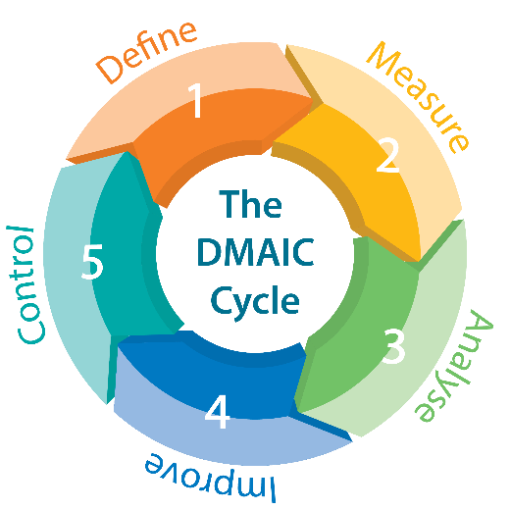
The structure is not necessarily linear and encourages teams to go back and forth in the process to add more information where needed.
Figure 8 - Five stages of the DMAIC Methodology (Lean Six Sigma Training Ireland, 2017)
There are two main ways of implementing a DMAIC project, the Project-team approach and the Kaizen approach. The project-team approach uses a full-time team approach, where black belts are deployed full time, usually over a one to four-month time frame. The Kaizen approach is a more intense implementation of DMAIC. It usually takes one week or less to work through the DMAIC methodology except for full-scale implementation (George et al., 2005).

3.5.2 DMEDI
Similar to DMAIC is DMEDI, an acronym for the six-sigma methodology used to focus on the development of new products, services, processes and machinery. It stands for Define, Measure, Explore, Develop and Implement and just like DMAIC each heading is a separate process which needs to be undertaken in order for a successful project. DMEDI works just the same as DMAIC would however the focus in on the development of new, instead of improving the old (Shankar, 2009). DMEDI is also extremely similar to DMADV – Define, Measure, Analyse, Design, Verify, a design for six sigma process (Scheid, 2016).

Define Phase – The Define phase for both DMEDI and DMAIC are very similar. The purpose of this stage is clearly state the project problems with clear relation to the business problems, desired results, timings and constraints.

Measure Phase – The measure phase for both DMEDI and DMAIC are also both very similar however this is where the first differences between the two methodologies begin to show. The DMEDI process is much more involved as there is very little, if any current process definition. It is important during this stage in order to identify the real needs of the project so that specific areas can be researched in the Explore stage (Jones, 2016).

Explore v Analyse – Although Explore from DMEDI and Analyse from DMAIC are similar in certain ways, they serve different purposes. The DMEDI Explore phase is focused on looking at new ways or concept ideas to a problem whereas the Analyse phase of the DMAIC process looks to break down data for an existing process to identify defect root causes (Watson-Hemphill, 2018).

Develop v Improve – The methodologies are again similar during this stage of the process. Both are developing or improving a process in order to create a more future proof process. DMAIC is more data driven where as DMEDI produces a design based largely on meeting customers’ needs and desires (Carter, 1992).

Implement v Control – Both of these stages are similar in the fact their purpose is to meet project objectives. The difference is that the Implement stage for DMEDI is a permanent change and it is a brand-new process. The two processes are however quite similar. They both have controls in place to make sure and monitor how the new or improved processes is working (George et al., 2005).

Most projects start off as DMAIC as this is most common but it is soon realised that root causes often point to products or processes that do not yet exist and hence DMEDI is then used. In the case of this project, it is clear from the outset that the processes surrounding vehicles and pedestrians are basically non-existent and therefore a DMEDI mapping stream will be followed (Voehl et al., 2014).
Similar to a DMAIC project, not one phase will be completely finished before the next one is commenced. The project is supposed to be fluid and moving between the phases is needed to make sure that all necessary areas are covered and nothing is forgotten about.

The DMEDI process will be followed during this project as it more suited as explained however some people think that this DMEDI can only be used for designing new processes, but in this case a new product will be designed (Watson-Hemphill, 2018). Following the DMEDI structure however will allow the project team, most of whom are experienced with the DMAIC process, have a better understanding of how the project is progressing by comparing it to DMAIC.

3.5.3 Quality Function Deployment (QFD)

According to Akao, the original developer of QFD, Quality function deployment is;
‘A method for developing a design quality aimed at satisfying the consumer and then translating the consumer’s demands into design targets and major quality assurance points to be used throughout the production stage.’ - (Akao, 1972)

QFD is extensively used in new product development. The purpose is to help ensure that all critical funtions of a product or process are alligned to satisfy the customer requirements. It does this by transforming quantative data from the customer demands into quantative parameters which can be used in order for the process or product to satify the customers needs (Oswald & Burati, 1993).

3.5.3.1 House of Quality

House of Quality is a process from within QFD. The process involves a diagram (see figure 7) which can be separated into three main categories. The customer requirements on the left, which sets focus on what the customer wants. Technical requirements are places at the top of the house and displays the engineering methods and requirements needed for product execution. Finally, at the base is the technical attributes where all the technical specifications are detailed. The purpose of the house of quality is to listen to customers, translating their desires into a written plan or diagram and from there prioritising what steps are most important to the customer (WhatIsSixSigma, 2018).
QFD may or may not be used during the project. Due to there being limited customers, Ford BEP being the only one at present, the focus on the greater customer’s needs are less than it would be had a process been changed. The literature has been included however to give the author an understanding to what typically the customer may what and how this relates to the final end product. This will then allow the project champion to relay this information and make informed decisions based on what they think is best for the customer.
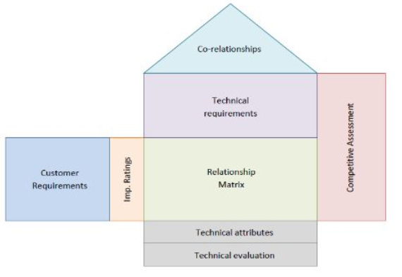
Figure 9 - House of Quality Template (Master of Project Academy, 2018)

3.5.4 Failure Mode and Effects Analysis (FMEA)

Failure Mode and Effects Analysis (FMEA) is process which uses table to calculate how a certain process of product can potentially fail (Stamatis, 2003). The table is useful as it has the ability to identifying these potential failuresas well as identify the root causes. The table can then be used to prioritise what steps and actions need to be taken and also improve existing control measures if they are already in place (Mikulak et al., 2008).
The FMEA table can prioritise actions by calculating a Risk Priority Number (RPN). The RPN is calculated by multiplying three numbers;
Severity of Failure (SEV): These are numbered 1-10, with 10 representing the most severe impact on customers.
Likeliness the failure will Occur (OCC): These are numbered 1-10, with 10 representing most likely to occur.
Detectability of Failure (DET): These are numbered 1-10, with 10 representing the least likely to be noticed with the current control measures.
To calculate the RPN, you simply multiply these numbers together.
SEV x OCC x DET = RPN
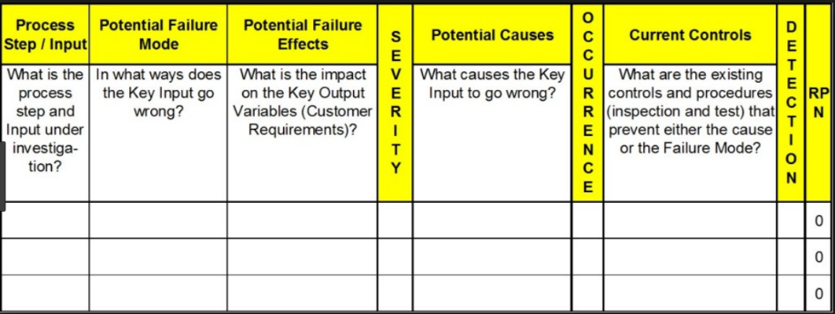
For an FMEA table to work correctly, preventative actions need to be taken and improvements made. These should be measured and analysed and documented. The RPN should then be recalculated based on these improvements and new control actions (Mikulak et al., 2008).
Figure 10 - FMEA Template (Six Sigma DSI, 2019)

The use of an FMEA chart allows information to be made into measurable figures which can then be analysed. This will allow the project champion to make decisions based on numerous factors and prioritise these so that they can be concentrated on by the rest of the project team.

3.5.5 The 5S’s
The 5S technique is one of the most widely used tools within continuous process improvement and lean manufacturing. It is considered that 5S is one of the foundations to lean manufacturing and processing and it is the base to establish the stability required for successful continuous improvement (Brady, 2011). The primary objective of 5S is to create a clean, orderly environment- an environment where there is a place for everything and everything is in its place (Moulding, 2010).
The 5S’s are broken down and known as (see figure 9);
Sort - Seiri
Set - Seiton
Shine - Seiso
Standardise - Seiketsu
Sustain - Shitsuke
The 5S methodology is directly linked with Visual factory. The purpose of 5S is to ultimately organise a workplace so that it is not only organised but also safe (Moulding, 2010).

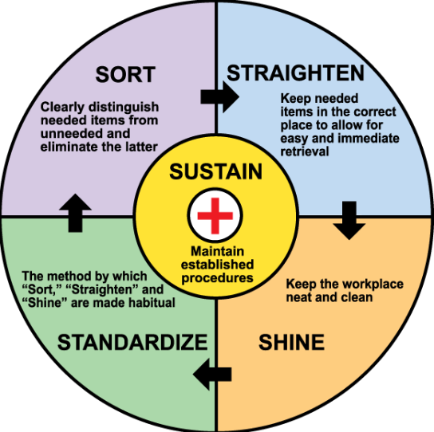
Figure 11 - 5S Diagram (The Lean Accountants, 2011)

If the project is successful the next step will be to implement it across the whole of BEP. The 5’s will be important to standardise that process. Not only that, any reaction and monitoring plans that may be produced in order to track the new system will also need to be standardised. This not only makes it easier for the project champion but it also makes it easier for anyone else involved in the project. If the system is standardised then it will be easier to reproduce and repair and therefore consideration will be made to the ‘5 S’s’ throughout the project.

3.5.5.1 Visual Factory
Visual communication is constantly around us in today’s society. Visual signals can be used to clearly communicate and signal to one another which can infuence physical actions. Although not commonly realised in manufacturing, they are often there (Ortiz & Park, 2011). The whole purpose of a visual factory is to provide visual control to enable recognition of abnormalities, thus facilitating immediate response (Hirano, 1995).
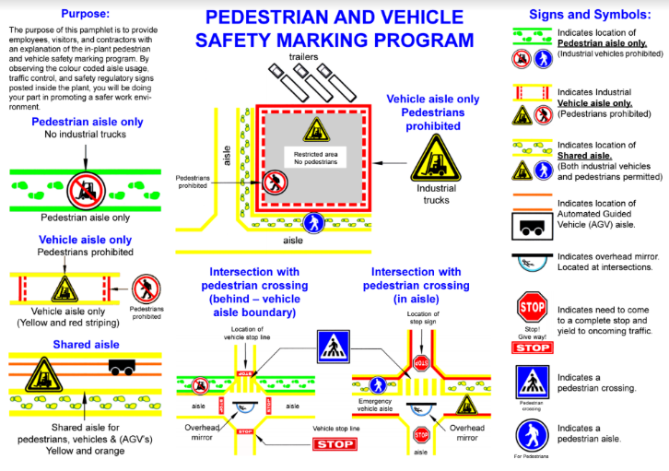
BEP operates a visual factory. One of the main purposes of the visual factory is to provide employees with a safe place to work by implementing a Pedestrian and Vehicle Safety Marking Program (see figure 10).
Figure 12 - Ford Pedestrian and Vehicle Safety Marking Program (John, 2019)

As already mentioned in the Define stage, most of BEP has shared yellow accessways. This means that both industrial vehicles and pedestrians are permitted. This will play a significant role within this project as it is quite clearly a point where a near miss could occur and will need to be taken into account when making recommendations and also analysing whatever data may be collected.

3.5.6 Critical to Quality (CTQ)

A CTQ is a Critical to Quality product feature that must be maintained in order to meet customer expectations. CTQ’s are useful in helping manufacturing teams know where to focus their efforts in designing robust processes (DMAIC Tool, 2017). CTQ’s must be measurable to determine from the start where to focus but also whether there has been improved customer satisfaction at the end of the project.
CTQ’s can be broken down and prioritized into three areas to focus the team (Kano, 1984).
‘Must-be’ requirements; also known as dissatisfiers, these are basic requirements and have to be fully met in order for the customer to be satisfied as they are already expected. If any of these characteristics are not met then the customer will be very dissatisfied.
‘Performance’ requirements; also known as satisfiers, the better these are, the happier the customer will ultimately be. They need to be met in order to improve competitiveness and remain in the market (Kano, 1984).
‘Delighters’; these are characteristics that may not be focused on and sometimes overlooked, they are not expected by the customer however improvement to delighter characteristics can improve customer satisfaction greatly as they are generally unexpected and opens the opportunities to excel and become World Class (George et al., 2005).
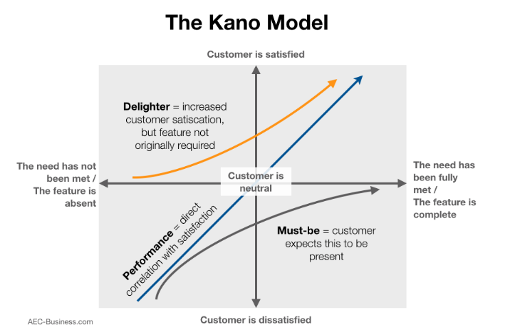
Figure 13 - The Kano Model (Mind Tools, 2018)

3.5.7 Root Cause - 5 Why’s Analysis and Cause and Effect Diagrams

‘Five why’s’ analysis, is a lean tool used to determine root causes by continuously asking why to a problem and subsequent solution. It is called the five whys as according to some professionals, after five repetitions the root cause is often found. First developed by the Toyota Production System, it has since become a staple lean tool and one that is understood and easily used by many (Tague, 2004). There are some that think that root cause analysis using the five whys is limited and cause often lead to an answer that is not known (Gitlow & Oppenheim, 1989). Although this may be the case, using it during this project could prove very useful and will be a tool that the project team can deploy during any stage of the project as it is so simple to use.
Many think that a Cause and Effect diagram is a more structured technique that gives a more detailed analysis. A Cause and Effect Diagram, also known as a ‘Fishbone’ or ‘Ishikawa’ diagram, starts with a problem and then each fish bone contains a main cause and then each smaller individual bone is a root cause of the main cause (Gitlow & Oppenheim, 1989). A cause and effect diagram often take more time than 5 whys, however once started it can constantly be added to by any team member at any time using a whiteboard and sticky note (George et al., 2005). This will be particularly useful during this project as many team members work different shifts and often do not get contact with each other for weeks at a time.
There is nothing to say that both techniques cannot be used at the same time and this is something suggested by certain academics (Bergman, 2010) and a technique that is probably best suited to the project team and will be used later during the project.

3.5 Management of Change Culture

There are many internal and external needs and drivers that force change.
‘Change is an inevitable and constant feature. It is an inescapable part of both social and organisational life and we are all subject to continual change of one form or another.’ (Mullins, 2010)
With any project, for a successful outcome, some sort of change must take place. Within an organisation, planned organisational change is always from these external forces however (Mullins, 2010). In the case of this project, the external forces are coming from Ford’s European Health and Safety Management, the HSE with an attitude to drive accidents to zero but also from a Ford Financial point of view. As previously mentioned, the cost of accidents can have a profound effect on the business and as such needs to be eliminated.
Management and leadership are a vital part of making any change within an organisation. This is due to the human race being naturally resistant to change (Eidelman et al., 2010). It is thought that is because a certain ‘way’ or ‘process’ that they are accustomed to is normal and any change could have consequences for them. This means that when change comes about, there is often conflict and unwillingness to accept the change. It ultimately means that you must get rid of the old and good, for the new and not good. This means that change is often a challenge for management and many theories have been developed to try and combat this resistance (Eidelman et al., 2010).
One theory that has been developed was that by Kurt Lewin. Lewin was one of the first to produce a change theory which he presented in 1947 and called the ‘Change Model’. This model has since become known as ‘Lewin’s Three Stage Theory’. It was developed to keep an organisation stable during a time of change. It looked to balance two main sets of behaviours during change, those perusing change and those who want to maintain the current status-quo. When both of these forces are equal, Lewin described it as ‘quasi-stationary equilibrium’ (Cummings & Worley, 2015).
Management of any change will be very important to the project team. As already explained the general attitude to change is negative and for this reason the project team will try and engage as many people from management to factory floor staff to make them feel valued and make sure that a common ground is found so that any change is positively accepted and therefore more likely to be adhered to.

1
2
3
4
5
6
7
8
9
10
11

4.0 Measure: Data Collection

4.1 Cause and Effect Diagram

Before any data is collected, it is important to have a general idea of what the main causes of the problem are. The Project team is responsible for making this assumption and brainstorming ideas. The purpose is to help build a data collection plan, to know where to collect data from and what type of data is needed (George et al., 2005).
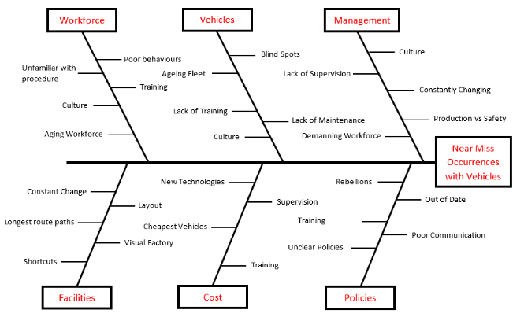
In order to get a better understanding of why near misses with vehicles within BEP are occurring a ‘Cause and Effect’ diagram, also known as a ‘Fishbone’ or ‘Ishikawa’ diagram has been produced. The purpose of this high-level diagram is to identify possible likely reasons and root causes. It is often used during the Define phase of a six-sigma project and but can be used elsewhere such as the measure stage as a working diagram, meaning it can be added to by anyone from the team at any time. The diagram below has been broken down into six categories; Management, Vehicles, Workforce, Policies, Cost and Facilities. From these categories, a brainstorm is carried out initially to identify all possible reasons to why the near misses are occurring and it can be used to target areas to collect data from (George et al., 2005).
Figure 14 - Near Miss Occurrence Cause and Effect Diagram

4.2 Data Collection Plan

As previously mentioned, the DMEDI Measure process is much more involved as there is very little, if any current process definition. It is important during this stage in order to identify the real needs of the customer and as such special tools such as quality function deployment (QFD) or house of quality (HOQ) need to be used (Jones, 2016).
To do that, specific data will need to be collected and therefore a data collection plan can be used to target specific areas in order to collect precise, useful data. The plan is needed in order for the team to fully understand what data is needed and how, when and where it will be collected from (Master Of Project, 2017).
4.2.1 What data will be collected?
4.2.1.1 Near Miss Data
In order to quantify the problem which has already been defined, it is necessary to collect any data surrounding near misses between vehicles and pedestrians within BEP. A near miss should be reported every time a pedestrian comes within 3ft of a moving vehicle. The can also be reported at the discretion of the driver or pedestrian if they think someone has done something potentially dangerous or something that has the ability to cause an accident. Near misses are reported via Foremen/Supervisors to the Health and Safety (H&S) department who then collect and hold the data for 4 years.
4.2.1.2 Collision Data
Every vehicle within BEP with the exception of a few such as cherry pickers and MEWPS have on-board gyroscopes. This means that any time a vehicle hits something, readings are taken and sent wirelessly to the Plant Fleet Engineer. The data will again help to quantify the problem as more and more accidents are occurring. This not only has the potential to cause harm to the driver, it also costs the company money due to high repair costs.
4.2.1.3 Health and Safety Executive (HSE) Data
Data from the HSE will be collected in ordered to gather a wider picture from around the UK and help with calculating the costs and consequences of an accident between a vehicle and pedestrian. The HSE being the UK government agency responsible for the encouragement, regulation and enforcement for the workplace, will have over 40 years’ worth of valuable data.
4.2.1.4 MP&L Driver Questionnaire
Part of the data collection stage will include an anonymous questionnaire. This questionnaire will be distributed to all MP&L staff who drive vehicles as part of their day to day activities. The data collected will help give me more honest and detailed insight as many employees do not bother reporting near misses. This way, the questionnaire data will give a more detailed and true perspective on the problem.

4.2.2 Why is the data needed?
4.2.2.1 Near Miss Data
The data from the near misses recorded to the H&S department will be used later in the measure stage to separate them into various categories such as severity, time and location. This data can then be used and can be further analysed using tools such as root cause and cause and effect analysis. This will then be used to try and eliminate or develop solutions to the near misses.

4.2.2.2 Collision Data
The data from the on-board collision detectors will be used in a similar fashion to the near miss data. The data will be used to create a baseline to see whether any developments which may have been made improvements to the driver’s behaviours. It will also highlight problem areas within the plant where collisions are happening regularly and again tools such as root cause analysis and 5S’s can be used to eliminate or develop solutions to the collisions.

4.2.2.3 Health and Safety Executive (HSE) Data
Data collected from the HSE will be used to highlight the potential cost savings for the company. Although it is often reiterated that safety is paramount, often this is due to the potential fines as money is a bigger ‘eye opener’ for larger companies. This means that figures collected from HSE data can provide this monetary value to cutting near misses and potentially a fatal accident.

4.2.2.4 MP&L Driver Questionnaire
Some of the MP&L drivers have worked with BEP for over 30 years. Many have vast experience and therefore their opinions should be greatly valued. The questionnaire is also a means to get a ‘real idea’ of the problem. The project also hopes to involve the drivers as much as possible and make them feel valued as already researched, it is important to reduce conflict and so that they are more inclined to accept any changes.
4.2.3 Who is responsible for the data collection?
The Project Champion will be responsible for collecting the data needed and creating the questionnaire that is to be distributed to the MP&L staff. The MP&L drivers will be responsible for completing the anonymous questionnaire.
4.2.4 How will the data be collected?
4.2.4.1 Near Miss Data
The data from the near misses will be collected from the H&S department within BEP. The H&S Department use a programme called FordAX where all accidents and near misses are logged and reported to. This data will be extracted by a H&S staff member and then the Project Champion will collate it.

4.2.4.2 Collision Data
The data from the on-board collision detectors is sent to the Fleet Engineer via a system called FactoryVision. The data is categorised automatically by the programme depending on the severity of the collision. The data will be extracted by the Plant Fleet Manager and then collated by the Project Champion.

4.2.4.3 Health and Safety Executive (HSE) Data
Data from the HSE will be collected by the Project Champion via their extensive website. The HSE website has over 40 years of data available however less than that will be used in order to save time and reduce complexity.

4.2.4.4 MP&L Driver Questionnaire
A simple questionnaire will be handed across the four shifts. There are currently 22 personnel per shift. The questionnaire will be anonymous and therefore a ballot style box will be used to collect them. The data from the questionnaires will then be extracted by the Project Champion and documented later in the Measure phase.

4.2.5 When will the data be collected by?
The data will be collected over a 2-month period starting in January 2019. This should be sufficient time to capture ‘live’ data which has been recorded recently but also provide enough time to access historical data. This also allows time for the Project to be completed within the project timeline and deadline. A further two months will be given to extract and analyse all the data for the purpose of the project.
4.2.6 Where will the data be collected from?
The data will be collected from various departments within Bridgend Engine Plant and also online for the HSE data. The near miss data will be collected from the Health and Safety Department. The collision data will be collected from the Plant Fleet Engineering Department and the questionnaire will be collected from employees working within the MP&L department.

4.3 Data Collection Results

4.3.1 BEP Near Miss Data

The near miss data collected was combined from 2013 to 2018.
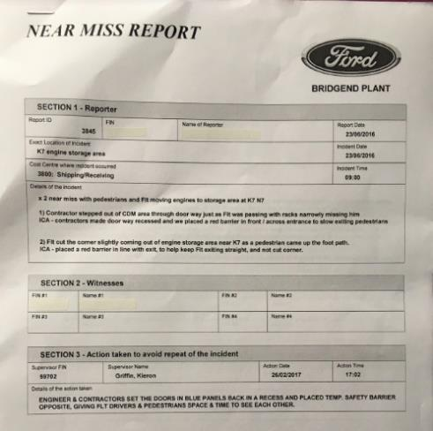
Each near miss describes the area where the incident happened and also a number of other details such as time, date and persons involved (see figure 15). For the purpose of the report, data such as names have been removed.
Figure 15 - BEP Near Miss Report
The data was collated from the near misses and exported to a spread sheet so that the data was organised and any accumulations could be seen more clearly.

4.3.1.1 Total Near Miss Reports
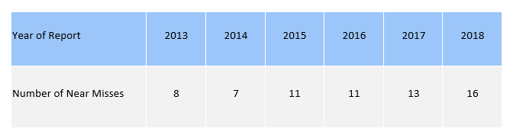
Firstly, the total number of near misses where listed (see table 2). This meant it was possible to get a historical view which would enable the project team to see if there was in fact a worsening problem or a problem that was slowly being reduced over time secondary by other means.
Table 2 - Number of Near Misses Per Year

Figure 16 - Graph Showing Increasing Near Misses

It is quite clear to see from figure 16 that apart from a slight reduction in 2014, the number of near misses being reported to the H&S department have been increasing for the past five years. The decrease in 2014 is thought to be down to the change in fork truck supplier. In 2014 fork trucks were changed from Linde to Jungheinrich and a delay meant that only 65% of vehicles were delivered on time and there was a shortage within BEP. This meant that due to the lower number of vehicles, less near misses occurred. It proves that the problem exists and are directly linked with the number of fork trucks operating within plant and it is essential that the root causes are properly defined in order to combat the rise which is being shown.

4.3.1.2 Reasons for Near Miss Reports
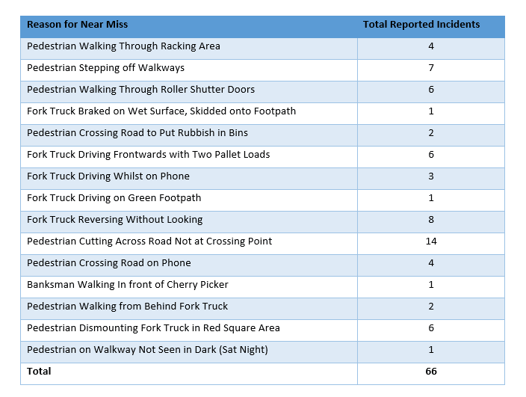
It is important to find out the main reasons for the near misses. This information can then be used to compare against the questionnaires to see if any particular situations occur more often than is actually recorded via near misses. This will then allow root cause analysis to be carried out to reduce or eliminate the particular situation which in turn would reduce the near misses and the likelihood of an accident occurring.
Table 3 - Reasons for Near Misses

From table 3 which shows the of reasons for near misses, there are five reasons that have occurred greater than four times. This means that the reasons are reoccurring over a five-year period and are not happening on the off chance. The main reasons are;
- Pedestrians Cutting Across Road Not at Crossing Point
- Fork Truck Reversing Without Looking
- Pedestrian Stepping off Walkways
- Pedestrians Walking Through Roller Shutter Doors
- Fork Truck Driving Frontwards with Two Pallet Loads
- Pedestrian Dismounting Fork Truck in Red Square Area
All of the main reasons for the near misses are behavioural issues. Culture can play a huge part in the increase of accidents or near accidents (Onsite Safety, 2018). These can be targeted through better management and this is something the report will be recommending, however in the short term, there may be other ways of protecting employees that will need to be explored as with the rising cases of near misses, action needs to be taken to ‘override’ the behavioural problems within BEP. This is what the project will aim to do and something already mentioned as the reason car manufacturers are accelerating with the development of autonomous vehicles, as explained in the literature review.

4.3.2 BEP Collision Data

Management in BEP had noticed that near misses between vehicles and pedestrians were increasing and when this problem was first noted, it was also apparent that damage was present on nearly all vehicles within plant as well as barriers and bollards showing collision damage.
The project team decided to see whether these two incidents had any similarities. BEP had a system installed in 2017 called VisionFactory. Each vehicle is fitted with a device which logs the driver and also has an onboard collision warning system. A G-Sensor is fitted within the device and sends signals to a server whenever a change in G-Force is registered.
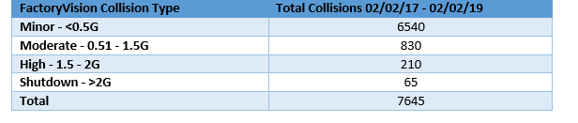
As an example, a 1 tonne car, travelling at 10 kph (Same max speed as a BEP vehicle) will register a G-Force of around 2G in a collision where the car comes to a stop almost instantaneously. The VisionFactory devices have the ability to disable to vehicle if a collision is detected. A high collision of 1.5G-2G will shut down the vehicle however the driver can restart it themselves, however a collision of over 2G will disable the vehicle and only a code held by management can restart it.
Table 4 - FactoryVision Collison Data
It is clear to see from table 4 that there is a huge amount of collisions that have taken place over the two-year period since it has been operational. This data proves that large collisions are occurring and although does not link near misses and collisions, goes to show that there is a problem that needs addressing before a serious injury occurs. There could be a number of reasons why the number of collisions is so high but it is thought by the project team that this is down to driver behaviour and therefore it is something that will be challenged by producing a questionnaire for the drivers to fill out anonymously.

4.3.3 Data Collection Questionnaire
The questionnaires were handed across the three shifts to all 22 personnel per shift. The questionnaire was anonymous in the hope than the drivers would answer more honestly and openly. They were returned to a ballot style box outside of the Foreman’s Office.
Questionnaire – MP&L Near Miss Situations
This questionnaire is anonymous. You are therefore you are not required to write any personal details that may affect you or someone else. Please respond as honestly as possible. Please complete the questionnaire and place it in the box outside the MP&L Foreman’s Office by March 1st 2019.

Q1. Have you ever had a near miss with a Pedestrian? If yes, please briefly describe how the situation occurred. Also mention if you reported it as a near miss. If no, have you ever witnessed one?
Q2. What do you think is the cause of the rise in near miss occurrences?
Q3. What do you think can be done to improve safety with regards to vehicles and pedestrians within plant?
Figure 17 - MP&L Questionnaire

The questionnaire that was handed to the MP&L Staff was analysed with each answer being interpreted into smaller responses so that they could if possible be categorised into common problems. An example of this would be in question 1, one answer stated they could not see the pedestrian due to the frame of the fork truck. Another answer stated that due to the reversing and looking over one shoulder they could not see fully around to their left-hand side. Both of these can be interpreted as blind spot problems. Once all the answers were categorised, they were plotted onto a frequency bar chart for ease of analysis and reporting to the Project team.

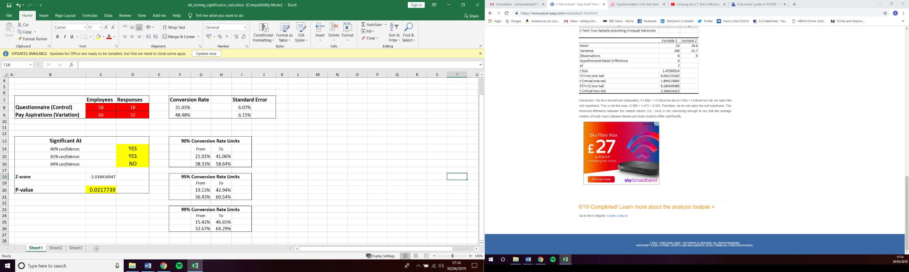
Of the 58 questionnaires (66 total, 22 per shift – 8 were on long term absence) that were handed out, only 18 were returned. They were handed out on the same date as the pay aspiration forms which were attached to pay slips. These forms were also sent out to the same employees; however, 32 pay aspiration forms were returned. This provided enough data to test if the questionnaire results were statically significant (see table 5).
Table 5 - Statistically Significant Test

A/B testing was used in table 5 to compare two versions of a single variable, which is use to typically test a subject's response to variant A against variant B, and determining which of the two variants is more effective (Pardot, 2012). The results were gathered by comparing the number of questionnaires sent out vs the amount received back and the amount of pay aspiration forms sent out vs the amount of forms received back. The results show that of the questions answered, it is 95% likely that the answers of those questions are true, although not 99% likely. This could have been improved by also sending the questionnaires out attached to payslips, sending email reminders or perhaps doing face to face questionnaires. Although the significance could be improved, a 95% statistically significant answer will certainly be helpful at guiding the project team towards the true reasons for the answers.

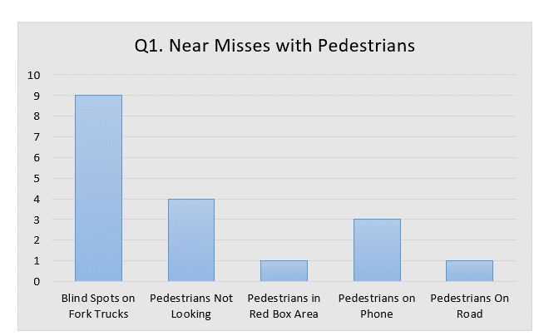
Question 1 was designed to see whether in actual fact the number of near misses reported to the H&S department were a true reflection of the problem. Unexpectedly, many of the drivers from MP&L blamed blind spots on the fork trucks for not seeing the pedestrians. However, there was no mention of causes such as ‘Fork Truck Driving Frontwards with Two Pallet Loads’ or ‘Fork Truck Reversing Without Looking’ which were two main reasons for the near miss reports. This could be due to the drivers not wanting to put blame onto themselves, which was expected (See Figure 18).
Figure 18 - Q1 Have You Ever Had A Near Miss with a Pedestrian Results

Worryingly, all 18 MP&L drivers who returned the questionnaires states that they had encountered a near miss at some point with a pedestrian. Within question 1, there was also a secondary request asking the drivers whether they had reported their near miss as a formal near miss to their foreman or the H&S department. Of the 18 drivers, only 2 answered ‘Yes’ and that they had reported it. The remaining 16 stated that they had not reported it (See figure 19). This proves that the near miss report data analysed off the H&S department is not a true reflection of the near miss occurrences within plant. The reason they are not reporting the near misses remains to be found however it could be down to not wanting to get a colleague into trouble for one reason or another. This is something that needs to be addressed and should be passed on to the relevant managers to discuss how to improve how the drivers can report near misses without getting anyone else into trouble.
Figure 19 - Q1 Did You Enter Near Miss Report Results

Question 2 was designed to get an honest opinion of if the drivers think there is a problem, what problems the drivers are facing and why they think they are facing them when it comes to coming into contact with pedestrians.
Unexpectedly, the results interpreted from question 2 actually put the reason down to the drivers themselves. Of the 18 responses, 10 drivers stated that increased pressure from management to deliver more parts around the plant quicker meant that near misses were increasing. A further 5 responses thought that pedestrians not taking care and rushing was the main reason (see figure 21). The root cause of both of these could be pressure from senior Ford management to cut costs, meaning less people are working, meaning the drivers and pedestrians within plant have to do their jobs quicker than they would have previously had to, in order to complete their tasks/scores for the day.

Figure 20 - Q2 Reasons for Increase in Near Misses Results

Question 3 was designed to see if there was anything that the Project team could use within the Explore and Development stage. It is often said that the people who use a machine most, have the best ideas when improvements are needed. The voices of those using the fork trucks every day should not be taken for granted and any advice or recommendations should be taken into account.
As expected by the Project team, the main response received off the drivers was to increase the staffing levels within the MP&L Department. This again is a culture issue where employees will always want more staff as they are ‘protecting’ jobs and doing ‘their part’. Unfortunately, Ford of Europe is going through a major ‘Reset’ at the time of the report and therefore jobs are being lost and positions cut to save money all over Europe and the UK including BEP. This will however be brought up as a recommendation to the management during the conclusion of the project.
Interestingly however, there was a positive response from some employees who mentioned an early warning system and automatic braking system that these employees currently have on their cars (see figure 22). As previously mentioned, many cars manufacturers are working towards autonomous driving and some of the autonomous systems introduced already have this technology onboard and therefore the MP&L drivers have already experienced it. This may prove to be useful when root cause analysis is carried out to find out what can be done to reduce near misses and lower the chances of an accident between a vehicle and pedestrian occurring within BEP.
Figure 21 - Q3 Ideas to Reduce Near Misses Results
Staff = Less

4.3.4 The Health and Safety Executive (HSE) Accident Data

The Health and Safety Executive (HSE) is a Government agency who purpose is to regulate and enforce workplace safety. The HSE collect vast amounts of data from every workplace across the UK. They have access to some of the world’s leading science to help protect people from injury whilst at work (HSE, 2018).
The purpose of collecting data from the HSE is to get a greater understanding of how often incidents between vehicles and pedestrians occur year on year within the whole of the UK and also what sort of impacts those incidents can have on employees and businesses.
Within all industries within the UK, 144 employees were killed at work during the 2017-2018 working year. Of the 144, in total 26 were killed as a result of being struck by a moving vehicle (see figure 23) (HSE, 2018).
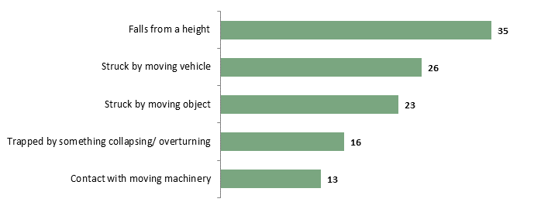
Figure 22 - Main Kinds of Fatal Accidents for Workers 2017/18 (RIDDOR, 2018)

Further to the deaths of 26 people in 2017-2018, from the years of 2013-2103, being struck by a moving vehicle accounted for 18% of all fatalities (see figure 24). This equated to 129 deaths over five years (see table 6), a staggeringly high number considering most industrial vehicles are slow moving.
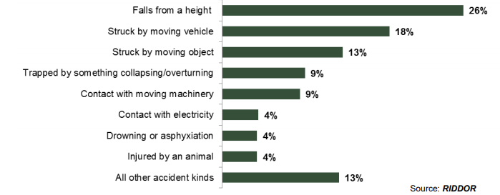
Figure 23 - Fatal Injuries to Workers by Accident Kind 2013/14-2017/18 (HSE, 2018)

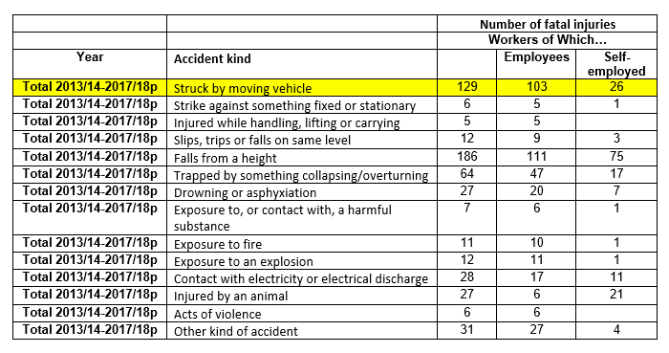
Table 6 - Number of Fatalities per Accident Kind 2013-2018 (HSE, 2018)
This data is proof that the potential for fatalities within BEP is a real possibility unless something is done to combat the rising near miss trend. The data is showing that being Struck by a moving vehicle is the second biggest killer in the work place.
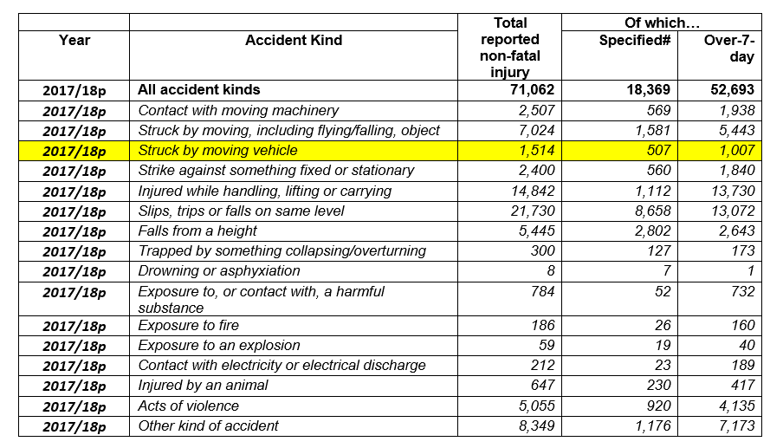
The number of non-fatal injuries caused by being struck by moving vehicles is even more worrying, however. Statistics produced by the HSE, show that in the working year 2017/18 alone, there were in fact 1,514 reported non-fatal injuries caused by employees being stuck by a moving vehicle. Over the same five-year period as the stats from table 7 show, this would equate on average to over 7,500 serious but non-fatal injuries.
Table 7 - Number of Non-Fatal Injuries per Accident Kind 2017-2018 (HSE, 2018)
The data is proof that any incident between a moving vehicle and a pedestrian is over 60% of the time going to mean that the employee requires over 7 days off work. Although no data is provided to show the total amount of time each employee had off work, it can be assumed that it was a serious injury and some of those employees may never be able to return to work.

4.3.5 Accident Cost Data

As already mentioned, companies will only make changes if it is to benefit them. Therefore, with the rising near misses between vehicles and pedestrians it is important to explore the potential cost consequences of an accident. The HSE holds various data regarding the costs of accidents to a company and therefore this data will be extracted to offset the cost of any development and implementation work of this project and potentially provide what the company can see as a positive outcome and money saving action by reducing near misses and the potential accident waiting to happen.
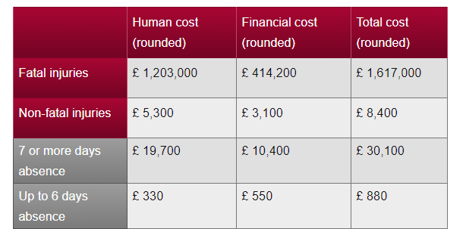
Figure 25 shows the average direct costs of an accident in the workplace. The human costs are specified as the ‘monetary estimate of the loss of quality of life, and loss of life in the case of fatal injuries. The Financial costs are specified as the sum of productivity costs (including net income costs and production costs), employers liability insurance premium costs and increases, health and rehabilitation costs and administrative and legal costs (HSE, 2018).
Figure 24 - Total Estimated Cost of Fatal and Non-Fatal Injuries (HSE, 2018)
Figure 25 does not take into account any fines that a company may occur as a result of a non-fatal injury or fatality due to a failing. The HSE data states that for the year 2017-2018 the following fines were enforced;
Total Cases Prosecuted: 493 (95% Conviction Rate)
Total Fines Received: £72,600,000
Highest Single Fine: £3,000,000
Average Fine: £147,000 (HSE, 2018)
This means that on top of the estimated direct costs, the potential of an added fine due to a collision between a vehicle and pedestrian within BEP could potentially reach £4,000,000 for a fatality. As previously mentioned, just over 60% of all accidents involving a pedestrian being struck by a moving vehicle resulted in more than 7 days absence. Taking this into consideration, for an accident, there is a very real likelihood of a total cost in excess of £175,000.

4.3.6 Collision Cost Data

As already found from the collision data collected from FactoryVision, table 4 shows that there is a huge amount of collisions that have taken place over the two-year period since it has been operational, over 7000. Each time a collision is detected, this means that a vehicle has come into contact with something and the likelihood is that damage of some sort will have occurred.
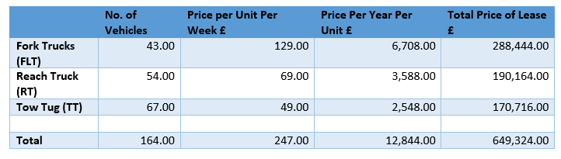
Keith Allen who is part of the project team, is the plant fleet engineer for BEP. His role is to keep track of all vehicles in plant and work with suppliers to lease the various vehicles. Within BEP all the FLT’s, RT’s and TT’s are leased straight from Jungheinrich (Allen, 2019).
Table 8 - Total Lease Costs for Vehicles in BEP (Allen, 2019)
Due to the vehicles being leased, according to Allen, any vehicles that are damaged will incur a charge to be repaired at the end of the 1-year lease. Each year the damages are estimated based on previous years charges and for 2019 the estimated charges can be seen in table 8.
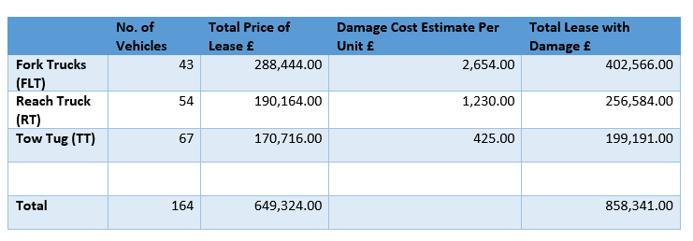
Table 9 - Total Estimated Vehicle Damage Charges

From table 8 it is clear that the total price added for damage is;
Total Damage Estimate = £858,341 - £648,324 = £210,017
This means that every year and estimated £210,017 is spent to cover accidental damage to vehicles in plant which has been caused by unnecessary damage as seen in figure 4.

1
2
3
4
5
6
7
8
9
10
11

5.0 Explore: Current Technologies

5.1 Data Impact

The purpose of the DMEDI ‘Explore’ approach is to explore and research the various options available to provide a conceptual design of a new product or process that satisfies customer needs and specifications in the best way (Nayab, 2017).
The collected data from the questionnaires and collision data will be collated and compared with the rest of the data from BEP and the HSE and categorised into common problems using tools and techniques previously researched in Chapter 3. This will then be analysed against the customer’s needs so that further direction can be added to the Development phase of the project. Any relationships that have arisen from the collected data will have final root cause analysis carried out on them to determine the root causes so that research can take place during this phase of the process.
The VOC statement states; The current level of near miss occurrences between vehicles and pedestrians is increasing. Damage is being recorded on more vehicles and barriers designed to protect pedestrians. If a vehicle were to come into contact with a pedestrian then the consequences could be a fatality or at best a very serious, life changing injury.
With this in mind HSE data states that a serious injury to a person could result in a total loss of over £175,000 as calculated previously. Near misses between vehicles and pedestrians has been increasing year on year for the past five years and MP&L Drivers have stated that they have all encountered near misses yet not reported them. This leads the project team to make the assumption that the near miss occurrences are actually much higher than the H&S department are led to believe.
MP&L drivers have noted an increasing pressure to deliver parts which is causing them to work faster which ultimately means they are ‘cutting corners’ when it comes to checking blind spots and stopping at stop points. The drivers have noted that this is a problem and an early warning or automatic breaking system would be advantages although the project team worries that this may further lessen their attention whilst driving. This would however solve the problem of blind spots on the fork truck and pedestrians lack of attention when walking within plant.
To further investigate, FMEA will be carried out to potentially identify a root cause but also prioritise what steps and actions need to be taken. Once this has been carried out, further research will be carried out to explore potential solutions.

5.2 FMEA
As previously mentioned Failure Mode and Effects Analysis (FMEA) is process which uses table to calculate how a certain process of product can potentially fail (Stamatis, 2003).
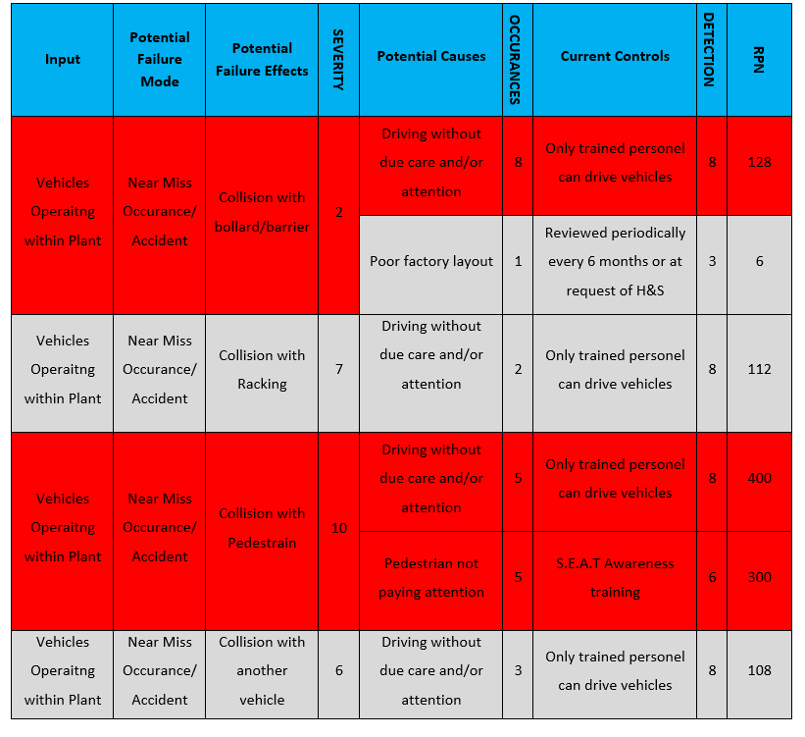
As explained previously the FMEA table can prioritise actions by calculating a Risk Priority Number (RPN). The RPN is calculated by multiplying the Severity x Occurrences x Detection. From table 10 it is clear to see that the main actions that need prioritising are the incidents involving collisions with the barriers and bollards and near misses with the potential of a collision with a pedestrian.
Table 10 - FMEA Table

5.3 Root Cause Analysis

The FMEA table (table 6) has highlighted three issues which have been highlighted as a priority. The next step is to carry out root cause analysis to determine the root of the problem which will then allow the project team to focus on what to explore and what development steps to take. Section 3.2.7 explained how root cause analysis can be carried out using the 5 why’s technique. From the potential causes column, it shows that driving without due care and or attention has the greatest risk (RPN) number. Although pedestrians not paying attention is another potential cause with a high RPN, if all drivers payed attention then no matter what the pedestrian was doing, there would not be a collision and therefore driving without due care and attention will be the focus of the root cause analysis.

1a) Why are drivers driving without due care and attention?
Cause 1 – Not fully checking their surroundings.
1b) Why aren’t drivers checking their surroundings?
Driving faster means that drivers can go to break earlier and are failing to check their blind spots.
1c) Why aren’t blind spots being checked?
Root Cause 1: Blind spots coving a large proportion of the vehicle.
Proposed Corrective action: System to notify driver of what is in the blind spot.

2a) Why are drivers driving without due care and attention?
Cause 2 – Drivers are hitting barriers.
2b) Why aren’t drivers seeing barriers?
Barriers are often in blind spots of the vehicle.
2c) Why aren’t blind spots being checked?
Root Cause 2: Blind spots coving a large proportion of the vehicle.
Proposed Corrective action: System to notify driver of what is in the blind spot.

3a) Why are drivers driving without due care and attention?
Cause 3 – Having near misses with pedestrians.
3b) Why aren’t drivers seeing pedestrians?
Drivers are often focused on what load they are carrying and are not checking what is in their blind spots only the direction they are travelling.
3c) Why aren’t blind spots being checked?
Root Cause 3: Blind spots coving a large proportion of the vehicle.
Proposed Corrective action: System to notify driver of what is in the blind spot.

4a) Why are drivers driving without due care and attention?
Cause 3 – Lack of training.
4b) Why aren’t drivers being trained properly?
Training has been cut within BEP due to the reset which aims to save money.
Root Cause 4: Drivers not sufficiently trained.
Proposed Corrective action: Restart regular driver training and refreshers.

The root causes can be seen above and a why tree (see figure 26) shows how each of the root causes are interlinked with each other and the main causes.

Root Causes
Why 3
Why 1
Why 2
D
A
C
B
Driving Without Due Care and Attention
Not Checking Surroundings
Hitting Barriers
Nearly Hitting Pedestrians
Not Trained Sufficiently
Regular Training and Refresher Courses
Failing to Check Blind Spots
Barriers Are Out of View of Driver
Pedestrians Are Out of View of Driver
Blind Spots Blocking Great Proportion of View
Figure 25 - Why Tree

5.3.1 Proposed Corrective Action

Carrying out the FMEA table and root cause analysis has led the project team to two proposed corrective actions. The first being that more regular training is needed for drivers’ and refresher courses outlining the dangers of fork trucks operating around pedestrians and the potential consequences. Drivers need to be made aware of blind spots and training should also focus on this. This suggestion shall be passed to the H&S department as well as the relevant managers and training department outlining that this is a corrective action that has been generated via plant research and analysis.
The second proposed corrective action is to completely remove blind spots from the driver’s view. Due to the construction of the FLT’s and RT’s within plant, the roof is a vital part of the structure of the vehicle and holds up a protective roof which protects the driver from falling objects (see figure 27).
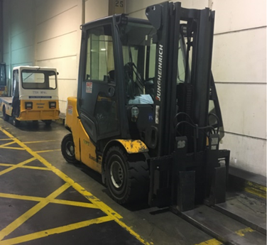
Figure 26 - BEP Fork Truck

This means that it is not viable to remove the current blind spots that the driver’s face. Figure 28 shows that people can be stood in close vicinity to the fork truck, however figure 29 shows the driver’s view and the blind spots that they face. It is easy to see how pedestrians can be hidden within these blind spots and if a driver is not playing full attention then they may not be seen at all.

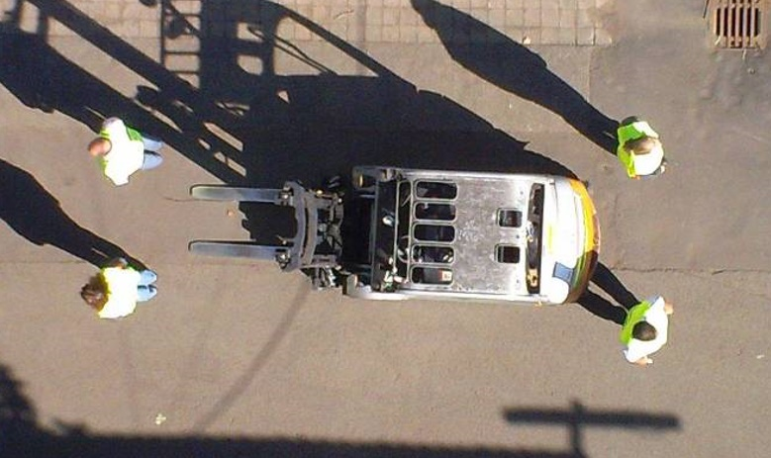
Figure 27 - Pedestrians Stood Around FLT in Blind Spots

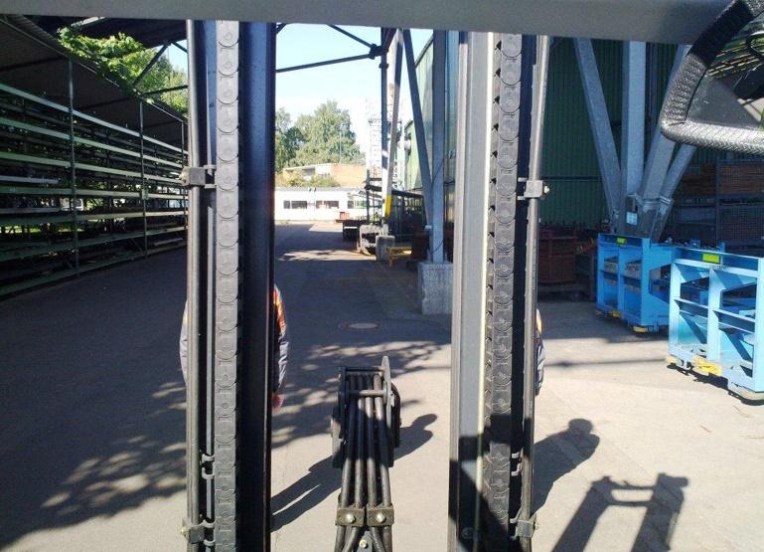
Figure 28 - Drivers View of Pedestrians Hidden in Blind Spots

There is an opportunity however to design a system that could ‘see’ in these blind spots. As already researched in section 3, many cars are not equipped with systems that allow them to drive without any input from the driver. This mean they can ‘see’ the road ahead and make decision based on what is in front of them.

5.4 Current Detection Systems

The project team has decided that it will explore cutting edge technologies and how these could potentially be combined in order to provide a solution to the project problem. This research will then be used in the development stage to create a product that can incorporate these state of the art technologies to be adapted to be used on a fork truck within BEP as a system that would ‘see’ what the driver cannot and notify them of what may or may not be in their blind spot.
An innovative solution has been decided upon because having carried out research, there is currently no retro fit detection systems on the market currently. As previously mentioned, car manufacturers are increasingly using detection systems in their cars, however these are often kept secret due to not wanting to give any other manufacturer an upper hand. The project team has decided that they will design a solution, using the cutting-edge technologies explored that will serve as not only a detection system for now, but also a system that can be adapted and expanded in the future.

5.4.1 You Only Look Once (YOLO) Real-Time Object Detection
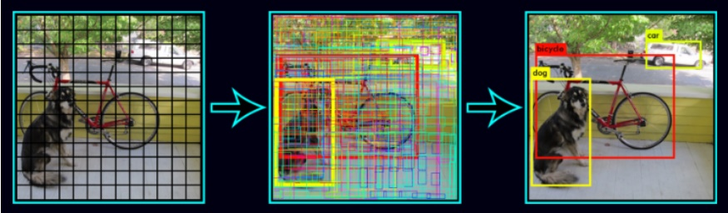
You Only Look Once (YOLO) is a state of the art, real-time object detection system. It applies a single neutral network to a full camera image. This network then divides the image into regions and predicts bounding boxes and probabilities for each region (see figure 30). The bounding boxes are weighted by the prediction probabilities (Redmon & Ali, 2018). The higher the probability, the more likely of a successful detection.
Figure 29 - Yolo Grid Detection (Ying, 2018)

YOLOv3 predicts an object score for each bounding box using a system known as logistic regression (see figure 31). The logistic regression works by predicting four coordinates for each bounding box, t_{x}, t_{y}, t_{w}, t_{h}. If the cell is offset from the top left corner of the image by (c_{x}, c_{y}) and the bounding box prior has width and height p_{w}, p_{h}, then the predictions correspond to (Redmon & Ali, 2018):

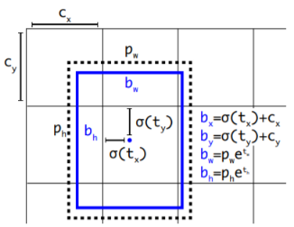
Figure 30 - Yolo Logic Regression (Redmon & Ali, 2018)
b_{x} = σ(t_{x}) + c_{x}
b_{y} = σ(t_{y}) + c_{y}
b_{w} = p_{w}e ^{tw}
b_{h} = p_{h}e^{th}

The score for each bounding box should equal to one if the bounding box prior overlaps a ground truth object by more than any other bounding box prior. If the bounding box prior is not equal to one but does overlap a ground truth object by more than some threshold, the prediction is ignored (Ren et al., 2016).
YOLO is said to be the fastest processing object detection system available, something Amazon dispute (AWS, 2019). Many others agree with Redmon & Ali’s (YOLO Founders) claims however. Some even think that YOLO as a computer vision tasks and identification system surpasses human performance and it more accurate and faster at identification than a human being (He, 2018).
For this project YOLO has the potential to act as an object detection system by detecting pedestrians. This could be used then to notify the driver every time a pedestrian is within close proximity to the fork truck, thus ‘seeing’ what the driver cannot. It also has the potential to detect barriers and bollards however due to the different shapes this could potentially be harder to achieve but is definitely something the project team can explore. YOLO is also FREE to use. Due to it being released to an Open Source website the developers encourage the use of the software.

5.4.2 Amazon DeepLens

According to Amazon, (2018) the Amazon Web Services (AWS) DeepLens camera is;
‘… the world’s first deep-learning enabled video camera for developers of all skill levels to grow their machine learning skills through hands-on computer vision tutorials, example code, and pre-built models.’ – (AWS, 2018)
Similar to the YOLO system, AWS DeepLens is a is a wireless-enabled video camera and development platform integrated with the AWS Cloud. It lets you use the latest Artificial Intelligence (AI) tools and technology to develop computer vision applications based on a deep learning model (AWS, 2019). Unlike YOLO, the AWS DeepLens however is confined to a single all in one unit for the purpose of easy and simple learning needs and set up takes less than ten minutes (AWS, 2019).
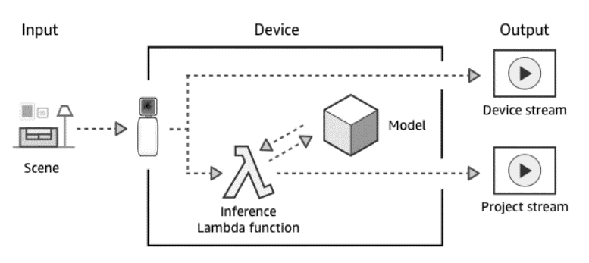
Figure 31 - Amazon DeepLens Architecture (AWS, 2019)

The problem with the Amazon system is that it is one whole unit and cannot be bought separately. The current unit price is £275 whereas the YOLO software is free to use and can be used with any quality webcam costing as little as £15.
DeepLens Total Cost per 198 Vehicles - £275 x 198 = £54,450.
YOLO also has an extensive forum platform where developers can go and talk about any problems they have encountered. As the DeepLens is still a fairly new product, this platform is yet to develop. The developers of YOLO have also claimed that the DeepLens can miss interoperate information, for example identifying a cat as a dog (Redmon & Ali, 2018). If the DeepLens was used conjunction with an FLT and a mis interpretation occurred then there is a possibility that a pedestrian walking close to a FLT may not be recognised.
YOLO also claims the AI system is not as effective as the teaching method employed by YOLO (Redmon & Ali, 2018). Due to only needing to detect pedestrians and potential barriers, the project team have decided that YOLO will be the better option of the two detection systems.

5.4.3 Radio Frequency Identification (RFID)

Radio Frequency Identification (RFID) is a process which uses radio waves to read information which has been attached to a tag and stored on an object. Unlike a barcode scanner which has a similar purpose, there does not need to be a direct line of site for the reader to be tracked (Zaino, 2014).
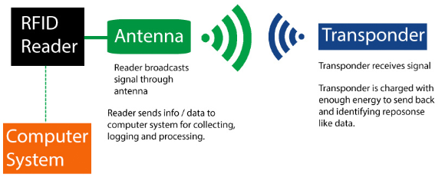
RFID is a combination of radio-frequency and microchip. The transponder chips used by RFID are much smaller and smarter than when they were first invented in the 1960’t which means they can be added to a variety of components. The range of RFID has also drastically improved (Narayanan et al., 2005).
Figure 32 - How RFID Works (Narayanan et al., 2005)

Advantages of RFID include a long scanning range, self-charging systems, high reliability and the ability to be linked to various computer systems to allow tracking which could be useful for tracking near misses within plant. However, one major disadvantage is the cost of RFID;
The project discussed the idea of each employee having an RFID Active Tag on their person via a clock in card or similar at a total cost of $15 each. The least expensive reader available would then be $3,000 and each vehicle would need one of these. The total costs would be very, very high to implement this type of technology as seen below:
RFID Tags Per Person - £15 x 1600 = £24,000
RFID Readers Per Vehicle - £3000 x 198 = £594,000
Total cost of implementing RFID within BEP at least £618,000
Although cost should not affect safety, as already discussed, it is often the deciding factor and as such this project aims to create a product for a cheap as possible. As previously calculated the estimated cost of a non-fatal injury equates to roughly £175,000 and therefore BEP would need to justify sending over half a million dollars to potentially save only one third of that cost.

5.4.4 Radio Detection and Ranging (RADAR)

Radio Detecting and Ranging, better known as RADAR is a detection system that used radio waves. A transmitter sends out electromagnetic radio waves in short pulses in predetermined directions. An object that ‘get in the way’ of these waves reflect part of the wave back towards the radar receiver. This information means that the radar system is then able to work out where the reflection is occurring and therefore defining the distance between the object and the transmitter/receiver (Skolnik, 2008).
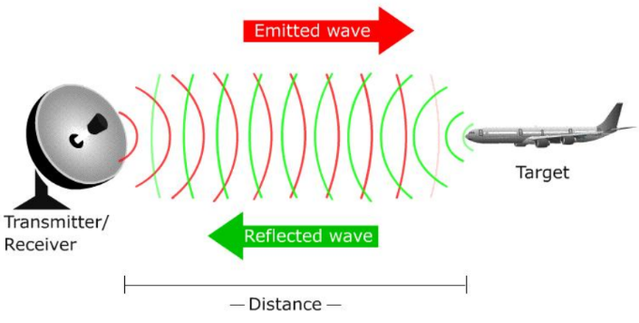
Figure 33 - How RADAR Works (Spanawave, 2015)

The radar can not only be used in plain sight but it can also penetrate and see through insulators. Radar also has the ability to distinguish between fixed and moving objects. Due to radio waves being less absorbent than other types of waves such as light, Radar is useful and can be used over long distances and if often used for military and meteorology purposes (Neal, 2018).
One major flaw, especially with regards to this project however, is that radar cannot distinguish between targets (RF World, 2018). For example, a radar system would not be able to tell the difference between a bollard or a pedestrian. This however could be used to combat the problem of increased collision and vehicular damage.
Radar accounts for more than 35% of the collision avoidance sensor market and its market penetration is increasing, surpassed only by cameras. The cost of the most basic radar system is around £55 and therefore fitting a radar system to every vehicle in plant would roughly equal (Manz, 2018);
RADAR total cost Per 198 Vehicles - £55 x 198 = £10,900.
With this in mind, it could be a very useful application and something the project team need to consider carefully due to its low cost to BEP.

5.4.5 Light Detection and Ranging (LIDAR)

Light Detection and Ranging (LIDAR) just like Radar, is a detection system, however it uses light, specifically, laser light to measure distances (Fowler, 2000). The wavelengths of light (10⁻⁹ meters) are much smaller than the wavelengths of radio waves (10³ meters) and this means that lidar is able to detect smaller objects and also have a much higher resolution, meaning they are more accurate and better at defining objects.

Unlike 2D radar, lidar has the ability to create a 3D image of the surroundings by shooting out a pulse of light from the transmitter which is subsequently reflected back by an object, which is then detected by the receiver. The total time of flight along with the speed of light can then be used then used to calculate the distance to the object as shown in figure 35.
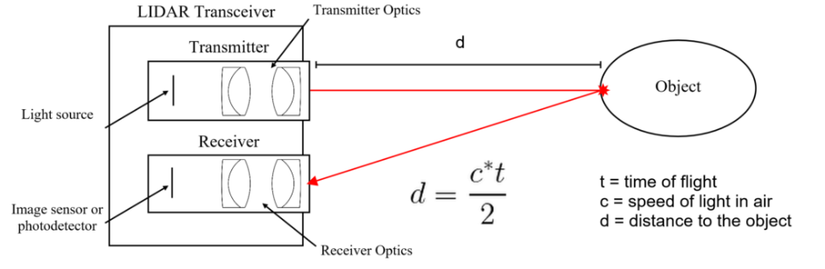
Figure 34 - Calculating the Distance of an Object Using LIDAR (Eckhardt Optics LLC , 2019)

As previously mentioned, the LIDAR transceiver doesn’t just shoot a single beam out in one direction and this means it has the ability to create a 3D image or scan. The transmitter, transmits and receives over 100,000 pulses per second over an area using a beam steering device which is usually a rotating mirror through 360 degrees. This mean a 3D imagine of the surroundings can be built very quickly (Eckhardt Optics LLC , 2019).
LIDAR’s ability to 3D map so quickly is exactly why it is so beneficial in driverless cars. It has the ability to generate huge three-dimensional maps that a car can then circumnavigate. This means that a driverless car is able to not only determine whether there is a sign or traffic light ahead but also detect and track moving pedestrians (Taylor-Smith, 2018).

From the projects prospective LIDAR looks extremely promising. Its ability to map its surroundings, track pedestrians and have a 360-degree continuous view means it would have the ability to solve many of the problems being faced within BEP. As with any new and developing technology however, it is extremely expensive. The price of one LIDAR system currently stands at $75,000 per unit, although Google claim to have recently cut that cost by 90% which if proven to be true would be a significant step forward (Muoio, 2017). At the time of writing however, the cost of implementing a LIDAR system on every vehicle would be the most expensive solution yet;
LIDAR Total cost Per 198 Vehicles - £75,000 x 198 = £14,850,000
Costing nearly £15 million to fit BEP vehicles with LIDAR is just uneconomical and therefore at this moment in time not an option. This is something the project team can continue to develop however and as LIDAR cost decreases, look how it can be implemented and used in conjunction with the vehicles within BEP to improve safety and save costs through collisions.

5.4.6 Ultrasonic Sensing Systems

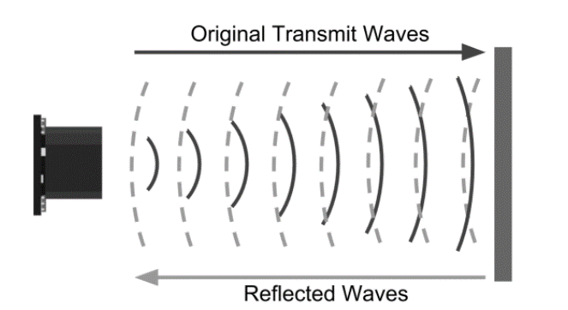
Ultrasonic sensing systems work just like Radar and Lidar. They however use sound waves instead of radio or light waves. The Ultra sonic sensors send out a sound which vibrates at a frequency above the range of human hearing which is at 20kHz. Transducers are then used as a microphone to receive the sounds which have been reflected by an object in the sound waves path, just like radar and lidar. The sensor determines the distance to a target by measuring time lapses between the sending and receiving of the ultrasonic pulse (see figure 36) (Hikita, 2010).
Figure 35 - How an Ultrasonic Senor Works (ElectronicWings, 2019)

Like Radar and Lidar, we know that,
Distance = Speed x Time
And that the speed of sound waves is 343 m/s.
Therefore
$$\frac{343 x Time of Echo Pulse}{2}$$
Total Distance =

Total distance is divided by 2 because signal travels from the sensor to an object and then returns back to the sensor.
While radar and ultrasonic sensors can be used for some of the same purposes, ultrasonic sensors are readily available and much cheaper than the radar or lidar alternative. In certain situations, they may detect objects more effectively than radar too. Some radar and lidar sensors can sometimes have problems sensing clear plastic. Ultrasonic sensors have no problem with this (Cook, 2018).
At the time of writing this report a HALJIA HC-SRO4 ultrasonic sensor, which has a detection range of 2cm – 500cm at 40kHz, is priced at £3.99 per unit. If bought in a box of 540 this reduces to £2.09 per unit (RS Components, 2019).
Each vehicle would need to be fitted with at least three of these sensors, to each cover a 90-degree area of the three none forked sides of the vehicle, or four for people carriers (21 – see table 1).
Therefore, the total cost of Ultrasonic sensors being fitted would be;
21 (PC’s) x 4 (Sensors needed) = 84 x £2.09 = £175.65
177 (All other Vehicles) x 3 = 531 x£2.09 = £1109.79
Total Cost of Retrofitting Ultrasonic Sensors = £1285.44
With Ultrasonic sensors working out at almost 10 times less than Radar, it is something the project team will explore as it has great potential to act as an object detection system. Although it is a ‘dumb’ system and as such cannot tell the difference between any one object be it barrier or pedestrian it could be used then to notify the driver every time a barrier or bollard is within close proximity of the forktruck, thus ‘seeing’ what the driver cannot, just like how ultrasonic sensors are used on cars as parking aids.

5.4.7 Arduino

Arduino, like YOLO is an open-source platform. This means that any software is free to use and develop, although hardware does come at a cost. Arduino is a combination of an easy to use hardware and software electronics platform. Its main purpose according to Arduino is a tool for fast prototyping and programming. It can be used for an unlimited amount of applications from wearable tech to 3D printing to drones (Ardunio, 2019).
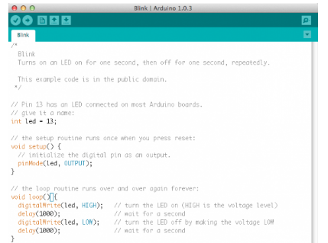
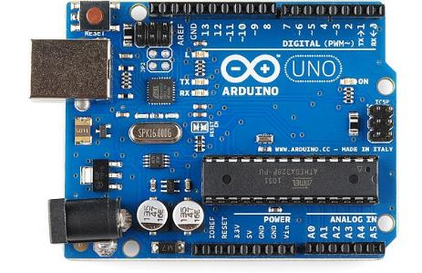
As already explained, Arduino is made up of a programmable circuit board (PCB) known as hardware (see figure 37) and a means of programming the PCB through the Integrated Development Environment (IDE) known as software (see figure 38).
Figure 36 - Arduino IDE (Ardunio, 2019)
Figure 37 - Arduino PCB (Ardunio, 2019)

Due to Arduino being open-source it has the ability as previously mentioned, to be adapted into an unlimited amount of applications. From the projects point of view, it has the ability to run YOLO as a detection system but also be incorporated as the main system module for an ultrasonic sensor. More research will need to be carried out during the development stage as to how to programme the PCB using the IDE software.
At the time of writing a basic Arduino Uno Rev3 which has built in Wi-Fi modules, Bluetooth Modules, Flash Memory and an AC-DC power converter is priced at £16 (Ardunio, 2019).
Therefore, the total cost of Arduinos being fitted to every vehicle would be;
Total Cost of Arduino for 198 Vehicles = £16 x 198 = £3,168

5.5 Conclusion and Relevance

Exploring the cutting edge technology available to the has meant that the next stage of the project can take place. The project team will decide what technoloy they think is applicatble based on the skills within the team, the cost of implementing the technology and the likelihood of it coming toget to develop a succesful product which solves the project problem.
Firstly due to YOLO being a free to use software it is something the project team have decided to use in the development stage of the process. Futher research will be carried out and during the development stage the team will try to understand the limitations of YOLO but also the power of it. It is hoped that YOLO will be used in conjunction with a camera as a pedestrian detection system. The purpose of this system will to be to identify pedestrians which in turn will send a signal to warn the vehicle driver of their presence. This will be controlled via an Arduino Processor.
Again, Arduino is a free to develop and free to use hardware and software prototyping tool and as such will allow the project team to build a product that can satisfy the project problem. It allows for continuous change and development of the system and means that further technology can be added at any time during the development process or later should the need arise.
Finally, again coupled and controlled by Arduino, Ultrasonic sensors will be retro fitted to vehicles within plant. The aim of this is to notify the driver of an object within close vicinity of the vehicle to decrease the number of collisions to barriers and bollards which in turn will have a huge cost saving effect if completely eliminated.
The estimated total cost of the developed as found from exploring the technology is;
Total Cost of YOLO = FREE
Total Cost of Retrofitting Ultrasonic Sensors = £1285.44
Total Cost of Arduino for all Vehicles = £16 x 198 = £3,168
Estimated Total Cost of Development Deployment on 198 Vehicles = £4,453
There will also be small cost considerations to make such as connectors, cabling, lighting, camera and alarms to notify the drivers, but this is estimated to cost £5,000 maximum. The prototype that will be developed will utilise parts found within BEP and therefore no extra charge will occur.

1
2
3
4
5
6
7
8
9
10
11

6.0 Develop: Detailed Design

6.1 Action Plan

During the development stage, a design is developed based largely on meeting customers’ needs and desires. To do this an action plan will be created following which all actions will be developed and met in order for a successful product to be created (George et al., 2005).
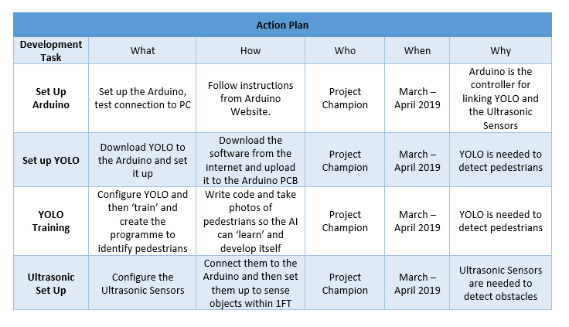
Table 11 - Development Action Plan

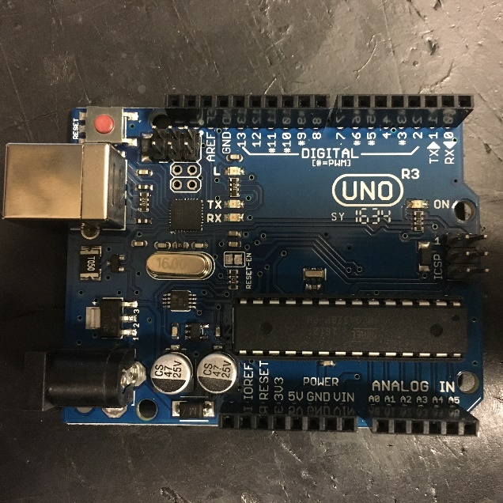
6.2 Setting up the Arduino
Figure 38 - Arduino UNO PCB bought by BEP

Due to Arduino being open-source, there is a vast amount of information online on how to set it up, ideas of how to use it, what applications it can be used for as well as support forums, help desks and information packs which are all easily accessible (Ardunio, 2019).

Setting up the Arduino is a very easy process and one that can be found on the Arduino website. It gives a set by step guide on how to set up the Arduino and what software needed to be downloaded (see figure 40).
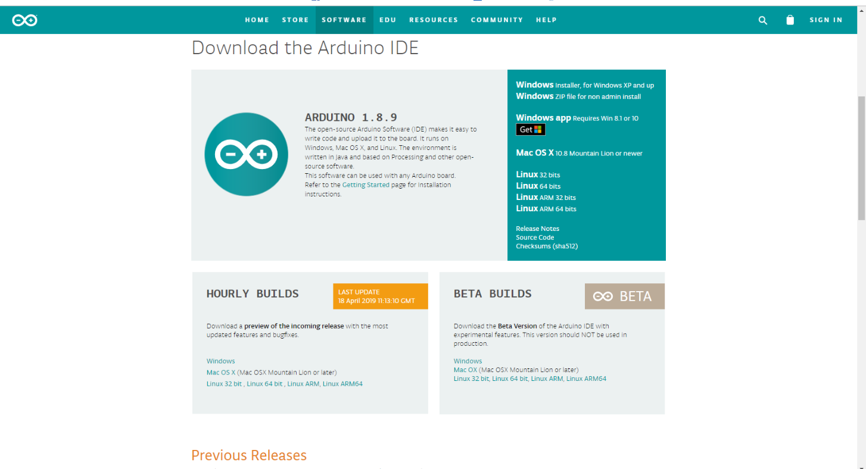
Once the IDE software downloaded, the next step was to connect the Arduino and test the connection to the PC as per the Action plan. Arduino can also be connected and edited online, meaning it does not always need to be connected to a PC with the IDE software installed, just one with an internet connection (Ardunio, 2019).
Figure 39 - Downloading Arduino IDE Software (Ardunio, 2019)
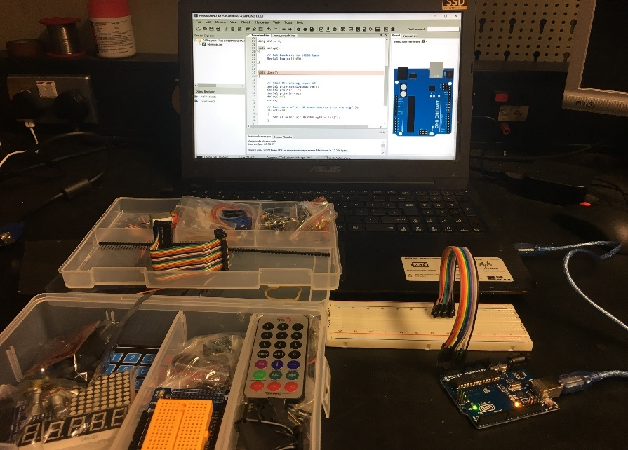
Figure 41 shows the Arduino being connected to the laptop PC. The connection was successful as the Arduino powered up and the software automatically downloaded all the set specification settings of the PCB.
Figure 40 - Arduino PCB Powering Up

6.3 Setting up of the YOLO

Following the successful set up of the Arduino hardware and software, the next set was to set up the YOLO software and download the base settings to the Arduino to make sure that it could run the software. This was a vital step as it is the main software needed to detect a pedestrian and the one needed for the project to ultimately be a success. The set by step guide followed was created by the YOLO creators (Redmon & Ali, 2018).
Firstly, a base system was installed called Darknet, again an open-source free to use software. From Darknet a separate operational dependency called CUDA was installed to the Arduino (see figure 41) and cloned to the DarkNet Git repository (see figure 42). This was all carried out via a personal PC as the IT department within BEP would not allow for the download of certain open-source software.
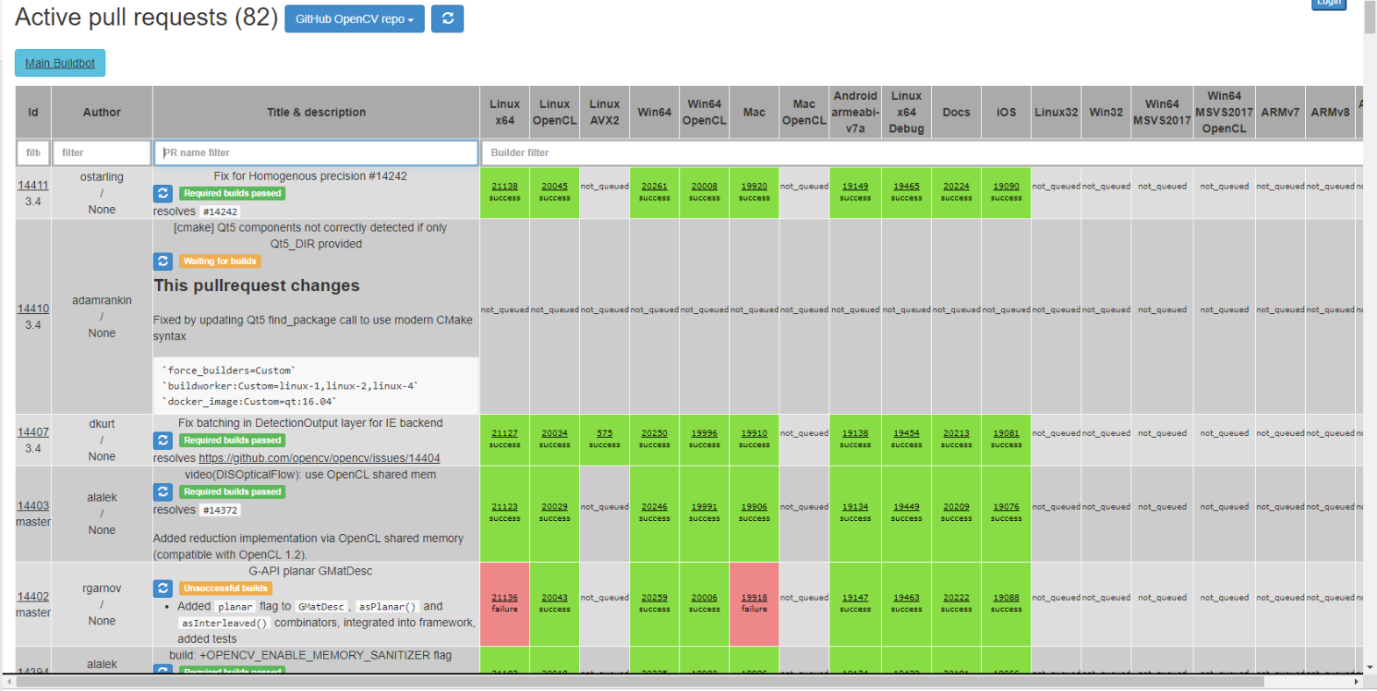
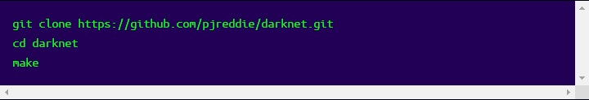
Figure 41 - CUDA GPU Dependency Installation Page
Figure 42 - Cloning the Darknet Git Repository

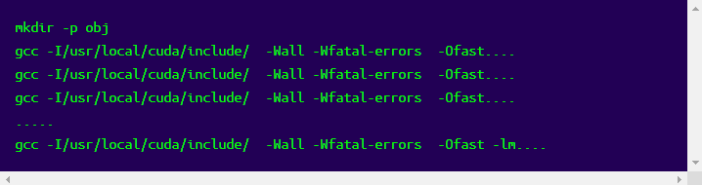
A Git repository is a selection of data files. This can be changed overtime and as such, if all vehicles were connected wirelessly to Wi-Fi, a single change could be made to all vehicles instantaneously by editing the git repositories.
Figure 43 - Errors downloading Darknet to Arduino

At first it was apparent that errors had occurred when downloading Darknet to the Arduino (see figure 43) however this was due to downloading the incorrect git file. Once the correct repository has been downloaded YOLO is ultimately connected to the Arduino and ready for programming.

6.4 Training of the YOLO

As previously mentioned, YOLO software is a deep learning detection system. This means that once the system knows what rough image the system is looking for, although an image may be different, it has learnt that it is similar enough to be the same as the rough imagine. This is explained in chapter 3 and shows how the grid system predicts probabilities of an object being similar to that the system is looking for.
Also previously mentioned is the difficulties that could be faced with identifying bollards and barriers using YOLO. Although possible, at this early stage of development the project team decided to solely focus on detecting pedestrians. To do this a pre-trained model can be downloaded; this is an image library of random images that have been tested previously by YOLO users (Redmon & Ali, 2018).
It was decided by the project team to use the datasets provided online from OpenCV. OpenCV is a library of images also known as weights, from humans to dogs, giraffes, cars, bikes and horses. YOLO allows if necessary, to create your own data sets to be detected if they do not yet exist, for example a bumblebee. Each dataset includes around 120 images and this is the reasoning behind using a predefined set. Taking 120 of pedestrians around BEP would not only be time consuming but permissions would also need to be granted.
The first step is to redirect the config file for YOLO to the main directory and then download the OpenCV weight library (see figure 45). This would ensure that when power is lost, the same programme reboots every time.
Figure 44 - Downloading the OpenCV Weight Library
The weight library as already explained contains a multitude of different image types and although nearly all of these were not needed, the file was not changed to save making the project any more complex than it needed to be. The file contained that of humans which would be needed to detect pedestrians near a vehicle within BEP.
Once the weight library was downloaded to YOLO the next step was to then train the YOLO model which had been uploaded onto the Arduino.
Figure 45 - Running the Weight Library Train Command
Once YOLO had been trained the next step was to test it using a webcam linked to the Arduino. The wiring diagram was found on GitHub, an open-source web sharing platform. The camera was connected and wired as per figure 48.
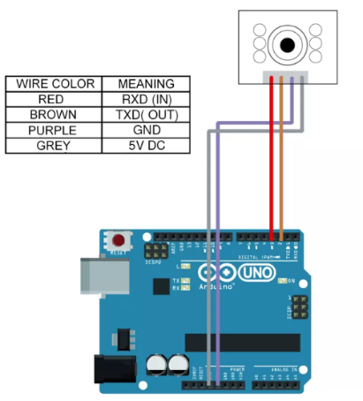
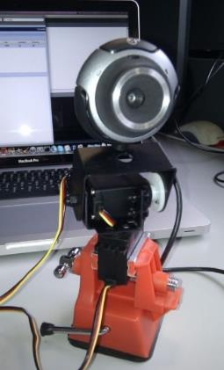
Figure 46 - Webcam to Arduino Wiring Diagram
Figure 47 - Webcam Being Wired to Arduino PCB

During testing it was apparent that the measurement system was showing that a person standing less than 3ft away at 0.84m showing a trigger red box even though that was not the case. The measurement system needed to be set up in order to get an accurate reading for when a pedestrian was within the target zone. Problems also occurred with the use of the webcam and it was decided by the project team to use a laptop webcam instead, something that would need to be addressed before being fitted to a vehicle.
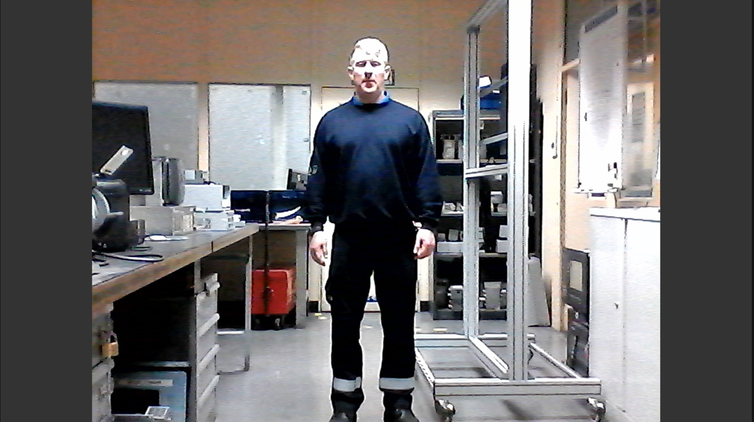
Figure 48 - Testing the YOLO Software
PERSON 0864

To do this a distance of 1000mm (1m) was measured from the camera to the core of the person which is roughly just over 3ft which as previously mentioned in Chapter 3 is the maximum distance a pedestrian can come within a vehicle within BEP. This data was then uploaded to YOLO and the weights redownloaded (see figure 50). This process would need to be verified on every vehicle as otherwise it would not make the driver aware that a pedestrian was within 3ft, it would notify them at all times.
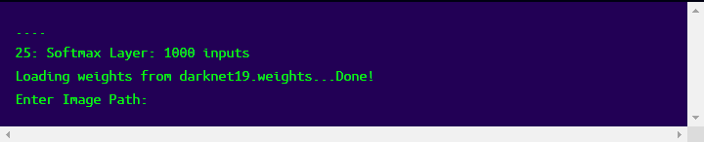
Figure 49 - Calibrating the Camera
The results are as seen below in figure 51. It is noted that the person standing at 1.1m is highlighted in red and the person standing at 0.34m is highlighted in green. This is showing that the boundary zones are now correct and any persons within 3ft will trigger a response from YOLO to the Arduino.
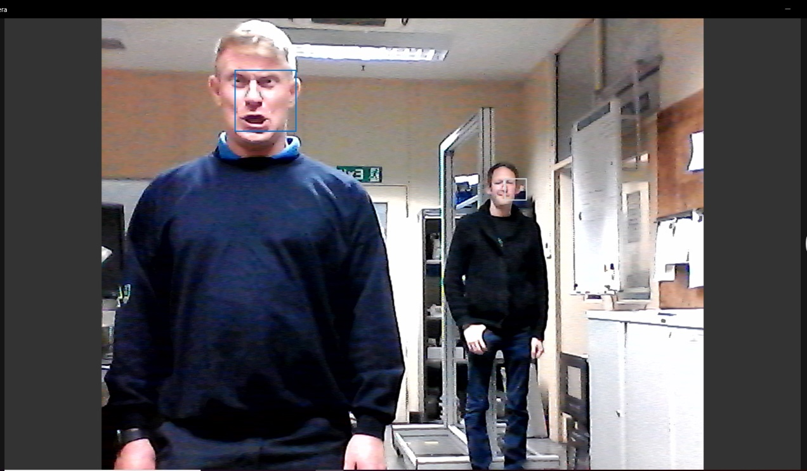
Figure 50 - YOLO Software Test Showing Response
PERSON 0342
PERSON 1102

This is very basic YOLO training and it can get much more complicated. As this project is only developing a prototype it will not stand the full operational tests. Before this were to happen, a greater depth of training and testing would be needed to fully understand the distance at which a pedestrian needs to be identified for a driver to react in time along with other characteristics such as the effect of lighting and speed of a moving vehicle.
The camera is also covering a 110-degree view as per the specifications of the camera. For the system to be successful a 360-degree view would be needed and therefore either more cameras or a 360-degree camera would need to be implemented. This will be a recommendation for future development but for the prototype, a single camera will be utilised in order to gain data and make sure the system is working at very little expense.

6.5 Setting up of the Ultrasonic Sensor

As previously mentioned, each vehicle would need at least 3 ultrasonic sensors to cover each side of the vehicle (see figure 52). Those with forks would only use 3 as the fork facing sensor would otherwise pick up on any loads whereas passenger carriers could use 4 sensors to also protect the front of the vehicles from any objects and obstructions.

Figure 51 - Diagram showing Ultrasonic Sensors Required

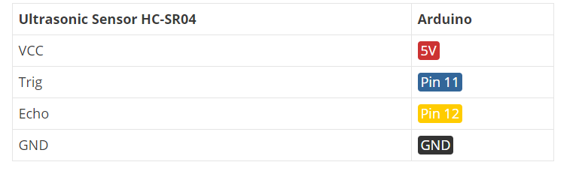
The pin outs of the ultrasonic sensors are as shown in figure 53 and the wiring schematic for the ultrasonic sensor in figure 54. This data was gathered via the IDE open source forum (Santos, 2019).
Figure 52 - Pin Outs for Ultrasonic Sensor (Santos, 2019)

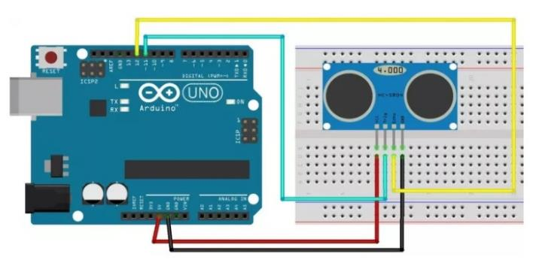
Figure 53 - Wiring Schematic of Ultrasonic Sensor (Santos, 2019)

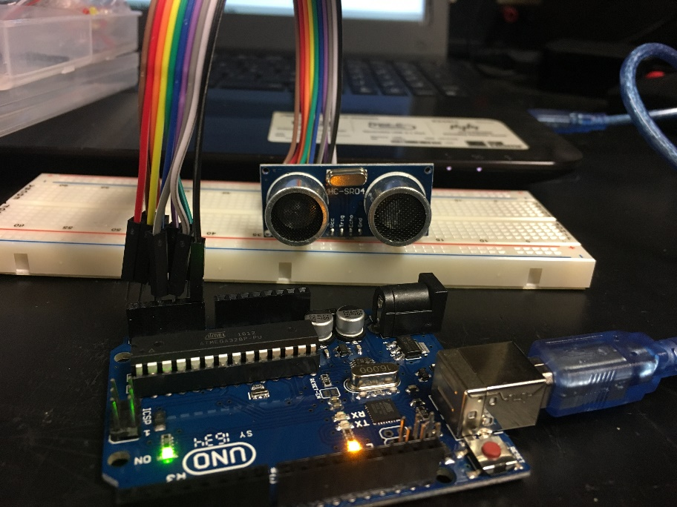
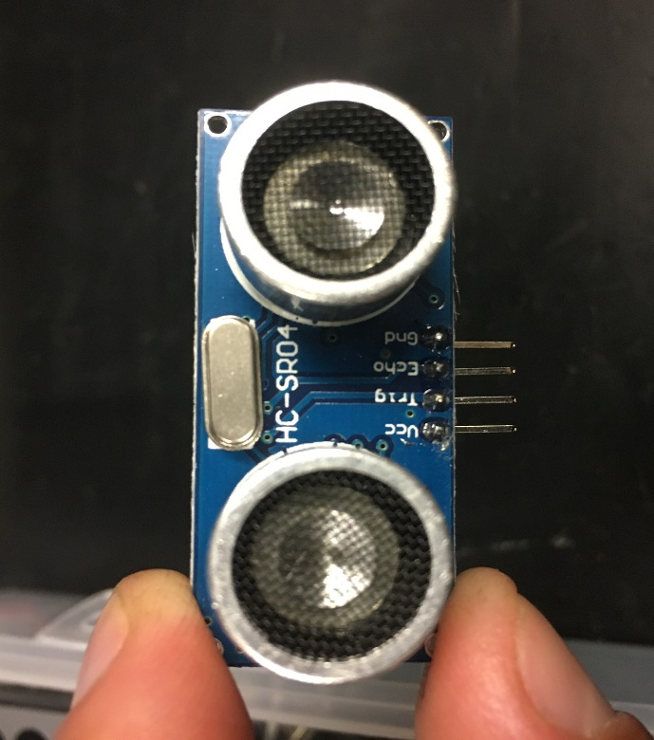
For the purpose of the project, the team have set up one sensor to show how it would be operated (see figure 55). The final design would need to incorporate at least three as previously mentioned.
Figure 54 - Setting up of the Ultrasonic Sensor

The next step is to write the code to the Arduino using the free IDE software. Again, the code was sourced via IDE’s open source website which encouraged users to share information (Santos, 2019). The code is a mix of C/C++ functions which are as follows;

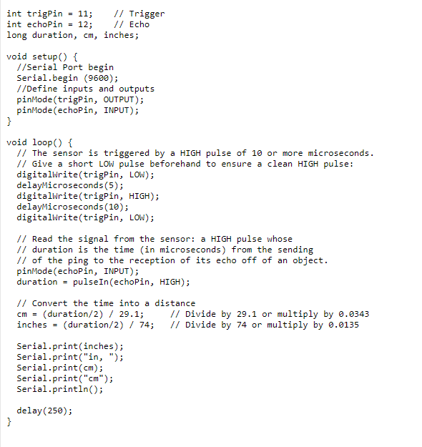
Figure 55 - Code for the Ultrasonic Sensor (Santos, 2019)

To break down the code so that it can be understood by the rest of the project team, figure 57 shows the creation of variables for the trigger and echo pin called trigPin and echoPin. The trigger pin is connected to digital Pin 11, and the echo pins is connected to digital Pin 12 as shown in figure 53 and 54. Also created is three variables of written as long duration, cm and inch. The duration variable saves the amount of time taken between the transmitting signal and receiving signal (Santos, 2019). The cm variable will save the distance in centimetres, and the inch variable will save the distance in inches. This was done as the preferred method of measurement in the UK is cm however Ford and BEP use ft as the measurement for a pedestrian to a vehicle as described in Chapter 3 and hence why this measurement was included.
In the setup up sequence, the serial port of the Arduino is initialised at a baud rate of 9600, note this is already done simultaneously with the YOLO software. The trigger pin is then set as an output and the echo pin is set as an input as shown in figure 57.
Figure 56 - Creating Variables for Trigger and Echo (Santos, 2019)

In the loop sequence, a low pulse from the sensor is sent in order to clear any surrounding interference and then a high pulse triggers the sensor for 10 milliseconds (see figure 58). This is on a continuous loop. This could eventually be triggered by another means such as the vehicle in motion or vehicle deadman’s switch enabled.

Figure 57 - Loop Sequence for the Ultrasonic Sensor (Santos, 2019)

The echo will then receive any returning sound waves when it senses the high pulse retuning and will convert the time duration from the transmission signal to the receiving signal into distance.

As previously explained, Distance = Speed x Time
And it is known that the speed of a sound wave is 343 m/s.
Therefore
$$\frac{343 x Time of Echo Pulse}{2}$$
Total Distance =

The total distance is divided by 2 because signal travels from the sensor to an object and then returns back to the sensor. By knowing that the speed of sound is 343 m/s and therefore equal to 0.034 cm/µs or 1/29 cm/µs, the equation can be entered as seen in figure 59.
The end results are then printed into the serial monitor, this is where the data can then be used as data which the Arduino can determine and if necessary, outputs such as a light or siren can be activated based on this data (Santos, 2019) .
Figure 58 - Converting Time into Distance (Santos, 2019)

6.6 Combining the Development

The final stage of the development chapter is to combine the whole development into one working prototype. As previously shown, YOLO and Arduino work together and therefore has the ability to detect pedestrians with a 1m (3ft) radius of the vehicles. Simultaneously, the Ultrasonic Sensor and Arduino have the ability to detect objects from a 2cm to 100cm range (this range can also be modified).
In order to notify the driver, the project team have decided to use a warning alarm with two LED’s which will light up if a pedestrian is detected (RED) and an object/obstacle is detected (BLUE) (see figure 60).
The camera and ultrasonic sensor have also been combined onto the same breadboard in order for the prototype to become a complete unit as seen in the wiring schematic in figure 60. Although the system would not be able to be fitted in its current state, as a working prototype it can be used as a development piece and refined into a robust working system.
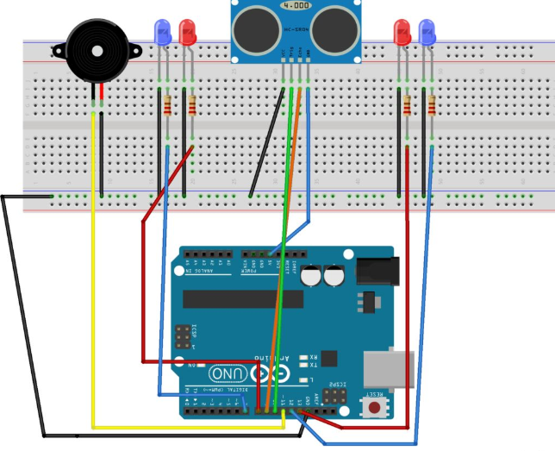
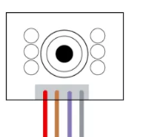
Figure 59 - Final Combined Wiring Diagram

1
2
3
4
5
6
7
8
9
10
11

7.0 Implement: Final Design

7.1 Implementation of the Prototype

As previously explained in chapter 3, the Implement stage for a DMEDI Project is all about having controls in place to make sure that the new process or product in this case is not only working correctly but that it is monitored and any problems are reacted to positively to make the change a success.
The project team have decided to fit the prototype to the Electronics Personnel Carrier (see figure 61). This four-seater vehicle is used daily but due to it no being needed for production or MP&L purposes, it is well suited as a test vehicle.

Figure 60 - Electronics Personnel Carrier

The prototype will need to be continuously tested and monitored for operational discrepancies and anomalies. As with any new product and system, it is known that the project team are likely to incur problems at this stage. Although the system has been tested in a workshop, being fitted to a moving vehicle could present problems not envisioned by the project team and therefore the following monitoring and reaction plans have been developed to try and make sure that these are picked up quickly and rectified.

7.2 Monitoring Plan

Part of making sure that any product is successful is monitoring it to spot any problems that may arise and so that changes which are made are maintained long after the project has ended (George et al., 2005). In order to track whether the system would be a success a monitoring control chart was designed (see table 11). The purpose of the chart is to collect data from FactoryVision for the Electronics Vehicle and compare that with the data collected by the Pedestrian detection and collision prevention system to make sure that they are comparing correctly with each other.
The monitoring chart will be used to standardise the method for collecting data which can eventually be implemented when the system is rolled out to more vehicles within BEP.
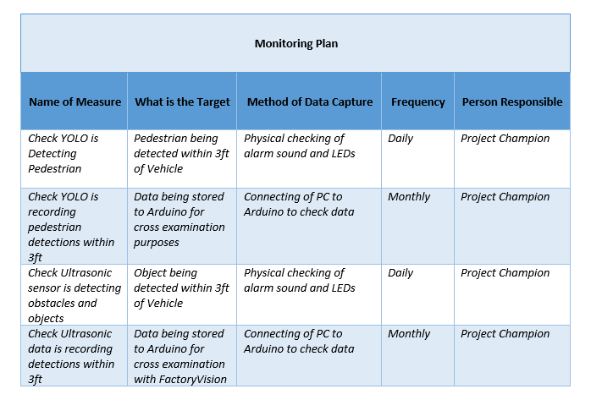
Table 12 - Monitoring Plan

At this stage, due to only one prototype being produced, the monitoring plan is fairly basic. Once more systems are built and fitted to more vehicles, the monitoring plan will have to become more robust and remote and it may not be practical to make daily checks. By creating the monitoring plan now however, it can easily be updated when required.

7.3 Reaction Plan

As mentioned, monitoring the detection system is essential to the success of the project. Due to the project and system only being a prototype however, it is assumed that for whatever reason the system may not react as intended. For this reason, a reaction plan has been produced (see figure 62).
The purpose of the reaction plan is to react to any discrepancies to the standards set by the project. This will allow any anomalies to be identifies and combated to prevent a re-occurrence.
The reaction plan has been standardised so that it can continually be used by the project team throughout the whole implementation of further prototyping and eventual role out of the detection system.
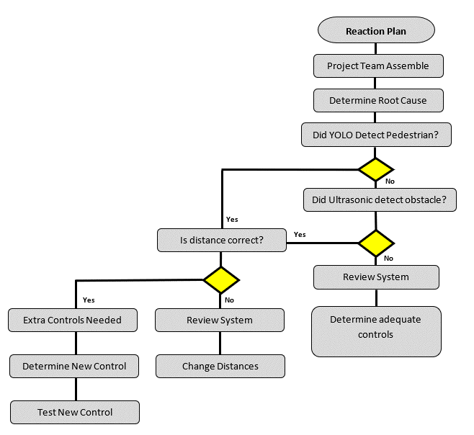
Figure 61 - Reaction Plan

7.4 Change Management and Culture Control

Finally, before any implementation takes place, change management and change culture of BEP needs to be recognised.
As explained during the literature review; with any project, for a successful outcome, the change which has taken place has to be accepted by those who are most likely to be affected by it.
As already explained, strong management and leadership are a vital part of making any change within an organisation. This is due to the human race being naturally resistant to change (Eidelman et al., 2010). It is thought that is because a certain ‘way’ or ‘process’ that they are accustomed to is normal and any change could have consequences for them. This means that when change comes about, there is often conflict and unwillingness to accept the change. It ultimately means that you must get rid of the old and good, for the new and not good. This means that change is often a challenge for management and many theories have been developed to try and combat this resistance (Eidelman et al., 2010).
In order for a successful change to occur, as mentioned in chapter 3, Kurt Lewin talks of keeping a status-quo. This basically means that neither those who want change or those who do not want change can overwhelm each other. This is a particular problem within BEP as there is a clear divide between management and the production staff due to a number of reasons. This however could have a knock-on effect as when management all of a sudden request changes, the production staff including the MP&L drivers might oppose it without deciding if it is actually to benefit them. With this in mind it is important to get the MP&L staff involved as much as possible and make sure that the communication between management and production staff is maintained throughout the whole development of the project.
It is often also easy for the management to place blame during change as explained in the literature review which can further lead to conflict and the resistance to change. Management personnel need to understand that which such a fluid project, one that is continuously being developed, mistakes are going to be made and drivers other staff should not automatically be blamed. Instead monitoring and reaction plans should be followed to make sure that the driver or operator does not feel victimised for something that could potentially be caused by a faulty system.

1
2
3
4
5
6
7
8
9
10
11

8.0 Conclusion and Recommendations

8.1 Potential Cost Savings of the Project

Although the main aim of the project, especially from the project teams view, was always to improve safety within BEP by reducing near misses and vehicle collisions, it could not be helped thinking by the project champion that there was also a financial aspect to the project. Due to the accident that had occurred in 2018, the threats of fines from the HSE were an ever more real threat and although it is presumed that management did really care about the safety of their employees, it was more likely financially driven.
From the research carried out by the project team, the estimated cost to the company of an accident involving a vehicle and pedestrian was between best case £175,000 and worst case £4,000,000.
Further research also found that the estimated cost to the company for damage to the leased FLT’s, RT’s and TT’s was £210,017.
Unfortunately, due to lack of data, the cost of barrier and bollard repair could not be calculated. Often the damage is left until it is deemed unsafe by the H&S department and therefore is not included, although the project team would like to also point out this admission which would have made the potential cost savings even greater.
The total cost direct parts needed to build the detection system for all 198 vehicles within BEP was £4,453. Added to this there will also be small cost considerations to make such as connectors, cameras, cabling, LED’s and alarms to notify the drivers, but this is estimated to cost £5,000 maximum. This takes the total cost for full, plant wide implementation to a maximum value of £9,453.
With this in mind, the potential cost saving from potential fines and extra lease payments due to vehicular damage to;

Potential Fines + Estimated Lease Damage Claim – Max Project Cost = Potential Cost Saving
£4,000,000 + £210,017 - £9453 = £4,200,564
With this figure calculated it can be used to prove that the potential cost savings of the project have been identified, hopefully forcing management to invest more resources into the development of the system and in turn ultimately making BEP a safer place to work.

8.2 Project Conclusion

The main aim of the project, set out by management of BEP was;
To decrease the number of near miss occurrences and vehicle collisions within Bridgend Engine Plant.
In order to achieve the main aim, the following objectives were set;
- Research lean six sigma project tools in order to discover potential opportunities to increase efficiency and safety though the project.
- Measure and collect current accident data and look for similarities within in order to find a ‘root cause’ in order to tackle the problem.
- Research and explore current detection methods within the automotive and other industries to see how these could be implemented within BEP.
- Research and develop an effective detection system that has the ability to be implemented within BEP in order to reduce near misses and vehicle collisions.

- Produce and implement a prototype to measure and collect data to see whether the system works correctly.

The aims highlighted in green have been achieved by the project team, evidence of which can be found within this report. The aim highlighted in amber is an aim that has partially been met and is currently a work in progress.
To elaborate further, in order of the aims above, firstly the individual aims were decided and set by the project team as a way of achieving the main aim set out at the beginning of the report. The aim was set by management due to an accident that had occurred within BEP and they had stated that the project could be used to better improve the safety of the employees within plant. Although the project team had found no evidence to suggest otherwise, it soon became apparent that maybe the real driving force was financial although we had nothing to confirm this. Either way the main aim stayed the same and from that smaller objectives were set as targets to be completed.

The first of those was met by using the DMEDI process was used as the main body and structure throughout the project. This lean six sigma technique was researched during the literature review and found to be the best way of structuring the project so that all the other aims could be successfully met. Each phase meant that the project could concentrate on hitting a different aim each time which would ultimately mean that the project was a success. Other lean tools were also researched, some which proved vital such as FMEA and root cause analysis.
After the bulk of literature had been researched the next phase was to collect sufficient data, mainly to justify that the problem really did exist. It was not until this data was collected that the apparent size and cost of the problem was actually realise and it was at this point that the project team realised that maybe the finical benefits to BEP outweighed the human consequences, especially during the current time where a major reset is underway with the goal of cutting jobs to save money. Many of the project team did not realise the cost implications of the problem; accident costs ranging from between £175,000 to £4 Million. These figures were useful as they could be used to prove the effectiveness of the overall project if it turned out to be a success. Questionnaires were used to gather information off employees, this was particularly useful as again it surprised the author and the project team as the problem seemed to be much worse than the BEP management had been led to believe. Of the 18 employees who answered, everyone had had a near miss, but only 2 of those had actually reported it. The questionnaires also got the employees involves and asked them what changes they would like to see made. Although they knew the project team had no relation to senior management level, the overwhelming answer was one involving more jobs, more men and more hours, something the project team could not provide. However, some useful answers were received, such as an early warning system, or a second pair of eyes. These were ideas that the project team had already talked about and therefore this was taken as a positive because it would make the employees feel like their opinions were valued, which they were. The questionnaire could have been improved by increasing the sample size. This could have been done as previously mentioned by attaching the questionnaires to the employees pay slips or finding time to speak to each employee one by one. This would have then given a more statistically significant result.
Following the data collection, FMEA and Root Cause analysis showed that a detection system could have the potential to satisfy the main aim and therefore it was decided that a detection system was going to be produced. The objective was to explore current technologies which had the ability to be used as a detection system. Some older technology was included such as RADAR, but newer tech such as LIDAR and Arduino were also researched. This gave the project team a wide range of potential technologies to work from but ultimately it was decided by cost. Some of the technologies were very expensive and would have meant that the costs would have outweighed any benefits, therefore the option to choose YOLO a free detection software, cheap ultrasonic sensors and an Arduino were used.
The most challenging objective was next. To develop an effective detection system. This meant that the system had to work, it had to detect pedestrians to reduce near misses and it had to detect obstacles to reduce collisions between vehicles and objects within BEP. Although most of the software was found on the internet via free to use, open-source websites, combining it all into one working system was a challenge. Firstly, downloading YOLO onto Arduino was not without trouble and at many points the project team looked back at the Explore stage to see if other routes and technologies were available. Eventually, the team together with help from an IT specialist within BEP managed to get YOLO onto the Arduino and working via a laptop webcam. This would be a problem at present due to not being able to fit a laptop to a moving vehicle and therefore more development is needed to get the webcam to function properly. Other problems did occur and there were often errors around the distance of pedestrians from the camera. More testing and development is needed with YOLO or possibly developing a combination of the ultrasonic sensor or another means of measuring distance which would work in conjunction with the camera so that it is fault proof. The ultrasonic sensor connected without any trouble and the team had a fully operational working prototype.
The final stage was to implement a working prototype. The prototype had not yet been fully implemented after this report had been produced do to the problems outlined above. Another problem started to arise with HR when discussing the use of a webcam, due to regulations and filming within the workplace. Further work needs to take place regarding the legality of employees being on a camera without consent, although the image would never be able to be seen. The prototype had been produced, although it needed a great deal of work to make it robust enough to be vehicle mounted, the hard work had been done by the project team to get it to the position where it was able to detect pedestrians within 3ft and also objects within 3ft.
Reverting back to the main aim of the project; ‘To decrease the number of near miss occurrences and vehicle collisions within Bridgend Engine Plant’ although no data has been collected from the prototype to prove that this aim has been met, it is assumed by the project team that had the system been fully implemented within BEP, drivers would have at least had two extra warning systems to notify them of obstacles and pedestrians, therefore reducing the likelihood of collisions with either occurring.

8.3 Recommendations

8.3.1 Short Term
The initial short-term recommendation is to continue working on the prototype to get it to a position where it is robust enough to be mounted to a vehicle within BEP. This would then allow data to be collected to see whether the system works, but also that the implementation processes such as the monitoring and reaction plan are followed. Simultaneously, the Company, HR and Union need to come to an agreement about using cameras that are not for crime prevention uses. This is a major stumbling block and one that needs to be sorted for this project to even have the slightest chance of succeeding.
The prototype needs to be fault proof and therefore another recommendation is to add a further system which will work in conjunction with YOLO to define the distance the pedestrian is away from the vehicle and make this particular system fault proof. The use of a webcam also needs to be developed it is not possible to fit a laptop or tablet to every vehicle.
A further recommendation, is aimed at management. From the collected data and questionnaire is the lack of training for MP&L drivers within BEP and also the pressures they are feeling need to be addressed. Many felt they were being rushed and therefore making mistakes so even though not directly related to the project aims, it is something the management should be made aware of for the safety of the employees.

8.3.1 Long Term

The long-term recommendation is to replicate the project and work simultaneously with other Ford facilities, opening up greater expertise. BEP is one of over 25 Ford Manufacturing Facilities where the exact same technology has the potential to be introduced. With access to more plants, more data could also be gathered and the data pool was fairly small and limited within BEP and often questionable. By collecting a greater amount of data, over a greater amount of time and continually monitoring and reacting to any system problems, the project could become a tool to completely remove workplace accidents between vehicles and pedestrians, saving over 26 lives a year in the UK alone.
Further development of the system over a longer term would also prove beneficial. As already mentioned without proper testing, anomalies and problems are going to occur but in the right hands the system has the potential to be a brand-new product with the potential to go to market.
1
2
3
4
5
6
7
8
9
10
11

9.0 References

Akao, Y., 1972. New Product Development and Quality Assurance Deployment System. Standard Quality Control, Volume 25, pp. 243-246.
Allen, K., 2019. How many vehicles in plant [Interview] (11 02 2019).
Amazon, 2018. The world’s first deep learning enabled video camera for developers. [Online]
Available at: https://aws.amazon.com/deeplens/
[Accessed 28 03 2019].
Ardunio, 2019. Adunio Store. [Online]
Available at: https://store.arduino.cc/
[Accessed 24 04 2019].
Automotive News, 2003. Ford in Europe - An historical timeline. [Online]
Available at: https://www.autonews.com/article/20030602/SUB/306020857/ford-in-europe-an-historical-time-line
[Accessed 20 02 2019].
AWS, 2019. What Is AWS DeepLens?. [Online]
Available at: https://docs.aws.amazon.com/deeplens/latest/dg/what-is-deeplens.html
[Accessed 28 03 2019].
Bergman B, K. B., 2010. Quality: from customer needs to customer satisfaction. Lund: Studentlitteratur AB.
Blain, L., 2017. Self-driving vehicles: What are the six levels of autonomy?. [Online]
Available at: https://newatlas.com/sae-autonomous-levels-definition-self-driving/49947/
[Accessed 14 04 2019].
Brady, 2011. 5S / Visual Workplace. Canada
Breach, M., 2009. Dissertation Writing For Engineers and Scientists. Student Edition ed. Essex: Pearson Education Limited.
Carter, C., 1992. Seven basic quality tools. Society for Human Resource Management.
Chan, L. & Wu, M., 2002. Quality Funciton Deployment. European Journal of Operational Research, Volume 143, pp. 463-497-.
Connelly, M., 2015. The Kurt Lewin Change Management Model. [Online]
Available at: http://www.change-management-coach.com/kurt_lewin.html
[Accessed 21 March 2017].
Cook, J., 2018. Ultrasonic Sensors: How They Work. [Online]
Available at: https://www.arrow.com/en/research-and-events/articles/ultrasonic-sensors-how-they-work-and-how-to-use-them-with-arduino
[Accessed 24 04 2019].
Cummings, T. & Worley, C., 2015. Organization development and change. 10th ed. Andover: Cengage Learning.
DMAIC Tool, 2017. CTQ. [Online]
Available at: https://www.dmaictools.com/dmaic-define/ctq
[Accessed 05 10 2017].
Drucker, P. F. & Maciariello, J. A., 2008. Management. New York: Collins.
Eckhardt Optics LLC , 2019. LIDAR – Light Detection and Ranging. [Online]
Available at: https://eckop.com/lidar-light-detection-and-ranging/
[Accessed 23 04 2019].
Eidelman, S., S. Crandall, C. & Pattershall, J., 2010. Longer is Better. Journal of Experimental Social Psychology, p. 993–998.
ElectronicWings, 2019. Ultrasonic Module. [Online]
Available at: https://www.electronicwings.com/sensors-modules/ultrasonic-module-hc-sr04
[Accessed 24 04 2019].
Ford Motor Company, 2018. 2017 Annual Report. [Online]
Available at: https://shareholder.ford.com/investors/financials/annual-reports/default.aspx
[Accessed 20 02 2019].
Fowler, R. A., 2000. THE LOW DOWN ON LIDAR. Earth Observation Magazine, pp. 1-6.
Frohm, J., 2008. Levels of Automation in Production Systems, Göteborg, Sweden: CHALMERS UNIVERSITY OF TECHNOLOGY.
George, M. L., Rowlands, D., Price, M. & Maxey John, 2005. The Lean Six Sigma Pocket Toolbook. 1st ed. New York: McGraw-Hill.
Gitlow & Oppenheim, 1989. Tools and Methods for the Improvement of Quality. Boston: Irwin.
Graves, A., 2014. SIX SIGMA FUNDAMENTALS: WHAT IS DMAIC?. [Online]
Available at: http://www.sixsigmadaily.com/six-sigma-fundamentals-dmaic/
[Accessed 27 09 2017].
Gunn, C., 2017. eegrid Supports Auto Industry Growth with Automated Vision Guided Vehicles. [Online]
Available at: https://www.businesswire.com/news/home/20170202005691/en/Seegrid-Supports-Auto-Industry-Growth-Automated-Vision
[Accessed 02 04 2019].
He, Y., 2018. Object Detection with YOLO on Artwork Dataset. Computer Science Department, Xi’an Jiaotong University, Volume 1, pp. 1-5.
Hikita, M., 2010. An introduction to ultrasonic sensors for vehicle parking. [Online]
Available at: http://www.newelectronics.co.uk/electronics-technology/an-introduction-to-ultrasonic-sensors-for-vehicle-parking/24966/
[Accessed 24 04 2019].
Hirano, H., 1995. 5 Pillars of the Visual Workplace. lorida: CRC Press.
Hirsh, E., Jullens, J. & Kalpundi, G., 2016. The Auto Industry’s Real Challenge. [Online]
Available at: https://www.strategy-business.com/media/file/sbWeb-TheAutoIndustrysRealChallenge.pdf
[Accessed 01 04 2019].
HSE, 2018. Appraisal values or 'unit costs'. [Online]
Available at: http://www.hse.gov.uk/economics/eauappraisal.htm
[Accessed 11 04 2019].
HSE, 2018. Kinds of accident statistics in Great Britain, 2018. [Online]
Available at: http://www.hse.gov.uk/statistics/causinj/kinds-of-accident.pdf
[Accessed 17 02 2019].
HSE, 2018. RIDDOR - Reporting of Injuries, Diseases and Dangerous Occurrences Regulations. [Online]
Available at: http://www.hse.gov.uk/statistics/tables/index.htm#riddor
[Accessed 17 02 2019].
ISIXSIGMA, 2018. Gantt Chart. [Online]
Available at: https://www.isixsigma.com/dictionary/gantt-chart/
[Accessed 05 03 2019].
John, C., 2019. Safety Zones within BEP [Interview] (28 01 2019).
Jones, S., 2016. O USE DMEDI OR TO USE DMAIC?. [Online]
Available at: https://www.isixsigma.com/new-to-six-sigma/design-for-six-sigma-dfss/dmedi-or-dmaic/
[Accessed 21 03 2019].
Kano, N., 1984. Attractive Quality and Must-be Quality. The Journal of the Japanese Society for Quality Control, pp. 39-48.
Lipson, H. & Kurman, M., 2016. Driverless: Intelligent Cars and the Road Ahead. Massachusetts : MIT Press.
Manz, B., 2018. A Radar in Every Bumper. [Online]
Available at: https://www.mouser.co.uk/applications/radar-every-bumper-autonomous/
[Accessed 23 04 2019].
Master of Project Academy, 2018. 6 Steps to Build a House of Quality. [Online]
Available at: https://blog.masterofproject.com/house-of-quality/
[Accessed 14 04 2019].
Master Of Project, 2017. Data Collection Plan: Learn to Create It In 8 Steps. [Online]
Available at: https://blog.masterofproject.com/data-collection-plan-six-sigma/
[Accessed 16 10 2017].
Mikulak, R. J., McDermott, R. & Beauregard, M., 2008. The Basics of FMEA. 2nd ed. Florida: CRC Press.
Milosevic, D. Z., 2003. Project Managment Toolbox: Tools and Techniques for the Practicing Project Manager. 1st ed. New Jersey: John Wiley & Sons.
Mind Tools, 2018. Kano Model Analysis. [Online]
Available at: https://www.mindtools.com/pages/article/newCT_97.htm
[Accessed 14 04 2019].
Mind Tools, 2019. Cause and Effect Analysis. [Online]
Available at: https://www.mindtools.com/pages/article/newTMC_03.htm
[Accessed 21 03 2019].
Moulding, E., 2010. 5S: A Visual Control System for the Workplace. Bloomington: Author House.
Mullins, L. J., 2010. Management and Organisational Behaviour. 9th ed. London: Pearson.
Muoio, D., 2017. Google just made a big move to bring down the cost of self-driving cars. [Online]
Available at: https://www.businessinsider.com/googles-waymo-reduces-lidar-cost-90-in-effort-to-scale-self-driving-cars-2017-1?r=US&IR=T
[Accessed 23 04 2019].
Narayanan, A., Singh, S. & Somasekharan, M., 2005. Implementing RFID in Library: Methodologies, Advantages and. Recent Advances in Information, Volume 1, pp. 271-281.
Nayab, N., 2017. The Difference Between DMAIC and DMEDI. [Online]
Available at: https://www.brighthubpm.com/six-sigma/74977-differences-between-dmaic-vs-dmedi/
[Accessed 13 04 2019].
Neal, A., 2018. LiDAR vs. RADAR. [Online]
Available at: https://www.sensorsmag.com/components/lidar-vs-radar
[Accessed 23 04 2019].
Onsite Safety, 2018. How To Spot A Bad Safety Culture. [Online]
Available at: https://www.onsitesafety.com/safety-articles/how-to-spot-a-bad-safety-culture/
[Accessed 10 04 2019].
Ortiz, C. & Park, M., 2011. Visual Controls. New York: Productivty Press.
Oswald, T. & Burati, J., 1993. Adaptation of Quality Function Deployment to Engineering and Construction Project Development. South Carolina: Construction Industry Institute.
Redmon, J. & Ali, F., 2018. YOLOv3: An Incremental Improvement. arXiv.
Ren, S., Sun, J., Girshick, R. & He , K., 2016. Faster R-CNN: Towards Real-Time Object. arXiv.
RF World, 2018. Advantages of Radar | Disadvantages of Radar. [Online]
Available at: http://www.rfwireless-world.com/Terminology/Advantages-and-Disadvantages-of-Radar.html
[Accessed 23 04 2019].
RIDDOR, 2018. Fatal injuries in Great Britain. [Online]
Available at: http://www.hse.gov.uk/statistics/fatals.htm
[Accessed 17 02 2019].
RS Components, 2019. Ultrasonic Proximity Sensors, Online: RS Components.
Santos, R., 2019. Complete Guide for Ultrasonic Sensor HC-SR04. [Online]
Available at: https://randomnerdtutorials.com
[Accessed 25 04 2019].
Savant, 2019. The History of AGVS. [Online]
Available at: http://www.agvsystems.com/history-agvs/
[Accessed 02 04 2019].
Scheid, J., 2016. One-Stop Guide to Six Sigma Including Free Tools and Certification. [Online]
Available at: https://www.brighthubpm.com/six-sigma/125036-a-comprehensive-guide-to-six-sigma-methodology/
[Accessed 25 03 2019].
Seegrid, 2019. AUTOMATED GUIDED VEHICLES (AGVS) DRIVEN BY SEEGRID VISION. [Online]
Available at: https://seegrid.com/automated-guided-vehicles
[Accessed 02 04 2019].
Shankar, R., 2009. Process Improvement Using Six Sigma: A DMAIC Guide. Milwaukee: ASQ.
Sharda, 2017. An Insight into the Automated Guided Vehicle (AGV) Used in the Maritime Industry. [Online]
Available at: https://www.marineinsight.com/guidelines/an-insight-into-the-automated-guided-vehicle-agv-used-in-the-maritime-industry/
[Accessed 02 04 2019].
Simonite, T., 2014. Lazy Humans Shaped Google’s New Autonomous Car. [Online]
Available at: https://www.technologyreview.com/s/527756/lazy-humans-shaped-googles-new-autonomous-car/
[Accessed 23 04 2018].
Simon, K., 2018. HISTOGRAM. [Online]
Available at: https://www.isixsigma.com/tools-templates/graphical-analysis-charts/histogram/
[Accessed 26 03 2019].
Six Sigma DSI, 2019. Lean Six Sigma FMEA. [Online]
Available at: https://sixsigmadsi.com/product/lean-six-sigma-fmea-online-training/
[Accessed 14 04 2019].
Skolnik, M. I., 2008. Radar Handbook. 3rd ed. New York: McGraw-Hill Education.
Spanawave, 2015. What is Radar? How does it work?. [Online]
Available at: https://www.spanawave.com/store/radar.asp
[Accessed 23 04 2019].
Stamatis, D. H., 2003. Failure Mode and Effect Analysis: FMEA from Theory to Execution. 2nd ed. Milwaukee: ASQ Quality Press.
Tague, N. R., 2004. The Quality Toolbox. In: USA: ASQ Quality Press, pp. 236-240.
Taylor-Smith, K., 2018. How is LiDAR Used in Driverless Cars?. [Online]
Available at: https://www.azooptics.com/Article.aspx?ArticleID=1383
[Accessed 23 04 2019].
The Editors of Encyclopaedia Britannica, 2019. Ford Motor Company. [Online]
Available at: https://www.britannica.com/topic/Ford-Motor-Company
[Accessed 20 02 2019].
The Lean Accountants, 2011. 5S – 5 Pillars for the Visual Workplace. [Online]
Available at: https://www.leanaccountants.com/2011/08/5s-5-pillars-for-the-visual-workplace.html
[Accessed 14 04 2019].
Turck Trucks, 1999. RFID Guided AGV. [Online]
Available at: https://www.turck.de/en/rfid-guides-agv-in-suspension-production-6870.php
[Accessed 14 04 2019].
Ullrich, G., 2014. Automated Guided Vehicle Systems: A Primer with Practical Applications. New York: Springer.
Voehl, F., Harrington, J. H., Mignosa, C. & Charron, R., 2014. The Lean Six Sigma Black Belt Handbook. Florida: CRC Press.
Watson, G., Gallagher, K. & Armstrong, M., 2006. Managing for results. 2nd ed. London: Chartered Institue of Personnel and Development.
Watson-Hemphill, K., 2018. DESIGNING FINANCIAL SERVICES WITH DMEDI. [Online]
Available at: https://www.isixsigma.com/new-to-six-sigma/design-for-six-sigma-dfss/designing-financial-services-dmedi/
[Accessed 25 03 2019].
WhatIsSixSigma, 2018. What is House of Quality / QFD Example. [Online]
Available at: https://www.whatissixsigma.net/house-of-quality-qfd/
[Accessed 26 03 2019].
Winton, N., 2019. Ford Motor Staying In Loss-Making Europe. [Online]
Available at: https://www.forbes.com/sites/neilwinton/2019/01/10/ford-motor-stays-in-loss-making-europe-for-now/
[Accessed 20 02 2019].
Ying, L., 2018. Deep Learning + IPFS + Ethereum Blockchain in practice. [Online]
Available at: https://medium.com/coinmonks/deep-learning-ipfs-ethereum-blockchain-in-practice-7ef6665330dd
[Accessed 17 04 2019].
Zaino, J., 2014. Leveraging an RFID infrastructure can improve productivity and enhance worker safety.. RFID Journal, Volume 6, pp. 1-6.

