BMIH4005
Marketing essentials
Component A
Word count: 1331

Marketing plan for Moxy hotels

Introduction
I am going to introduce a marketing plan for the Moxy hotels which are relatively new in the hospitality industry with their first hotel opened in 2014 in Milan. Currently there are more than 70 locations opened on four continents. Their main target customers are the so called millennials (young people).
This project is prepared for my university tutor and within my work I am going to be using multiple frameworks such as SWOT analysis , Marketing mix , Ansoff’s matrix , Bowmans’s strategy clock , PESTLE analysis tool etc, that will help me examine the brand correctly and effectively.

Situational analysis
Identifying Moxy’s strengths, weaknesses, opportunities and threats will help us get better understanding of the brand
Moxy has incredible decoration from the inside and out of their hotels. It is their unique concept of providing customers with stylish yet affordable and friendly atmosphere and experience. One of Moxy’s top features is the complimentary drink offered at the bars which are also the check in spot. Moxy are owned by Marriott and sponsored by IKEA so they have big financial support.
On another note for some people the brand’s concept could be a bit difficult to understand because they are supposed to be a hotel where people can rest but in the same time they offer non-stop party. They are also quite expensive compared to their competitors and according to multiple customer reviews the rooms are equipped with just the basics and are not always clean to high standards. They don’t have enough social media presence
The main thing the brand can focus on as opportunity is to expand in new locations as well as engage with digital marketing
Having how successful Moxy is there are already other brands following the same strategy so they have to find a way of becoming stable and unique.
The Moxy’s main demographic target are millennials , young people who are also fun-hunters. Having that the targeted segment for this company is becoming the desired one for many others , young people need a reason to choose Moxy over their competitors. What differentiates Moxy is their personal service to guests as well as their stylish and hipster decoration.
According to Similar Web 25.49% of the visitors are directly visiting the Moxy website when exploring the hotel. YouTube runs almost 100% of the social network traffic which shows lack of involvement with digital channels , social media and websites. The company partnered with online dating site Bumble as ‘’inclusive environment to meet your Bumble connections whether for hook-ups or professional networking’’
PESTLE , or what are the external factors that could affect our brand. The political climate is crucial for businesses success for example if there is military conflict as the one currently in Ukraine that would definitely disrupt business. Airbnb could be a technological factor that poses a threat to traditional hotels as 6 million people stayed in Airbnb properties in 2013 alone. Environmental factors that could impact the industry are the rising electricity and fuel prices. The change of climate for example the rising ocean level that could flood beaches or the global warming that could make some beaches too hot to stay could affect Moxy and other hotels.
The current marketing strategy that Moxy is following is targeting young people who appreciate stylish and affordable places with great service. For Moxy the service is more important than the product.

Objectives
When analysing the brand we identified gap in Moxy’s room amenities and digital marketing. Customers tend to say they expected larger, cleaner and better equipped rooms for the price they have paid so our goal is within 1 year time frame to improve and introduce fridge, wardrobe and desk in the king size rooms as a beginning as well as bring social traffic and engage people with our improved product .

Strategy
We set a marketing goal after identifying what the company is currently missing on and could improve. Ansoff’s matrix is going to be in use here because it will guide us through the way of improvement using one of its four strategic choices which for this marketing plan is going to be product development. Moxy can make changes to its existing product by improving it and adding new amenities in guest rooms which will increase the customer demand and sales. When coming to the not really developed digital marketing we plan to change this by investing in social media marketing and improving search engine marketing.

Tactics
After coming up with a strategy now it’s time for the real work to be done. How are we going to add value to the product and reach out effectively to the demographic target? We observed the marketing mix and realised that changes should be made especially to the product and the way we market the brand. Similar Web showed that Moxy is lacking efficient digital marketing. The Moxy’s concept and product is without doubt hugely successful and unique but if they want to fully satisfy customers they need to invest in extra room amenities and in online advertising. This means the main focus of the marketing plan would be altering the place and the product from the marketing mix 4P’s. We wouldn’t wish to increase or decrease the current prices because that’s what the brand is most popular for - the affordability of the product. The vast majority of people were satisfied with the pricing. The target segment which are again young people engage a lot with social media channels so this would definitely be one of the right digital channels to use to market and distribute our product. By posting consistently content on social media is a way of reaching our desired audience. For some businesses this may not be a brilliant idea but I think in our case influencer marketing might be beneficial because the young generation is following these fake stars content and admiring everything they do and by paying a legitimate influencer who has many followers to promote our product this would definitely reach many of the target segment. Adding keywords related to our product and backlinks to other websites onto our main Moxy website we would be upper in the google ranking , like this we are optimising the search engine marketing. Once we reached out to people and generated sales we want to engage them with the product and make them regular customers through personalisation. Adding 15% discount to a loyal customer’s next stay with the hotel would be thrilling.

Action
Now that we know what our audience wants and which channels they use it is time to deliver
Gannt Chart is a visual representation of when I am going to do certain type of marketing activity and the period of time planned for that activity. After looking at Similar web we noticed that comparing to last month , this month there is decreasing to the traffic and visits by 6.65%. We will introduce a 3months sales activity from April to July and also add Promotional codes from March until June to attract customers. Having that there are many not that good reviews about the hotel we will aim to maintain and improve relationship with customers by using public relations. 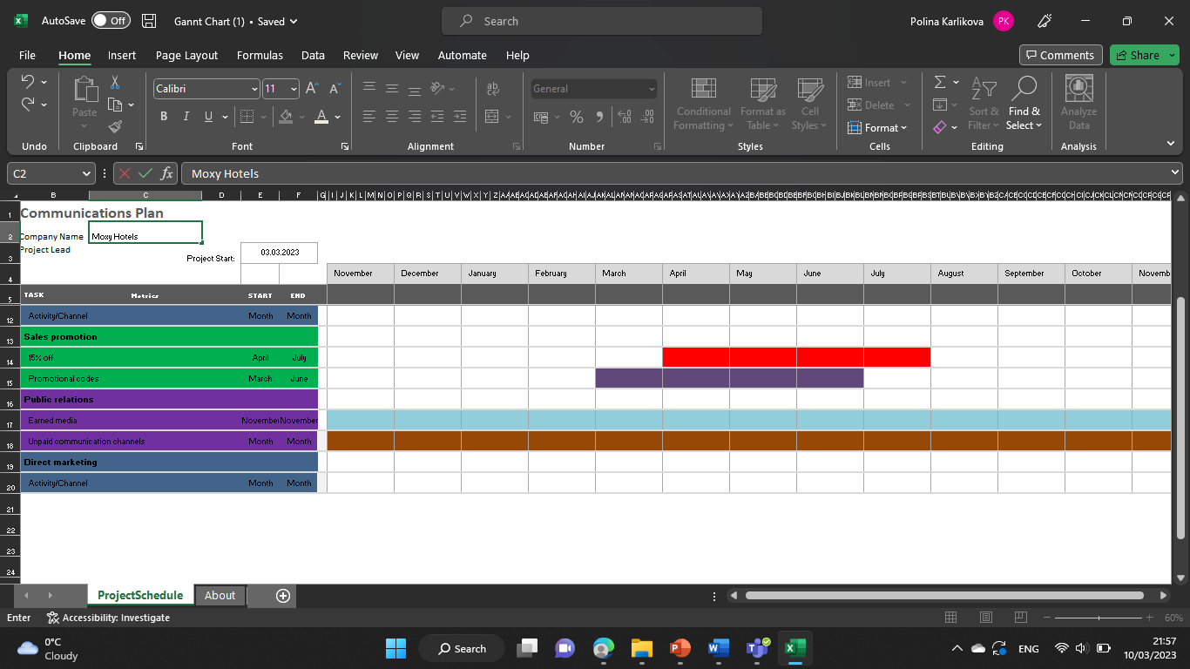

Control
After creating a business plan and strategy we want to measure our success through the key performance indicators that will show us the customer behaviour and acceptance of our new ideas. The marketing channels that we used and the improvements that we introduced will be monitored in order for us to see if the customers are engaging and showing interest in our product.

Conclusion
After having a deep look into Moxy hotels current marketing strategy we were able to identify what they are doing good at the moment ,what are their gaps and outlined a marketing plan to improve those gaps with the help of few proven business frameworks.

Appendix
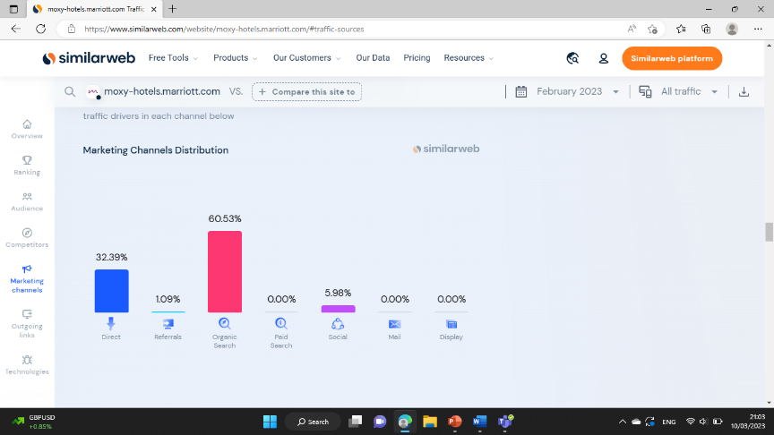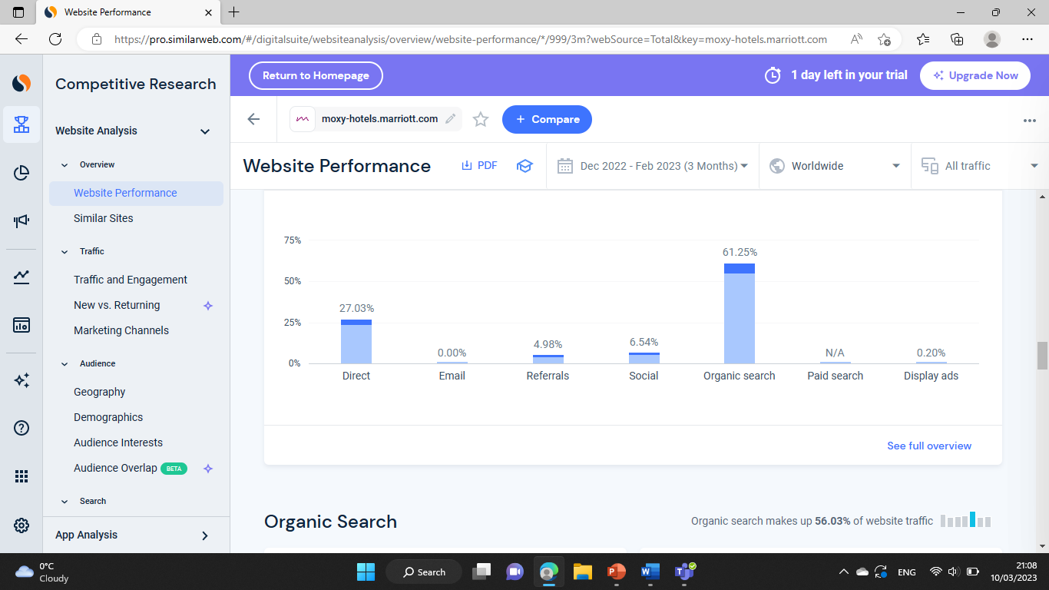
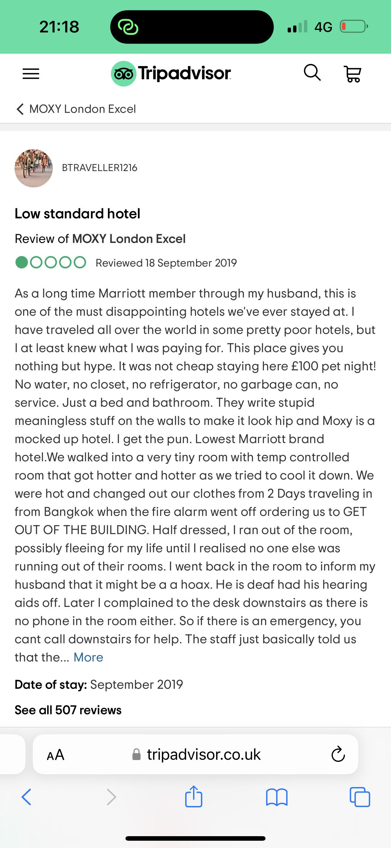
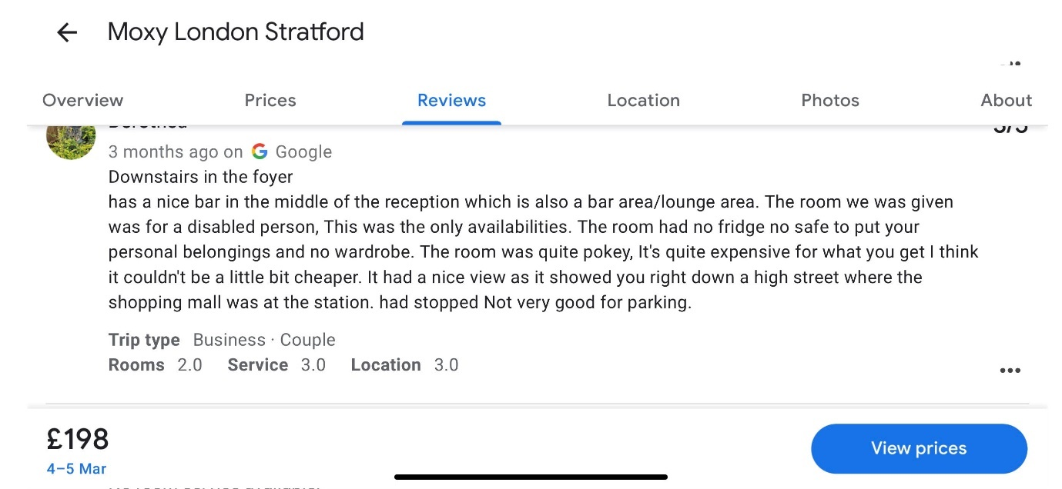
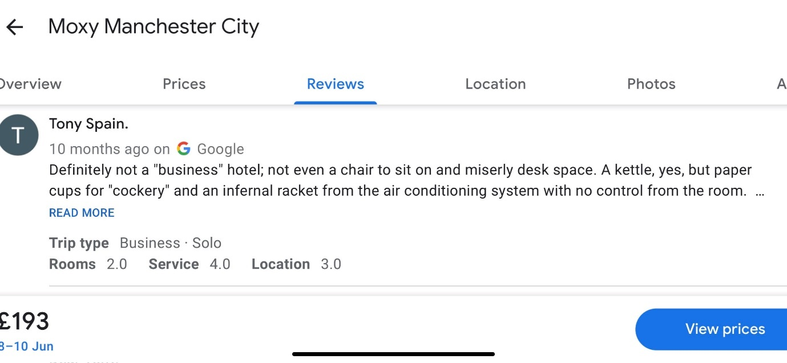
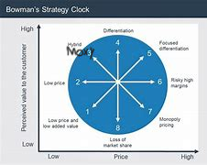

Presentation slides and script:
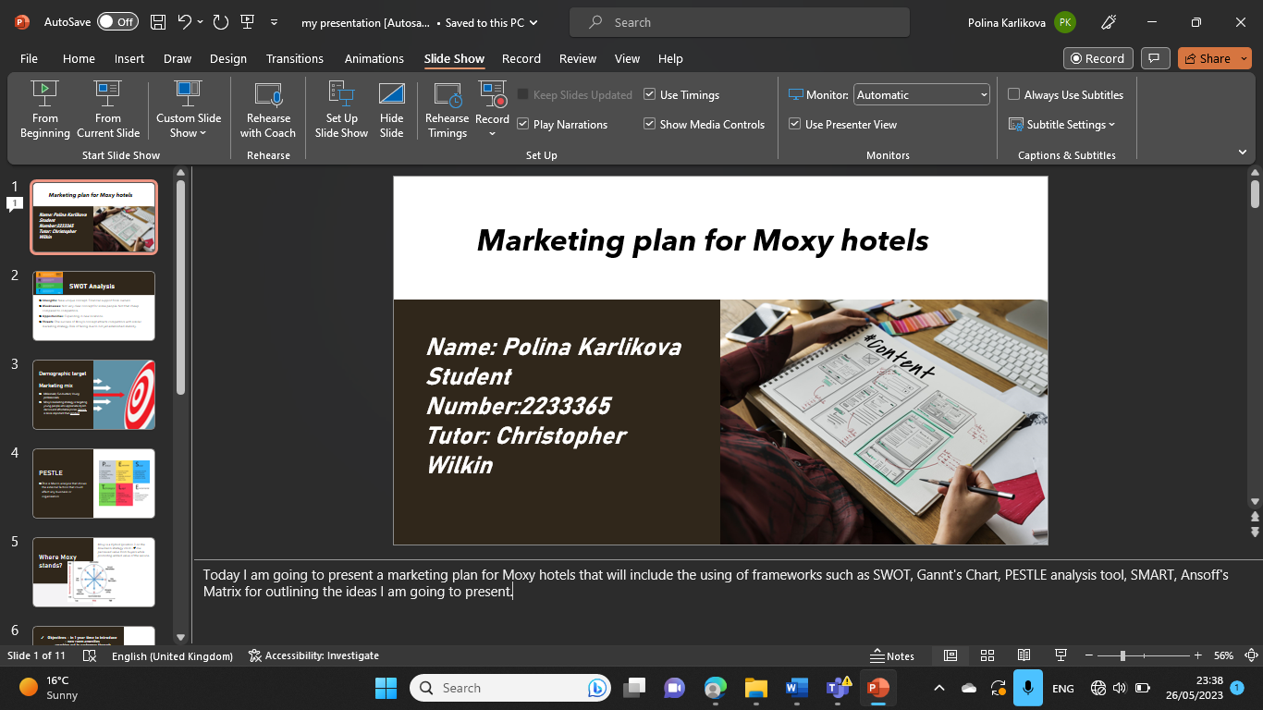
Today I am going to present a marketing plan for Moxy hotels that will include the using of frameworks such as SWOT, Gannt's Chart, PESTLE analysis tool, SMART, Ansoff's Matrix for outlining the ideas I am going to present.
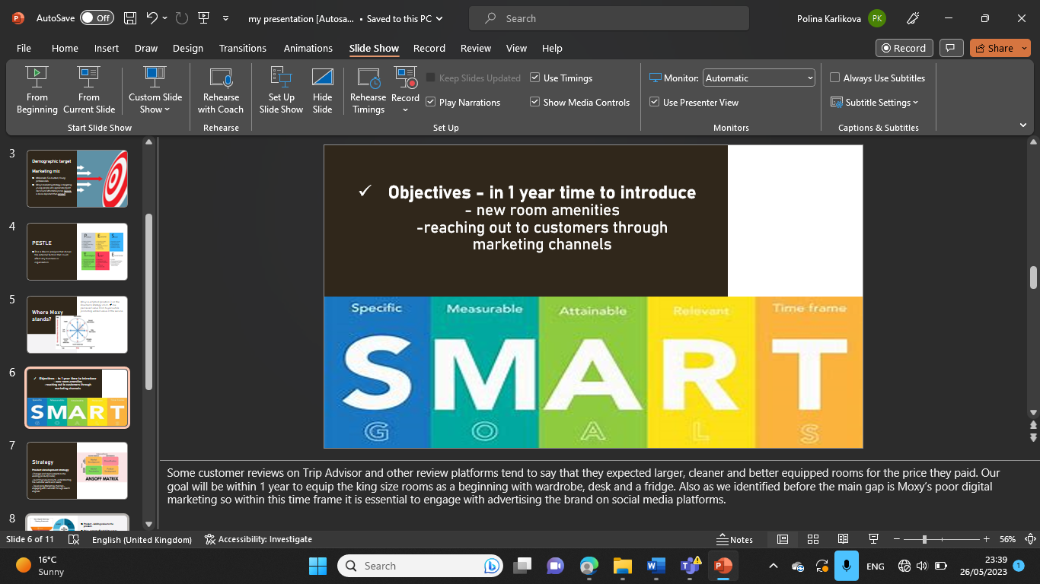
Moxy is a brand that has an exceptional concept which is hugely successful and desirable by its guests. They offer a complimentary drink at the bar which is also the check in spot. The punk spirit of the interior design is very distinctive. However it is a hotel and some people find it hard to rest having the hotel is promoted as a non stop party hunter. Having that the brand is doing great in what they do there are many businesses who are implementing similar kind of ideas and Moxy should find a way of staying unique. According to Similar Web 25.49% of guests visit directly the Moxy website while Youtube runs 100% of their current social network traffic. This shows us lack of social media presence which is something very crucial for businesses nowadays so they could definitely improve on this. 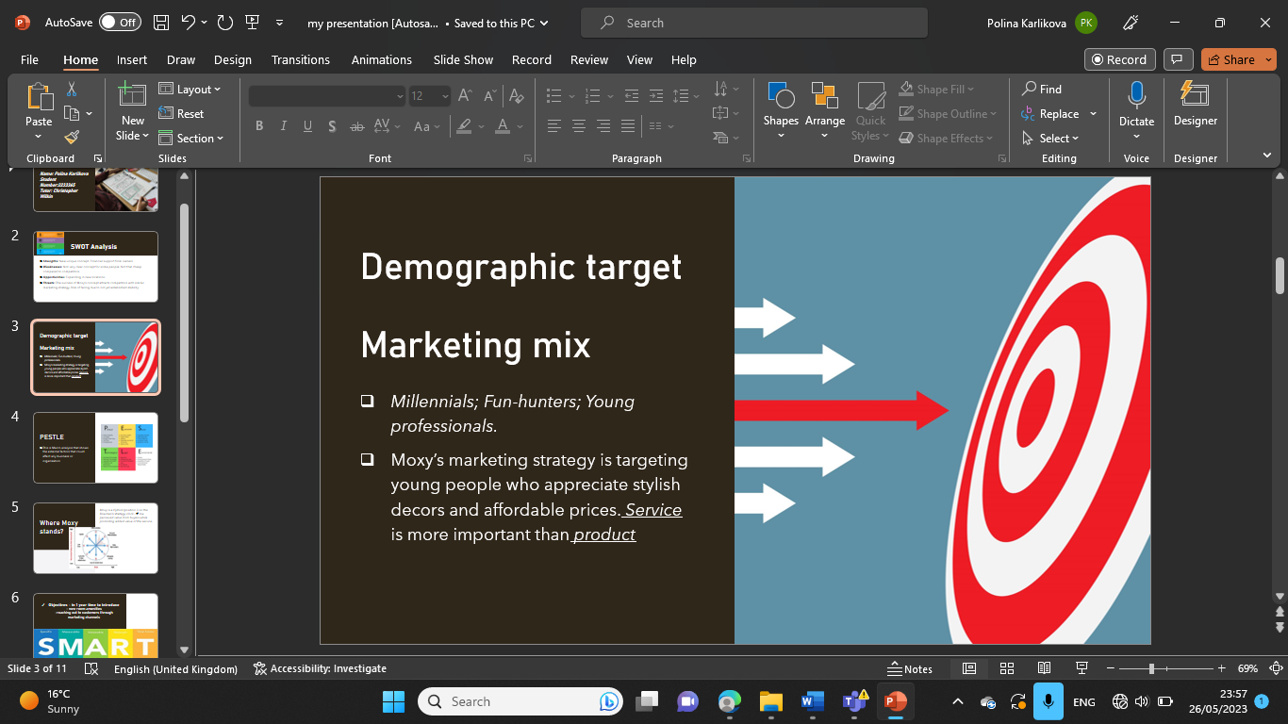
Moxy hotels main target are the millennials and young professionals and it is no wonder why the brand offers partying, contemporary fund activities and hipster design. Some people tend to find Moxy more expensive than its competitors and the potential customers of Moxy need a reason to choose them over others.
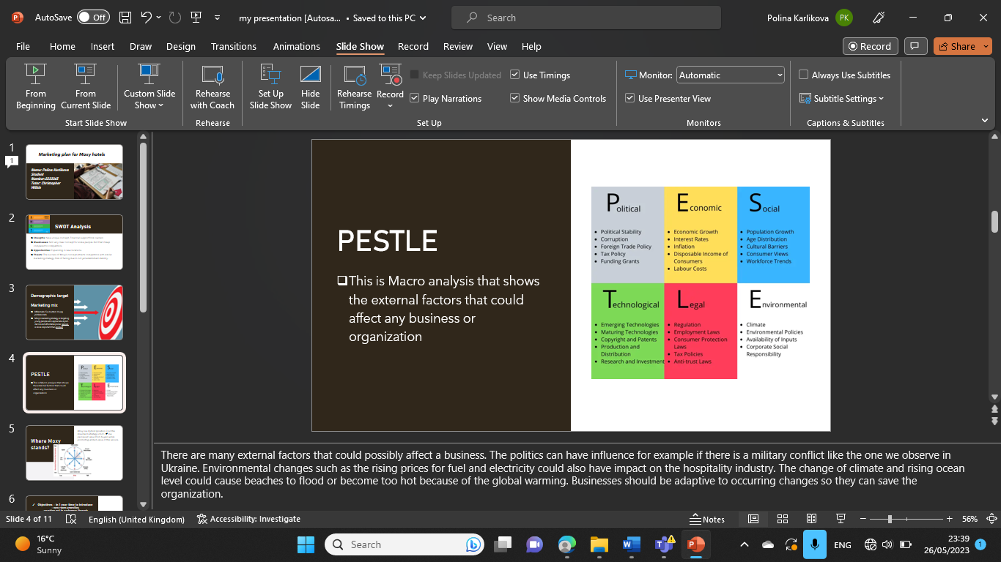 There are many external factors that could possibly affect a business. The politics can have influence for example if there is a military conflict like the one we observe in Ukraine. Environmental changes such as the rising prices for fuel and electricity could also have impact on the hospitality industry. The change of climate and rising ocean level could cause beaches to flood or become too hot because of the global warming. Businesses should be adaptive to occurring changes so they can save the organization.
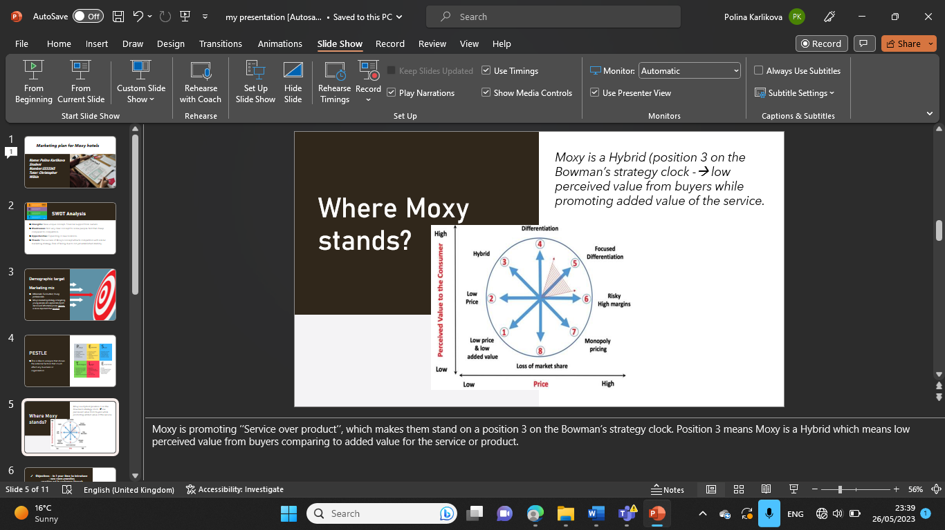 Moxy is promoting ‘’Service over product’’, which makes them stand on a position 3 on the Bowman’s strategy clock. Position 3 means Moxy is a Hybrid which means low perceived value from buyers comparing to added value for the service or product.
Some customer reviews on Trip Advisor and other review platforms tend to say that they expected larger, cleaner and better equipped rooms for the price they paid. Our goal will be within 1 year to equip the king size rooms as a beginning with wardrobe, desk and a fridge. Also as we identified before the main gap is Moxy’s poor digital marketing so within this time frame it is essential to engage with advertising the brand on social media platforms.
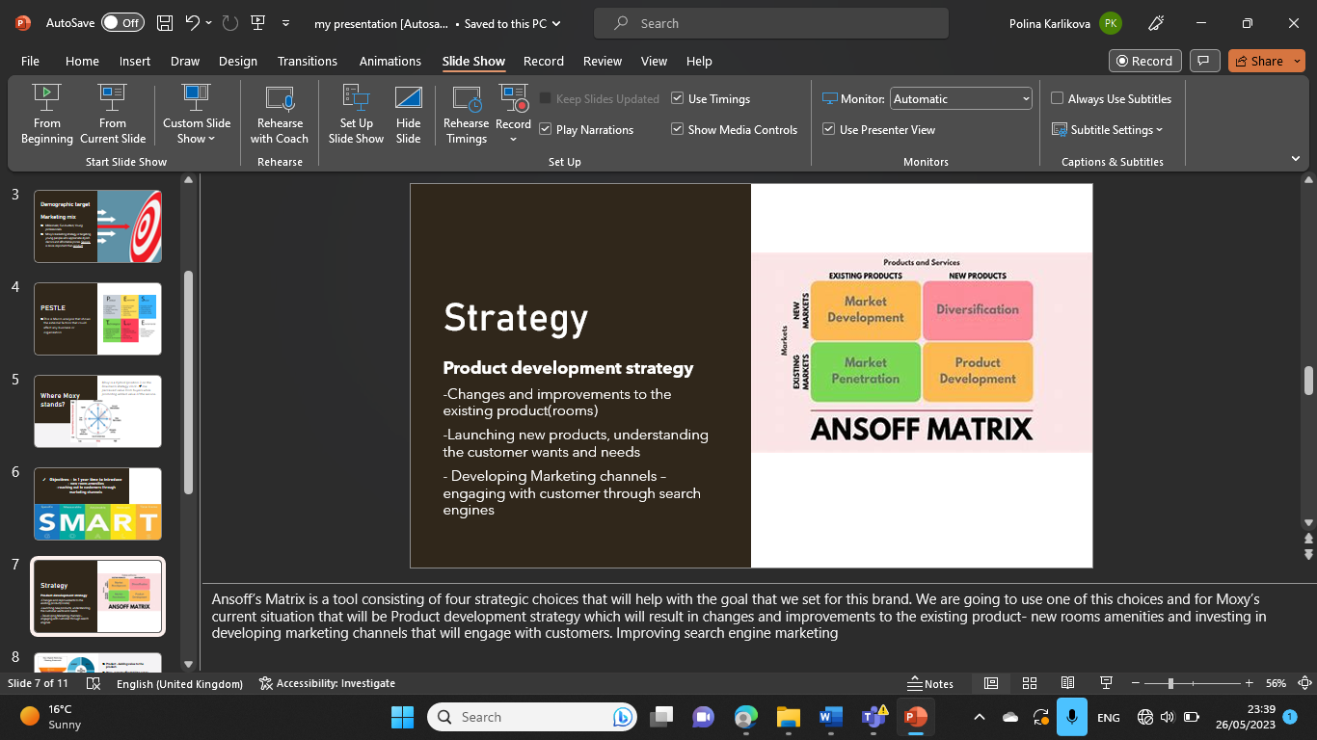 Ansoff’s Matrix is a tool consisting of four strategic choices that will help with the goal that we set for this brand. We are going to use one of this choices and for Moxy’s current situation that will be Product development strategy which will result in changes and improvements to the existing product- new rooms amenities and investing in developing marketing channels that will engage with customers. Improving search engine marketing 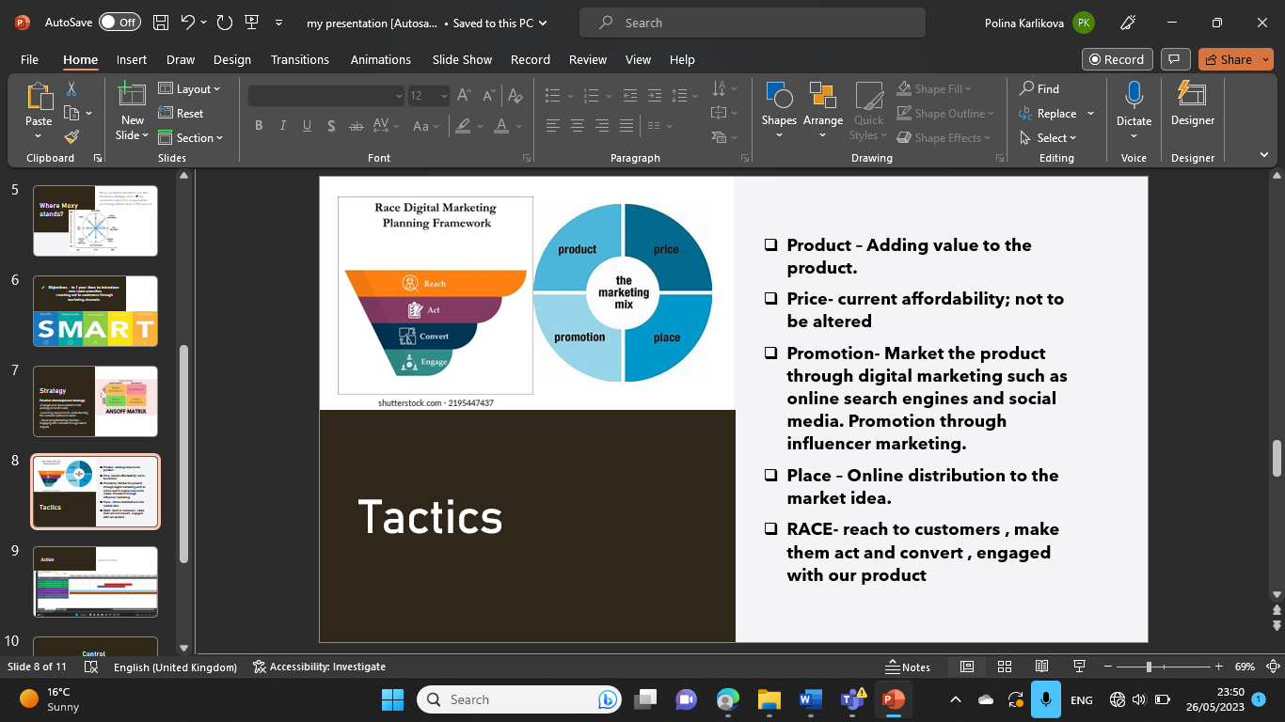 After setting the goal we should describe how are we going to make it happen. After observing the marketing mix it was outlined that changes should be made to the product and the way its marketed. The main focus of the marketing plan would be to alter the place and the product of the marketing mix 4P’s meanwhile the price doesn’t need changing because its already affordable to people and its one of the things Moxy is famous for. The hotel’s demographic target are young people who are non-stop online and browsing different social media platforms so appearing on there by uploading content and updates everyday will be beneficial. Influencer marketing is becoming more and more popular and is another tool that could be used to market the product it can reach so many of the young people. Paying a legitimate influencer with many followers to promote our product it’s the way to do. Adding keywords related to the product and backlinks on our website will make us upper and more visible in the google ranking. Once this is done we would now want to engage further with the clients and make them loyal to our company. We can achieve that through personalisation, for example adding 15% off on the regular customer’s next stay with us.
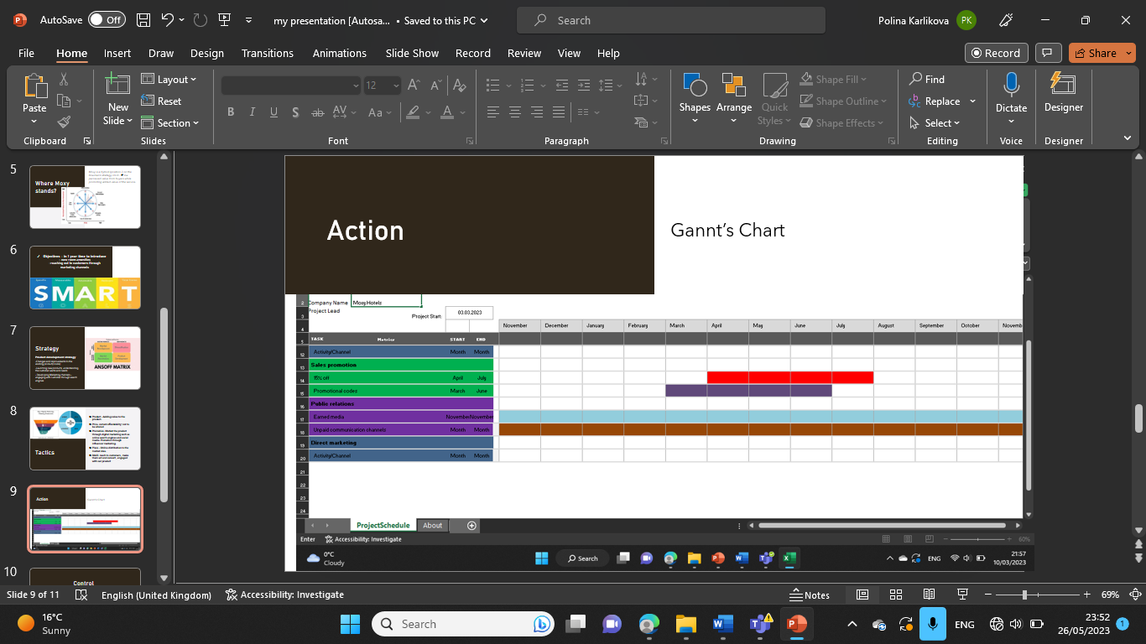 Now we know how to reach our audience and it is time to deliver. To do that we are going to use Gannt’s Chart which is a visual representation of when we are going to engage with certain marketing activity and the period of time planned for it. Statistics on Similar Web showed that this month the traffic and visits decreased by 6.65% so we will introduce a 6month sales activity from April to July and also add Promotional codes from March until June aiming to attract more customers. We will use public relations to improve our relationship with the customers because of some not that flattering reviews.
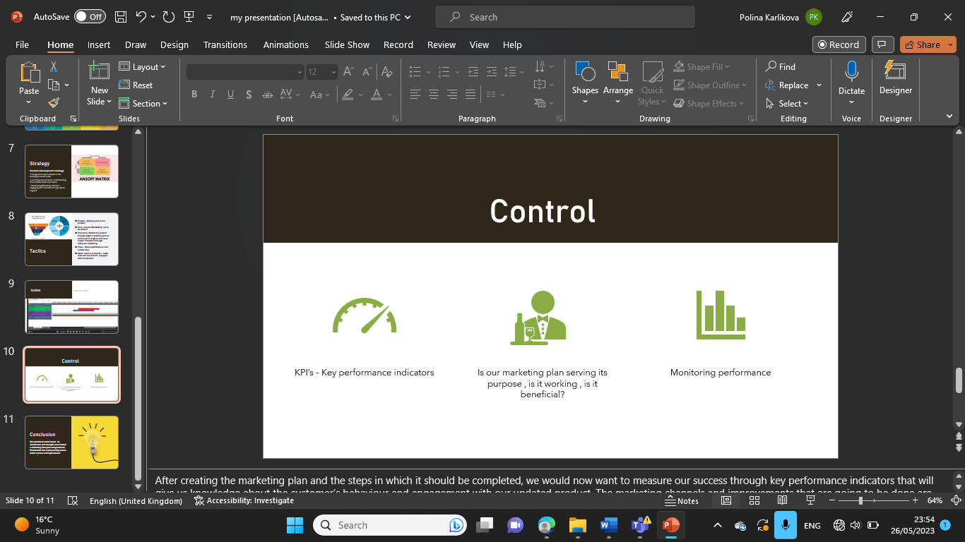 After creating the marketing plan and the steps in which it should be completed, we would now want to measure our success through key performance indicators that will give us knowledge about the customer’s behaviour and engagement with our updated product. The marketing channels and improvements that are going to be done are going to be monitored to see if customers are accepting and showing interest in the product.
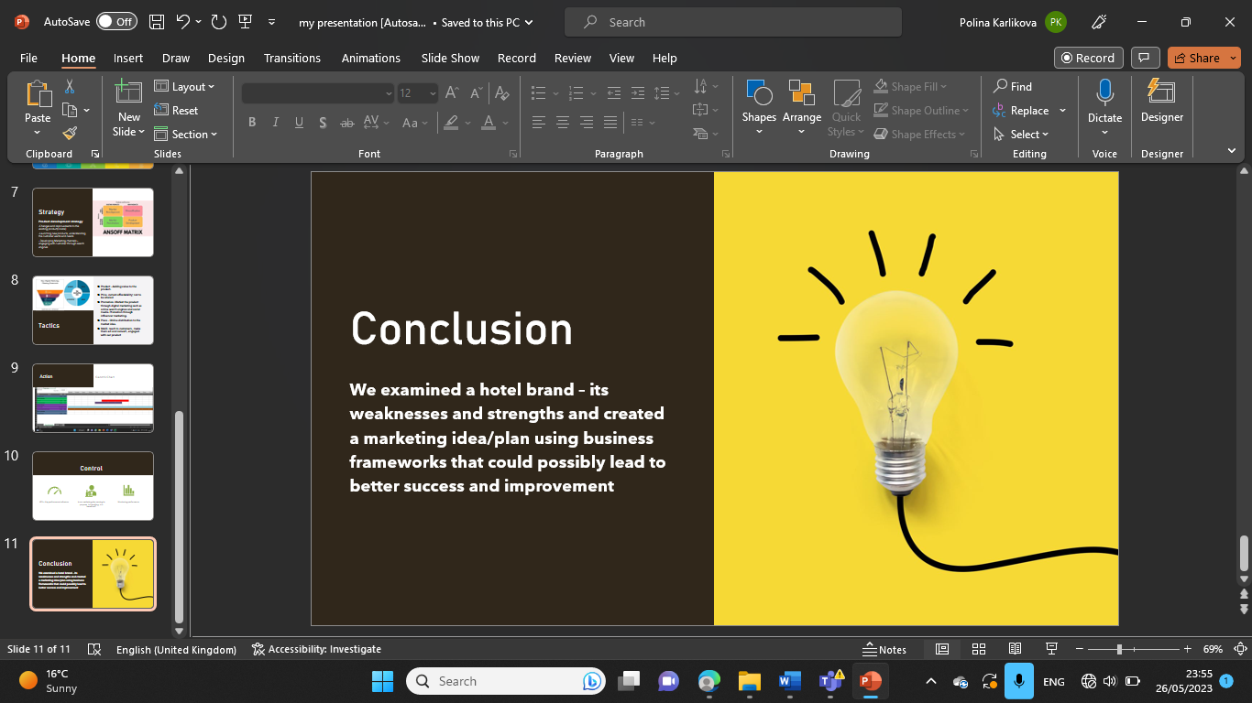
Throughout this project we looked into the hotel brand Moxy current marketing strategies and performance and with the help of few business frameworks we created a detailed marketing plan that could potentially drive more visits and customers through engaging with social media presence
References:
Hanlon, A. (2021) The ansoff model, Smart Insights. Available at: https://www.smartinsights.com/marketing-planning/create-a-marketing-plan/ansoff-model/ (Accessed: March 10, 2023).

Introduction to bowman’s strategy clock (no date) Lucidity. Available at: https://getlucidity.com/strategy-resources/introduction-to-bowmans-strategy-clock/ (Accessed: March 10, 2023).

Managing public relations and the media(2022) Gov.au. Available at: https://www.business.qld.gov.au/running-business/marketing-sales/marketing/activities/public-relations (Accessed: March 10, 2023).

Stylish & playful hotels (2019) Moxy Hotels. Available at: https://moxy-hotels.marriott.com (Accessed: March 10, 2023).

The 4 PS of marketing: What they are and how to use them (2022) Coursera. Available at: https://www.coursera.org/articles/4-ps-of-marketing (Accessed: March 10, 2023).

Unknown (no date) The moxy hotels: Creating experiences as the new Marketing approach (by lea Scholz), Linchikwok.net. Available at: https://www.linchikwok.net/2018/04/the-moxy-hotels-creating-experiences-as.html?m=1 (Accessed: March 10, 2023).

Berry, E. (2017) Pestle analysis: Prepare the best strategies in advance. North Charleston, SC: Createspace Independent Publishing Platform.
hkG., D. (2018) Services Marketing Mix: The 7 P’s of Marketing explained, expert. EPM. Available at: https://expertprogrammanagement.com/2018/03/services-marketing-mix-7-ps/ (Accessed: March 10, 2023).

SimilarWeb Identity (no date a) Similarweb.com. Available at: https://pro.similarweb.com/#/digitalsuite/websiteanalysis/traffic-overview/*/999/3m/?category=no-category&webSource=Total&key=moxy-hotels.marriott.com (Accessed: March 10, 2023).

SimilarWeb Identity (no date b) Similarweb.com. Available at: https://pro.similarweb.com/#/digitalsuite/websiteanalysis/overview/website-performance/*/999/3m?webSource=Total&key=moxy-hotels.marriott.com (Accessed: March 10, 2023).

Boogaard, K. (2021) “How to write SMART goals,” Work Life by Atlassian. Atlassian, 26 December. Available at: https://www.atlassian.com/blog/productivity/how-to-write-smart-goals/amp (Accessed: March 10, 2023).

Grant, M. (2010) Gantt charting: Definition, benefits, and how they’re used, Investopedia. Available at: https://www.investopedia.com/terms/g/gantt-chart.asp (Accessed: March 10, 2023).

MindTools (no date) Mindtools.com. Available at: https://www.mindtools.com/amtbj63/swot-analysis (Accessed: March 10, 2023).

Moxy’s Positioning Statement (2019) blogmarketing1819b_8.1. Available at: https://blogmarketing81.home.blog/2019/05/20/moxys-positioning-statement/ (Accessed: March 10, 2023)

(No date) Tripadvisor.co.uk. Available at: https://www.tripadvisor.co.uk/Hotel_Review-g186338-d12124894-Reviews-MOXY_London_Excel-London_England.html (Accessed: March 10, 2023).

