Tristan Budenis (2428021)
2428021@student.uwtsd.ac.uk
LEARNING in the Digital Era (Computing & Electronics)
Assignment 1: E-Portfolio
Apprenticeship in Computing (Data and Information Systems) (BSc Hons)

Contents
E-portfolio 2
Link to online e-portfolio homepage: 2
Screenshot 2
Task 1 – Written Summary 3
Task 2 – Mind map & Academic Poster 4
Link to view Mind-Map online 4
Screenshot of the mind map 4
Link to view Poster online 4
Screenshot of poster 5
Screenshot of task 2 e-portfolio page 6
Task 3 – Automatic Referencing Tool 7
Task 4 – e-Portfoilio creation and review 8

E-portfolio
Link to online e-portfolio homepage: https://2428021.wixsite.com/2428021tristanbudeni

Screenshot


Task 1 – Written Summary
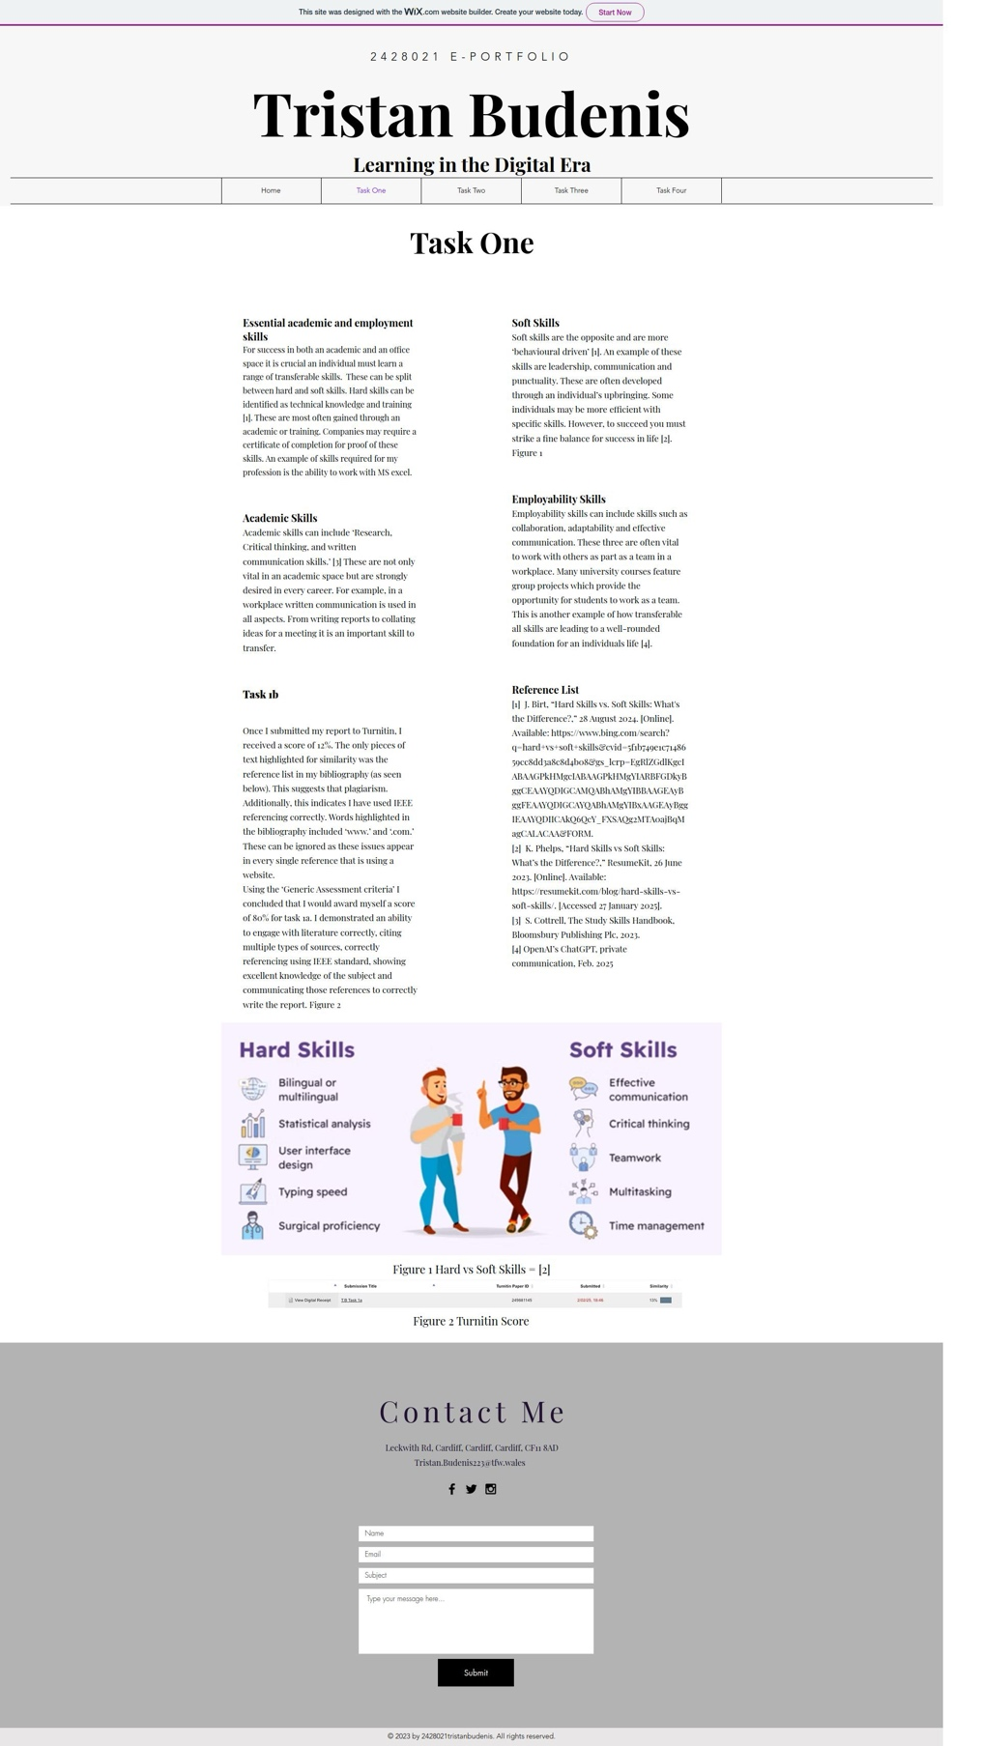

Task 2 – Mind map & Academic Poster
Link to view Mind-Map online
Key considerations of effective teamwork - MindMeister Mind map

Screenshot of the mind map
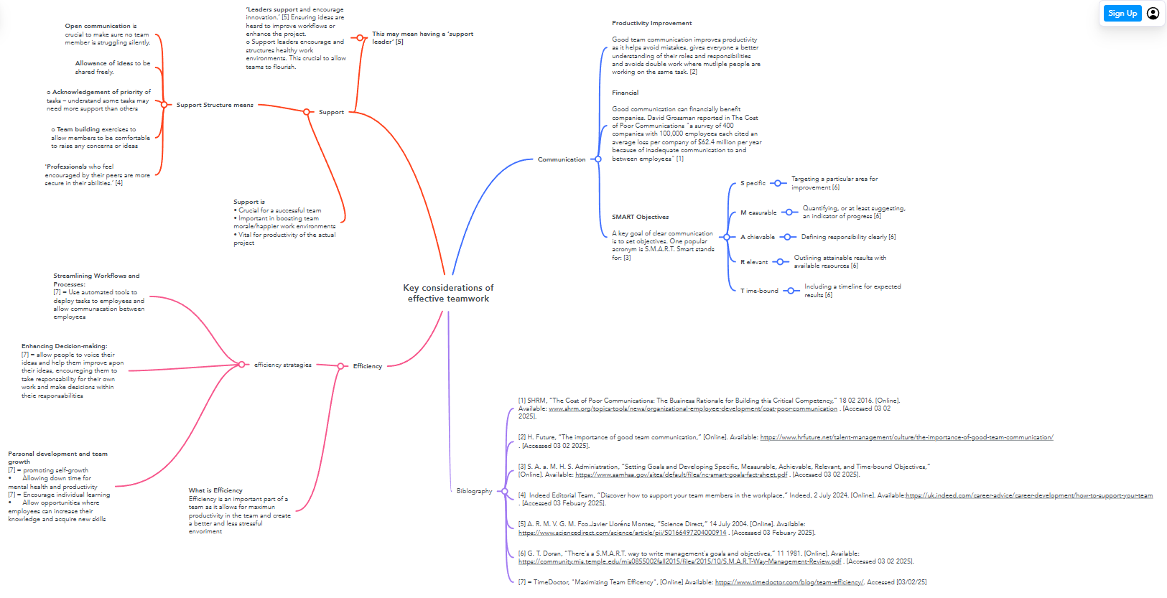

Link to view Poster online
Life is a team sport poster

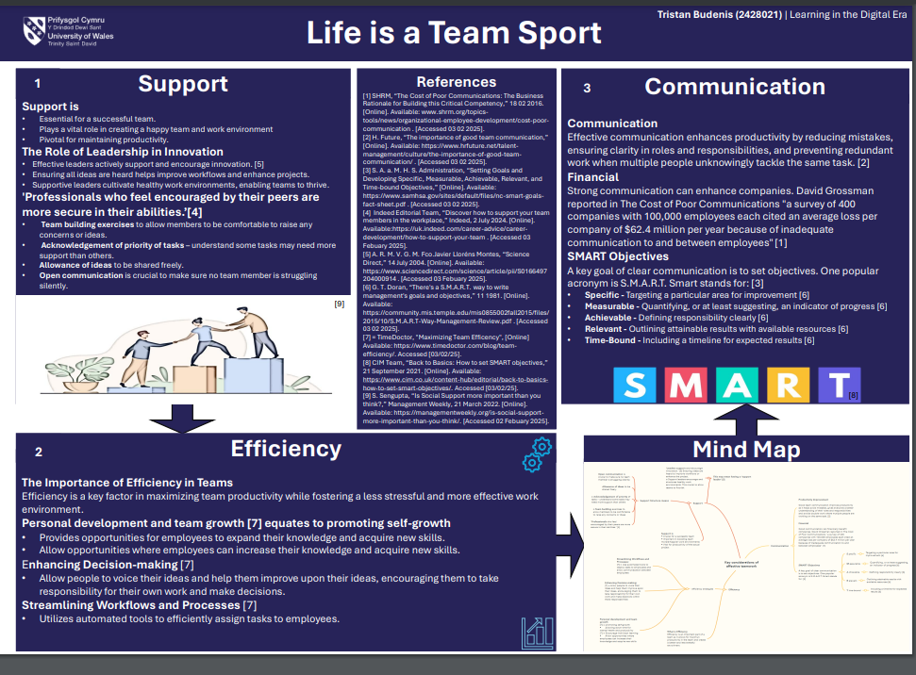
Screenshot of poster

Screenshot of task 2 e-portfolio page
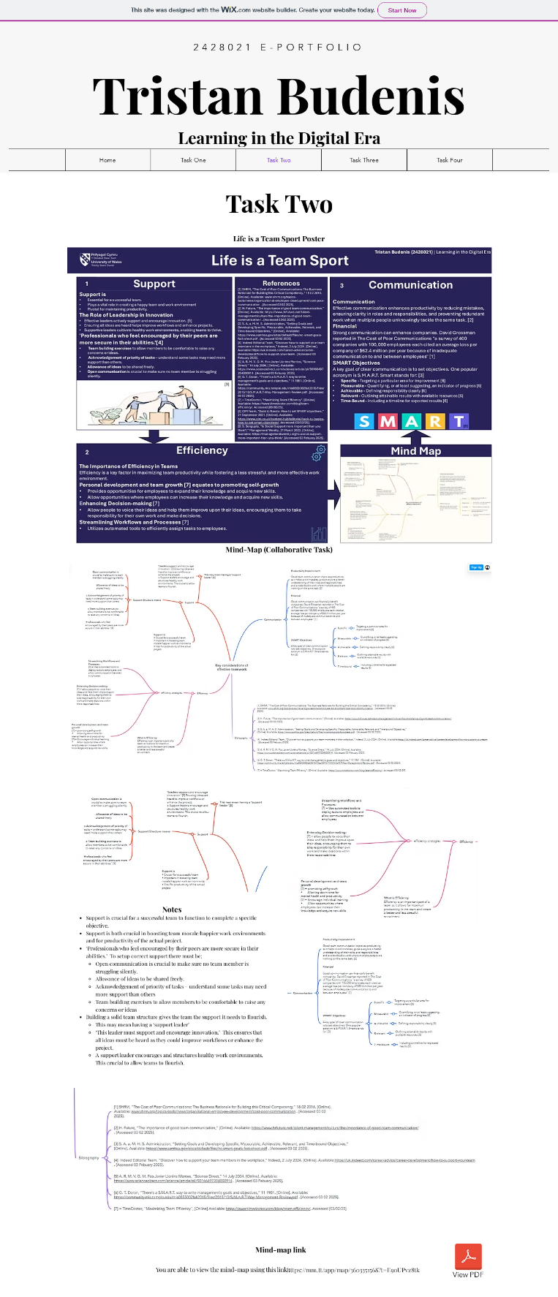

Task 3 – Automatic Referencing Tool
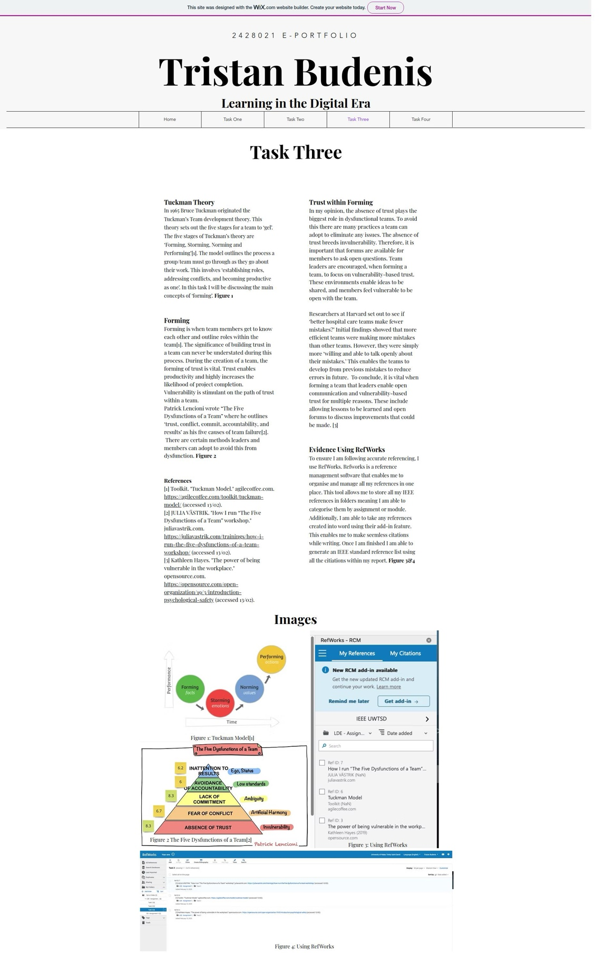

Task 4 – e-Portfoilio creation and review


