4/27/2018
Software Defined Networking
(SDN)
Nicholas Evans
M4X01498 - 1704662
Table of Contents

Table of Figures 1
1.0 Introduction 2
2.0 History of SDN 3
3.0 Benefits of SDN 4
4.0 The Future Prospects of SDN 4
5.0 Conclusion 5
Bibliography 6

Table of Figures

Figure 1 - SDN [2] 2
Figure 2 - Layers [5] 3

Introduction

The purpose of this report is to look into what defines as software defined networking, from the perspective of a person uneducated in the field, which isn’t as easy a task as one would think. The term “software defined networking” or SDN for short, can be often seen in many places on the web including social media. Which isn’t surprising considering it is being implemented by compony giants such as Amazon, Facebook, Microsoft and Cisco just to name a few. With that said, what exactly is SDN? How does it differ to standard networking?
Computer networks are built by utilizing several devices connected to at least two computers, such as routers, switches, different types of middleboxes which are used to manipulate traffic, e.g. firewall, that are used to help connect the user to devices such as printers or scanners.
SDN is a flexible architecture that provides central control to a network using application program interfaces (APIs). The platform consists of three successive layers: an infrastructure layer, a control layer and an application layer, all of which are open. An SDN controller heads operations, relaying information to systems and routers using APIs. [1]
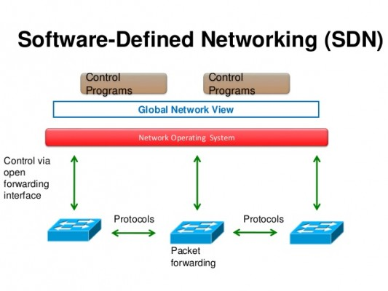
With the use of SDN becoming more and more popular, even crucial within some infrastructures, and the future of the technology looking so promising, it makes you wonder when was it first developed? How did it become such a crucial tool within the industry?
Figure 1 - SDN [2]

History of SDN

Back in the day when there was only closed and propriety networks, a PHD student by the name of Martin Casado from Stanford, developed something called Ethane in 2006. By 2011, It had led to the development of the first OpenFlow. It was also the time when the Open Network Foundation was formed to drive standardisation in the small industry. [3]
OpenFlow is known to be one of, if not the, first software defined networking standards. It’s come about defined the communication protocol in SDN that allowed the SDN controller to directly communicate with the forwarding plane of network devices such as routers and switches, both physical and virtual, so it could better adapt to changing business requirements. [4] I’ve mentioned the term ‘layers’ and ‘planes’ briefly already, but what does it mean? To summarise it as simply as possible:
Infrastructure layer (Data plane)
Network switches and routers, forwarding data to the appropriate destination.
Control layer (Control plane)
These determine how traffic should flow based on the status of the infrastructure layer and the requirements specified by the application layer. Here it is centralised rather than distributed across various and possibly disparate devices.
Application layer (Application plane)
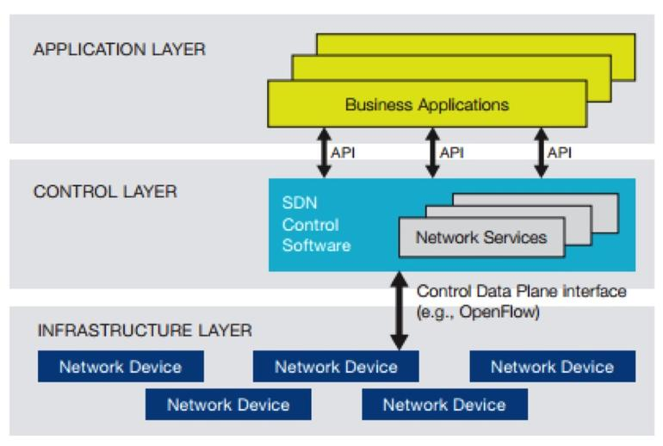
Network services, utilises and applications which interface with the control level to specify needs and requirements. These may be what is known as “network aware”. [5]
Figure 2 - Layers [5]

Benefits of SDN

Networking can be very complex and difficult to manage. With that being said, SDN offers the ability to create an infrastructure which is far easier to manage, by utilizing network admins to manage and direct network protocol simply by programming. This enables the user to control all access remotes within the localised area, with the added bonus of easily maintaining and upgrading the network capabilities. This includes bolstering security, control of traffic and even parental controls.
All of this is possible thanks to how SDN enables us to centralize the control plane, allowing forwarding decisions to be made globally across the SDN domain rather than at each hop. [6]
The result of this is the network now appears to the applications as a single, logical switch. This simplifies the networking devices themselves since they no longer need to know how to process the many thousands of protocol standards, but instead, can now just accept the instructions directly from the SDN controllers.

The Future Prospects of SDN

Even with the innovative and benefits that SDN brings to the table, it is still mainly looked at with severe caution by most. Due to the lack of education surrounding the topic, and the many controversies surrounding SDN online, resulting wary confusion by most. The cost to businesses to switch up their network can be considered too high, and the idea hasn’t much been adopted into commercial use as of yet.
There is also the risk to security. Due to SDN being an open Source technology, there is a great risk of hackings thanks to the console/remote capabilities. Plus, thanks to today’s technology, everyone carries a device that can completely change your network! (people with the ability are few and far between mind)
But it isn’t all doom and gloom. More companies are starting to see the great and many benefits SDN has to offer. The Open Networking Foundation and Open Networking Lab has agreed to become a single organisation, with their combined number of companies and partners now working under the same roof with the idea of the standardisation of SDN at its core. Thanks to this, the idea will undoubtedly become more accepted.

Conclusion

Looking into the field for the first time, it is obvious just how different people feel about SDN due to either lack of knowledge or trust in its future. The security risks are worrisome and warranted. But that doesn’t mean the relatively new technology is out for the count yet. The potential is there, the benefits are great, and honestly, without it, a lot of things will not be working as smoothly. If the research into newer security measures are to eliminate most threats from occurring, or even inviting in some cases to outside influences, and of course with technology advancing at such a rate, the cost will inevitably come down, it is not hard to see, even from an untrained eye, that the prospects of SDN for the future looks bright.

Bibliography

[1] | N. Cranford, “www.rcrwireless.com,” 22 June 2017. [Online]. Available: https://www.rcrwireless.com/20170621/wireless/three-examples-of-sdn-deployments-tag99-tag27.
[2] | pr-inside.com, “www.pr-inside.com,” [Online]. Available: https://www.pr-inside.com/software-defined-networking-sdn-market-analysis-re-r4499067.htm. [Accessed 17 April 2018].
[3] | T. Howarth, “www.virtualizationpractice.com,” 03 December 2014. [Online]. Available: https://www.virtualizationpractice.com/sdn-history-things-sdn-29890/.
[4] | “www.sdxcentral.com,” [Online]. Available: https://www.sdxcentral.com/sdn/definitions/what-is-openflow/. [Accessed 17 April 2018].
[5] | S. Matteson, “www.techrepublic.com,” 13 February 2014. [Online]. Available: https://www.techrepublic.com/article/software-defined-networking-the-cisco-approach/.
[6] | J. Stretch, “packetlife.net,” 02 May 2013. [Online]. Available: http://packetlife.net/blog/2013/may/2/what-hell-sdn/.

