Problem
Analysis and Solution
Development

Module Name: Analysing and Solving Problems
Module Code: ACCA 4019
Student Name: Jomir Ali
Student ID: 2442127
Group:2
Lecturer’s Name: Dr Redhwan Al-amri

Table of Contents
Table of Contents 1
1. Introduction 2
2. Deconstruct the Problem 3
2.1 MoSCoW Technique 4
2.2 Variables Identification: 7
3. Proposed Solution 9
3.1 Flowchart 10
3.2 Flowchart Explanation 11
4. Reflection and Justification 14
4.1 Abstract thinking 14
4.2 Sub-dividing 14
4.3 Justification of the solution 15
4.4 Limitation 15
4.5 Assumption 16
5. Conclusion 17
References 18
References 18

Introduction
College classroom management can be unexpectedly challenging. It is simple for issues to occur when there are a lot of classes going on at once and few rooms available. While some rooms are not utilised to their maximum potential, others are congested. In addition, scheduling conflicts can cause courses to be disrupted, and teachers and students frequently lose time travelling between facilities. Both the quality of education and the institution's overall effectiveness may be impacted by these problems.
This focuses on coming up with a workable solution to enhance the distribution of classrooms. Ensuring equitable and efficient room assignments based on class sizes and space capacity is the primary objective. Additionally, it seeks to minimise needless movement between classes and scheduling problems to improve college operations.
Using basic planning approaches like MoSCoW prioritisation, this problem is divided into smaller components. This makes it easier to distinguish between the more and less crucial requirements.
The step-by-step procedure for allocating classrooms in an orderly and transparent manner is then demonstrated using a flowchart. This facilitates understanding and adherence to the solution.
The overall goal of this task is to apply structured thinking to a practical issue and provide a solution that enhances classroom utilisation, minimises time wastage, and promotes a better learning environment for both staff and students.

Deconstruct the Problem

The classroom allocation challenge is divided into smaller, more manageable components in the diagram. Ineffective classroom distribution is the primary issue at the top. This is broken down into three main categories: precise timetabling, cutting down on time waste, and effective classroom allocation.
Matching class sizes to room capacity is the main goal of efficient classroom allocation. This helps avoid underuse, which occurs when huge rooms are not used to their full potential, and overcrowding, which occurs when too many students are in one area. Space can be used more efficiently by allocating the appropriate room size.
Reducing time waste examines how staff and students transition between classes. People may arrive late and waste time walking if the rooms are far apart. Reducing transportation and saving time can be achieved by assigning adjacent rooms and maintaining classes in similar places. This guarantees that classes begin on time as well.
Timetabling that is accurate guarantees that there are no conflicts. This implies that students do not have overlapping classes, lecturers are not scheduled in two locations at once, and rooms are not double-booked. Preventing these conflicts ensures that the schedule functions efficiently.
Overall, the picture illustrates how resolving minor issues may enhance the system, making it more effective, structured, and user-friendly for both employees and students.
Figure1:
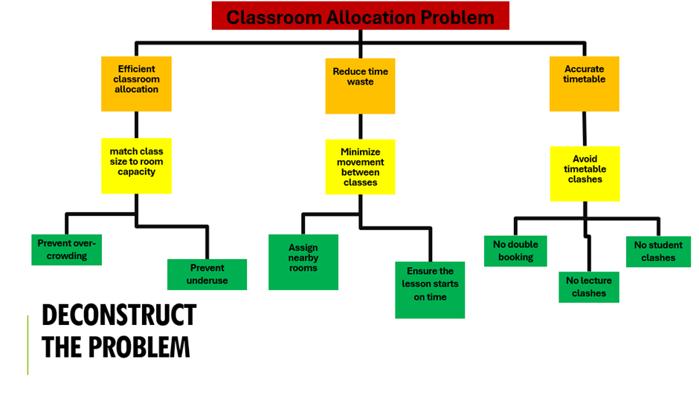

MoSCoW Technique

One of the most popular approaches for engineering and setting requirements in the implementation and development of software products is the MoSCoW method. It assists stakeholders in assessing each requirement's relative urgency and importance. Its four hierarchical categories, Must have, Should have, Could have, and Won't have, form its foundation. The requirements are categorised into the four designated groups. [1]
helps identify the most crucial features and requirements for the system so that its deployment doesn't interfere with the organization's operations, and which needs can be expanded.
Must Have: The information system's implementation depends on the requirements listed in this category. These are the fundamental or necessary features that ought to be included in the current version or release. The implementation project or the system's usability would fail if these requirements weren't met; that is, the system wouldn't be effective and wouldn't cover the real business processes.
Should Have: While not as crucial as the Must Have requirements, the requirements in this category are nevertheless significant. They are crucial elements that enhance the system's performance and functionality. If time and resources allow, should-have criteria are typically added after must-have requirements are given priority.
Could Have: This category includes desirable additions and functionalities that could improve the system but are neither necessary nor crucial. After the requirements in the "Must have" and "Should have" categories have been identified, these lower-priority criteria might be taken into consideration for execution if more time and resources become available.
Won't Have: requirements that are made clear as being outside the scope of the current project or difficult to carry out. When the system was being constructed, certain criteria were not included in the project's initial scope due to time, resource, or technological constraints. These requirements are typically either completely disregarded or put off until later iterations. [2]

Must Have | Descriptions
1: Accurate Classroom Allocation | Assign rooms based on:  • Class size  • Room capacity  To prevent crowding, rooms are allotted according to class size and room capacity.
2: A Clash-Free (Timetable) | Use a best-fit (the smallest to the largest suitable room)  No double-booking of:  - Rooms  - Lecturers  - Student groups  This helps you create a feasible and efficient scheduling system.
3: Centralised Timetable System | To keep all rooms, classes, and available time slots in one location, a centralised system should be utilised to ensure all lessons start on time.  - All rooms  - All classes  - All IT rooms  - All time slots
4: Consistency | Real-time updates maintain consistency across the timetable and enables for real-time updates when any modifications are made.

Should Have | Descriptions
1: Minimise Movement Between Classes  Schedule classes in: | This helps to save time and reduce lateness for students, staff, and lecturers.
2: Room Suitability Matching | Rooms should be matched with the essential equipment, such as labs or IT facilities, to prevent incorrect room allocations.
6. Basic Optimisation | This ensures all room usage and timetable efficiency can be improved by making simple changes, such as swapping rooms.

Could Have | Descriptions
1: Optimisation | Use advanced optimisation algorithms for improved efficiency.
2: Visual timetable system | Provide a simple visual timetable for staff and students.
3: Planning or predictions | Include a simple future tense for planning room usage.  This helps predict how rooms will be needed later.

Won’t Have | Descriptions
1: Fully automatic AI scheduling system | No need for a fully autonomous AI scheduling system is initially not needed because extensive machine learning is not required.
2: System integration | System integration ties the system to transport systems and external campus data.

Variables Identification:

Input: The information required by the system to generate a schedule is known as input variables. They contain details about lecturers, student groups, available time slots, class sizes, room sizes, and the number of classrooms. They also contain information about the room's amenities, such as IT equipment or labs. The system uses these inputs to match classes to the appropriate rooms and times, making them crucial. This data is used by the system to prevent conflicts and crowding. The schedule wouldn't function correctly without the right input variables. To put it simply, input variables are all the fundamental information the system requires to schedule classes.

Variables | Descriptions
1: Classrooms | List of available rooms
2: Room capacity | Number of students each room can hold
3: Classes | List of all classes to be scheduled
4: Class size | Number of students in each class
5: Time slots | Available periods for scheduling
6: Lecturers | Teachers are assigned to classes.
7: Student groups | Groups attending each class
8: Room facilities | Equipment available (e.g., labs, IT)

Process: Process variables are the things the system does with the provided data. The approach matches class sizes with suitable room capacity to avoid crowding and wasted space. It arranges classes to available time slots and allots the proper rooms for each session. It also searches for scheduling issues, such as when a hotel is double-booked or a lecturer is planned in two places simultaneously. To decrease movement between sessions, the concept organises lessons in nearby rooms. In short, the system employs process variables to set up the schedule clearly, efficiently, and conflict-free.

Variables | Descriptions
1: Room allocation | Match classes to suitable rooms
2: Time scheduling | Assign classes to time slots.
3: Clash detection | Check for room, lecturer, and student conflicts.
4: Movement optimisation | Reduce the distance between consecutive classes.

Output: After the system has processed all the input data, the output variables are the results. Among these is the finished schedule, which details the times and locations of each session. They also feature room assignments, which indicate which classroom is used for each lesson. A clash-free schedule, which prevents overlaps between classrooms, instructors, and student groups, is another result. Additionally, the approach ensures that areas are not wasted or overloaded by producing improved room usage. Additionally, it can shorten travel time between classes. To put it simply, output variables are the final organised results that make the schedule understandable, effective, and simple to follow.

Variables | Descriptions
1: Room assignments | Rooms allocated to each class
2: Clash-free schedule | No overlaps or double bookings
3: Improved room usage | Efficient use of available space
4: Reduced movement time | Less travel between classes
5: Timetable | Final schedule of classes

Proposed Solution

The proposed solution for this is a flowchart, a graphical representation of a process that employs symbols, arrows, and organised steps to demonstrate how an issue is resolved, is the method used. Flowcharts are frequently used in programming education since they aid beginners in understanding logic prior to writing actual code. Because they lessen the challenges posed by unfamiliar development environments and programming terminology, flowchart-based learning tools are particularly useful for inexperienced programmers.
Flowcharts make it simpler to fully understand the flow of logic by breaking a problem down into smaller, more manageable chunks. In a flowchart, each shape has a distinct meaning: ovals stand for the beginning and finish of a process, rectangles for operations or instructions, and diamonds for decisions. These symbols correspond to arrows that indicate the stages' order. This methodical visual approach aids in developing a solid mental representation of a program's operation.
The key feature is that flowcharts may be created from problem descriptions in natural language. This means that students may better visualise answers by turning a written problem into a step-by-step diagram. These methods combine knowledge-based systems and natural language processing to enhance problem-solving abilities.
All things considered, flowcharts are crucial to teaching programming. They facilitate logical reasoning, make difficult issues simpler, and assist novices in comprehending the structure of actual programs. They are, therefore, a useful tool for simply and visually teaching and understanding programming topics. [3]

Flowchart
Figure:1
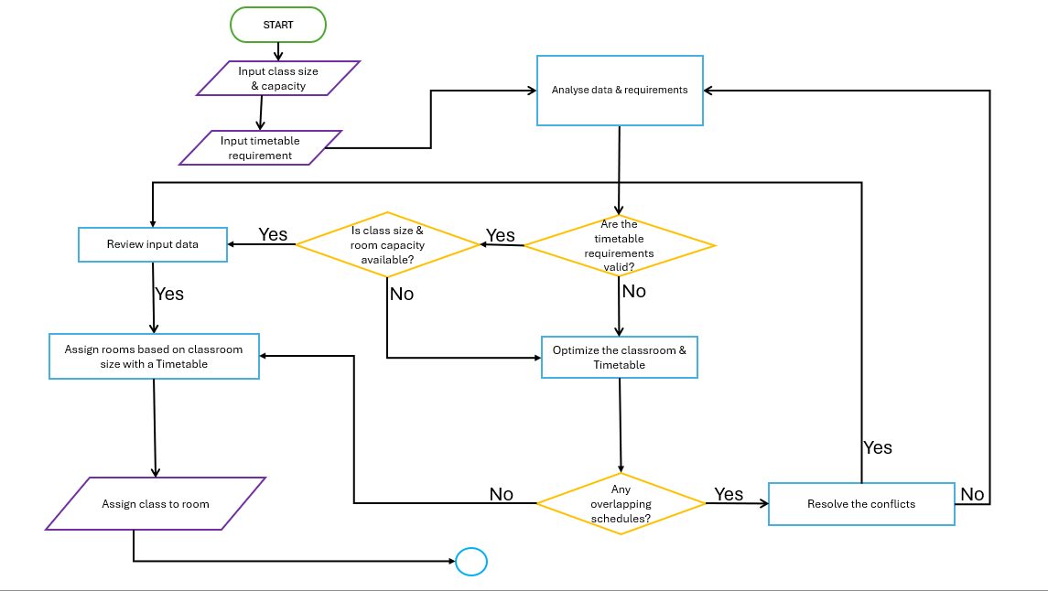
Figure 2:
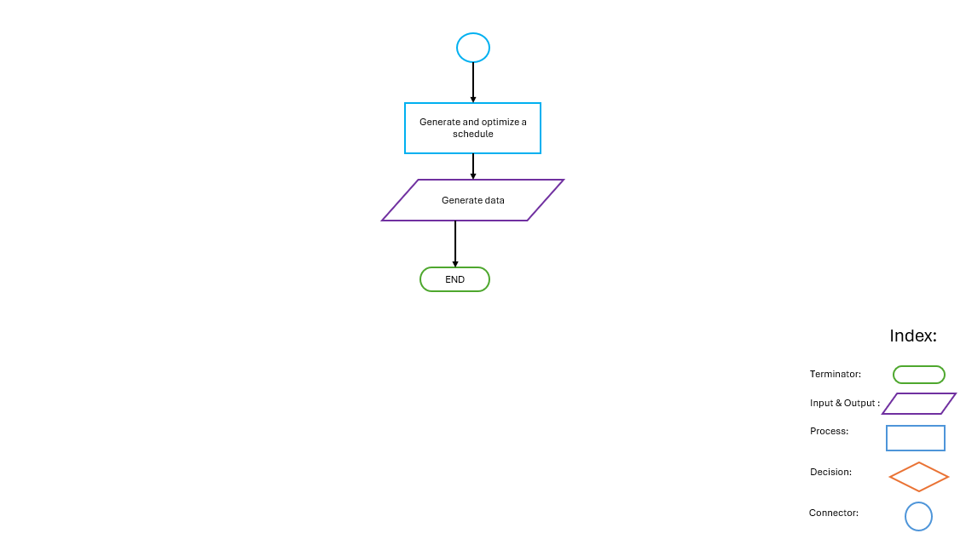

Flowchart Explanation
Figure 1:
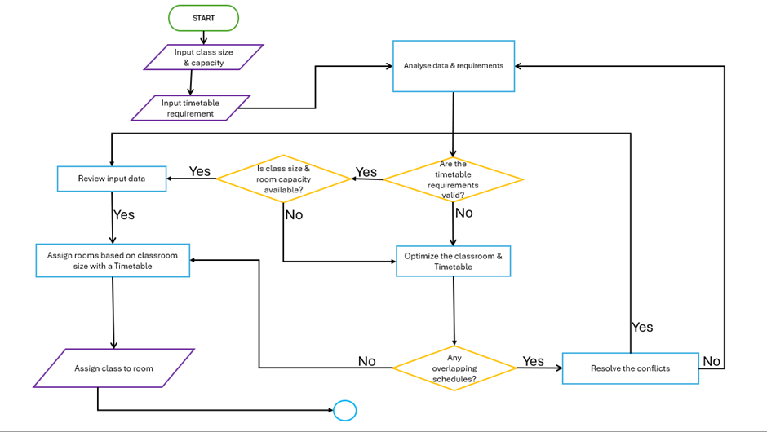
Class sizes, room capacities, and schedule needs are entered at the beginning of the procedure in this section. After that, all of this data is forwarded to the analysis step, where it is reviewed and prepared by the system. It guarantees that all necessary information is gathered before scheduling decisions are made.

This section of the flowchart shows a straightforward checking procedure. The system first examines the input data to determine whether the class size is appropriate for the available space. If it does, it then verifies the validity of the scheduling criteria. The procedure loops back to check that everything is still functioning properly if both requirements are satisfied. The method works to address the issue before moving on if the room capacity or schedule is inappropriate.
Figure 2:
This section of the flowchart demonstrates how the system responds to issues. It first determines whether the schedule is legitimate and whether the class size suits the space. The system attempts to enhance or modify the classroom and schedule if either of these are incorrect. It then determines whether there are any schedules that overlap. If there are disagreements, it attempts to settle them; otherwise, the procedure proceeds. To put it simply, the purpose of this part is to resolve problems and ensure that there are no scheduling conflicts before proceeding.
This section of the flowchart demonstrates what transpires following data verification. After reviewing the supplied data, the system assigns rooms according to the class size and schedule if everything checks out. Once an appropriate room has been selected, the class is assigned to that room. Simply put, the system selects a suitable room and schedules the lesson there when the information is verified to be accurate.
Figure 3:
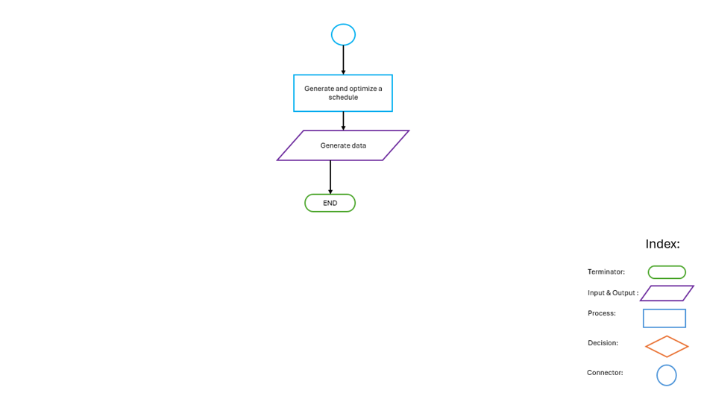
The flowchart's final section demonstrates what occurs following the creation of the schedule. In order to deliver the results or outputs based on the optimised schedule, the system first generates data (such as timelines, resource utilisation, or performance indicators). The process then comes to a conclusion, which indicates that nothing further has to be done. After the schedule is created, the procedure is completed when the system generates the final results.

Reflection and Justification

Abstract thinking

Instead of addressing each classroom and course individually, an abstract thinking approach to the classroom allocation problem focuses on the system as a whole. According to this method, the college is divided into two primary components: classes (needs) and classrooms (resources). The primary objective is to simply match each class with an appropriate room so that no space is wasted. All classes are categorized according to size, and all rooms are grouped according to the maximum number of pupils they can accommodate in order to simplify the problem. Rather than making arbitrary or one-time choices, clear rules are used. For instance, no room should be used simultaneously by more than one class, and each class should occupy the smallest space that yet accommodates everyone. To prevent conflicts, scheduling is also meticulously arranged. This ensures that there are no duplicate reservations for instructors, students, or rooms, and everything operates smoothly. Reducing confusion, saving space, and facilitating room transitions are the key goals. Rather than addressing issues as they arise, the system is designed ahead of time to ensure smooth operation and ease of use each term.

Sub-dividing

It's important to break down the problem into smaller, more manageable parts to make it easier to tackle. It becomes complicated, and mistakes are more likely to happen if we attempt to solve everything at once. Listing every class and the number of students enrolled in each is the first step. This makes it clear how much room each group requires. We then provide a list of every classroom that is available, in addition to the number of seats in each. This aids in our understanding of the resources we truly possess. We can then begin assigning classes to rooms. This gets done by making certain that every classroom is situated in a space that can accommodate every student. The room should ideally be as close to the class as feasible without being too small. The next step after allocating rooms is to create a schedule. This requires making sure that no space is reserved for two classes simultaneously. It also entails making sure that teachers and pupils are not asked to be in two locations at once. Finally, we analyze the system to determine whether it can be improved. For example, we might need to change the allocation if certain rooms are still unoccupied while others are occupied. The task becomes much easier to handle and less intimidating when it is divided into these smaller steps.

Justification of the solution

The goal of the approach is to make classroom utilization more equitable and practical. Preventing overcrowding is one of the key advantages. It can be hazardous and uncomfortable for students to be housed in small spaces. We ensure that every student has adequate space by matching class sizes to room capacities. Making better use of the existing space is another advantage. Certain rooms in many colleges are nearly empty, while others are packed. By ensuring that rooms are used more effectively, this approach helps counteract that. Larger classes are assigned rooms of the proper size, while smaller classes are housed in smaller spaces.

Additionally, the solution saves time. Teachers and pupils don't have to walk between inappropriate or far-off rooms when room assignments are set up correctly. As a result, the school day runs more smoothly and is less stressful. The technology also increases the precision of timetabling. Careful planning guarantees that there are no conflicts or duplicate reservations because each room can only accommodate one class at a time. Lessons are therefore more likely to begin on schedule and proceed smoothly. All things considered, the solution makes the system more dependable and well-organized, which is beneficial to both employees and pupils. It makes greater use of college resources, increases comfort, and saves time.

Limitation

The solution has disadvantages, even though it enhances classroom distribution. One drawback is that ideal room usage might not always be achievable. There might still be some unused space in some rooms because class sizes don't always match room capacity perfectly. The system's heavy dependence on correct data is another downside. The allocation will not function correctly if class sizes are inaccurate or room capacities are out of date.

Problems can also arise from unexpected alterations. For instance, the schedule may need to be swiftly modified if a teacher is absent or a room becomes unavailable for maintenance, which could cause system disruptions. Special requirements may potentially cause problems for the solution. Certain classes could require spaces, such as computer rooms or science labs, which aren't usually readily interchangeable with regular classrooms. Lastly, the system can occasionally need to be manually adjusted, especially when handling intricate schedules or last-minute modifications.

Assumption

Several assumptions have been made to simplify the problem in designing this solution. All class sizes are believed to be exact and known beforehand. It would be impossible to distribute rooms correctly without accurate data. In addition, it is presumed that all classroom capacities are accurate and current. To prevent crowding, this is crucial. Another presumption is that there are no outside constraints, like repairs or reserved spaces, and that every room is available for scheduling. Each class is presumed to only require one room at a time and does not need to be divided among several rooms. In addition, it is believed that there won't be any last-minute adjustments to the schedule after it is prepared. Although changes do occur in real life, it is anticipated that the timetable will remain constant for this system. Finally, unless otherwise specified, it is presumed that all rooms are suitable for general instruction, which means they can be utilized for any typical class.

Conclusion

To sum up, this work examined the issue of ineffective classroom distribution settings and offered a methodical solution. It became simpler to comprehend the essential requirements and constraints by segmenting the problem into smaller components and applying strategies like MoSCoW prioritisation. Using a flowchart made it easier to understand how classes might be assigned logically and systematically.
The suggested approach focuses on minimising needless transit between sessions, eliminating schedule conflicts, and aligning class sizes with appropriate space capacity. Despite its simplicity, the method offers a useful and efficient technique to increase scheduling effectiveness.
Overall, this challenge shows how fundamental algorithmic design and clear thinking can be applied to solve real-world educational difficulties, resulting in greater resource utilisation and a more seamless learning experience for both staff and students.

References

[1] | D. Tudor and G. A. Walter, «Using an agile approach in a large, traditional organization,» в AGILE 2006 (AGILE'06), Minneapolis, MN, USA, 23-28 July 2006.
[2] | R. S. Kostev, «Challenges and Problems of the MoSCoW Method Application in ERP System Implementation,» в 2023 International Scientific Conference on Computer Science (COMSCI), Sozopol, Bulgaria, 16 November 2023.
[3] | R. B. A. M. H. N. M. N. a. W. C. M. D. Hooshyar, « Flowchart-based approach to aid novice programmers: A novel framework,,» в 2014 International Conference on Computer and Information Sciences (ICCOINS), Kuala Lumpur, Malaysia, 03-05 June 2014.

