Hayley Clark 1907913

Module Title:
Cycle 1 Core Studies: The Learner: who am I teaching?
Module Code ECAD4007
Using the pupil profile given, identify how specific aspects of the child’s holistic development be met within an educational setting. Underpin this with references to relevant theories, research and examples of excellent practice.

Contents
Introduction 2
Ella’s Cognitive Development 3
Ella’s Social Development 4
Ella’s Physical Development 6
What else needs to be done for Ella 7
References 9
Appendix 1 10
Appendix 2 10
Appendix 3 11
APPENDIX 4 13
Appendix 5 14

Introduction

Ella is four years old and in reception class. Ella’s teacher is becoming concerned as she feels her progress is limited. It is crucial that a teacher has good knowledge of child development, so accurate assessments can be made. If a teacher understands where the children in their class should be in their development, then if a child is showing signs of delay, appropriate interventions can be put in place. A teacher’s observational skills play a key role in the everyday practice in the Foundation Phase. This helps to determine where they are on the learning continuum in order to help them progress, and to identify any difficulties. Through observation, evidence can be gathered before and after children have been taught skills, and then reviewed over time. In order to build a picture of the whole child it is important that observations are made in both the indoor and outdoor environments. This enables practitioners to assess how much progress the children have made and whether they need further intervention (Welsh Government, 2017).

A learner is considered to have additional learning needs if they have a learning difficulty or disability which calls for additional learning provisions. Because Ella Is finding certain aspects of school difficult, she will need additional support, therefore Ella has Additional Learning needs. It is not for Ella’s teacher to diagnose, although her teacher’s role would be to observe and collect evidence of Ella’s development. Concerns should be discussed with the school’s Additional Learning Needs Coordinator, then if a referral to external services is necessary that can be arranged. The Equality Act protects pupils with disabilities from discrimination. Teachers must help pupils to overcome barriers they may have to learning, participation and achievement. This can be done by adapting tasks, giving extra support, and by using different resources (Glazzard, at el, 2015).
When looking at Ella’s development it is important that we have a holistic approach. It is important to meet all of Ella’s needs, not just the learning needs but also her emotional, physical, spiritual and physical needs. Schools also need to ensure they are meeting all the UNRC rights of the child (see appendix 4). All aspects of her development should be perceived as interrelated. An example of this could be, that a child who is not thriving physically could be expected to fail in other areas (Smidt, 2013). When looking at Ella’s development I will be focusing on three main areas, cognitive, social and physical development.

Ella’s Cognitive Development

There are many theories on how children develop and the age that children should reach different milestones. Piaget’s stages of cognitive development has four stages (see appendix 1). Ella should fall into the preoperational stage. The preoperational stage according to Piaget is for children between two and seven. Piaget theory states that children in this stage are continuing to develop language skills, manipulate their environment and have limited amounts of logical thought. This stage can be broken down into two substages, the preconceptual phase for two to four-year olds and the intuitive stage for four to seven-year olds. The preconceptual stage would be where children use imaginative and symbolic play. Piaget felt play was essential for cognitive development. Thinking in this stage can be limited by egocentrism, making it difficult to see the world from another’s point of view. Also, Piaget feels animism, rigidity of thought and transductive reasoning limit thinking at this stage. The second of Piaget’s substages, the intuitive phase, is only a slight advancement. In this stage children are getting better at seeing the whole scene, rather than focusing on smaller aspects. Piaget believed that towards the end of this stage children will ask endless questions and know the difference between fantasy and reality. (Gray and Macblain, 2015). According to Piaget, Ella should have transitioned into the intuitive stage. Ella knows the difference between reality and fantasy, she is still egocentric and plays in the role play area. According to Piaget, Ella is in the appropriate stage for her age. The problem with using Piaget’s stages to assess where someone is developmentally is that the age range of each stage is broad. Within the foundation Phase outcome for writing Ella is achieving gold, which is three skill steps below where she would be expected (see appendix 3). Ella still has no hand preference and cannot draw zigzags. One theory to support Ella would be Vygotsky’s theory of proximal development. This theory describes the gap between what a child can do, and what I child could do with help from a more knowledgeable person (Pound, 2006). For Ella this could be the class teacher, classroom assistant or a peer. At my bridging school they use a model called ask three before me. This would be to first ask themselves, then it would be resources within the class, such as waggles (these are picture cards with good examples), then it would be a classmate, only after that would it be the class teacher or learning support assistant. But as Ella’s communication skills are still limited, this would need to be helped and encouraged by the adults within the class. This would be in line with Vygotsky’s theory that she could do more with the help of others.

Bruner felt that children learn best through the medium of play. Bruner also developed the spiral curriculum, the idea that children will revisit materials and activities over the years but use them differently (Lindon, 2001). For Ella at this early stage of her school life this would be to include access to lots of materials and learning that can be built upon. An example could be water play, this can used to explore movement, floating and sinking at this stage. Later this could be built upon for learning volumes, and then in key stage two even for looking at tidal energy. My placement school use the approach of a growth mindset by Carol Dweck with their students. They use language such as “yet” rather than cannot. This encourages children to achieve rather than them thinking they are unable, or not good enough. Research has shown the link between mindsets and achievement. If you believe your brain can grow, you behave differently (Mindset Works, 2017).

Ella’s Social Development

Social development is vital to a child’s education. According to Vygotsky social development is related to cognitive development. He emphasised the importance of the child families, community and other children. According to Vygotsky, if Ella is struggling socially or not communicating then she cannot reach the higher levels of achievement. (Pound, 2006). Sharman states that socially a four-year-old should be able to share and take turns, although they may cheat. He also said they should be capable of showing sympathy is a child is hurt. Emotionally they should be becoming more independent and self-willed, which may turn to conflict, and be able to show sensitivity to others. Children who have not reached this development by four may be described as having a learning difficulty (Glazzard et al. 2010). When Ella’s profile is compared to this measurement she is falling behind. Ella does not share in the classroom or show sympathy to other children. Emotionally Ella is not always independent as she likes others to look after her and does not show empathy to other children.

Socially Ella is working within Foundation Phase Outcome one. We know this because Ella plays on her own or parallel to her peers. Also, Ella does not share and does not consistently show care and respect for others. According to the Foundation Phase Handbook (Welsh Government 2017) Ella should be working within the Foundation phase outcome 3 (See appendix 2). This places her two skill ladders below where she would be expected to be for her age.

One way to help Ella to develop socially would be circle time. Circle time is usually led by the class teacher, who sits in the circle with the children. I observed Circle Time on school placement. It is an activity that’s used to help develop relationships between children. It can give children the tools needed to engage with and listen to each other. It can also be used to help solve problems that affect the class, such as bullying or negative behaviour. During my observation a teddy was used, children could only speak when they had the teddy. This encourages children to take turns and respect each other, two things which Ella is struggling with in school. One intervention I observed in school was Bucket time, it was introduced to the school as a speech and language program for specific children within the class, but the teacher decided to carry on as it helped with all the children. It’s a simple idea where a small group of children sit in a semi-circle and the teacher holds a bucket. The Teacher then pulls things out of the bucket and they talk about it. Then the teacher will continue to pull different things of the bucket, with activities or questions to go along with the objects. The children will then take it in turns to join in with the activities. This could be joining in with a painting, counting or colour sorting with tweezers. The teacher also uses the technique of raising then lowering her voice to keep attention. This would be something that Ella’s teacher could introduce to help Ella socially with turn taking and communication. But also, could be used to work on Ella’s fine motor skills, counting and attention skills.

Ella’s Physical Development

A child’s physical development is an important part of their holistic development. The brain is fed by physical experiences. Piaget states that infants in their first two years must structure their growing understanding of the world through exploring their environment. When thinking about physical development we cannot ignore the importance of our senses. We receive information from all of them. Children should be encouraged to use all their senses to make sense of the world around them and make connections between new information and what they already know (Nurse, 2009). In the classroom Ella should be given the opportunity to learn through things such as touch, taste, smell as well as what she sees and hears.

Children are not moving as much as they did years ago. This means that children are not developing the physical skills that they need to be able to be physically active throughout life. Physical Literacy is a journey we are all on and continues throughout our lives. This journey starts when we are very young and start to learn about our bodies and how we move. The more we play and explore in our environment the more we learn about moving. Children need lots of experiences and lots of opportunities to move in lots of different environments (Wales Academy for Health and Physical Literacy, 2015). During my observation at a school I observed a program called SKIP. SKIP is a Physical literacy program used to increase gross motor skills. It emphasises good techniques and helps children become more confident. This would aid Ella’s physical skills as she can be unsteady and is still unable to walk up and down steps without adult support.

What else needs to be done for Ella

One thing which needs to be done for Ella is an IEP, which stands for Individual learning plan. It is a teaching and learning plan drawn up for children with special educational needs. It should include, targets, strategies, the names of the people who will support Ella, a date for review, the success criteria and outcomes (Grigg, 2010). It is important to remember that when anything is put in place for a child that differs from the rest of the class, permission must be obtained from the child’s parent or guardian. With an IEP the parent or guardian, as well as the child, will be given input and themselves and the teacher will sign to say they all agree. This fits in with Bronfenbrenner's Ecological Theory of Development (see appendix 5). Bronfenbrenner emphasises the importance of the environment and the people around the child. Another thing that needs to be put in place is a one-page profile. This will have Ella’s likes and dislikes, as well as the best way to support her. It can also be used for all pupils as a way of making lessons more person centred. Personalising lessons is also about giving children choices. Teaching that allows children a choice and is relevant will be more engaging (Griggs, 2010).

“Development can be seen as a road along which all children travel, yet they do not all travel and make progress at the same speed and some children may pause at times and/or take detours along the way.” (Woodfield, 2004, p4). It is important to remember that because Ella is showing some delay in development now, it does not mean that she will always be behind or that she will not reach the same milestones.

References

Glazzard, J. Hughes, A. Neverwood, A. Neve, L. and Stokoe, J. (2019) Teaching Primary Special Educational Needs. Exeter: Learning Matters Lmt.
Glazzard, J. Hughes, A. Neverwood, A. Neve, L. and Stokoe, J. (2015) Teaching and Supporting Children with Special Educational Needs and disabilities in Primary Schools. London: Sage Publication Lmt.
Gray, C. and Macblain, S. (2015) Learning Theories in Childhood. London: Sage Publication Lmt. Pg 66-75
Griggs, R. (2010) Becoming an Outstanding Primary School Teacher. Essex: Pearson Education Lmt.
Lindon, J. (2001) Understanding Children’s Play. Cheltenham: Nelson Thornes Ltd.
Mindset Works. (2017) Available at: https://www.mindsetworks.com/science/ (Accessed: 9th December 2019)
Nurse, A. (2009) Physical Development in the Early Years Foundation Stage. Oxon: Routledge.
Pound, L. (2006) How Children Learn. London: MA Education Lmt.
Smidt, Sandra. (2013) The Developing Child in the 21st Century. Oxon: Routledge.
Wales Academy for Health and Physical Literacy. (2015) Available at: http://physicalliteracy.cymru/what-is-physical-literacy/ (Accessed: 9th December 2019).
Welsh Government (2017) Foundation Phase Profile Handbook. Available at: https://gov.wales/sites/default/files/publications/2018-03/foundation-phase-profile-handbook-revised-september-2017.pdf (Accessed: 3rd December 2019).
Woodfield, L. (2004) Physical Development in the Early Years. London: Continuum International Publishing Group.

Appendix 1
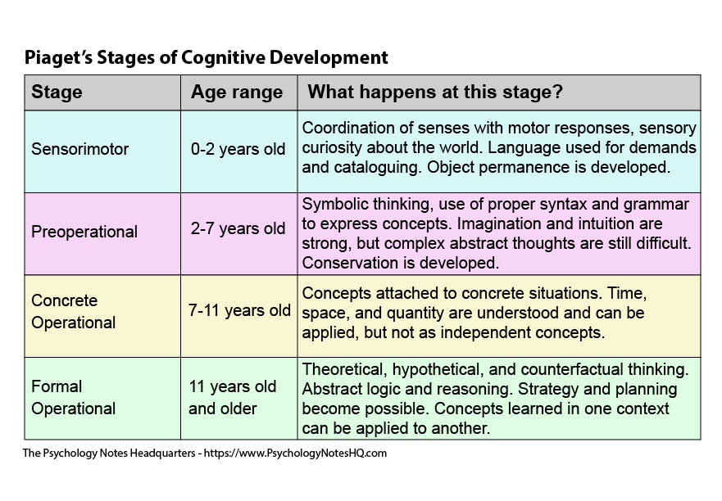

Appendix 2
Foundation phase Social interaction (Compact Profile) skill ladder
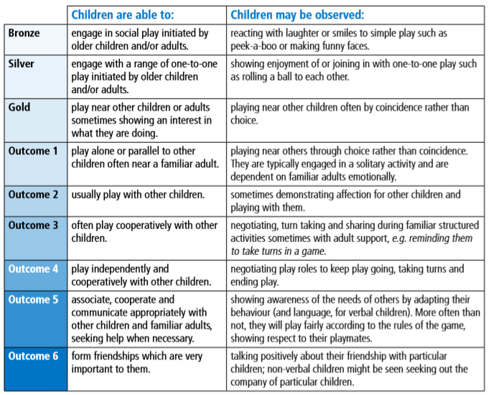
file:///C:/Users/Hayley/Pictures/foundation-phase-profile-handbook-revised-september-2017.pdf

Appendix 3
Foundation phase writing-handwriting skill ladder
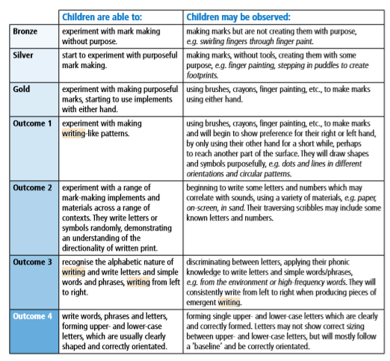

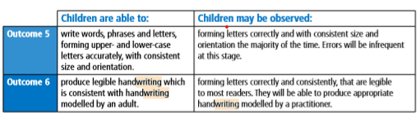

file:///C:/Users/Hayley/Pictures/foundation-phase-profile-handbook-revised-september-2017.pdf

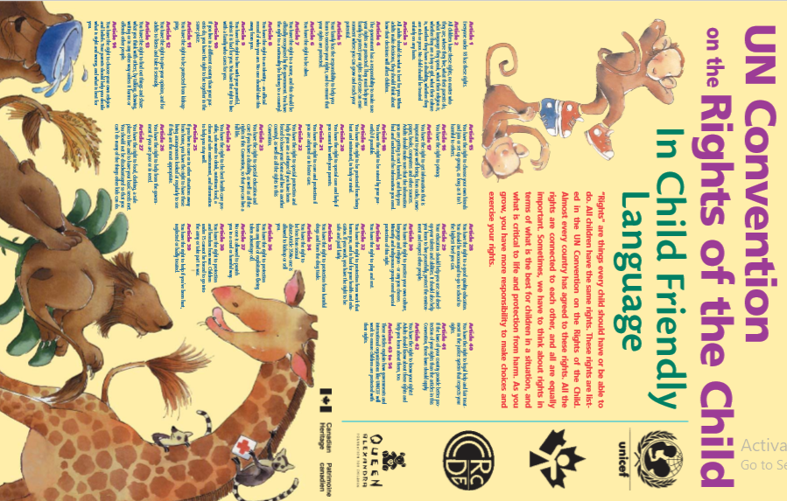
APPENDIX 4

file:///C:/Users/Hayley/Pictures/uncrcchilldfriendlylanguage.pdf

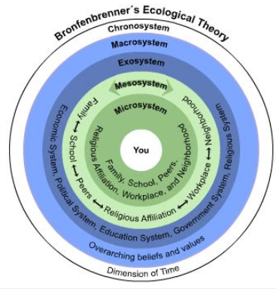
Appendix 5
http://peahstudybloggie.blogspot.com/2013/01/bronfenbrenners-ecological-theory-of.html

