Student Name: Ionela Mocanu  Student ID: 2232076  Module Title: Foreign Languages & Cultural Awareness  Module Code: BMIH5003  Lecturer: Heidi Prosser  Date: 06.02.2024 | 
ASSIGNMENT 1: PORTFOLIO
(4 Components)

Component 1: Professional Reflection (500 words +/- 10%)

Weighting: 25%
As a waiter at Yeovil Town Centre Hotel, I recently encountered a cultural misunderstanding with a French hotel guest during breakfast service. The guest, Monsieur Dubois, approached me and requested "pain" with his breakfast. Confident in my language skills, I swiftly brought him a plate of bread, assuming he meant the English word "pain" for bread. However, Monsieur Dubois seemed perplexed and clarified that he was asking for "pain au chocolat," a popular French pastry.
Reflection:
This incident highlights how easily cultural misunderstandings can occur, even in seemingly simple interactions like ordering breakfast. Language plays a crucial role, as words may have different meanings or interpretations across cultures. In this case, my assumption that "pain" solely referred to bread stemmed from my limited understanding of the French language and culture.
To prevent such misunderstandings in the future, I recognize the need to develop several skills and make behavioral changes:
- Language Proficiency: Improving my language skills, particularly in French, is paramount. While basic proficiency may suffice for everyday interactions, working in a diverse hospitality environment like Yeovil Town Centre Hotel demands a higher level of fluency. Engaging in language courses or online tutorials can enhance my vocabulary and comprehension, enabling me to better understand and fulfill guest requests.
- Cultural Awareness: Cultivating a deeper understanding of French culture is essential for effective communication with French guests. Beyond language, I need to familiarize myself with cultural norms, customs, and culinary preferences. This includes learning about traditional French dishes and their proper pronunciation to accurately interpret guest orders. By embracing cultural diversity, I can bridge the gap between different cultural backgrounds and provide a more personalized service experience.
- Active Listening: Improving my listening skills is crucial for avoiding misinterpretations. Instead of making assumptions based on partial understanding, I should actively listen to guest requests and seek clarification when needed. Paraphrasing or repeating back orders ensures accuracy and demonstrates attentiveness to guest needs. By actively engaging with guests and acknowledging their perspectives, I can mitigate the risk of cultural misunderstandings.
- Adaptability and Flexibility: Cultivating adaptability is essential in the dynamic hospitality industry. Recognizing that cultural norms may vary; I must remain flexible in my approach to guest interactions. This involves being open-minded, patient, and willing to adjust my communication style to accommodate diverse cultural preferences. By embracing flexibility, I can create a welcoming atmosphere where guests feel valued and understood.
In conclusion, the encounter with Monsieur Dubois underscores the importance of addressing cultural misunderstandings in F&B service. By enhancing language proficiency, cultural awareness, active listening, and adaptability, I can effectively navigate cross-cultural interactions and provide exceptional service to guests from diverse backgrounds. As a committed F&B professional at Yeovil Town Centre Hotel, I am dedicated to continuous learning and growth to ensure memorable experiences for all guests, regardless of cultural differences.

References:
Hofstede, G., Hofstede, G. J., & Minkov, M. (2018). Cultures and Organizations: Software of the Mind (3rd ed.). McGraw-Hill Education.
Jandt, F. E. (2020). An Introduction to Intercultural Communication: Identities in a Global Community (10th ed.). Sage Publications.
Samovar, L. A., Porter, R. E., McDaniel, E. R., & Roy, C. S. (2019). Communication Between Cultures (9th ed.). Cengage Learning.

Component 2: Training Plan (500 words +/- 10%)

Weighting: 25%

Identified cultural misunderstanding (in a few words):
Yeovil Town Centre Hotel provides exceptional service to guests from diverse cultural backgrounds. Recognizing the importance of cross-cultural competence in delivering personalized experiences, we have developed a comprehensive training plan for all employees. This training aims to equip staff with the necessary skills and knowledge to effectively navigate cross-cultural interactions and prevent misunderstandings in the future. Identified cultural misunderstanding: Misinterpretation of the term "pain" by a French guest during breakfast service, leading to confusion over the desired item (bread vs. pain au chocolat).
Training plan (Why/What//Who/Where/When):
Why: To equip Yeovil Town Centre Hotel staff with the necessary skills and knowledge to effectively navigate cross-cultural interactions, prevent misunderstandings, and enhance guest satisfaction.
- Enhance Language Proficiency: Improve employees' language skills, particularly in languages commonly spoken by hotel guests, to facilitate clearer communication and better understand guest needs.
- Develop Cultural Awareness: Increase awareness of different cultural norms, values, and communication styles to foster empathy, respect, and appreciation for cultural diversity.
- Strengthen Active Listening Skills: Train employees to actively listen, seek clarification when needed, and demonstrate empathy to ensure accurate understanding and interpretation of guest requests.
- Foster Adaptability and Flexibility: Cultivate adaptability among staff members, encouraging them to adjust their communication styles and behaviors to accommodate diverse cultural preferences and expectations.

What:
- Language Proficiency Training: Provide language courses or resources focusing on key phrases and vocabulary relevant to hospitality, especially in languages commonly spoken by hotel guests, such as French.
- Cultural Awareness Workshops: Organize interactive sessions led by cultural experts to explore different cultural norms, values, and communication styles, promoting empathy, and understanding.
- Active Listening Skills Development: Conduct training sessions focusing on active listening techniques, such as paraphrasing and clarifying questions, to ensure accurate understanding of guest requests.
- Adaptability and Flexibility Exercises: Integrate cross-cultural scenarios into staff meetings or team-building activities, encouraging employees to adapt their communication styles to diverse cultural preferences.
- Role-Playing Scenarios: Conduct role-playing exercises to simulate real-life guest interactions and practice applying language skills, cultural awareness, and active listening techniques in various situations.
Who: All employees of Yeovil Town Centre Hotel, including front desk staff, restaurant servers, housekeeping, and management team members, will participate in the training program.
Where: Training sessions will be conducted on-site at Yeovil Town Centre Hotel in designated meeting rooms or training facilities.
When: The training plan will be implemented periodically throughout the year to ensure all staff members can participate. Additional refresher courses and ongoing learning opportunities will be available to support continuous development.
By investing in cross-cultural competence training, Yeovil Town Centre Hotel demonstrates its commitment to providing exceptional service and creating memorable experiences for all guests. Through language proficiency, cultural awareness, active listening, and adaptability, employees are empowered to navigate cross-cultural interactions confidently and effectively, fostering positive relationships and enhancing guest satisfaction.

References:
Chen, G. M., & Starosta, W. J. (2018). Foundations of Intercultural Communication. Routledge.
Lustig, M. W., & Koester, J. (2019). Intercultural Competence: Interpersonal Communication Across Cultures (8th ed.). Pearson.
Ting-Toomey, S., & Chung, L. C. (2022). Understanding Intercultural Communication. Oxford University Press.

Component 3: Student Self-Reflection (500 words +/- 10%)

Weighting: 25%
Throughout my journey in the hospitality industry, my understanding of the importance of cultural awareness has evolved significantly. Initially, I approached cultural awareness as merely a courtesy, a way to avoid causing offense to guests from different backgrounds. However, as I gained more experience and encountered various cultural interactions, my perspective deepened, leading me to appreciate the profound impact of cultural awareness on guest satisfaction and overall service quality.
- Description:
  - At the outset of my career, cultural awareness seemed peripheral to my duties in the hospitality industry. My primary focus was on providing efficient service and ensuring guest satisfaction, with minimal consideration for cultural nuances.
  - Over time, I encountered situations where cultural misunderstandings arose, leading to guest dissatisfaction and communication breakdowns. For example, I recall an incident where a Japanese guest felt uncomfortable with our direct communication style, preferring a more indirect approach.
  - These experiences prompted me to recognize the importance of cultural awareness in fostering positive guest experiences and maintaining a welcoming environment for all guests.
- Feelings:
  - Initially, I felt overwhelmed by the complexities of cross-cultural communication. I was unsure how to navigate unfamiliar cultural norms and feared making mistakes that could potentially offend guests.
  - However, as I embraced cultural awareness as a learning opportunity rather than a challenge, I felt more confident in my ability to engage with guests from diverse backgrounds. I began to see each cultural interaction as a chance to broaden my understanding and enhance my skills.
  - Despite occasional discomfort or uncertainty, I felt motivated by the prospect of creating memorable experiences for guests through culturally sensitive service.
- Evaluation:
  - Reflecting on my experiences, I realized that cultural awareness goes beyond surface-level gestures of respect. It involves understanding the underlying values, beliefs, and communication styles of different cultures, which significantly influence guest expectations and preferences.
  - I evaluated my own approach to guest interactions and identified areas for improvement, such as enhancing my language skills and deepening my knowledge of cultural customs and traditions.
  - I recognized that investing in cultural awareness not only improves guest satisfaction but also enriches my own personal and professional development by fostering empathy, curiosity, and open-mindedness.
- Analysis:
  - Through introspection and self-analysis, I gained insights into the intricacies of cross-cultural communication and its relevance in the hospitality industry.
  - I realized that cultural awareness is not a static skill but a continuous journey of learning and adaptation. It requires ongoing effort to stay attuned to the evolving needs and preferences of diverse guest demographics.
  - Analyzing my experiences within the context of academic literature on intercultural communication and hospitality management deepened my understanding and provided theoretical frameworks to guide my practice.
- Conclusion:
  - In conclusion, my journey of self-development has highlighted the fundamental importance of cultural awareness in the hospitality industry. By embracing cultural diversity and honing my cross-cultural communication skills, I can create inclusive environments where all guests feel valued and respected.
  - Moving forward, I am committed to ongoing learning and growth, recognizing that cultural awareness is not only essential for professional success but also for fostering meaningful connections and promoting intercultural understanding in an increasingly globalized world.

References:

Hall, E. T. (2018). Beyond Culture. Anchor.
Hofstede, G. (2018). Culture's Consequences: Comparing Values, Behaviors, Institutions, and Organizations Across Nations (2nd ed.). Sage Publications.
Lashley, C., & Morrison, A. (2020). In Search of Hospitality. Goodfellow Publishers.

Component 4: Training Presentation (6 Slides)

Weighting: 25%
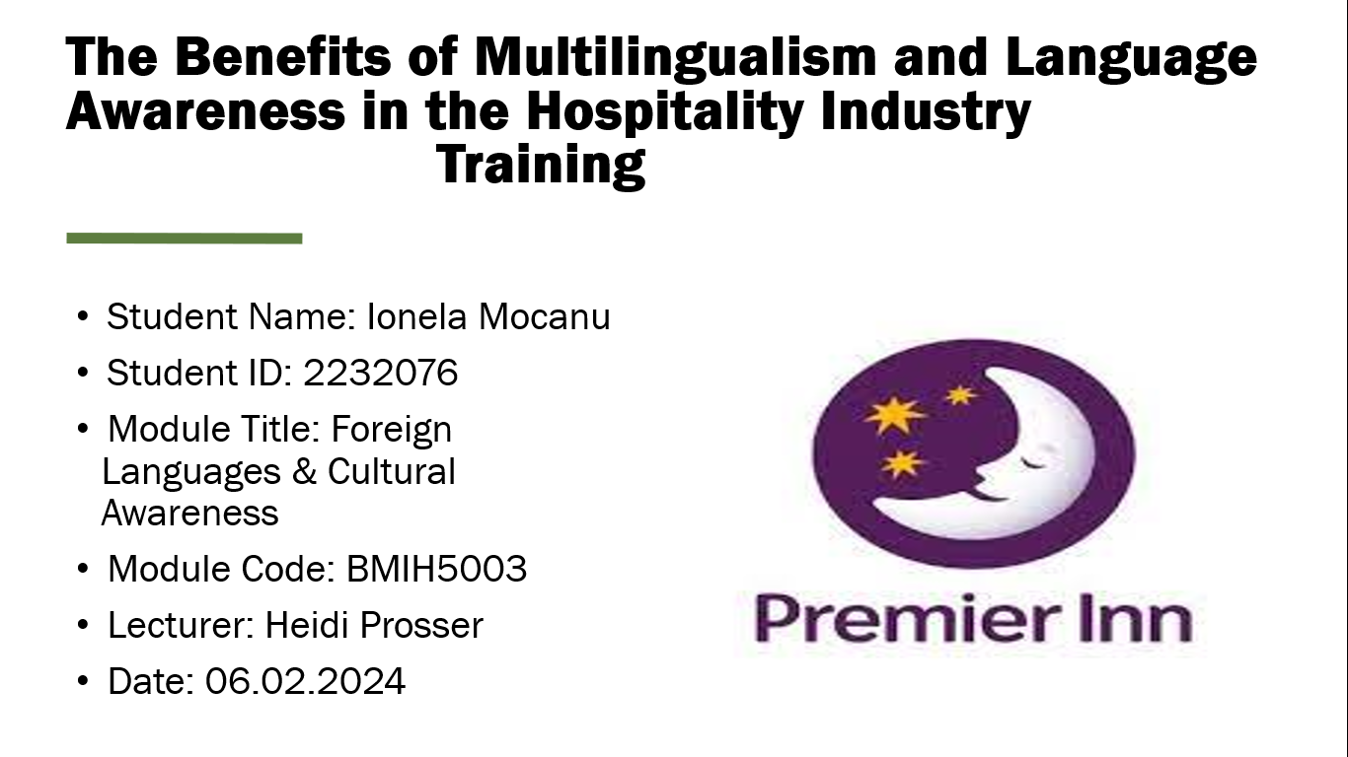
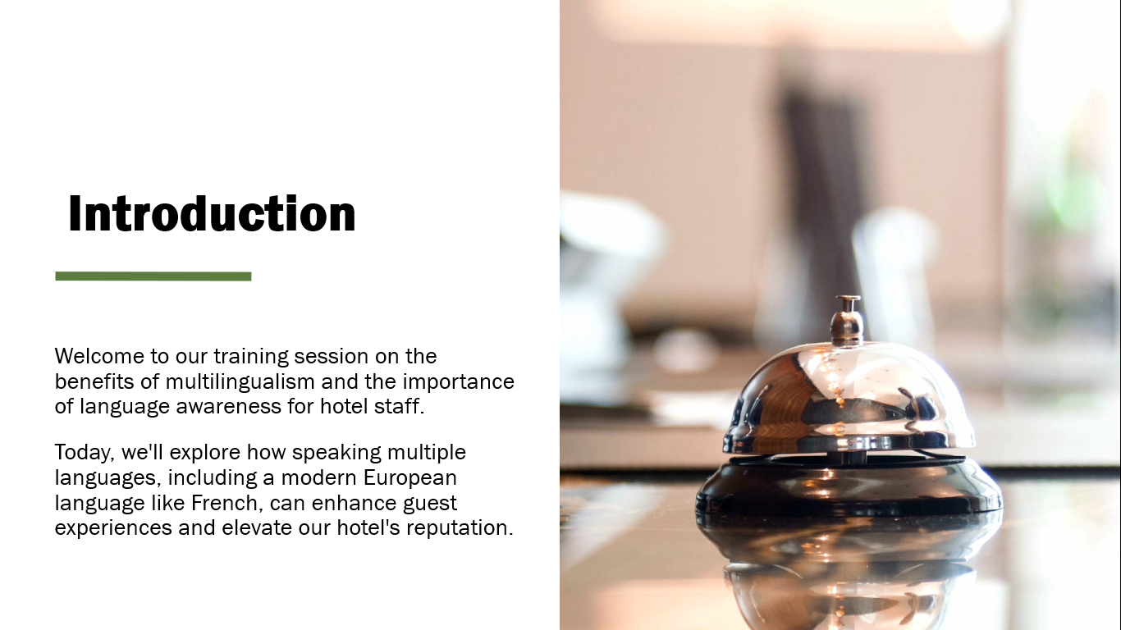
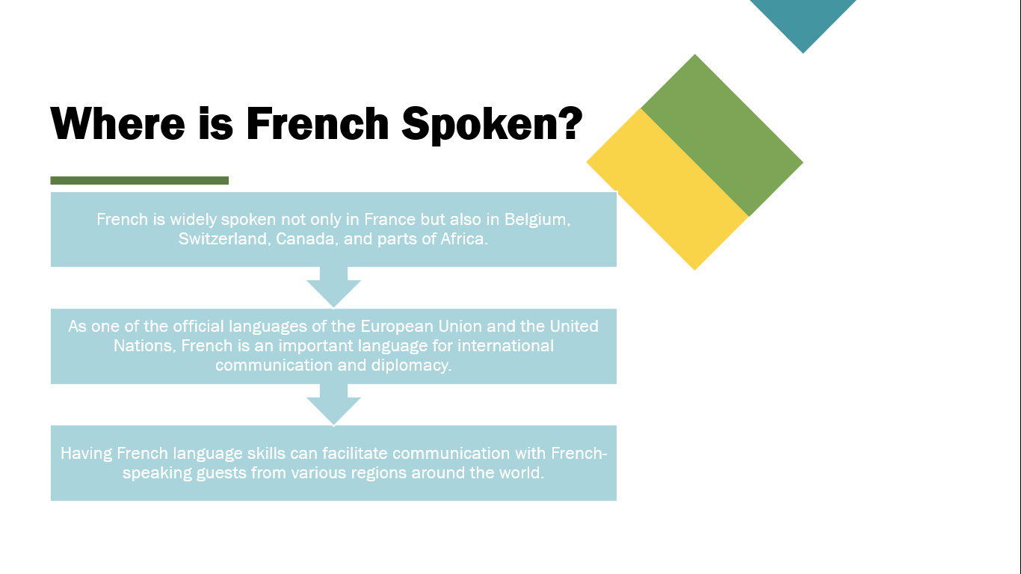
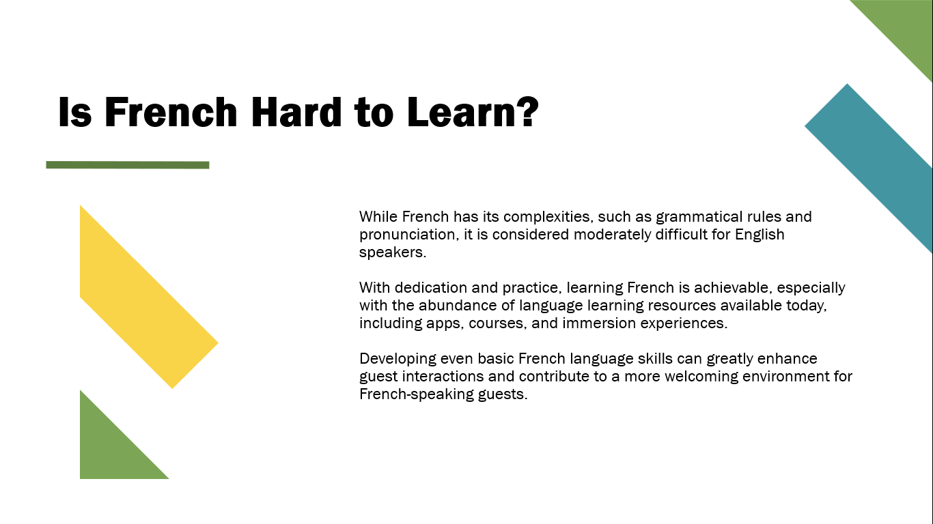

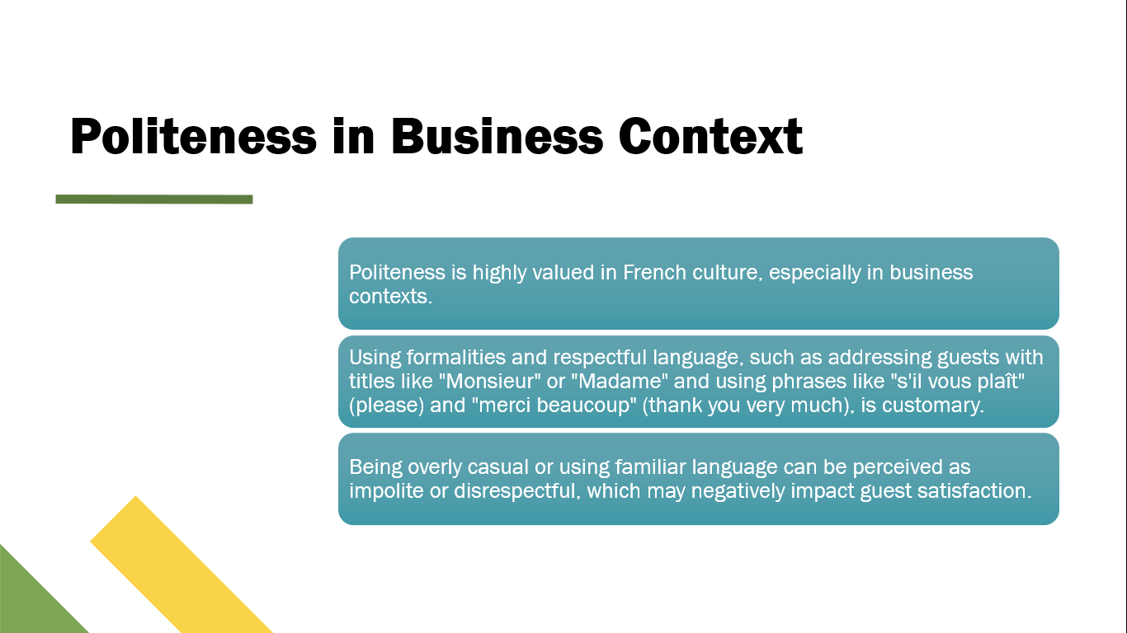

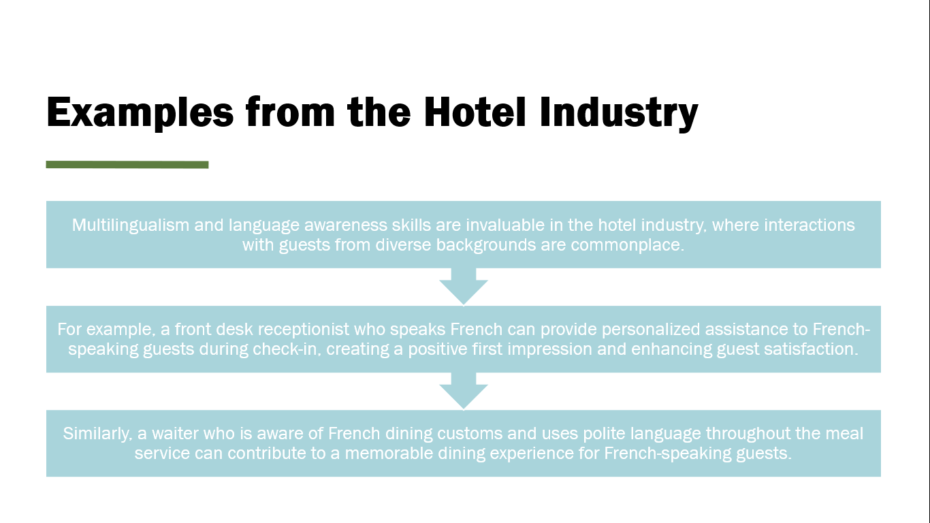
References (no screenshots):
Byram, M. (2018). Teaching and Assessing Intercultural Communicative Competence. Multilingual Matters.
Holmes, J. (2020). An Introduction to Sociolinguistics (6th ed.). Routledge.
Kluck, P. (2021). French: A Linguistic Introduction (2nd ed.). Cambridge University Press.
Lodge, D. (2018). French: A Linguistic Introduction. Cambridge University Press.
Saville-Troike, M. (2018). Introducing Second Language Acquisition (2nd ed.). Cambridge University Press.

