Continuing Professional Development
BMPF7081: Module Portfolio

Guy Daz
11 Jan 2024

Table of Contents

Appendix | Content | Page Number
Written element of approximately 2500 words |  | 2
Appendix 1 | Current Annotated Curriculum Vitae (C.V.) | 9
Appendix 2 | Current Annotated Job Description | 15
Appendix 3 | Learning or Training Needs Analysis (TNA) | 22
Appendix 4 | Assessment Instruments | 23
Appendix 5 | SWOT Analysis | 26
Appendix 6 | Personal Development Plan | 27
Appendix 7 | References | 30

Reflective Essay: Evacuation Experience in a Conflict Zone

The Cambridge Dictionary defines evacuation as moving people from danger to safety. We often first experience this during school fire drills and in workplaces. As a security professional, I am tasked with planning and executing these drills and applying them to larger scales in the event of significant threats. Yet, citywide evacuations are unrealistic to practice, so we rely on conceptual procedures. This can lead to a false sense of security that all evacuations could follow a plan. I argue that successful evacuations rely more on problem-solving.

This report focuses on the efforts of World Bank East Africa Security members: DE, KP, SY, BM, and me, Guy Daz. Our team, with experience in over ten evacuations, successfully executed a complex overland evacuation from Khartoum, Sudan during severe armed conflict in April 2023.

I'll critically reflect on the evacuation using the DIEP (Description, Interpretation, Evaluation, Planning) method.

Description
In the Description phase, I will recount the details of the specific critical incident, focusing on what happened, who was involved, and where and when it occurred.
Following the successful 2019 revolution against former president Omar al-Bashir, a transitional government was formed in Sudan. However, nearing the transfer of power date to civilians, the Sudanese Armed Forces (SAF) and Rapid Support Forces (RSF) staged a coup in October 2021. This resulted in mass protests, civil unrest, and tensions within the SAF over integrating the RSF. By April 2023, these tensions peaked. In response to these events, our team enhanced security measures, ensuring staff access to radios, emergency supplies, and training on emergency procedures.
On 14 April 2023, SAF leader Al Burhan and RSF leader Mohamed Hamdan Dagalo ("Hemetti") were televised discussing the final details of Sudan's Political Frameworks Agreement. This seemingly innocuous event was the precursor to a civil war in Khartoum the following day.
On the morning of April 15, 2023, Khartoum awoke to the sound of gunfire as clashes erupted between the SAF and RSF, sparking fights over key city locations and suspending all commercial flights. The conflicts used a range of weapons in central Khartoum and surrounding areas where most WBG staff live. I promptly alerted the staff to shelter in place. Fortunately, most of the staff were already at home. BM accounted for all personnel within hours, despite communication disruptions. The Emergency Management Team (EMT) was set up under the leadership of the Regional Vice President at the World Bank Head Quarters (HQ), where I provided regular briefings on the situation.
Over the next few days, WBG staff sheltered in place, amidst rocket impacts, small arms fire, and criminal activity. Emergency supplies dwindled and the RSF reportedly committed violent crimes, including looting and sexual assault. Consequently, I advised staff to relocate to safer areas where possible. There were also reports of attacks on the embassy and UN convoys. The guards at the WBG Country Office (CO) reported stray bullet impacts, but no injuries. On April 19, 2023, upon RSF's order, guards evaluated the WBG CO's building. On my orders, the guards disabled the elevators, locked doors, and secured equipment. I alerted the facilities and IT teams who began network shutdowns. On April 20, due to increased activity near the residence of the WBG Country Managers (CM), a decision was made to relocate to a nearby embassy.
KP's analysis suggested a prolonged conflict, leading DE, and I to evaluate extraction options. Though airlift was preferred, the conflict at Khartoum International Airport ruled it out. Alternate options, including the nearby Merowe airport, were also compromised. RSF and SAF checkpoints, along with sporadic fights outside Khartoum, added to the complexity. Despite initial reports, major fighting was mostly in Western and Southwestern states, with minimal conflict in the Eastern states. Consequently, I suggested to DE we consider a road extraction to Ethiopia, given my prior experience with the route in 2019. After a brief discussion, I started drafting a concept of operations (CONOPS), while also exploring marine and other air options.
By April 20th, in desperation, local staff began self-evacuating from Khartoum, some towards Egypt, others towards safer areas in Jazeera state. This galvanized the road extraction CONOPS, which was presented to the EMT. SA found a vendor charging 20,000 USD for three buses, requiring payment in cash. I coordinated to acquire cash and explored other payment options.
In levity reminiscent of the Afghan military evacuation, I named the evacuation ‘Operation Strawberry Express’.
On April 22, our team, including two drivers, a protocol officer, and six buses, and I headed toward the Sudanese border to prepare for the potential operation. In Khartoum, SA unified all buses at one assembly point due to the drivers' reluctance to go to separate locations. Staff in Khartoum were instructed to self-assess their risk, prepare for a departure at 7 AM on April 23, 2023, and were briefed on current conditions, packing, attire, and potential challenges on the road.
Early morning on April 23, 2023, Operation Strawberry Express received approval to proceed from the Country Director.
Under fire, WBG CO Khartoum's brave staff, consultants, and dependents navigated to the assembly point despite roadblocks, delaying departure by four hours. Eventually leaving Khartoum at 1100 hrs., encountering sporadic stops and checkpoints, they headed east for Gadaref.
At the Sudan border, my team and I liaised with networks established earlier. These networks gave us insights on the border status and facilitated introductions. The Ethiopian head of immigration was receptive, offering resources and confirming the border's 24/7 operation. I was informed of a one-kilometer freedom-of-movement area for Sudanese and Ethiopian citizens and as the only valid visa holder then crossed into Sudan.
The head of Sudanese immigration appeared less welcoming and mockingly stated that crossings needed authorization from SAF leader Al Burhan. This statement showed a willingness to negotiate, so I began building rapport and waited for an opportunity to improve our position.
Due to Ethiopia's security situation, cellular data was limited, prompting a search for Wi-Fi at the border for reporting and correspondence. After finding Wi-Fi, I informed DE and the management team, and I found a basic hotel for the overnight stay.
The Sudanese convoy took an hour's rest in Gadaref before heading to the border. Previously I completed this route in four hours, so I estimated the trip to take 4.5 hours. However, the journey took longer due to deteriorated road conditions and potholes, leading to constant overheating and frequent stops thus the arrival was delayed until 2330 hrs.
The team, expecting the convoy's arrival, reached the border and discovered it was closed. Despite our attempts, it remained closed. I informed DE and SA about the situation and suggested that everyone rest. Eventually, the faint lights of the buses carrying the WBG, consultants, and dependents were visible at the border, separated only by a few hundred meters of bureaucracy. SA and I decided to meet at the border at 0600 hrs. for an early crossing.
The next morning, I reached the border and was met by an apologetic Ethiopian immigration head, who promised support on the Sudanese side. I crossed over again and met with SA. After greeting the weary colleagues, I started collating passports, realizing that three offices had to be visited. This took up the morning and revealed issues: an expired passport and reluctance to permit Sudanese males without a security check.
After a period of aggressively negotiating these issues, 48 colleagues crossed the border into Ethiopia at 0940 hrs. An hour later, SA and I celebrated this milestone with a beer. Then, with six buses of people and an escort from the Ethiopian National Defense Force, we set off to the nearest airport in Gondar city. Sporadic data on the way allowed for updates to DE and the management team. We reached the hotel in Gondar, and a sigh of relief was palpable as everyone rested for the night.
In the morning, we traveled to Gondar airport for our short charter flights to Addis Ababa. Thus, concluding one of the most complex land evacuations in the history of WBG.

Interpretation
In this section, I will analyze the incident in the context of emotions and motivations that contributed to it and examine any emerging patterns.
After the experience of evacuation, the act of reflecting unveiled a broad spectrum of intense emotions that had a profound and lasting impact on me. There was a palpable sense of urgency and fear due to the rapidly escalating levels of violence in the city of Khartoum. This fear was further fueled by the sheer unpredictability of the situation and the concerns for the safety of the WBG staff and their families, resulting in feelings of uncertainty and anxiety.
The stress and tension were not only heightened by the immediate danger but were also exacerbated by the need to swiftly navigate through the complex maze of bureaucratic obstacles. These obstacles, coupled with the necessity to conduct diplomatic negotiations in a high-pressure environment, added a layer of complexity to the situation.
Throughout the evacuation, every action I took and the decisions I made were driven by an intense and profound sense of responsibility. I was fully committed to protecting the safety and well-being of the WBG staff members and their families who were entrusted to my care. This sense of duty was not just a professional obligation, but a deeply personal one.
As I found myself amid an intricate and rapidly changing situation in Khartoum, I was motivated by a strong desire to navigate these complexities adeptly. It was a challenging scenario to navigate, with new developments unfolding by the minute. Yet, I was determined to stay on top of it all, to understand the implications of each new development, and to adjust our course of action accordingly.
The pressure was intense, but it served to highlight the pivotal necessity to make efficient and effective decisions. Every choice had potential consequences, and it was crucial to weigh each option carefully, yet swiftly, to ensure the best possible outcome for our team.
My drive to surmount any obstacles and challenges that came our way played a crucial role in our ability to carry out a successful evacuation. This was an attitude that I carried with me throughout the process - a determination to overcome, to find solutions, and to bring everyone safely home. It was this drive that fueled my resolve, allowed me to face each new challenge head-on, and ultimately, played a key role in achieving a successful evacuation.
Despite the overwhelming challenges and the emotional turmoil, relief and satisfaction prevailed once the evacuation was completed. The feeling of accomplishment was immense knowing that the safety of all staff members was ensured. The collective sigh of relief that echoed amongst the team was a testament to the successful execution of our plan under such dire circumstances.

Evaluation
In the Evaluation phase, I will critically reflect on the incident, considering its impact, consequences, and ethical dimensions.

Personally, the intense stress and immense pressure during the evacuation process likely had a profound impact, heightening my understanding of the importance of safety measures and my inherent ability to maintain a calm and focused demeanor in high-pressure situations. This incident likely pushed me to my limits, testing my resilience and endurance. It also offered an opportunity to strengthen my crisis management abilities by compelling me to handle unexpected crises effectively and efficiently. Furthermore, it likely instilled in me a renewed appreciation for life and the importance of ensuring the safety of others.

Professionally, this incident likely catalyzed the enhancement of my crisis management skills. It also likely strengthened my negotiation abilities and increased my capacity to make swift, effective decisions under immense pressure. This experience provided invaluable, firsthand insights into the dynamics of conflict zones and the intricacies of complex bureaucratic systems. The incident underscored the importance of preparedness, efficient communication, and adaptive strategic planning in the face of rapidly changing circumstances.

The ethical dimensions of the incident had a profound impact on me. As the one responsible for the safety and well-being of WBG staff members and their families, I was faced with several ethical dilemmas throughout the evacuation process with bureaucratic obstacles and the unpredictability of the situation.

Moreover, the incident forced me to consider the ethical implications of my actions and decisions. I was constantly mindful of the potential effects of my decisions on the lives of those under my care. Balancing the urgency of the situation with the need to respect and uphold the rights and dignity of all involved was a critical ethical dimension of the incident.

Furthermore, I was not only responsible for their physical safety but also for their emotional well-being. The intense stress and fear they experienced during the evacuation required me to demonstrate empathy and understanding, while also maintaining a level-headed and focused approach to managing the situation.

Planning

In the planning phase, I will try and identify potential strategies or actions to address similar incidents in the future. I will also consider how to apply what I have learned from the reflection to improve their practice or decision-making.

On reflection, it becomes evident that future strategies for similar scenarios should incorporate a multitude of factors. Firstly, the development of comprehensive evacuation plans is crucial. These plans should be tailored to the unique contexts of each city and country, considering the distinct challenges that each location may present. In addition, promoting adaptability to unforeseen circumstances is paramount, as no two situations are identical.

Equally as important is the enhancement of our communication solutions. One such solution could be the implementation of satellite Wi-Fi at a corporate level. This could provide a reliable and accessible means of communication in areas where cellular data is restricted or unavailable, ensuring that all staff members can stay informed and connected.

Furthermore, regular training exercises should be conducted to prepare staff for potential evacuation scenarios. These exercises should include guidance on self-risk assessments, emergency packing, and appropriate behavior during confrontations. This will provide staff with the knowledge and skills needed to respond effectively in a crisis.

The diplomatic negotiation skills of key personnel should also be improved. These skills are vital for navigating complex bureaucracy and obtaining the necessary permissions during crises. By improving these skills, we can increase our ability to respond quickly and effectively in a crisis. Fostering relationships with key local stakeholders, such as government officials and diplomatic entities, is another important aspect of our future strategy. These relationships can aid in negotiations and facilitate smoother transitions at borders and checkpoints, reducing the stress and uncertainty associated with evacuations.

Having backup plans, such as alternate evacuation routes or additional transportation provisions, is essential in uncertain situations.

Finally, we must prioritize the mental health of our staff. Mental health resources should be readily accessible to staff before, during, and after evacuations. This includes counseling services, which can provide critical support to staff managing the stress and trauma associated with evacuations.

Conclusion

In conclusion, this reflection critically examines an evacuation from Khartoum. It serves not just as a recounting of events but as a learning exercise providing valuable insights to improve future responses. Revealing the complexity and unpredictability of evacuations in non-permissive environments.

It explores aspects of the evacuation such as adaptability and effective communication, to adjust rapidly to changing situations and convey information. Negotiation skills and the significant role in dealing with stakeholders and facilitating the process. It emphasizes the importance of mental well-being in crisis management, as high-stress environments can severely impact mental health, and the importance of decision-making, where each choice significantly impacts the safety of those involved and how that weighed on me.

It challenges the notion that all evacuations can be meticulously planned and successful when following a set procedure. Instead, it highlights the importance of problem-solving and adaptability in the face of rapidly changing circumstances.

Word Count: 2629, References

Appendix 1: Current annotated curriculum vitae (C.V.)

Professional Profile
I am a motivated security manager, instructor, and surveillance operator with experience in the military and private sectors. I have strong situational awareness and attention to detail, proven in successful operations in high-risk environments. I received an extraordinary field promotion by the Chief of the General Staff while operating with indigenous troops in Mali.

I have conducted risk mitigation analysis and managed security operations for international entities, embassies, and high-net-worth clients worldwide. I have investigated incidents and made assessments based on intelligence-led observations. I have planned and executed complex close protection operations.

I am skilled in training and mentoring foreign military and civilian personnel in hostile environments, using innovative methodologies to up-skill individuals in low infrastructure settings.

I have demonstrated the effective application of technical knowledge in various roles. I can lead and work in a team under pressure, find quick solutions, and communicate effectively with higher management. I am highly trained in collecting human intelligence, conducting impact analysis, and achieving specific targets. I am a language specialist, fluent in English and conversational in Japanese, with basic knowledge of French, Dari, Urdu, Swahili, and Arabic.
Career Summary

2020 – Present Day Country Security Specialist: World Bank Group: Ethiopia, Sudan, Eritrea
As a dedicated Country Security Specialist at the World Bank (WB), my primary role revolves around delivering comprehensive security support to various stakeholders within the organization. Specifically, I am entrusted with aiding the WB Country Office Management, Security Focal Points, and staff members involved in security risk management. One of my key responsibilities is to ensure that individuals are well-informed about security matters. To achieve this, I actively engage in enhancing security awareness among the personnel. Additionally, I am involved in the development and implementation of contingency plans, which are crucial for effectively managing unforeseen security incidents. Another aspect of my role entails overseeing protective operations. This includes coordinating guard force contracts in the cities of Addis Ababa and Khartoum, where I work closely with contracted security personnel to ensure optimal security measures are in place.
Residential security is a significant concern, and I provide valuable advice to staff members on how to enhance the security of their residences. Understanding the importance of being prepared for emergencies, I am available to offer 24-hour on-call emergency security support, ensuring that immediate assistance is provided whenever required. In summary, as a Country Security Specialist at the WB, I play a vital role in safeguarding the well-being of personnel and assets. Through my expertise in security risk management, security awareness, contingency planning, protective operations, and residential security advice, I contribute to maintaining a safe and secure environment for all.
- Security Risk Management
As part of the risk management responsibilities with the World Bank (WB), I support regional management at the WB in handling security and travel arrangements for East African regions. This includes developing and managing daily office security programs, ensuring security measures for travel to WB development program areas, and providing inputs for Security Risk Assessments in Ethiopia, Sudan, and Eritrea. I oversee video surveillance, card access systems, and other physical security and fire/life safety systems. I conduct regular testing and evacuation drills. I manage security equipment programs for WB country offices, including procurement, contract management, training, and reporting. I provide security advice and collaborate with Corporate Real Estate for facility selection, renovation, and security measures. I offer guidance on residential security upgrades and security arrangements at various locations. I advise on WB Road Safety policy implementation. I establish relationships with government officials, security advisors, and private security firms for coordination and information sharing. I assist in incident reporting and tracking of staff and missions. I facilitate secure missions to high-threat locations. I remotely supervise local guard staff in Sudan and Eritrea. I represent the World Bank and prepare security programs for program reviews at the headquarters.
- Security Awareness
In my role in security awareness, I am responsible for providing practical security advice and contact information to newly arriving staff and visiting missions in Addis Ababa, Khartoum, and Asmara. This includes giving briefings upon their arrival and offering support for field missions. I also draft staff security advisories to mitigate risks based on the general security situation, specific incidents, and periods of heightened risk. This is to ensure safe travel for missions in remote areas of Ethiopia and Sudan. Additionally, I conduct regular security awareness briefings and coordinate relevant security training for all staff.
- Contingency Planning
I assist in coordinating and revising Crisis Management Plans regularly or as needed. I serve as an advisor or member of the Country Office's Crisis Management Teams. I update and maintain all contingency planning materials, reference documents, and appendices. I coordinate and conduct periodic tests for the staff telephone tree, warden system, and local contingency plans. I organize security and fire/life safety training and briefings for staff. I conduct emergency drills such as fire, shelter-in-place, and bomb threats. I improve the country office's emergency contact and locator systems and ensure coordination with UNDSS and the WB Security Operations Centre. I plot all staff residences, assembly points, office locations, UN offices, and other relevant points on mapping software for each country office. I continuously assess options for in-country relocation and out-of-country evacuation. I, along with Senior Managers, review existing contracts and procure new contracts within the allocated budget when necessary.
- Protective Operations
My duties in protective operations include providing advice, coordinating official vehicle movements, and arranging special security measures for specific movements, locations, or individuals. I conduct security assessments and coordinate arrangements, plan emergency responses to threats, and take proactive and reactive measures to prevent and respond to incidents. I also arrange security for visiting senior officials and coordinate host government support. Additionally, I coordinate security for conferences and training events held in Ethiopia and Sudan when required. I assist in developing security policies and procedures, including determining approved and prohibited locations, and ensuring staff are informed through a communication mechanism.
- Guard Force Contract Management
I oversee the management of security guard service contracts for the country office. This includes handling procurement, and contract extensions, conducting periodic reviews with contract management, certifying invoices, documenting non-performance and other issues, making contract modifications, and ensuring required reporting and documentation in collaboration with Corporate Security. I work closely with the GCSCS Security Specialist - Guard Services at the World Bank Group headquarters and the East/South Africa Senior Security Specialist. Additionally, I provide remote supervisory oversight of the local guard staff in Khartoum, Sudan, in coordination with the Resource Manager. I visit Khartoum at least quarterly to monitor performance and offer professional training opportunities when possible. I also draft yearly performance evaluation reports for the guard staff and update staff employment Terms of Reference as needed.

2016 – 2020 Security Risk Management, and Security Training Consultant: Various Organizations, Globally
I worked as a security, training, and risk management consultant, providing client-led services to organizations in the security field. This involved short and long-term contracts with government, non-governmental, commercial, and international organizations to deliver unique risk management solutions. I also oversaw intelligence, surveillance, and close protection operations for high-net-worth clients worldwide. Additionally, I provided specialized security training such as Hostile Environment Awareness Training (HEAT), Safe and Secure Approaches in Field Environments (SSAFE), Strengthen Personal Security (SPS), and Driver Training for various entities. Furthermore, I successfully conducted investigations into theft and the recovery of high-value items.

2015 – 2016 General Manager Security Operations and Training: Skills Academy, Africa
In 2015 I was headhunted to the position of General Manager for a new security training and risk management company called the Skill Academy.
- Risk Management
I managed and delivered security projects and risk management services for high-net-worth individuals, international organizations, and NGOs throughout Africa.
- Security Training
I have successfully solved problems and provided solutions and training packages for multinational clients, including Actis Investments, Kempinski Group, Premier Academy, Orange, Safari-com, Crown Plaza Hotel, and various Kenyan military and government bodies. The solutions and training packages covered areas such as Crisis Evacuation Planning, Surveillance, Investigation, Hostile Environment Close Protection, Fire Prevention, and Major Incident Emergency Response. I managed and coordinated the operations, as well as delivered training to up to 150 candidates daily in different security disciplines in Kenya. This included organic static guard duties, crisis management emergency response teams, and kinetic direct-action troops for various security entities. Additionally, I planned and conducted non-permissive hostile intervention courses for international and government organizations.
- Close Protection
I organized and managed close-protection tasks, including the airside (aprons) movement, for high net-worth clients like Madonna, Clinton Foundation, Vital Voice, and Ludin Foundation/Africa Oil. I also assisted US Homeland with security management during President Obama's visit to Kenya.

2014 – 2015 Senior Operations, Training, and Special Projects Consultant: Securex Agencies, Kenya
I effectively led the Operations Stem Command Team, managing six departments and over 5000 employees, with a focus on security. As the designated manager, I supported the Head of Operation by implementing workflows, overseeing manning schedules, and strategically planning for operational commitments. I reviewed physical security measures, ensuring they met customer needs through training evolutions, process streamlining, and specialized training for Securex and its assets at all levels.

2004 – 2014 Surveillance, Sniper, Reconnaissance, and Intelligence Team Leader, Military Instructor, Junior Commander: HM Forces, Globally
After the September 11, 2001, events, I joined the HM Forces. Following a year of vetting and another year of training, I graduated to the military ranks. Throughout the decade, I commanded teams authorized to use various methods for intelligence gathering, surveillance, and reconnaissance which supported the implementation of the strategic plan. I led teams in different environments such as the Arctic, bush, desert, jungle, and mountains while utilizing advanced tactics, navigation, and tracking. Additionally, I conducted force multiplier operations, working alongside indigenous forces including small unit reconnaissance, offensive and defensive operations, high-value target strikes, amphibious raids, riverine operations, and ground domination. I also specialized in underground sensors, biometric data collation, and evidence collection. I was also trained as a communications operator and proficient in the use of VHF, HF, UHF, and satellite means to coordinate assets. I am also proficient in operating and maintaining various soft-skin and armored wheeled vehicles.

Education and Qualification

Level 6 - Graduate of the City & Guilds Institute GCGI (bachelor’s degree), Leadership and Management
A Levels- English, Maths, Chemistry and Physics

Professional Development & Membership

- United Nations Trainer Development Certification
- Stoof AV Security Driver Training
- Military Sniper, Surveillance and Reconnaissance Operator
- UK Security Cleared (04-14)
- Tactical Intelligence Analyst
- Static and Live Field Firing Range Safety Supervisor
- Military Team Medic
- Explosive Method of Entry and Demolitions
- Combat Engineer
- Satellite Communicator
- Covert Underground Sensor (UGS) Operator
- Counter Improvised Explosive Devices and Search
- Survive Evade Resist and Escape B
- Unit Environmental Health
- Combat Rifle and Pistol Coach
- HM Forces Command Leadership Management Level 2

Member Of:
- United Nations System Staff College
- Our Underground Railroad

IT Skills

- Microsoft Word, Excel, PowerPoint, Access, Outlook

Personal Details

Honours and Awards World Bank GCS Recognition Team Award 2023
World Bank CSO Team Award 2023
World Bank VPU Award 2023
World Bank IFC Award 2023
World Bank ITSGC Award 2022
World Bank GCS Recognition Team Award 2022
World Bank Sudan- Above and Beyond Award 2022
World Bank GCS Values Award 2021
World Bank GCS Recognition 2020
Field Promoted by Chief of the General Staff General Sir Peter Wall
EUTM Mali Medal
OP Herrick Medal
OP Telic Medal
Non-Article 5 (NATO) Medal
Commanders Commendation – Afghanistan 2009
German Armed Forces Badge for Military Proficiency (Gold)
Bisley Army 100
Driving License Full/Clean
Health Excellent, non-smoker
Interests Outdoor pursuits

References Are Available on Request

Appendix 2: Current Annotated Job Description

Appendix 3: Learning or Training Needs Analysis (TNA)
Current Skills
Leadership and Security Risk Management- Skill Level 4/5
Crisis Management- Skill Level 4/5
Specialist Training and Mentoring- Skill Leve 4/5
Surveillance and Target Acquisition- Skill Level 3/5
Risk Assessment and Execution- Skill Level 3/5
Security Compliance Management- Skill Level 3/5
Physical Security Management- Skill Level 4/5
Potential Training Needs | Estimated Training Timeline
Advanced Higher Education-  Pursuing further higher education in a field relevant to security and risk management could provide deeper theoretical understanding and expose the me to the latest research and developments in the field. This could be in the form of a PhD or a specialized postgraduate degree. | 3-6 years
Advanced Language Skills-  Despite having basic knowledge in several languages, I will benefit from advanced language training, especially in the languages relevant to the regions I operate in. | 6-12 months
Advanced Cybersecurity Training-  Given the increasing role of digital technologies in security, advanced training in areas such as cybersecurity, digital surveillance, and online intelligence gathering could be beneficial. | 3-6 months
Cultural Sensitivity Training-  Operating in various global regions may require a deeper understanding of cultural norms and sensitivities. Therefore, cultural sensitivity training or cross-cultural communication training might be beneficial. | 1-2 months
Modern Surveillance Technology-  Given the rapid advancement in surveillance technology, staying updated with the latest tools and techniques can enhance efficiency and effectiveness. | 3-6 months,

Appendix 4: Assessment Instruments
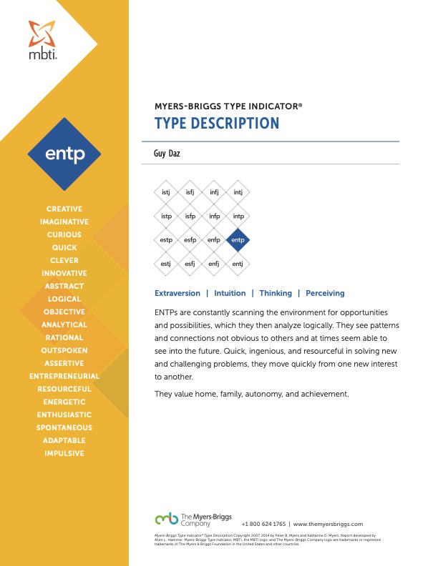
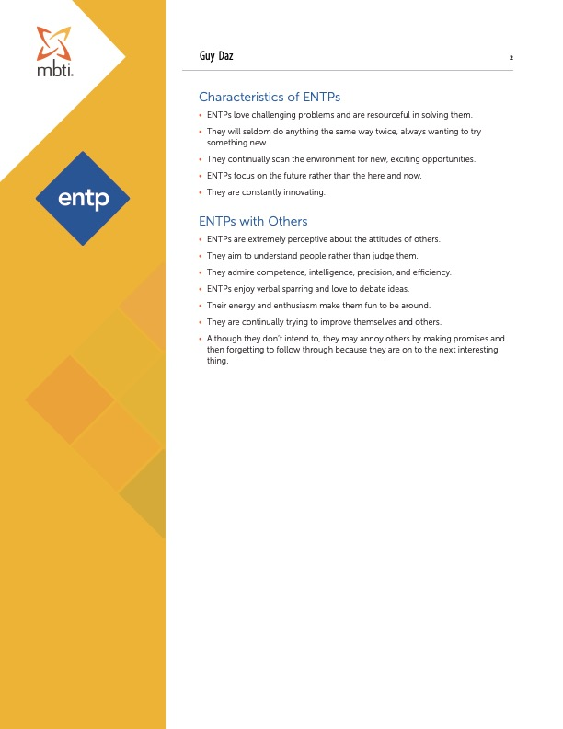
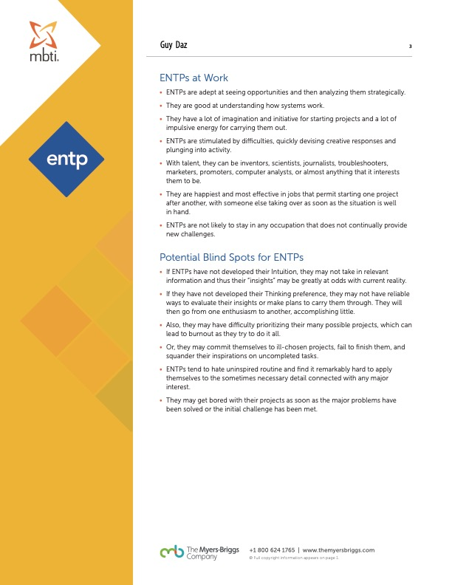

Appendix 5: SWOT Analysis

Strengths | Proven leadership skills and experience in security risk and crisis management.  Specialist in training and mentoring personnel in hostile environments.  Proficient in surveillance and target acquisition. | Weaknesses | Advanced language skills need improvement.  Cybersecurity training could be expanded.  Cultural sensitivity and understanding can be deepened.
Opportunities | Promotion to a regional role.  Return to working as a consultant.  Create your own crisis response company. | Threats | The rapidly changing nature of global security risks requires constant updating of skills and knowledge.  Technological advancements in the field of security may require constant learning and adaptation.  The multilingual nature of the job requires maintaining language skills, which can be challenging.

Appendix 6: Personal Development Plan

Goal Setting
- Short-term goal: Complete advanced cybersecurity training by July 2024.
- Long-term goal: Earn a PhD or a specialized postgraduate degree in a relevant field by 2030.

Self-Assessment
- Strengths: Leadership, Security Risk Management, Specialist Training and Mentoring.
- Weaknesses: Advanced Language Skills, Advanced Cybersecurity Training, Cultural Sensitivity.
- Skills: Surveillance and Target Acquisition, Risk Assessment and Execution, and Security Compliance Management.
- Areas for improvement: • Advanced Higher Education, Modern Surveillance Technology, and Action Planning.
- Enroll in advanced language courses and professional cybersecurity training by February 2024.
- Attend cultural sensitivity workshops and pursue a certification in crisis management by June 2024.
- Stay updated with surveillance technology and apply for higher education in a relevant field by December 2024.

Continuous Learning
- Opportunities for growth: Advancing language skills, mastering cybersecurity, and understanding cultural norms and sensitivities in various regions.
- Commitment to continuous learning: Regularly attend workshops, seminars, and training sessions related to my field.

Accountability
- How will you hold yourself accountable? By setting clear, measurable goals and regularly reviewing my progress toward achieving them.

Monitoring and Review
- How often will you assess your progress? Every month.
- How will you adjust your plan if necessary? By reassessing my goals and strategies based on the progress made and the challenges encountered.
- How will you celebrate achievements? By rewarding myself with short breaks or small treats.

Support System
- Mentors, coaches, or peers who can provide guidance and encouragement: Colleagues in the security field, professional mentors, and academic advisors.

SMART Objectives

Advanced Higher Education
- Specific: Enroll in a PhD or a specialized postgraduate degree in a relevant field.
- Measurable: Receive an acceptance letter from a university.
- Achievable: Research relevant programs, prepare application materials, and apply to multiple universities.
- Relevant: Higher education in a relevant field will provide theoretical understanding and exposure to the latest research and developments.
- Time-bound: Aim to start the program within the next 2 years.

Advanced Language Skills
- Specific: Achieve intermediate proficiency in Japanese and Arabic.
- Measurable: Pass an intermediate-level language proficiency test in both languages.
- Achievable: Enroll in an advanced language course and practice daily.
- Relevant: Enhancing language skills will improve communication with international clients and teams.
- Time-bound: Aim to achieve this goal within the next 12 months.

Advanced Cybersecurity Training
- Specific: Obtain a professional certification in cybersecurity.
- Measurable: Successfully pass the certification exam.
- Achievable: Enroll in a cybersecurity course and dedicate weekly study hours to prepare for the exam.
- Relevant: Cybersecurity is a critical aspect of security risk management, and advanced skills in this area will enhance job performance.
- Time-bound: Aim to obtain the certification within the next 6 months.

Cultural Sensitivity Training
- Specific: Complete a cultural sensitivity training course.
- Measurable: Receive a certificate of completion for the course.
- Achievable: Register for a course and participate actively in all sessions.
- Relevant: Understanding cultural norms and sensitivities is crucial when operating in various global regions.
- Time-bound: Complete the course within the next 2 months.

Modern Surveillance Technology
- Specific: Stay updated with the latest tools and techniques in surveillance technology.
- Measurable: Attend at least three workshops or training sessions on modern surveillance technology.
- Achievable: Regularly check for relevant workshops and training sessions and register for them.
- Relevant: Staying updated with the latest tools and techniques can enhance efficiency and effectiveness in surveillance.
- Time-bound: Attend the workshops or training sessions within the next 6 months.

Appendix 7: References
- Boud, J., Keogh, R., & Walker, D. (1985). Promoting reflection in learning: A model. In D. Boud, R. Keogh, & D. Walker (Eds.), Reflection: Turning Experience into Learning (pp. 18-40). Routledge.
- Brookfield, S. (1995). Becoming a critically reflective teacher. Jossey-Bass.
- Cambridge Dictionary. (n.d.). Evacuation. Retrieved from link
- Gibbs, G. (1988). Learning by doing: A guide to teaching and learning methods. Further Education Unit.
- International Committee of the Red Cross. (2017). Guidelines on the Protection of War Victims. Retrieved from https://www.icrc.org/en/publication/0873-guidelines-protection-war-victims.
- Johns, C. (2000). Becoming a Reflective Practitioner. Blackwell Publishing.
- "MBTI Online - Myers-Briggs Type Indicator". [Online]. Available: https://explore.mbtionline.com/.
- RMIT University. (n.d.). Writing an Academic Reflection. [Online]. Available: https://emedia.rmit.edu.au/learninglab/content/writing-academic-reflection
- United Nations Office for the Coordination of Humanitarian Affairs. (2019). Evacuation Guidelines. Retrieved from https://www.unocha.org/sites/unocha/files/Evacuation Guidelines 2019. pdf.

