Research Proposal
Title:
The Ethical and Legal Challenges of AI-Powered Cyber Threat Detection
Student Name: Colin Bonehill
Student ID: 2132686
Module: Research Methods and Professional Development
Module Code: ACFA7004
Programme: MSc Computing Portfolio
Pathway: Data and Artificial Intelligence (Cybersecurity)

1. Introduction
Artificial intelligence (AI) has become a game changer in the field of cybersecurity, and it is a vital element that changes the way cyber threats are identified, analysed and reduced [1]. Although traditional security tools remain crucial, they are becoming less effective when it comes to the complexity, magnitude, and pace of an attack nowadays. However, AI-driven systems, such as machine learning-based intrusion detection systems (IDS), automated threat intelligence systems, and malware classification deep learning models, allow real-time processing of large data volumes, identification of suspicious patterns, and responsive attitude to changing attack patterns. Such functions make AI a foundation of modern cyber defence designs in the government and in the business context. Not only attack surfaces have increased with the spread of big data and cloud computing, and with the Internet of Things, but also unprecedented opportunities have arisen in automated defensive measures [2]. AIs have become increasingly popular with security operations centres, used to screen alerts or prioritize incident types and suggest actions. Advocacy in the technological domain, e.g., graph neural networks, generative AI, and large language models, further increase defensive potential, enable predictive threat hunting and adaptive incident response.
With all those technological advancements, the application of AI in cybersecurity raises the most serious ethical and legal concerns. AI systems are often modelled as black boxes and they make high-accurate predictions without much understanding of decision-making mechanisms. This level of opaqueness begs serious concerns of accountability, fairness and trust that may arise especially when AI systems produce false positives or are unable to recognize advanced attacks. In addition, the AI training data are frequently sensitive or personal, which may violate the privacy and compliance with the law (like the General Data Protection Regulation (GDPR)).
The recent events point at the necessity to find a balance between AI-driven cyber defence innovation and responsible governance. Regulation, such as in the form of AI Act of the European Union, seeks to make the high-risk AI systems, including cybersecurity ones, transparent, explainable, and consistent with the human rights principles. Ethics codes devised by other organisations like IEEE and the OECD focus on fairness, accountability, and reduction of bias. However, in execution of cybersecurity activities, there is still no consistent production of these principles. The study is thus aimed at examining the meeting point between AI technology, ethics, and law to facilitate the management of AI responsible adoption in the domain of cyber threat detection [3].

  - Context and Background
Artificial intelligence has turned into a vital aspect in the contemporary cybersecurity frameworks in response to the complexity and bulk of cyber threats in the digital ecosystems around the world [4]. The history of AI involvement in cybersecurity started with first expert systems and developed advanced machine learning and deep learning applications, which can analyse billions of data points in real time [5]. Big data analytics, cloud computing, and Internet of Things (IoT) converging have only increased the magnitude of cyber risks and the necessity of intelligent and automated defence mechanisms.
The current threat environment has seen AI assist in intrusion detection, phishing, malware, and behavioural analytics to enable security operations centers to recognize abnormalities more money and more accurately. Nevertheless, such developments are accompanied by a greater ethical and legal oversight. The frequent use of AI systems in data collection may infringe on privacy and create bias and complicate the process of regulatory compliance. Legislations like the GDPR as well as newly developed AI-specific laws like the EU AI Act indicate the increase in focus on the ethical regulation and responsibility in AI usage.
As a result, the interaction point of AI innovation and governance is currently a point of research and practice focus [6]. With organisations relying more on AI to provide real-time cyber defence, it is now important to know how such technologies can be deployed in a manner that does not interfere with privacy, fairness, and legal limitations. This background underlines the importance of examining ethical and legal aspects of AI-enabled cybersecurity, and this is what the present study is grounded on.
1.2 Research Problem
Although AI-based cybersecurity mechanisms present the most prospects of high efficiency, flexibility, and active threat-solving opportunities, their ethical and legal impacts are not thoroughly investigated and formalized. The key issue behind this difficulty is that there is no detailed regulatory and moral framework that could help in guiding organizations on the ethical and legal aspects of deploying AI-driven threat detection systems [7]. Such systems are commonly based on massive data gathering, plus ongoing tracking of network action to identify an irregularity or malicious acts. Although such practices may prove beneficial in a technical sense, they may disturb the individual rights to privacy, data-protection laws, or even push the legally definite data-processing limits, especially when it comes to sensitive personal or corporate data. Additionally, historical data might cause biasness in AI models, leading to the unequal alerting or targeting of certain group of user demographics, roles, or segments of the network, which can further strengthen inequities in the organization and undermine the integrity of security-related activities.
Another important issue is accountability. AI systems which automatically block network traffic, raise warning signs, or take defensive measures put complex scenarios into place where assigning blame to false positives, system failures, or breaches are legally Gray. This uncertainty is enhanced by the fact that deep learning models are inherently opaque, and decision-making processes are difficult to track and have proper explanations to regulators or other stakeholders or impacted individuals [8]. These opaque systems make it more challenging to adhere to basic principles of data-protection, e.g., purpose limitation, minimization of data, and the right to be informed, increasing the ethical as well as legal concerns surrounding the implementation of autonomous cybersecurity AI.
As it is noted in the existing literature, technical performance of AI in detecting threats has improved greatly, yet ethical and legal guidelines have been underdeveloped. The majority of the researches focus on the metrics of accuracy of detection, latency decrease or minimization of false-positive, and little efforts to human oversight, regulatory adherence and ethical data management. This oversight has practical implications: not solving these ethical and legal aspects will undermine confidence in artificial intelligence-based cybersecurity and subject organizations to regulatory fines and bring operational ambiguities to highly valued digital scenes.
This study will, therefore, provide a systematic understanding of ethical and legal dilemmas of AI-driven cybersecurity by finding loopholes in the current governance systems and suggesting a systematic and evidence-based strategy to use AI responsibly. Incorporating the factors of fairness, transparency, accountability, and legal compliance, the study is aimed at ensuring that AI-improved cybersecurity mechanisms are technologically sound and ethically and legally justifiable, which will eventually contribute to the sustainable confidence in digital security infrastructures.
  - Research Aim and Objectives
The main goal of the paper is to critically explore the ethical and legal issues related to the use of AI-based cyber threat detection systems and to propose a viable framework that will guarantee responsible, transparent, and legally valid implementation. Although AI has multiple beneficial outcomes in improving the speed, accuracy, and flexibility of cybersecurity practices, its adoption creates complicated ethical issues and regulatory challenges that are yet to be sufficiently resolved [9]. The points to be examined in this research will be the problem of algorithmic bias, the absence of transparency, the autonomy of decisions, and responsibility in cases when AI systems produce false positives or cannot detect threats or violate the rules of privacy and data protection. The congruence of the existing AI practices and the existing legal frameworks, such as General Data Protection Regulation (GDPR) and the new AI-specific laws will also be studied. Through ethical analysis, legal overview, and technological analysis, the research will offer practical advice, which will create trust, adherence, and the responsible use of AI in the organizational cybersecurity systems.
The research questions are to:
1. Analyse AI applications in cyber threat detection status quo.
2. Represent and assess the main ethical issues, such as fairness, transparency, and accountability.
3. Examines the legal and regulatory frameworks of AI in the area of cybersecurity, such as GDPR, and emerging laws on AI.
4. Evaluate discrepancy and incompatibility between existing AI practices and ethical and legal standards.
5. Introduce an idea of a framework or principles of responsible and legal AI use in the cybersecurity case.

1.4 Significance of the Research
The growing use of artificial intelligence in cybersecurity shows that there is an urgent necessity to clarify ethical and legal standards [10]. Academically, the study adds to the interdisciplinary perspective on the ethics of AI, cybersecurity governance, and technology law and incorporates the formerly divided discussions into a structured and practical framework. In practice, it will guide developers, cybersecurity experts, as well as policymakers with evidence-based policies on how AI systems can be designed and implemented so that they are technically efficient and, more importantly, trustworthy, accountable and in full compliance with the applicable legal requirements. The study advances digital rights, transparency, and sound security measures in the society as well as enforcing the use of AI within the well-defined ethical and legal boundaries. The systematic approach to the intersection of technology, ethics and law allows filling the gap between the fast development of technologies and the accountable regulation, assisting in organisations decision-making, regulatory adherence, and sustainable AI introduction into cybersecurity settings.
Figure 1Intersection of AI Technology, Ethics, and Legal Frameworks in Cybersecurity

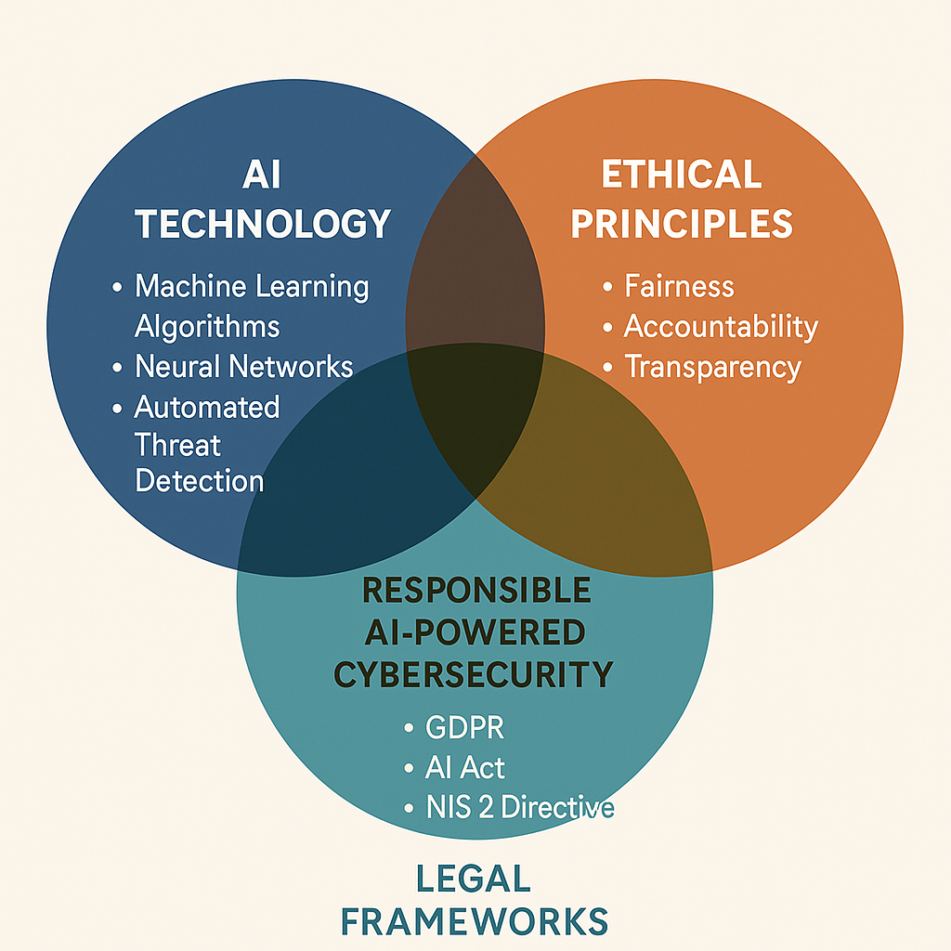

2. Literature Review
Artificial intelligence has completely redefined the world of cyber threat detection, with the capabilities it provides being much, much faster, adaptable and scalable than traditional ones. Neural networks, support vector machine and decision trees are supervised learning models that are very effective in the identification of recognisable attack patterns, which allows quick recognition and reaction to familiar attacks. Unsupervised learning methods, conversely, aim at identifying anomalies in network traffic, which helps to identify zero-day exploits and attacks that are not yet classified [11]. Complex hybrid systems, combining several machine learning methods, have shown significant further detection precision, and lowering false positives at the same time, which is a long-standing challenge related to cybersecurity operation. Reinforcement learning also extends AI to allow systems to suggest and implement threat mitigation measures autonomously or semi-autonomously and adapt to the changing conditions of a network. Though these technological developments are associated with highly advantageous implications, the growing dependence on artificial intelligence-based decision-making presents a massive ethical, legal, and governance dilemma, especially when organisations get over-dependent on AI to the detriment of human control.
AI-based cybersecurity ethical aspects are complex and essential in the professional implementation of the technologies. Discrimination, explainability, responsibility and presence of human supervision are still pertinent ethical issues [12]. The biased, incomplete, or unrepresentative nature of the datasets used to train AI models can lead to discriminatory behaviour and therefore disproportionately targeting some groups of users or network behaviours, which can put organisations both ethically and reputational at risk. Also, due to the opaque and black box characteristics of many of the AI models, there is less transparency, which lacks stakeholder trust and turns the process of making security decisions difficult to explain to the regulators, customers, or internal auditors. The issue of accountability is especially complicated when AI systems are run autonomously; mistakes, false positives or malfunctions of the system may make it unclear who is to be held responsible, whether it is the developer, the system operator or the organisation. The ethical implementation of human-in-the-loop mechanisms, then, is a deliberate implementation of how automation is used so that it is an addition, not a replacement, of human judgement, and moreover in high-stakes decision-making paradigms where judgement errors may have serious consequences.
The AI-based cybersecurity systems exist in a highly complicated regulatory landscape in the legal sphere. The General Data Protection Regulation (GDPR) [13] has become very strict on the legality of collecting, processing, and storing personal data, including its principles like minimisation of data, limitation of its purpose, and entitlement to explanation of automated decision making. The suggested European Union AI Act further categorizes cybersecurity systems as high-risk, which means that they require transparency, detailed documentation, and constant human control. With these frameworks, the distribution of liability is quite unpredictable often shared between developers, operators and organisations, which presents a lot of ambiguity in operations. Globally, there are inconsistent legal frameworks and different regulatory strategies that amplify the burden of compliance and thus multinational organisations find it hard to make sure that AI cybersecurity systems address all the relevant ethical and legal requirements.
Recent studies in AI cybersecurity have taken technical performance indicators, like accuracy of detection, response time and false-positive, with little empirical consideration of ethical, legal, and governance aspects. There are limited studies in the real world in terms of human control, organisational risk control, and compliance with regulations. Moreover, the high pace of development of autonomous AI systems poses new risks - i.e. automated offensive actions or unexpected system behaviours - which are not yet reflected in the current legislation. With the aim of filling these gaps, the present paper attempts to integrate the technical, ethical, and legal approaches into a unified system of governance. The combination of these dimensions will help the research to inform organisations on how to deploy AI in cybersecurity in a way that is both operationally sound and capable of being ethically and legally justified. Finally, the research will help fill the gap between the rapid technological development and the responsible governance and ensure the sustainable and credible integration of the AI into the multifaceted cybersecurity context and facilitate the transparency, responsibility, and trust of society.
Figure 2 Ethical and Legal Challenges of AI in Cybersecurity
Ethical Issues | Legal Frameworks
Bias | GDPR
Accountability | EU AI ACT
Transparency | NIS 2
Privacy | OECD

3. Research Design and Methodology
The research design used in this study is qualitative and theoretical research design which focuses on the governance and ethical-legal analysis as opposed to technical implementation [14]. The major goal is to develop a conceptual framework that would combine ethical, legal, and technological aspects to inform the responsible usage of artificial intelligence (AI) in cybersecurity. The qualitative method is suitable since the investigation is concerned with interpreting regulatory, ethical and theoretical aspects but not measuring the technical performance. Such an interpretivist orientation endorses an in-depth comprehension of how normative principles and governance systems can influence reliable AI implementation.

3.1 Research Design
The study is based on the principles of Design Science Research (DSR), which is appropriate in research that develops and improves conceptual artefacts like framework or models. DSR offers an iterative method with a high level of structure connecting theory and practice. In this work, DSR will help to develop an ethical-legal system of governance of AI-based cybersecurity systems [15].
It includes three stages interrelated to each other:
1. Problem identification and situational analysis - generalising the knowledge of literature, policies and legislation to reveal ethical and legal lapses in the current practices of AI cybersecurity.
2. Framework development Design of a starting model based on the standards, e.g. the IEEE 7000, the OECD AI Principles, and regulatory frameworks, e.g. the GDPR, the EU AI Act, and the NIS2 Directive.
3. Review and improvement- checking and updating the model using comparative analysis and example. research to ascertain concept validity and relevance.
This design helps the study to fill the gap between the ethical theory and operational compliance, which generates a framework that can support the responsible AI adoption in the cyber-defence context.
3.2 Research Methods
The analytical process is supported by a qualitative content analysis, which will allow developing a systematic interpretation of textual information in various sources. The code of conduct is presented in terms of fairness, transparency, accountability, privacy, and compliance, which offer the themes of the analysis structure.
To study the data, document analysis will be used in relation to three primary categories of data:
- Articles, following the development of AI-based cybersecurity and its ethical-legal criticism [16].
- The ethical standards, such as IEEE 7000, OECD AI Principles, and the AI Ethics Recommendation published by UNESCO.
- Legal instruments, in particular, GDPR, EU AI Act, NIS2 Directive, the transparency and accountability of AI and the risk classification instruments.
The real-world ethical or legal issues such as bias in anomaly-detection algorithms or opaque automated decision-making will be demonstrated with the help of case studies of AI-enabled cybersecurity systems. These will aid in proving the relevance of the framework and bring out contextual challenges.

3.3 Data Collection and Analysis Tools
The sources that will be used to extract data include peer-reviewed journals, international policy documents, government publications and legal databases which are all publicly available. Qualitative data will be themed by the use of NVivo or manual coding. The hybrid deductive-inductive coding approach will permit pre-determined categories of ethics-legal issues to exist with the emergent knowledge. Excel will be used to visualize the relationships between ethical principles, regulatory obligations and the governance outcomes by using matrix comparisons.
The result of the analysis will be a unified ethical-legal governance system that simulates how AI-decision making, accountability systems, and compliance will interact in cybersecurity settings [17]
Summary
This methodology will be effective in helping to explore and investigate the ways in which ethical and legal principles can be integrated into AI-assisted cybersecurity by integrating the Design Science Research with qualitative content analysis. The resulting theoretical framework will be both academically sound and practically effective and in line with the general objective of facilitating responsible, transparent, and legally acceptable AI governance.
Figure 3 Research Methodology Flowchart

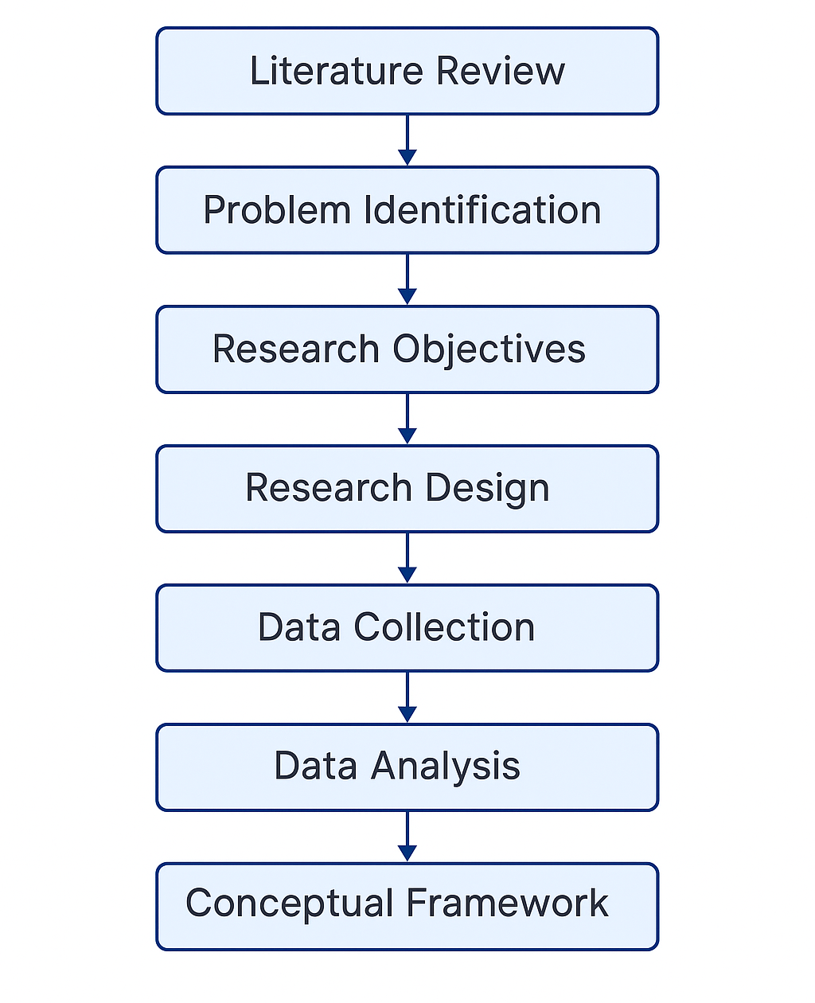

4.Expected Outcomes
The study will yield an in-depth perspective on ethical issues and legal implications of the implementation of AI-enhanced cyber threat detection tools and will develop a conceptual framework that will support the responsible and clear use of such technologies in compliance with the law. Through a critical analysis of the intersection of the principles of fairness, accountability, transparency, and privacy within the AI-based cybersecurity contexts, the study is expected to contribute to the theoretical and practical understanding to the new domain of AI governance.
The overall result will be the formulation of a unified ethical-legal governance system [18]. Such an outline will combine informational resources in the academic literature, ethical principles (IEEE 7000 and OECD AI Principles), and legal documents (GDPR, EU AI Act, and NIS2 Directive). It will systematize the relationships between technical operations of AI systems, including data processing, finding anomalies, and automated decision-making, and normative governance concerns, including human control, fairness, and explainability. The framework will therefore be used as a systematic reference model of organizations that desire to implement AI systems in cybersecurity environments without violating the ethical requirements as well as the law.
The study is also expected to produce evidence-based suggestions to the main stakeholders. To policymakers and regulators, the findings will be important in offering critical information on how current laws and standards can be harmonised to deal with the dynamic risks posed by autonomous cybersecurity systems. To developers and data scientists, the framework will bring out the practical design-consideration, including the integration of explainable AI (XAI) methods, bias reduction approaches, and privacy data-handling approaches. To managers and decision-makers in the field of cybersecurity, the study will provide operational guidelines on efficiency and compliance in ensuring that automation enhances, and not diminishes organisational accountability and user trust.
The theoretical contribution of this study to the field of academia is that it interdisciplinarily synthesized the fields of ethical philosophy, legal doctrine and information systems governance. It expands upon existing literature by going beyond the prevailing consideration of the technical performance measures, e.g., the accuracy or the speed of detection, to consider the normative and legal aspects that form the basis of reliable AI. Moreover, it shows how the principles of Design Science Research (DSR) may be put into practice to create governance artefacts, which can be used to transform abstract ethical and legal demands into concrete practice models.
The expected practical implication of the research is also important. The research can enhance accountability and transparency in AI-aided security activities by offering a conceptual framework, which organizations can alter to suit their organizational environments. This, in its turn, will foster the confidence of the stakeholders, minimize reputational risks, and assist sustainable compliance in the ever more tightly regulated technological environment.
A number of limitations are however noted in the study. The use of secondary data implies that the results are limited with regards to the depth and quality of literature available and publicly accessible case studies. These limitations to the validity of the proposed framework in terms of generalisability to other organisational or technological contexts have been indicated by a lack of empirical validation (e.g., interviews or in-depth analysis of the live system). Moreover, the problem of jurisdictional differences in data protection and AI legal application can also pose an extra difficulty; rules that have been developed at the EU level, e.g., might not be readily applied to other jurisdictions.
To overcome these shortcomings, the study will guarantee thorough triangulation of several data sources and promote the subsequent empirical investigations to verify and correct the suggested framework under the operational environments. In the end, it is hoped that the desired result is a strong, interdisciplinary model that does not only enhance academic knowledge about AI ethics and cybersecurity law but also offers practical opportunities to establish and implement AI systems that are both technically and ethically viable and legally acceptable.
Figure 4 Conceptual Framework Integrating Ethical and Legal Considerations into AI Cybersecurity Systems

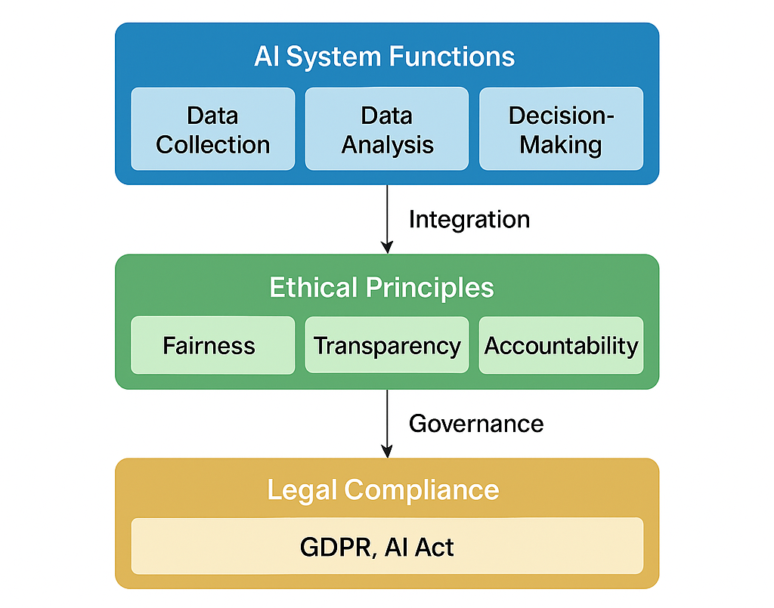

5. Timeline
It is suggested to have a five-month project plan where it will start in September and end in January [19]. In September, the literature review and clear definition of the gap in the research will be carried out. The gathering of the pertinent documents, coding of the themes and the advancement of the conceptual framework in a cyclical manner will take place in October and November. The month of December will be devoted to the work on the proposal, and the inclusion of the feedback of the supervisors. Lastly, January will be devoted to making the last revisions and submitting the work to be evaluated.
Figure 5 Gantt Chart Representing the Five-Month Project Timeline
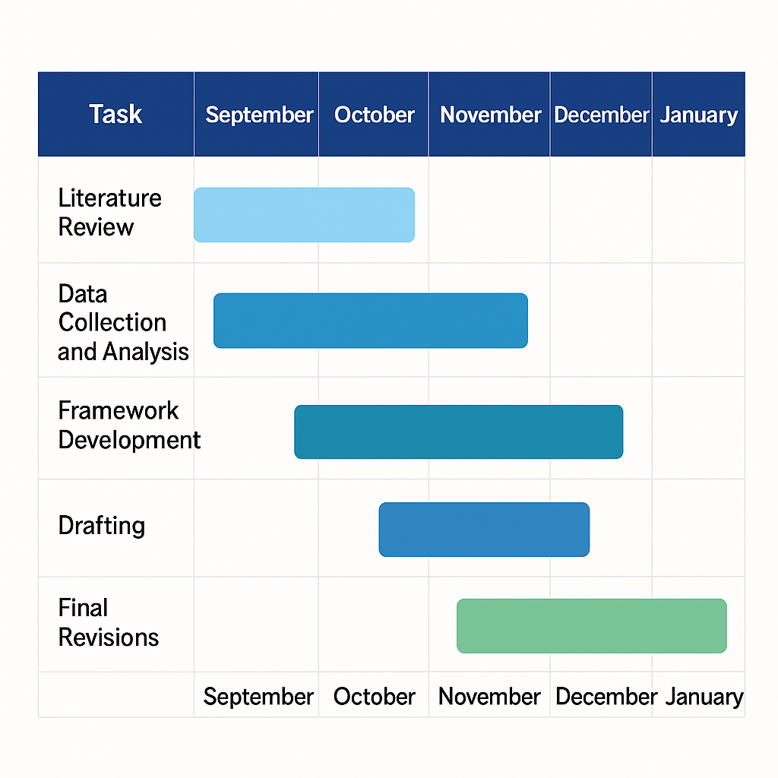

6. Conclusion
AI has now been an inseparable part of contemporary cybersecurity design, providing automation, flexibility, and analytics, which are much more effective than conventional defence systems. AI, which can be used to detect and predict risks, provide intelligent analytics and advanced models of machine learning to detect threats in real-time and provide automated responses, can enhance the speed and reliability of security operations. But as the technologies advanced and become more entrenched in organizational structures, they bring about a high level of ethical, legal, and governance issues that need to be looked at.
These concerns include privacy of data, accountability, transparency, and bias in algorithms and are central to these challenges [20]. The use of AI systems frequently is grounded in large amounts of data and self-directed decision-making, as a result of which they may violate the principle of data protection without intent or increase the existing differences. The fact that most AI algorithms are non-transparent, or opaque, or have what is known as the black box problem makes them less traceable, compromising trust and accountability. Also, new laws like the General Data Protection Regulation (GDPR) and the EU AI Act are establishing new principles of legal and ethical AI usage, especially in high-stakes application areas such as cybersecurity.
To address these emerging complexities, this study will seek to come up with a composite ethical-legal governance framework in AI-powered cyber threat detection systems. The framework will combine the knowledge of scholarly sources, ethical standards (including IEEE 7000 and OECD AI Principles), and the most important legal tools to encourage responsible innovation and adherence. It will offer a systematic framework in aligning AI-enabled cybersecurity practices with the ethic of fairness, transparency, accountability, and human oversight and hence moderating the speed of technological progress and responsible governance.
The contribution that is expected by the study is theoretical and practical. Ideally, it will aid academic knowledge on how the concept of ethical and legal enactment can be implemented in AI-based cybersecurity systems. In practice, it will provide decision-makers, developers, and policymakers with a starting point of introducing the effective, trustworthy and legally sound AI tools. This way it is filling a vital requirement of frameworks that will balance efficiency and innovation, with ethical integrity and respect of the society.
Finally, this study sees a scenario in which AI innovation is associated with ethics and legal accountability. By considering the principles of governance into creating and implementing AI systems, organisations can enhance the digital resilience and safeguard the basic rights and values. The paper therefore will help to shape a cybersecurity ecosystem in which technological innovation will benefit humanity safely, transparently and ethically.

References
[1] Jimmy, F., 2021. Emerging threats: The latest cybersecurity risks and the role of artificial intelligence in enhancing cybersecurity defenses. Valley International Journal Digital Library, 1, pp.564-74.
[2] Nag, A., Hassan, M.M., Das, A., Sinha, A., Chand, N., Kar, A., Sharma, V. and Alkhayyat, A., 2024. Exploring the applications and security threats of Internet of Thing in the cloud computing paradigm: A comprehensive study on the cloud of things. Transactions on Emerging Telecommunications Technologies, 35(4), p.e4897.
[3] Vashishth, T.K., Sharma, V., Samania, B., Sharma, R., Singh, S. and Jajoria, P., 2025. Ethical and legal implications of AI in cybersecurity. In Machine Intelligence Applications in Cyber-Risk Management (pp. 387-414). IGI Global Scientific Publishing.
[4] Jonas, D., Yusuf, N.A. and Zahra, A.R.A., 2023. Enhancing security frameworks with artificial intelligence in cybersecurity. International Transactions on Education Technology (ITEE), 2(1), pp.83-91.
[5] Ghillani, D., 2022. Deep learning and artificial intelligence framework to improve the cyber security. Authorea Preprints.
[6] Birkstedt, T., Minkkinen, M., Tandon, A. and Mäntymäki, M., 2023. AI governance: themes, knowledge gaps and future agendas. Internet Research, 33(7), pp.133-167.
[7] Lachova, M., 2024. Data, Privacy and Human-Centered AI in Defense and Security Systems: Legal and Ethical Considerations. Information & Security, 55(2), pp.213-221.
[8] Taherdoost, H., 2023. Deep learning and neural networks: Decision-making implications. Symmetry, 15(9), p.1723.
[9] Ejjami, R., 2024. Enhancing Cybersecurity through Artificial Intelligence: Techniques, Applications, and Future Perspectives. Journal of Next-Generation Research 5.0.
[10] González, A.L., Moreno, M., Román, A.C.M., Fernández, Y.H. and Pérez, N.C., 2024. Ethics in artificial intelligence: An approach to cybersecurity. Inteligencia Artificial, 27(73), pp.38-54.
[11] Zoppi, T., Ceccarelli, A. and Bondavalli, A., 2021. Unsupervised algorithms to detect zero-day attacks: Strategy and application. Ieee Access, 9, pp.90603-90615.
[12] McDermid, J.A., Jia, Y., Porter, Z. and Habli, I., 2021. Artificial intelligence explainability: the technical and ethical dimensions. Philosophical Transactions of the Royal Society A, 379(2207), p.20200363.
[13] Hussein, R., Wurhofer, D., Strumegger, E.M., Stainer-Hochgatterer, A., Kulnik, S.T., Crutzen, R. and Niebauer, J., 2022. General data protection regulation (GDPR) toolkit for digital health. MEDINFO 2021: One World, One Health–Global Partnership for Digital Innovation, pp.222-226.
[14] Al Ismaili, K.R.A. and Al Athumani, J.H.S., 2024. Ethical Success Factors Affecting E-government Implementation. Journal of development perspectives, 1(1), pp.3079-1723.
[15] Ilari, L., 2025. Navigating Ethical Challenges in Cybersecurity: From Risk Assessment to Quantum-AI Applications.
[16] Vashishth, T.K., Sharma, V., Samania, B., Sharma, R., Singh, S. and Jajoria, P., 2025. Ethical and legal implications of AI in cybersecurity. In Machine Intelligence Applications in Cyber-Risk Management (pp. 387-414). IGI Global Scientific Publishing.
[17] Oluoha, O.M., Odeshina, A., Reis, O., Okpeke, F., Attipoe, V. and Orieno, O.H., 2022. Artificial Intelligence Integration in Regulatory Compliance: A Strategic Model for Cybersecurity Enhancement.
[18] Xue, L. and Pang, Z., 2022. Ethical governance of artificial intelligence: An integrated analytical framework. Journal of Digital Economy, 1(1), pp.44-52.
[19] Moore, M.T., Taylor, J.M. and Hoeksema, J., Effect of Partial, Post-Harvest Flooding of Cropland on Reduction of Contaminant Export in the Mississippi Delta. In ASA, CSSA, SSSA International Annual Meeting. ASA-CSSA-SSSA.
[20] Alabi, M., 2025. Ethical Challenges in AI: Addressing Bias, Privacy, and Accountability.

