

A report focussing on:

The management of Health, Safety and Welfare in Construction.

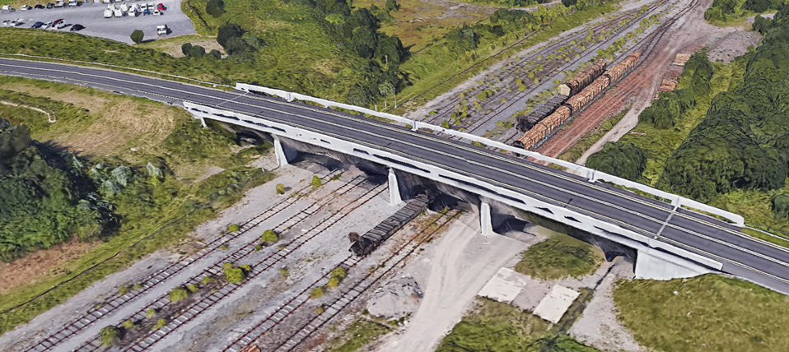

Prepared for:
D. Hughes

Created by:
R.J. Preece

Date completed:
May 3rd 2020
Table of Contents
Page Number
1.0 Executive Summary 3
2.0 Terms of reference 3
3.0 Procedure 3
4.0 Findings 4
5.0 Conclusion 13
6.0 References 14
7.0 Bibliography 15
8.0 Appendices 16

- Executive Summary
This report aims to examine how health, safety and welfare can be managed on a construction site. This report will focus on my scenario of a bridge being built to connect two industrial estates. All health and safety risks and control measures have been shown in general and about this scenario.

- Terms of Reference
  - The principal focus is:
    - Different ways in which health, safety and welfare are managed on a construction site.
    - To examine the different types of legislation relevant to the scenario I have chosen.

- Procedure
This section identifies the research sources used.
  - The research included secondary sources on the subject of health and safety from websites and textbooks set out in the references and bibliography.
  - University notes also provided background to the research.

- Findings
Construction Phase Plan

Your name/company – RJP Construction Ltd
Name and address of client – NPTCBC, Central Ave, Port Talbot

Contact details of architect or principal designer – Architect: Bob Jones, 07654787231
Bob_architect@outlook.com
What is the job? – Construction of a bridge to link two halves of an industrial estate.

Is there anything the client has made you aware of? – Construction of the bridge will take place over a small railway line.
Key dates: Start – 6th May 2020 Finish - Not stated Other -
Where are your toilet, washing and rest facilities? Sketch of the welfare facilities can be found in Appendix A.
Who else is on-site – and their contact details? Other people on site will be the employees. All contact details for the employees can be found in the office.
Who will be the principal contractor? The principal contractor will be appointed by the client. This person will manage health and safety risks of all contractors involved in the project.
How will you keep everyone on site updated during the job? – Team meetings will take place regularly to ensure everyone is completing the job they are supposed to be doing and to make important announcements.
What are the main dangers on-site and how they can be controlled:
- Falling from height (Fall of materials and fall of persons) – ensure workers have training in working at height and make sure a safe system of work has been implemented.
- Injury from incorrect manual handling – ensure mechanical aid is used when possible and make changes in the working area to reduce the distance travelled with the load.
- Injury from slips and trips – ensure suitable footwear is worn and ensure the workspace is kept clear when possible.
- The collapse of scaffold – ensure that Scaffold is erected, adapted and dismantled progressively.
- Noise and vibration – ensure PPE is always worn and make sure tools are mounted in ways to reduce the vibration level.
- Contact with contaminated risings or groundwater – ensure a foundation risk assessment has been done under Environment Agency guidelines.
- Contact with plant and machinery - ensure correct PPE is being worn to reduce the risk of injury and ensure safe working practices are being applied.

Method Statement

Project: Construction of a bridge
Site Address: Central Ave, Port Talbot

Start of works: 6th May 2020
End of works: Not stated
Location
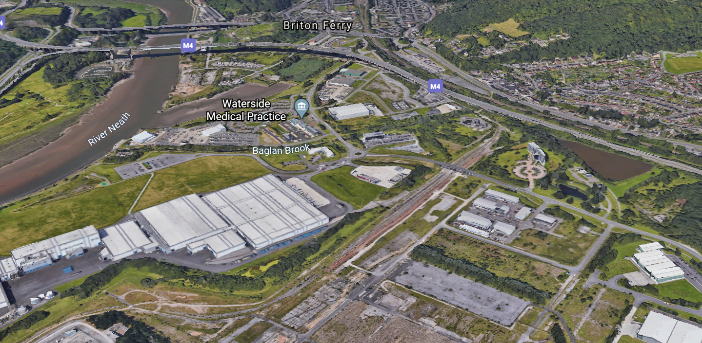
Figure 2
Our site can be found at Central Ave, Port Talbot and indicated in the red circle above.
Description of activity
Building a bridge to link two halves of an industrial estate.
Involves:
- Building a bridge over a small railway line.
- Installing piled foundations, reinforced concrete piers and install a deck that is manufactured off-site.

Start of Works
All employees will attend the RJP construction Ltd site induction before any work starts. Workers must sign in and will be given daily outlining’s of safe working systems. All workers must inspect their equipment daily to ensure no maintenance is needed. If maintenance is needed, then consult with the site supervisor.
Step by step procedure of works
- Start of works. The site foreman will ensure the site is safe to commence work.
- Employees and contractors will put on personal protective equipment.
- Groundworks will begin. Excavations will take place ready for the pile foundations.
- Piles will be implemented and capped off.
- Scaffolding to be put up to start work on the piers.
- Work on piers commences.
- Once piers have been constructed, the deck of the bridge can be installed.
- The deck will be brought in off-site and put down using a crane.
- Workers will install the deck to the piers while on the scaffolding.
- Check for quality of finishes and test the bridge.

Main construction activities
- Earthworks will be required for piled foundations to be implemented – There are health hazards such as contact with contaminated risings or groundwater and contact with hazardous materials or dust, noise and vibration. There is also a possibility of contact with plant or machinery during lifting, slewing and pitching of piling elements.
- Reinforced concrete piers will then be implemented. Scaffolding will be placed up meaning employees will be working at height during these works.
- The last stage is the installation of the deck. This is a heavy object and will require mechanical assistance to lift it on to the piers. There is a risk of the deck falling so control measures must be put in place to prevent this from happening. Employees will also be working at height. A crane will be in use and other heavy machinery will be used to install the deck.
- Construction of a bridge is a dangerous job, so control measures must always be followed. General control measures can be found in the method statement and specific control measures for each job can be found in the risk assessment.

The main hazards to your safety and health
- Falling from height (Fall of materials and fall of persons).
- Injury from incorrect manual handling.
- Injury from slips and trips.
- The collapse of the scaffold.
- Noise and vibration.
- Contact with contaminated risings or groundwater.
- Contact with plant and machinery.

Preventative measures you must take
- You must be a “competent” worker to carry out the task.
- Follow safety signs and procedures.
- Never work in unsafe areas.
- Report defects and near misses.
- You must ensure that you have had relevant training before carrying out the task.
- Barriers must be erected at entrances and around the work area if it is deemed necessary by the foreman or safety officer.
- You must follow manual handling regulations and ensure not to lift beyond your capabilities.
- Visitors and other members of staff must be accompanied by a competent person, all visitors must be issued with personal protective equipment.

Legislation
Below is a list of the main pieces of legislation that must be followed on this job. All pieces of legislation were taken from the HSE site.
- Health and Safety at Work Act 1974
- The Management of Health and Safety at Work Regulations 2006
- Workplace (Health, Safety and Welfare) Regulations 1992
- Provision and Use of Work Equipment Regulations (PUWER) 1998
- The Work at Height Regulations 2005
- The Personal Protective Equipment at Work Regulations 2002
- The Manual Handling Operations Regulations 1992
- The Construction (Design and Management) Regulations 2015
- Electricity at Work Regulations 1989
- Pressure Equipment Regulations 1999 (SI 1999/2001)

PPE Requirements
- Hard hats
- Safety glasses
- Hi-vis vest
- Safety gloves
- Safety boots

Training

All employees must ensure that they have been trained in the areas that they will be working in. Workers must hold the following training certificates:
- Working at heights training
- SG6 manual handling for scaffolders.
- Suitable training for using a pile driver.
- If training is not required, then a supervisor must ensure to explain how to do the job correctly and safely.

Welfare
All welfare arrangements must be supplied by the client or the principal contractor. These arrangements must follow the Construction Design & Management Regulations 2015 (CDM). A sketch of the welfare facilities can be found under Appendix A. All projects being carried out must have the minimum amount of welfare facilities for workers, which include:
- Changing rooms and locker
- Heating
- Toilets
- Washing facilities
- Drinking water
- Rest facilities

First Aid
Employers must ensure that adequate first aid provisions are in place for staff. This means that a trained first aider and suitable first aid equipment must be on site. A trained first aider is someone who has attended an HSE approved course and has re-trained at least every three years.
Emergency Procedures
The client or principal contractor must ensure that the existing site emergency procedures are followed, and relevant information is given to workers at the time of induction or when changes have been made. The closest hospital from the site is Neath Port Talbot Hospital, Baglan Way, Port Talbot SA12 7BX, United Kingdom. Red circle = Site. Yellow circle = Hospital.
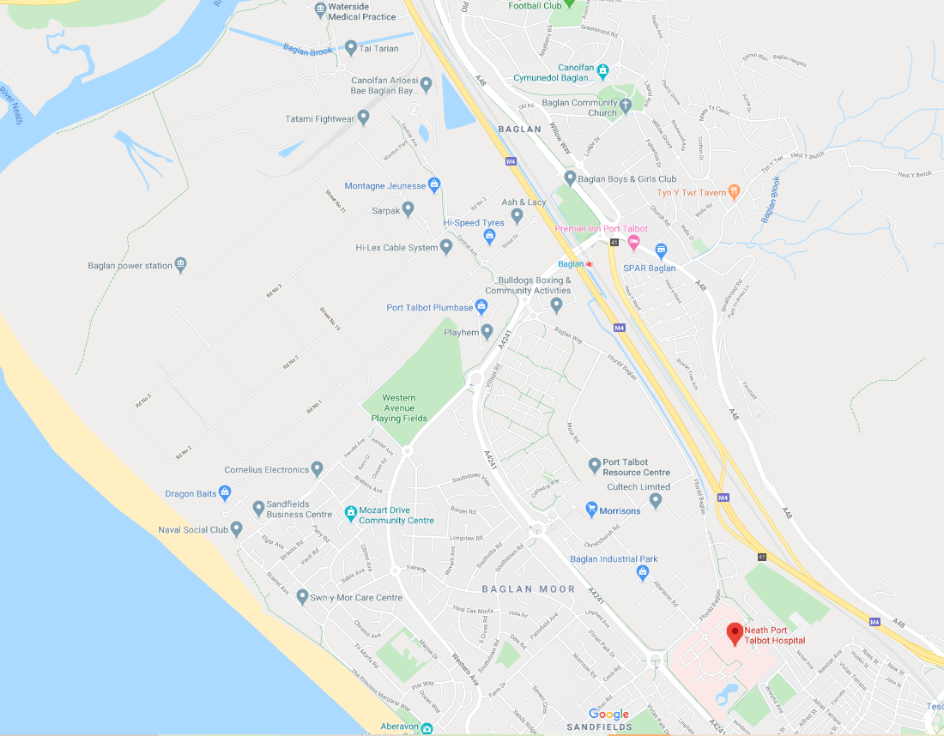
Figure 3
Risk Assessments
Activity to be Assessed |  |  |  |  |  |  |  |  |  |  |  | Assessment Number
Installing piled foundations
Persons undertaking or affected by the activity
 |  |  | Employees |  | Contractor |  |  | Public |  |  | Service User
 |  |  | Other …………………………………………………………………………………………….
Identified Hazards and Associated Risks |  |  |  |  |  |  |  |  | Likelihood |  |  | Severity |  | Risk Level
1 | Collapse of excavations |  |  |  |  |  |  |  | 3 |  |  | 5 |  | 15
2 | Underground services |  |  |  |  |  |  |  | 2 |  |  | 4 |  | 8
3 | Contact with contaminated risings or groundwater |  |  |  |  |  |  |  | 3 |  |  | 4 |  | 12
4 | Noise and vibration |  |  |  |  |  |  |  | 5 |  |  | 3 |  | 15
5 | Contact with plant or machinery during lifting |  |  |  |  |  |  |  | 5 |  |  | 5 |  | 25
6 | Working adjacent to major highways or railways |  |  |  |  |  |  |  | 5 |  |  | 3 |  | 15
Existing Control Measures / Additional Control Measures Required
1 | - Ensure correct wall props have been put in place.  - Check wall props regularly to ensure they are not failing.
2 | - Enquiries must be made to utility companies to establish the presence of services.  - Ensure that there is a permit to dig/work systems.
3 | - Ensure a foundation risk assessment has been done under Environment Agency guidelines.  - Consider increasing pile size of the number of piles to allow piles to stop above the water table.
4 | - When piles are being placed, absorbent materials must be used on the machine to reduce workers’ noise exposure.  - Ensure machinery and equipment are maintained and lubricated to reduce noise and vibration.
5 | - If workers are not using machinery, then they should be a safe distance away from them.  - PPE must always be worn to protect yourself from machinery when lifting processes are taking place.
6 | - Implement appropriate method statements and lifting plans.  - An agreement must be made for working clearances with the relevant authority
Reassessment of Activity Hazards |  |  |  |  |  |  |  |  | Likelihood |  |  | Severity |  | Risk Level
1 | Collapse of excavations |  |  |  |  |  |  |  | 2 |  |  | 5 |  | 10
2 | Underground services |  |  |  |  |  |  |  | 1 |  |  | 4 |  | 4
3 | Contact with contaminated risings or groundwater |  |  |  |  |  |  |  | 2 |  |  | 4 |  | 8
4 | Noise and vibration |  |  |  |  |  |  |  | 3 |  |  | 3 |  | 9
5 | Contact with plant or machinery during lifting |  |  |  |  |  |  |  | 3 |  |  | 5 |  | 15
6 | Working adjacent to major highways or railways |  |  |  |  |  |  |  | 3 |  |  | 3 |  | 9
Name: Rhydian Preece  Position: Site supervisor |  |  |  |  |  | Signed:  R.J.Preece |  |  |  |  |  | Date of Completion:  03/04/2020

Federation of Piling Specialists (2010) provided me with information on piling hazards and control measures.
Activity to be Assessed |  |  |  |  |  |  |  |  |  |  |  | Assessment Number
Erection and dismantling of scaffolding for piers.
Persons undertaking or affected by the activity
 |  |  | Employees |  | Contractor |  |  | Public |  |  | Service User
 |  |  | Other …………………………………………………………………………………………….
Identified Hazards and Associated Risks |  |  |  |  |  |  |  |  | Likelihood |  |  | Severity |  | Risk Level
1 | Manual handling (Unloading, loading of materials) |  |  |  |  |  |  |  | 4 |  |  | 4 |  | 16
2 | Slips, trips and falls |  |  |  |  |  |  |  | 5 |  |  | 3 |  | 15
3 | Working at height (Fall of materials) |  |  |  |  |  |  |  | 5 |  |  | 5 |  | 25
4 | Working at height (Fall of persons) |  |  |  |  |  |  |  | 5 |  |  | 5 |  | 25
5 | Collapse of scaffold |  |  |  |  |  |  |  | 3 |  |  | 5 |  | 15
6 | Access to scaffold |  |  |  |  |  |  |  | 3 |  |  | 5 |  | 15
Existing Control Measures / Additional Control Measures Required
1 | - All employees must have attended SG6 manual handling for scaffolders.  - When handling materials, good manual handling techniques must be utilised.
2 | - Ensure the area is clear and well lit.  - Follow NASC industry guidance SG31:15 Management of slips and trips.
3 | - Work must never take place over the head of others.  - Materials must be raised/lowered in a controlled, hand-to-hand manner.
4 | - Only trained employees may carry out activities while working at height.  - All work will be carried out following industry guidance Sg4:15 (Preventing falls in scaffolding operations).
5 | - The scaffold will be erected/adapted/dismantled progressively.  - Scaffold design and operations carried out in accordance with regulations.
6 | - Before Scaffold work can commence, a suitable exclusion zone must be established.  - On commencement of scaffold work, access to the scaffold work will be restricted and ‘incomplete scaffold’ signage will be posted at all possible scaffold access points.
Reassessment of Activity Hazards |  |  |  |  |  |  |  |  | Likelihood |  |  | Severity |  | Risk Level
1 | Manual handling (Unloading, loading of materials) |  |  |  |  |  |  |  | 3 |  |  | 4 |  | 12
2 | Slips, trips and falls |  |  |  |  |  |  |  | 3 |  |  | 3 |  | 9
3 | Working at height (Fall of materials) |  |  |  |  |  |  |  | 2 |  |  | 5 |  | 10
4 | Working at height (Fall of persons) |  |  |  |  |  |  |  | 2 |  |  | 5 |  | 10
5 | Collapse of scaffold |  |  |  |  |  |  |  | 1 |  |  | 5 |  | 5
6 | Access to scaffold |  |  |  |  |  |  |  | 2 |  |  | 5 |  | 10
Name: Rhydian Preece  Position: Site supervisor |  |  |  |  |  | Signed:  R.J.Preece |  |  |  |  |  | Date of Completion:  03/04/2020

Swift scaffolding Ltd (2017) provided me with information on scaffolding hazards and control measures.

Activity to be Assessed |  |  |  |  |  |  |  |  |  |  |  | Assessment Number
Installation of deck
Persons undertaking or affected by the activity
 |  |  | Employees |  | Contractor |  |  | Public |  |  | Service User
 |  |  | Other …………………………………………………………………………………………….
Identified Hazards and Associated Risks |  |  |  |  |  |  |  |  | Likelihood |  |  | Severity |  | Risk Level
1 | Injury from using plant machinery |  |  |  |  |  |  |  | 4 |  |  | 5 |  | 20
2 | Utility disruption |  |  |  |  |  |  |  | 3 |  |  | 5 |  | 15
3 | Moving objects (Deck) |  |  |  |  |  |  |  | 5 |  |  | 5 |  | 25
4 | Working in sunlight |  |  |  |  |  |  |  | 3 |  |  | 3 |  | 9
5 | Working at height (Fall of materials) |  |  |  |  |  |  |  | 5 |  |  | 5 |  | 25
6 | Working at height (Fall of persons) |  |  |  |  |  |  |  | 5 |  |  | 5 |  | 25
Existing Control Measures / Additional Control Measures Required
1 | - Ensure correct PPE is being worn to reduce the risk of injury.  - Ensure safe working practices are being applied.
2 | - Ensure work is a safe distance away from overhead lines.  - When the deck is being installed, extra precautions must be taken to ensure that it doesn’t hit the overhead lines.
3 | - Decide how many people will be required to perform the task safely.  - Ensure all lifting of heavy objects are moved mechanically.
4 | - If you are exposed to a lot of sunlight, ensure that you are in the shade whenever possible, during breaks and lunchtime.  - Use a high factor sunscreen on any exposed skin and drink plenty of water to avoid dehydration.
5 | - Work must never take place over the head of others.  - Materials must be raised/lowered in a controlled, hand-to-hand manner.
6 | - Only trained employees may carry out activities while working at height.  - All work will be carried out following industry guidance Sg4:15 (Preventing falls in scaffolding operations).
Reassessment of Activity Hazards |  |  |  |  |  |  |  |  | Likelihood |  |  | Severity |  | Risk Level
1 | Injury from using plant machinery |  |  |  |  |  |  |  | 2 |  |  | 5 |  | 10
2 | Utility disruption |  |  |  |  |  |  |  | 1 |  |  | 5 |  | 5
3 | Moving objects (Deck) |  |  |  |  |  |  |  | 2 |  |  | 5 |  | 10
4 | Working in sunlight |  |  |  |  |  |  |  | 2 |  |  | 3 |  | 6
5 | Working at height (Fall of materials) |  |  |  |  |  |  |  | 2 |  |  | 5 |  | 10
6 | Working at height (Fall of persons) |  |  |  |  |  |  |  | 2 |  |  | 5 |  | 10
Name: Rhydian Preece  Position: Site supervisor |  |  |  |  |  | Signed:  R.J. Preece |  |  |  |  |  | Date of Completion:  03/04/2020

Relevant Legislation
All the information for the legislation has been taken from the HSE website. The legislation below is relevant to the scenario chosen for this assignment. All information taken from each piece of legislation can be found in the reference list.

Health and Safety at Work Act 1974

This piece of legislation is the most important for any construction company. This act sets out the general duties that employers have towards employees and members of the public, what employees have to themselves and others and what certain self-employed have towards themselves and others. This is the primary piece of legislation that covers occupational health and safety in Great Britain. The person mainly responsible for this piece of legislation is the employer

The Construction (Design and Management) Regulations 2015

These Regulations aim to improve health and safety in the industry in many ways:
- Sensibly plans the work so risks are managed from start to finish.
- The right people for the right job at the right time.
- Co-operation and co-ordination between other workers.
- Communication of information to workers that need to know.

The person responsible for the management of the project is the client and will be supported by the principal designer and principal contractor at different phases of the project.

The Work at Height Regulations 2005

The purpose of these regulations is to prevent death and injury caused by a fall from height. If you are an employer or you control work at height, then these regulations apply to you. The employers and those in control of any work at height job must ensure work is planned, supervised and completed by competent people. The employer has the responsibility to ensure employees are working at height safely, but employees have general legal duties to take reasonable care of themselves and others who may be working alongside them.

The Personal Protective Equipment at Work Regulations 2002

PPE is equipment that will protect a worker against health and safety risks at work. PPE is very important in the workplace as even when engineering controls have been put in place, some hazards remain. “Employers have duties concerning the provision and use of personal protective equipment (PPE) at work”.

Provision and Use of Work Equipment Regulations (PUWER) 1998

These regulations require that equipment provided for work is:
- Suitable for the intended use
- Safe for use, maintained and inspected to ensure it is correctly installed
- Used by people who have received relevant training and instruction
- The use of equipment must be accompanied by suitable health and safety measures.

These regulations place duties on people and companies who own, operate, or have control over the work equipment. PUWER also places responsibilities on businesses whose employees use the equipment, whether it is owned by them or not. The duties are first placed in the company that owns the equipment, but it is placed on the employer when they decide to buy this equipment for the use of their employees.

5.0 Conclusion
5.1 To conclude, I have successfully shown how companies would manage health and safety risks on a project. A construction phase plan, method statement and risk assessments have all been included to ensure workers on the site have all the relevant information to start the job. At the end of this report, I included pieces of legislation that are relevant to this scenario and would be most helpful to the business carrying out this job.

- References

- Federation of Piling Specialists (2010) - Examples of Hazards associated with Piling and Diaphragm Walling Works and how these might be managed within the design phase of a project (neither exhaustive nor exclusive). FPS.

- Figure 1/Figure 2 – Photo showing the site. [Online]. [Accessed 20 March 2020]. Available from: https://earth.google.com/web/@51.6202079,-3.82457872,5.1900202a,1280.75974506d,35y,16.92746984h,60.00674793t,-0r

- Figure 3 – Photo showing the site and nearest hospital. [Online]. [Accessed 24 April 2020]. Available from: https://www.google.co.uk/maps/@51.6090952,-3.8156063,15.2z

- HSE (1974) – Health and Safety at Work Act 1974. HSE

- HSE (1998) – Provision and Use of Work Equipment Regulations 1998 (PUWER). HSE.

- HSE (2002) – Risk at Work – Personal Protective Equipment (PPE). HSE.

- HSE (2005) – The Work at Height Regulations 2005. HSE

- HSE (2015) – The Construction (Design and Management) Regulations 2015. HSE

- Swift scaffolding Ltd (2017) – Method Statement & Risk Assessment. Ccsbestpractice.

- Bibliography
- HSE – Provided me with different types of information on legislation. [Online]. Available from: https://www.hse.gov.uk/

- Appendices

Appendix A – Map taken from: https://www.google.co.uk/maps/@51.6209762,-3.8227621,3a,75y,132.21h,75.87t/data=!3m6!1e1!3m4!1sAuoS_AhR_wV48Cad2-zhiQ!2e0!7i16384!8i8192 Pencil sketch completed by me.


