



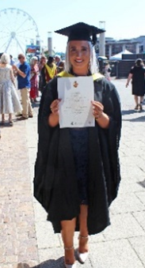


Reasons for entering the profession
I am an enthusiastic individual who has a passion for helping children to achieve their goals, no matter how small. I would love to be given the opportunity to have a positive impact on the lives of the children that I teach. I have excellent knowledge of the new curriculum reform and am excited to implement new ideas in my practice.

Areas/Subjects I Could Teach
I specialise in Primary Education and have lots of experience within the Foundation Phase! I would love to hold extra-curricular activities at your school, such as Dance, Drama or Netball.
About Me
I am Miss Richards and I love to spend time with my family and friends. I enjoy learning to play the piano and I love to dance! I enjoy going on trips and exploring new places. I like to keep fit and have raised money for charity by participating in running events.

Academic History
GCSE Maths – C
AGORED CYMRU Level 3 – Application of Number
GCSE English Literature & Language – C
AGORED CYMRU Level 3 - Literacy
GCSE Religious Education – B
GCSE ICT – B
BTEC Level 2 Applied Science – Merit
BTEC Level 2 Extended Certificate Performing Arts (Performance) – Distinction*
BTEC Level 3 Health and Social Care – Merit
BTEC Level 3 Sport – Distinction*
Bachelor of Arts with Honours in Primary Education Studies – Second Class, Division One

Previous Teaching Experiences
I have volunteered at many schools, both mainstream and ALN. I have worked with children across the Foundation Phase and Key Stage 2 and attended many school trips as part of the staff.
I have an interest in outdoor learning and I have visited 3 schools in Switzerland, one of them being an outdoor nursery!
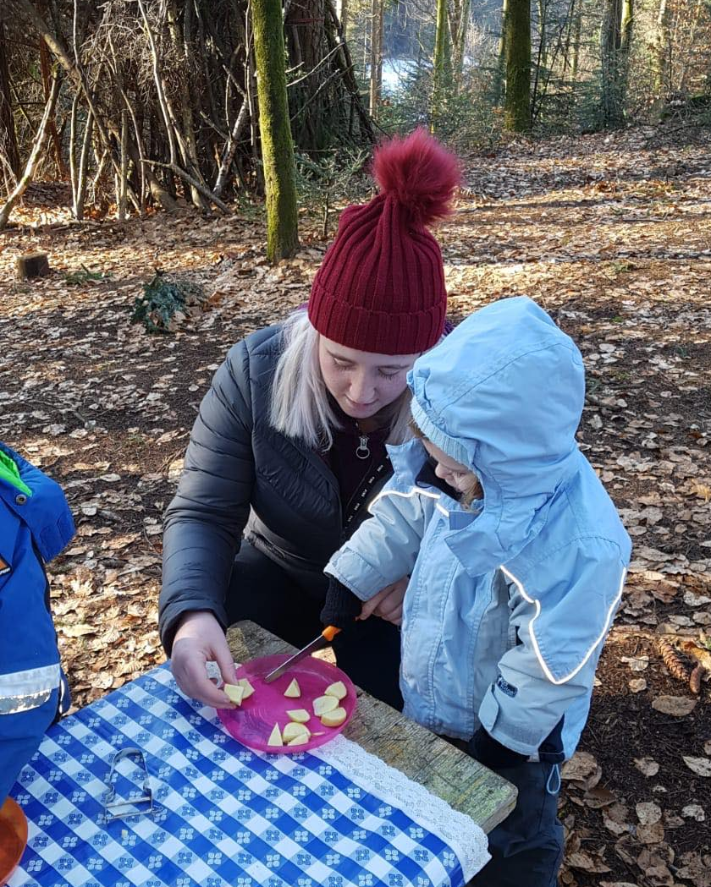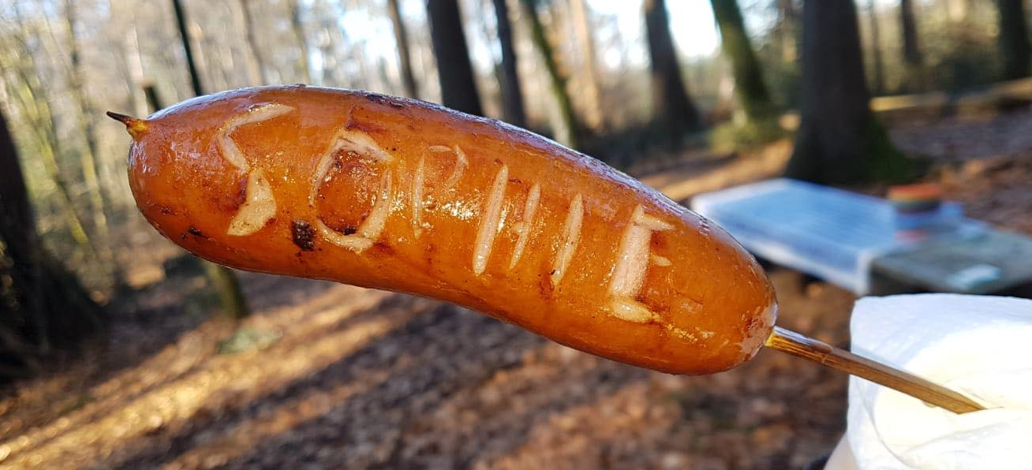
I have worked with children who have Profound and Multiple Learning Difficulties (PMLD) and focused my dissertation on how Sensory Approaches can promote their communication development.
The kind of teacher I aspire to be
I aspire to be a good role model and develop my skills and knowledge to become the best teacher that I can be.
I aspire to be organised, prepared and enthusiastic, so that the children I teach have the best learning experiences, both inside and outside the classroom.

