Line Rosenskiold (P151225)

Marketing Communications Strategy (M5X02059)
NomNom Chocolate
Marketing Communications Plan

Table of Contents
1.0 Introduction 2
2.0 Context Analysis 2
2.1 Business Context 2
2.2 Customer Context 2
2.3 Internal 3
2.4 External 3
3.0 Promotional Goals 6
4.0 Promotonal Strategy 8
4.1 Push 8
4.2 Pull 8
4.3 Profile 9
5.0 Co-ordinated communications Mix 9
6.0 Scheduling and Resources 11
7.0 Evaluation and Control 13
8.0 Bibliography 14

Introduction
NomNom chocolate is a Welsh chocolate brand with its roots based in West Wales, United Kingdom. The chocolate brand was originally developed by Liam Burgess at the age of eighteen and was launched in November 2011. Using the world’s finest cacao, combined with a variety of welsh ingredients makes the chocolate distinguish from other brands within the market (NomNom, 2018)
This report will use the Fill Marketing Communications Planning framework in order to produce a marketing communications plan to drive the company into its next phase of development. The researcher has been given a budget of £ 2 million to do so.

Context Analysis
Context analysis is a method that is used to examine the internal environment in which a business operates. It is argued to be the very first step of any planning process as the analysis aims to confirm if a project is informed by the contextual factors that could possibly affect its implementation and sustainability (Vascellari, 2018).

Business Context
According to IBIS World (2017) the chocolate and confectionery production industry’s revenue has been declining the last five years. However, chocolate is still argued to be one of the most profitable components of the chocolate and confectionary industry. Some of the key competitors and leading brands within the global chocolate market, as well as the British chocolate market includes Nestle SA, Mondelez International (Milka and Cadbury), Mars Inc. and the Fererro Group (Persistence, 2018). The Chocolate Society (2017) Argues that the reason for the decline in the chocolate and confectionery market is due to a shift from high street chocolate to quality products. Further it is also argued that it seems that customers are willing to pay more for a more luxuries and healthier chocolate due to a shifting in trend of health and diet.

Customer Context
In terms of NomNom chocolate, their customers are defined as the different shops and supermarkets selling their products, also known as wholesalers (Haldorsen, 2017). It can be argued that the most simple and beneficial way to sell a product is directly to consumers. However, manufacturers seldom have the funds to produce, distribute and market their own products. As a result of this, wholesalers often act as a link between the manufacturers and the consumers (Mack, 2018). Wholesaler´s typically buy a large quantity of products directly from its distributor. It often involves high-volume purchase orders and the distributors tend to provide discounts on a higher number of items purchased (Cole, 2018). As for NomNom chocolate, their customers are therefore seen to be wholesaler such as supermarkets as they will be selling their products.

Internal
The internal environment within the business is arguably vital to its success. Abukhames (2015) argues that the internal environment within an organisation is something that is controllable, unlike the external environment.
NomNom Chocolate has been experiencing lack of communication between line managers and staff, resulting in demotivated and ineffective employees. Lack of communication being the biggest challenge internally within the organisation has contributed failing to achieve the organisational goals. Another internal challenge NomNom Chocolate is currently experiencing is the lack of resources provided in order to work efficiently. This mainly being resources such as production equipment and computerised systems. According to Herzberg (1966) relationship with line manager works as a hygiene factor that causes extreme dissatisfaction if not met, however, on the contrary recognition works as a satisfier and will keep the employees long-term motivated.

External
In order to look at the (internal) and external factors affecting NomNom Chocolate, the researcher found it necessary to develop a SWOT analysis looking into the organisations strengths and weaknesses in addition to their opportunities and threats. Additionally, it was found highly essential to develop a PEST analysis looking at the political, economic, social and technological factors that may be affecting the company’s performance. According to Rouse (2018) a SWOT analysis can be defined as a framework and part of the strategic planning of a business where they can identify and analyse the internal and external factors that can possibly have an impact on the organisation. Please see table 1 below.

Internal | Strengths  High quality chocolate  Offers a wide range of tastes  Niche product | Weaknesses  Fairly low awareness of its brand  Expensive in comparison to high street chocolate brands
External | Opportunities  Increasing demand for high quality chocolate  Development of seasonable ranges  A significant focus on a healthy lifestyle may result in opportunities in developing a healthier range of chocolate such as protein bars, or dark chocolate | Threats  Strong competition within the chocolate and confectionery market  Heavy focus on a healthy lifestyle may result in a lack of interest in chocolate
Table 1 - SWOT Analysis

Pestle Analysis (2013) defined the analysis as a method that is used to assess the macro environment of the organisation. It can further be debated that the PEST analysis supports the organisation in determine how every factor will affect the performance and actions of the business in the long-term. Please see table 2 for a PEST analysis of NomNom Chocolate below.
Political | Economic | Social | Technological
-Rodionova (2016) debated that the price of Cocoa rose by 1,5% due to Brexit and a fall in pounds compared to other currencies.  -Trade negotiations with the world’s largest cocoa beans named Ivory Coast may be affected of Brexit due to them doing most of its business in the EU (Akinyelure, 2016)  -New tax regulation may have an impact on the production of sugary products in the UK. | -According to Statista (2018) turnover for manufacture of coca, sugar and chocolate has decreased with £ 1131 million between 2008 and 2016 | -Emphasis on a healthy lifestyle can arguably result in a decrease in future sales  -The Mintel Global Food and Drink Trends 2016 showed that 33% of adults in the UK admitted to be eating comfort food in order to deal with work related stress (Mintel, 2016)  -Mintel (2016) also stated that 62% of adults within the UK are concerned about the sugar contents in food in addition to 53% stating they are actively trying to reduce or limit sugar in their daily diet. | -Developments in technology may make it more efficient in terms of production and packaging
Table 2 – PEST Analysis

3.0 Promotional Goals
Berry and Thomas (2018) stated that business objectives that are SMART (Specific, Measurable, Achievable, Relevant and Timely), are more likely to be achieved. Further they argue that SMART objectives include; focusing attention on work plans, commitment and to performance targets.
The researcher is looking to produce aims and objectives that are SMART for NomNom Chocolate, and as a result, NomNom chocolate is recommended to have the following marketing and communication objectives through the duration of this 12-month plan;
- To increase sales with 5% within 12 months
- To have a Halloween range ready by September 2018
- To have a Christmas range ready within October 2018
- To have a Valentines range ready within December 2018
- To have an Easter range ready within January 2019
- To create a healthier chocolate bar within the 12-month period
- To create an Instagram profile, aiming for 2000 followers within June 2019
- To create a Facebook page within August 2018
- To position the product as a one of the most exclusive chocolate brands within the UK within the 12-month period
- To rise the general awareness of products from 25% to 50% within 10 weeks
In order to complete the promotional goals mentioned above, it must be defined where within the market NomNom Chocolate should be placed. As a result, the researcher has produced a positional map in order to gain a better understanding where the business stands in comparison to its competitors. Please see positioning map below.
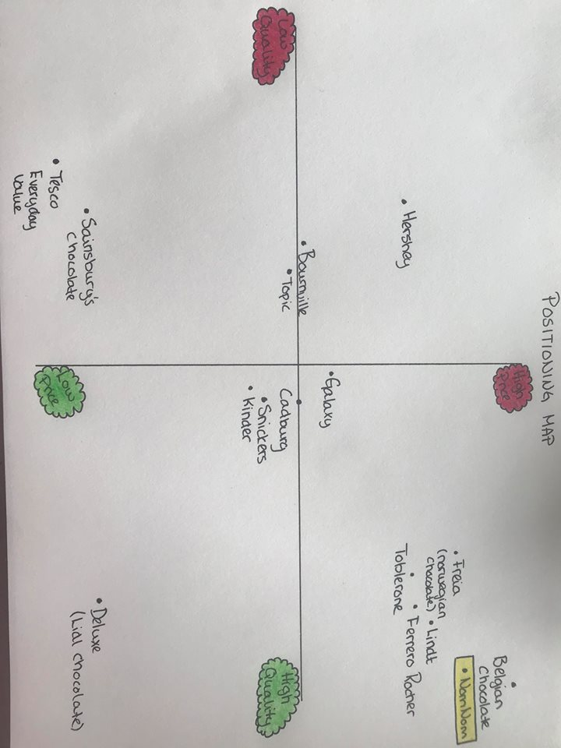
Figure 1 - Positioning Map
As shown in the positioning map, NomNom Chocolate is seen to be providing chocolate of high quality in addition to be priced higher than high street chocolate. The organisation must therefore find solutions to market their product in a way that is suitable to the brand itself. NomNom chocolate is aiming to be a more luxurious product, offering a wide range of different and unusual tastes. Crawford (2014) stated that there are five marketing tactics to increase premium chocolate sales. Flavour being a major driver for chocolate, NomNom can be seen to benefit by adding even more flavours to their selections. Secondly, Crawford also recommends that manufacturers of premium chocolate exploit their consumers interest in health and fitness. Further suggested actions are to increase accessibility and to produce smaller portions for less money. The idea of offering a smaller sized product at a lower price is to get the consumers attention and interest for the brand, making the price barrier less of a concern (Crawford, 2014).

4.0 Promotonal Strategy
An organisation only having one marketing strategy for marketing communications often limits their reach. As a result, it is more common for organisations to use both pull and push strategies. It is however, important that the organisation choses the strategies that are beneficial to them, that being either one strategy or a combination. Mixing these strategies will arguably make it harder for the customers and/or consumers to resist purchase of product (Toggl, 2018)
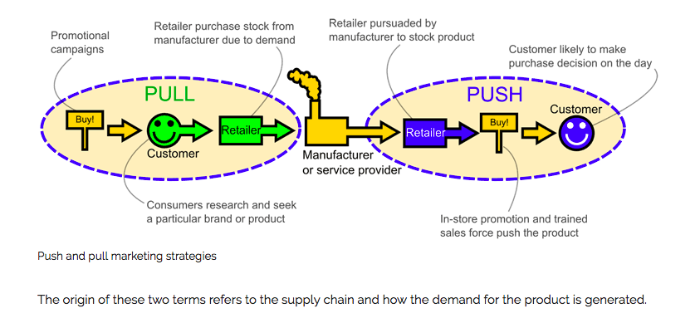
Figure 2 - Push and Pull Marketing Strategies
Combining push and pull strategies can arguably push customer demand if the company continues to constantly develop new and existing products; and pull their customers towards their products using different methods of advertising and promotion deals (Magloff, 2018).

4.1 Push
Push strategy can be defined as the work a manufacturer has to accomplish in order to get the product to the customer. Push strategy is often seen to be used in B2B (Business-2-Business) marketing as it often involves setting up distribution channels and encourage retailers to stock your product (Marketing Made Simple, 2018). This promotional marketing strategy aims to push their products at the consumers (Robertson, 2018).
Using this strategy will assist NomNom Chocolate in pushing their products down through the channels using supermarkets and other retailers to stock their products.

4.2 Pull
Pull marketing strategy, on the other hand takes an opposed approach. Pull marketing strategies often requires a lot of advertising as the strategy aims to get the consumer to come to you by pulling them using different advertising approaches (Robertson, 2018). It was stated by Magloff (2018) that pull strategy involves building customer demand for a product or service using strategies such as promotions, discount offerings and building demand using social media.
In terms of NomNom Chocolate, combining push and pull marketing strategy can arguably benefit the organisation massively. Using push strategy, the organisation can use supermarkets in addition to other retailer to stock their products. Meanwhile, NomNom Chocolate can advertise their products with the aims of pulling the consumers to into buying their products in store.

4.3 Profile
A profile strategy can be slightly challenging to some organisations as it involves the organisations profile on how its stakeholders view the business (StudioWide, 2017). It can also be described as a way of keeping in a dialogue with stakeholders and keeping them informed with progress (New Flight, 2018). It is however recommended that NomNom Chocolate use this strategy in combination with both push and pull in order to maximise results.

5.0 Co-ordinated communications Mix
Kokemuller (2018) describes marketing communications mix as specific methods that is used to promote either the company or its products. The marketing communications mix involves the following activities.
Advertising – Often includes passing a message to a targeted audience using different methods that the business delivers through a medium (Frue, 2016).
Personal Selling – With this element of the communications mix, the aim is to use personal selling as a type of communication between the buyer and the product using a sales representative (Lumen, 2018).
Sales Promotion – Involves offering discounted price on their product in order to encourage purchase of product (Kokemuller, 2018).
Public Relations – Establish a relationship with various stakeholder groups such as customers, shareholder and employees through formal communication (Biz Development, 2009).
Direct Marketing – Direct marketing involves making direct contact with both existing and potential customers with the aim to promote your product or service (Marketing Donut, 2018).
It can be debated that NomNom Chocolate is more likely to succeed in growing their business further if they implement the push, pull and profile methods in to their overall marketing strategy. Further, NomNom´s communications mix will include the following activities:

Digital marketing
- Social Media Marketing
Creating a profile on different social media platforms will arguably support NomNom Chocolate to receive greater brand recognition. The organisation can additionally run contests on their different social media accounts making their audiences feel more included and appreciated. Further, NomNom Chocolate can benefit from using social media platforms such as YouTube in order to advertise their products. Doing social media marketing will also most likely improve brand loyalty. A report published by Texas Tech University showed that brands who engage on social media experience higher loyalty form their customers (Bell, 2013).
- Email Marketing
Email marketing is an effective way to reach an already interested audience. This method is most commonly used due to it involving a lower cost than with other marketing activities. NomNom Chocolate can use this method in order to reconnect with already purchasing consumer. It might also be beneficial to the organisation as to promote new products.
Sales Promotion
Sales promotion is a technique that is used to persuade customers to take a particular action such as purchasing a product (Joseph, 2018). On that note, NomNom Chocolate is recommended to do sales promotion such as “buy one get one free” in addition to a free gift with purchase of their products. Doing this will contribute in people trying their product for the first time, and possibly result in repeat purchase.
Advertising
Oubaiche (2015) stated that the main purposes of advertising a product or a service is to expand market and to increase sales. It is therefore suggested that NomNom Chocolate use these advertising methods.
- Billboard and outdoor advertising
Outdoors advertising in not only billboards, but also posters that suits all budgets (Marketing Donut, 2018).
Advertising and promote NomNom´s products using outdoors advertising will assist the business in increasing their brand awareness. It is advised that the organisation use transport networks to advertise on buses and trains as well as any other public transport that are highly visible. This enables the organisation to captive their audiences on multiple levels. NomNom can also be seen to benefit from advertising in shopping centres or in high streets to reach their potential customers.
- Newspaper
Newspaper advertising is a great way to reach a larger number of potential customers. This especially includes the older audiences as they tend to read the paper more regularly than younger demographic groups (Entrepreneur Europe, 2018). As a result, doing newspaper adverts will arguably enable NomNom Chocolate to reach an audience that they are not likely to reach through social media.
- Direct mail
With direct mail marketing, the organisation has the benefit of deliver something tangible in comparison to other advertising methods. Pulcinella (2017) argued that direct mail is to be considered superior in contrast to other marketing channels. NomNom Chocolate can use this marketing method to send brand-aware promotional gifts as well as additional information on their products.
- Radio
Gordon (2007) stated that 80% of all adults listens to radio when in their cars. Further, it is argued that many radio stations now stream their program on the internet in order to reach additional audiences. It is therefore suggested that NomNom Chocolate use radio as a way of marketing as it empowers them to reach a wide range of audiences without spending the same amount of money as with for example TV advertising.
It is debatable that NomNom Chocolate will reach their organisational goal of further development if implementing the marketing mix that was stated above. In addition, the organisation is recommended to have monthly staff meetings, in order to improve the communication within the organisation. This will also arguably improve their overall organisational performance.

6.0 Scheduling and Resources
It can be argued that in order to complete these marketing objectives, NomNom Chocolate is reliant on a schedule. By keeping a schedule, the organisation is able to develop a solid plan for the near future. This will arguably help the organisation in keeping their costs down and allow them to run according to budget. It will additionally make the aims and objectives of the organisation more realistic and achievable.
As a result, the researcher has developed a schedule of the already mentioned marketing tactics. Please see table 3 below.

Month | Description | Start date | End date | Price £ (in pounds)
JUNE 2018 | Create Instagram and Facebook  Staff meeting | 04.06.2018  04.06.2018 | 04.06.2018  04.06.2018 | 0  98,12
JULY 2018 | Staff meeting  Healthy Range  Outdoor Adv.  Social Media | 02.07.2018  06.07.2018  17.07.2018  01.07.2018 | 02.07.2018  24.07.2018  30.07.2018  31.07.2018 | 98,12  118.540,00  275.765,00  1012,00
AUGUST 2018 | Halloween Range  Staff meeting  Outdoor Adv.  Social Media | 01.08.2018  07.08.2018  01.08.2018  01.08.2018 | 17.08.2018  07.08.2018  31.08.2018  31.08.2018 | 102.534,00  98,12  287.372,00  978,00
SEPTEMBER 2018 | Staff meeting  Radio Advertising  Outdoor Adv.  Social Media | 05.09.2018  02.09.2018  06.09.2018  01.09.2018 | 05.09.2018  30.09.2018  30.09.2018  31.09.2018 | 98,12  240.832,00  212.348,00  994,00
OCTOBER 2018 | Staff meeting  Christmas Range  Social Media | 01.10.2018  01.10.2018  01.10.2018 | 01.10.2018  16.10.2018  31.10.2018 | 98,12  104.768,00  1011,00
NOVEMBER 2018 | Staff meeting  Social Media  Sales Promotion | 04.11.2018  01.11.2018  06.11.2018 | 04.11.2018  30.11.2018  24.11.2018 | 98,12  986,00  21.432,17
DECEMBER 2018 | Staff meeting  Valentines Range  Radio Advertising  Social Media | 02.12.2018  03.12.2018  01.12.2018  01.12.2018 | 02.12.2018  28.12.2018  22.12.2018  31.12.2018 | 98,12  87.623,00  180.832,00  1112,00
JANUARY 2019 | Staff meeting  Easter Range  Social Media | 05.01.2019  04.01.2019  01.01.2019 | 05.01.2019  31.01.2019  31.01.2019 | 98,12  103.812,00  998,78
FEBRUARY 2019 | Staff meeting  Social Media  Newspaper | 02.02.2019  01.02.2019  05.02.2019 | 02.02.2019  28.02.2019  12.02.2019 | 98,12  986,14  7345,66
MARCH 2019 | Staff meeting  Social Media  Sales Promotion | 07.03.2019  01.03.2019  09.03.2019 | 07.03.2019  31.03.2019  31.03.2019 | 98,12  1002,17  18.957,14
APRIL 2019 | Staff meeting  Social Media  Newspaper | 04.04.2019  01.04.2019  10.04.2019 | 04.04.2019  30.04.2019  14.04.2019 | 98,12  916,28  12.345,00
MAY 2019  TOTAL | Staff meeting  Social Media  Sales Promotion | 02.05.2019  01.05.2019  06.05.2019 | 02.05.2019  31.05.2019  15.06.2010 | 98,12  1001,76  20.452,12  1.805.051,28
Table 3 - Budget
Staff meeting, Radio Advertising, Social Media Marketing, Outdoor Advertising, Sales Promotion, Newspaper Advertising.
Please note that the remaining £194.948,72 will be to cover new equipment.

7.0 Evaluation and Control
In order to ensure that the organisations marketing communications is working effectively, the organisation must evaluate their performances. NomNom must therefore look at the return on their investments. This will help the organisation to consider whether the capital used on the marketing plan has resulted in a profit. In addition to this, the organisation is to consider whether their marketing reach has expanded. Natural growth indicates a successful and effective marketing strategy (Morello,2018).

8.0 Bibliography
Abukhames, H., 2015. Internal Factors that May Affect the Business Organization. [Online]
Available at: https://www.linkedin.com/pulse/internal-factors-may-affect-business-organization-hatim-abukhames
[Accessed 14 May 2018].
Akinyelure, D., 2016. Brexit´s bitter-sweet meaning for chocolate lovers - and Ivory Coast. [Online]
Available at: http://www.bbc.co.uk/news/world-africa-38155872
[Accessed 11 May 2018].
Bell, T., 2013. Establishing Brand Loyalty through Social Media. [Online]
Available at: http://www.depts.ttu.edu/comc/research/outpost/blog/brand-loyalty.php#sthash.GymG5BDh.dpbs
[Accessed 16 May 2018].
Berry, S. & Thomas, R., 2018. Use SMART Objectives To Focus Goals, Plans And Performance. [Online]
Available at: https://www.projectsmart.co.uk/use-smart-objectives-to-focus-goals-plans-and-performance.php
[Accessed 05 May 2018].
Biz-Development, 2009. Promotion Mix: Public Relationship (B). [Online]
Available at: http://www.biz-development.com/Marketing/5.9.Promotion-Mix-Public-Relationship.htm
[Accessed 15 May 2018].
Cole, R., 2018. Differences Between Wholesalers, Distributors and Retailers. [Online]
Available at: http://smallbusiness.chron.com/differences-between-wholesalers-distributors-retailers-30836.html
[Accessed 16 May 2018].
Crawford, 2014. 5 marketing tactics helping premium chocolate sales outpace overall category. [Online]
Available at: https://www.foodnavigator-usa.com/Article/2014/12/09/5-strategies-helping-premium-chocolate-sales-outpace-overall-category
[Accessed 16 May 2018].
EntrepreneurEurope, 2018. Newspaper Advertising. [Online]
Available at: https://www.entrepreneur.com/encyclopedia/newspaper-advertising
[Accessed 16 May 2018].
Frue, K., 2016. How to Use the Marketing Communication Mix to Boost Business. [Online]
Available at: http://pestleanalysis.com/marketing-communication-mix/
[Accessed 15 May 2018].
Haldorsen, V., 2017. Hva er forskjellen mellom en kunde og en forbruker. [Online]
Available at: http://vadoknoppen.com/category/diverse/hva-er-forskjellen-mellom-en-kunde-og-en-forbruker.php
[Accessed 16 May 2018].
Herzberg, F., 1966. Work and the nature of man. 1st ed. Cleveland: World Publishing Company.
Joseph, C., 2018. Sales Promotion Advantages. [Online]
Available at: http://smallbusiness.chron.com/sales-promotion-advantages-1059.html
[Accessed 16 May 2018].
Kokemuller, N., 2018. What Is a Marketing Communication Mix. [Online]
Available at: http://smallbusiness.chron.com/marketing-communication-mix-63541.html
[Accessed 14 May 2018].
Lisa, M., 2018. Push & Pull Promotional Strategy. [Online]
Available at: http://smallbusiness.chron.com/push-pull-promotional-strategy-10972.html
[Accessed 08 May 2018].
Lumen, 2018. Reading: Personal Selling. [Online]
Available at: https://courses.lumenlearning.com/clinton-marketing/chapter/reading-personal-selling/
[Accessed 16 May 2018].
Lumen, 2018. Reading: Personal Selling. [Online]
Available at: https://courses.lumenlearning.com/clinton-marketing/chapter/reading-personal-selling/
[Accessed 16 May 2018].
Mack, S., 2018. Selling to Wholesalers. [Online]
Available at: http://smallbusiness.chron.com/selling-wholesalers-65164.html
[Accessed 10 May 2018].
MarketingDonut, 2018. Direct Marketing. [Online]
Available at: https://www.marketingdonut.co.uk/direct-marketing/direct-marketing-overview
[Accessed 16 May 2018].
MINTEL, 2016. Working Up An Unhealthy Appetite. [Online]
Available at: http://www.mintel.com/press-centre/social-and-lifestyle/working-up-an-unhealthy-appetite-33-of-workers-turn-to-comfort-food-to-tackle-work-stress
[Accessed 12 May 2018].
Morello, R., 2018. 7 Ways to Evaluate Your Marketing Plan. [Online]
Available at: http://smallbusiness.chron.com/7-ways-evaluate-marketing-plan-58331.html
[Accessed 16 May 2018].
NewFlight, 2018. The 3 P´s of Marketing Communication. [Online]
Available at: http://newflight.co/blog/3-ps-of-marketing-communication/
[Accessed 14 May 2018].
Oubaiche, Z., 2015. Advantages of Advertising: 12 Major Advantages of Advertising - Explained!. [Online]
Available at: https://www.linkedin.com/pulse/advantages-advertising-12-major-explained-zahira-oubaiche
[Accessed 16 May 2018].
Persistence, 2018. Chocolate Market: Global Industry Analysis and Forecast 2016-2024. [Online]
Available at: https://www.persistencemarketresearch.com/market-research/chocolate-market.asp
[Accessed 16 May 2018].
PESTLE, 2013. Understanding Pest Analysis with Definitions and Examples. [Online]
Available at: http://pestleanalysis.com/pest-analysis/
[Accessed 09 May 2018].
Pulcinella, S., 2017. Why Direct Mail Marketing Is Far From Dead. [Online]
Available at: https://www.forbes.com/sites/forbescommunicationscouncil/2017/08/30/why-direct-mail-marketing-is-far-from-dead/#1847c2e3311d
[Accessed 16 May 2018].
Robertson, T., 2018. Difference Between Push & Pull Marketing. [Online]
Available at: http://smallbusiness.chron.com/difference-between-push-pull-marketing-31806.html
[Accessed 06 May 2018].
Rodionova, Z., 2016. Brexit is making chocolate more expensive. [Online]
Available at: https://www.independent.co.uk/news/business/news/brexit-is-making-chocolate-more-expensive-a7126471.html
[Accessed 10 May 2018].
Rouse, M., 2018. SWOT Analysis (strenghs, weaknesses, opportunities and threats analysis). [Online]
Available at: https://searchcio.techtarget.com/definition/SWOT-analysis-strengths-weaknesses-opportunities-and-threats-analysis
[Accessed 08 May 2018].
Simple, M. M., 2018. Push pull marketing strategies. [Online]
Available at: http://marketing-made-simple.com/push-pull-marketing-strategies/
[Accessed 05 May 2018].
Society, T. C., 2017. Luxury Chocolate Winning Over Mass Marketed Bars In UK. [Online]
Available at: https://www.chocolate.co.uk/blogs/news/luxury-chocolate-vs-mass-marketed-uk
[Accessed 05 May 2018].
Statista, 2018. Consumer Goods & FMCG. [Online]
Available at: https://www.statista.com/statistics/481625/chocolate-and-sugar-confectionary-sales-turnover-united-kingdom-uk/
[Accessed 09 May 2018].
Studiowide, 2017. What are push, pull and profile strategies?. [Online]
Available at: https://www.studiowide.co.uk/push-pull-profile-strategies/
[Accessed 08 May 2018].
Toggl, 2018. Marketing Mix: The 4Ps Of Marketing For Businesses. [Online]
Available at: https://toggl.com/marketing-mix-4ps/
[Accessed 10 May 2018].
Vascellari, A., 2018. Context Analysis - What? Why? How?. [Online]
Available at: http://www.andreavascellari.com/2014/01/context-analysis/
[Accessed 09 05 2018].

