On the nitration of methyl benzoate and guanidine
ACDA6020 lab report 3
Quinn Dunbar
2217666

Contents
1. Introduction 3
2. Experimental 4
2.1 Nitration of methyl benzoate 4
2.2 Nitration of guanidine 4
3. Results 5
3.1 Methyl 3-nitrobenzoate 5
3.2 Nitroguanidine 5
3.3 Improving yield 5
4. Mechanisms 6
4.1 Formation of nitronium ion 6
4.2 Formation of methyl 3-nitrobenzoate 6
4.3 Formation of nitroguanidine 7
5. Conclusions 8

Introduction
Nitration is the process of adding the nitro group (-NO₂) to an organic molecule. Due to the carbon nitrogen bond strength, the nitro groups structure and its nitrogen content, the nitro group is an important component of explosives, with most secondary explosives containing several nitro groups [1]. Like many reactions, nitration can form several products, so clean up steps are required to from a pure product. This report details the synthesis and recrystallisation of methyl 3-nitrobenzoate from methyl benzoate and nitroguanidine from guanidine nitrate. These are of interest as methyl 3-nitrobenzoate contains a benzene ring, similar to explosives such as TNT and nitroguanidine is frequently used in propellants.

Experimental

Nitration of methyl benzoate
Methyl benzoate, a liquid, was nitrated using mixed acid, a combination of concentrated sulfuric and nitric acids. This was performed dropwise into a conical flask submerged in an ice bath. The reaction is exothermic and hence requires cooling to keep under control. Conducting the reaction increases the likelihood of producing a di-nitrated product rather than the desired mono-nitrated product. At higher temperatures more nitrogen oxides would have been generated from the nitric acid, contaminating the final product. Once all the mixed acid has been added, the reaction was allowed to continue at room temperature.
On completion of the reaction, the solution was poured onto ice. The lower temperature reduced the solubility of the methyl 3-nitrobenzoate in the solution, causing it to crash out of the solution as a solid. This solid was then vacuum filtered and washed with cold distilled water to remove any impurities present in minor amounts as these would dissolve in the water, whereas the bulk of product would not dissolve due to methyl 3-nitrobenzoates low solubility in cold water.
The product was purified through recrystallisation, where the product was dissolved into hot ethanol to minimise the amount of solvent required to fully dissolve the produced amount. As the solution cools the solubility of methyl 3-nitrobenzoate in the ethanol drops causing it to crystalise out of solution, with ethanol being chosen as it methyl 3-nitrobenzoate has a large difference in solubility between hot and cold ethanol. Any minor contaminants remain in solution, along with a small amount of the product that remains dissolved. The crystal product was then vacuum filtrated and washed with cold ethanol to remove any impurities that remain on the crystal surface. The product was then dried by vacuum filtration to remove any remaining ethanol from the crystals.

Nitration of guanidine
Guanidine was supplied in the form of guanidine nitrate, so nitration could be conducted using only concentrated sulfuric acid. Concentrated sulfuric acid was chilled in an ice bath and solid guanidine nitrate was added a spatula at a time. As the nitration is exothermic the reaction required cooling to reduce side products being formed or the decomposition of the product. Once all the solid was added the reaction was allowed to continue before the mixture was added to a flask containing ice water to ensure all the product crashed out, before being vacuum filtered and washed with ice water to remove impurities.
The nitroguanidine was recrystallised using hot water, due to its difference in solubility between hot and cold water. The recrystallised product was then washed with further cold water to remove surface impurities and dried using a vacuum desiccator to remove any remaining water.

Results

Methyl 3-nitrobenzoate
The nitration of methyl benzoate has the following equation:
C₆H₅COOCH₃ + HNO₃ → C₆H₄CNO₂COOCH₃ + H₂O
Hence 1 mole of the reactants produces 1 mole of product, with the reactant present in the lower amount acting as the limiting reagent and hence determines the maximum possible yield. Sulfuric acid acted as catalyst so is absent from the equation and does not need to be considered when calculating maximum theoretical yield.
2.775 g of methyl benzoate was decanted, with a molar mass of 136.15 g mol⁻¹ [1] giving 0.02038 mol used. 2.4 cm³ of 15.7M (70%) nitric acid [1] was decanted, giving 0.036 mol used. Hence methyl benzoate is the limiting reagent, giving a theoretical yield of 0.02038 mol. Methyl 3-nitrobenzoate has a molar mass of 181.15 g mol⁻¹ [3], so the maximum theoretical mass of the product was 3.692 g.
The actual mass of the product was 2.6185 g, giving a yield of 70.9%.

Nitroguanidine
The production of nitroguanidine from guanidine nitrate has the following equation:
C(NH)(NH₂)(NH₃)NO₃ → C(NH)(NHNO₂)(NH₂) + H₂O
With a sulphuric acid catalyst, so the theoretical yield is only reliant on the amount of guanidine nitrate. 3.954 g of guanidine nitrate was weighed out, with a molar mass of 122.08 g mol⁻¹[4], 0.0324 mol was reacted. Nitroguanidine has a molar mass of 104.07 g mol⁻¹ [4], so a theoretical yield of 3.371 g.
The actual mass of the product was 1.960 g giving a yield of 58%.

Improving yield
Yield can be reduced by a number of factors, including incomplete reactions and inefficient recrystallisation. The yield of these reactions could be improved by using fewer pieces of glassware, as transferring between glassware for each step in a synthesis leaves residue behind that isn’t carried through the rest of the synthesis and hence not all the starting material is reacted. Also, a lesser amount of washing the crystal product and also using colder solvent would reduce the amount of crystal that is dissolved by the wash and hence lost as filtrate. Recrystallising at a lower temperature for a longer time would also increase yield, as more of the product would have time to leave the solution.

Mechanisms
Both nitroguanidine and methyl 3-nitrobenzoate are produced via the electrophilic substitution mechanism [6], where an area of high electron density attacks the electron deficient positively charge nitrogen atom in the nitronium ion, the delocalised pi electrons in the case of the benzene ring, and the lone pair on a nitrogen atom in the case of guanidine.

Formation of nitronium ion
The nitric acid is dehydrated by the sulphuric acid, as sulphuric acid is a stronger acid so protonates the nitric acid causing water to be formed as a leaving group. In the case of guanidine nitrate, the nitrate ion is protonated by 2 separate sulphuric acid molecules sequentially to produce the nitronium ion.
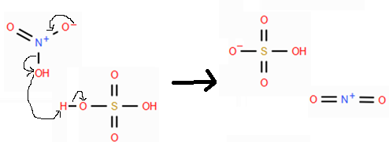
Figure 1 - Formation of nitronium ion

Formation of methyl 3-nitrobenzoate
The ester group bonded to the benzene ring deactivates the ring as it is electron-withdrawing. It is meta directing as the lower electron density on carbon-1 means a stable carbocation cannot from there, and hence the intermediate resonant form has carbocations on carbons 2, 4 and 6 resulting in it being a meta-directing group [6].
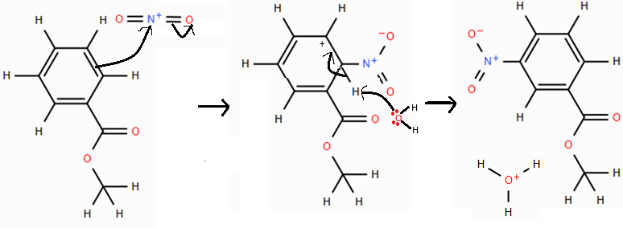
Figure 2 - Formation of methyl 3-nitrobenzoate

Formation of nitroguanidine
The guanidium ion is deprotonated by a base, such as the hydrogensulfate ion produced by the formation of the NO₂⁺. Guanidine and the guanidium ion exist as resonance structures due to proton transfer between the imine and amine nitrogens. A single form is used in the mechanisms.
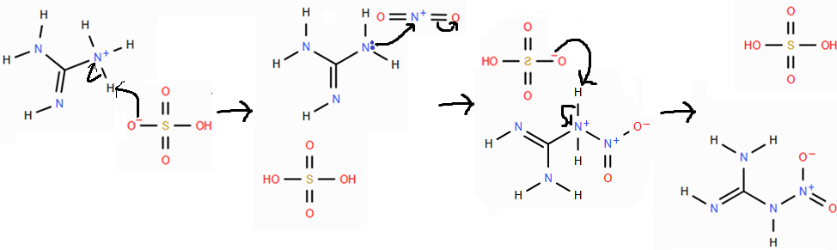
Figure 3 - Formation of nitroguanidine

Conclusions
Both N-nitration (as for nitroguanidine) and aromatic nitration (as for the benzene ring) are used extensively in the synthesis of energetics. The procedures performed herein show the basic principles required to understand the reactions involved in nitration. Improved apparatus and longer laboratory times could lead to an increase in yield, as shown by the different procedures used for these reactions within the industry [9].

References

[1] | C. Zhang, “Review of the establishment of nitro group charge method and its applications,” Journal of Hazardous Materials, vol. 161, no. 1, pp. 21-28, 2009.
[2] | Merck, “Methyl benzoate,” [Online]. Available: https://www.sigmaaldrich.com/GB/en/product/aldrich/m29908?srsltid=AfmBOorWYiCidFMYgrGNsvIAldt-Rd73MsGU0g_LvbiDsVRkDO7YKm3k. [Accessed 4 December 2025].
[3] | Merck, “Acid & Base Normality and Molarity Calculator,” [Online]. Available: https://www.sigmaaldrich.com/GB/en/support/calculators-and-apps/molarity-calculator?srsltid=AfmBOop7nZsl8iq8OwfGsXnb_g6DA_m48vguDJADRQ1NL2j13xHRx2CB. [Accessed 4 December 2025].
[4] | Merck, “Methyl 3-nitrobenzoate,” [Online]. Available: https://www.sigmaaldrich.com/GB/en/product/aldrich/155977. [Accessed 4 December 2025].
[5] | Merck, “Guanidine nitrate,” [Online]. Available: https://www.sigmaaldrich.com/GB/en/product/aldrich/234249. [Accessed 4 December 2025].
[6] | Merck, “Nitroguanidine,” [Online]. Available: https://www.sigmaaldrich.com/GB/en/product/aldrich/n17351?srsltid=AfmBOopO8b8u13560OPywJ3N3sFRmyc9cZbeNK0EFuUwpoYuSHywbmez. [Accessed 4 December 2025].
[7] | E. Blackall and E. Hughes, “N-Nitration and C-Nitration by the Nitronium Ion,” Nature, vol. 170, pp. 972-972, 1952.
[8] | J. Ashenhurst, “Ortho-, Para- and Meta- Directors in Electrophilic Aromatic Substitution,” Master organic chemistry, 12 June 2025. [Online]. Available: https://www.masterorganicchemistry.com/2018/01/29/ortho-para-and-meta-directors-in-electrophilic-aromatic-substitution/. [Accessed 4 December 2025].
[9] | E. Pritchard and G. Wright, “PRODUCTION OF NITROGUANIDINE WITH HIGH BULK-DENSITY,” Canadian Journal of Research, vol. 25, no. 4, pp. 257-263, 1947.

