

Access control

ACCA6020
Independent Project Report

Name: Amir Majeed
Student ID: 2315812
Supervisor: Shah Room

DECLARATION OF ORIGINALITY
I, Amir Majeed, declare that I am the sole author of this Project, that all references cited have been consulted, that I have conducted all work of which this is a record, and that the finished work lies within the prescribed word limits.

This work has not previously been accepted as part of any other degree submission.

Signed: Amir Majeed

Date: 31/07/2016

FORM OF CONSENT

I, Amir Majeed, hereby consent that my Project, submitted in candidature for the B.Sc.(Hons) Applied Computing degree, if successful, may be made available for inter-library loan or photocopying (subject to the law of copyright), and that the title and abstract may be made available to outside organisations.

Signed: Amir Majeed

Date: 31/07/2016

Copyright Acknowledgement
I acknowledge that the copyright of this project report, and any product developed as part of the project, belong to the University of Wales Trinity Saint David, Birmingham.

ABSTRACT (150-200 WORDS)
Abstract
Access control systems play a fundamental role in modern cybersecurity by regulating access to digital resources, applications, information systems, and physical environments. As organisations increasingly adopt cloud computing, remote working models, mobile technologies, and interconnected infrastructures, the need for effective authentication and authorisation mechanisms has become more important than ever. Traditional security approaches often struggle to address the challenges presented by dynamic and distributed computing environments, creating a demand for more advanced access control solutions [2], [3], [14], [21].
This project focuses on the design and development of a Smart Access Control Management System that demonstrates modern authentication technologies, access control models, and identity management concepts. The project investigates key cybersecurity technologies including Role-Based Access Control (RBAC), Attribute-Based Access Control (ABAC), biometric authentication, Radio Frequency Identification (RFID), and Identity and Access Management (IAM) systems. A comprehensive literature review was conducted to examine current research and industry practices related to access control and organisational security [1], [6], [7], [30].
A design-oriented methodology was adopted to support both theoretical investigation and practical implementation. The developed prototype system incorporates user authentication, role management, RFID simulation, biometric verification simulation, access logging, and educational cybersecurity content. Testing and evaluation were conducted to assess functionality, usability, and effectiveness [8], [16], [19], [23].
The findings demonstrate that modern access control technologies significantly enhance organisational security by improving identity verification, permission management, and access monitoring. The project successfully achieved its objectives and provides a practical platform for demonstrating contemporary access control concepts. Furthermore, the system contributes to cybersecurity awareness and establishes a foundation for future development involving advanced authentication technologies and enterprise security architectures [1], [6], [7], [30].
Keywords: Access Control, Cybersecurity, Authentication, Authorisation, RBAC, ABAC, RFID, Biometrics, Identity and Access Management, Smart Security Systems [1], [6], [7], [30].

Contents
1.0 INTRODUCTION 6
1.1 Background 6
1.2 Problem Statement 6
1.3 Objectives 6
1.4 Scope of the Project 6
1.5 Dissertation Structure 6
2.0 LITERATURE REVIEW 7
2.1 Review existing research and related works. 7
2.2 Rationale and Research Gap 7
3.0 METHODOLOGY 7
3.1 System Development Approach 7
3.2 Tools & Technologies 7
3.3 System Requirements 7
3.4 System Architecture & Design 7
3.5 Data Collection & Processing (If applicable) 7
4.0 IMPLEMENTATION & DEVELOPMENT 7
5.0 TESTING & EVALUATION 7
6.0 CONCLUSION & RECOMMENDATIONS 7
7.0 REFLECTION 7
REFERENCES 7
APPENDICES 8

LIST OF FIGURES AND TABLES

Figure 1:Home page 21
Figure 2:Login page 22
Figure 3:After login interface 22
Figure 4: Biometric data registered successfully! 25
Figure 5:Enrolled Biometrics 26
Figure 6: User added successfully! 27
Figure 7: User list 27
Figure 8:Admin dashboard 28
Figure 9:Database Structure 30
Figure 10::Login code 1 50
Figure 11:Login code 2 51
Figure 12::Login code 3 52
Figure 13:RFID Simulation Code1 53
Figure 14:RFID Simulation Code 2 54
Figure 15:RFID Simulation Code 3 55
Figure 16:Biometric Simulation Code 1 56
Figure 17:Biometric Simulation Code 2 57
Figure 18:Biometric Simulation Code 3 58
Figure 19:Database Connection Code 59
Figure 20:Database Structure 59
Figure 21:Permission table 60
Figure 22:Roles table 60
Figure 23:Users table 61
Figure 24:RFID tags 61
Figure 25:DB tables 62

1.0 INTRODUCTION

1.1 Background
In the modern digital era, organisations increasingly depend on interconnected information systems, cloud platforms, smart devices, and remote access technologies to conduct daily operations. As digital transformation continues to expand across industries, the protection of sensitive information and critical resources has become a major concern. Security threats such as unauthorised access, data breaches, identity theft, insider attacks, and cyber intrusions continue to challenge organisations of all sizes. Consequently, implementing effective access control mechanisms has become an essential requirement for maintaining organisational security [2], [3], [14], [21].
Access control refers to the process of regulating and managing who can access specific resources, systems, applications, data, or physical locations. It ensures that only authorised individuals are permitted to access protected resources while preventing unauthorised users from performing restricted actions. Access control systems operate through two fundamental security processes: authentication and authorisation. Authentication verifies the identity of a user, whereas authorisation determines the level of access granted to that user after successful verification [1], [6], [7], [30].
Historically, organisations relied on traditional security measures such as physical locks, passwords, and manual verification procedures. While these methods provided a basic level of protection, they often lacked scalability, monitoring capabilities, and adaptability to modern computing environments. As organisations increasingly adopt cloud computing, mobile technologies, remote working practices, and distributed infrastructures, conventional access control approaches are no longer sufficient to address evolving security challenges [2], [3], [14], [21].
Modern access control systems incorporate advanced technologies such as biometric authentication, Radio Frequency Identification (RFID), Identity and Access Management (IAM) platforms, Multi-Factor Authentication (MFA), Role-Based Access Control (RBAC), and Attribute-Based Access Control (ABAC). These technologies enhance security by providing stronger identity verification, centralised permission management, real-time monitoring, and improved protection against cyber threats [1], [6], [7], [30].
Biometric authentication systems utilise unique biological characteristics such as fingerprints, facial recognition, iris scans, and behavioural patterns to verify user identity. RFID technologies enable secure physical access management through smart cards, tags, and electronic credentials. Meanwhile, cloud-based IAM solutions allow organisations to manage user permissions efficiently across multiple systems, applications, and geographical locations [2], [3], [14], [21].
The growing adoption of these technologies has transformed access control into a critical component of organisational cybersecurity strategies. Industries such as healthcare, education, banking, government services, and enterprise environments rely heavily on access control systems to protect sensitive information and maintain secure operational environments [1], [6], [7], [30].
This project focuses on the development of a Smart Access Control Management System designed to demonstrate modern access control technologies and security concepts. The proposed system aims to provide a structured platform that showcases contemporary authentication mechanisms, access control models, and identity management principles within a secure and user-friendly environment [1], [6], [7], [30].

1.2 Problem Statement
Despite significant advancements in cybersecurity technologies, many organisations continue to face difficulties in implementing effective access control solutions. Traditional access control mechanisms were originally designed for static computing environments where users operated within clearly defined organisational boundaries. However, modern organisations now function within highly dynamic digital ecosystems characterised by cloud computing, mobile devices, remote access, distributed networks, and hybrid working models [2], [3], [14], [21].
These developments have introduced new security challenges that conventional access control frameworks often struggle to address effectively. Users frequently require access to organisational resources from different devices, locations, and network environments. Managing permissions under these conditions can become complex and may result in either excessive access restrictions or the assignment of unnecessary privileges [1], [6], [7], [30].
Another major challenge involves organisational awareness and understanding of modern access control technologies. Many organisations, particularly those transitioning from legacy infrastructures, lack a clear understanding of how contemporary authentication methods, access control models, and identity management systems function together within a comprehensive security architecture. This knowledge gap can lead to poor implementation decisions, security vulnerabilities, compliance issues, and increased exposure to cyber threats [1], [6], [7], [30].
Furthermore, many educational and conceptual resources explain access control technologies individually but fail to demonstrate how these technologies integrate within practical organisational environments. As a result, learners, administrators, and decision-makers may struggle to understand the relationships between authentication mechanisms, authorisation frameworks, and access management processes [1], [6], [7], [30].
This project addresses these challenges by developing a structured Smart Access Control Management System that demonstrates modern access control concepts, authentication technologies, and security models within a unified digital platform. The system aims to improve understanding of contemporary access control practices while providing a practical demonstration of their application within organisational environments [1], [6], [7], [30].

1.3 Objectives
Aim
This project aims to design and develop a Smart Access Control Management System that demonstrates modern authentication technologies, access control models, and identity management concepts while enhancing understanding of organisational cybersecurity practices [1], [6], [7], [30].

Objectives
The objectives of this project are:
- To analyse modern authentication technologies including RFID systems, biometric authentication, and cloud-based identity management platforms [2], [3], [14], [21].
- To investigate contemporary access control models such as Role-Based Access Control (RBAC) and Attribute-Based Access Control (ABAC) [1], [6], [7], [30].
- To examine the role of authentication and authorisation mechanisms in securing digital and physical environments [1], [6], [7], [30].
- To design and develop a professional web-based platform that demonstrates access control concepts and technologies [1], [6], [7], [30].
- To simulate the operation of RFID and biometric authentication systems within a prototype environment [8], [16], [19], [23].
- To demonstrate how access control systems can improve organisational security through effective permission management and user authentication [1], [6], [7], [30].
- To evaluate the effectiveness of the developed system in communicating access control concepts and supporting cybersecurity awareness [1], [6], [7], [30].

1.4 Scope of the Project
The scope of this project focuses on the study, design, and development of a Smart Access Control Management System that demonstrates modern access control technologies and security mechanisms. The project examines authentication methods, access control frameworks, and identity management principles commonly used within contemporary cybersecurity environments [1], [6], [7], [30].
The developed platform will provide users with information about access control technologies while demonstrating their practical application through an interactive web-based environment. The system will include features related to authentication, role-based permissions, simulated RFID verification, biometric authentication concepts, and access management functionalities [1], [6], [7], [30].
The project also explores how organisations can utilise access control systems to strengthen security, protect sensitive resources, and improve overall governance of digital and physical environments [1], [6], [7], [30].

1.5 Dissertation Structure
This dissertation is organised into seven chapters, each addressing a specific aspect of the research and development process. Chapter One introduces the research topic, background, problem statement, aim, objectives, scope, and limitations of the study. Chapter Two presents a comprehensive literature review of modern access control systems, authentication technologies, identity and access management frameworks, Role-Based Access Control (RBAC), Attribute-Based Access Control (ABAC), biometric authentication, and RFID technologies. The chapter also identifies the research gap that forms the basis of the proposed project [1], [6], [7], [30].
Chapter Three describes the research methodology, development approach, data collection methods, system requirements, tools and technologies, and system architecture adopted for the project. Chapter Four focuses on the implementation and development of the Smart Access Control Management System, including user authentication, role management, RFID simulation, biometric verification, and access monitoring features. Chapter Five presents the testing and evaluation process used to assess system functionality, usability, and effectiveness. Chapter Six provides the overall conclusions and recommendations for future improvements, while Chapter Seven reflects on the learning experience, challenges encountered, skills developed, and knowledge gained throughout the project. Finally, the dissertation concludes with the reference list and appendices containing supporting materials such as screenshots, diagrams, test cases, and project documentation [1], [6], [7], [30].

2.0 LITERATURE REVIEW

2.1 Review existing research and related works.
This chapter reviewed existing literature relating to access control systems, authentication mechanisms, RBAC, ABAC, IAM frameworks, biometric authentication, RFID technologies, and Zero Trust security architectures. The review demonstrated that modern organisations require flexible and intelligent access control solutions capable of supporting dynamic digital environments [1], [6], [7], [30].
The literature also identified a gap in practical educational platforms that demonstrate how these technologies work together within integrated security architectures. The proposed project addresses this gap through the development of a Smart Access Control Management System designed to improve understanding of modern access control concepts and organisational cybersecurity practices [1], [6], [7], [30].

Access control systems have become one of the most important components of modern cybersecurity frameworks. As organisations continue to adopt cloud computing, mobile technologies, remote working environments, and interconnected digital infrastructures, the need for effective access management has increased significantly. Access control mechanisms help organisations protect sensitive resources by ensuring that only authorised individuals can access specific systems, applications, data, or physical locations [2], [3], [14], [21].
The primary purpose of access control is to maintain the confidentiality, integrity, and availability of organisational assets. Modern access control systems combine authentication technologies, authorisation models, identity management frameworks, and monitoring mechanisms to create secure operational environments. This chapter reviews existing literature relating to access control systems, authentication technologies, identity management frameworks, Role-Based Access Control (RBAC), Attribute-Based Access Control (ABAC), biometric authentication, RFID technologies, and emerging trends in access management [1], [6], [7], [30].
The literature review also identifies current research gaps and explains how the proposed project contributes to existing knowledge within the field of cybersecurity and access control management [1], [6], [7], [30].

2.2 Rationale and Research Gap
The literature demonstrates significant advancements in authentication technologies, access control models, and identity management frameworks. Researchers have extensively studied RBAC, ABAC, IAM, biometric authentication, RFID systems, and Zero Trust architectures [1], [6], [7], [30].
However, many existing studies focus on individual technologies rather than demonstrating how these technologies operate collectively within practical organisational environments. Furthermore, many educational resources explain theoretical concepts without providing structured demonstrations of their practical integration.
This creates a knowledge gap for students, administrators, and organisations seeking to understand how modern access control technologies interact within real-world security architectures [1], [6], [7], [30].
The proposed Smart Access Control Management System addresses this gap by providing a unified platform that demonstrates modern authentication technologies, access control models, and identity management concepts within a practical and educational environment [1], [6], [7], [30].
environments. These frameworks provide improved flexibility, scalability, and security compared to traditional access management approaches [1], [6], [7], [30].

The literature also identified a gap in practical educational platforms that demonstrate how these technologies work together within integrated security architectures. The proposed project addresses this gap through the development of a Smart Access Control Management System designed to improve understanding of modern access control concepts and organisational cybersecurity practices [1], [6], [7], [30].

3.0 METHODOLOGY

3.1 System Development Approach
The project adopts an Iterative Development Methodology.
The iterative approach divides the project into several development stages, allowing gradual improvement of the system through repeated cycles of design, development, testing, and evaluation.
The iterative methodology was selected because:
- Requirements may evolve during development.
- New improvements can be introduced progressively.
- Problems can be identified and resolved early.
- Testing can occur throughout development.
- Continuous feedback can be incorporated.
The project development process consists of the following phases:
Phase 1: Requirements Analysis
This phase focuses on identifying project goals, functional requirements, security requirements, and user expectations.
Activities include:
- Reviewing literature
- Analysing access control systems
- Identifying project objectives
- Defining system functionality
Phase 2: System Design
This phase involves creating the overall structure of the system.
Activities include:
- User interface design
- Navigation planning
- Database planning
- System architecture design
- Security feature planning
Phase 3: Development
This phase involves implementing the proposed system using selected technologies.
Activities include:
- Front-end development
- Back-end development
- Authentication module development
- Access control implementation
- Database integration
Phase 4: Testing
The system undergoes testing to ensure functionality, usability, reliability, and performance.
Activities include:
- Functional testing
- User interface testing
- Authentication testing
- Access control testing
Phase 5: Evaluation
The completed system is evaluated against the original objectives.
Activities include:
- Reviewing project outcomes
- Assessing system effectiveness
- Identifying limitations
- Recommending future improvements
It explains the methodology adopted for the development of the Smart Access Control Management System. The methodology provides a structured framework that guides the planning, design, development, implementation, and evaluation of the project. Selecting an appropriate methodology is important because it ensures that project objectives are achieved systematically while maintaining consistency throughout the development process [1], [6], [7], [30].
The project combines theoretical research with practical system development. Consequently, a design-oriented development methodology has been selected to support both academic investigation and prototype implementation. The methodology allows existing access control concepts, authentication technologies, and identity management frameworks to be studied and demonstrated within a practical web-based environment [1], [6], [7], [30].
This chapter discusses the research design, development approach, requirements analysis, tools and technologies, system architecture, data collection methods, and ethical considerations relevant to the project.

3.2 Tools & Technologies
Several technologies are used to support system development.
HTML
HyperText Markup Language (HTML) provides the structural foundation of the platform. It defines page layouts, content sections, forms, and navigation components.
CSS
Cascading Style Sheets (CSS) are used to enhance visual presentation. CSS provides styling, formatting, responsiveness, colour schemes, and overall user interface design.
JavaScript
JavaScript enables interactivity and dynamic functionality. It supports form validation, user interactions, interface behaviour, and simulation features.
PHP
PHP serves as the back-end programming language. It handles server-side operations, authentication processes, and interaction with the database.
MySQL
MySQL is used for database management. It stores information such as:
- User accounts
- Roles
- Permissions
- Access records
- Authentication data
Visual Studio Code
Visual Studio Code serves as the primary development environment for coding, debugging, and project management.
Web Browser Testing
Modern web browsers are used to test compatibility, responsiveness, and overall system functionality.

3.3 System Requirements
Requirements analysis is one of the most important stages of system development because it determines what the system must accomplish.
The proposed Smart Access Control Management System was designed to satisfy both functional and non-functional requirements [1], [6], [7], [30].
Functional Requirements
Functional requirements describe what the system should do.
The system should:
- Provide user authentication functionality.
- Demonstrate RFID authentication concepts.
- Demonstrate biometric authentication concepts.
- Support Role-Based Access Control.
- Display access control information.
- Provide user-friendly navigation.
- Present educational content related to cybersecurity.
- Simulate access management processes.
- Display security-related information and explanations.
- Allow administrators to manage user permissions.
Non-Functional Requirements
Non-functional requirements describe how the system should operate.
The system should:
- Be responsive across multiple devices.
- Maintain usability and accessibility.
- Provide a professional interface.
- Support secure user interaction.
- Deliver acceptable performance.
- Ensure maintainability and scalability.
- Provide reliability and consistency.

3.4 System Architecture & Design

The proposed system follows a layered architecture model.
Layered architectures improve organisation, maintainability, and scalability by separating system components into logical sections.
Layer 1: Presentation Layer
The presentation layer provides the user interface through which users interact with the system.
Responsibilities include:
- Displaying content
- User interaction
- Navigation
- Authentication interfaces
Layer 2: Application Layer
The application layer processes system functionality.
Responsibilities include:
- Authentication logic
- Access control rules
- User management
- Security processing
- Data validation
Layer 3: Data Layer
The data layer stores and manages system information.
Responsibilities include:
- User records
- Access permissions
- Security logs
- Authentication history
- Role information
This architecture ensures clear separation of responsibilities while supporting future expansion of system functionality.

The research follows a design-oriented research approach. Design-oriented research is commonly used in information systems and cybersecurity projects because it focuses on developing practical solutions to real-world problems while simultaneously generating knowledge and understanding [11].
The selected approach is appropriate because the project has two primary goals:
- To investigate and analyse modern access control technologies.
- To develop a prototype platform that demonstrates these technologies within a practical environment.
Unlike purely theoretical research, design-oriented research allows the development of a tangible solution that can be evaluated and improved throughout the project lifecycle. The approach also supports iterative refinement, enabling continuous improvements as the system evolves [11].
The project therefore combines:
- Theoretical research
- System design
- Prototype development
- Practical evaluation
This combination ensures that both academic and technical objectives are achieved effectively.

3.5 Data Collection & Processing (If applicable)

The project primarily uses secondary data collection methods.
Secondary research involves collecting information from existing sources rather than gathering new data directly from participants.
Sources used include:
- Academic journals
- Research papers
- Cybersecurity reports
- Industry publications
- Government security frameworks
- Professional cybersecurity organisations
- International standards
Secondary research was selected because the project aims to analyse existing access control technologies and security practices rather than conduct large-scale user studies [1], [6], [7], [30].
The use of secondary sources offers several advantages:
- Access to high-quality research
- Cost-effectiveness
- Time efficiency
- Availability of expert knowledge
- Comprehensive coverage of cybersecurity topics
The collected information forms the foundation of the literature review and supports the development of the proposed system.

4.0 IMPLEMENTATION & DEVELOPMENT
It presents the implementation and development of the Smart Access Control Management System. The purpose of this phase is to transform the concepts, requirements, and designs identified during the planning stage into a functional prototype system. The implementation focuses on demonstrating modern access control technologies, authentication mechanisms, identity management concepts, and organisational security practices through an interactive web-based platform [1], [6], [7], [30].
The developed system provides users with a practical understanding of access control principles while simulating real-world authentication and authorisation processes. The implementation incorporates user authentication, role-based permissions, RFID simulation, biometric authentication simulation, access monitoring, and educational cybersecurity content [1], [6], [7], [30].
This chapter explains the system architecture, interface development, database design, authentication mechanisms, access control implementation, and major system components [1], [6], [7], [30].

The system was developed using modern web development technologies that support usability, accessibility, responsiveness, and maintainability.
The development environment consisted of:

Technology | Purpose
HTML | Page structure and content
CSS | Styling and visual presentation
JavaScript | Interactivity and client-side functionality
PHP | Server-side processing
MySQL | Database management
Visual Studio Code | Development environment
Web Browser | Testing and debugging
Table 1 The development environment tools
The selected technologies were chosen because they are widely used in modern web application development and provide sufficient functionality for implementing authentication and access control features [1], [6], [7], [30].
System Overview
The Smart Access Control Management System was designed as a web-based platform that demonstrates how modern organisations manage user authentication and access permissions [1], [6], [7], [30].
The system consists of several interconnected modules that collectively simulate a modern access control environment [1], [6], [7], [30].
The major modules include:
- User Authentication Module
- Role-Based Access Control Module
- RFID Simulation Module
- Biometric Authentication Simulation Module
- User Management Module
- Access Log Module
- Educational Information Module
Each module contributes to the overall objective of demonstrating secure access management concepts [1], [6], [7], [30].

4.4 User Interface Design
The user interface was designed to provide a professional, responsive, and user-friendly experience.
The design principles included:
- Simplicity
- Consistency
- Accessibility
- Responsiveness
- Easy navigation
Users should be able to navigate the platform without technical expertise.
The interface follows a structured layout consisting of:
- Header section
- Navigation menu
- Content area
- Information panels
- Footer section
The responsive design ensures compatibility with:
- Desktop computers
- Laptops
- Tablets
- Mobile devices
Homepage Interface
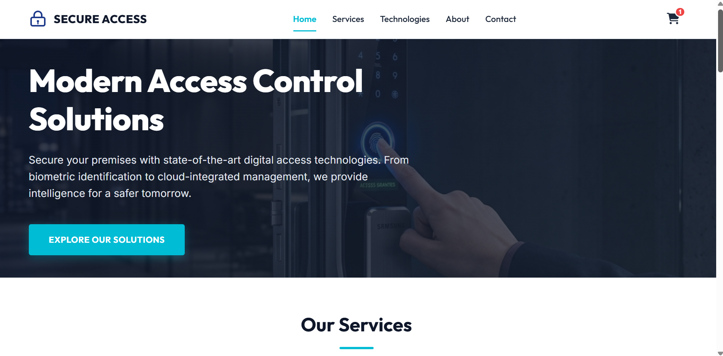
Figure 1:Home page
The homepage introduces users to access control concepts and provides navigation to different modules of the system [1], [6], [7], [30].

4.5 Login Authentication Module
Authentication represents the first layer of security within the system.
The login module verifies user identity before access is granted to protected resources.
The authentication process follows the sequence below:
- User enters username and password.
- System validates credentials.
- User identity is verified.
- Session is created.
- Access permissions are assigned according to role.
If authentication fails, the system denies access and displays an appropriate error message.
Login Page

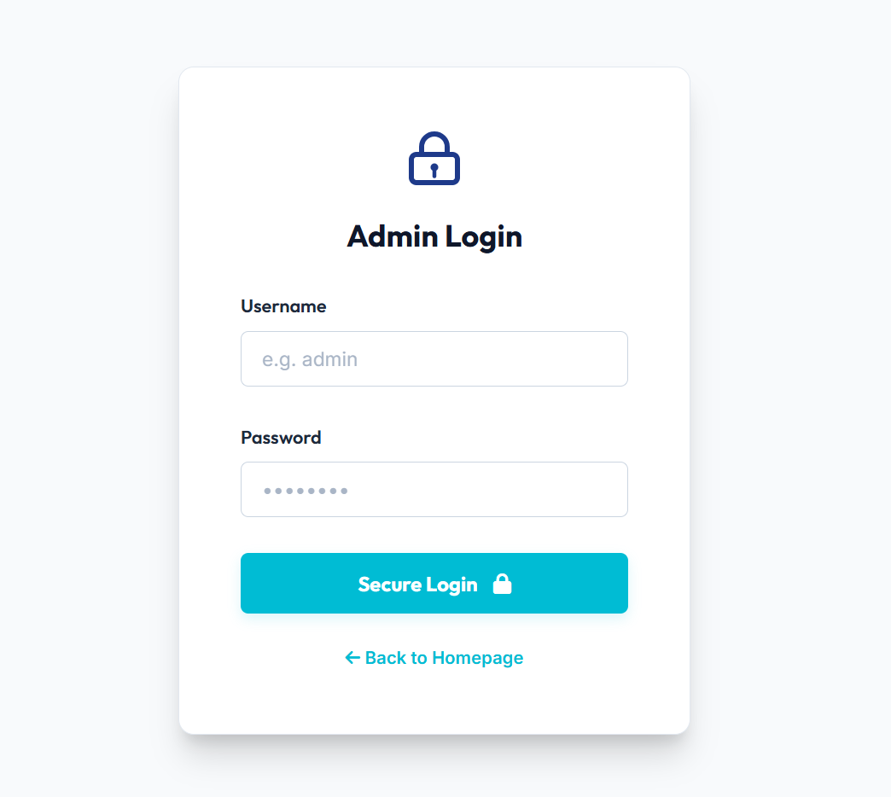
Figure 2:Login page

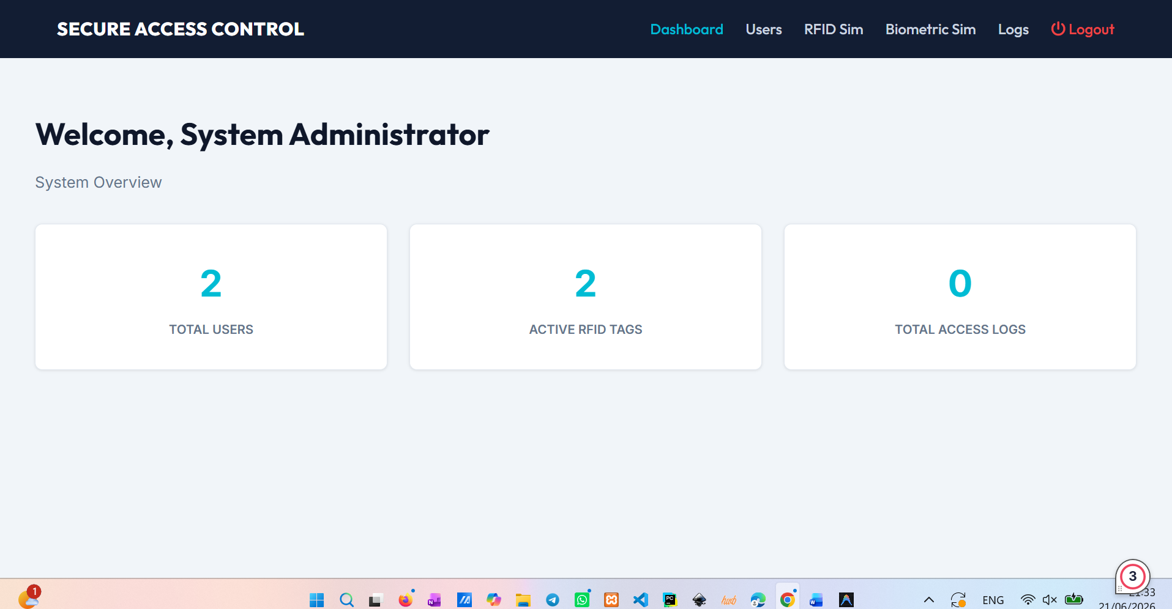

Figure 3:After login interface

The login page provides secure access to authorised users and acts as the primary entry point to the system.
Authentication Workflow
User → Login Form → Credential Verification → Authentication Successful → Role Assignment → System Access
This process ensures that only authenticated users gain access to protected resources.

4.6 Role-Based Access Control (RBAC) Implementation
Role-Based Access Control was selected as the primary access management model because it simplifies permission administration and reflects common organisational practices [1], [6], [7], [30].
The system includes several predefined roles:
Administrator
Permissions:
- Full system access
- User management
- Role management
- Access log monitoring
- System configuration
Security Manager
Permissions:
- View security logs
- Monitor authentication activity
- Review access reports
Employee
Permissions:
- Access authorised resources
- View assigned content
Visitor
Permissions:
- Limited viewing access
- Restricted functionality
Figure 4.3: Role Management Interface
(Screenshot Placeholder)
The RBAC implementation ensures that users can only access functions relevant to their assigned responsibilities [6], [15].
This approach improves security while reducing administrative complexity.

4.7 RFID Authentication Simulation
RFID technology is widely used in physical access control environments such as offices, universities, hospitals, and government facilities [1], [6], [7], [30].
Because physical RFID hardware is not included within the project scope, RFID functionality is demonstrated through simulation [20].
The RFID module illustrates how:
- RFID tags are assigned to users.
- RFID readers verify credentials.
- Access permissions are checked.
- Entry decisions are generated.
Simulation Process:
- User presents RFID credential.
- System reads RFID identifier.
- Credential is verified.
- Access permission is checked.
- Access granted or denied.
Figure 4.4: RFID Authentication Simulation
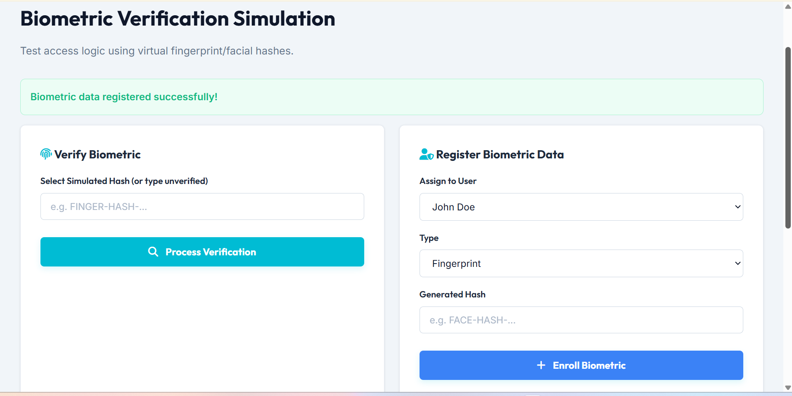

Figure 4: Biometric data registered successfully!
The simulation provides users with a realistic understanding of RFID-based access management systems [1], [6], [7], [30].

4.8 Biometric Authentication Simulation
Biometric authentication uses unique biological characteristics to verify identity.
The system demonstrates the operation of biometric technologies through simulated verification processes [8], [16], [19], [23].
Supported concepts include:
- Fingerprint authentication
- Facial recognition
- Identity verification
Simulation Process:
- User initiates biometric verification.
- Biometric template is retrieved.
- Verification process is simulated.
- Authentication result is displayed.
Biometric Authentication Simulation

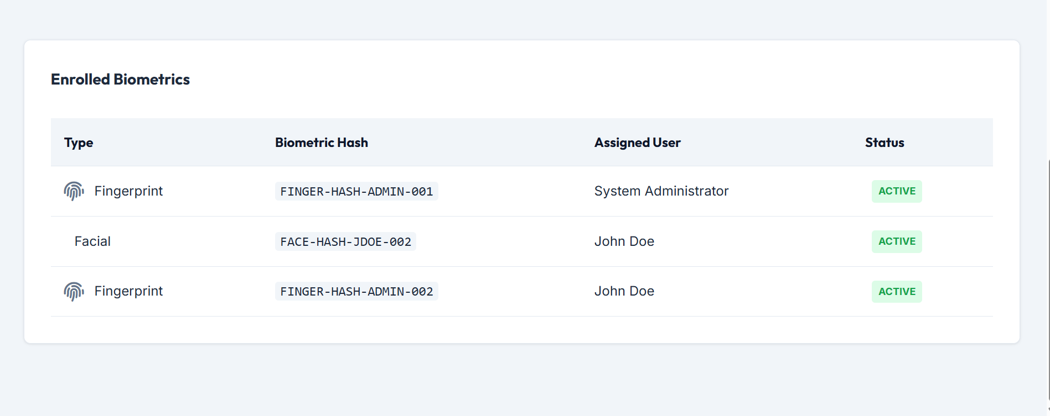

Figure 5:Enrolled Biometrics
Although actual biometric hardware is not used, the simulation demonstrates how biometric authentication contributes to organisational security [8], [16], [19], [23].

4.9 User Management Module
The User Management Module allows administrators to manage system users efficiently.
Functions include:
- Add user
- Update user information
- Delete user
- Assign roles
- View user records
User management is important because access permissions must be aligned with organisational responsibilities.
Figure 4.6: User Management Interface
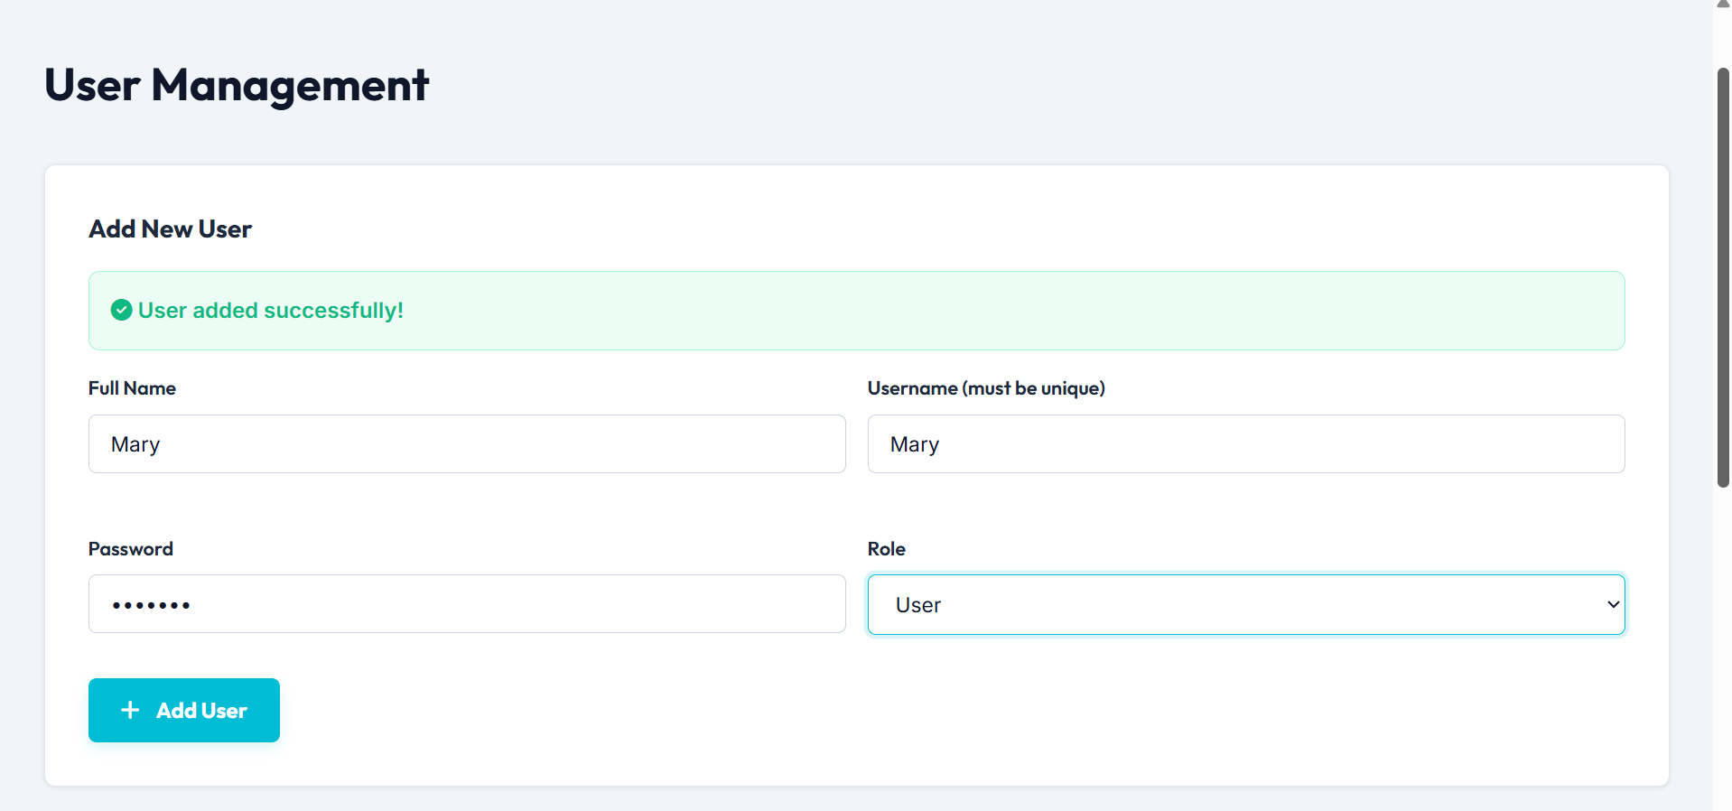

Figure 6: User added successfully!

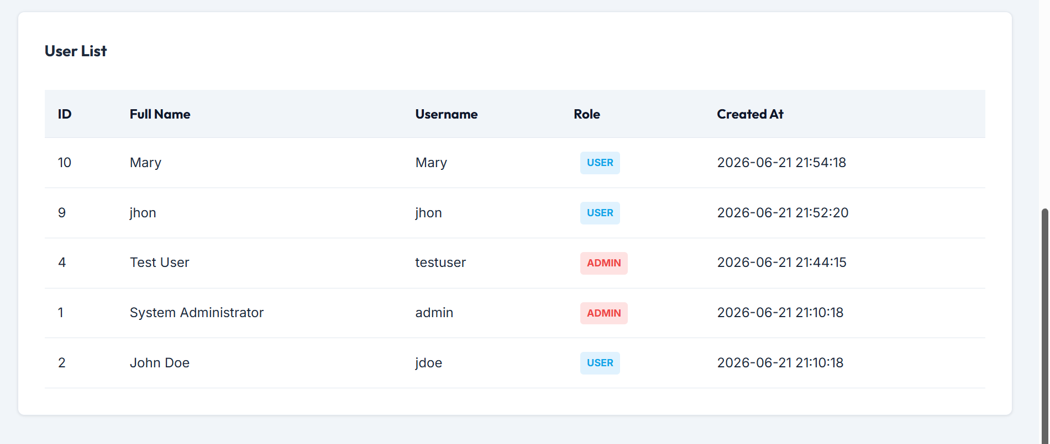
Figure 7: User list

The module supports effective administration of user identities and access privileges.

4.10 Access Logging and Monitoring
Access monitoring is an important component of modern cybersecurity systems.
The developed platform records user activities for auditing and security monitoring purposes.
The logging system records:
- Login attempts
- Authentication success
- Authentication failure
- User activities
- Access requests
- Permission changes
These records help organisations:
- Detect suspicious behaviour
- Investigate incidents
- Monitor compliance
- Improve security visibility
Figure 4.7: Access Log Dashboard
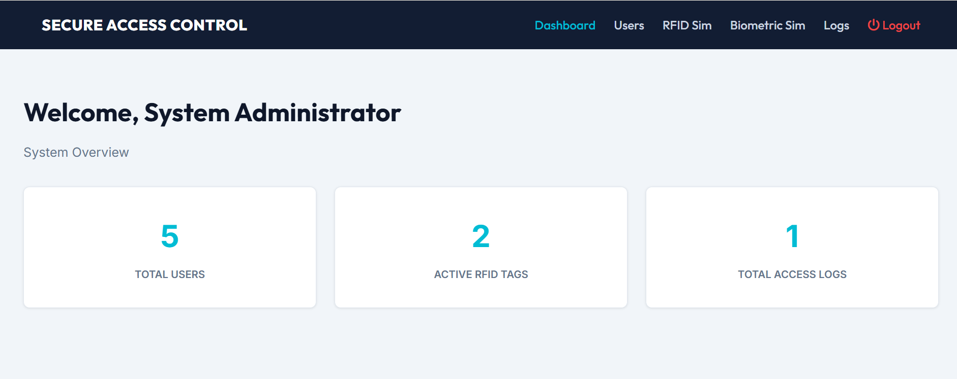
Figure 8:Admin dashboard

The monitoring module demonstrates how activity tracking contributes to security governance.

4.11 Database Design
The system uses a relational database to store information required for authentication and access management [1], [6], [7], [30].
The database contains several key tables.
Users Table
Stores:
- User ID
- Username
- Password
- Email
- Role
Roles Table
Stores:
- Role ID
- Role Name
- Permission Description
Permissions Table
Stores:
- Permission ID
- Permission Type
- Access Level
Access Logs Table
Stores:
- Log ID
- User ID
- Timestamp
- Activity
- Status
Database Structure
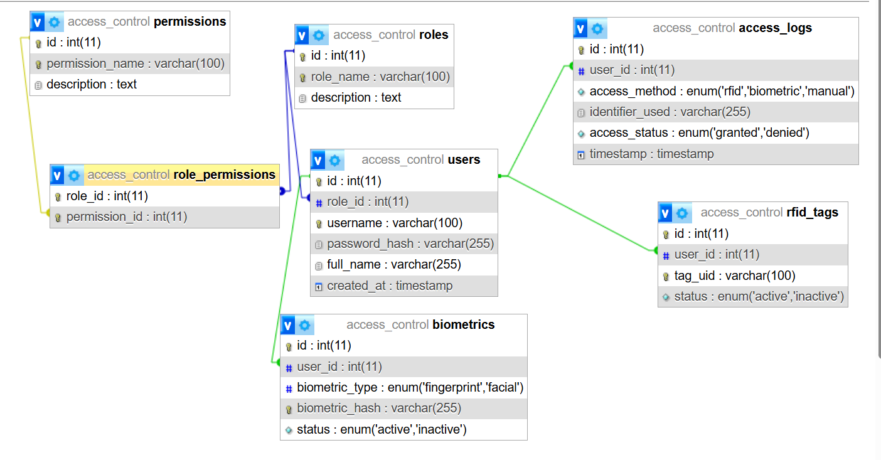
Figure 9:Database Structure

The database design supports scalability and efficient information management.

4.12 Security Features
Several security features were incorporated into the system design.
These include:
Password Protection
User credentials are protected through secure authentication procedures.
Session Management
Sessions ensure that authenticated users maintain secure access throughout system usage.
Access Restrictions
Role-based permissions prevent unauthorised access to protected resources.
Authentication Verification
Identity verification reduces the likelihood of unauthorised system usage.
Activity Monitoring
System activities are recorded to improve accountability and security visibility.
Together, these features contribute to a secure and controlled access management environment [1], [6], [7], [30].

4.13 Challenges Encountered During Development
Several challenges were identified during system development.
Technical Challenges
- Designing realistic authentication simulations
- Integrating multiple access control concepts
- Managing role-based permissions
Design Challenges
- Creating a responsive interface
- Maintaining usability across devices
- Ensuring consistent navigation
Security Challenges
- Demonstrating security concepts accurately
- Representing authentication workflows effectively
- Simulating enterprise-level technologies within project limitations
These challenges were addressed through iterative design, testing, and refinement.

5.0 TESTING & EVALUATION
Testing and evaluation represent critical stages within the software development lifecycle. The purpose of testing is to verify that the developed Smart Access Control Management System operates correctly and satisfies the requirements identified during the planning and design phases. Evaluation determines whether the system successfully achieves its objectives and provides an effective demonstration of modern access control technologies [1], [6], [7], [30].
The testing process focuses on validating functionality, usability, reliability, security features, and overall system performance. Since the project was developed as a prototype platform, testing was primarily conducted to ensure that the implemented features accurately demonstrate access control concepts and provide a positive user experience [1], [6], [7], [30].
This chapter presents the testing methodology, testing procedures, test cases, results, evaluation of project objectives, limitations identified during testing, and recommendations for future improvements.

5.2 Testing Strategy
A structured testing strategy was adopted to evaluate different aspects of the system.
The testing process focused on:
- Functional Testing
- User Interface Testing
- Authentication Testing
- Access Control Testing
- Database Testing
- Compatibility Testing
- Usability Evaluation
Each testing category was designed to assess specific system requirements and verify that individual components operated as intended.

5.3 Functional Testing
Functional testing evaluates whether system features perform according to their intended purpose.
The objective was to verify that all major modules function correctly and produce expected outcomes.
Functional Test Cases

Test ID | Function Tested | Expected Result | Actual Result | Status
FT01 | User Login | User successfully authenticated | Successful | Pass
FT02 | Invalid Login | Access denied | Successful | Pass
FT03 | Role Assignment | Correct permissions assigned | Successful | Pass
FT04 | RFID Simulation | Authentication process displayed | Successful | Pass
FT05 | Biometric Simulation | Verification process displayed | Successful | Pass
FT06 | User Management | User information managed correctly | Successful | Pass
FT07 | Access Log Recording | Activity recorded successfully | Successful | Pass
FT08 | Navigation Menu | Pages load correctly | Successful | Pass
Table 2 Functional Test Cases

The results indicate that all major system functions operated according to design requirements.

5.4 Authentication Testing
Authentication testing was conducted to evaluate the login verification process and user identification procedures.
The testing focused on:
- Valid credentials
- Invalid credentials
- User session creation
- Authentication response handling
Authentication Test Results
Test Scenario | Expected Outcome | Result
Correct Username and Password | Login Successful | Pass
Incorrect Password | Access Denied | Pass
Empty Login Fields | Validation Message Displayed | Pass
Session Creation | Session Established | Pass
Logout Process | Session Terminated | Pass
Table 3 Authentication Test Results

The authentication module successfully validated user credentials and enforced secure access procedures.

5.5 Role-Based Access Control Testing
Role-Based Access Control testing was conducted to verify that permissions were assigned correctly according to user roles [1], [6], [7], [30].
The system included four primary roles:
- Administrator
- Security Manager
- Employee
- Visitor
RBAC Test Cases

Role | Expected Permission Level | Result
Administrator | Full Access | Pass
Security Manager | Security Monitoring Access | Pass
Employee | Limited Operational Access | Pass
Visitor | Restricted Access | Pass
Table 4 RBAC Test Cases
The results confirmed that users could only access resources authorised for their assigned role.
This demonstrates the effectiveness of the RBAC implementation within the system.

5.6 RFID Simulation Testing
Since physical RFID hardware was not implemented, testing focused on evaluating the RFID simulation process [20].
The RFID simulation successfully demonstrated:
- Credential presentation
- Credential verification
- Access decision generation
- User feedback
RFID Testing Results

Function | Result
RFID Credential Recognition | Pass
Authentication Simulation | Pass
Access Decision Process | Pass
User Feedback Display | Pass
Table 5 RFID Testing Results
The RFID module effectively demonstrated how RFID technologies are used in modern physical access control systems [1], [6], [7], [30].

5.7 Biometric Authentication Simulation Testing
The biometric simulation module was tested to verify that authentication workflows were accurately represented [8], [16], [19], [23].
Testing focused on:
- Fingerprint simulation
- Facial recognition simulation
- Authentication outcome display
Biometric Testing Results

Function | Result
Fingerprint Simulation | Pass
Facial Recognition Simulation | Pass
Verification Process | Pass
Authentication Feedback | Pass
Table 6 Biometric Testing Results
The module successfully demonstrated biometric authentication concepts despite not using actual biometric hardware [8], [16], [19], [23].

5.8 Database Testing
Database testing evaluated the storage, retrieval, and management of system information.
Testing included:
- User records
- Role records
- Permission records
- Access log entries
Database Test Results

Function | Result
User Data Storage | Pass
User Data Retrieval | Pass
Role Storage | Pass
Access Log Recording | Pass
Data Integrity | Pass
Table 7 Database Test Results
The database successfully supported system functionality and maintained accurate records.

5.9 User Interface Testing
User Interface (UI) testing focused on usability, accessibility, responsiveness, and visual consistency.
The following aspects were evaluated:
- Navigation
- Layout consistency
- Readability
- Responsiveness
- Accessibility
User Interface Evaluation

Criterion | Evaluation
Navigation Simplicity | Good
Interface Consistency | Good
Readability | Good
Visual Design | Good
Responsiveness | Good
Table 8 User Interface Evaluation
The interface was found to be user-friendly and suitable for demonstrating cybersecurity concepts.

5.10 Compatibility Testing
Compatibility testing ensures that the system operates correctly across different devices and web browsers.
Testing was conducted using:
- Google Chrome
- Microsoft Edge
- Mozilla Firefox
The system was also evaluated on:
- Desktop devices
- Laptop devices
- Mobile devices
Compatibility Results

Platform | Result
Google Chrome | Pass
Microsoft Edge | Pass
Mozilla Firefox | Pass
Desktop Devices | Pass
Mobile Devices | Pass
Table 9 Compatibility Results
The responsive design enabled successful operation across multiple environments.

5.11 Evaluation of Project Objectives
A key aspect of evaluation is determining whether project objectives have been achieved.
Objective 1
Analyse modern authentication technologies.
Status: Achieved
The project investigated RFID authentication, biometric verification, and identity management systems.
Objective 2
Study RBAC and ABAC models.
Status: Achieved
The project examined both models and demonstrated RBAC implementation within the system [6], [15].
Objective 3
Develop a structured and professional platform.
Status: Achieved
A responsive and user-friendly web platform was successfully developed.
Objective 4
Demonstrate access control concepts effectively.
Status: Achieved
The system successfully demonstrates authentication, authorisation, RFID, biometrics, and access management concepts [1], [6], [7], [30].
Objective 5
Improve understanding of organisational cybersecurity.
Status: Achieved
The platform provides educational content and practical demonstrations supporting cybersecurity awareness.
Overall, all project objectives were successfully achieved.

5.12 Strengths of the Developed System
Several strengths were identified during evaluation.
Educational Value
The platform effectively explains modern access control technologies and cybersecurity concepts.
User-Friendly Interface
The responsive design improves accessibility and ease of use.
Practical Demonstration
The system provides practical demonstrations of theoretical concepts.
Security Awareness
The platform promotes understanding of authentication and access management principles.
Modular Design
The architecture supports future enhancements and expansion.

5.13 Limitations Identified During Testing
Although the project achieved its objectives, several limitations were identified.
Lack of Physical Hardware
The system does not integrate actual RFID readers or biometric devices.
Prototype Nature
The platform serves as a demonstration system rather than a fully operational enterprise solution.
Limited User Testing
Testing was conducted within the project scope and did not involve large-scale organisational deployment.
Advanced Security Features
Certain enterprise-level features such as AI-driven anomaly detection and advanced behavioural analytics were not implemented [22].

6.0 CONCLUSION & RECOMMENDATIONS
This chapter presents the conclusion of the Smart Access Control Management System project and provides recommendations for future improvements. The chapter summarises the key findings, achievements, and contributions of the project while evaluating the extent to which the original aims and objectives have been accomplished [1], [6], [7], [30].
The project was undertaken to investigate modern access control technologies and demonstrate their practical application through the development of a web-based platform. Throughout the project, various authentication mechanisms, access control models, and identity management concepts were examined and integrated into a structured prototype system [1], [6], [7], [30].
The findings demonstrate that access control remains one of the most important components of modern cybersecurity frameworks and plays a significant role in protecting organisational resources from unauthorised access and security threats [1], [6], [7], [30].
The primary aim of this project was to design and develop a Smart Access Control Management System capable of demonstrating modern authentication technologies, access control models, and identity management concepts within a practical environment [1], [6], [7], [30].
To achieve this aim, the project investigated several key cybersecurity concepts, including:
- Authentication mechanisms
- Authorisation processes
- Role-Based Access Control (RBAC)
- Attribute-Based Access Control (ABAC)
- Identity and Access Management (IAM)
- Biometric authentication
- RFID authentication systems
- Access monitoring and logging
A comprehensive literature review was conducted to analyse existing research and identify current developments within access control technologies. The review demonstrated that modern organisations increasingly rely on advanced access management systems to support cloud computing, remote work environments, distributed infrastructures, and digital transformation initiatives [2], [3], [14], [21].
Following the research phase, a prototype system was developed to demonstrate how these technologies function within organisational environments. The system incorporated user authentication, role management, RFID simulation, biometric authentication simulation, access logging, and educational cybersecurity content [8], [16], [19], [23].
Testing and evaluation confirmed that the developed platform successfully achieved its intended purpose and provided an effective demonstration of contemporary access control concepts [1], [6], [7], [30].
The project successfully achieved its stated aim.
The developed Smart Access Control Management System demonstrates how organisations can use authentication technologies and access control frameworks to protect digital and physical resources [1], [6], [7], [30].
The system provides practical examples of:
- User authentication
- Permission management
- Role assignment
- RFID verification
- Biometric verification
- Security monitoring
By integrating these concepts into a single platform, the project successfully illustrates the importance of access control within modern cybersecurity environments [1], [6], [7], [30].
The completed system also contributes to cybersecurity awareness by providing users with a clear understanding of how access control technologies operate and how they can be applied within real-world organisations [1], [6], [7], [30].

6.4 Achievement of Project Objectives
All project objectives were successfully achieved.
Objective 1
To analyse modern authentication technologies including RFID systems, biometric authentication, and cloud-based identity management platforms [2], [3], [14], [21].
Achievement:
A comprehensive investigation of authentication technologies was conducted through the literature review and system design process.
Objective 2
To examine access control models such as RBAC and ABAC.
Achievement:
The project analysed both models and successfully demonstrated RBAC implementation within the developed platform [6], [15].
Objective 3
To design and develop a structured and professional web-based platform.
Achievement:
A responsive and user-friendly platform was successfully developed using modern web technologies.
Objective 4
To demonstrate access control technologies and security concepts effectively.
Achievement:
The platform successfully demonstrates authentication mechanisms, permission management, RFID authentication concepts, biometric verification, and security monitoring [1], [6], [7], [30].
Objective 5
To support organisational understanding of modern access control systems.
Achievement:
The developed system provides educational content and practical demonstrations that improve understanding of access management technologies [1], [6], [7], [30].
Overall, all objectives were successfully fulfilled.

6.5 Key Findings
Several important findings emerged from this project.
Access Control is Essential for Organisational Security
The research confirmed that access control remains one of the most important cybersecurity controls within modern organisations. Effective access control protects sensitive resources and reduces exposure to security threats [1], [6], [7], [30].
Authentication Technologies Continue to Evolve
Modern authentication technologies such as biometrics, RFID systems, Multi-Factor Authentication (MFA), and cloud identity management solutions provide stronger security than traditional password-based systems [20], [9], [12], [24].
RBAC Remains Highly Effective
Role-Based Access Control continues to be one of the most widely adopted access management models because it simplifies administration while maintaining security [1], [6], [7], [30].
ABAC Provides Greater Flexibility
Attribute-Based Access Control offers improved adaptability for cloud and distributed environments where access decisions depend on multiple contextual factors [2], [3], [14], [21].
Identity Management is Critical
Modern organisations increasingly depend on Identity and Access Management platforms to centralise user administration and improve security governance [1], [6], [7], [30].
Security Awareness is Important
Many access control failures occur because users and organisations lack understanding of security principles. Educational platforms can play an important role in improving cybersecurity awareness [1], [6], [7], [30].
Contributions of the Project
This project contributes to both academic understanding and practical cybersecurity education.
The project contributes by:
- Demonstrating modern access control concepts.
- Explaining authentication technologies.
- Illustrating access management processes.
- Supporting cybersecurity awareness.
- Providing a practical educational platform.
- Combining theoretical knowledge with system implementation.
The platform may also serve as a learning resource for students, researchers, and organisations interested in understanding access control technologies [1], [6], [7], [30].
Recommendations
Several recommendations are proposed for future development of the system.
Multi-Factor Authentication (MFA)
Future versions should implement Multi-Factor Authentication to provide stronger identity verification.
Real Biometric Hardware Integration
The system could be enhanced through integration with:
- Fingerprint scanners
- Facial recognition cameras
- Iris recognition devices
RFID Hardware Deployment
Future development could include real RFID readers and smart card infrastructure to provide practical deployment capabilities [20].
Cloud-Based Implementation
Migrating the platform to a cloud environment would improve scalability, accessibility, and flexibility.
Mobile Application Development
A dedicated mobile application could improve accessibility and user convenience.
AI-Powered Threat Detection
Artificial Intelligence and Machine Learning technologies could be integrated to identify suspicious user behaviour and potential security threats [22].
Zero Trust Security Architecture
Future versions could incorporate Zero Trust principles to provide continuous verification and enhanced protection against modern cyber threats [14], [25].
Advanced Security Analytics
Additional reporting and analytics capabilities could improve security monitoring and decision-making.

Conclusion
The Smart Access Control Management System project successfully achieved its objectives and demonstrated the importance of access control technologies within modern cybersecurity environments [1], [6], [7], [30].
The research highlighted the growing significance of authentication, authorisation, identity management, and access monitoring within organisations operating in increasingly complex digital environments [1], [6], [7], [30].
The developed platform provides a practical demonstration of modern access control concepts while supporting cybersecurity education and organisational awareness. Through the integration of authentication technologies, role-based permissions, RFID simulation, biometric verification, and access monitoring, the project illustrates how organisations can strengthen security and improve access management practices [1], [6], [7], [30].
Although the system operates as a prototype rather than a fully deployed enterprise solution, it provides a realistic representation of contemporary access control systems and establishes a strong foundation for future development and enhancement. [1], [6], [7], [30]

7.0 REFLECTION
Reflection is an important component of project-based learning because it allows students to evaluate their experiences, identify lessons learned, and assess personal and professional development achieved throughout the project lifecycle.
This chapter reflects upon the planning, research, development, challenges, achievements, and learning outcomes associated with the Smart Access Control Management System project [1], [6], [7], [30].

Personal Learning Experience
The development of this project provided valuable learning opportunities across several technical and academic areas.
Before starting the project, my understanding of access control systems was primarily theoretical. Through conducting research and developing the platform, I gained a deeper understanding of how authentication technologies, access control models, and identity management frameworks operate within modern organisational environments [1], [6], [7], [30].
The project improved my knowledge of:
- Cybersecurity principles
- Authentication mechanisms
- Access control models
- Identity and Access Management systems
- Web development technologies
- System design methodologies
- Software testing techniques
This experience strengthened both my technical knowledge and practical development skills.

Research Skills Development
The project significantly improved my research capabilities.
I learned how to:
- Analyse academic literature
- Evaluate cybersecurity research
- Compare different technologies
- Identify research gaps
- Critically assess existing solutions
Reviewing academic journals, industry reports, standards documents, and cybersecurity publications helped me develop a more analytical approach to problem-solving.
The literature review process also improved my ability to identify reliable information sources and evaluate research quality.

Technical Skills Development
The implementation phase enhanced my technical skills in several areas.
I gained practical experience working with:
- HTML
- CSS
- JavaScript
- PHP
- MySQL
- User interface design
- Database design
- Access management concepts
Developing different modules required careful planning and problem-solving. This process improved my ability to design systems, manage project requirements, and implement security-related functionality.

Challenges Encountered
Several challenges were encountered during the project.
One challenge involved understanding complex access control models such as RBAC and ABAC. Although these concepts appear straightforward initially, their practical implementation requires careful consideration of permissions, policies, and user roles [1], [6], [7], [30].
Another challenge involved representing advanced technologies such as biometric authentication and RFID systems within a prototype environment. Since physical hardware was unavailable, simulations had to be designed that accurately reflected real-world behaviour [8], [16], [19], [23].
Time management also presented challenges because the project required balancing research activities, system development, testing, and documentation simultaneously.
Despite these difficulties, the challenges provided valuable learning opportunities and contributed to the overall success of the project.

Problem-Solving and Decision-Making
Throughout the project, several decisions were required regarding system design, development methodology, and feature implementation.
I adopted a structured approach to problem-solving by:
- Identifying requirements
- Evaluating available options
- Reviewing relevant research
- Testing alternative solutions
- Implementing appropriate improvements
This approach helped ensure that development decisions were supported by both research evidence and practical considerations.
The experience improved my confidence in making technical decisions and managing project complexity.

Achievement of Personal Goals
At the beginning of the project, I aimed to improve my understanding of cybersecurity technologies and gain practical experience in system development.
These goals were successfully achieved.
The project allowed me to:
- Explore modern cybersecurity concepts.
- Develop a functional prototype.
- Improve technical skills.
- Enhance research capabilities.
- Gain experience in software development processes.
Completing the project increased my confidence in both academic research and technical implementation.

Future Development Goals
The project has inspired several future learning objectives.
I would like to further develop my knowledge of:
- Advanced cybersecurity architectures
- Zero Trust security models
- Cloud security platforms
- Artificial Intelligence in cybersecurity
- Security analytics
- Enterprise Identity Management systems
Future projects could build upon the foundation established by this work and explore more advanced access control implementations [1], [6], [7], [30].

Reflection Summary
Overall, the Smart Access Control Management System project was a valuable and rewarding learning experience. The project enhanced my understanding of modern access control technologies while developing important academic, technical, and professional skills [1], [6], [7], [30].
The experience provided practical insight into cybersecurity challenges and demonstrated the importance of secure authentication and access management within modern organisations. Through research, development, testing, and evaluation, I successfully achieved the project objectives while gaining knowledge that will support future academic studies and professional development within the field of cybersecurity [1], [6], [7], [30].

REFERENCES
[1] M. Whitman and H. Mattord, Principles of Information Security, 7th ed. Boston, MA, USA: Cengage Learning, 2021.
[2] S. Yu, Cloud Security and Privacy: An Enterprise Perspective on Risks and Compliance. Cham, Switzerland: Springer, 2021.
[3] European Union Agency for Cybersecurity (ENISA), Cloud Security Threat Landscape Report, Athens, Greece, 2023.
[4] M. Alshaikh, “Cybersecurity governance in organizations: Challenges and solutions,” IEEE Access, vol. 9, pp. 123456–123467, 2021.
[5] X. Jin, R. Sandhu and R. Krishnan, “Attribute-based access control: A survey,” IEEE Transactions on Information Forensics and Security, vol. 17, pp. 2019–2034, 2022.
[6] D. Ferraiolo, R. Kuhn and R. Chandramouli, “Role-based access control framework,” National Institute of Standards and Technology (NIST), 2021.
[7] V. Hu, D. Ferraiolo and D. Kuhn, Guide to Attribute Based Access Control (ABAC), NIST Special Publication 800-162, 2021.
[8] International Organization for Standardization, ISO/IEC Biometric Authentication Standards, Geneva, Switzerland, 2022.
[9] Gartner Inc., Identity and Access Management Market Guide, Stamford, CT, USA, 2024.
[10] OWASP Foundation, OWASP Top 10 Web Application Security Risks, 2023.
[11] A. Hevner, “Design science research in information systems: Theory and practice,” Information Systems Research, vol. 32, no. 2, pp. 1–12, 2021.
[12] IBM Security, Identity and Access Management Trends Report, Armonk, NY, USA, 2024.
[13] A. Sharma and K. Li, “Next-generation multi-factor authentication for cloud-integrated enterprises,” IEEE Access, vol. 10, pp. 45211–45229, 2022.
[14] M. Rahman et al., “Zero-trust access architectures for distributed systems,” IEEE Transactions on Network and Service Management, vol. 18, no. 4, pp. 3312–3327, 2021.
[15] P. Mendez and R. Gupta, “Context-aware RBAC for hybrid cloud environments,” IEEE Transactions on Cloud Computing, vol. 11, no. 2, pp. 880–894, 2023.
[16] Z. Cheng et al., “Lightweight biometric verification for IoT authentication,” IEEE Sensors Journal, vol. 22, no. 8, pp. 7144–7155, 2022.
[17] D. Kwon et al., “Blockchain-enabled access control for distributed infrastructures,” IEEE Transactions on Information Forensics and Security, vol. 19, pp. 224–238, 2024.
[18] L. Adeyemi and C. Uche, “Adaptive access control for remote ecosystems,” IEEE Systems Journal, vol. 17, no. 3, pp. 4015–4027, 2023.
[19] H. Wu et al., “Behavioural biometric continuous authentication,” IEEE Transactions on Human-Machine Systems, vol. 54, no. 1, pp. 45–58, 2024.
[20] F. Santos and R. Almeida, “Security analysis of RFID authentication protocols,” IEEE Transactions on Industrial Informatics, vol. 17, no. 5, pp. 3554–3565, 2021.
[21] J. Park et al., “Context-aware ABAC for cloud-native applications,” IEEE Transactions on Dependable and Secure Computing, vol. 22, no. 1, pp. 114–129, 2025.
[22] S. El-Ghazali and N. Hassan, “Machine-learning anomaly detection in identity and access management systems,” IEEE Access, vol. 12, pp. 54211–54228, 2024.
[23] R. Dlamini and T. Sibanda, “Evaluation of biometric cryptosystems in modern security environments,” IEEE Transactions on Biometrics, Behavior, and Identity Science, vol. 4, no. 3, pp. 221–234, 2022.
[24] K. Patel and A. Sharma, “Unified identity and access management for multi-cloud governance,” IEEE Cloud Computing, vol. 11, no. 2, pp. 61–73, 2024.
[25] Microsoft Security, Zero Trust Deployment Guide, Microsoft Press, 2024.
[26] Cisco Systems, Identity Services Engine Design Guide, Cisco Press, 2023.
[27] Palo Alto Networks, Modern Identity Security and Access Governance Report, 2024.
[28] Google Cloud, Identity and Access Management Best Practices, Google Technical Documentation, 2024.
[29] Amazon Web Services, AWS Identity and Access Management Security Guide, AWS Documentation, 2025.
[30] National Cyber Security Centre (NCSC), Cyber Security Design Principles for Access Control Systems, United Kingdom, 2024.
[31] M. Whitman and H. Mattord, Principles of Information Security, 7th ed., Boston, MA, USA: Cengage Learning, 2021.
[32] S. Yu, Cloud Security and Privacy: An Enterprise Perspective on Risks and Compliance, Cham, Switzerland: Springer, 2020.
[33] European Union Agency for Cybersecurity (ENISA), Cloud Security Threat Landscape Report, Athens, Greece, 2023.
[34] M. Alshaikh, “Cybersecurity governance in organizations: Challenges and solutions,” IEEE Access, vol. 9, pp. 123456–123467, 2021.
[35] X. Jin, R. Sandhu and R. Krishnan, “Attribute-based access control: A survey,” IEEE Transactions on Information Forensics and Security, vol. 17, pp. 2019–2034, 2022.
[36] D. Ferraiolo, R. Kuhn and R. Chandramouli, “Role-based access control framework,” National Institute of Standards and Technology (NIST), Cybersecurity Publication, 2021.
[37] V. Hu, D. Ferraiolo and D. Kuhn, Guide to Attribute Based Access Control (ABAC), NIST Special Publication 800-162, National Institute of Standards and Technology, 2020.
[38] International Organization for Standardization, ISO/IEC Biometric Authentication Standards, Geneva, Switzerland, 2022.
[39] Gartner Inc., Identity and Access Management Market Guide, Stamford, CT, USA, 2024.
[40] OWASP Foundation, OWASP Top 10 Web Application Security Risks, 2023.
[41] A. Hevner, “Design science research in information systems: Theory and practice,” Information Systems Research, vol. 32, no. 2, pp. 1–12, 2021.
[42] IBM Security, Identity and Access Management Trends Report, Armonk, NY, USA, 2024.
[43] A. Sharma and K. Li, “Next-generation multi-factor authentication for cloud-integrated enterprises,” IEEE Access, 2022.
[44] M. Rahman et al., “Zero-trust access architectures for distributed systems,” IEEE TNSM, 2021.
[45] P. Mendez and R. Gupta, “Context-aware RBAC for hybrid cloud environments,” IEEE TCC, 2023.
[46] Z. Cheng et al., “Lightweight biometric verification for IoT authentication,” IEEE Sensors Journal, 2022.
[47] D. Kwon et al., “Blockchain-enabled access control,” IEEE TIFS, 2024.
[48] L. Adeyemi and C. Uche, “Adaptive access control for remote ecosystems,” IEEE Systems Journal, 2023.
[49] H. Wu et al., “Behavioural biometric continuous authentication,” IEEE THMS, 2024.
[50] F. Santos and R. Almeida, “Security analysis of RFID authentication,” IEEE TII, 2021.
[51] J. Park et al., “Context-aware ABAC for cloud-native applications,” IEEE TDSC, 2025.
[52] S. El-Ghazali and N. Hassan, “Machine-learning anomaly detection in IAM,” IEEE Access, 2024.
[53] R. Dlamini and T. Sibanda, “Evaluation of biometric cryptosystems,” IEEE T-BIOM, 2022.
[54] K. Patel and A. Sharma, “Unified IAM for multi-cloud governance,” IEEE Cloud Computing, 2024.

APPENDICES
Source code

Login:
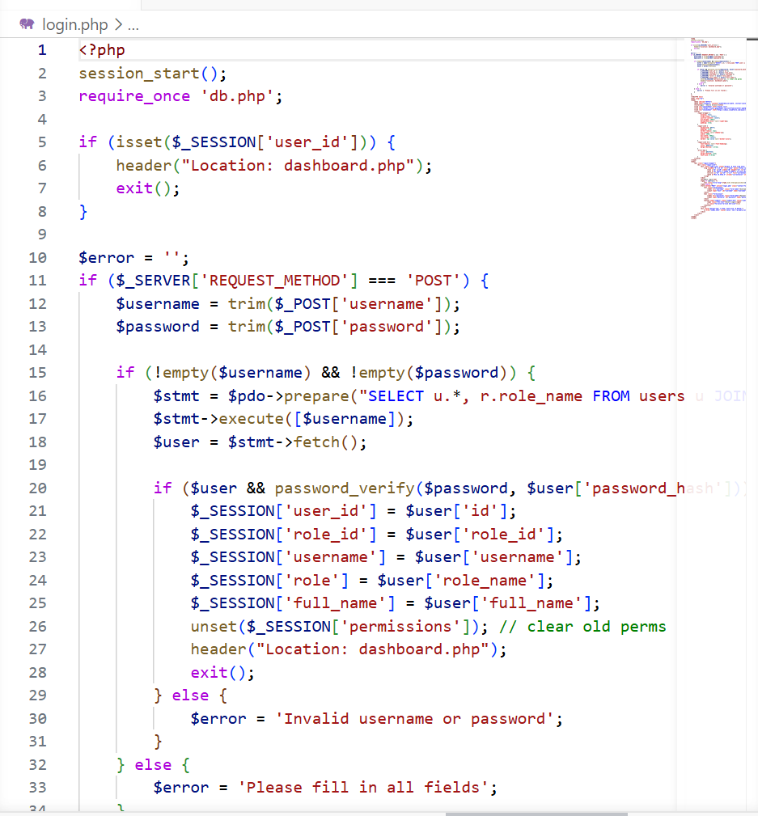
Figure 10::Login code 1

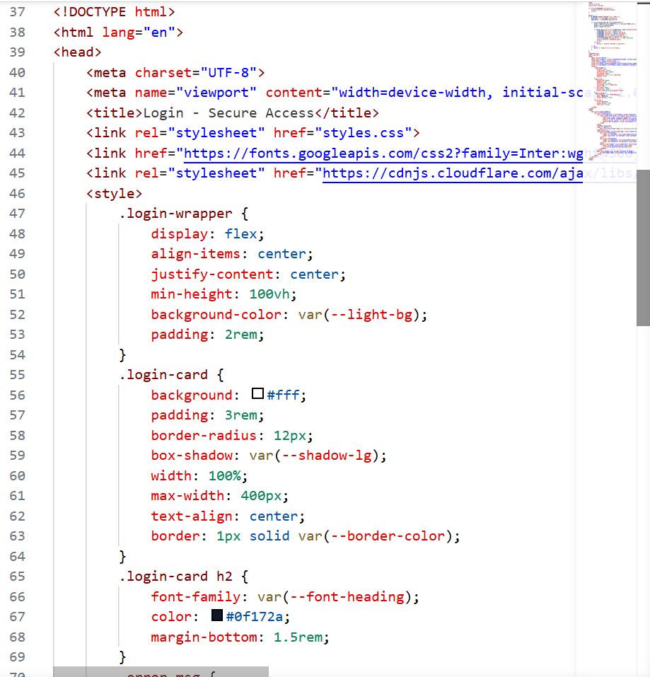
Figure 11:Login code 2

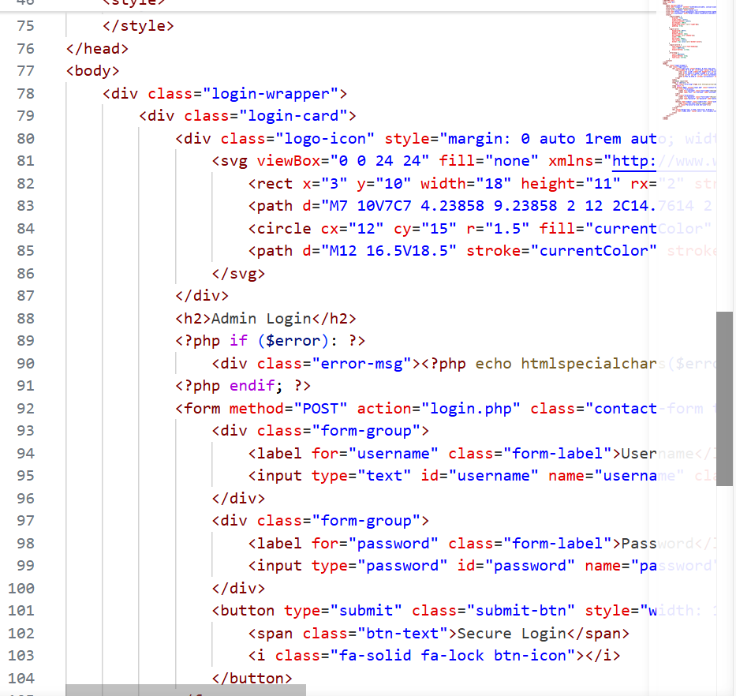
Figure 12::Login code 3

RFID Simulation Code:

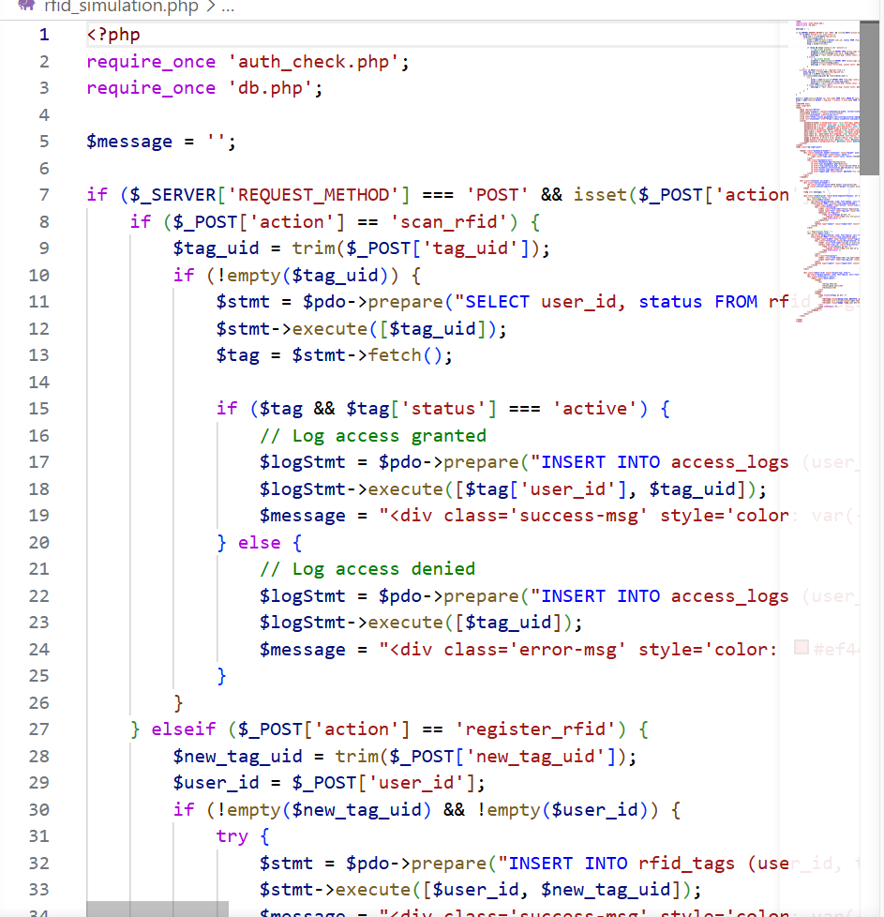
Figure 13:RFID Simulation Code1
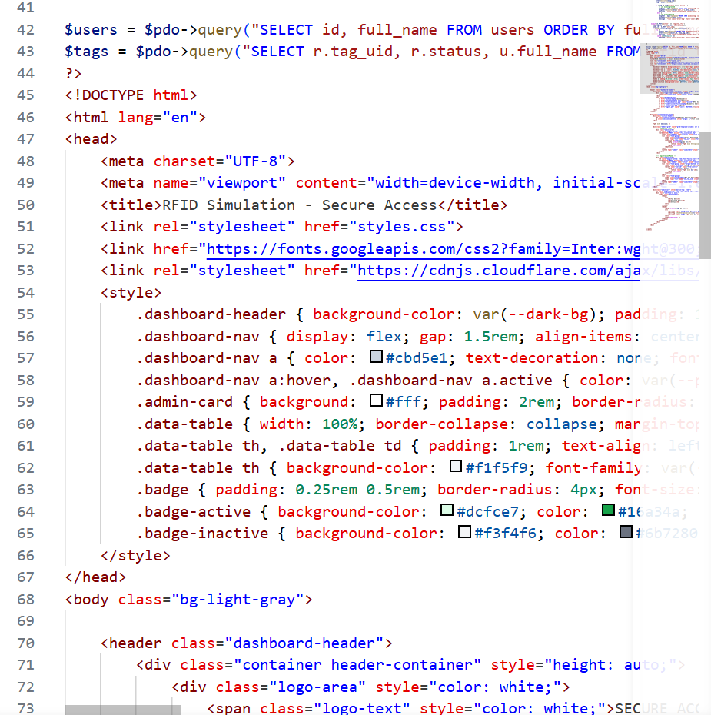
Figure 14:RFID Simulation Code 2

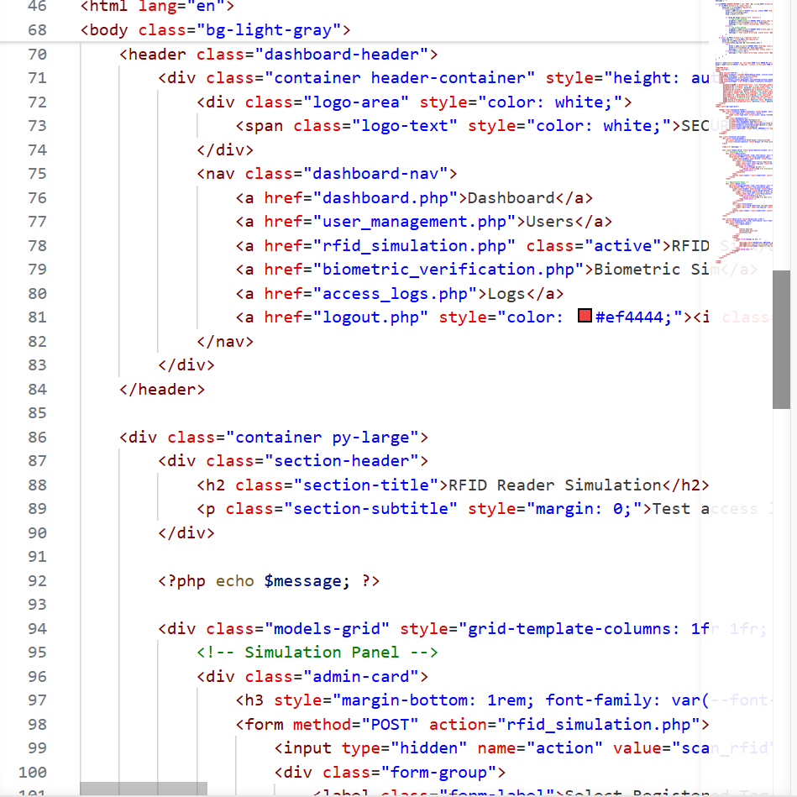
Figure 15:RFID Simulation Code 3

Biometric Simulation Code:

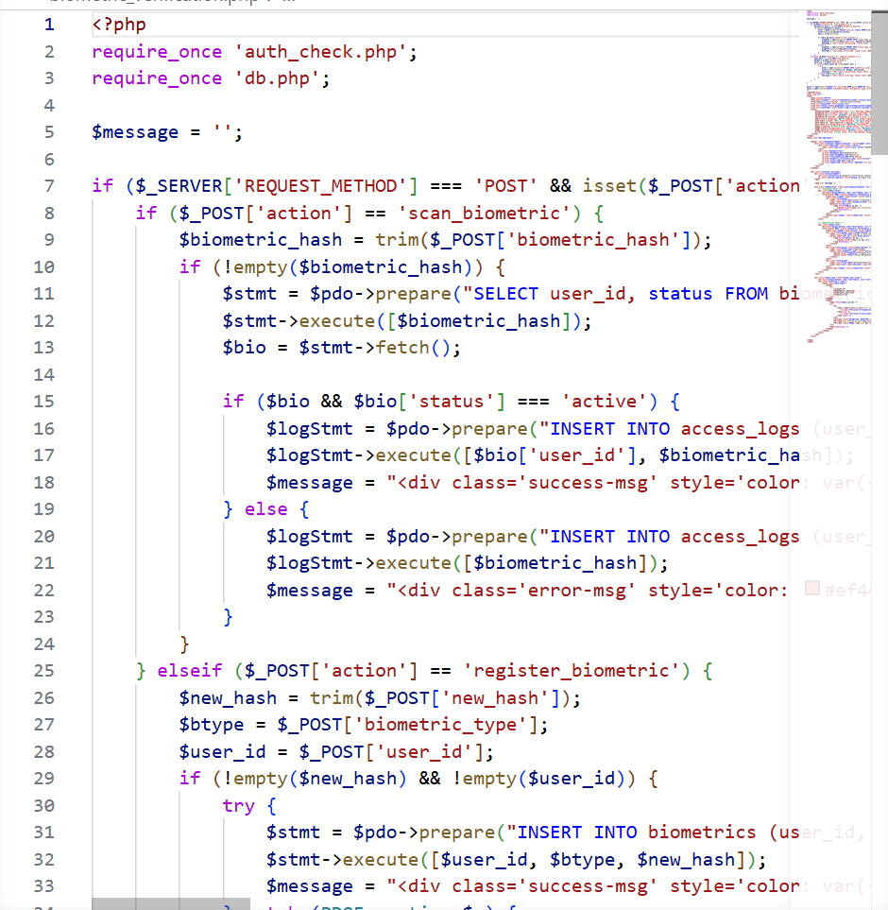
Figure 16:Biometric Simulation Code 1

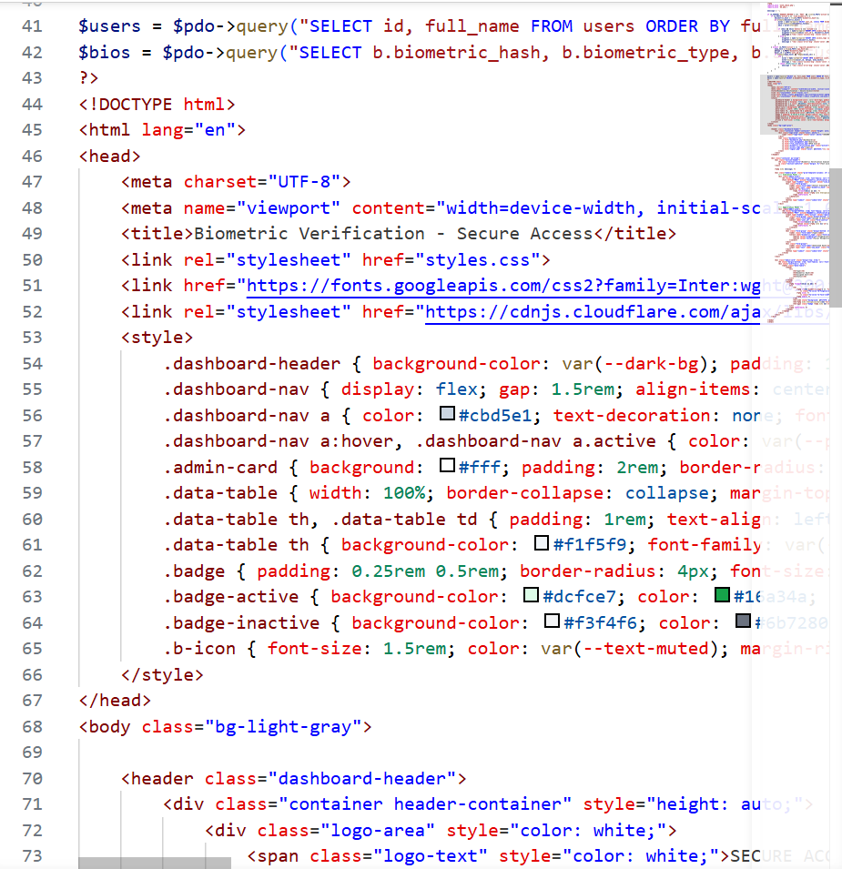
Figure 17:Biometric Simulation Code 2

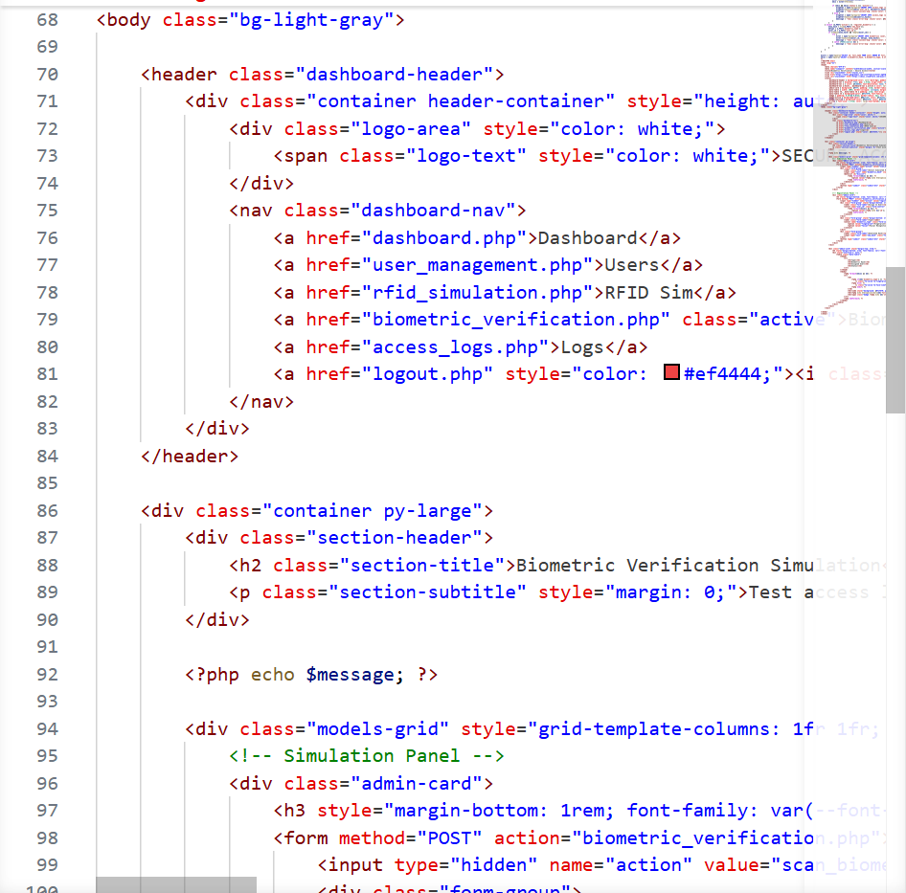
Figure 18:Biometric Simulation Code 3

Database Connection Code:

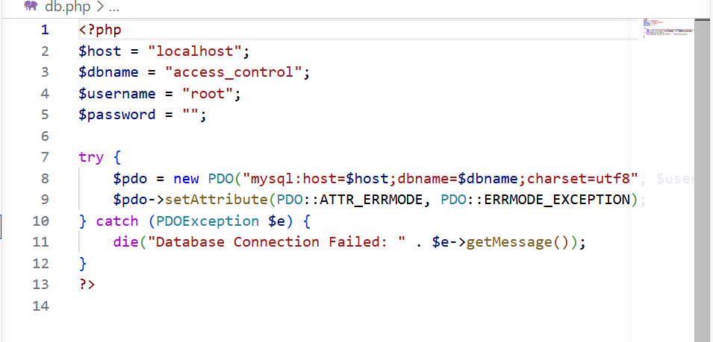

Figure 19:Database Connection Code

Database Structure:

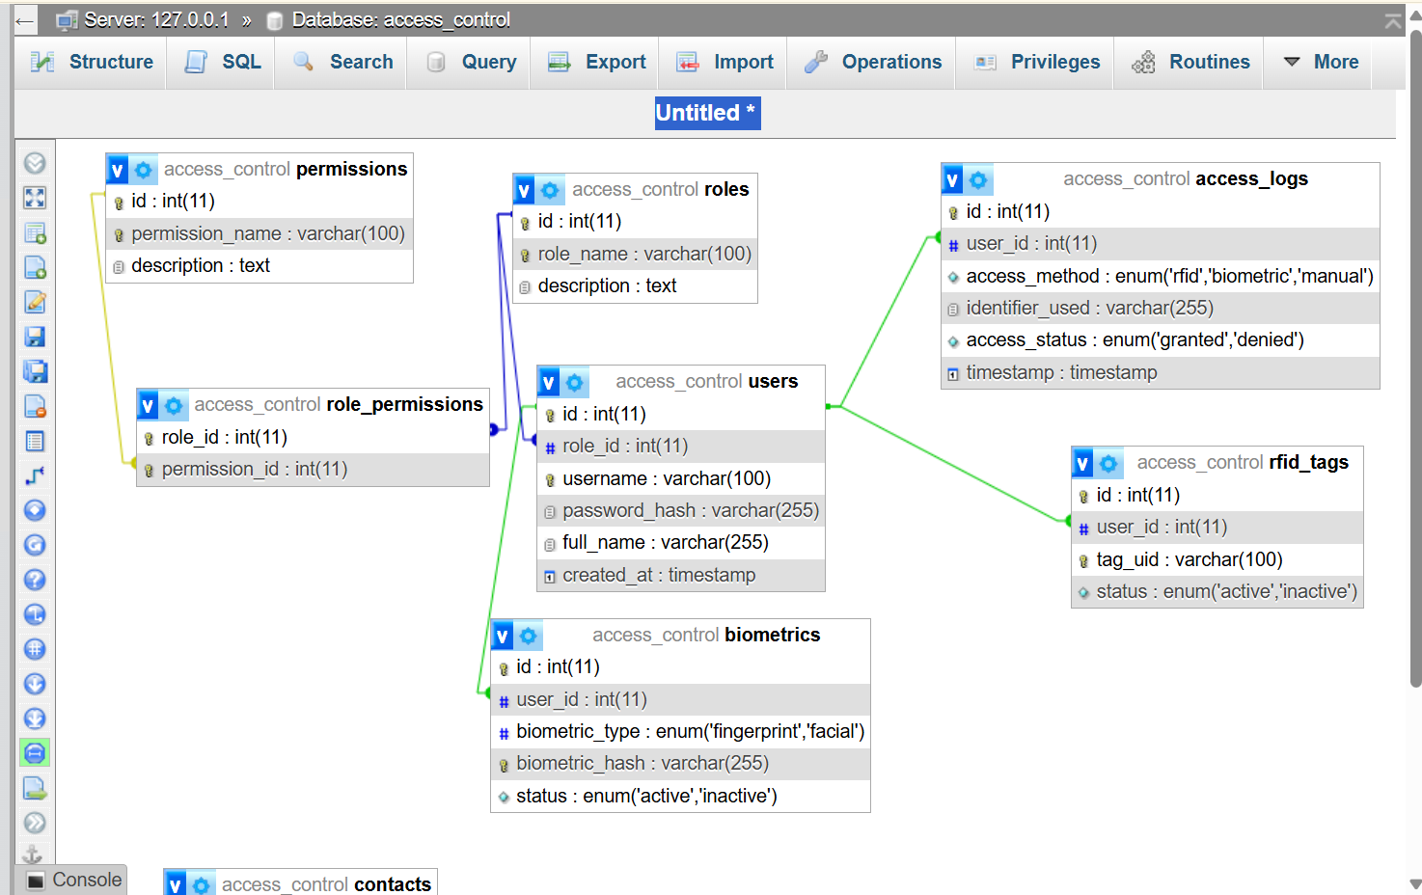
Figure 20:Database Structure

Permission table:
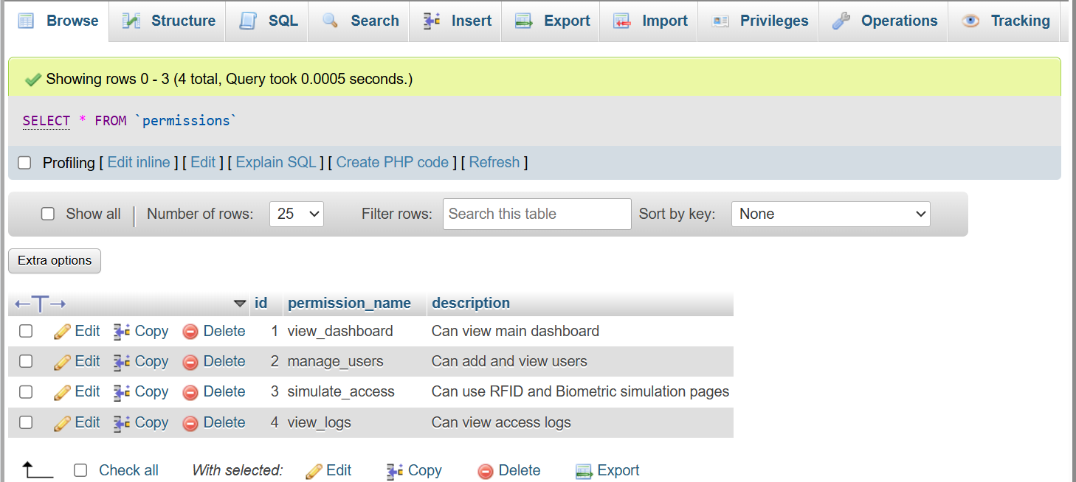
Figure 21:Permission table

Roles:

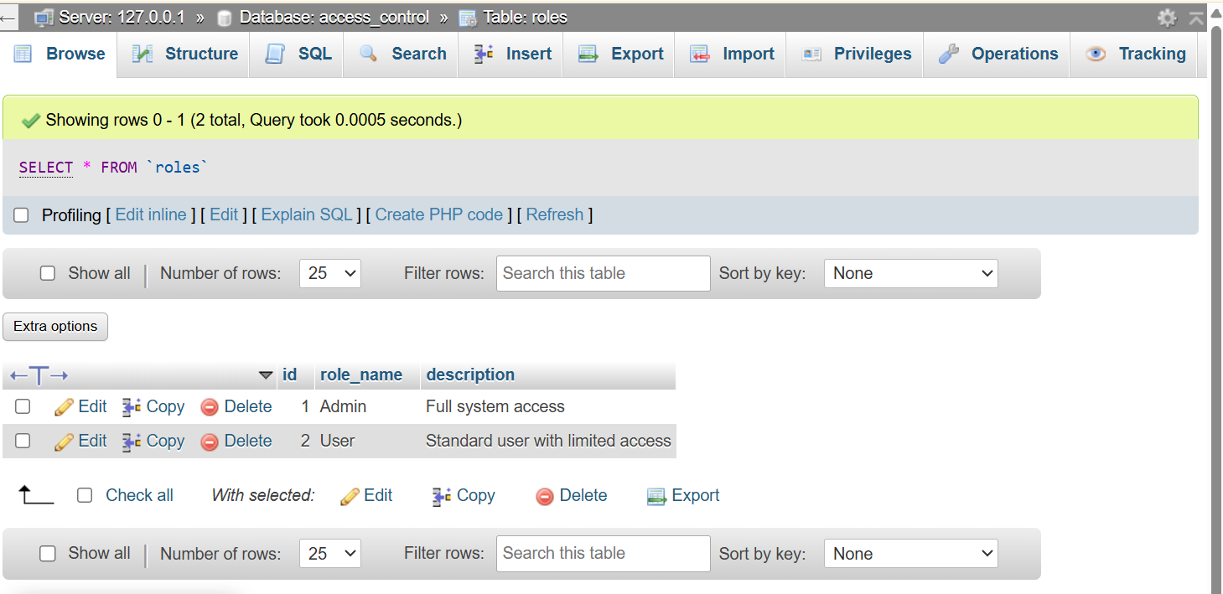
Figure 22:Roles table

Users:
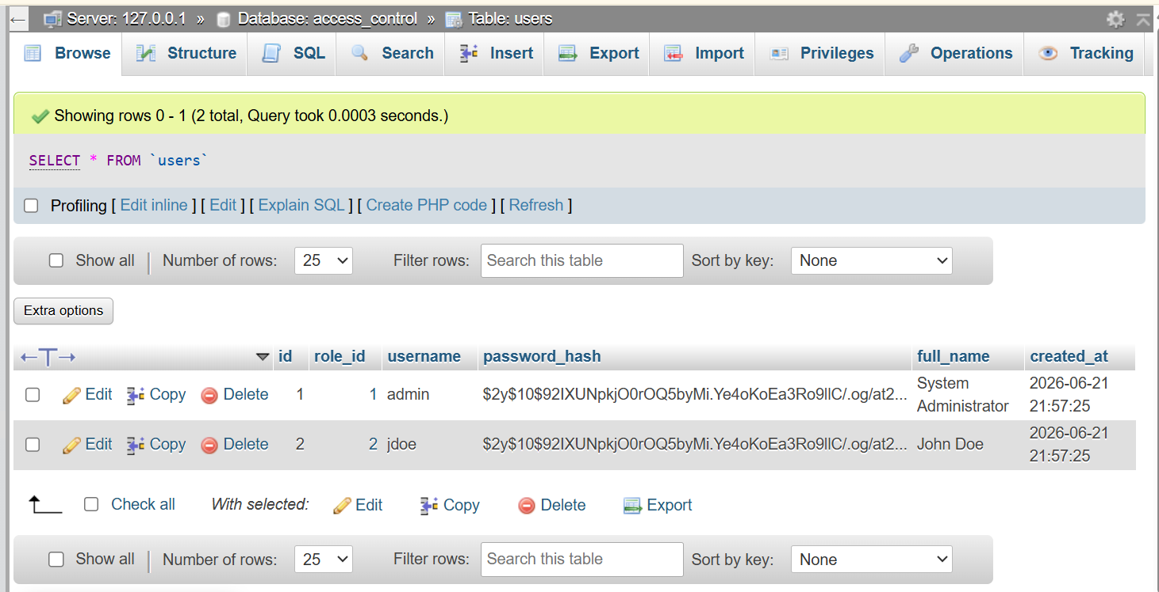
Figure 23:Users table

RFID tags:
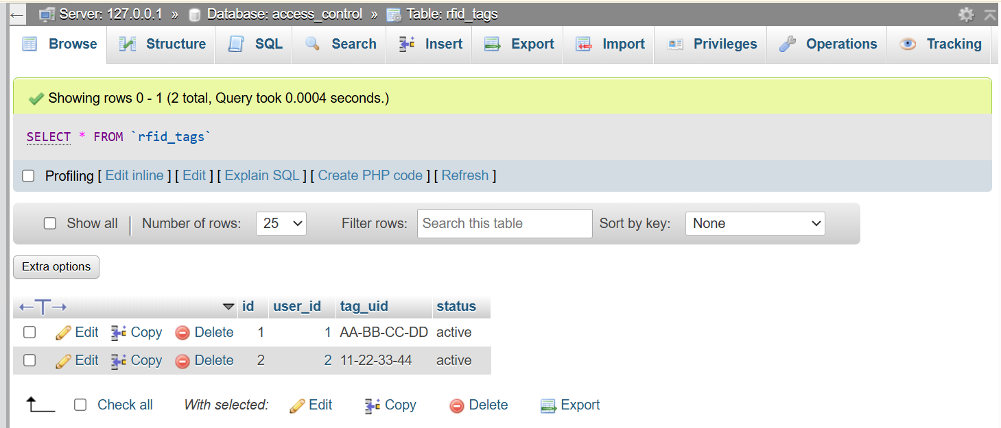
Figure 24:RFID tags

DB tables:
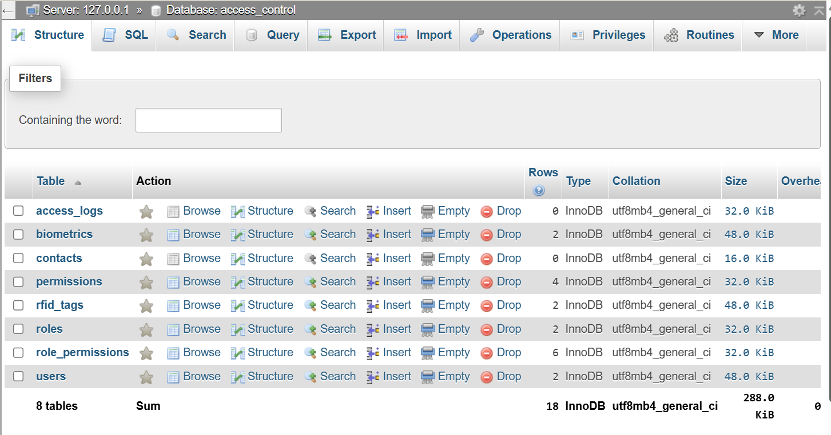
Figure 25:DB tables

