

Design and Realization of Automated Test System for GaN Power Devices

by
Jiaqi Zhang
Supervisor: Steve Mosey

Project submitted as part of the requirements for the award of MSC Software Engineering

November 2021

DECLARATION

I,Jiaqi Zhang declare that I am the sole author of this Project; that all references cited have been consulted; that I have conducted all work of which this is a record, and that the finished work lies within the prescribed word limits.

This work has not previously been accepted as part of any other degree submission.
Signed : .......... .......
Date : ......... .11/11/2021....................

FORM OF CONSENT

I, Jiaqi Zhang hereby consent that my Project, submitted in candidature for the M.Sc. Software Engineering degree, if successful, may be made available for inter-library loan or photocopying (subject to the law of copyright), and that the title and abstract may be made available to outside organisations.

Signed : ....... ..........

Date : ........... 11/11/2021..................

Abstract
With the vigorous development of electronic information technology, semiconductor devices, as key elements of hardware circuits, have also experienced three generations of evolution in the course of development in recent decades. As a representative of the third-generation semiconductor, gallium nitride GaN has the characteristics of large forbidden band width, large critical breakdown electric field, high saturated electron drift speed, and stable chemical properties. Due to the many performance parameters of GaN power devices, traditional manual testing is relatively cumbersome and the test parameters are biased. Therefore, the research on GaN power device automatic test system is of great significance.
This project uses NI-LabVIEW as the software platform and the source measurement unit (SMU) as the hardware platform to develop an automated test system. VISA (Virtual Instrument Software Architecture) technology realizes the communication between software and instruments, and uses MYSQL database to complete data storage and sharing. The test system realizes user account management, parameter setting of test instruments, measurement of GaN power device characteristic parameters, and can display the collected data on the waveform graph while saving the data to files and databases. The system not only can comprehensively evaluate and truly reflect the performance level of the device, but also saves labor costs, reduces the risk of error, and greatly improves test efficiency.
The GaN device test system can accurately and effectively complete the automated test of GaN power devices. The host computer page is friendly and easy to operate, and can display and store the collected data. Through the system test, the communication module can realize the communication between the upper computer and the instrument and the switch matrix, and the upper computer software can run stably, and can realize the functions of instrument parameter setting and important parameter storage, and meet the design requirements.

Table of content
DECLARATION I
Abstract II
Chapter 1 Introduction 1
1.1 Aim 2
1.2 Objectives 2
1.3 Structure of the report 3
Chapter 2 Literature review 5
2.1 Research progress of GaN power devices 5
2.2 Automated test system 7
2.3 The research direction of this system 10
2.4 Technical introduction 10
2.4.1 Virtual instrument technology 11
2.4.2 SCPI 12
2.4.3 VISA 13
2.4.4 MYSQL 14
2.5 Conclusion 16
Chapter 3 Research methodology 17
3.1 Research overview 17
3.1.1 Research Philosophy 17
3.1.2 Research Approach 18
3.1.3 Research strategy 18
3.2 Research design 19
3.3 Development methods 20
3.4 Conclusion 22
Chapter 4 System Analysis 23
4.1 Requirement analysis 23
4.1.1Functional requirement analysis 23
4.1.2 Non-functional requirements analysis 25
4.2 Feasibility analysis 27
4.2.1 Economic feasibility analysis 27
4.2.2 Technical feasibility analysis 28
4.2.3 Social feasibility analysis 28
4.3 Conclusion 29
Chapter 5 Design and implementation of system 30
5.1 System overall design 30
5.1.1 Hardware structure design 30
5.1.2 Software structure design 31
5.2 User login management module design 35
5.3 Design of Test module 38
5.3.1 Communication method 39
5.3.2 Parameter configuration 42
5.3.3 Instrument control 44
5.3.4 Data Management 45
5.4 Implementation of User Login Management Module 47
5.4.1 Login page 47
5.4.2 Account Management Page 48
5.5 implement of Test module 55
5.5.1 Instrument communication 55
5.5.2 Parameter configuration 57
5.5.4 Data Management 59
5.6 Conclusion 62
Chapter 6 Evaluation 63
6.1 Test content 63
6.2 Test methods 64
6.2.1 Interface test 64
6.2.2 Function test 65
6.3 Conclusions from the test 67
6.4 Realization with literature review 68
6.5 Aim and Objects implementation 68
6.6 Expected results 69
6.7 Do it again 69
Chapter 7 Conclusions and recommendation 71
7.1 Summary 71
7.2 Conclusion 72
7.3 Suggestions for further study 72
Chapter 8 Reflection 74
References 75

Table of diagram
Diagram 1 Block diagram of research methodology 19
Diagram 2 Structured development block diagram 22
Diagram 3 Use case diagram of administrator 28
Diagram 4 Use case diagram of tester 28
Diagram 5 Hardware block diagram of GaN power device automated test system 32
Diagram 6 Software block diagram of GaN power device automated test system 33
Diagram 7 Operation process of GaN power device automated test system 34
Diagram 8 Account management system block diagram 37
Diagram 9 Account management system operation process 39
Diagram 10 System sending instruction flow 42
Diagram 11 System receiving data flow 43
Diagram 12 Account management operation process 50
Diagram 13 State transition diagram 58

Table of Figure
Figure 1 Login interface 39
Figure 2 Test module interface 41
Figure 3 VISA function 42
Figure 4 Parameter configuration interface 46
Figure 5 Data result save data table 48
Figure 6 User login code 49
Figure 7 Account management interface 50
Figure 8 Add user program code 52
Figure 9 Delete User program code 53
Figure 10 Update User Password program code 54
Figure 11 Account query code 54
Figure 12 Serial port initialization code 57
Figure 13 Send Command code 58
Figure 14 Parameter configuration code 59
Figure 15 Instrument control part code 61
Figure 16 Characteristic parameter graph 62
Figure 17 Generate report code 63
Figure 18 Test Results 63
Figure 19 Test data saved in the database 64

Table of table
Table 1 Comparison of the main static characteristics for several GaN devices 45
Table 2 Test cases for each functional module 69

Chapter 1 Introduction
As an important field that promotes the technological revolution and industrial revolution, and an important driving force for the deep integration of informatization and industrialization, the electronic information industry has developed tremendously in the past few decades. As the basis for the development of modern electronic information industry, semiconductor materials have undergone several generations of changes. The third-generation semiconductors represented by silicon carbide (Sic) and gallium nitride (GaN) have high frequency, high efficiency, high power, and high voltage resistance, high temperature resistance, radiation resistance, etc., suitable for the production of high-frequency, high-efficiency and high-power devices that work in high-temperature and high-voltage environments. Because GaN high electron mobility transistors have the characteristics of wide band gap, high temperature, high radiation resistance and high output power, they can meet the needs of new generation electronic equipment for high temperature, high power and light volume of microwave power devices, so they can be widely used in new energy vehicles, Communications and household appliances and other fields.
The performance of GaN devices is reflected by its characteristic parameters. In microwave communication systems, users have increasingly higher expectations for the high reliability and low cost of GaN power devices. In various application fields, it is particularly important for users to have an understanding of the various characteristic parameters and indicators of the GaN devices used according to their own needs. In addition to users, in order to improve product quality and meet the different needs of users, manufacturers of GaN power devices also need to conduct rigorous tests on different characteristic parameters and indicators of their products to provide users with accurate characteristic parameter curves.
Therefore, whether it is for users or manufacturers, the measurement of the characteristic parameters of GaN devices is of great significance. In the past, the measurement of the characteristic parameters of GaN devices was mostly carried out by a combination of relatively backward automatic and manual methods. In the test process, because the parameter setting and control are manual, which causes large errors in the test results, not only the test time is long, but also the quality of GaN device production is directly affected.

1.1 Aim
The main aim of this report is:
Develop a set of automated test systems for GaN power devices to provide test technical guarantees for comprehensive assessment, true reflection of device performance levels, and greatly improved test efficiency.

1.2 Objectives
After the test system is developed, the following functions are expected to be realized:
(1) Have a separate user management module, which can set the user's account and password;
(2) There is a separate communication module, which can communicate with the instrument and switch matrix;
(3) The page layout of the host computer is reasonable, which is convenient for users to operate;
(4) Provide a special instrument configuration function, can set the scanning start value, end value, step value, limit value, etc. of the digital source meter through the host computer;
(5) The host computer software can collect the data returned by the instrument, and display the data on the chart and waveform diagram. The waveform diagram can well reflect the changes in the different characteristics of GaN power devices;
(6) The upper computer software can well save the collected data to a local file and upload it to the database, which not only completes the local storage but also performs backups and realizes data sharing.

1.3 Structure of the report
This paper is mainly divided into three main parts: The first part is a literature review and research methods, which analyzes the current research progress of GaN power devices and the third-generation automated test system, and lays a theoretical foundation for the research of the system; the second part introduces GaN The demand analysis of the power device automatic test system, and the test system is designed and implemented according to the demand; the third part is to test the realized automatic test system and get the test results.
The structure of this paper is divided into eight chapters, and the specific chapters are arranged as follows:
Chapter One This chapter briefly introduces the project, and proposes the research Aim and Object of the project.
Chapter 2 The content of this chapter is a literature review. It introduces the research progress of GaN power devices and the third-generation automated test system, proposes the research direction of the system, and introduces the technology needed for the project.
Chapter 3 This chapter discusses the research methods used in the project and selects the structured development method according to the characteristics of the system.
Chapter 4 This chapter mainly focuses on the functions to be realized by the system and does demand analysis and non-demand analysis. At the same time, it conducts feasibility analysis from the three aspects of society, technology and economy.
Chapter 5 This chapter is the core part of the thesis, which mainly introduces the design and implementation of the test system. According to demand analysis, five functional modules are designed for the system: communication module, user login management module, parameter setting module, instrument control module, data display and storage module. Then use the labview programming language, VISA, SCPI, MYSQL and other technologies to realize these functional modules.
Chapter 6 This chapter mainly tests the system. The test is divided into two aspects: interface test and function test. During the test, the results were compared with the expected results, and the conclusion that the system can operate normally was obtained.
Chapter 7 This chapter analyzes and summarizes the results and finds the deficiencies of the design. According to the actual application situation, it is necessary to further expand the function of the system.
Yes, improve equipment performance and put forward constructive suggestions.
Chapter 8 This chapter is the author's reflection on the whole project.

Chapter 2 Literature review

2.1 Research progress of GaN power devices
Compared with the first generation semiconductor material silicon (Si) and the second generation semiconductor material gallium arsenide (GaAs), the third generation semiconductor material gallium nitride (GaN) has a large band gap (3.39 eV) and high strength. Breakdown electric field, saturated electrons with high drift speed, high thermal conductivity, small dielectric constant, high frequency resistance, high voltage resistance, high temperature resistance, high light efficiency, high power, strong radiation resistance and stable chemical properties And other superior performance, so it can be prepared to run stably at high temperature, and it is more reliable at high voltage and high frequency.
Relying on semiconductor devices, the device can consume less power and obtain stronger operating capabilities. Gallium nitride meets major national strategic needs such as energy saving and emission reduction, intelligent manufacturing, and information security, and has become an important development direction of the electronic information industry in the future, becoming the forefront of global semiconductor research and the focus of industrial competition [1-2]. Gallium nitride is one of the materials of choice for the preparation of high-temperature, high-frequency, high-power and high-density integrated microwave devices. Due to its unique band gap, it can emit blue light with a shorter wavelength than red light and can be made into highly efficient Blue, green, purple and white light-emitting diodes and photodetectors [3]. As a typical representative of the third generation of semiconductor materials, gallium nitride is a key material and core device in the strategic emerging optoelectronic information and integrated circuit industry. It is the technological commanding heights of 5G communication technology, green energy-saving and environmental protection technology, and national defense and military safety. It is a strategic emerging Industrial highland [2,4].
With the popularity of power electronics, new energy, electric vehicles, 5G communications, high-speed rail trains, energy Internet, and smart industry, the rise of applications such as wireless charging, lidar for driverless cars, data centers, and the Performance puts forward new demands. However, traditional silicon devices have reached their physical limits due to material characteristics and cannot meet emerging demands in terms of performance[5]. Therefore, it is urgent to find the next replacement driven by Moore's Law. Therefore, major international semiconductor manufacturers have turned their attention to electronics. Gallium nitride, which has excellent performance and is considered a noble new generation of semiconductor materials. Acquisitions, mergers, and industrial integration of gallium nitride devices are happening constantly, and gallium nitride power semiconductors have increasingly become the focus of attention worldwide.[6].
The research on GaN power devices can be traced back to the late 1990s. F. Ren et al. designed the first GaN power device in the world using gallium oxide as a gate dielectric [7]. Then in 2000, the GaN power device made by J.W Johnson and others was made using SiO2/Gd2〇3 as the gate dielectric. Its highest gate voltage can reach 7V, and the drain-source maximum withstand voltage With a value of 80V, within the allowable voltage range of the gate voltage, the modulation effect of the GaN power device is revealed.
After entering the 21st century, in the course of more than ten years of development, GaN power devices have developed rapidly along the four development directions of higher power, higher frequency, higher bandwidth and higher efficiency. In 2003, researchers such as R. Behtash used molecular beam epitaxy (MBE) to develop AlGaN/GaN HEMTs on Si substrates. The power density of this transistor exceeds 6.5W/mm, and the power added efficiency is close to 50. %[8]; Around 2006, S. Joblot used the same method to develop gallium nitride power devices, and the electron migration rate reached 1500 cm2/Vs [9]; by 2009, Haifeng Sun, Benedickter H, etc. developed The cut-off frequency of gallium nitride HEMT devices exceeds 100GHz. When the operating frequency is greater than 10GHz, there is still a power gain close to 20dB [10]; in 2015, research results published by Philippe Altuntas et al. showed that the power of gallium nitride developed The gate length of the device is 75nm, and the power gain is greater than 6dB under the operating frequency of 40GHz [11]. While these gallium nitride power devices have achieved major scientific research results, they have also been widely used commercially, which promotes the continuous progress and development of gallium nitride power devices. Compared with foreign research on GaN power devices, related research in related fields in China started late, and there is still a certain gap in performance compared with foreign products, but certain research results have also been achieved. In 2012, the Institute of Microelectronics of the Chinese Academy of Sciences used a 300nm gate length process to achieve a power output of 18W of gallium nitride power devices, with an operating frequency close to 14GHz [12]; in 2014, the 55th Research Institute of China Power Group successfully adopted a 25nm process A power amplifier with a working frequency of up to 4GHz has been developed, and its output power has reached 150W[13]; around 2015, the 13th Research Institute of China Power Group has developed a 4~8GHz gallium nitride power device, and its output power Achieved 120W [14]. It is worth mentioning that the Hao Yue research team of Xidian University successfully independently developed an S-band HEMT device in 2014, and its output power exceeded 100W. The following year, the team designed a C-band gain close to 30dB. The power amplifier [15] has achieved great success.

2.2 Automated test system
With the emergence of circuit boards with a wide range of functions and different types of semiconductor devices, the tasks of modern testing have become heavier and the test workload has become heavier, and the year-on-year increase in labor costs has also brought heavy burdens to enterprises. The development of science and technology and the needs of the market led to the birth of early automatic test equipment[16]. With the continuous expansion of market demand, automatic test technology has also been rapidly developed. The appearance of computers in the 1960s perfected automatic test equipment. Compared with manual testing, automatic testing has huge advantages in terms of test efficiency, product consistency, and labor costs, and plays an important role in the development of national defense and scientific research[17].
With the computer as the core, under the control of the program, the instrument system that automatically completes the specific test tasks is called the automatic test system (ATS)[18]. ATS was first developed to meet the needs of multi-point automatic patrol inspection. After adopting computer technology, ATS has made great progress. It can not only quickly and automatically complete the itinerant detection of hundreds of physical parameters and switch states, but also has many functions such as process monitoring, data analysis, fault diagnosis and prediction. The development of the automatic test system can be traced back to the SETE program that the United States launched in the 1950s to solve the problems encountered in the maintenance of military electronic equipment[19]. By the 1960s, computers began to be used in the testing field, and automatic testing technology has also been rapidly developed and widely used.
The development of automation systems has probably undergone a three-generation process from a dedicated type to a general-purpose type. The first-generation automated test system is a special-purpose test system. This type of system is developed for specific tested instruments and test requirements. It is generally built with specific equipment and test boards, and the software is also customized. This kind of test system is aimed at strong performance, compact structure, and high test efficiency [20]; the disadvantages are: high development cost, poor adaptability, test resources cannot be shared, and poor interoperability [21]. The second-generation test system is called a building block desktop instrument system, which consists of two parts. The first part is a variety of desktop instruments, and the second part is a standard bus interface. The instruments that make up the system are all traditional instruments, and each instrument has the same characteristics, that is, it is equipped with bus plug interfaces such as PXI and VXI. When combined into a system, only the cables of the corresponding bus protocol are required for testing. Just connect all of the instruments. The building-block feature makes the second-generation system's adaptability to products greatly enhanced compared with the first-generation, and the equipment has a high reuse rate. When not forming a system, the instrument can also be used alone. The disadvantage is that the data transmission efficiency on the serial line is too low, and it is not convenient to form a high-speed and high-efficiency ATS; at the same time, there are repeated configurations of system resources, which makes it difficult to build a portable test system [22]. The third-generation automated test system is a modular instrument test system. With the development of test bus technology, especially the development of VXI, PXI, LXI and other technologies, many manufacturers of module instruments based on standard test bus have appeared abroad, such as Keysight (formerly Agilent), Racal, NI, Tektronix, etc. Manufacturers have introduced thousands of instrument modules to provide a good foundation for the construction of the test system. From this, the third generation of automatic test system, the modular instrument test system, emerged[23]. This type of test system is constructed with modular instruments, shares the chassis and power supply, and uses software to achieve various test and measurement functions, which can comprehensively cover various test requirements. Its characteristics are: high system test efficiency, reasonable allocation of resources, and the test system is light and mobile. The main disadvantage is that there is still a lot of room for improvement in high-frequency coverage, interoperability, TPS portability, system test adaptation, fault diagnosis, etc. [24].

2.3 The research direction of this system
Based on the existing platform, design an automatic test system for GaN devices on-chip and after packaging to improve test capabilities and test efficiency; for the characteristics of GaN high-power devices with multiple test parameters and high device parameter levels, through GaN high-power device test technology research, development A highly integrated intelligent automatic test system based on existing test equipment and switch matrix units. The automated test platform is composed of software and hardware. The software is responsible for controlling the test process, collecting test data, calculating and archiving test results. The hardware is mainly the GaN test system hardware platform, which is mainly composed of measuring instruments, relay circuits and devices under test. In the development process of the test equipment, the National Instruments development platform was used for actual application development, which mainly completed the overall framework design, login interface design, module test design, image display and data storage design, and realized third-party data viewing design.
This article will realize the communication between LabVIEW and the database, encrypt the account data and save it in the database, so that the user's privacy information is protected, and save the test data in the database to facilitate the access of third-party software, and realize the remote analysis, processing and management of the data.

2.4 Technical introduction
The GaN device automatic test system is a test system based on virtual instrument technology. In the process of developing the system, some related technologies and development tools are used.

2.4.1 Virtual instrument technology
With the continuous breakthrough and development of computer hardware, a new concept-virtual instrument has emerged. The emergence of virtual instrument has caused a revolution in the field of test instruments, and the status of traditional instruments has been challenged. The virtual instrument (Virtual Instrument, referred to as VI) is a close combination of the processor and the instrument. It takes the PC platform and equipment with measurement and control functions as the hardware of an instrument, and on this basis, defines and produces a tailor-made software according to its own needs, and realizes the functions of the instrument on the computer. The advent of virtual instruments has broken the situation that manufacturers design instruments and equipment, but customers can only passively accept it, allowing customers to make their own test equipment according to their own wishes. "Software is the instrument". In the system developed using it, it is not the hardware but the software that occupies the core position. Different from the general system, the hardware exists only to transmit signals, to output and input signals, and all other parts are completed by software. In the virtual instrument system, the realized function can be determined by the user. Instead of relying on the instrument manufacturer, the user can redesign or modify the inherent design through the software platform to make it a tailor-made instrument for their own enterprise.
VI is essentially not a new type of equipment, but an advanced R&D concept. Simply put, virtual instruments are not limited to any form. The performance of virtual instruments depends on the selection of hardware, that is, the choice of which precision signal acquisition equipment and system structure; but the key part is still software, which is the software. The core component of VI is also the most difficult part of the entire design. There are various software development tools. LabVIEW is the abbreviation of laboratory Virtual Instrument Engineering workbench[25].
The advantage of virtual instrument technology is that it is composed of bus-type control and modular hardware and uses high-efficiency algorithms and convenient interfaces to meet user production inspection needs and intelligent detection functions. The development of virtual instruments relies on computers. It uses and inherits the advantages of computer technology. It uses high-efficiency multi-threaded processors to read, write, control and calculate files and programs. It also supports storage devices and outputs test conclusions to the outside world. Assume. As the inspection and acceptance of products requires more and more diversified types of measuring equipment, more powerful functions, and higher precision, virtual instruments are becoming more and more important in the field of measurement, and they will develop rapidly in the future. Become a leader in the measurement field.

2.4.2 SCPI
With the development of measurement technology and instrument technology, a variety of measurement instruments have appeared in the intelligent standard test instrument industry. These intelligent instruments have their own standard interfaces, such as GPIB interface, PCI interface, USB interface, RS232 interface, and so on. Through these interfaces, instruments from different manufacturers and with different functions can form an automatic test system, which has hardware compatibility. However, each manufacturer has its own programming language, the same command may have different meanings in different instruments, that is, there is no compatibility in the programming language. SCPI provides a consistent programming environment for the use of instrument control and data transmission by specifying programming language, instrument response and data format[26]. It is suitable for all programmable instruments and does not need to distinguish between instrument manufacturers, reducing the development of automatic test instruments. time. In this programming environment, you can use the same commands and parameters to control different instruments with the same functions. Commands and parameters can be sent to the instrument from the computer via IEEE488.1, VXI bus, RS-232 and other interfaces. The SCPI instrument is very flexible in the format of the received commands and parameters, which makes programming of the instrument simple. The data returned by the instrument to the computer can be measured data or instrument status information. Therefore, the use of SCPI is only related to the performance and functions of the instrument, so other factors such as the hardware foundation of the instrument and the manufacturer can be ignored.
SCPI is an ASCII-based instrument command language, suitable for test and measurement instruments, to achieve the purpose of reducing application development time. Therefore, instrument manufacturers are required to strictly abide by the instructions stipulated by SCPI, so that instrument program developers do not need to learn the instruction language of a certain instrument, which ensures the compatibility and ease of use of instrument system development. Since SCPI was released in 1990, it has been continuously expanded and updated, and it has also been supported by major instrument manufacturers in the world, such as Agilent and NI. SCPI is suitable for a variety of programmable instrument systems. It has very flexible guidelines, which facilitates the development of software for users, improves development efficiency, and the test program is simple and easy to understand, which greatly improves the interchangeability of instruments.

2.4.3 VISA
In the automatic test system, the I/O driver software is used to handle the communication between the computer and the instrument. For example, the computer communicates with the instrument through various interfaces such as GPIB, serial interface, VXI, ETHERNET, etc., which requires the support of the I/O driver software. Different I/O driver software has different characteristics and different user interfaces. The open structure and interoperability of VXI require that instruments use standard I/O libraries. VISA (Virtual Instrument Software Architecture) was developed for this purpose. It has nothing to do with instrument type, interface type, operating system, programming language and network device. It can be seen from this independence that VISA is not an I/O function library only used for VXI bus, but a standard that can be used universally. That is, the software written in VISA can be used for multiple interfaces such as GPIB, VXI, ETHERNET and serial interfaces and multiple operating systems, which also reflects the main goal of VISA design: to create a single, easy-to-use I/O control Function set; At the same time, it can transparently adapt to single-processor, multi-processor and fully distributed system structures, and provide an upgrade from non-distributed systems to distributed systems and existing assembled I/O libraries Way.
The purpose of the VXI plug&play Systems Alliance is to provide an open, multi-vendor VXI system for instrument end users. The organization strives to achieve this goal through the standardization of software and hardware products. Use the existing formal standards and industry de facto standards to define the functional framework structure of the instrument and equipment. In this framework structure, users can obtain true interoperability at the software and hardware levels of the instrument [27].

2.4.4 MYSQL
Due to the wide variety of databases, the choice of database is very important to the project, and many factors such as project content, data relationships, cost, maintainability, and stability must be considered at the same time. Databases are divided into two categories: Relational Database and Non-Relational Database. Non -Relational Database is a data storage system that uses key-value pairs to store data. The structure is not fixed, and the distributed data storage system does not follow the ACID principle. The advantage is that users add data types according to the actual situation. In SMS [28], mainstream software representatives include Couchbase, MongoDB, Amazon DynamoDB, etc.; Relational database refers to a Relational Type database, which refers to a database that uses Relational Dodel to organize data, and Relational Model refers to a data mapping relationship in a two-dimensional table. Relational Database is a data organization structure composed of such two-dimensional tables through mapping. It is characterized by easy understanding, convenient use and strong maintainability. The mainstream representative software includes Oracle, Microsoft SQL Server, MySQL, PostgreSQL, DB2, etc. According to the actual situation of the project, this project chooses a relational database [29].
Microsoft SQL Server database has the advantages of strong ease of use, good distributed organization ecosystem, and high cost performance. Data management and analysis are flexible, fast response to changes, complete database and data analysis package, fully Web-supported database and XML support capabilities; the disadvantage is that it does not have openness, the client only supports C/S mode, SQL Server C The /S structure only supports ADO, DAO, OLEDB, ODBC connections for windows clients, and the compatibility is not strong [30].
The Oracle database is portable, can run on mainstream platforms, and supports all industry standards. Adopting an open strategy enables customers to migrate Data Base to UNIX Oracle Parallel Server, and it can have a very good degree of convergence on UNIX platforms with different configurations [31]. Oracle has high performance and maintains world records in TPC-D and TPC-C under the open platform. The disadvantages are that it requires high hardware support, expensive, difficult to maintain, and not very convenient to use the system. At the same time, the technical level of the programming process is high, and the skills of the practitioners are required to reach a considerable height. MySQL has the advantages of low database storage space requirements, timely calculation and running time response, low capital investment, open source, etc., and can adapt to different Operating Systems. At the same time, the interface has multi-language connection operations, and the core instructions use Multithreaded Programming, which does not occupy much system resources. It can make full use of CPU resource authority and the password system is flexible and safe. The code anti-cracking technology is used when the instruction is transmitted, and it needs to be set to host password verification. Supports Microsoft Open Database Interconnection, supports all 2.5 version open database interconnection functions and other related functions, and can also use Microsoft's relational database management system to connect to the MySQL server. Supporting large databases can also provide highly diverse programming language interfaces such as C+, Perl, Java, PHP, Python, etc.. The disadvantage is that it does not support hot backup.
In summary, in relational databases, because LabVIEW has a free toolkit LabSQL for accessing databases, it has the characteristics of cross-platform and multi-database, so the open source code MySQL database management system is chosen.

2.5 Conclusion
As a representative of the third-generation semiconductor devices, GaN power devices have excellent band gap, good thermal conductivity, and ultra-high electron migration rate. However, due to the many test parameters of GaN power devices and the high level of device parameters, if manual testing is used, the measurement results will be affected due to deviations in the actual test. Therefore, a set of automation is designed based on measuring instruments and basic relay units. The test system can not only effectively solve the problem of inaccurate test parameters, but also ensure that the test efficiency of the system is higher, the allocation of resources is more reasonable, and the test system is more portable and mobile.

Chapter 3 Research methodology

3.1 Research overview
Research methodology is a systematic way to solve a problem. Research methodology is a broad set of principles that help researchers choose which methods they should use to conduct their experiments. Methodology is a broad concept that covers research philosophy, research strategy, research design, research approach, sampling, and data collection. collection technique, data analysis and other related techniques. The following Diagram shows its hierarchical structure as follows:
Diagram 1 Block diagram of research methodology

3.1.1 Research Philosophy
In terms of research strategy, the project adopts positivist research philosophy. Positivism (Positivism) refers to a philosophical viewpoint that requires any science to start with sensible facts and is limited to describing these sensible facts and their laws. In this project, GaN power devices, automated test systems, and virtual instrument technology have existed objectively and have been widely used. Therefore, the research idea is to use virtual instrument technology to develop an automated test system for GaN power devices. The method proves whether this research is feasible.

3.1.2 Research Approach
In terms of research approach, the project uses induction to conduct research. Induction (inductive inference), one of the most basic forms of logical inference, refers to a method of inference that infers that all objects of this type of thing have this property based on a certain characteristic of a thing. Using this method, through the research of multiple types of automated test systems for semiconductor devices, it is finally concluded that the best way to develop automated test systems for gallium nitride devices is to use virtual instrument technology.

3.1.3 Research strategy
In terms of research strategy, this project adopts the literature research method and case study. First of all, this article consulted a lot of literature on GaN devices, and summarized some of the characteristics of GaN devices as third-generation semiconductor devices that are different from other semiconductor devices; then, retrieved a large number of documents on automated test systems, and summarized the third-generation The components and advantages of an automated test system. Finally, through the learning and understanding of virtual instrument technology, it was decided to use virtual instrument technology to realize the automatic testing of the characteristic parameters of GaN power devices. In addition to literature research, this article also studies related cases. Aiming at the characteristics of the third-generation GaN devices with many test parameters and high device parameter levels, the Labview visual programming platform is used for program design, which makes the interaction more intuitive and the interface more concise.

3.2 Research design
This project takes a military research institute as the research object. The research institute mainly produces some GaN-based microwave power devices for users to use. During the research process, we mainly observe the inspection methods of the third-generation semiconductor devices such as GaN and SiC produced by the institute. The survey results are as follows:
(1) Because the development of GaN power devices includes materials technology, semiconductor technology, microwave technology and other disciplines of technology. At present, the research institute develops GaN power devices with a certain technical foundation, such as a fixed production line and relatively stable process parameters, but the current products are limited to ground solid discharge parts, and there is a lack of comprehensive reliability evaluation and verification.
(2) For the developed GaN power devices, most of the testers in the institute use manual fixtures to connect the devices, digital source meters provide voltage/current sources, and measure voltage/current methods to test various characteristic parameters of GaN power devices. This manual testing method not only causes certain errors in the measurement parameters, but also causes a waste of human resources.
(3) In the process of testing the GaN device, the device characteristic parameters are measured manually, and the test time is too long. During the test, the test time will have a greater impact on the measurement effect and test efficiency. Long test time will cause the temperature of GaN power devices to rise, and various performance indicators of GaN power devices will change as the temperature rises. Therefore, it is necessary to reduce the test time to improve measurement accuracy and test efficiency.
(4) For the large amount of measurement data obtained after testing the GaN power device, the tester needs to manually filter the required data, and can only draw the data by saving the data to an Excel table to observe the change trend of the characteristic curve. It is very inconvenient to view the test results in this way, and it is time-consuming and labor-intensive.
In view of the above problems, it is very necessary to design a GaN power device automated test system for users.

3.3 Development methods
In terms of software development, this project adopts a structured approach to develop system software. The structured programming method advocates the step-by-step subdivision of the software system according to the function (corresponding to the smallest unit function in the structured program), so it is also called the function-oriented programming method. Each function of this design method is responsible for processing the data once, that is, each function accepts some input data and outputs some data after processing. This way of processing data is also known as data flow-oriented processing. It is characterized by the principle of functional decomposition; top-down, gradual refinement; knowing where to implement software functions, simple and practical.
To develop a system with a structured system development method, the entire development process is divided into five stages connected end to end, namely a life cycle, as shown in the Diagram:
Diagram 2 Structured development block diagram
The structured development method is a system development method that uses structured analysis, structured design, and structured programming technology. Structural analysis helps developers define what the system needs to do (functional requirements), what data the system needs to store and use (data requirements), what input and output are needed, and how to combine these functions to complete the task; structured The design adopts top-down programming to decompose complex programs into multiple program modules; structured programming decomposes complex programs into multiple subroutines, each subroutine has only one entry and one exit, and the sequence is adopted within the subroutine , Selection, and repeat three basic control structures.
The task of the structured analysis stage is to do a detailed system requirements investigation, collect system data flow and business processing information and data, so as to understand the data flow in the system, business processing procedures and methods, and provide a model for the establishment of the system analysis stage Sufficient basis. In this project, it is necessary to investigate the user's needs and opinions on the GaN power device automated test system, the user's expectations for the test system, the parameters that need to be measured and the data that needs to be saved, etc.
The task of the structured design stage is to determine the software's technical architecture, functional modules, user interface, data composition and other content.
In this project, the system design has four main parts: account management, parameter setting, instrument control, and data storage.
The task of the structured programming stage is to complete system coding, system testing, project deployment and other related work. System coding mainly uses structured programming technology. Each module divided in the structured design stage can be used as a subroutine. The subroutine uses three basic control structures: sequence, selection, and repetition. In this project, Labview of NI is selected as the development platform. LabVIEW is a development platform for Graphic language programming. The programming feature of LabVIEW is driven by data flow. It is an ideal choice for developing measurement or control systems. Choose MySQL database to manage data. LabVIEW has a free toolkit. LabSQL is used to access the database. It has the characteristics of cross-platform and multi-database, so the open source code MySQL database management system is selected.

3.4 Conclusion
This chapter mainly discusses the research methods and research design used in the project. The project adopted the induction method, using a design method combining literature review and case studies to conduct research. A structured development method is selected for software design and development. The next chapter will discuss the functional and non-functional requirements of the system and analyze its feasibility.

Chapter 4 System Analysis
This chapter mainly analyzes the requirements of the GaN power device automated test system and summarizes the functions that the test system needs to achieve. Requirement analysis has a decision-making, strategic and directional role. It is a very important part of the software development process, and it is also the most difficult part. In the development process of GaN device automated test system, the role of GaN power device test requirements is far greater than its program design. Developers should pay enough attention to demand analysis to better develop software that meets customer needs.

4.1 Requirement analysis

4.1.1Functional requirement analysis
The GaN power device automated test system is aimed at the characteristics of GaN power devices with multiple test parameters and high level of device parameters. Through the research on GaN power device test technology, a highly integrated automatic test system based on existing test equipment and new switch matrix units has been developed. Test the system. First of all, the system can use different communication methods to connect to the instrument to achieve communication with the instrument. Secondly, the system can not only display the measurement data in real time in the form of graphics, but also effectively manage the data in combination with database technology to realize data storage, display and other functions. The GaN test system consists of five modules: communication module, user login management module, parameter setting module, instrument control module, data display and storage. The demand analysis of GaN power device automated test system is as follows:
(1) User login
Users (testers and managers) can successfully log in and use the system. Testers and managers first choose their own identities, and then log in to the GaN power device automated test system with the obtained account and password to perform related operations.
(2) User account management
This function is mainly suitable for managers. After the administrator enters the account and password and successfully logs in to the system, they can perform operations such as creating new users, deleting users, and resetting passwords to manage user accounts.
(3) Instrument communication
The test system can be connected to the digital source meter through different kinds of interfaces, for example: using LAN or RS232 communication. Provides a variety of communication methods for users with different needs. Users can choose the best way to connect to the instrument to measure various characteristic parameters.
(4) Parameter setting
After successfully connecting to the instrument, the user can set the parameters of different test items on the front panel. For example: set the product model, product batch, production stage, rated voltage, etc.; at the same time, you can also set the parameters required for various characteristic tests: start and end voltage, step voltage, limit current, scan points, etc.
(5) Instrument control
After the user has set the parameters, the system can issue corresponding instructions to the instrument, and the instrument can respond to relevant instructions, output voltage and current, and measure the voltage and current values ​​of the device.
(6) Test automation
After setting the parameters, the user clicks the test button without manual intervention to obtain the measurement data of the characteristic parameters of the GaN power device. The test software should be simple to operate, realize automated testing through simple configuration and operation, reduce the workload of test operators, and improve test efficiency.
(7) Graphic display
After the measurement is completed, the system can automatically read the data (voltage, current) returned by the digital source meter and can draw these data into graphics and display them on the page of the host computer in general or logarithmic form, which is convenient for users to measure the characteristics Curve to view.
(8) Data storage
After the measurement is completed, the system can automatically store the data in the folder selected by the user and upload the data to the database by the way to realize data sharing and backup.

4.1.2 Non-functional requirements analysis
In addition to the basic functional requirements of the Labview-based automated test system for GaN power devices, the following non-functional requirements are also considered:
(1) The interface design is friendly and beautiful;
(2) Modular design ideas, easy to update and expand the software;
(3) Simple operation and easy to use;
(4) You can choose whether to save the test results to avoid wrong data caused by problems such as cable connection;
(5) The account password is stored confidentially to avoid leakage of user information;
(6) Realize the red/blue two-color curve drawing, make the interface result display more clearly;
(7) The database is classified and stored, and the tests of different characteristic parameters should be stored in different databases.
4.1.3 Use case diagram
Through the demand analysis of the GaN power device automated test system, the function points that the test system needs to realize are obtained. According to the different types of users, users can be divided into two categories: administrators and testers. The administrator mainly performs login and account management operations. The management content includes adding, deleting, and changing user information. Testers mainly carry out testing work, including logging in to the system, connecting instruments and equipment, setting instrument parameters, starting tests, and verifying test results. The user's use case diagram is shown in the following diagram:
Diagram 3 Use case diagram of administrator
Diagram 4 Use case diagram of tester

4.2 Feasibility analysis
Before the software system is formally developed, it must first demonstrate its feasibility. Only when the system is proved to be implementable, can we organize technology, manpower, etc. to carry out project development work. Under normal circumstances, the feasibility analysis of the automated test system for semiconductor devices is analyzed from the economic, technical and social aspects, and the functional and performance requirements are clarified [32].

4.2.1 Economic feasibility analysis
In the process of developing automated test systems for GaN devices, the technologies used in system development and design are all technologies that are ubiquitous on the market today, and have been developed for many years, and most system personnel have been able to use them proficiently, so No need to spend additional funds for technology development. It can guarantee the development quality of the system and control the time of system development [33].
Since the system is uniformly performed for each user during the operation, it is possible to allow testers to perform system tests at the same time, which shortens the training time. Through GaN power device testing, multiple test items can be carried out simultaneously, shorten the test time, improve the efficiency of the test, and bring economic benefits to the enterprise at the same time. Reduce business operating costs.
In summary, it can be seen that the system is economically feasible.

4.2.2 Technical feasibility analysis
Traditional semiconductor testing has been carried out abroad in the past. However, in recent years, my country has made great breakthroughs in semiconductor testing related technologies, and new technologies are being continuously promoted. Semiconductor testing technology is gradually being introduced into the country, making my country's third-generation semiconductor testing work gradually expanded in the country.
In the development process of the GaN device automated test system, more advanced virtual instrument technology is used, and the lower computer (digital source meter) is used to collect and display the characteristic parameters of the GaN power device. By designing different modules, different characteristic parameters of the device can be tested.
The system can allow the connection of LAN and RS232 to communicate between information. At the same time, in the research process of this subject, more advanced software engineering technology ideas are combined to make the technical development of this system feasible.

4.2.3 Social feasibility analysis
In the development of GaN power device testing in this system, the concept of virtual instrument is combined, so that GaN power device testing can be combined with advanced concepts to carry out technological changes. And the testing process can be monitored. System testing can allow multiple test items to be carried out simultaneously, shortening the overall time for testing third-generation semiconductor GaN power devices. Therefore, the development of this system has social significance for the social semiconductor testing industry.

4.3 Conclusion
This chapter mainly analyzes the functional requirements and non-functional requirements of the test system and summarizes the functions that the system needs to provide for different users, including login, account management, parameter settings, and test execution. At the same time, the feasibility of the test system is analyzed from the three levels of technology, economy and society..

Chapter 5 Design and implementation of system
The last chapter conducted a demand analysis and feasibility analysis on the GaN power device automated test system. These analyses are necessary, but only a theoretical conception. This chapter pays more attention to practice, mainly discussing the design and implementation of GaN power device automated test system.

5.1 System overall design

5.1.1 Hardware structure design
This test system takes the computer (industrial computer) as the control core, and is based on the test development management software platform and test method set. Through the standard instrument bus and interface, the automatic test instrument and equipment, the device under test and the switch matrix circuit are assembled into a flexible automatic Test system [34].
As shown in the Diagram, it is a block diagram of the hardware composition of the "GaN Power Device Automated Test System". In Diagram 5, the system hardware part specifically includes the system controller, GPIB/LXI/USB instruments and equipment, switch matrix and adaptation circuit.
Diagram 5 Hardware block diagram of GaN power device automated test system
The test system controls the digital source meter through Ethernet (LAN) or serial communication, and controls the switch matrix (relay) circuit changes through LAN. The execution steps of the hardware system are as follows: First, control the relay unit to close or open the relevant circuit to form an adaptation circuit. Then, use the source function of the digital source meter to apply voltage or current to the device under test (GaN power device). Then, read the current voltage and current values of the device under test through the measurement function of the digital source meter. Finally, the collected data is displayed on the interface of the host computer in the form of images to complete the evaluation of the characteristic parameters of the GaN power device.

5.1.2 Software structure design
According to demand analysis, the GaN power device automated test system needs to implement the following functions:
(1) Account login, that is, identity verification. Only authorized users are allowed to use the program, and the test operator's name information is added to the test report to facilitate the analysis of the test results of different testers.
(2) User management. Managers can maintain all accounts, including creating new accounts, deleting accounts, or resetting passwords.
(3) Parameter setting and instrument control. After the user configures the parameters and clicks the "Start Test" button, LabVIEW will control the instrument and the relay to execute the test program by sending SCPI commands to the instrument.
(4) After the test is completed, collect the data returned by the instrument on the back panel of the program and process the data, and then display the processed data on the front panel (program page) in the form of graphics.
(5) LabVIEW prints the test results in report form and saves the test results to the database.
Based on the demand function, two large modules are designed for the system: the account login management module and the test module. The two large modules are subdivided into five main functional modules according to specific functions: communication module, user login management module, parameter setting module, instrument control module, data display and storage module. As shown in Diagram 6.
Diagram 6 Software block diagram of GaN power device automated test system
The operation process of the entire system is shown in Diagram 7:
Diagram 7 Operation process of GaN power device automated test system
- User login management module
The account management and identity verification of the GaN power device automated test system are two different functional modules. Account management is the responsibility of system administrators, who can manage permissions, add or delete user accounts or reset account passwords; the authentication part ensures that the account that enters the test system is legally authorized, and at the same time distinguishes the operating permissions of different accounts, click to log in After the button, the user interface will be activated according to the authority; the password in the account is encrypted to ensure that the user's personal information is not leaked.
- Communication module
This module is mainly responsible for the communication between the automated test system and the instrument. In the test system, the communication module is the most basic and most important part. Only when the upper computer (test system) and the lower computer (instrument) successfully establish communication, and the upper computer system can receive the data uploaded by the lower computer, can the measured characteristic parameters of the GaN power device be accurate.
- Parameter setting and instrument control module
The parameter setting module and the instrument control module are the core function modules in the test system. The parameter setting module is mainly used for the user to set the instrument parameters on the front panel, and the main function of the instrument control is to convert the parameters set by the user on the page into corresponding SCPI commands and send them to the instrument to control the instrument to perform related operations. These two modules are interrelated and are essential for the entire test system.
- Data display and storage module
The system report output module of the GaN power device automated test system can import the test content and test data of the test system into the report template, and then save or print it in an Excel file format. When the test report is generated, the test data and results will be written into the database, which is convenient for managers and programs to query, analyze and process. In order to avoid the test result being wrong due to the tester's operation, the test report generation is started by the tester clicking the "save report" button after the test is completed..

5.2 User login management module design
At present, there is no account management in the testing software or data acquisition system based on LabVIEW, or there is only simple account management but the account information is saved in the local disk of the computer in plain text, which has defects such as easy tampering, copying, or deletion. In this design, considering that the software will be deployed on multiple computers, and accurate tester information needs to be recorded in the test report for information traceability, the accuracy and security of the login account is one of the important functions.
In response to this problem, we use the server to save the account, which has the following advantages:
(1) The account and password are stored on a remote server, and will not be read, copied, tampered with, or deleted by local users;
(2) User password privacy issues, user passwords are not obtained by super administrators and server maintenance personnel;
(3) Account numbers and passwords are stored in a database, account information is easy to share, and software can be deployed on multiple computers.
Account management mainly has two main functions: account management and identity verification. Identity verification is implemented through the login interface. The login interface design mainly considers application functions and security. The main function of the login interface is to confirm account numbers, identities and passwords, and grant users different software permissions. In addition to the identity verification function, the account management has also designed a set of account maintenance related functions: the administrator creates and deletes an account, and the password reset function. The login interface and account management interface constitute the user account management system, and the system block diagram is shown in Diagram 8.
Diagram 8 Account management system block diagram
The user login management interface is mainly to confirm the account and password, and then authorize the user to log in. This function is completed by the login interface. The login interface has user name and password input fields, and the password input field displays "*" during the input process to protect the user's password from leaking.
Considering that testers may have specific problems such as entry and resignation, as well as forgetting their passwords, management personnel are required to maintain the tester's account. The login interface is designed with an identity drop-down menu option. Identities are divided into "tester" and "administrator", automated testers choose "tester", and managers choose "administrator". Users of different identities enter different interfaces after clicking "Login". After entering the correct account and password, the tester will be authorized and enter the automated test interface. After the administrator is authorized, the administrator will enter the administrator interface. The login interface software running interface is shown in Figure 1.
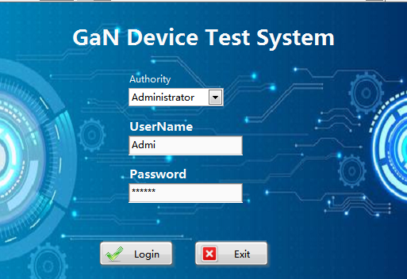
Figure 1 Login interface
In addition, regardless of whether the identity is a "tester" or "administrator", software users need to log out after using the system. Clicking to log out can clear the account information on the page to avoid leakage of user account and password information. The process of the entire account management system is shown in Diagram 9:
Diagram 9 Account management system operation process
The main program of the user login management system consists of a state machine written by a while loop and a case structure. The state machine immediately calls the login interface subroutine after initialization and hangs and hides it. The subroutine activation interface is displayed and executed in response to the interface operation. After the subroutine exits, the parameters will be passed to the main program, and the main program will enter the next state according to the parameters and the current state of the state machine.

5.3 Design of Test module
The test module is an important part of the automated test process for GaN devices. The design of the test module mainly considers the communication mode between the host computer system and the instrument, the configuration of the test parameters, the control of the instrument, the generation of reports, and the data saving to the database.
The page design of the test module is as follows:
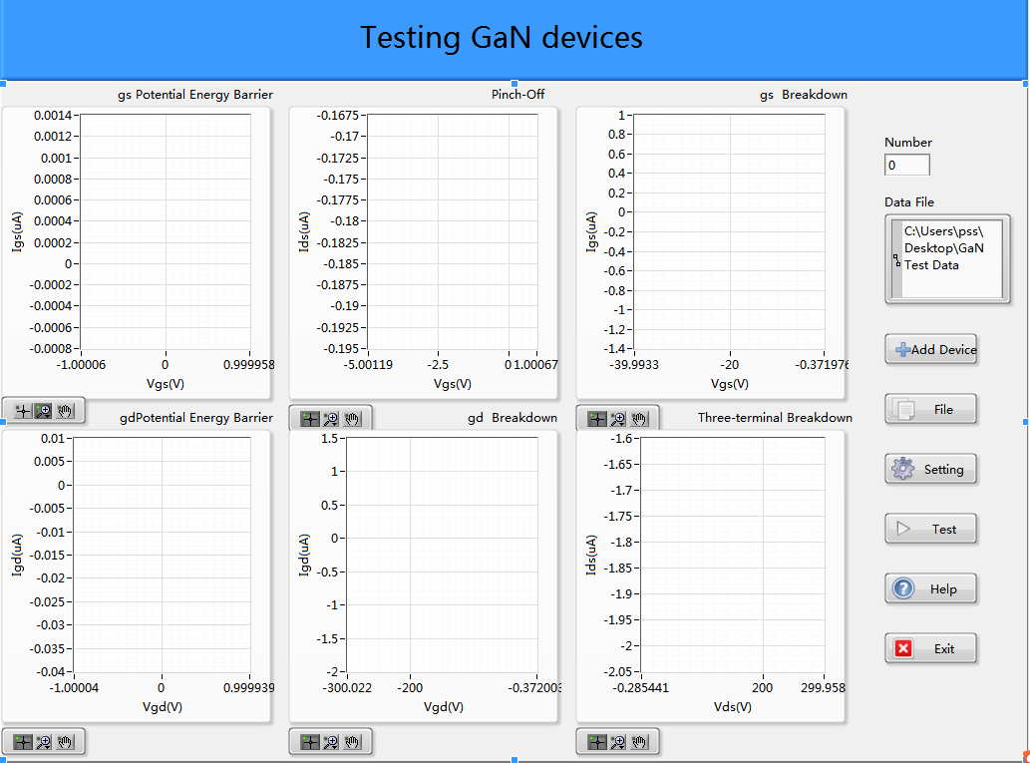
Figure 2 Test module interface

5.3.1 Communication method
Common communication methods are divided into low-speed and high-speed according to the transmission rate. Low-speed transmission mainly includes serial ports and CAN buses. High-speed transmission, mainly Ethernet, PCIe, etc.
The several communications mentioned above are all serial communications in a broad sense. The serial communications we are talking about here refer to asynchronous serial ports with a rate of 2400bps to 115200bps, using only two transmit and receive data lines, or synchronous serial ports with synchronous clock signals. Serial communication, as the name implies, refers to the sequential transmission of data one by one, with simple communication lines and low cost. According to the data transmission direction, it can be divided into simplex (only one data line), half-duplex and full-duplex. We generally use full-duplex asynchronous serial port transmission. Although the current computer has cancelled the serial port, asynchronous serial communication can be realized through USB-to-serial devices. The hardware of the USB-to-serial interface is cheap, generally at tens of yuan.
Ethernet is a computer local area network technology. At present, PCs and notebooks have Ethernet interfaces, so there is no need to purchase additional conversion equipment. Ethernet is a high-speed serial port with three common rates of 10M, 100M and 1000Mbp. The specific rate is negotiated by the devices at both ends. The Ethernet transmission rate is fast and has a common protocol, which can meet the user's requirements for the test rate.
LabVIEW provides the VISA serial port function (Figure 3) dedicated to the network port and serial port, making development simple and fast.
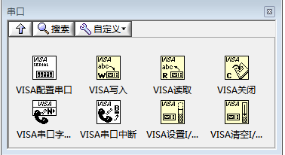
Figure 3 VISA function
In the automated testing of GaN power devices, in order to adapt to the different types of instrument interfaces and meet the requirements of some users for the test rate, serial communication and network port communication are used to realize the communication between the PC and the tooling circuit board.
Communication with the instrument is mainly divided into two parts: sending instructions to the instrument and receiving data from the instrument.
The process of sending instructions to the instrument is shown in the Diagram 10:
Diagram 10 System sending instruction flow
After starting the program, perform the initial configuration of the serial port/network port. The configuration parameters should be consistent with the serial port of the lower computer to ensure the completion of the communication. After the serial port/network port configuration is completed, send the command and wait for the instrument to return the data. If no data is detected within 1.2s, it is judged as no data, and the command is sent again; after the data is detected, the data receiving program is started.
The process of receiving data from the instrument is shown in the figure below:
Diagram 11 System receiving data flow
After setting the delay time and the byte length of the received data, start to receive the data. If the reception is successful, the data content will be read; if the reception fails, try to increase the delay and receive the data again. Finally, while displaying the received data on the human-computer interaction interface, the data is stored under the action of the data storage module.

5.3.2 Parameter configuration
Design the parameter configuration function according to the static parameters of the GaN power device to be measured. The static characteristic index of the power device determines the basic performance of the device, and is a key parameter for designing device application circuits. The static characteristics of GaN power devices mainly include drain-source breakdown voltage, maximum drain current, on-resistance, input and output capacitance, threshold voltage and reverse transmission characteristics. The definition of static parameters is similar to that of silicon-based power devices. Table 1 shows the comparison of the main static characteristic parameters of several GaN devices. EPC2010C is an E-mode GaN power device from EPC, GS66506T is an E-mode GaN power device from GaN System, XGP6508B is a Dalian Xinguan Technology Co., Ltd. Developed Cascode-type GaN power device.
Main performance parameters | XGP6508B | EPC2010C | GS66506T
Drain-source breakdown voltage(V) | 650 | 200 | 650
Drain current(A) | 21 | 22 | 22.5
Gate source voltage(V) | -20~20 | -4~+6 | -10~+7
Threshold voltage(V) | 1.62 | 1.4 | 1.7
Table 1 Comparison of the main static characteristics for several GaN devices
In the GaN power device test system, the static parameters that need to be measured include the barrier characteristic test, the pinch-off voltage test, the pinch-off characteristic, the two-terminal breakdown characteristic test, and the two-terminal breakdown characteristic. These test items mainly need to provide voltage to one or both ends of the GaN device, so the parameter configuration mainly includes setting the voltage across the gate source/gate drain/drain source. The parameter setting page is as follows:
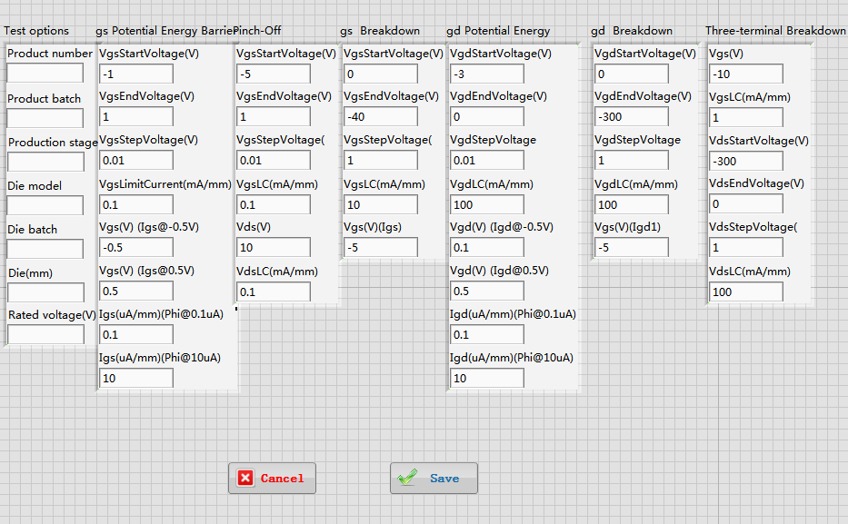
Figure 4 Parameter configuration interface

5.3.3 Instrument control
At present, there are three main ways to realize the control of instruments and meters: direct sending of hexadecimal commands, SCPI programming, and TSP programming.
Sending hexadecimal commands directly is generally suitable for instruments with a single control function, such as relays and DC power supplies. Taking a certain relay as an example, sending the instruction of 0X 55 01 32 00 00 00 01 89 to it means that it controls the first way to pull in. Since the digital source meter used in the test system has more complicated functions and does not support this control method, this method is not used for instrument control.
The Test Script Processor (TSP) allows the instrument to respond to a series of commands sent by the controller. It can send individual commands to any TSP-enabled instrument. TSP commands can be function-based or attribute-based. Function-based commands are commands to control actions or activities. Attribute-based commands define the characteristic function or operation of the instrument. At present, only some companies such as Keithley have realized the TSP control of the instrument. TSP programming is not applicable to the instruments produced by all instrument companies, so this method is not used to control the instruments.
SCPI is a standardized instrument program control command programming language based on the standards IEEE488.1 and IEEE488.2. As a command language used to control the instrument, SCPI defines the structure rules of the information exchange layer between the controller and the measuring instrument and provides a widely compatible programming environment [35]. It uses a standard way to describe the functions of various types of instruments, and the way of description has nothing to do with the composition of the hardware itself, which saves a lot of time for the development of automated test system software. From the perspective of development cost and versatility, SCPI programming is selected for instrument control.

5.3.4 Data Management
(1) Report generation
Reports are an important part of the database application system. The use of forms, charts and other formats to dynamically display data is the most commonly used form of printing out data. The system uses the report generation function in Labview combined with Microsoft Excel to generate reports. In order to better facilitate the operation of the operator and simplify the errors in the production process, the system has designed a one-key output test result function, which summarizes the verification results and generates a verification report, reducing errors caused by manual filling.
(2) Data storage
After saving all the data obtained from the test to a local file, the system also needs to upload the results obtained from the one-click test to the database for the administrator and quality monitoring software to query and use. According to the test content, first design a data sheet, in the data sheet, there are test date, detailed test status of each test, test data, etc.
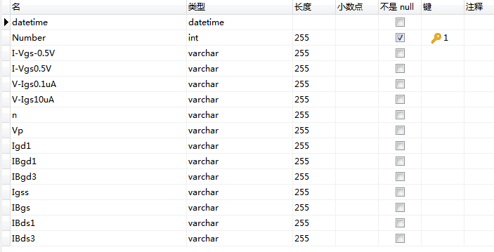
Figure 5 Data result save data table

5.4 Implementation of User Login Management Module

5.4.1 Login page
GaN power device performance test record data has important reference value in various industries. There are strict requirements for its preservation and modification. It is not allowed to modify or refer to the test records of others without permission. In order to ensure data security, the system provides different user names and passwords for different operators. The main interface of the login interface is the first interface to interact with the user. Without the correct account and password, it will not be authorized and start other interfaces. The main interface of the login interface adopts the frame design of the combination of state machine and event structure and is realized by the combination of Labview and LabSQL programming. The software program is shown in Figure 6:
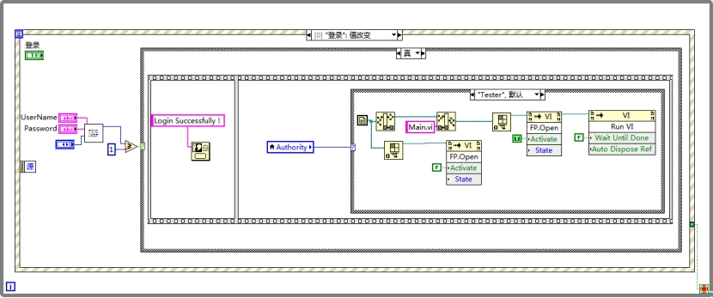
Figure 6 User login code
The basic constituent elements of the state machine pattern are the while loop and the case structure, and the basic constituent elements of the event structure pattern are the while loop and the event structure, so the new pattern should be composed of the while loop, case structure and event structure. The purpose of the while loop is to ensure the continuous operation of the program, so it must be at the outermost layer, so that there are only two combinations left, the event structure outside the case structure and the event structure inside the case structure. Since the login is triggered by the event structure and then the page to jump to is determined according to the user's authority, this program uses the method of placing the event structure outside the case structure. In this way, the "login" event structure is triggered every time the login button is clicked. In this event, the program first judges the entered account and password to see if it matches the account password value in the database. If the match is successful, enter a sequence structure, first pop up the "Login Successfully!" pop-up window, and then jump to the test/management page corresponding to the identity permission according to the selected permission.

5.4.2 Account Management Page
Account management is mainly the administrator's management of common user (tester) accounts, with three functions: register (create) users, modify passwords, and delete users. Based on security considerations, the administrator does not have the authority to register, modify, or delete the administrator, and the administrator authority should be managed by an account with higher authority. The front panel of the account management interface is shown in Figure 7:
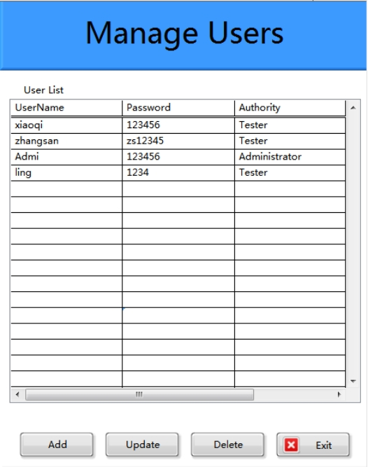
Figure 7 Account management interface
The account management design idea is to first query whether the account exists, and then call the account password update subroutine to update the password in the MySQL database when the password meets certain conditions. The account here is entered by the user, not a parameter passed by the main program.
Every time you enter the account management interface, all the account information stored in the database will be displayed. When you click different operation buttons, the current page will pop up a pop-up window for the corresponding operation (such as Add), which is convenient for users to add, delete, and modify individually.
Diagram 12 Account management operation process
- Add User
When the "Add" button is pressed, a new window will pop up on the current page. At this point, the administrator can fill in the permissions, user name, and password of the newly added user on the page, and then click the "OK" button, and the newly added user information will be displayed in the list column in real time. In order to prevent the administrator from entering the wrong password for the first time, two password entries are designed so that the administrator can confirm again when entering the new password.
New users need to meet the following conditions: a. The user name does not exist in the MySQL database; b. The password is no empty and the new password is consistent with the password confirmation. Here we have not considered the password security policy for the time being, for example, the password needs a certain length or different character requirements. After the above conditions are met, the program will call the account creation subroutine to create new user data in the MySQL database. The block diagram of the new user program is shown in the figure.
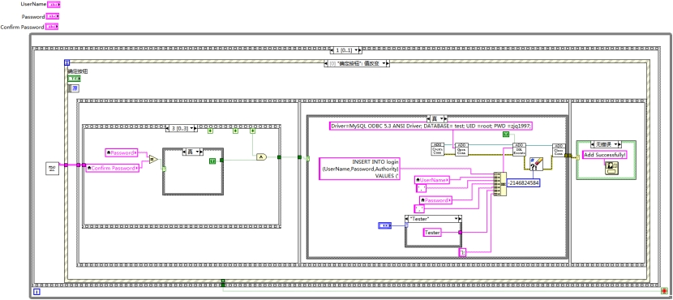
Figure 8 Add user program code
- Delete User
If you want to delete a certain user information, you need to click the delete button, and then the delete user operation page will pop up. The user enters the user name to be deleted in the text box and clicks the "OK" button to delete the current user. The list column will update the remaining user information after deleting a user in real time. The block diagram is shown in the figure.
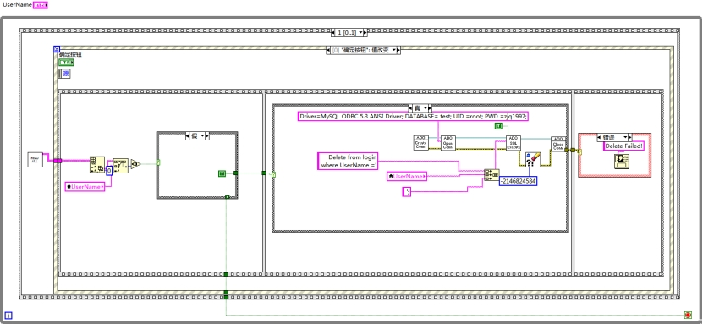
Figure 9 Delete User program code
- Update Password
When you need to modify the user's password or permissions, you need to click the Update button, and then the page for modifying the user's password pops up. The user enters the user name of the user who needs to change the password in the text box, then enters the new password, and enters the password again for password verification. After the modification is completed, click the "OK" button, and the modified information will be updated to the list column in real time, as shown in the figure. When modifying user information, only the user password can be modified, and the user's authority and user name cannot be changed.
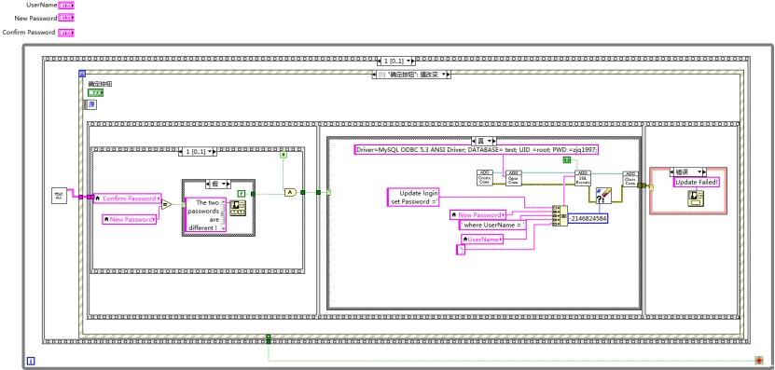
Figure 10 Update User Password program code
(4) Account operation procedures
The account operation program is mainly responsible for reading and writing the data in the user table in the MySQL database. There are three programs: account creation, account deletion, and account password update. Through the LabSQL package provided by LabVIEW, we have realized the manipulation of MySQL data.
Account query mainly realizes the query of account existence and confirmation of account password, and outputs the query results to other programs for use. The block diagram of the query is shown in Figure11:
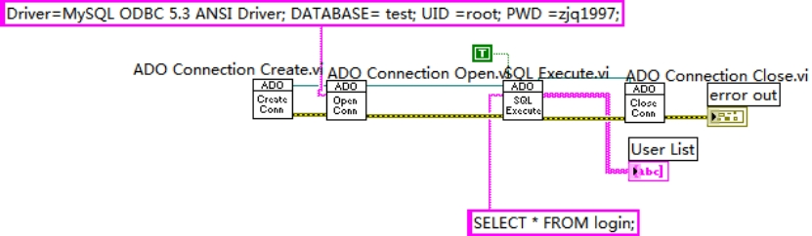
Figure 11 Account query code
First, create an ADO operation reference through the ADO Connection Create function provided by the LabSQL toolkit, and then open ADO based on the DSN parameters through the ADO Connection Open function. At this point, we can call the SQL Execute function to implement the operation of the MySQL database through the ODCB data source. In order to check whether the account and password are correct, we use the MySQL statement to query:
SELECT * FROM login;
WHERE UserName ='user_name' AND
password=('password') AND
authority='tester';
If you only query whether the account exists, you do not need to check the password. The MySQL code is as follows:
SELECT * FROM login
WHERE UserName ='user_name' AND
authority='tester';
The result of the query output is a 2D array of strings, and the result is output through the index operation. If the output result is empty, it means that the query has not failed. If it is not empty, it means that the query is successful. In this design, multiple accounts of the same account are not considered, because according to the design, before creating a new user, the program checks whether the account exists. And to avoid the existence of this bug, if there are multiple identical accounts, the delete account function will delete them all at once.
The difference between the block diagram of the account creation subroutine and the account query is that SQL is called, and the return data parameter of the function is set to false, indicating that no data is required to be returned.
INSERT INTO login(UserName,
Password,
Authority)
VALUES ('user_name',
'password',
'tester',
);
The account deletion procedure is similar to the account creation subroutine, and the MySQL statement is as follows:
DELETE FROM login
WHERE UserName='user_name' AND
Authority='tester';
MySQL statement of account and password update subroutine:
UPDATE login
SET Password ='new_password'
WHERE UserName ='user_name' AND
Authority='tester';
After the ADO call operation of the above subroutine is completed, we need to call the ADO Connection Close function to close the call to ADO resources to avoid resource leakage.

5.5 implement of Test module

5.5.1 Instrument communication
The upper computer software chooses to adopt the virtual instrument software architecture (Virtual Instruments Software Architecture, VISA) function. The VISA function can realize the connection with different interfaces by changing the configuration parameters of VISA. This test system has designed two communication methods: LAN and serial port. Here we take serial port communication as an example to introduce the realization method of communication between the system and the instrument.
The structure of the entire serial communication can be divided into four main parts:
(1) Serial port initialization configuration and serial port selection
Configure the serial port control to initialize the serial port through VISA. It should be noted that the baud rate is generally 9600bps by default. In this system, the user can also choose to set the baud rate to 115200bps; enable the terminator to be configured as T; to terminate the setting The character is a newline character'\n', and the ASCII code of'\n' is 10; the data bit, parity, etc. are not configured, and the default value is used. The code structure is shown in the figure:
. 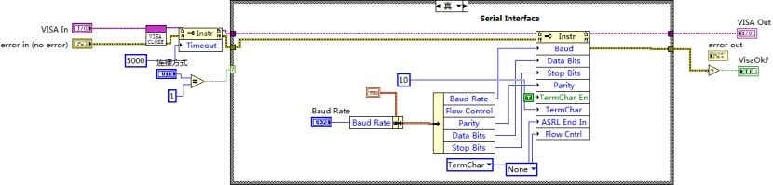
Figure 12 Serial port initialization code
(2) Send instructions
The sending instruction is mainly realized through the VISA write control, and the sent instruction and the set parameters are written into the buffer area.
(3) Data reception
Receiving data is mainly realized by VISA reading control. Serial communication can read the number of bytes of data written in the serial port through the property node, but this does not apply to LAN communication. LAN communication can only receive data by specifying the number of bytes received. Here, since it is known that the number of bytes returned by the instrument is 77, the number of received bytes is directly set. The sending and receiving part of the program is shown in the figure: In this process, because the instrument responds to the command to upload data, it takes a certain time, so in order to ensure smooth communication, a certain time delay needs to be added after the command is sent, and the delay is set here. The time is 200ms.
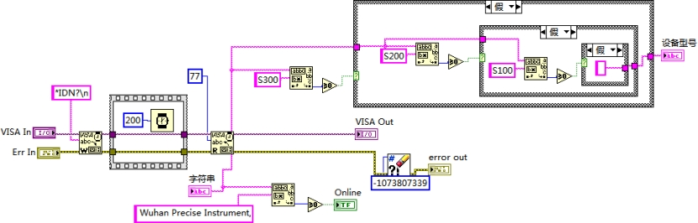
Figure 13 Send Command code
(4) Clear the cache and close
After the data is received and displayed, the I/O buffer area is cleared through the VISA clear I/O buffer control, and then the VISA session handle is closed and the simple error handler is connected. In this module, because the communication with the instrument will continue later, the VISA session is not closed.

5.5.2 Parameter configuration
Some functions of parameter configuration are mainly realized by means of a simple state machine. The block diagram is as follows:
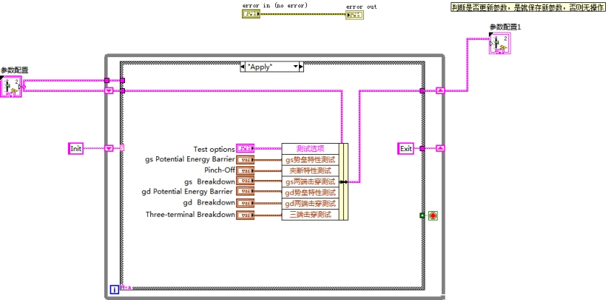
Figure 14 Parameter configuration code
The state machine mainly has five states: initialization, event state, application setting, cancel setting, and exit. The program first enters the initialization state, saves the configuration information obtained from the main program into the parameter configuration cluster of the sub-vi, and then enters the Event state. After setting the parameters on the front panel, clicking any button on the front panel will trigger the Event event. Click the "Apply" button, the program enters the Apply state, save the parameters set on the front panel, and then enter the "Exit" state to exit the loop; click the "Cancel" button, the program first enters the Cancel state, and then enters the "Exit" state to exit the loop.
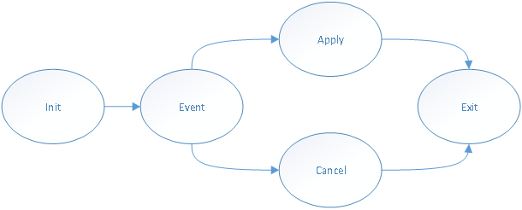
Diagram 13 State transition diagram
5.5.3 Instrument control
After setting the parameters, you need to transfer these parameters to the corresponding SCPI commands and send the commands to the instrument.
Here is an example of sending scan commands to introduce the meaning of each SCPI command
:ROUT:YERM FRON\n Set front panel test
:SYST:RSEN OFF\n Set 2-wire measurement
:SOUR:CURR:MODE SWE\n Select instrument scan function
:SOUR:FUNC CURR\n Set the output source to be a current source
:SOUR:CURR:RANG 1\n Set the current range to 1A
:SENS:VOLT:RANG 30\n Set the limit voltage range to 30V
:SENS:VOLT:NPLC\s0.01\n Set the value of NPLC to 0.01
:SOUR:CURR:STAR 0\n Set the starting value of sweep current to 0A
:SOUR:CURR:STOP 1\n Set the scan current stop value to 1A
:SOUR:SWE:POIN 100\n Set the number of sweep points to 100
:SOUR:CURR:VLIM 0.1\n Set the scan step value to 0.1A
:OUTP ON\n open output
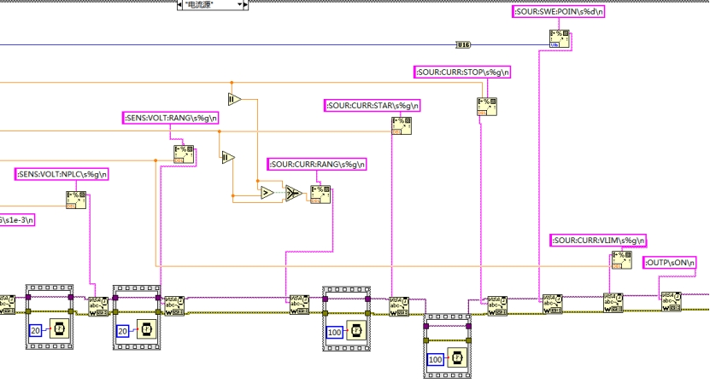
Figure 15 Instrument control part code

5.5.4 Data Management
(1) Image display and report generation
Use Labview's own drawing tool XY diagram for graphic display. After reading the data returned by the instrument, transfer the voltage array data to the X array of the XY graph, and transfer the current array data to the Y array of the XY graph. In the end, the various characteristic parameters of the GaN device can finally be displayed on the host computer page in the form of an image. The image is as shown:
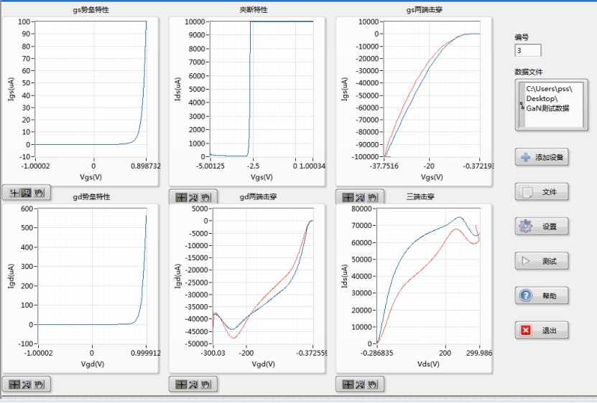
Figure 16 Characteristic parameter graph
Regarding the generation of reports, first, a set of Excel templates was designed based on the test results, and then a bookmark was inserted where the content needs to be automatically filled in. Then call the MS Office Report tool in Labview, in the tool, we can set the input port according to the bookmark in the template, and through simple processing, the result can be printed into the report. The report can be opened in Excel format or saved to Excel. The MS Office Report data input port can be connected to multiple data types. After using a two-dimensional array of strings, the data type needs to be converted to a string. At the same time, because the relative position of a two-dimensional array is used for positioning, any string will assign a value to the entire cell. Therefore, for positions that do not need to be assigned and have preset constants, the cells with preset constants in the template can not be modified by not assigning values to the corresponding positions of the two-dimensional data. However, for the cells that need to be modified, the data unit cannot be preset when a two-dimensional array is used, and the data unit needs to be realized by string splicing. Finally, our test report output block diagram is shown in Figure 17. Output report in Figure 18.
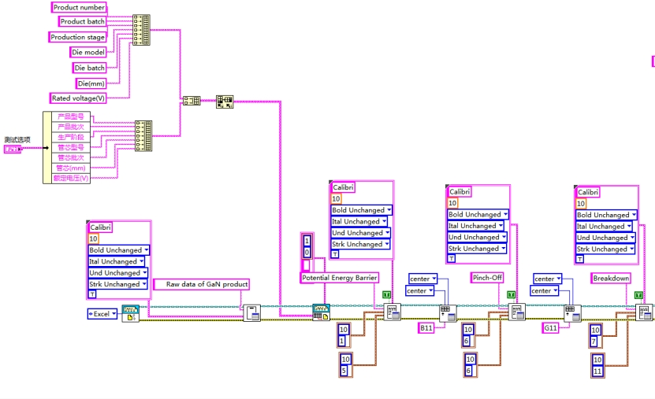
Figure 17 Generate report code
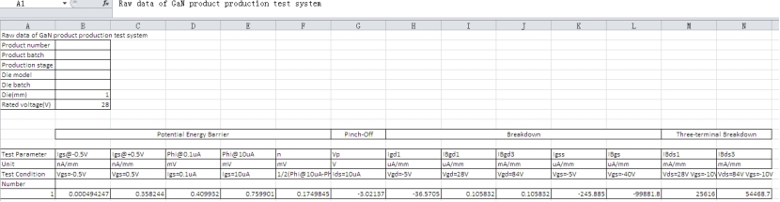
Figure 18 Test Results
(2) Data storage
After generating and saving the Excel report, the program will upload the test results to the MySQL database for the administrator and quality monitoring software to query and use. According to the test content, a data sheet is designed. In the data sheet, there are test dates and test data for each test. The design of the data table to save the test results can be implemented in Navicat software. In the LabVIEW program, the data is saved to a table named test in the MySQL database by using the LabSQL toolkit and the MySQL INSERT command. After the data is saved, the program will set the save button to the Disable state to prevent the tester from accidentally triggering the result to be repeatedly saved.
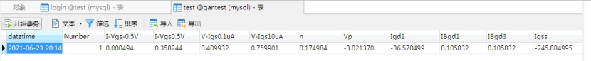
Figure 19 Test data saved in the database

5.6 Conclusion
Based on the analysis of system requirements, this chapter proposes the hardware and software framework design ideas of the GaN power device automated test system. First, the design ideas and implementation methods of the user login management module are introduced. Then, from the selection of communication methods and the planning of the test process, the design ideas and implementation details of the entire test software are introduced in detail; finally, the generation of data reports and the use of MySQL database to save test results are realized.

Chapter 6 Evaluation
After completing the design and implementation of the GaN power device automated test system, it is necessary to run the system to test the upper computer software to verify whether it has achieved the expected function. Since the automated test system mainly has two parts, the user login management module and the test module, the test is also divided into two parts: the test of the user management interface and the test of the test module. For the user management page, directly use the PC to test; for the test module, it is necessary to build a hardware test platform for testing.

6.1 Test content
The test of this GaN power device automated test system is mainly divided into two categories: interface test and functional test. The following will introduce from these two aspects.
1.Interface testing
The user interacts with the system through the interface, so it is necessary to test the page. The main purpose of the interface test is to check whether the style of the user interface meets the customer's requirements, whether it is universal, whether the text is normal, whether the page is beautiful, whether the text and pictures are perfectly combined, whether the operation is friendly, and so on. These requirements are specific to the GaN power device automated test system, mainly including the following points:
(1) Test whether the interface design of the system is beautiful and the layout is reasonable;
(2) Whether each functional area is divided accurately, whether the buttons of similar functions are placed together, and the style is different from the buttons of other functions, so that the user's operation is more convenient and concise;
(3) Whether the design of the operation process is reasonable, whether it can reduce the user's workload and help the user improve work efficiency.
2. Function test
Functional testing is also called black box testing. It treats the test object as a black box, does not consider the internal structure and processing of the program, and only detects whether the actual software function meets the needs of the user. When testing, you need to use functional testing methods to perform unit testing and system testing.
The unit test is a separate test for each function, mainly the test of the user management module and the test of the test module. Among them, the test module also needs to separately test the communication, parameter setting, instrument control, data storage and display modules.
After these several unit tests are completed and confirmed to be correct, the functions of the entire system must be jointly debugged, especially in conjunction with the work of the lower computer. This part of the test is very complicated and time-consuming. First of all, it is necessary to ensure the smooth communication between the lower computer and the upper computer in any working mode. Secondly, it is necessary to detect whether the upper computer itself is running or not. Finally, it is necessary to ensure that the upper computer can accurately complete the function according to the set. All expected goals.

6.2 Test methods

6.2.1 Interface test
In order to test whether the page design of the GaN power device automated test system meets the needs of users, the project invited 8 users to use the test system and asked participants to fill out relevant questionnaires to evaluate the test system. The main contents of the questionnaire are as follows:
(1) Do you think the page design is beautiful and meets your standards?
(2) Is the layout of the page buttons reasonable and easy to operate?
(3) Is the division of operating procedures clear?
(4) Is the connection of the instrument smooth? Is there a prompt for connection failure?
(5) Does the parameter setting meet your needs? Do you need to set other parameters?
(6) Did you encounter other problems during the test?
(7) Is the image display clear and easy to obtain the required data information?
Is data storage easy to operate and meet your needs?

6.2.2 Function test
The functional test of the automated test system is mainly to test the different functional modules of the host computer system, which is divided into two parts: unit test and system test. In the unit test, a test case is designed for each functional module to detect the realization of the module's function.
Test module | Test steps | Test Conditions | expected outcome | actual results | Test status
User login test | 1.Choose user permissions  2. Enter the account password  3. Click the "Login" button |  | If the user identity is "Administrator", the page jumps to the user management page; if the user identity is "Tester", the page jumps to the manage user page. | If the user identity is "Administrator", the page jumps to the user management page; if the user identity is "Tester", the page jumps to the manage user page. | Pass
User management interface test | 1. Click the "Add"/"Update" button, enter the account password, and click "ok";  2. Click the "Delete" button, enter the account number, and click ok. | The user logs in to the system as an administrator | The operation of adding users, deleting users, and modifying user passwords was successful. | The operation of adding users, deleting users, and modifying user passwords was successful. | Pass
Instrument communication test | 1. Click the "Add Device" button;  2. Select the network port mode and enter the IP address of the instrument  3. Click the "ok" button | The user logs in to the system as a tester; the instrument connects to the host in the form of a serial port/network port | The device flashes green and the page displays "Connected successfully" pop-up window | The device flashes green and the page displays "Connected successfully" pop-up window | Pass
Parameter setting, instrument control test | 1. Click the "setting" button;  2. Enter the value of each parameter;  3. Click "save"  4. Click "Test". | The instrument is connected successfully | The instrument outputs voltage/current according to the set parameters | The instrument outputs voltage/current according to the set parameters | Pass
Data display and storage | Click "File" to set the file storage directory | The instrument is successfully connected and the test is complete | Data and test results are stored in the set file directory and the test results are uploaded to the database | Data and test results are stored in the set file directory and the test results are uploaded to the database | Pass
Table 2 Test cases for each functional module

6.3 Conclusions from the test
Through the continuous development and function adjustment of the automatic test system interface, the interface of the test system has basically met the needs of users. In the final test process, run the host computer in different test environments, such as different operating systems and different resolutions, to check whether the interface can be displayed normally. At the same time, 8 users were invited to participate in the questionnaire survey to evaluate the test system interface. The survey results show that 80% of users believe that the interface basically meets the test requirements; 90% of users believe that the operation process is simple and easy for users to operate; 60% of customers agree that the user is beautiful and the layout is reasonable. In summary, the page of the GaN power device automated test system can meet the requirements of users, but the aesthetics of the page need to be improved.
The functional test of the automated test system is mainly completed by the test cases of each module written in the previous section. First, perform a separate functional test (black box) test for each module. According to the test case, check whether the user can enter the test page, whether the administrator enters the management user page, whether the test system can successfully connect to the instrument, whether the test system can successfully set the parameters and send them to the instrument, and whether the read data can be displayed in The page is stored successfully. After the unit test is passed, perform a system test on the entire test system to check whether each module can be connected normally, whether the interface is available, and whether the test system can run normally in different test environments (different operating systems). In the end, the GaN device automated test system passed most of the test cases, and the system basically met the design requirements.

6.4 Realization with literature review
The GaN power device automated test system basically realizes the functional design described in the literature review. The development of the automated test system used the Labview development platform of National Instruments, and designed the user login module, test module and data display storage module to realize the automated test of the characteristic parameters of GaN power devices. Just click the test button, without manual connection, you can get the test results of the static parameters of the device. At the same time, the system successfully connected Labview and MYSQL database and realized their communication. User information and final test results are stored in the database to realize remote analysis, processing and management of data, etc.

6.5 Aim and Objects implementation
The system uses LabSQL technology to establish communication with the MYSQL database and realizes the user login management function; then, using VISA technology, the communication between the host computer software and the instrument is smoothly realized; using SCPI technology, the parameters that need to be set are issued to the instrument. , To provide voltage to the GaN power device; finally, the voltage/current value returned by the instrument is displayed on the upper computer page in the form of images, and saved in the file and database in the form of data. The user can finally obtain the characteristic parameters and parameters of the GaN power device. Characteristic curve. The automated test system has basically achieved the main goals identified in the report. The parameters that may be tested may not cover all the static parameters of GaN power devices, but the current test data can also evaluate GaN power devices.

6.6 Expected results
The overall completion of the automated test system is good, and the actual results are roughly consistent with the expected results. First of all, the system implements the user login function, so that users of different identities can enter different functional pages: the administrator can enter the user management page, and the tester can enter the test interface. Secondly, the system has designed a communication module to realize the LAN and serial communication between the system and the equipment. Furthermore, the system is designed with parameter setting and instrument control functions to complete the setting of test conditions for different characteristic parameters of GaN power devices. Finally, the system realizes the data display and storage function, which is convenient for users to view and analyze the data and evaluate the quality of GaN power devices. It's just that the characteristic parameters currently measured are limited to some static parameters, and the measurement of dynamic parameters can be added later.

6.7 Do it again
If I want to design and develop an automated test system for GaN power devices again, I will spend more time considering design patterns and page design. At present, the design mode adopted by the entire system is the producer-consumer cycle mode. When new test items are added to it during the design process, the code is redundant and repetitive and cannot be reused. If it can be redone, I will develop the system with a more advanced design pattern to improve code utilization. In addition to the design mode, the design of the page also needs to be improved. The current page is not very good in terms of aesthetics. In the future, some design elements need to be added to make the page look clearer and more beautiful.

Chapter 7 Conclusion and recommendation

7.1 Summary
In the first half of the report, the research background of this project is first discussed: the research status of GaN power devices and the development status of the third-generation automated test system, combined with the current lack of specialized automatic test systems for third-generation semiconductor high-power devices , Put forward the research goal of developing a set of characteristic parameter test system for GaN devices. In the aspect of researching Methodology, this article adopts empirical method, literature review method, case study method and questionnaire survey. By using these methods, it provides a theoretical basis for the development of the system. Then, the main technology used was determined: NI’s Labview development platform was selected as the development platform, and the virtual instrument technology provided by it was used to complete the development of the system; the standard IO function provided by VISA (virtual instrument software structure) was used to implement the system and instrument Communication; use SCPI (Standard Commands for Programmable Instruments) commands to achieve control of the instrument; use MYSQL database technology to achieve data storage.
In the second half of the report, it first discusses the functional requirement analysis, non-functional requirement analysis and feasibility analysis of the test system. Then, according to the demand analysis, the overall design of the test system and the design of each module were carried out, and the whole test system was divided into five main modules: user login management module, instrument communication module, parameter setting module, instrument control module, and data display and storage module. Subsequently, the specific implementation methods of the functions of these modules are described; then the interface testing and functional testing of the implemented modules are carried out. Finally, I came to a conclusion: GaN power device test system can basically realize the test of device characteristic parameters, which basically meets the needs of users.

7.2 Conclusion
The purpose of this paper is to establish an automatic test system for GaN power devices, aiming at the characteristics of GaN high-power devices with multiple test parameters and high device parameters, through the research of GaN high-power device test technology, the development of existing test equipment and new switches The highly integrated intelligent automatic test system based on matrix circuit provides test technology guarantee for comprehensive assessment, true reflection of device performance level, and greatly improved test efficiency.
The research content of this paper is the development of an automated test system for GaN power devices based on Labview. First, the background of GaN power devices and the third-generation automated test system is explained. Secondly, a demand analysis and feasibility analysis were carried out on the system. Then, the test system is divided into five modules according to function, and each module is designed. Subsequently, the realization method of the main module and the technology used are introduced. Finally, perform software testing on the test system, including interface testing and functional testing. The test results show that the system basically meets the design requirements and can be used normally.

7.3 Suggestions for further study
This design considers the priority of LabVIEW graphical interface programming in data acquisition and test control and the advantages of the database and tries to combine the LabVIEW-based GaN power device test software with the MySQL database to provide a more convenient data processing environment.
This design has actual use value in the project. The integration of the project has a certain degree of complexity, involving software, hardware and modular design. Due to the limited professionalism, much of the work in this project needs to be further studied. Future work considers starting from the following aspects:
1. Further strengthen the research on hardware modules, especially the anti-interference ability of interface circuit modules and the effectiveness and real-time responsiveness of data links.
2. Consider the maintainability and upgradeability of the equipment.
3. There are certain flaws in the way the software multi-interface is implemented. When the software has a BUG, ​​the interface is prone to problems such as unresponsive or unable to close.
4 The structure of the software is not optimized enough, and part of the design is redundant or the implementation is too complicated.
5. ADO is prone to some abnormalities when connecting to the database. The software should be able to recover and accurately locate the abnormality when it is abnormal.
Through this design practice, I have greatly improved my understanding of the use of LabVIEW and MySQL database. At the same time, I have a better understanding of the framework of software design.

Chapter 8 Reflection
In the process of participating in the entire research project, I learned a lot, experienced a lot of difficulties, and grew a lot. This research topic is a research project undertaken by the company where I practiced. After I finished the PC software, I took it as my master's thesis project.
In the early days of designing this test system, I encountered many difficulties. Because, at first, I didn't understand the concept of host computer, and I didn't have the foundation and development experience of Labview graphical programming language. After a week of getting started quickly with Labview, I started the development of the test system. Because I am not familiar with the instrument and some communication protocols are not understood, so it took a lot of time to communicate with the instrument at the beginning. Later, with the improvement of the programming language and the deeper understanding of the project, the development work proceeded more and more smoothly. In the end, I successfully realized the development of an automated test system for GaN power devices.
The success of the project has doubled my confidence. The next task is to convert the completed software system into the form of a paper. This process seems easy, but it is not easy to implement. How to express the realized function in the form of words requires reading a lot of literature and reading a lot of source code to have something to write. During this process, my supervisor gave me a lot of guidance and advice, and he let me know how to write a good thesis.
Finally, through this design practice, I have greatly improved the use of LabVIEW and the understanding of MySQL database. At the same time, I have a better understanding of the framework of software design. In the future, I will continue to use the Labview platform to do host computer development related work.

References
[1] Niu Shuang jiao, Li Qian. Research progress of gallium nitride materials [J]. Guangdong Chemical Industry, 2017, 44(2): 84-86.
[2] Observation of the third generation of semiconductor industry. Gallium nitride of the third generation semiconductor material (GaN)[EB/OL]. https://baijiahao.baidu.com/s?id=1670910224276391004&wfr=spider&for=pc, 2020-06-30.
[3] He Liang, Liu Yang. The development status and challenges of the third-generation semiconductor GaN power switching devices Challenge [J]. Journal of Power Supply, 2016, 14(4): 1-13.
[4] Yajuan Zhao. Analysis and enlightenment of research hotspots of gallium nitride materials[J]. 2006.
[5] Xinrong Xie. Research progress of the third generation semiconductor material gallium nitride (GaN)[J]. Guangdong Chemical Industry, 2020, 47(18): 92-93.
[6] Gallium nitride (GaN): physics, devices, and technology [M]. CRC Press,
2017.
[7] Behtash R, Tobler H, Neuburger M, et al. AlGaN/GaN HEMTs on Si (111) with 6.6 W/mm outputpower density[J]. Electronics Letters, 2003, 39(7): 626—627.
[8] Joblot S, Cordier Y, Semond F, et al. AlGaN/GaN HEMTs on (001)silicon substrates[J]. Electronics Letters, 2006, 42(2): 117-118.
[9] Sun H, Alt AR, Benedickter H, et al. 102GHz AlInN/GaN HEMTs on silicon with 2.5W/mm outputpower at 10 GHz[J]. IEEE Electron Device Letters, 2009, 30(8): 796—798 .
[10] Altuntas P, Lecourt F, Cutivet A, et al. Power Performance at 40 GHz of AlGaN/GaN HighElectron Mobility Transistors Grown by Molecular Beam Epitaxy on Si (111) Substrate[J]. IEEE Electron Device Letters, 2015, 36 (4): 303-305.
[11] Ge Q, Chen XJ, LuoWJ, et al. A Ku band internally matched high power GaN HEMT amplifier With over 30% of PAE [J]. Journal of Semiconductors, 2012(33), 1:014003.
[12] Zhong Shichang, Chen Tangsheng, Qian Feng, et al. Ku-band 60W AlGaN/GaN power tube[J]. Research and Progress in Solid State Electronics, 2014 (34), 4:350-353.
[13] Lou Chen, Zhang Beibei, Yin Jun. C-band high-power GaN HEMT internal matching device[J]. Semiconductor Devices, 2015 (40), 3:201—204.
[14] Zheng JX, Ma XH, Lu Y, et al. A C-Band 55% PAE high gain two-stage power amplifier based on AlGaN/GaN HEMT [J]. Chinese Physics B, 2015(24), 10: 107305.
[15] Chen Wanjun, Wong King-Yuen, Chen Kevin J. Single-chip boost converter using monolithically integrated AlGaN/GaN lateral field-effect rectifier and normally-off HEMT. IEEE Electron Device Letters, 2009, 30( 5) : 430-432.
[16] Lin Xiang. Research and implementation of automatic test system based on labVIEW [D]. South China University of Technology, 2016.
[17] Du Jinbang, Wang Yueke, Wang Xiangqi, etc. The development trend of military automatic test equipment [J]. Computer automatic measurement and control,
2001,9(5):1-3
[18] Wang Shasha. Universal design of electronic equipment automatic test system[J]. Computer Measurement and Control, 2012,20(3):642-647
[19] Yu Jinsong, Li Xingshan. The architecture and key technologies of the next-generation automatic test system [J]. Computer measurement and control,
2005,13(1): 1-3
[20] Anton Pirker-Fruhauf. A knowledge-based test program following the ATML Standard. Austria Institute for Computer Engineering, Vienna University of Technology, 2009
[21] Liu Jinfu, Wang Hong. Research on the structure of foreign avionics ATS [J]. Measurement and Control Technology, 2002, 21(1): 5-8
[22] Qin Honglei, Lu Hui. Automatic test system hardware and software technology [M]. Beijing: Higher Education Press, 2007, 208-210
[23] JAMES M S. System Testing of Desktop and Web Applications Information Systems Education Journal.2011,9(8):68-82
[24] Huang Xiaoqing, Wang Weiguo, Liang Yue, Liu Wenbo. Overview of research on the versatility of automatic test system software technology [J]. Measurement and control technology, 2013,21(10):4-6
[25] Lin Xiang. Research and implementation of automatic test system based on labVIEW [D]. South China University of Technology, 2016.
[26] Li Hailong. SCPI command interpreter design [D]. Hefei University of Technology, 2012.
[27] Jiang Ronghua. Virtual instrument software structure-VISA design and implementation [D]. University of Electronic Science and Technology of China, 2006.
[28] Cheng Lu. Automated test platform for circuit board tooling based on LabVIEW [D]. University of Electronic Science and Technology of China, 2020.
[29] Bi Hu, Lu Fangcheng, Li Yanqing, Li Heming. Several different methods of accessing database in LabVIEW [J]. Sensors and Instruments, 2006, 22: 131-134
[30] Na Er Ying. The difference between a relational database and a non-relational database[EB/OL].https://blog.csdn.net/flyingshadower/article/details/83626799.html, November 1, 2018
[31] Guijun626. Introduction, comparison and description of relational and non-relationaldatabases[EB/OL].https://blog.csdn.net/Guijun6/article/details/81205767.html, July 25, 2018 day
[32] Lai Qingjian. Design and Implementation of Semiconductor Test Management System[D]. Hunan University, 2019.
[33] ROSS W A. The Impact of Next Generation Test Technology on Aviation Maintenance[C]. DoD Automatic Test Systems Executive Agent Office Naval Air Systems Command PMA260D.
[34] Liu Enpeng. The development of a new generation of aviation general test system[J]. Aviation Manufacturing Technology, 2007,21(12):56-59
[35] Zhou Zichao. Implementation of SCPI in oscilloscope and its application on host computer [D]. University of Electronic Science and Technology of China, 2016.

