Marketing plan written for

______________________________Premier in______________________________

______________________ Precious Dennis____________________________

_ 2121893__________________

Marketing Essentials BMIH4005

_____________ Luciana_Suardi__________________

Introduction
The purpose of this marketing plan is to express new ideas and define the marketing aims and objectives that align with the vision for the organisation. In this plan it will contain a breakdown of new and improved creative ideas portrayed in a SOSTAC planning system. This system will show a step-by-step plan of how the aims and objectives mentioned can be achieved. This marketing plan will be for the chosen hotel premier inn.

Situation Analysis
Strengths:
The ability to satisfy any customer for their service purchased..
To catch the attention of these customers the company requires a good marketing campaign which this company also manages to succeed in.
Another aspect of the companies strength are the motivated an highly engaged management team (uk.indeed.com)

Weaknesses:
. Global presence not as elaborate as international hotel chains
. Intense competition for the brand means small margins
(www.mbaskool.com)

Opportunities:
There are many competitors in the area of the business but a few that provide the same quality services premier inn provides so its important that this taken advantage of.

Threats:
Apart from competitors there are no major threats that could harm or effect the business.

Premier inn’s customer segmentation is split into two parts, one for business one for leisure. They have four key variables in common including price sensitivity, how far in advance of a hotel stay they booked, and whether they bought products and services.
Then for leisure their engagement as a brand for premier inn was an extra leisure-specific segment characteristic; whereas for business, how much control they had over their booking was an extra business specific segment characteristic(www.bigdifferencemarketing.com). They also target middle class families.
Porters 5 forces:
Industry competition | Premier inn’s main competition are:  Travel lodge, ACCOR, and Days in worldwide inc.
Threat of new entrants | Economies of scale, high entry costs and government regulations are all examples of why it’s difficult for competitors to become established.
Threat of substitute product | The quality of the service premier inn offer isn’t matched by many competitors therefore there’s not much of a threat
Bargaining powers of buyers | Weak
Bargaining power of suppliers | Relatively low
(www,investtopia.com)

Premier Inn’s parent company Whitbread PLC has been engaged in a strategic partnership with Emirates Group since 2008. There are no premier inn franchises.

Objectives
Objectives for this company to achieve are to improve staff training so all staff are comfortable in their role and are able to provide the best service possible. Also increase the number of services they provide i.e. activities to do at the hotel whilst they’re at their this includes things like a bar, a pool, play area for children, a café, gaming room and even a cinema room. Things like these will enlighten the customers experience and therefore bring repeat and more customers in the future. Another idea is to improve the quality of food within the hotel and again bettering the service. Also exploring many different food cuisines and offering them to customers.

Strategy
By selling their services at a fairly low price yet still offering some of the highest quality services premier inn are able to attract customers; they’re able to do this because the level of quality they provide within in their services are matched by some of the top hotel chains across the UK, so by selling their service at a fairly low price it gives customers the option to stay at an affordable hotel and still be able to feel the same level of comfort at a more expensive hotel. That is also an example of how the company manages to differentiate so well within the industry. With these customers we can find out what other products or services may be appealing to them. So, the steps needed are to offer these services/products to the targeted customers and see how much of an impact it creates.

Tactics
Product – Premier inn offer many different types of rooms for different customers. They have family sized rooms containing a king size bed and two pull out sofa beds for children; they even provide a travel cot for a baby. Specific rooms are interconnected for parents who wish to keep an eye on their kids. As well as the family rooms the rest of the rooms are categorised as single double and accessible. In these rooms there’s free tea, hair dryer and also free Wi-Fi(www.howandwhat.net).
Place – The company can be located all across the UK having over 800 hotels and can also be found abroad in countries such as United Arab Emirate, Qatar, Germany, Ireland but this specific hotel can be found in Blackpool.
Price – There many competitors in the area as Blackpool is a place which is known to attract tourists. Because of this, hotels are spread all around hoping to attract customer some simple few flashy. So setting the price at a high cost won’t do any well therefore owners are forced to set prices at a fairly reasonable cost. The price of the different hotels is the main competition in this area after that is the quality of service they provide/offer. Premier Inn has different pricing strategies i.e., Flex, Semi-Flex, Advance, Standard, and Non-Flex rates. These gives the customers different options. Flex is the most flexible option which permits them to cancel or lengthen their stay up to 1pm on the day they are due to arrive(howandwhat.net). All the information on the different offers available can be found online on their website.
Promotion – The company it self already has had a succeeding marketing campaign which will help with its recognition to customers but there are many other ways which include tv adverts, radios, online adverts, leaflets, bill boards and many more. The best way to advertise in a place such as Blackpool is to place leaflets/forms of advertisement in public where tourist are always likely to be at. They can also use social media as a form of advertisement which is very popular these days.

Action
BBW.xlsx
Within this marketing schedule the different objectives are spread out into different dates to allow the focus of one objective at a time. The reasoning for this is to allow the main focus to be on the chosen objective. This ensures all attention is purely focused on one thing at a time instead of trying to achieve all objectives at once which would hinder that likeability. Each objectives performance will be analysed and measured to determine whether the objective may be unachievable or difficult to achieve within the time period given.

Control
An advantage of USP it would be a clear differentiation that is the companies or product attribute and in this case for Premier inn it would be their ability to sell their service at a low price and still receive so many sales as the quality and level of service is so high; this is why they have been the leading hotel chain in 2018 and 2019(www.finder.com) (www.statista.com). To monitor success a system can be used to monitor the performance of a product and by this it is easier to know weather a product or service is doing well or not. If something is not working it would be vital to stop it because time is vital so it is important it is not waisted

Conclusion
In this marketing plan I have highlighted different innovations that could better the experience for customers, and highlighted objectives in the plan that need to be achieved such as introducing and exploring different cuisines in the food industry and to expand what is to offer for customers in the restaurants. Another idea was to improve staff training this to ensure all staff are aware and comfortable at performing their roles to supply the best quality service possible. Things like a children’s play area, gaming room and even a cinema room were all ideas for objectives

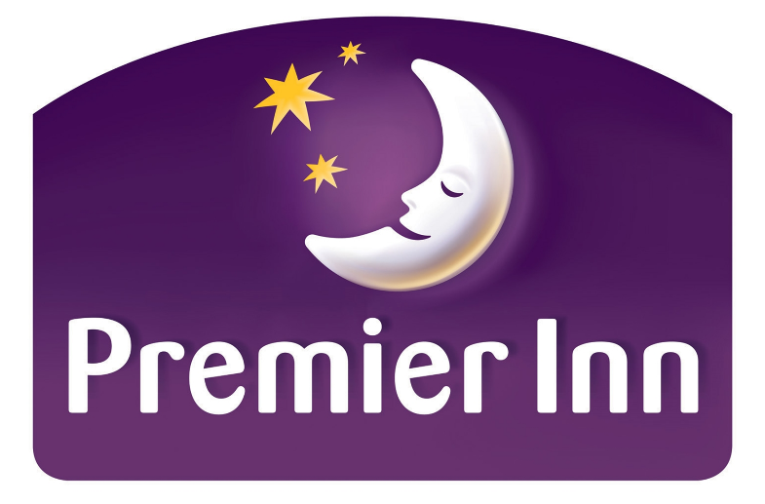
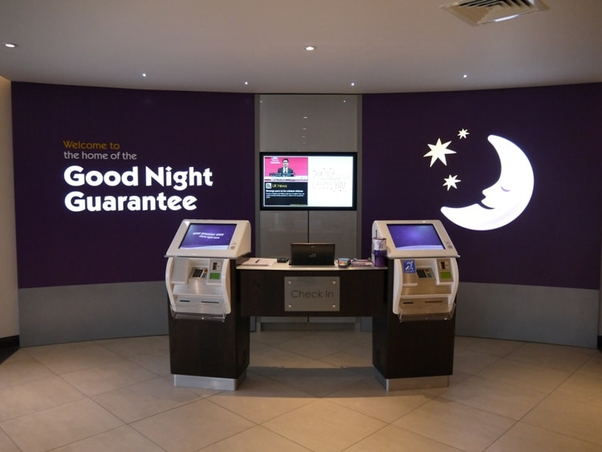
Objectives that can be brought to the table:
. Enhancing the quality of food provided
. Introducing a gaming/cinema room
. Improving staff training

