DECLARATION

This work has not previously been accepted in substance for any degree and is not being concurrently submitted in candidature for any degree

Signed- Pushpa Dammarpal Thapa

Date- 27/04/2020

STATEMENT 1
This dissertation is being submitted in partial fulfilment of the requirements for the degree of BA.

Signed- Pushpa Dammarpal Thapa

Date- 27/04/2020

STATEMENT 2
This dissertation is the result of my own independent work/investigation, except where otherwise stated.

Other sources are acknowledged by footnotes giving explicit references. A bibliography is appended.

Signed- Pushpa Dammarpal Thapa

Date- 27/04/2020

STATEMENT 3
I hereby give consent for my dissertation, if accepted, to be available for photocopying and for interlibrary loan, and for the title and summary to be made available to outside organisations.

Signed- Pushpa Dammarpal Thapa

Date- 27/04/2020

STATEMENT 4
I hereby give consent for my dissertation, if accepted, to be available on the university’s IT system to those who have consent to use the system.

Signed- Pushpa Dammarpal Thapa

Date- 27/04/2020



Athrofa Rheolaeth ac Iechyd /Institute of Management and Health

BSc (Hons) Health Portfolio

Investigating the physiological debilitations of dementia?

By Pushpa Dammarpal Thapa (1701353)

Disclaimer
This document was correct at the time of publication. The Module Coordinator reserves the right to modify any statement if necessary, make variations to the content or methods of delivery of programmes of study, to discontinue programmes, or merge or combine programmes if such actions are reasonably considered to be necessary by UWTSD. Every effort will be made to keep disruption to a minimum, and to give as much notice as possible. An electronic copy of this handbook can be found on the Moodle page for the module.

ACKNOWLEDGEMENTS

I am grateful for all the support and advice that Tania Davies has provided me at the beginning of the thesis where we had to find our topic and now I am truly thankful because I managed to complete my thesis on ‘investigating the physiological debilitations of dementia’ within the given time by her. I would like to thank her for guiding me to work on the right path.

I would also like to express my deep and sincere gratitude to my research supervisor, Jaymie Phillips for giving me an indispensable guidance during the research work. His prophecy, genuineness has deeply inspired me. He has taught me the methodology to conduct the research and many more. It was such a privileged to work and study under his guidance.
Working from home during this a global pandemic certainly has its challenges therefore once again I would like to take an opportunity to thank Tania Davies and Jaymie Phillips for providing immense virtual supports in this COVID-19 pandemic.

Lastly, I would like to thank my family and friends for their constant source of inspiration.

ABSTRACT

Investigating the physiological debilitations of dementia is the main aim of the thesis and there are about four objectives to it. Dementia is affecting 1 in 14 people in the UK who are over the age of 65 and 50 million people around the globe. Dementia is not a disease which people are often refer rather it is a word which is use to describe the cognitive decline and it has the abilities to become severe enough to affect the daily life. It is caused by the physical changes within the brain. There are more than 400 types of dementia but the Alzheimer’s disease and vascular dementia is the most common types of dementia. Scientists are urgently trying to find the cure but unfortunately have not discovered any medicines that can cure the condition. In respond to this there are treatments available to ease the symptoms.

Caring for a family member is a very rewarding experience but when it comes to dementia it is unpredictable. It changes the family relationship and impacts the psychological and physical health of a carer. Depression is a major outcome of dementia in caring role in the family and Burden appeared to be increasing rates among the family caregivers compared to the non-caregivers.
Social services are available for dementia people as well as public on how they can help and respond to dementia patients for example, there are many campaign about dementia and the current campaign is called’ Dementia Action Plan Wales 2018-2022’ there provides all the information on how government working to help carers and patients and by when.
This thesis has done the secondary research to find out the results because it needed to find out what has already been studied and the gaps between so that it will help for future research. Based on the research and results, it also provides the recommendations for the future in this field.

Contents

Section Name | Page Number
Declaration | 1
TITLE PAGE | 2
ACKNOWLEDGEMENTS | 3
ABSTRACT | 4
CONTENTS | 5
CHAPTER 1: INTRODUCTION TO THE PROBLEM STATEMENT | 6, 7, 8, 9
CHAPTER 2: METHODOLOGICAL AND SEARCH PROCESS | 10, 11, 12
CHAPTER 3: LITERATURE REVIEW | 13, 14, 15, 16, 17, 18, 19
CHAPTER 4: CONCLUSION AND RECOMMENDATIONS | 20, 21
CHAPTER FIVE: REFERENCE LIST / BIBLIOGRAPHY | 22, 23, 24
APPENDICES | 25,26,27,28,29, 30, 31

CHAPTER 1: INTRODUCTION TO THE PROBLEM STATEMENT

The topic of this thesis is what are the physiological effects of dementia. The study will show how these effects can impact individuals as a whole. The first chapter, will discuss about the background of the topic and main aim and objectives of the study. Also, the clear justification of the topic will be clarified. The second chapter of the study, will explain the methodological and search process by defining the search strategy and literature review. The chapter three, will establish the literature review where seven journal articles will be use to answer the question. In chapter four, this will be the last chapter where conclusion and recommendation about how practice should be improved. Finally, at the end there will be bibliography and referencing.

Dementia UK (2019) states that the human brain is made up of neurones cells (nerve) which helps to communicate by carrying messages. When a person has dementia the nerve cells in their brain damages so the messages cannot be sent and that affects body to function in normal state. Dementia is continuing decline of the brain function.
The word dementia defines the symptoms which may involve memory loss, difficulties with thinking and hard to solve problems and impact on language. Also, an individual experience changes in their mood and behaviour. These changes in a person life may be small to start with however to someone it can be severe enough to affect daily life (Alzheimer’s disease, 2019).
According to NHS (2019) people with dementia find hard to do usual daily activities and have problems with controlling their emotions. They may lose who they are as the condition get worst and may hallucinate. As dementia impact the mental abilities they may find difficult to organise and maintain and their independence might be the problem. That is why the person with dementia need help and support from family and friends.

NHS (2019) and Alzheimer’s Society (2019) both suggests that dementia is not a single disease and many different diseases may cause dementia and these diseases are related to abnormal build-up of proteins in the brain. This causes nerve cells to functions less and eventually die. When the nerve cells die, different areas of the brain shrink. They also state that Alzheimer’s disease and a series of strokes are the most common type of dementia.
Dementia mainly affects to those who are over the age of 65, one in every 14 people in this group have dementia and are more likely to develop dementia. The common forms of dementia more likely to cause due to the combinations of genetic and environmental factors. If you have a family history of dementia then you have an increased risk to get dementia compare to other people with no history of dementia (Brisbourne, 2015)

Dementia can happen to anyone at any age but the prevalence of dementia is 5 percent for aged 65 to 70, 10% for 75 to 80 and more after age 80. According to WHO, (2019) states that 35.6 million people worldwide are living with dementia. This number is expected to be double by 2030 and triple by 2050. Alzheimer’s Society, (2019) states that there are 40,000 people in the UK living with some form of dementia and it mostly affects people aged 65 and over but under this age can also develop and this is called early onset dementia.

Background of topic

Dementia is not a disease but it is a collection of other symptoms which result from damage into the brain which caused by different diseases like Alzheimer’s and these symptoms is differ according to the part of the brain which is damaged ( NHS, 2019).
Different types of dementia can affect people differently and every individuals will experience symptoms in their own way. There are many types of dementia but the most common are:
- Alzheimer’s disease
It is the most common type of dementia in the UK and more than 20,000 cases a year in UK. It is an ongoing decline of the brain cells which impact memory, thinking skills and other mental abilities. It is most common in females and there is no cure for this disease but treatment can help manage the condition. It is most common for ages 60 and over. The main causes of this disease has not been fully discovered but it is understood that many things can increase the risk of growing the condition. Such as age, family history of the condition, untreated depression and the lifestyle factors and the conditions associated with heart disease (NHS, 2019)
- Vascular dementia
Vascular dementia is the second most common in the UK after Alzheimer’s disease, affecting 150,000 individuals in the UK. This dementia is occur when there is problem with the blood supply in the brain, which reduced the blood supply to the brain. In order to function healthy, human brain cells need constant blood supply to bring the oxygen and nutrients. If the blood vessels leak or blocked then the blood in the brain cannot reach to the brain cells and they will die. And that death of brain cells can cause problems with memory and thinking. When these cognitive function is impact and have significant effect on daily life which is known as vascular dementia ( Alzheimer’s Society, 2019)
- Dementia with Lewy bodies
This dementia is also the second most common and it causes due to the abnormal build-ups protein into nerve cells in the brain and this protein is also associated with Parkinson’s disease. This dementia causes progressive decline of the mental abilities (Mayo clinic, 2019)

- Frontotemporal dementia
NHS, (2019) explains that this dementia is not known as other types of dementia but it affects the front and sides of the brain (frontal and temporal lobes) which causes problems with behaviour and language. Dementia is known for problems with mental abilities causes by changes and damages in the brain. Dementia affects people aged over 60 or 65 over but this frontotemporal dementia start at a younger age and most cases are diagnosed aged 45 to 65. Like other dementia it is also develop slowly and get gradually worse over the time.

Symptoms of dementia (early symptoms may appear before diagnosis)
- Finding difficult concentrating
- Memory problems are most obvious
- Struggle to follow conversation
- Finding hard to find the right words to explain
- Hard to carry out their daily simple tasks, like doing shopping and confused over the correct change
- Get confused about the time and place
- Changes in mood, behaviour and personality
There are mild symptoms but these will gets worse over the time. Dementia is not a natural part of ageing that is why it is key to talk to GP sooner rather than later if it concerns about memory problems or other symptoms (NHS, 2019).

Things people should know about dementia
- Dementia people can still live well with dementia: there is no cure for dementia but researchers and scientists are working hard to find one. While they searching treatment for dementia, there are other treatments and supports which are available to support with symptoms and managing their daily life. These supports can actually allow dementia individuals to lead active and they can carry out doing the things which matter most to them.
Treatments
- According to Mayo Clinic, (2019) there are medications that may help individuals and stop the symptoms progressing for a while. One of the medication was Cholinesterase inhibitors including- donepezil ( Aricept), rivastigmine (Exelon) and galantamine (Razadyne), these medications work to boost the levels of a chemical messenger which involves in memory and judgement. This was used to treat Alzheimer’s disease but these medications also use to prescribe for other dementias such as vascular, Parkinson’s disease dementia and Lewy body dementia. Side effects of this medications could be nausea, vomiting, diarrhea, slowed heart rate, fainting and possibly sleep disturbances.
- Memantine ( Namenda) which works when regulating the activity of glutamate another chemical messenger which involves in brain functions such as learning and memory. Sometimes memantine is given with a cholinesterase inhibitor and a common side effect of this is dizziness.
- Doctor could prescribe other medications to treat other symptoms like depression, sleep disturbance and hallucinations
Therapies- dementia symptoms and behaviour can be treated using nondrug approaches such as occupational therapy to cope behaviours and prevent accidents such as falls and manage behaviour. Modifying the environment such as reducing noise which helps dementia individual to focus and function such as hiding the objects which can be threaten safety like knives, car keys. Simplifying tasks which means break down the tasks to make them easier to do steps by steps and focus on success (Mayo Clinic, 2019)

According to Alzheimer’s society, (2019) it elaborates that researcher are learning more about dementia each day and working with dementia people and their families to look into the main causes of dementia and looking at how it could be prevent and diagnose earlier and how to improve quality of life for people living with the condition.

Alzheimer’s Society (2015) and NHS, (2019) both described that while caring for loved one in the family who has dementia their relationship turns from daughter or wife to a carer. Dementia changes the family relationships and leaves people with isolated and family carers scarifies their time and own wellbeing to make sure that the loved one who has dementia gets the best care. On the other hand, caring for an individual with dementia in the family may be expensive since it requires hiring help, paying for membership at a day centre or enlisting them in the care home.

Justifications
The main reason of doing this topic is because so many people out there around the world live with dementia not even knowing that it’s a progressive condition not a disease which effects the brain. For example in Nepal they do not have a term for dementia even to date. In Nepali society when the individual has surpass the last stage of dementia they recognise as it related to memory and they think the person lost his/her mind and taken as a serious psychiatric patient. The society is still to be taught about the dementia and its symptoms and the progressive development of the condition and provide the supports they need to make the lives easier for patients. People perceive dementia as a serious mental illness which has impact on so many lives (Koirala, 2016).
The main purpose of doing this thesis is to gain more knowledge and understanding of dementia for example, to know how families and carers are affected by this condition and to know the support systems available for carers and service users. The example above mentioned about the Nepal is one of the best example to tell that there are countries out there which lacks the understanding of this condition and society believe as stigma.

Aim and objectives

- The main aim of this project is to investigate the physiological debilitations of dementia.

- Objective 1: define what dementia is and find out what age of people are most likely to affect and why

- Objective 2: Analyse the current research on different articles relating to dementia. Critically examine how families and carers are affected during providing care

- Objective 3: Critically evaluate the social policy and services available in place

- Objective 4: Answer the questions and provide the recommendations

CHAPTER 2: METHODOLOGICAL AND RESEARCH PROCESS

The author of this thesis decided to do the literature review which needs a lot of research papers to find. To help find the valid papers the researcher is going to narrow with CASP. Therefore, this chapter of thesis will describe the methodological and the search process including literature review, ethical considerations and about Critical Appraisal Skills Programme which is also known as CASP (CASP, 2020). It will define how the journal articles are found to carry out this work. This part of the thesis will also define why ethical considerations is key to carry out the work.

What is methodology?
Methodology in research is the specific methods which is used by an individual to carry out their work Business Dictionary (2020) this allows the reader to assess the work critically and see the overall validity and reliability of the work. The main aim of the methodology is to see: how the information has been found or produced and how was it analysed. According to O’Brien et al (2016) and Hansen (2017) both agree that methodology is a system of methods that is used in field of research paper to answer the questions. For example, conducting surveys, questionnaire or non-numerical data which is about doing interviews and actually talking to the people and getting information.

Different types of methodology: qualitative methods and quantitative methods

Qualitative methods is mainly focus on people’s beliefs, their experience, behaviour and the interactions and based on observed and not measured. According to Pathak et al, (2013) qualitative research is now more familiar for its ability to enhance a new dimension into interventional education which cannot be gain through measurement. In addition, qualitative research was used in psychological studies while the researchers establish it repetitive to evaluate the human behaviours in numeric. Since then, qualitative approach is actually can help the data to view more broadly. It reinforces the clinical trials by increasing user involvement in it. There are about three categories of qualitative research which is observation, interview and documentary also analysis of different written papers. Qualitative methods truly gives voice to the participants in the study which helps participants to share their knowledge and experience. In addition to this, comparing to quantitative methods qualitative methods has given researcher and participants to become less formal. Qualitative research has a huge contribution to the medical field in health research as it impact on data collection, analysis and understanding of results. In the perspectives of quantitative, qualitative methods gives the better understanding of the health related issues. Qualitative methods generally gain the answers by verbal information and understanding the topic by research while quantitative methods relies on the gathered and analysis numerical data. (Pathak, 2013)

Quantitative methods Boeren, (2017) is the data which are collected using structured guidelines such as making questionnaire and asking their opinions so that when the data is collected it has facts and statistics to guide the researcher. Quantitative methods is more useful in marketing so the customers reviews can help the business to improve their products and services by letting customers to make informed decisions based on hard data.
Marketing Donut, (2020) explains that quantitative methods can be carry out usually through customer surveys and questionnaires which can be carry out face-to-face having a clipboard and pen, through the telephone or post and emails. The questionnaires has to be considered very carefully that the outcomes provide meaningful result. The main goal of the questionnaire is asking same questions to the people ultimately, gives the possible and clearer picture of what people want and the business can use that quantitative data to guide business decisions. Choosing to conduct the survey can be a significant problem to catch people when they have time to talk. The best way to do is face to face works if you need to explain anything regarding about products to respondent. So, when you finish talking to customer and explaining what they want and after that is the good timing to ask customers to fill out the questionnaire (Marketing Donut, 2020)
In short form qualitative research is more focus to gather reliable and quality answers from the people while on other hand quantitative methods focus on numerical data and get more quantity over quality.

The researcher of this thesis decided to do the secondary research because “investigating the physiological debilitations of dementia” which is the main topic of this thesis needed to find out what has already been found out and what are the gaps between so that it will help for future research. This is because the answers of the objectives are already been researched. The journal article will be used to answers the questions therefore, the secondary is more suitable for this thesis than primary research Secondary research is about summary, collection and works that has already been done by other researchers. Secondary research is using primary research as sources of data to analysis the topic (Bjork, 2015)

Search strategy
In order to do the right research for this thesis, search strategy was very important to find out the key terms in order to get an accurate results. There was a session in a class for students to find out about the online library of University of Wales Trinity Saint David to find out about how students can search and find out the right tools such as articles, books or journals online without help of lecturers. By simply going to the online library and learning resources of UWTSD, the researcher managed to find the research papers to support the thesis (UWTDS, 2020)

University of Leeds (2020) explains that search strategy is a structured of an organised crucial words which can be used to search a database. The search strategy is helps to combine all the important ideas of the search question in order to perceive the precise results. For an example, there was a search sheet created for all the students to log the searches as they do their thesis work. That helped the researcher of this thesis to organised the work and search with keywords and right search terms but at the same time it was very time consuming as researcher had to write everything that has been searched to find the answers. So, the researcher will use the Thesis Search Sheet to write all the information down.

The CASP is an appraisal tool which is set with 10 questions to help researcher to find out the accurate research papers. According to CASP, (2020) this is designed to use while reading the research to think about the systematically. There are about 10 questions but first two are screening questions which is quick to answer and if the first two questions is answered with ‘yes’ then it means you can carry with the rest questions. The CASP is checklist designed to use as educational tools. The researcher used this CASP methods to find out the right journal articles for her thesis because it was important to check reliability and falsifiability.

What is a literature review
The University of Edinburgh, (2020) states literature review is an academic written work demonstrating knowledge and understanding of the academic literature on a particular subject area. The literature review is always a secondary source which other people have already found in specific subject. It is also about establishing familiarity and understanding of the current research in specific area before doing any further new investigation. Doing the literature review able to help researcher to find out what research has already been found and also helps to identify the study gaps within the topic.
Preparing for a literature review involves:
- Finding the reliable and accurate information
- Up to date material on the chosen topic
- Reading and summarising the important points from the literature
- Reviewing and assessing the ideas and concepts
- Finding specific areas to debate
- Preparing for new application of these ideas to a new research (Scribbr, 2020)
It is very necessary to know what type of material you looking for while searching for literature. There are so many questions to be consider while choosing right material such as;
- What is the key question or topic he/she focusing for assignment?
- What kind of literature is available out there for example, journal articles, books, documentary or government websites
- Has the research question itself wide enough to identified all the relevant material
?
- Will the reader find literature review relevant and appropriate and useful?
- Is there a good enough material sample of literature for the level (undergraduate, masters)
That is why it is vital that literature review are up to date as possible and try to get as many as good journal articles. Good approach is to entering the keywords into library catalogue search. Searching different words to get as many items as possible by being specific (University of Kent, 2020)

Ethical considerations
Ethical consideration is a key to carry out the any research work and failing to do this can be doomed. According to Research Methodology (2020) it is necessary to follow the principles related to ethical considerations in any research works. The principles are: research participants need to be safe from harm, respect the individuals and their dignity. Full consent must be acquired from participants before doing further study. Confidentiality must be ensured to protect. The author, of this thesis did the ethical consideration through her seven articles that she found. She made sure that the articles were ethical considerate.
The author of this thesis decided to do the CASP to check the validity and falsifiability of the journal articles. It helped to develop the skills and make sense of research evidence. It was time consuming but was worth it. In this thesis the researcher will take final approval from university lectures for the title of the topic, aims and objectives.

CHAPTER 3: A REVIEW OF THE LITERATURE
This chapter of thesis will discuss seven different journal articles in the field of Dementia. There will be sub-heading to support the work and make it clear so that easy to read. This chapter will also use synthesis model which means there will be list by category and discuss each articles underneath.

Physiological effects of dementia
Cunningham (2015) and Duong (2017) they both agree that dementia is a progressive cognitive decline which become worst over the time. Dementia is not a disease in itself which people often mistaken rather it is a word which is use to describe a different group of symptoms that occur when the brain cells are stop working correctly. The people that are over the age of 65 are most likely to get dementia. It gets worse over the time. Dementia is associated with ongoing decline of the brain functioning such as: memory loss, language, understanding, mood, movement, thinking and having difficulty carrying out the daily activities. According to these authors, an individual with dementia may also lose empathy, they lose ability to remember events and fully understand of the environment or situations. Dementia brings confusion, fear and loneliness to the patient’s and their families. Therefore, maintaining their independence and making decision through help of their family and friends is important.

Dementia is an umbrella term which is use to define in clinical term of progressive cognitive decline. The main caused of dementia is due to damage of brain cells which affects the ability of brain cells to communicate with each other. When the cells are damaged that is when the communication problem occurs, thinking, behaviour and feelings are affected. The author of this article stated that since, there are different types of dementia which is associated with particular types of brain cells are damaged in particular region of the brain. For example, Alzheimer’s disease caused due to high levels of protein inside and outside the brain cells that makes it hard for cells to stay healthy and connect with each other (Duong, 2017)
Cunningham (2015) described that dementia has three stages and they are known as mild (early), moderate (middle) and severe (late) these stages affects a patient differently. Mild stage a patient can still drive, work and be part of social activities. It becomes difficult to remember the right word or name. During the moderate stage it becomes difficult to perform tasks like paying the bills but they can still remember the details about their life. They confuse over where they are or what day it is and being unable to recall their own home address. When it comes to the final stage symptoms become severe. Communication become difficult, memory and cognitive skills continue to worsen, personality may change. In this stage dementia patient need assistance to help with daily activities and personal care.

There are more than 400 plus dementia and this condition has its subtypes and classified to the cause of dementia and the most common types are Alzheimer’s disease and Vascular dementia. Alzheimer’s disease is one of the most common disease which is responsible for cause of dementia (Duong, 2017). According to this author when it comes to late onset Alzheimer’s Disease is most commonly diagnosed an individuals who are over the age of 60, the early onset AD diagnosed in patient age of 30 to 60 and is very rare. The author of this article added by saying that inheritances is contributing factor to the development of Alzheimer’s Disease. The main reason of this disease is because of the damage appears in the brain called hippocampus which is the part of the brain necessity in developing memories. The nerve cells (neurons) in the brain damage due to build-up of two proteins called amyloid and tau which leads loss of connection between brain cells. As the nerve cells die, other parts of the brain are impact and when it comes to the severe stage (late) Alzheimer’s Disease damage is widespread and the brain tissues become shrunk significantly. Short term memory loss is the most common sign and slowly develops the cognitive function affecting memory loss, disorientation, unable to recognise the family members. Hallucinations usually appear in moderate to severe dementia.

Duong (2017) argued Vascular Dementia is the second most common cause of the dementia to people who are over 65. The main cause of vascular dementia happens due to having problems with blood flow around the brain. It is due to small blood clots that prevents oxygen reaching to the brain tissues. The author described when it comes to this vascular dementia memory problems is not an initial issue rather depends on which part of the brain has been damaged such as language, vision loss, reading, writing and communication can be affected, though memory problems may appear later on. Strokes can develop vascular dementia as strokes blocks an artery in brain.

According to the same author, Lewy body dementia is another type of dementia where it is caused by the abnormal deposits of proteins inside the neurons (nerve). The deposits affect chemical within the human brain which has effects on problem thinking, movement, behaviour and mood. In addition to this, over 80 % of people with Lewy body dementia are tents to develop parkinsonism. With the Lewy body dementia the onset of dementia appears up to 12 months before parkinsonism while parkinsonism disease dementia patients establish parkinsonism symptoms at the time of dementia (Duong, 2017)

Frontotemporal dementia affects the front and sides lobes of the brain. This dementia can appear at a younger age. The most cases are diagnosed in patients are aged 45-65 although it can affect younger and older people. Just like the other dementia, frontotemporal dementia also gradually develops and worse over the years. Personality changes and behavioural changes are key for example, such as neglecting personal hygiene, acting inappropriately and overdoing (Duong, 2017)

According to Duong (2017)and Cunningham (2015) they both have same viewpoint regarding the clinical evaluation the dementia and its types is based on patients details history, physical examination, intellectual assessment and also laboratory testing. Since, the cognitive problems is normally multifactorial therefore a detail history of a patient is necessary for example; present illness, functional state means basic activities in daily basis, safety means driving and finances ability, medical history, alcohol, smoking, family history and social history. Physical examination such as; neurological, ability to follow instructions, pulse, chest. Cognitive examination would be formal cognitive testing, depression, day to day activities of daily living and neuropsychiatric which involves delusions, hallucinations, agitation and aggression, sleep and appetite.

Cunningham (2015) describes the incidence of dementia in UK is rising with the aging people. The people who are living with dementia are the most dependent and vulnerable in terms of socially, physical and their mental health. Challenging the society and healthcare settings. Once the diagnosis for dementia is established, prognostic methods are necessary as it is still lacking and globally, the governments are acknowledging these challenges. The author add more on dementia by saying that in 2014 it was estimated that about 69% of people who were living in residential care home in UK were suffering from dementia. The older dementia people in care homes are often denied the basic human rights and freedoms. In most of the countries physical and chemical restraints are used significantly in residential home for older people also in an acute-care settings, even when the policies are put in place to uphold the rights of people to freedom and choice (WHO, 2019). Prince (2016) agree and states that there are about 50 million people live with dementia and every year there are 10 million new cases. It is also states that lower and middle income countries are most affected by dementia.

Dementia risk factors and prevention
Cunningham (2015) emphasize age is the main risk factors. There are other risk factors which may increase the risk of dementia if an individual drinks more than recommended. Poor diet meaning eating unhealthy for example, fast foods which are low in fibre or high in fat, salt and sugar can risk of developing dementia . In addition, eating a healthy balanced diet is truly important. Smokers have an increase chance of developing dementia than the non-smokers. According to Puckering, (2020) The Health organisation expected that 14% of cases of dementia globally may be caused by smoking. Hence, adult smokers in the UK has dropped in recent years but around 7.2 million people in the UK still smoke.
Unhealthy weight which means being overweight is also chance to develop however, evidence shows that it is less clear to people who are 65 over. High cholesterol, high blood pressure, type 2 diabetes, stroke which causes damage in the brain, kidney failure and heart disease can may increase risk of dementia. In contrast to this it has also argued that dementia incidence in the UK is decreasing because public health are providing better measures and taking action on these risk factors (Cunningham, 2015)

Franco et al (2013) found out that the higher physical activity leads to low risk of getting dementia. They discovered that physical activity may help the risk of dementia. Since, the physical activity helps to prevent chronic diseases such as heart disease and diabetes. The risk factors and pathways associated with heart diseases appears to play a role in the pathogenesis of dementia, doing physical exercise can have a positive effect on dementia. Doing regular exercise, being active can significantly reduce the risk of dementia by improving cerebral perfusion and increasing neurogenesis. It might also help to reduce the risk of cognitive decline. The studies has not been followed up over the periods so it is inconsistent and remains unclear if physical activity actually affects dementia during longer run. Duong (2017) also agree that physical exercise may not help to improve the cognitive problem or symptoms of depression but it may improve the ability to perform activities of daily living in individuals with dementia. There are other different cognitive training and exercise programs are available to make it improve and normal function an individuals with early to moderate dementia but additional evidence is necessary to support particular beneficial intervention. Similarly, social engagement is key to prevent as keeping contact with friends and doing activities might help to prevent but in against scientists are saying more studies and evidence in needed. Brain training may also benefits as it challenge the brain doing daily tasks for example, remembering shopping lists, crosswords and sudoku puzzles. There has not been any studies to show brain training prevents dementia but evidences shows that cognitive training may help older people to manage their daily tasks better.

Dementia treatment and care
According to Donegan (2017) dementia is impacting one in 14 people in the UK who are over 65 and 50million people globally. Hence, scientists are urgently trying to find the cure and why this condition affects some but not others. Dementia affects memory loss but unfortunately there are not any medicines which can cure the dementia or slow it down. In line to this there are treatments to help ease the symptoms. There are two most common medicines which prescribes to dementia patients and they are called memantine and cholinesterase inhibitors. These drugs are used by doctors to treat the symptoms of Alzheimer’s disease as this disease is most common dementia in the UK but doctors do prescribe to other dementia as well. Cholinesterase Inhibitors is a drug which prescribe to Alzheimer’s disease patient who is not severely affected and this medicine can be prescribe to Lewy bodies and vascular dementia. Memantine is prescribed to moderate to severe Alzheimer’s disease and vascular disease. This drug helps prevent a messenger chemical in the brain from breaking down and helps to delays the disease. The author argued that these two medicines remained steady until 2011 but since then it has rising and also discussed that if a patient is prescribed both drugs in same time then they are more likely to get side effects. Antipsychotic medicine such as risperidone and haloperidol also prescribed to those who shows aggression or distress. All these dementia treatment is made by the National Health Service (NHS) but Donegan (2017) criticize that there has been concerns about the harms related to antipsychotics in dementia. According to the author risperidone are not licensed for the treatment of dementia and yet they are common to use.

The article published by Lancet (2018) discussed about 850000 people in the UK are living with dementia which is costing the National Health Service (NHS) and whole UK more than £26 billion yearly. It also states that by the 2025, it is estimated that about 1 million people in the UK will have dementia. The prevalence and the costs to care for all these affected patients expected to double by 2025. This suggests that something needs to be done to improve the quality of care. The author, also introduces the interesting argument that the researcher and number of clinical trials testing might give some hope and the most common form of dementia which is Alzheimer disease is to be completed testing disease- modifying therapeutics by 2021. If the ‘disease-modifying’ therapy for Alzheimer’s disease become successful then it will offer the opportunity to change the lives of people who are living with dementia for the first time. While the trial is still yet to report, the NHS may allow the people with dementia to approach to new treatment sooner and also improving their quality of life. Adding, reducing the burden on the health care system and social care.
In line with Lancet (2018), Cunningham (2015) also agree that the economy cost of dementia is £26.3 billion per year. The unpaid carers was £11.6 billion and social care costs were estimated of £10.3 billion and healthcare costs £4.3 billion in comparison. In addition to this Gov.UK (2018) states that more than 40,000 people within the UK who are under the age of 65 are now living with dementia. Dementia costing the society about £34.77 billion per year in the UK and this cost is expected to rise as the population ages.
Some author such as Duong (2017) challenged the idea by stating of a medication review and reviewing of system must be a part of the evaluation due to different conditions might contribute to cognitive damage involving adverse drug effects, depression, thyroid disease, also vitamin B12 deficiency, sleep apnoea, delirium and hypercalcemia. The old people are more vulnerable than adults to the sedating impact of the medications, in addition medication can be a cause of cognitive impairment therefore pharmacists must assess the benefits of the medication also the possible contribution to cognitive impairment for every dementia patients.
According to the Jerkins (2016) physical and emotional wellbeing of dementia patient is closely linked to low mood due to pain in people with dementia is usually under-recognised or under-treated which lead to low mood. This impact patients to contribute to their own health and sometimes pain in them may leads to behavioural which can be challenging for nurses/ carers to cope with, for example; hitting out and shouting. However, in order to manage dementia patients requires patience, empathy, dedications and sensitivity. The skills such as compassion, empathy and sensitivity are core qualities that nurses/ carers develop while they care for dementia patient and every carers must need to have these core qualities (Jerkins, 2016)
In opposition to this, Souza et al, (2019) and Surr et al, (2019) argues that people with dementia are often admitted to general wards that patients with dementia is often not recognized and their healthcare needs are unaddressed. It also adds that doctors were more trained than nurses. The nurses on medical and surgical and orthopaedic wards, they think that their training was not enough than other medical staffs and nurses who works on care of older people wards. Every health care staffs in the hospitals should receive increase training in dementia care so that they know how to respond to the dementia patients. In other hand caring for dementia patients involves a holistic approach which means, management of cognitive symptoms, behavioural and psychological symptoms of dementia. Also, high quality care for example, regularly monitoring and appropriate systematic treatment which is key to support quality of care and life for dementia individuals.

How family carer are affected
According to Cunningham (2015) the personal impact of dementia on families is also increasing and acknowledged. According to the Jennifer (2016) caring for a dementia patients is challenging. When it comes to caring full time to dementia patient when they are in severe stage can leave a family carer feeling socially isolated, emotionally and physically exhausted. A similar focus study done by Alzheimer’s Research UK (2015) people who are caring for a family members who has dementia, discovered that it is difficult for family carer to maintain own life and looking after dementia family member. It also introduced the shocking argument that in the UK there are 700,000 people who are caring for their family member and due to of this, the economy is saving about £11.6 billion a year. Hence, therefore Alzheimer’s Society has committed £100 million towards the research for care provision and treatment and prevention for both caregiver and dementia people.
While doing the interviews, family carers revealed that dementia changes their relationship from wife/daughter to a carer. It changes family relationship and impacting both health and finances of family carers. Family carers sacrifice their own well-being to the loved one to make sure that they get the best care possible. Their experiences shows that urgent study need and research need to be done to make breakthrough as soon as possible (Alzheimer’s Society, 2018)

Jennifer (2016) argued that burden appeared in increasing rates among the dementia family caregivers compared to the non- caregivers, mostly a patient with behavioural symptoms being one of the toughest burden and the severity of dementia and their functional state. In relation to this, male caregivers have lower ratings of burden than female caregivers. The author argued in more specific that mostly caring for dementia patient are women providing care for family is an normally representative of an emotional commitment between care provider and a service user. Majority of these family caregiver they are not trained to manage the challenge they face in everyday or offered any formal assessment of their abilities and they left on their own without any resources. Caring for a family member is a rewarding experience which strengths family bonding but when it comes to dementia it is unpredictable. It changes family relationship and impacts psychological and physical health. The author also discussed that depression is a major outcome of dementia caregiving due to stress as a result of caring role. Furthermore, investigated that one in six family provider once thought of suicide. Caring for a dementia person is not an easy job because it is not like some other disability rather it is complex and unpredictable and progressive nature. Sleeping quality are impacted while providing the care. Countless sleepless nights due to caring at night. Caring for loved one who has dementia can be isolating and it takes so much time and energy which leads difficult to make time for own health and wellbeing, socialising with friends and get break from caring is becoming difficult for a family carer. In relation to this, author argued that there has been many study done in subject to psychological perspective and the result shows ‘burden’ is the main issue perceive by the family carers which has eventually impacted on their emotional, social, financial, physical and spiritual function. The study showed that caregivers reported the physical and verbal abuse received by the service users. Guild also a common experience received by carers, distress seeing the patient’s behavioural symptoms. They feel guild about abandoning their loved ones into respite care. In addition to this a carer needs a break in time to time from their job so that they can provide best care as possible after they come back from their vacation (Jennifer, 2016).

Social services available in place
Khan et al (2019) introduces the interesting arguments that researcher in the UK found out that a structured exercise programme did not slow cognitive impairment in dementia patients. They structured the high intensity exercise programmed compared with usual care in England for mild to moderate dementia patients to measure the trial cost effectiveness. When researchers did the trial there were 494 dementia patients who were clinically confirmed diagnosis in dementia were involved from 15 different regions across the England. The trial was conducted from February 2013 to June 2015 and were randomised to a middle stage dementia to high intensity exercise programmed, in addition to usual care alone. However, the study data showed no clinical benefit of the exercise to the dementia patients. Which means the 12 months programme cost £1269 meaning NHS and personal social service total costs were £5945 within the exercise group and £4597 in the control unit. The author thoroughly discussed that cost effectiveness examination revealed the exercise involvement was less effective and more costly than usual care.

Cunningham (2015) contributes to the research arguing the patients and relatives of dementia must be offered information and explanation. Also, the author refers to these websites which are there to help and support dementia patient. The Public Health Agency has established a booklet called ‘communicating effectively with a person living with dementia’ this booklet has helpful information on how people can interact with dementia patients. Speaking very clearly and slowly at a normal volume, keeping the language short and simple, repeat if a patients is unsure, allow time for patients to process what has been said and give them time to respond because they do not find correct words to explain and sometimes they cannot say it even though they it is in their mind. This booklet is available in their websites.
The Alzheimer’s Society also have their own local offices which provide information and support. Also, people who gets confuse with normal ageing and dementia the Alzheimer’s society websites provide explanation between normal ageing and dementia. For example possible signs of normal ageing may be forgetting the people names or appointments but remembering them later but possible signs of dementia is forgetting the names of close friends or family or forgetting the recent events and the visitors came that day. Such information can be find in Alzheimer’s Society websites (Alzheimer’s Society, 2020).
According to the same author Cunningham (2015) there is a scheme introduced known as ‘The Butterfly Scheme’ this scheme aim to reach out to the dementia patients and anyone who needs memory support in hospital settings. This scheme has currently works with 200 hospitals and healthcare teams across the UK and Ireland. When healthcare staffs want to provide the best care for the patients and to do that carers need to know that a patient has dementia or a memory impairment and to support these patients hospitals staffs use the skills and systems which is provided by the Butterfly Scheme, allowing them to care appropriately (The Butterfly Scheme, 2020).

There is another national campaign working with Welsh Government called ‘Dementia Action Plan for Wales 2018-2022’ happening to make Wales a dementia friendly nation by increasing awareness, recognising the rights of people who are living with dementia to make them valued and live independently as possible in their societies. The main aim of this campaign is to make a community without stigma where the dementia people can continue to go their day to day life with the wider public who understand know how they can deliver support. In order to achieve a dementia friendly nation requires a cross government, multi agencies and society’s perspectives. This campaign affects not only dementia people but also support those with young onset of dementia. This action plan set out to support person cantered dementia services to those who are living with dementia, their family, carers and service providers. In order to support this campaign they are investing £10million a year from 2018 to support and deliver the care. This is the biggest campaign and they working with local authorities, local health boards and public health Wales to considered needs of dementia people as part of the process. Making sure that NHS staffs ( support staff, receptionists, porters) are fully trained before they contact with public. Strengthening and working collaborate with social care and housing to provide people to stay in their own homes. Helping people to recognise symptoms earlier so that they can feel confident. Training is necessary to raise awareness amongst public transport workers. However, this campaign has its own detailed action plan which shows what they will do and by when also who will be involved in delivery the services (Gething, 2020).

Compare, contrast and study gap
In contrast to the articles, all of the seven articles were different to each other and they held different information on different topic which helped to enhance the work on different subheadings. While Cunningham (2015) and Duong (2017) were similar because they both studied about what dementia is. Despite being the similar articles Duong (2017) went on contributing to the research by emphasizing the different types of dementia in depth. While on other hand, Cunningham (2015) discussed more about risk factors of dementia as well as services for service users. On one hand Franco et al (2013), this article was different to rest of the others because it has information only on dementia prevention. The main aim of this article was examine the association of physical activity with dementia.
Donegan et al (2017) and Lancet (2018) these two articles contributed to this thesis on dementia treatment. These two articles were similar to each other because they both discussed and talked about the cost of NHS has on dementia and the treatment
Khan et al (2019) this article was different to other articles as it helped to talked about services available to dementia as well as contrary to the services provided not being able to succeed. In relation to this topic ‘social services available in palace’ there were not many articles found that actually talked, discussed or argued on this topic. Hence, it was quite difficult to find journal articles on this topic but there were organisations and websites which had plenty of information to support the topic.
On other hand this article Jennifer (2016) helped to discussed and argued about on ‘how family carers are affected’ this article actually provided with many information on this topic. This article was not similar to any other articles therefore it is different to other articles. The article only focused on how family carers are affected physically and mentally while caring for their loved ones. Most of the articles were similar as they were talking on similar topic and the main similarities all these seven articles had that they all were discussing and arguing about the dementia.
The methodological strengths of this thesis was most of the articles were a qualitative study and all the results that the researcher found was presented well. In other hand weakness of methodological would be there were not enough journal articles of UK to support some of the topic so the researcher of this thesis had to use websites such as Alzheimer’s Society and government websites.

Conclusion and recommendations
The researcher covered all the aim and objectives by doing secondary research to answers all the question. Secondary research is when the collection of works has already been done by other researcher. For example, the researcher of this thesis used journal articles, government websites, books as sources of data to analysis the answer of the main topic.
The word ‘dementia’ has been used in to explain the different symptoms of dementia including memory loss, confusion and personality changes which is caused these symptoms due to of different types of dementia such as vascular dementia, dementia with Lewy bodies, Alzheimer’s disease and Frontal dementia. Through the research, it discovered that most of the people are confused over dementia and Alzheimer’s disease as Alzheimer’s disease is a most common disease which is responsible for caused of dementia. The Studies, showed that in the UK there are more than 850000 people are living with dementia and that is costing National Health Service (NHS) £26 billion yearly. It also expected to rise by 1 million people with dementia by 2025. In line to this, globally there are about 50 million people live with dementia and every year 10 millions of new cases being recorded by WHO. It also found out that lower and middle income countries are most affected by dementia.

Based on the research it shows that there has not been any studies to show cognitive training prevents the dementia but in respond to this more studies needs to be done in this field. However, evidences showed that cognitive training may help people with dementia to manage the daily routine better but in extend studies need to understand that what it effects on dementia patients if doing this activity may have on an individual’s likelihood of developing dementia.
The studies also found out that in the UK dementia incidence is decreasing because of the better public health measures and taking action on risk factors. This shows that more help and supports is need in caring field either in the hospitals or care home. Also, recommends local health authorities needs to take similar actions so that in future it continue to decrease the dementia cases.
The studies also found out the main risk factors of dementia are: poor diet, lack of exercise and smoking. It turned out that smokers have the high chance of getting dementia than non-smokers due to it affects. The people can reduce the risk of dementia by doing regular exercise, not smoking, avoid drinking and controlling over weight and eating a healthy diet, blood sugar levels. Relating to this, study showed that doing high level of exercise can reduce the risk of developing dementia but the evidence showed these studies were relatively short follow-up and long follow-up evidence showed the inconsistent results. Hence, it emphasise it remains unclear whether doing regular physical exercise actually make a difference to dementia patients.
Since, the dementia is impacting worldwide the scientist from all around the globe are trying to find out the cure by numerous new treatments are being investigated in various stages of clinical trials yet, still has not found a cure for this condition. However, there are other options for dementia patients to delay the symptoms for example, there are medicines called memantine and cholinesterase inhibitors. Dementia treatments is costing £34.77 billion a year in the UK.
There are unpaid informal carers whom are about 70% and they are women because of these carers billions of pounds has been saved. These are informal carers who is a family member working full time looking after their loved ones and based on research studies it showed that these unpaid carers are emotionally and physically exhausted. Caring for a family member is a rewarding experience which expand the family bonding but when it comes to caring for dementia patient who is in a severe stage it is an unpredictable due to the progressive nature and it is not like some other disability. Dementia changes family relationships for example, gradually the family member become a carer from wife, daughter, husband to a carer.
They are working days and nights without a proper training to provide the best care as possible to a dementia patient therefore in response to this family carers should be provided with training on how they can reach to the challenging situation they face every day. Time to time they should receive a formal assessment from a local health board. These carers should not be left alone to deal on their own rather they must be provided with resources for example, materials and resources to lift up the patients from bed because when dementia hits severe stage it becomes difficult for one carer to handle everything on her own. Research shows that family carers thought of suicide because of the stress, physically, mentally exhausted. The carers said that while they are on respite care they feel guilt due to abandoning their family member in respite care. In this circumstances, carers can contribute to their loved ones by calling them or facetime if possible at least once or twice a day, so that patients mood can be lighten up as well as the burden may feel little less.

In relation to family carers providing better knowledge of dementia and how it changes the relationships and interaction will be a critical tool to educate carers and about what to expect according to research. The study also presented that family conflict and guilt are two main concerns which came repeatedly yet, it has not been study well. Which enlighten that there continues to be a need to understand the effect. Interventions is needed to help carers for example, may be an online course called ‘mindfulness’ which can help carers to cope with depression, stress and anxiety.
Overall, based on arguments and research it shows that families carers sacrifice their time and their wellness to look after their loved ones, their experiences underline the urgent need for more research should be done to make breakthrough possible.
In relation to the social services available in places for dementia patients based on the study and research that has been done it disclosed that there are websites which are there to help and support such as Public Health Agencies has established a booklet called ‘communicating effectively with a person with dementia’ because carers need to speak clearly and slowly using short sentences. Eye contact is the key when talking or asking questions and most importantly give them time to respond because they may feel pressured if a carer speed up and sometimes dementia patients do not find the right words to explain and sometimes they cannot say it even though it is in their head. The Alzheimer’s Society has their own local offices which provides information and supports. There is also another scheme called ‘The Butterfly Scheme’ they work with more than 200 hospitals in the UK to help patients who needs memory supports in hospitals settings. There is an another national campaign in Wales called ‘Dementia Action Plan for Wales 2018-2022’ this campaign is happening to make Wales a dementia friendly nation. This action plan was set out to support dementia patients, families, carers and service provider. In one of the articles stated that people with dementia often neglected their healthcare needs are not being addressed. The study also showed that nurses on medical wards felt their training was not enough than other medical staffs. To free this problem the Dementia Action Plan for Wales can help as one of their aim is to working with local authorities and public health Wales and making sure the NHS staffs including support staffs, receptionists and porters are to be fully trained before contact with dementia people. The positive part of this Dementia Action Plan Wales is that they are training public transport workers so that dementia patient would not feel left out rather they will fell part of the community. This campaign has all the details which shows that what they will do and by when and also who involves in delivery of the service. If this action plan works in wales to make dementia friendly nation by 2022 afterward this type of campaign should apply all over the UK. The study also found out that often basic human rights and freedoms of dementia patients is neglected and physical and chemical restraints were used greatly in residential homes for older people even the regulations are placed in places to uphold the rights of people to freedom and their choice. Therefore, an appropriate and helpful legislation environment to up lift the human rights standard must be in place to safeguard the highest quality of care for people who has dementia and their carers. The people who care for dementia clients in care homes must follow the rules and always protect their privacy and treat every individuals with dignity and respect.
Reference list and bibliography

- Alzheimer’s Research UK (2015) Dementia in the family: the impact on carers. Available at: https://www.alzheimersresearchuk.org/about-us/our-influence/policy-work/reports/carers-report/ (Accessed: 6 December 2019)
- Alzheimer’s Society (2018) carers for people with dementia struggling in silence. Available at: https://www.alzheimers.org.uk/news/2018-06-22/carers-people-dementia-struggling-silence (Accessed: 11 March 2020)
- Alzheimer’s Society (2019) five things you should know about dementia. Available at: https://www.alzheimers.org.uk/about-dementia/five-things-you-should-know-about-dementia (Accessed: 28 November 2019)
- Alzheimer’s Society (2019) Vascular dementia: what is it, and what causes it? Available at: https://www.alzheimers.org.uk/about-dementia/types-dementia/vascular-dementia[accessed (Accessed: 3 December 2019)
- Alzheimer’s Society (2019) what is dementia? Available at: https://www.alzheimers.org.uk/about-dementia/types-dementia/what-dementia (Accessed: 8 November 2019)
- Alzheimer’s Society (2019) who gets Alzheimer’s disease. Available at: https://www.alzheimers.org.uk/about-dementia/types-dementia/who-gets-alzheimers-disease (Accessed: 6 December 2019)
- Alzheimer’s Society (2020) normal ageing vs dementia. Available at: https://www.alzheimers.org.uk/about-dementia/symptoms-and-diagnosis/how-dementia-progresses/normal-ageing-vs-dementia (Accessed:11th March 2020)
- Bjork, C. (2015) secondary sources; journal articles. Available at: https://guides.ll.georgetown.edu/c.php?g=316532&p=2114456 (Accessed: 16 February 2020)
- Boeren, E. (2019) The Methodological Underdog: A Review of Quantitative Research in the Key Adult Education Journals. Available at: https://journals.sagepub.com/doi/full/10.1177/0741713617739347 (Accessed: 16 February 2020)
- Brisbourne, R. (2015) why do some people get dementia and not others?. Available at: https://www.dementiablog.org/why-do-some-people-get-dementia/ (Accessed: 5 December 2019)
- Business Dictionary (2020) methodology. Available at: http://www.businessdictionary.com/definition/methodology.html (Accessed: 2 February 2020)
- Critical Appraisal Skills Programme (2020) 10 questions to help you make sense of a review. Available at:https://moodle.uwtsd.ac.uk/pluginfile.php/62932/mod_resource/content/1/CASP%20sys%20review.pdf (Accessed: 2 March 2020)
- Cunningham, EL. et al. (2015) Dementia. Available at: https://www.ncbi.nlm.nih.gov/pmc/articles/PMC4488926/#CIT0004 (Accessed: 6 March 2020)
- Dementia UK (2019) what is dementia? Available at: https://www.dementiauk.org/get-support/diagnosis-and-next-steps/what-is-dementia/ (Accessed: 8 November 2019)
- Donegan, k. et al. (2017) trends in diagnosis and treatment for people with dementia in the UK from 2005 to 2015: a longitudinal retrospective cohort study. Available at: https://www.thelancet.com/journals/lanpub/article/PIIS2468-2667(17)30031-2/fulltext#seccestitle140 (Accessed: 12 March 2020)
- Duong, S. et al. (2017) dementia. Available at: https://www.ncbi.nlm.nih.gov/pmc/articles/PMC5384525/(Accessed: 2 March 2020)
- Franco, H.O. et al. (2013) the association between physical activity and dementia in an elderly population: the Rotterdam study. Available at: https://link-springer-com.ezproxy.uwtsd.ac.uk/content/pdf/10.1007/s10654-013-9773-3.pdf (Accessed: 26 February 2020)
- Gething, V. (2020) dementia action plan for wales. Available at: https://gov.wales/sites/default/files/publications/2019-04/dementia-action-plan-for-wales.pdf (Accessed: 11 March 2020)
- Gov.UK (2018) dementia: applying all our health. Available at: https://www.gov.uk/government/publications/dementia-applying-all-our-health/dementia-applying-all-our-health (Accessed 7 March 2020)
- Hansen, D. et al. (2017) European journal of preventive cardiology. Available at: https://journals.sagepub.com/doi/full/10.1177/2047487317702042 (Accessed: 4 February 2020)
- Jenkins, C. (2015) caring for patients with dementia. Available at: https://www.researchgate.net/publication/306291423_The_nurse's_role_in_caring_for_people_with_dementia (Accessed: 13 March 2020)
- Jennifer, M. (2016) the impact of dementia on family caregivers: what is research teaching us? Available at: https://search-proquest-com.ezproxy.uwtsd.ac.uk/docview/1813628492?accountid=130472&rfr_id=info%3Axri%2Fsid%3Aprimo (Accessed: 11March 2020)
- Khan, I. et al. (2019) exercise programme in dementia not cost effective in the UK. Available at: https://www.ncbi.nlm.nih.gov/pubmed/30206826 (Accessed: 6 March 2020)
- Koirala, S. (2016) Alzheimer’s disease in Nepal. Available at: http://ageingnepal.org/wp-content/uploads/2016/09/Alzheimers-disease-in-Nepal_final_sharad.pdf (Accessed: 22 November 2019)
- Lancet, T. (2018) dementia in the UK: preparing the NHS for new treatments. Available at: https://search-proquest-com.ezproxy.uwtsd.ac.uk/docview/2019871380/fulltext/BF8E6ECE689D49DAPQ/1?accountid=130472 (Accessed: 2 March 2020)
- Marketing Donut (2020) what is quantitative research? Available at: https://www.marketingdonut.co.uk/market-research/questionnaires-surveys-and-focus-groups/what-is-quantitative-research (Accessed: 16 February 2020)
- Mayo Clinic (2019) Dementia diagnossis. Available at: https://www.mayoclinic.org/diseases-conditions/dementia/diagnosis-treatment/drc-20352019 (Accessed 27 November 2019)
- Mayo Clinic (2019) Lewy body dementia. Available at: https://www.mayoclinic.org/diseases-conditions/lewy-body-dementia/symptoms-causes/syc-20352025 (Accessed: 3 December 2019)
- National Health Service (2019) about dementia. Available at: https://www.nhs.uk/conditions/dementia/about/ (Accessed: 8 November 2019)
- National Health Service (2019) Alzheimer’s disease. Available at: https://www.nhs.uk/conditions/Alzheimers-disease/ (Accessed: 2 December 2019)
- National Health Service (2019) causes of dementia. Available at: https://www.nhs.uk/conditions/dementia/causes/ (Accessed:7 November 2019)
- National Health Service (2019) dementia and relationship. Available at: https://www.nhs.uk/conditions/dementia/relationships-and-dementia/ (Accessed: 6 December 2019)
- National Health Service (2019) frontotemporal dementia. Available: https://www.nhs.uk/conditions/frontotemporal-dementia/ (Accessed: 4 December 2019]
- National Health Service (2019) Symptoms of dementia. Available at: https://www.nhs.uk/conditions/dementia/symptoms/ (Accessed: 5 December 2019]
- O’Brien, K. et al. (2016) advancing scoping study methodology: a web based survey and consultation of perceptions on terminology, definition and methodological steps. Available at: https://bmchealthservres.biomedcentral.com/articles/10.1186/s12913-016-1579-z (Accessed: on 4th February 2020)
- Pathak, V. (2013) qualitative research. Available at: https://www.ncbi.nlm.nih.gov/pmc/articles/PMC3757586/ (Accessed: 13 February 2020)
- Prince, M. (2016) World Alzheimer report 2016: improving healthcare for people living with dementia: coverage, quality and costs now and in the future. Available at: http://eprints.lse.ac.uk/67858/ (Accessed 6 March 2020)
- Puckering, K. (2020) all you need to know about smoking and dementia. Available at: https://www.dementiablog.org/all-you-need-to-know-about-smoking-and-dementia/ (Accessed: 12 March 2020)
- Research Methodology (2020) ethical considerations. Available at: https://research-methodology.net/research-methodology/ethical-considerations/#_ftn1 (Accessed 14 February 2020)
- Scribbr (2020) How to write a literature review. Available at: https://www.scribbr.co.uk/thesis-dissertation/literature-review/ (Accessed: 13 February 2020)
- Souza, R. et al. (2019) adequacy of training in dementia care for acute hospital staff. Available at: https://journals.rcni.com/nursing-older-people/adequacy-of-training-in-dementia-care-for-acute-hospital-staff-nop2012.05.24.4.26.c9070 (Accessed: 26 November 2019)
- Surr, C.A. et al. (2017) Effective Dementia Education and Training for the Health and Social Care Workforce: A Systematic Review of the Literature. Available at: https://www.ncbi.nlm.nih.gov/pmc/articles/PMC5613811/#bibr93-0034654317723305 (Accessed: 27 November 2019)
- The Butterfly Scheme (2020) reaching out to people with dementia and to anyone needing memory support. Available at: http://butterflyscheme.org.uk/ (Accessed: 11 March 2020)
- The University of Edinburgh (2020) literature review. Available at: https://www.ed.ac.uk/institute-academic-development/study-hub/learning-resources/literature-review (Accessed: 3 February 2020)
- University of Kent (2020) literature reviews. Available at: https://www.kent.ac.uk/learning/resources/studyguides/literaturereviews.pdf (Accessed: 3 February 2020)
- University of Leeds (2020) literature searching explained. Available at: https://library.leeds.ac.uk/info/1404/literature_searching/14/literature_searching_explained/4 (Accessed: 21April 2020)
- University of Wales Trinity Saint David (2020) library and learning resources. Available at: https://www.uwtsd.ac.uk/library/ (Accessed: 2 February 2020)
- World Health Organization (2019) dementia. Available at: https://www.who.int/news-room/fact-sheets/detail/dementia (Accessed:13 March 2020)

APPENDICES

The dementia called Umbrella term due to different types of dementia and its symptoms.

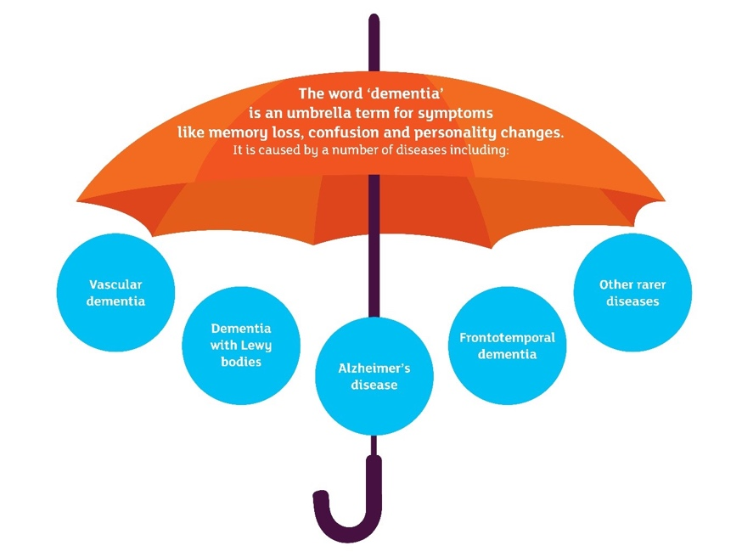
Puckering, (2020)

Critical Appraisal Skills Programme (CASP) used to find right journal articles.
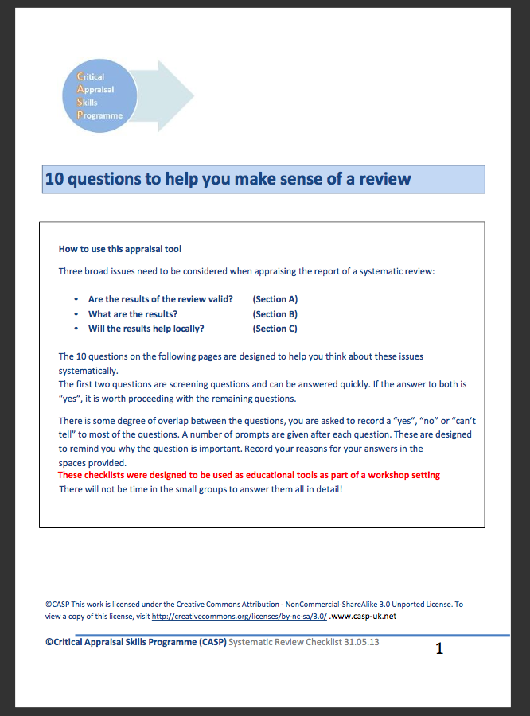

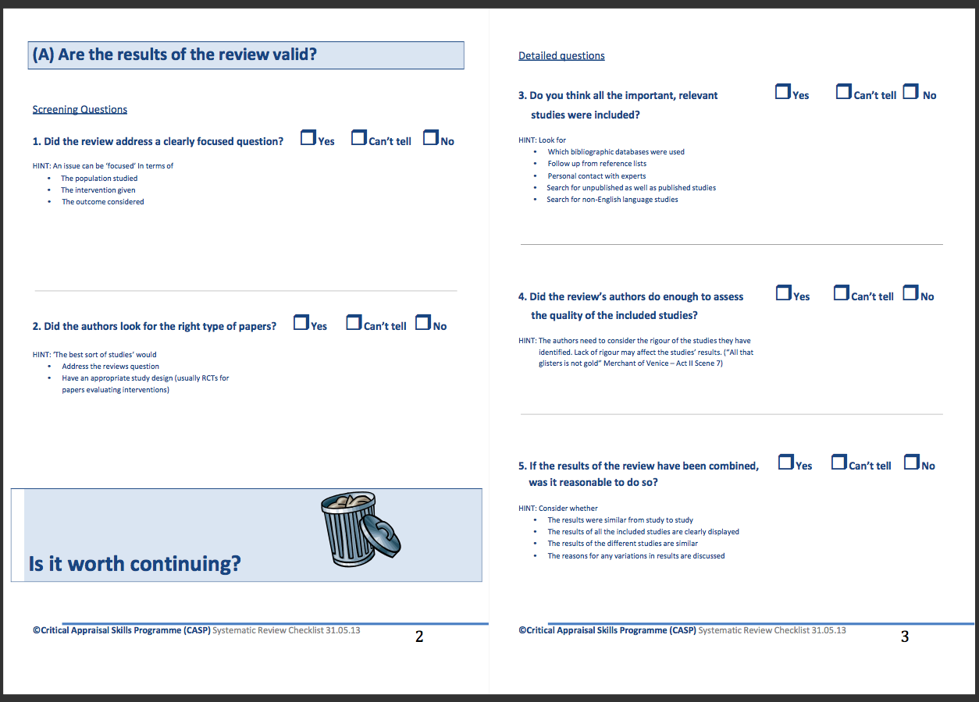

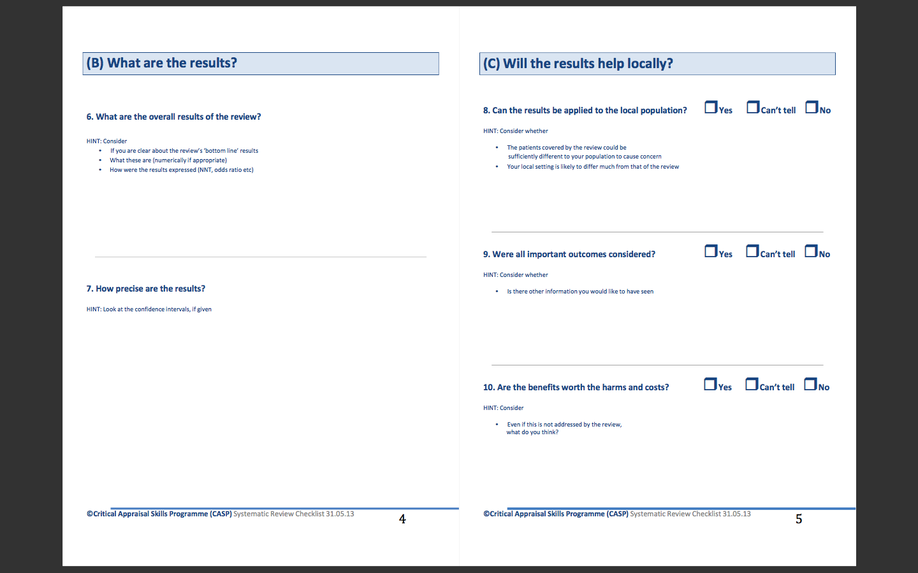

Thesis Search Sheet

My research question: |  |  | Investigating the physiological debilitations of dementia?
Places to search for information: |  |  | Google scholar, uwtsd library, google, government websites
Date | Database Name | Search Terms |  | No of Results | Links to: title, aim, objective number? | Your Comments
6/11/2019 | Google | What is dementia NHS |  | 26,500,000 | Chapter 1 | Relevant to the thesis
11/11/2019 | Uwtsd library | Why is it necessary to know about dementia |  | 29,100,000 | Chapter 1 | Available on Swansea campus
21/11/2019 | Google | Dementia in Nepal |  | 45.200,000 | Chapter –background and justifications | It was relevant to thesis
23/11/2019 | Google | Cure for dementia journal articles |  | 6,770,000 | Chapter – background
26/11/2019 | Google | Report of the national audit of dementia care in general hospitals |  | 33,400 | Chapter 1 | Not relevant to the topic
26/11/2019 | Google | Why is dementia training necessary in hospitals |  | 89,000,000 | Chapter 1 | Relevant to the thesis
27/11/2019 | Uwtsd library | Treatment for dementia journal articles |  | 10, 943 | Chapter 1 | There found some good journal articles
3/12/2019 | Uwtsd library | Stages of dementia and symptoms |  | 15,200,000 | Chapter 1
4/ 12/ 2019 | Uwtsd library | What is methodology |  | 2, 380, 272 | Chapter 2
4/12/ 2019 | Google | define methodological |  | 104, 000, 000 | Chapter 2
4/ 12/ 2019 | Uwtsd library | Methods for literature review |  | 1, 170, 000 | Chapter 2
4/12/2019 | Uwtsd library | how many stages of dementia are there and what are they |  | 66,800,000 | Chapter 1
3//12/2019 | Uwtsd library | What is vascular dementia |  | 167,000 | Chapter 3 | Available on Swansea campus
4/12/ 2019 | Uwtsd library | What is Alzheimer’s disease |  | 293, 278 | Chapter 3 | Available on Swansea campus
4/12/2019 | Uwtsd library | Dementia with Lewy bodies |  | 945,000 | Chapter 1 | Available on Swansea campus
3/12/2019 | Uwtsd library | Frontotemporal dementia |  | 6,830,000 | Chapter 1 | Available on Swansea campus
6/12/2019 | Uwtsd library | Who gets dementia and why journal articles |  | 141,000,000 | Chapter 1
6/12/2019 | Google | how families and carers affected by dementia |  | 111,000,000 | Chapter 1
02/1/2020 | Uwtsd library | journal articles on how families and career are affected while caring for dementia patients |  | 5,480,000 | Chapter 2/3
02/1/2020 | Uwtsd library | What is methodology |  | 2200,000,000 | Chapter 2 | There were so many articles but not relevant to the topic
02/1/2020 | Uwtsd library | What is qualitative research |  | 1, 229, 712 | Chapter 2 | Available on Swansea campus
02/ 1/ 2020 | Uwtsd library | Define quantitative research |  | 906, 592 | Chapter 2 | Available on Swansea campus
9/02/2020 | Uwtsd library | Cost of dementia in UK |  | 7,502 | Chapter 3 | Available on Swansea campus
10/02/2020 | Google | What is Secondary research |  | 2, 286, 537 | Chapter 2
10/02/2020 | Uwtsd library | What is literature review |  | 4, 375, 768 | Chapter 2
10/02/2020 | Google | Define literature review |  | 74, 600, 000 | Chapter 2
10/02/2020 | Google | What is ethics in research methodology |  | 35, 800, 000 | Chapter 2
11/03/20 | Uwtsd library | How does dementia impact on family and carers |  | 23,11 | Chapter 3
11/03/20 | google | Dementia treatment uk journal articles |  | 45,200,000 | Chapter 3
12/03/2020 | Uwtsd library | What is search strategy |  | 865,430 | Chapter 2
14/03/2020 | Google | Dementia action plan for wales |  | 2, 930, 000 | Chapter 3 | Relevant to chapter 3
14/03/2020 | Uwtsd library | Caring for patients with dementia |  | 21,332 | Chapter 3 | Available on Swansea campus
14/03/2020 | Google | What are the physiological effects of dementia journal articles |  | 40, 500, 000 | Chapter 3
17/03/2020 | Uwtsd library | What is dementia and what age are most likely to affect by dementia |  | 52, 598 | Chapter 3 | Available on Swansea campus
17/03/2020 | Uwtsd library | What are the risk factors of dementia journal articles |  | 8, 563 | Chapter 3 | Available on Swansea campus
18/03/2020 | Uwtsd library | Risk factors and prevention of dementia |  | 46, 822 | Chapter 3 | Available on Swansea campus
18/03/2020 | Uwtsd library | Dementia treatment and care journal articles |  | 8, 742 | Chapter 3
18/03/2020 | Uwtsd library | What are the treatments available for dementia condition |  | 19, 965 | Chapter 3 | Found some good journal articles
19/03/2020 | Uwtsd library | How family carer are affected by dementia journal articles |  | 437 | Chapter 3 | Available on Swansea campus. There was not relevant
19/03/2020 | Google | How family care are affected by dementia journal articles |  | 2, 620, 000 | Chapter 3
19/03/2020 | Google | What are the social services available for dementia people |  | 119, 000, 000 | Chapter 3
19/03/2020 | Google | How carers can help dementia patients |  | 87, 200, 000 | Chapter 3
19/03/2020 | Uwtsd library | How carers can help dementia patients |  | 9,390 | Chapter 3 | Available on Swansea campus

