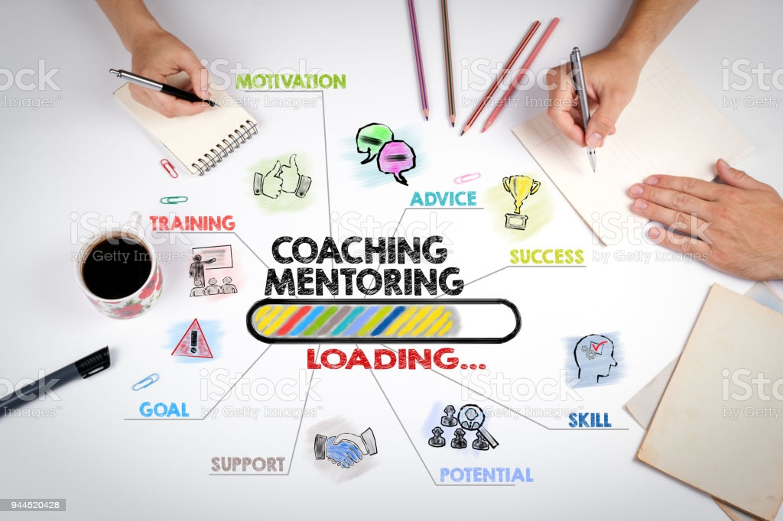

Coaching and Mentoring within an organizational context
  - University of Wales trinity saint david
Anita Kis| 1806311 | Coaching and Mentoring BMSW6105_SWAN | 10/12/2021

2. Executive Summary

Coaching and mentoring is important within every organisations. This report will discuss the importance of coaching and mentoring within the organisations but also the similarities and differences between coaching and mentoring. Other subjects regarding to coaching and mentoring will be analysed, such as the line manager as a coach, building resilience by coaching and mentoring, but also the author’s personal reflection as a coach. This report has been structured by 4 main headings according to the subjects. The first heading will discuss that coaching and mentoring could be similar as they both contribute to the personal growth of employees, but they are also different as coaching is a skill, while mentoring is the way of sharing experiences. Within this subject will be presented coaching methods and their effectiveness, such as the Instant Pay off, the GROW and the OSCAR method. The second heading will elaborate the advantages and throwback of a line manager being a coach. Within this subject it will be clear that many organisations are including coaching in the line manager’s role, but it isn’t always beneficial. Within the third subject about building resilience by coaching, will refer to how coaching could improve the employees well-being and keep them engaged and motivated. It will be stated, that employees need conculing to deal with changes. Finally, the last subject will cover a personal reflection on the author’s peer coaching exercise which will reflect what went well on the session, but also what skills will be needed to develop in the future. For the closure of this report, a conclusion will be conducted about every subject regarding to the results of the analysis.

3. Table of content

- Introduction……………………………………………………………………………………3

- Main Findings

  - The similarities and differences between coaching and mentoring…………………………………………………………………………3-5

  - The line manager as a coach/ mentor……………………………6-7

  - the role of coaching and mentoring in building resilience and dealing with change………………………………7-8

  - personal reflection of peer coaching exercise………8-9

- Conclusion………………………………………………………………………………………10

- reference list………………………………………………………………………………11-12

4. Introduction

The purpose of this report is to define the importance of coaching and mentoring as well as defining the similarities and differences between them. Within this subject will be critically discussed methods of coaching and their efficiency, such as the Instant Pay of Model, the GROW model and the OSCAR model. As part of the report the will be analysed the line manager as a coach, the role of coaching/ mentoring in building resilience and dealing with change, but also the author’s personal reflection will be conducted as a coach. The information for this report has been gathered from credible sources, mostly from books and journals. By the end of the report all the subjects will be covered and a conclusion will be conducted.

5. Main findings

5.1. THE SIMILARITIES AND DIFFERENCES BETWEEN COACHING AND MENTORING
Dietmar Sternad (2021) defined coaching as a training strategy where a more skilled or talented individual gives advice and assistance to an employee in order to help grow the individual's abilities, effectiveness, and profession. He believes that the goal of coaching is to help people enhance their individual efficiency through unlocking their capabilities. It assists people in learning rather than educating or instructing them. For example, if an employee is struggling with a situation at work, the coach will direct him to the solution instead of telling it. Max Landsberg’s (2015) Instant Payoff coaching framework is an example to encourage coaches to ask questions in regards to direct the coachee to the right answer and he believes that, based upon these replies and the intended objective, the coach and employee may devise a feasible strategy and prepare for it to emerge within a reasonable time frame. As its name states, it is an instant coaching method which doesn’t work for long term coaching as it meant to lead to results by a one-time meeting. John Whitmore’s GROW Model is a coaching paradigm that is used to unleash ability and opportunities in discussions, meetings, and everyday leadership. His theory of coaching is based on 4 key steps: Goal, (what do you want?), which includes the Reality (where are you now?), Options (what could you do?) and Will (what will you do?). This type of coaching can be described as an effective method, but it also can be time-consuming as it needs time and a good sets of questions to get results. In comparison with the Instant pay off coaching method, the GROW model needs multiple meetings to analyse the progress. An alternative method of the GROW model is the OSCAR method, which can be described as a much more complex model. Its name contains the acronym for Outcome, Situation, Choices & Consequences, Action and Review. This method of coaching cannot be used for simple coaching sessions like the Instant pay off coaching model, because it needs other sessions to track the progress, but it is also need an expert coach who is able to ask the right questions and build the sessions to fit into this type of coaching. It needs much more time to get results and also experience and ability of coaching.
Mentoring is most succinctly defined as when someone contributes their knowledge, skills, and experience to assist another person advance. This advancement might be professional or personal, however given the work/life balance that many of us today have, the crossing between the two is frequently discussed. Mentoring, unlike coaching relations, are often unpaid. The mentoring relationship is based on a semi-charitable principle: the more accomplished, older partner, the mentor, seeks to pass on some of what they've acquired to someone else who would learn from his knowledge. For example, if an employee is struggling with a new task which is important to his role, a mentor will share his knowledge and experience with him to help him learn and complete the task. Coaching is essentially distinct from mentoring; although, there are several similarities between the two: both contribute to a person's growth, both are centred on one-to-one interactions, both operate best when the involved sides have a solid friendly relationship, both usually include a number of meetings spread out over many months, interpersonal commitments (sometimes formal 'contracts' between both the involved individuals) are involved in both and both may be used into learning and development initiatives. Although, there are also some aspects which make the difference between coaching and mentoring. Mentoring typically focuses on longer-term issues, while coaching is more willing to cover current subjects such as abilities and effectiveness in the present position and that’s the reason why the mentoring contracts are typically for at least 6 months and coaching does involve a number of meetings, although they are usually for a shorter amount of time, possibly 2-3 months. In some organisations mentors are much more likely to come from inside organisation, while coaches are much more likely to be hired from outside sources. Despite of these differences, a mentor may apply coaching skills on occasion (ex: asking questions for relevant solutions), as well as a coach may occasionally express their ideas (when the coachee need more help). While coaching is a skill, mentoring is about sharing knowledge and experience. The tangible benefit of coaching and mentoring can be described as increased productivity and profitability, while the intangible benefit could be the improvement of workplace behaviour.

5.2 THE LINE MANAGER AS A COACH/ MENTOR
As an option to engaging professional coaches to train their employees, several companies are making their managers to be internal coaches. Managers, according to Downey (2014), should ideally blend leadership, management, and coaching abilities to fulfil their function. This provides them the freedom to employ the most suitable intervention to help their direct reports' of learning and development. Line managers are required to do a lot, especially in these unpredictable pandemic circumstances when organisations must adjust rapidly and with tremendous agility to ever-changing financial and social restrictions. Many staff may feel burdened by the sudden and drastic changes in their life, and if workers work remotely, it may be difficult for managers to accept their responsibilities as leaders to encourage, inspire, and assist members of the team in maintaining optimal effectiveness. Line managers must examine where they spend much of their time and establish 'secure environment' for coaching talks in order to facilitate coaching dialogues; nevertheless, many are expected to simply incorporate the position of coach into their employment with no training or supervision. Getting outcomes from others is fundamental to good management, and coaching is one technique for doing so. Although, the line manager as a coach could be beneficial for the organization as he have the trust of his employees and coaching allows managers to focus on growing their team members rather than managing them (Rogers, 2016), freeing up more time for strategic operations, by the other hand it could be overwhelming and difficult because it could affect his efficiency and fairness. A line manager must have skills of good listening, continuous learning in practice, questioning and also the ability of giving feedback. Coaching necessitates the development of several fundamental interpersonal skills, many of which are directly related to effective leadership abilities, such as transparency and the capacity to inspire trust are essential, emotional stability or intellect (the ability to recognise, control, and respond correctly to one's own and others' feelings) and the capacity to form strong cooperative ties. If a manager lacks these abilities or is unable to use them effectively, it will be hard to engage in the type of open and transparent discourse that would be the key to good coaching. On the other hand, an employee may be hesitant to bring up more emotional distress in coaching talks with their superiors. Alternatively, after discussing deeper, more personal topics, both participants may find it tough to return to their initial collegial attitude. For this reason, big companies are mostly using external coaches. Furthermore, if team members are more self-sufficient thinkers, managers no longer need to instruct them how to accomplish things or supervise them.

5.3 THE ROLE OF COACHING AND MENTORING IN BUILDING RESILIENCE AND DEALING WITH CHANGE
Resilience is becoming an extremely important skill in demanding work contexts. Resilient people are better equipped to deal with abrupt change, mistakes and failures, extremely stressful situations, and times of extreme activity. In general, symptoms of low resilience are easily noticeable. They include difficulty to act independently, recurrent simple health illnesses, low self-esteem, feeling anxious, little patience, and a quick temper. Coaches and mentors can assist in two ways: providing the coachee or mentee with the ability to deal with present conditions (resilience in the moment) or increasing their entire resiliency (resilience capacity). When it comes to assisting people in developing resilience, a great place to begin is by outlining the traits of highly resilient individuals and discussing with them how they may incorporate one or more of those qualities into their own viewpoint. Coaches and mentors can't quickly train their mentees or coachees to be more proactive — that comes from a strong real purpose. They may, however, assist the coachee or mentee in developing the habit of expecting change and seeking for opportunities to satisfy it with new modifications of their own that offer them a greater level of control about what is going on. As well a coach/ mentor will also need to possess resilience attributes, such as confident, optimistic, positive, self-aware and self-managing, in order to help others.

5.4 PERSONAL REFLECTION OF PEER COACHING EXERCISE
In this essay, I will be reflecting on a coaching session which I delivered as part of my assessment for
A Level P.E in April 2016.
In this essay, I will be reflecting on a coaching session which I delivered as part of my assessment for
A Level P.E in April 2016.
N this essay, I will be reflecting on a coaching session which I delivered as part of my assessment for
A Level P.E in April 2016.
In this report I will be reflecting my own coaching session which I’ve delivered as part of assignment for Coaching and Mentoring in November 2021. To complete this reflection I will use Gibbs 6 stage learning method: Description, Feelings, Evaluation, Analysis, Conclusion and Action Plan.
My coaching session has been delivered with the help of my colleague, Maria, as a coachee, who has an issue with her team’s productivity. After I heard the issue I prepared a set of questions, but I was also improvising questions regarding to the answers. The coaching session has been structured on the GROW method of coaching. Firstly, the coachee has been asked to define what she wants to achieve by the end of the session, by asking direct questions, such as what is your goal? Secondly, questions has been asked about the current situation, but also about the options to correct the issue. Finally, the coachee has been asked about how she thinks she can do to help her team. I felt confident about my technic, but I’ve missed some important issues by focusing on the pre-established and possible questions. The coaching session has been delivered in short time, nearly 10 minutes instead of 15, which could have been used for examining further issues. The questions has been well constructed, but also I have missed some points. I showed the necessary interest and empathy to make the coachee feeling comfortable, but at some point I’ve got lost in my thoughts about the next questions. By analysing my own performance as a coach, I can say that I am unexperienced in coaching, but I am a continuous learner in practice. I demonstrated that I have the ability of honesty and transparency and also I am able to handle issues with empathy. For further sessions I should listen more and be more prepared for questioning. Overall I consider myself an unexperienced, but good enough coach, as the coachee got the right idea about resolving the issue by the first coaching session. According to my personal development plan, I should improve my listening and questioning skills. I should pay more attention to the details. For this purpose I will take coaching and mentoring trainings and also ask experienced mentors for mentoring me.
PDP
Objective/Area of Development | Measure | Priority | Support and Development.  Internal/External | Review Dates | Other comments
Improve listening and questioning skills | Completing a coaching and mentoring course | H | Internal | March 2022 | Learning and Development team
Paying attention to the details | Learning from experienced mentor/ taking coaching sessions | M | Internal | Daily | Mentor/Manager feedback
Gain experience | Organizing more coaching sessions | L | Internal | June 2022 | Coachee

6. Conclusion

To sum up everything that has been stated, coaching is a skill, while mentoring is way of sharing knowledge. They are both important for the employees’ development, but they are used only for a limited time. As a result of this report, a line manager could be a good coach but it would make his day-to-day work hard and it may face difficulties by treating employees with fairness. On the other hand a line manager needs to have the necessary skills to be a coach, although, it could have impact on the future relationship with the employees. External coaches may help managers grow and strengthen their coaching positions, as well as provide as a backup source of coaching when needed. Also it can be stated that coaching and mentoring is important in building resilience, as it help in keeping employees engaged and motivated. By the other hand it is important that the coach/ mentor to possess the abilities of resilience. According to the personal reflection, it can be concluded that my skills are in development, but also other skills needs to be gained by taking training sessions and also it can be stated that the experience gained will make a good coach.

Reference
- Art of Mentoring. (2015). What is mentoring? [online] Available at: https://artofmentoring.net/what-is-mentoring/ [Accessed: 10. Dec. 2021].
- Bluckert, P. (2009). Psychological dimensions to executive coaching. Maidenhead: Open University Press.
- Brent, M. and Fiona Elsa Dent (2015). The leader’s guide to coaching and mentoring: how to use soft skills to get hard results. New York: Pearson Ft Pub. International.
- Brounstein, M. (2000). Coaching & mentoring for dummies. New, Ny: Wiley Pub.
- Cherry, K. (2019). How Some People Are More Resilient When It Comes to Stress. [online] Verywell Mind. Available at: https://www.verywellmind.com/characteristics-of-resilience-2795062 [Accessed: 6. Dec. 2021].
- Dietmar Sternad (2021). Developing Coaching Skills. La Vergne: Econcise Gmbh.
- Downey, M, (2014). Effective modern coaching. London: LID Publishing.
- Gilbert, A. (2009). The OSCAR coaching model. Worth Consulting.
- Goodman, E. (2020). The manager as coach: leadership, management and coaching. https://elisabethgoodman.wordpress.com/2020/02/04/the-manager-as-coach-leadership-management-and-coaching/ [Accessed 10. Dec. 2021].
- ‌Green, A. and Humphrey, J. (2012). Coaching for resilience: a practical guide to using positive psychology. Philadelphia, Pa: Kogan Page.
- Jackson, P.Z. and Mckergow, M. (2007). The Solutions Focus: Making Coaching and Change SIMPLE, Second Edition. Nicholas Brealey Publishing.
- Landsberg, M. (2015). The tao of coaching: boost your effectiveness at work by inspiring and developing those around you. London: Profile Books Ltd.
- Mcmillan, K. and Weyers, J. (2013). How to improve your critical thinking and reflective skills. Harlow, England: Pearson.
- Michael Bungay Stanier (2016). The Coaching habit. Toronto Box of Crayons Press.
- Neenan, M. (2017). Developing resilience: a cognitive-behavioural approach. London: Routledge.
- Passmore, J., Peterson, D.B. and Tereza Freire (2016). The Wiley-Blackwell handbook of the psychology of coaching and mentoring. Chichester, West Sussex; Malden, Ma: Wiley-Blackwell.
- Performance Consultants (2011). Grow Model | Sir John Whitmore’s Grow Coaching Model Framework - Performance Consultants. [online] Performance Consultants. Available at: https://www.performanceconsultants.com/grow-model [Accessed: 10. Dec. 2021].
- Rogers, J. (2016). Coaching skills: The definitive guide to being a coach (4th ed.) Berkshire: McGraw-Hill Education
- ‌Sherlock-Storey, M., Moss, M., & Timson, S. (2013). Brief coaching for resilience during organisational change—An exploratory study. The Coaching Psychologist, 9(1), 19–26.
- Skillsyouneed.com 2011-2019 (2011). What is Mentoring? | SkillsYouNeed. [online] Skillsyouneed.com. Available at: https://www.skillsyouneed.com/learn/mentoring.html [Accessed: 6. Dec. 2021].
- Whitmore, J. (2017). Coaching for performance: GROWing human potential and purpose: the principles and practice of coaching and leadership. 5th ed. London: Nicholas Brealey.
- Willcock, S. (2016). Help! I’m a manager: a practical guide to success as a first time people manager in professional services. England? Chaseville Press.
- Zhuo, J. (2019). The making of a manager: what to do when everyone looks to you. London: Virgin Books.

