Alice Patterson
2103651
BA Illustration
Word count: 2437
Chris Harrendence

Question 2: Analyse the work of illustrators and, particularly, author illustrators who tackle, difficult, sensitive, and sometimes shocking themes.
For centuries, children have been instructed on the ways of the world through books – primarily picture books - which are used to ‘communicate information’ (Nodelman, 1988, ix). Picture books have been used to ‘widen children’s horizons’ (Schwarcz, 1991, p.11) but can picture books be used to help children understand difficult and taboo topics?
One such topic is the subject of sexism – a problem which many children’s books have strived to tackle, especially in the last few decades. Some have fought against introducing children to difficult topics such as sexism, arguing that ‘young children must be protected from all things unpleasant and dangerous, in both life and literature’ (Sailsbury and Styles, 2012, p.113).
Engaging children into the conversation on sexism is critical, as ‘various studies suggest that gender-stereotypic portrayals in children’s literature can influence the readers’ attitudes and behaviours’ (Anderson and Hamilton, 2005, p. 145). This essay will explore feminist values in children’s books and how books that highlight sexism can decrease children’s stereotypes.
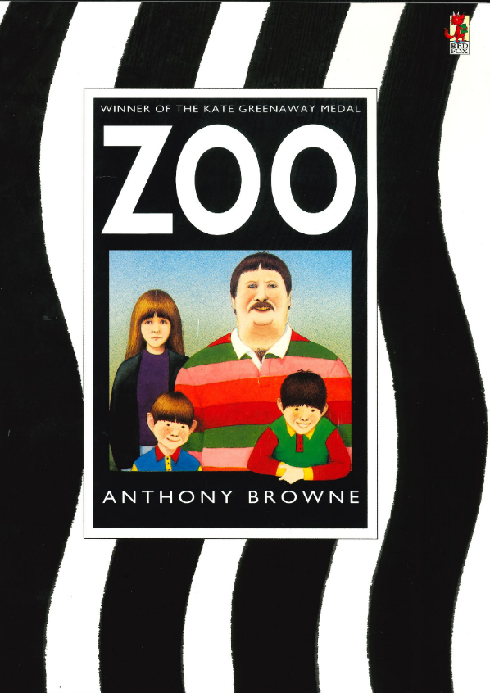
Figure 1: Zoo, Anthony Browne, 1992
Author-illustrator Anthony Browne’s work ‘demonstrates an intelligent observation of gender politics’ (Bradford, 1998, p.80) which he explores explicitly in his 1992 book, Zoo. In Zoo, Browne portrays a family on their day out at the zoo and how each character reacts to their environment. Berger believed that ‘seeing comes before words. The child looks and recognizes before it can speak.’ (Berger, 1972, p. 7). By Berger’s theory, the front cover of a book should hold as much importance as its pages. The front cover of Zoo (Fig.1) depicts a family of two children, a mother, and a father. The father is the largest character in the image, virtually pushing the mother out of frame. According to Bang’s ’10 Principles of Composing Images’, larger objects are seen as stronger. By using this to analyse Zoo’s cover, we can infer that the father is ‘strong’ (Bang, 2016), whereas the other, smaller characters are ‘vulnerable’ (Bang, 2016). By portraying the oldest male as ‘strong’ and the singular female character as ‘vulnerable’, it is clear that Browne has modelled the family on a traditional patriarchal structure in which ‘women are innately and inevitably inferior to men in intellectual and physical structure.’ (Chatraporn, 2006, p.35). Browne’s use of colour in the cover should also be noted, dressing the singular female in black and purple clothes. When applying Goethe’s Theory of Colours, we can view this as a choice to intensify the size difference between the characters, as Goethe believed that ‘black dresses make people appear smaller’. (Goethe, 1970, p.6).

Zoo’s publication in 1992 came at a critical time in the conversation around what a family should and could look like. By depicting a nuclear family reliant on stereotypical gender roles, Browne directly addresses ‘the traditional family […] where the parents are married, and stay married.’ (Douglas, 1990, p. 412), an ideal championed by the UK’s Conservative government at time of Zoo’s conception. At odds with the traditional government, in 1992 “third wave” feminism was finding its feet. “Third wave” feminists emerged in the early 1990s and unlike the “second wave” feminists who were ‘commonly known for being led mostly by white affluent women’ they
aimed to ‘create a mainstream movement that was inclusive of the various challenges women from different races, classes, and gender identities were facing.’ (Iannello, 2010, p.71). At this point in history, the women’s rights movement had ‘asserted equality with men in political, economic, and social spheres’, leading ‘gender roles’ to become ‘less distinct.’ (Wekesser, 1995 p. 105). However, there was still much room for improvement, as explained by socio-political activist and journalist Gloria Steinem in 1993, stating that ‘Until children are raised by men as well as by women, until men aren’t burdened by this compulsion to be in control or even violent, we won’t have [further] change.’ (Steinem quoted in Wekesser, 1993, p. 105). Like Browne, Steinem is here addressing the idea of traditional family values, where women are labelled as primary caregivers and men are seen as the true forces of control in a household. With Zoo’s familial focus, Browne’s choices – in both illustration and text – give us direct insight into his views on the failures of this model.
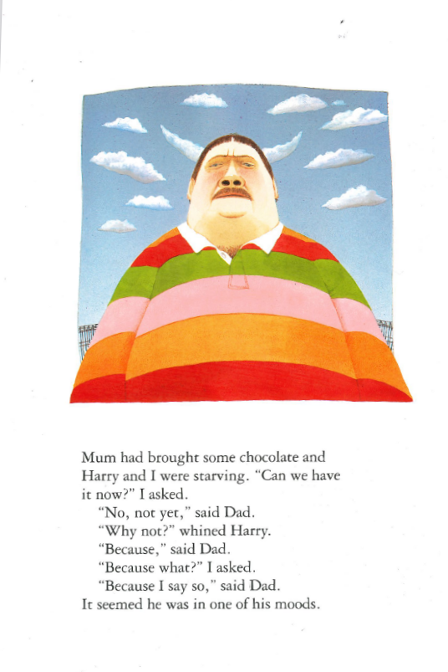
Fig 2: Zoo, Anthony Browne, 1992
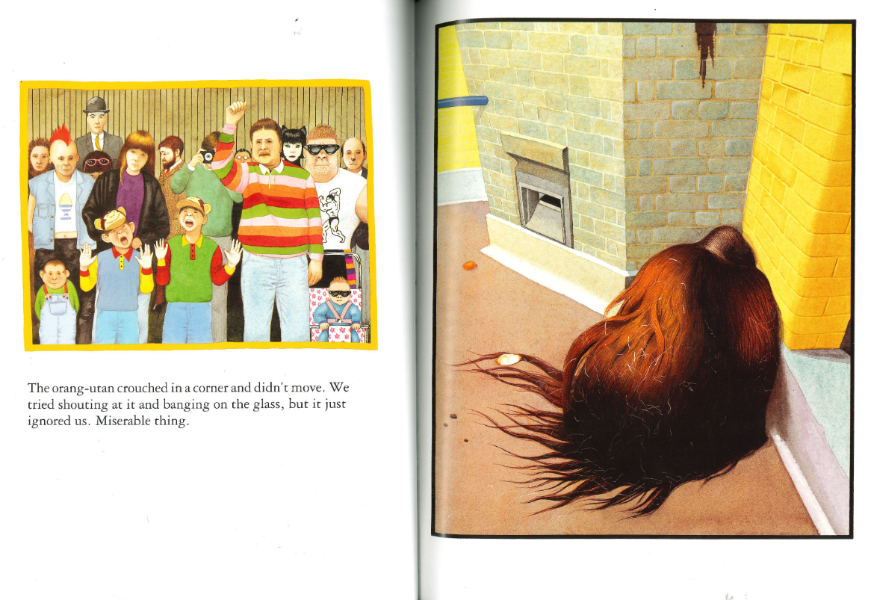
Fig 3: Zoo, Anthony Browne, 1992
Following the “traditional family model” Browne attempts to make the patriarch; Dad seems as if he is in control of the family. In page 6, (Fig 2.) Browne uses both a low viewpoint and zoomorphism to compare Dad to a threatening bull looking down on the reader. For the most part it appears that the male characters have a negative view of the animals, in pages 18 and 19 (Fig 3.) Dad and the children view the orang-utan as a ‘failure’ as it does not react to their ‘shouting (…) and banging on the glass’ by which they ‘become their own versions of orangutans.’ (Bradford, 1988, p. 88).
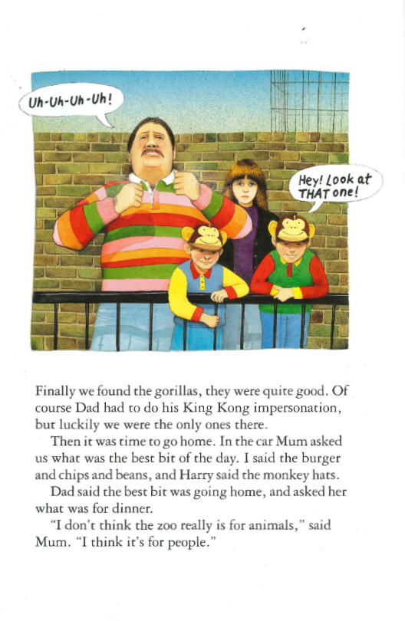
Fig 4. Zoo, Anthony Browne, 1992
Browne uses comparisons to animals throughout the book to describe Dad and his sons, which is shown explicitly in page 20 (Fig 4.) where Dad does his ‘King Kong impersonation’ and both boys are wearing their monkey hats as they look at the gorilla. In contrast, by showing the male characters adopting the characteristics of the animals Browne could be suggesting that they feel a growing empathy towards the animals in the zoo which is confirmed when the narrator asks, ‘Do you think animals have dreams?’ on the final page.

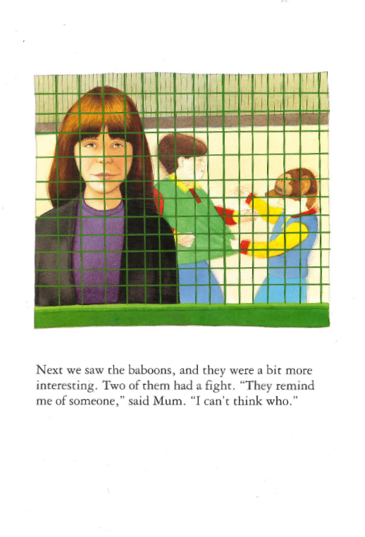
Fig 5. Zoo, Anthony Browne, 1992
In page 16 (Fig 5.) Browne entraps Mum and her children in a cage as she investigates the baboon enclosure, the symbol of the cage suggests that Mum is ‘trapped in a stereotypical gender role’ (Trities, 1997, p.6), she is trapped in the role of the caregiver. Browne correlates the suffering of women in the patriarchy with the entrapment of animals in captivity. When interacting with the animals Mum is seen with an ‘expression of sympathy and concern’ (Bradford, 1998, p.88) which reflects Browne’s own ‘advocacy of animal rights’ (Bradford, 1998, p. 86). Stereotypically, women are seen as being ‘nurturing and empathetic’ (Christov-Moore et al. 2014), Zoo upholds these stereotypes by making Mum the only character who expresses empathy for most of the book. However, Browne does not display these “feminine traits” as negatively as he makes it clear that readers should follow her example by showing the narrator physically showing empathy for the animals on the final page.
By choosing Mum to present the moral viewpoint of the story rather than the ‘strong male’ Browne instils a feminist message to his readers – that women should be listened to and respected and viewed as individuals rather than a ‘set of oppositions to the father’ (Bradford, 1998, p. 89.).
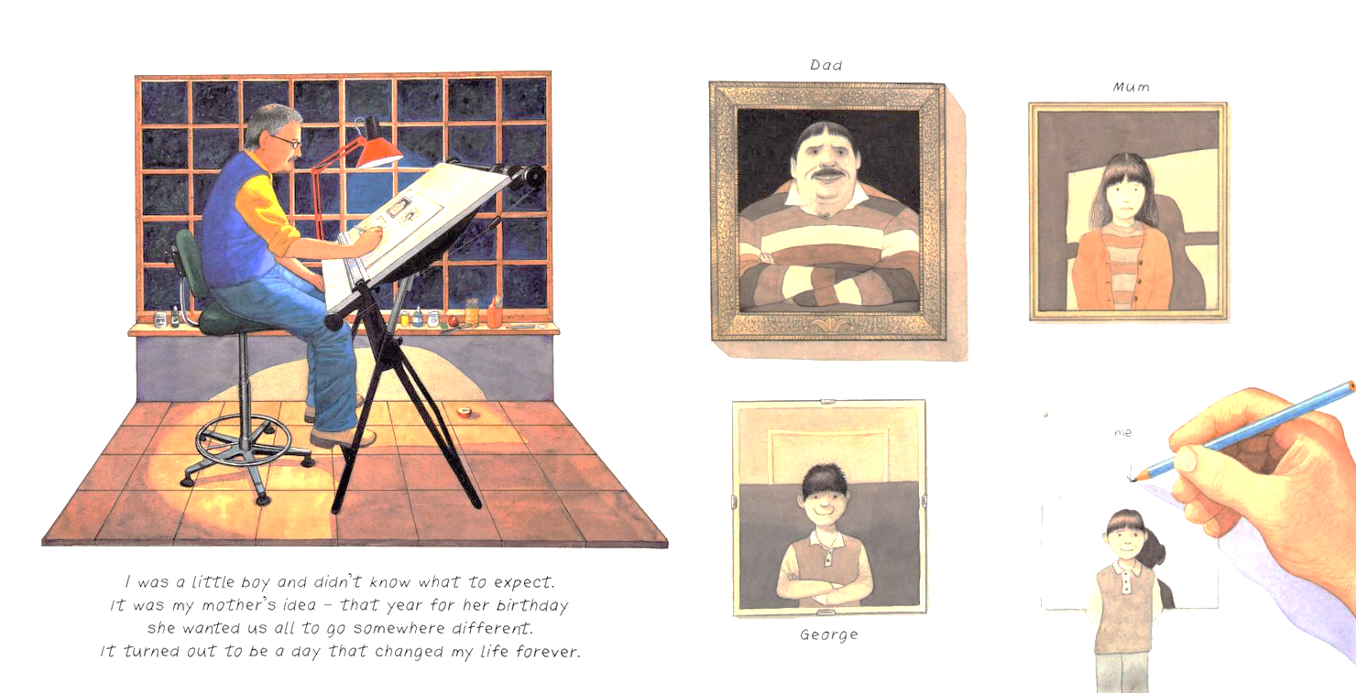
Fig 6 The Shape Game, Anthony Browne, (2003)
The Shape Game (2003) features the same family in Zoo and similarly, to Zoo the book shows the family on a trip. However, as a grown-up version of one of the boys explains ‘It was my mother’s idea’ which introduces the idea that this trip will go differently than their last day out. The Shape Game features a contrasting introduction page (Fig 6.) to Zoo in which Mum is wearing yellow. According to Goethe’s Theory of Colours, Mum’s change in clothing can infer a change in character as Goethe believed that ‘yellow excites a warm and agreeable impression’ and is ‘serene and noble’ (Goethe, 1970, 307-8). From the start of the book, Browne makes it apparent that Mum has adopted more of a leadership role in the family as she ‘initiates the trip and leads her family’ (Joosen, 2015, p. 155), her new role encourages readers to view her as a feminist because as Trities believes, the feminist character ‘does not simply grow, she grows in power. […] the feminist protagonist learns to recognize and appreciate the power of her own voice.’ (Trities, 1997, p.7-8).
Mum’s change in role in the family may reflect a change in gender attitudes from 1992 to 2003, as an American study found ‘support for gender equality declined in the mid-1990s, rebounded in the mid-2000s’ (Meagher and Shu, 2019).
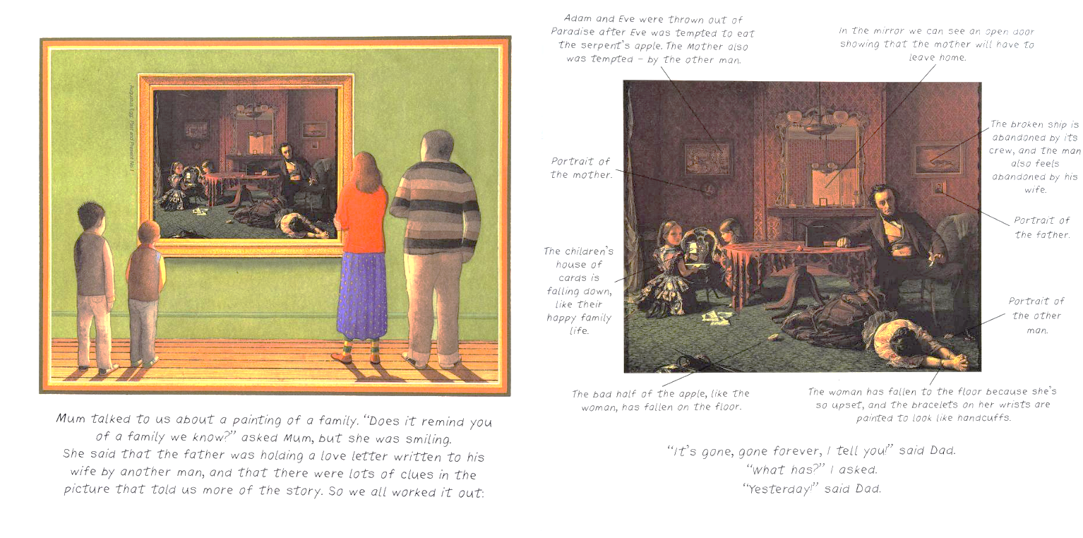Fig 7. The Shape Game, Anthony Browne, (2003)
At the gallery, Mum shows her family many different paintings and shows them how to analyse them. Browne’s choice of paintings directly links to the characters and structure of the family– ‘” Does this remind you of a family we know?” asked Mum, but she was smiling.’. The first painting (Fig 7.) that Mum explains is, Augustus Egg’s Past and Present No. 1 (1858) which depicts the ‘the discovery of the woman's infidelity and its consequences’ (Fowle, 2000). Past and Present No. 1 (1858) is a painting that is representative of how extreme sexism was in Victorian England where ‘a man could safely take a mistress without fear of recrimination, but for a woman to be unfaithful was an unforgivable crime’ (Fowle, 2000). Mum notices that the ‘bracelets on her wrist are painted to look like handcuffs’ a point that Bradford argues relates to the image of Mum being imprisoned in Zoo.

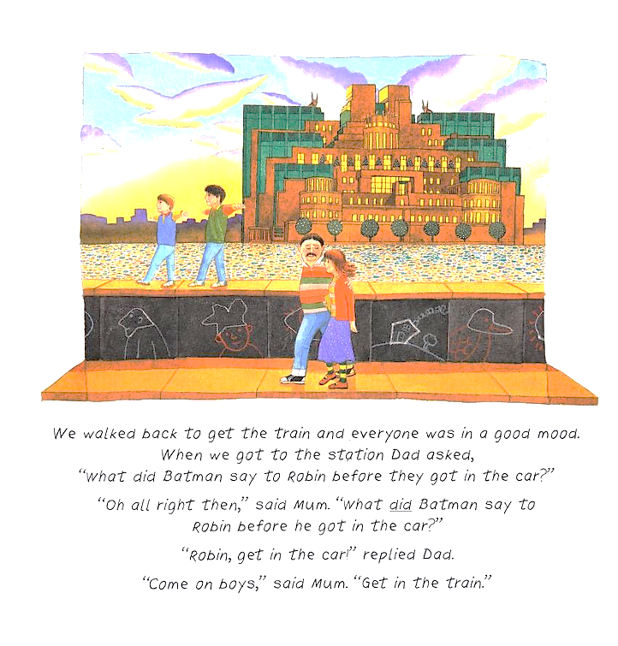
Fig 8. The Shape Game, Anthony Browne, (2003)
Unlike in Zoo Mum is given more opportunity to use her voice which makes her a more obvious feminist protagonist. Compared to Zoo, in The Shape Game the whole family listen and acknowledge her opinions and ideas as she encourages them to participate in analysing the art; ‘” Look more closely.” Said Mum’. Browne uses the character of Mum to unite the family which is seen in the (Fig 8.) of the family walking home together. This image contrasts to the beginning as it shows the family walking together rather than separately, Joosen infers that this page ‘suggests that the mother has not only raised their interest in art but has also managed to increase their coherence and love for each other’ (Joosen, 2015, p. 157).

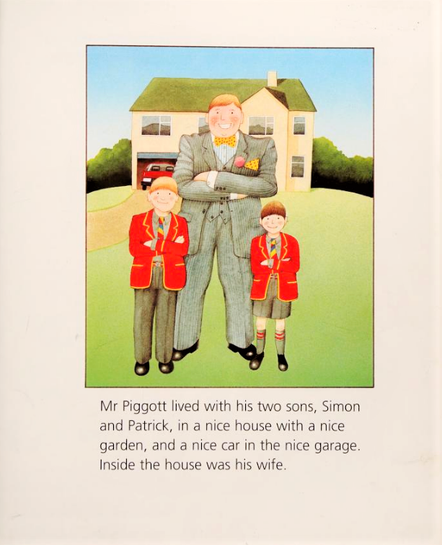
Fig 9. Piggy Book, Anthony Browne, (1986)
Another of Browne’s works that tackles the subject of sexism is 1986’s Piggy Book which looks at the life of a family that is disrupted when the Mum leaves home. The first page (Fig, 9) introduces the family: ‘Mr Piggott lived with his two sons, Simon and Patrick (…) Inside the house was his wife.’. The wife is not depicted in the accompanying illustration which is reminiscent of the ideals of the patriarchal family ‘when men were men and in charge, and women knew their place – which was at home looking after their husbands and offspring.’ (Douglas, 1990, p. 413).
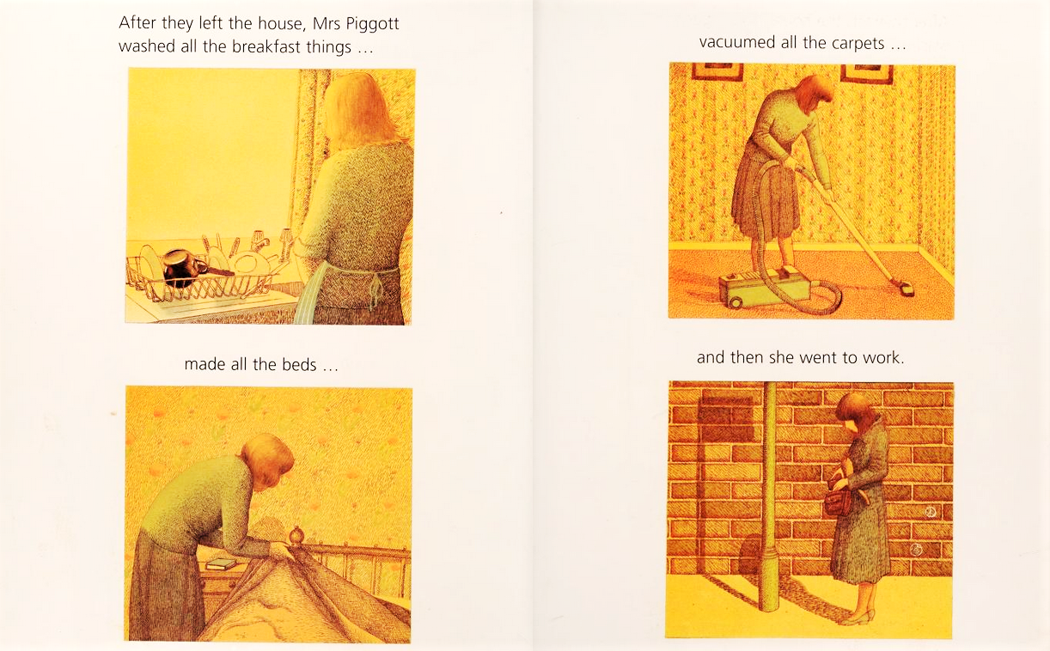
Fig 10. Piggy Book, Anthony Browne, (1986)
At the time Browne released Piggy Book, the United Kingdom was governed by a conservative government wherein many of its members stressed ‘the worth of the traditional family’ (Douglas, 1990, p.412). At the start Piggy Book appears to appeal to the idea of the traditional
family with pages 4 and 5 (Fig 10.) showing Mrs Piggot doing all the household chores whilst the rest of the family go on about their ‘very important’ lives. However, Mrs Piggot is not exclusively a housewife and has her own job - even if it is viewed as less important - much like many women in the 1980s who were encouraged to get jobs because of the ‘economic difficulties’ (Douglas, 1990, p.413).

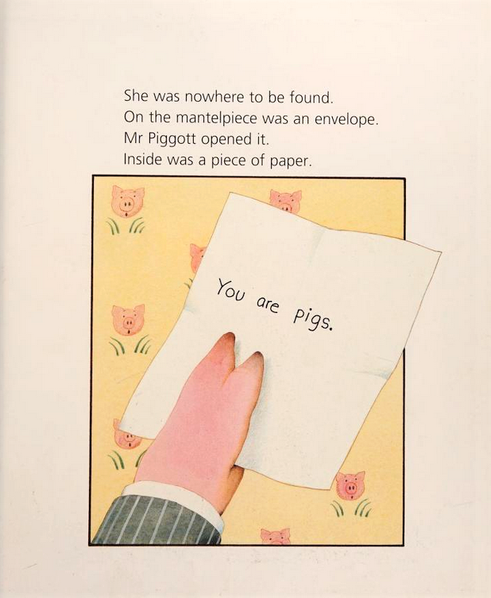
Fig 11. Piggy Book, Anthony Browne, (1986)
Halfway through Piggy Book Mrs. Piggott suddenly leaves the house after realising how she’s taken for granted, which can be seen as ‘‘A ‘click moment […] when a woman realizes she’s being treated like a doormat’’ (Douglas and Michaels, 2004, p. 41). The book’s click moment comes in the form of a note Mrs. Pigott leaves to her family (Fig 11.) - ‘You are pigs’, when the family find the note, they turn into pigs. Browne is referencing the term “male chauvinist pigs” (Joosen, 2015, p. 151) which was coined by “second wave” feminists in the late 1960s. Mrs. Piggot mirrors the “second wave” feminists who began questioning their ‘societal roles, particularly their disempowerment within the nuclear family and objectification as solely domesticated care-givers’ (Turner, 2019, p. 4).

According to Trities analysis, the feminist protagonist ‘discovers herself to be a strong, independent and articulate person’ this description can be applied to Mrs. Piggott as she frees herself from her oppressors and becomes independent. However, by the end of the book Mrs. Pigott has returned to the family but has replaced her job of doing household chores with mending the car (Fig 12.)
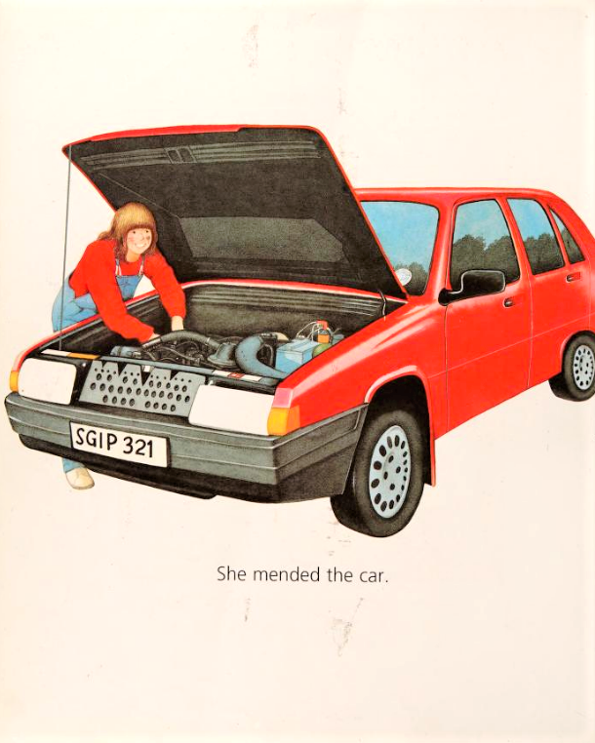
Fig. 12. Piggy Book, Anthony Browne (1992)
A criticism of the message of Piggy Book can be explored by Lissa Paul who states that ‘novels who engage in simple role reversal are no more feminist that their counterparts.’ (Paul quoted in Trities, 1997, p. 5), by having Mum shown at the end ‘mending the car’ it could be seen as her not ‘transcending gender roles’ (Trities, 1997, p.5) but becoming a ‘hero in drag’ (Paul quoted in Trities, 1997, p. 5).

Bradford sates that the use of role-reversal could be portrayed as ‘contesting the notion that if men and women exchange roles, gender equality will inevitably result.’ (Bradford, 1998, p. 86). However, from a child’s perspective the book clearly displays the notion that ‘women are able to do as men what men can do’ (Grosz, 1995, p.50) and the message of equality still stands even if it is done obviously. Piggy Book has the ability to make ‘the reader aware of how and when she is controlled’ (Trities, 1997, p.9) which according to Trities beliefs, constitutes it as a feminist picture book.

This essay has explored how Anthony Browne approaches the subject of sexism – particularly focusing on his portrayal of female characters. According to Trities theory on what constitutes as a feminist character it reveals that Browne’s depictions of women, especially mothers can be seen as feminist characters. By including feminist characters in his work Browne actively discourages negative opinions towards women and instils his readers with a view of women as leaders and as independent individuals. Browne often pokes fun at and distorts stereotypical gender roles which encourages children to hold less traditional and outdated values. Even though, in earlier works such as Piggy Book Browne leans into gender cliches to convey a message of equality, his later works suggest a better understanding of depictions of women in picture books. However, Piggy Book is a simple and concise introduction to sexism which children can understand the message of easily. It also encourages children to reflect on their own family dynamics and empowers female readers to take charge in their lives.

Bibliography
Anderson, D. A., and Hamilton, M. (2005). ‘Gender Role Stereotyping of Parents in Children's Picture Books: The Invisible Father’. Sex Roles: A Journal of Research, 52(3-4), pp. 145–151. DOI: https://doi.org/10.1007/s11199-005-1290-8
Arizpe, E. et al. (2003) Children reading pictures: interpreting visual texts. London: Routledge.
Bang, M. (2016) Picture this: how pictures work. Revised and expanded 25th anniversary edition. San Francisco, California: Chronicle Books.
Bradford, C. (1998) ‘Playing with Father: Anthony Browne’s Picture Books and the Masculine’, Children’s literature in education, 29(2), pp. 79- Available at: https://librarysearch.uwtsd.ac.uk/permalink/44WHELF_UWTSD/1ir6fgh/cdi_proquest_journals_1683898716 [Accessed on: 16th November 2022]
Browne, A. (1986) Piggy Book. London: Julia MacRae
Browne, A. (2003) The Shape Game. London: Julia MacRae
Browne, A. (1986) Piggy Book. London: Julia MacRae
Chatraporn, S. (2006). ‘The Defiance of Patriarchy and the Creation of a Female Literary Tradition in Contemporary World Popular Fiction’. Manusya: Journal of Humanities 9 (3), pp. 35-53, DOI: https://doi.org/10.1163/26659077-00903002
Christov-Moore, L. et al. (2014) ‘Empathy: Gender effects in brain and behavior’, Neuroscience & Biobehavioral Reviews, 46, pp. 604-627 Available at: https://www.sciencedirect.com/science/article/pii/S0149763414002164 [Accessed on: 3rd December 2022]
Diekman, A.B. and Murnen, S.K. (2004) ‘Learning to Be Little Women and Little Men: The Inequitable Gender Equality of Nonsexist Children's Literature.’ Sex Roles: A Journal of Research 50, pp. 373–385 DOI: https://doi.org/10.1023/B:SERS.0000018892.26527.ea
Douglas, G. (1990). ‘Family Law under the Thatcher Government’. Journal of Law and Society, 17(4), pp. 411-426. DOI: https://doi.org/10.2307/1409899
Fowle, F. (2000). Augustus Leopold Egg Past and Present, No. 1 1858 Available at: https://www.tate.org.uk/art/artworks/egg-past-and-present-no-1-n03278 [Accessed on: 30th November 2022]
Goethe, J.W. von (1970) Theory of colours. Cambridge, Mau: M. I. T. Press.
Iannello, K. (2010) ‘Women's Leadership and Third-Wave Feminism.’ Gender and Women's Leadership: A Reference Handbook. Ed. Karen O'Connor, pp. 70-77. Available at: https://cupola.gettysburg.edu/cgi/viewcontent.cgi?article=1017&context=poliscifac [Accessed on: 3rd December 2022]
Joosen, V. (2015) ’”Look More Closely,’ Said Mum”: Mothers in Anthony Browne’s Picture Books.’ Child Lit Educ, 46, pp. 145–15. DOI: https://doi.org/10.1007/s10583-015-9253-3
Meagher K. and Shu X. (2019) ‘Trends in U.S. Gender Attitudes, 1977 to 2018: Gender and Educational Disparities’. Socius 5, DOI: https://doi.org/10.1177/2378023119851692
Nodelman, P. (1990) Words about pictures : the narrative art of children’s picture books. Athens, Ga. ;: University of Georgia Press.
Paul, L. (1998) Reading otherways. Stroud: Thimble.
Salisbury, M. and Styles, M. (2012) Children’s picturebooks : the art of visual storytelling. London: Laurence King Pub.
Schwarz, J. and Schwarz, C. (1991) The Picture Book Comes of Age. Chicago and London: American Library Association
Turner, L. (2019) ‘The Cultural Accuracy of Gender Representation in Children's Literature: Ladybird Books During the Second Wave of Feminism’ The Journal of Publishing Culture 9, pp. 1-11 Available at: https://journalpublishingculture.weebly.com/uploads/1/6/8/4/16842954/turner.pdf [Accessed on: 29th November 2022]
Trites, R.S. (1997) Waking Sleeping Beauty : feminist voices in children’s novels. Iowa City: University of Iowa Press.
Wekesser, C. (1995) Feminism: Opposing Viewpoints. San Diego, CA : Greenhaven Press

