BA Business Management Level 5 Term 2 Group 1
Lyubomir Malamov 2019943
MODULE: ENTREPRENEURSHIP
ASSESSMENT 1

Table of Contents
1.0 Introduction 3
2.0 Part 1: Essay 3
2.1 4Ps of marketing 3
2.1.1 Product/services 3
2.1.2 Place 4
2.1.3 Price 4
2.1.4 Promotion 4
2.2 Feasibility analysis 5
2.2.1 Product/service feasibility 5
2.2.2 Target Market feasibility 5
2.2.3 Organisational feasibility 6
2.2.4 Financial feasibility 6
2.3 Market research 7
3.0 Part 2: Reflection 8
4.0 Conclusion 10
Reference list 11
Appendices 12
Appendix 1: Primary survey question 12
Appendix 2: Survey Responses 13

1.0 Introduction
Entrepreneurship is defined to be the ability and agility of an individual or group of individuals to organise, develop and operate a business entity to make a profit. In simpler terms, entrepreneurship is one's ability to integrate a new business as a reward. In the context of entrepreneurship, the inclusion of new product development becomes important in society as it leads to the growth of business and future sustainability which leads to economic growth. Thus in the study, the importance of introducing a new health drink product to the market over the summer is analysed to provide value to the customers. The study undertakes the creation of a new product into the market by Fizz, an emerging company in the field of soft drinks that aims to launch a new health drink that caters to the needs of the healthy population during the summer.

2.0 Part 1: Essay

2.1 4Ps of marketing
Fizz is going to introduce healthy drinks for the citizens of the United Kingdom for catering to the healthy population in summer. An entrepreneur is often seen to be a source of new concepts and ideas. In order to become a successful entrepreneur, it is required to develop certain skills such as communication, adaptability, business strategy, focus, vision and soft skills. The main aim of an entrepreneur is to introduce a new product into the market in order to add value to the customers. Hence, the needs of consumers are inclined toward the adoption of health-conscious products in order to remain healthy. It has been identified that the majority of non-alcoholic drinks contain a high concentration of sugar affecting the health of the population (Hartmann et al. 2018). The increase in demand for health-conscious products in the market has led to the adoption of this idea in research to add value to the customers.

2.1.1 Product/services
The product idea is the development of a healthy drink in summer due to the creation of healthy food demands. Moreover, the product life cycle is analysed on the production and development process for the new product launch. The product is likely to evolve in the market by following the product life cycle that includes four different stages (Taddese, Durieux and Duc, 2020). Such as the introduction of the product in the market, initiation of growth where the product reaches the market growth followed by maturity which undertakes stagnation of the product in the market having a constant demand and sale. The cycle ends with the declination phrase having a reduction in market demand. In this context, it can be said by considering the life cycle that the introduction to healthy drinks of Fizz is at the introduction phase where awareness is created regarding the product in order to initiate into the growth stage.

2.1.2 Place
The place selected for sustainably selling health drinks is likely to take place in all retail stores that sell non-alcoholic drinks in the UK. The product is to be sold in a physical store and online platform most precisely comprising specific target populations such as younger adults, professionals and children. The sale is more likely to take place through online and offline stores both.

2.1.3 Price
The economy pricing strategy will be adopted as the product is developed for health-conscious people and in order to do so, sugar is replaced with other elements that contain less sugar concentration. Therefore, the cost of production is low in comparison to the production of sugar-concentrated drinks. Thus under such a situation, the economic pricing strategy will be adopted for providing healthy drinks at lower prices.

2.1.4 Promotion
Online and offline promotion strategies will be adopted where communication is the key to understanding the needs of the consumers and at the same time displacing information about the product to the masses (Jiang et al. 2022). Thus in order to introduce products in the market online and offline marketing strategies will be adopted. In online marketing, there will be the use of different social media platforms such as Facebook, Instagram, and Youtube and marketing strategies such as paid promotion, influencer marketing and video marketing. Moreover, offline flyers and pamphlets will be developed to spread information to a larger segment.

2.2 Feasibility analysis

2.2.1 Product/service feasibility
Strength  - The rise in health-conscious consumers  - Lower concentration of sugar in the product | Weakness  - Increasing competition from Mondelez International, Danone, Glanbia PLC, Coca-Cola and General Nutrition Centres (MordorIntelligence, 2022).  - Low packaging quality
Opportunities  - The market size of Non-alcoholic beverages in the UK is 13.68 bn GBP (Statista, 2022).  - An increase in nutritional beverages in 2021 accounted for USD 5.2 billion (DataBridge, 2021). | Threats  - Limited market knowledge of consumers  - Biggest competitive players in the markets
Table 1: SWOT analysis
(Source: Self-developed)

2.2.2 Target Market feasibility
Industry rivalry:
The industry is highly concentrated with a number of established players gaining a competitive edge in the market such as Mondelez International, Danone, Glanbia PLC, Coca-Cola General Nutrition Centres and Premier Nutrition Company LLC (MordorIntelligence, 2022). Hence, the competitive rivalry is high as there are numerous competitors in the market.
The threat of substitutes:
The threat of substitutes for healthy drinks is moderate as there are a number of health drinks manufacturing companies available in the market, thus acting as substitutes for products.
Suppliers’ power:
The power of suppliers is found to be low as the majority of the products are derived from different suppliers in the market.
Buyers’ power:
The power of buyers in the food and beverage industry is found to be in a highly concentrated area due to the existence of competitors in the market and the availability of health drinks at lower prices. Hence, the buyers’ power is high.
The threat of new entrants:
The market size of non-alcoholic drinks is valued at USD 833.2 billion in 2021 and is expected to increase with a CAGR of 5.7% between 2022 to 2030 (MordorIntelligence, 2022). The reason behind the growth of this market is due to an increase in the attractiveness of products in the market making it highly competitive. Therefore the threats of new entrants in medium to high due to their increasing demand in the market.

2.2.3 Organisational feasibility
The organisation Fizz has been introduced in the market recently and is still in the process to be tested. However, the management of Fizz has identified its target customers in order to develop rightful opportunities for the introduction of the product into the market. The first and foremost aspect related to the product offered by Fizz is that it is comparatively new in the market that healthily offers summer drinks. Secondly, the customers are getting highly aware of the presence of health drinks in the market during summer.

2.2.4 Financial feasibility
The value of health drinks and food in the market is valued at $120,446.60 million in 2020 and it is expected to rise by 2031 with a CAGR of 11.44% (MordorIntelligence, 2022). Thus the estimated cost required for the production of a new health drink is $8000 which includes different units of production, packaging, supply chain management, employment wages and many others. Considering the financial feasibility of the non-alcoholic drink industry such as Coca Cola the revenue generated in the year 2021 accounted for over 38.66 billion U.S. dollars (Statista, 2022).

2.3 Market research
It is identified that the product portfolio of different brands such as Coca-Cola, Danone and many other non-alcoholic drinks contains sugar, and the introduction of new products by Fizz that does not involve the use of sugar can attain a higher market share. The market is researched with the use of primary and secondary research methods. In the primary method, the data is collected by performing surveys on 50 consumers within the UK regarding their drinking preferences. The results derived after performing the survey were that there is a high concentration of the population that prefers soft drinks which are healthier and meet their demands. On the other hand in the second method, all existing data are collected from diverse secondary sources. The findings represent that the nutritional health industry is expected to increase in the coming future by 11.44% and gain a profitable market share (MordorIntelligence, 2022). However, under the primary research method survey is performed on the population that prefers non-alcoholic drinks [Refer to appendix].

3.0 Part 2: Reflection
Gibbs reflective cycle is adopted in the research that undertakes 6 different stages that pertain to the overall experience gained while performing the research. Therefore all 6 cycles are implemented in the study in order to develop an understanding of the experience gained during the module.
Description
In the present scenario, the behaviour and preferences of the consumers are gradually making an inclination towards the adoption of health benefits food and drinks. As per Halimi et al. (2019), the adoption of nutritional food consumption not only improves physical health but also improves mental health and reduces the chance of occurrence of any disease. The increasing demand in the market regarding the utilisation and adoption of nutritional products by consumers has integrated me in developing business in this regard and introducing new products in the market that are beneficial to consumers from a healthy option perspective. Thus after participating in the project, I have developed the idea that my entrepreneurial skills and knowledge regarding healthy products contributed to the development of business ideas in a positive manner.
Feeling
The feeling that I evoked while performing the module is the existence of entrepreneurial skills and knowledge about healthy food products that have contributed significantly to introducing a new solution in the field of the beverage industry that summits the requirement of a healthy option population. Conversely, I feel that the development of communication skills needs to be improved and implemented in the project for attaining wider scope and information about consumer problems.
Evaluation
After evaluating the results and information that I have gained during the project, I have come to the concluding fact that I have implemented all my entrepreneurial skills and knowledge in order to present clear and resilient information regarding the increasing demand in the market. In this context, I found that over 90% of the respondents considered using non-alcoholic drinks followed by 60% of the respondents agreeing to prefer less concentrated drinks. The survey question 2 relates to the awareness of people regarding the existence of sugar-concentrated drinks. In response to the question, over 46% of the respondents were aware about the presence of sugar in drinks. Moreover, in the fourth question of the survey the participants were asked about the side effects of consuming soft drinks and over 40% of the respondents considered obesity as one major side effect. In the last question the respondents were asked about their preferences for healthy drinks over concentrated drinks and over 70% of the participants agreed to prefer healthy drinks. I have applied my problem-solving and decision-making skills in order to make an informed decision about the introduction of new products in the market by exploring the demand in the market that generates higher revenue to the company.
Analysis
The fact that I have evaluated myself is that there is a lack of communication skills within myself that has limited my approach and development of relationships with the customers. Therefore an improvement is required for improving my communication skills and in order to do so, I would like to engage myself in different social activities that involve making social interactions and communicating with people and using the 7Cs model. Improving communication skills can provide me with an opportunity to improve my self-confidence and develop my understanding of the problem faced by people by engaging with a wider section of the population. Along with that, I can improve my leadership skills with the adoption of a contingency leadership style.
Conclusion
The concluding fact presented in the reflection of my personal development is that my entrepreneurial skills of critical thinking, network building and active listening have contributed to solving the problem of health-conscious customers in the summers. On the other hand, during the assessment, I have identified certain gaps in my skills that have created a profound impact on my performance and this includes a lack of communication and informed decision-making capability.
Action plan
Development of objectives | Priorities | Activities | Control | Time-bound
Developing communication skills | High | Involving in social activities and using the 7Cs model | Making thorough communication with people by engaging in different social activities | 5-6 weeks
Improving decision-making ability | Medium | Undertaking feedback from seniors | Making the decision and reviewing the action from another perspective and self-introspection results | 7-8 weeks
Leadership | High | Short leadership course | Reviewing progress each week | 5 months
Table 2: Action plan
(Source: Self-created)

4.0 Conclusion
The conclusion derived after analysing the study that undertakes the development of the new product by Fizz in the beverage market in a healthy way. It is concluded that the preferences of consumers are taking a gradual change by inclining toward the adoption of healthy products. There is an increased rate of demand in the market for healthy drinks, thus understating the condition in the market the introduction of new soft drinks can provide an opportunity to Fizz for to gain a competitive edge in the market and give strong competition to soft drink companies such as Coca-cola and many other in an effective manner.

Reference list
Halimi, R.A., Barkla, B.J., Mayes, S. and King, G.J., 2019. The potential of the underutilized pulse bambara groundnut (Vigna subterranea (L.) Verdc.) for nutritional food security. Journal of Food Composition and Analysis, 77, pp.47-59.
Hartmann, C., Ruby, M.B., Schmidt, P. and Siegrist, M., (2018). Brave, health-conscious, and environmentally friendly: Positive impressions of insect food product consumers. Food Quality and Preference, 68, pp.64-71.
Jiang, H., Cheng, Y., Yang, J. and Gao, S., 2022. AI-powered chatbot communication with customers: Dialogic interactions, satisfaction, engagement, and customer behaviour. Computers in Human Behavior, p.107329.
MordorIntelligence, 2022. HEALTH DRINKS MARKET GROWTH, TRENDS AND FORECASTS (2022 - 2027). (Online). Available at: https://www.mordorintelligence.com/industry-reports/global-health-drinks-industry#:~:text=The%20health%20drinks%20market%20is%20projected%20to%20witness%20a%20CAGR,eating%20routines%20after%20COVID%2D19. [Accessed on 25th July 2022].
Statista, 2022. Non-alcoholic beverages and soft drinks in the UK - statistics & facts. (Online). Available at: https://www.statista.com/topics/8800/non-alcoholic-beverages-and-soft-drinks-in-the-united-kingdom/#topicHeader__wrapper. [Accessed on 25th July 2022].
Statista, 2022. The Coca-Cola Company's net operating revenues worldwide from 2007 to 2021. Available at: https://www.statista.com/statistics/233371/net-operating-revenues-of-the-coca-cola-company-worldwide/. [Accessed on 25th July 2022].
Taddese, G., Durieux, S. and Duc, E., 2020. Sustainability performance indicators for additive manufacturing: a literature review based on product life cycle studies. The International Journal of Advanced Manufacturing Technology, 107(7), pp.3109-3134.

Appendices

Appendix 1: Primary survey question
- Do you use non-alcoholic drinks?
Yes
No
- Are you aware that sugar concentration in soft drinks is harmful?
Yes
No
- Do you prefer to use less sugar-concentrated drinks?
Yes
No
- What are the side effects of soft drinks having sugar?
Weight gain
Obesity
Cavities
Heart disease
- Do you prefer healthy soft drinks over sugar-concentrated drinks?
Yes
No

Appendix 2: Survey Responses
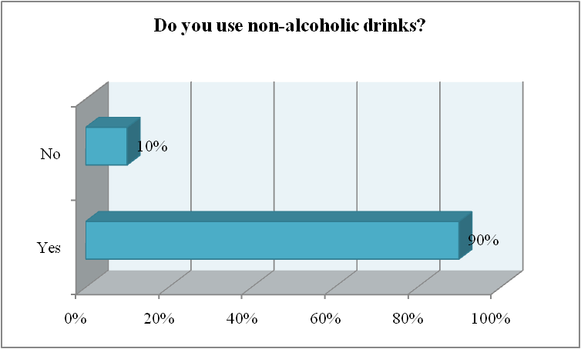
Figure 1: Response to survey question 1

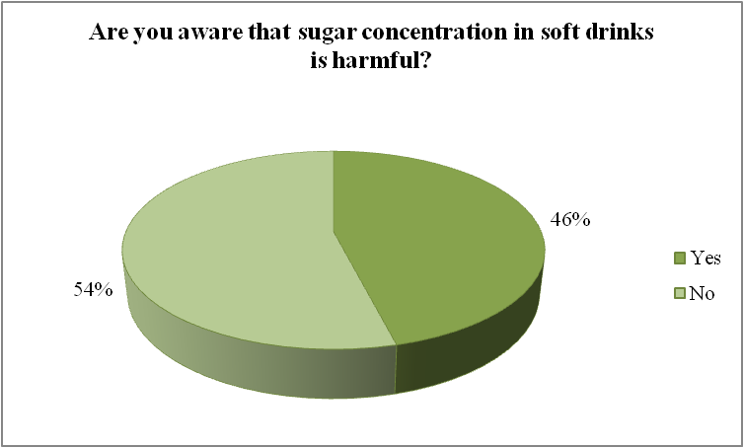
Figure 2: Response to survey question 2

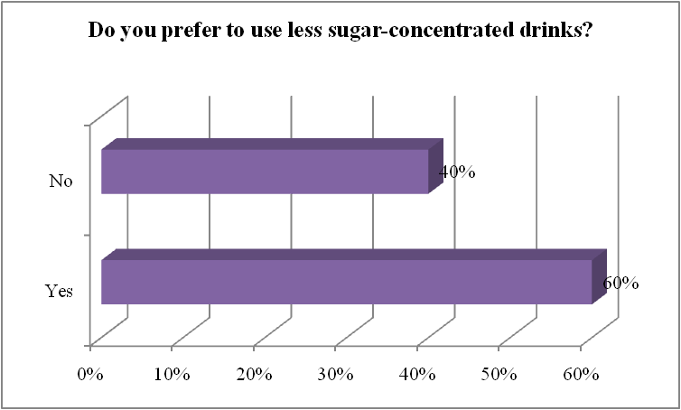
Figure 3: Response to survey question 3

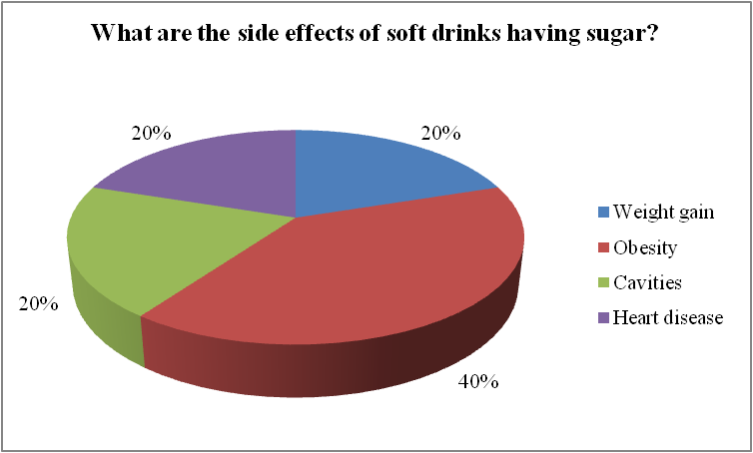
Figure 4: Response to survey question 4

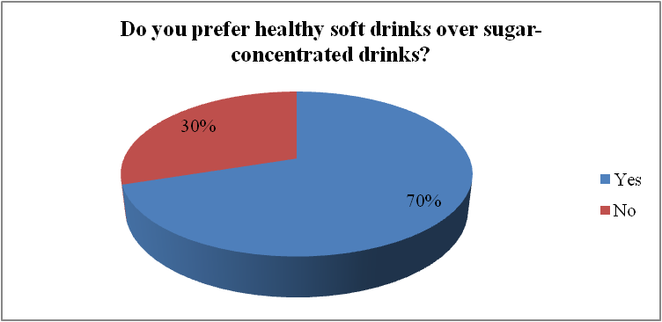
Figure 5: Response to survey question 5

