Database Systems
Assignment 2

Arthur Burke
2222155
DVLA: MSc Software Engineering (Web Development)
Word count: 2,821

Table of Contents
1 Introduction 2
2 NoSQL Databases 2
2.1 Document 2
2.1.1 Comparison with SQL 3
2.2 Graph 4
2.2.1 Comparison with SQL 5
2.3 Key-value 6
2.3.1 Comparison with SQL 7
2.4 Wide column 8
2.4.1 Comparison with SQL 8
3 When should SQL/NoSQL databases be used? 9
3.1 ACID vs BASE 11
3.1.1 ACID 11
3.1.2 BASE 11
4 Conclusion 12

Figure 1: MongoDB - document database example 3
Figure 2: Neo4j - graph database example 5
Figure 3: AWS - key-value database example 6
Figure 4: Apache Cassandra - wide-column database example 8

Introduction
The following report aims to explain various types of NoSQL databases as well as SQL databases. It will then compare each type of database with a view to provide Abertawe Entertainment with sufficient information for their needs, those being storage of customer and supplier data, media storage and transaction recording.
Fictional datasets were produced using Mockaroo [1] for Postgres, with the same data then being exported to JSON format for MongoDB using SELECT SQL statements in PostgreSQL as well as manually exporting data to CSVs.

NoSQL Databases

Document
Document databases are designed to store records, known as ‘documents’, which have varying details from one document to another. A popular database utilising this approach is MongoDB [2]. Examples of documents fitting this criteria include customer/user details – when a customer signs up to a service, they may provide more or less personal information than another user (Figure 1: MongoDB - document database example). Document databases means that database owners can store varying volumes of information for each document without the need to re-create or retrospectively amend the database.

Document databases typically store data as JSON (JavaScript Object Notation) objects. These documents can contain a wide range of data types and can be nested, meaning that one document can contain multiple subdocuments. Document databases are often used to store data that is complex and has a lot of relationships, such as customer orders or customer records. This is evidenced in the MongoDB database accompanying this report – where customers’ addresses are nested within customer records.
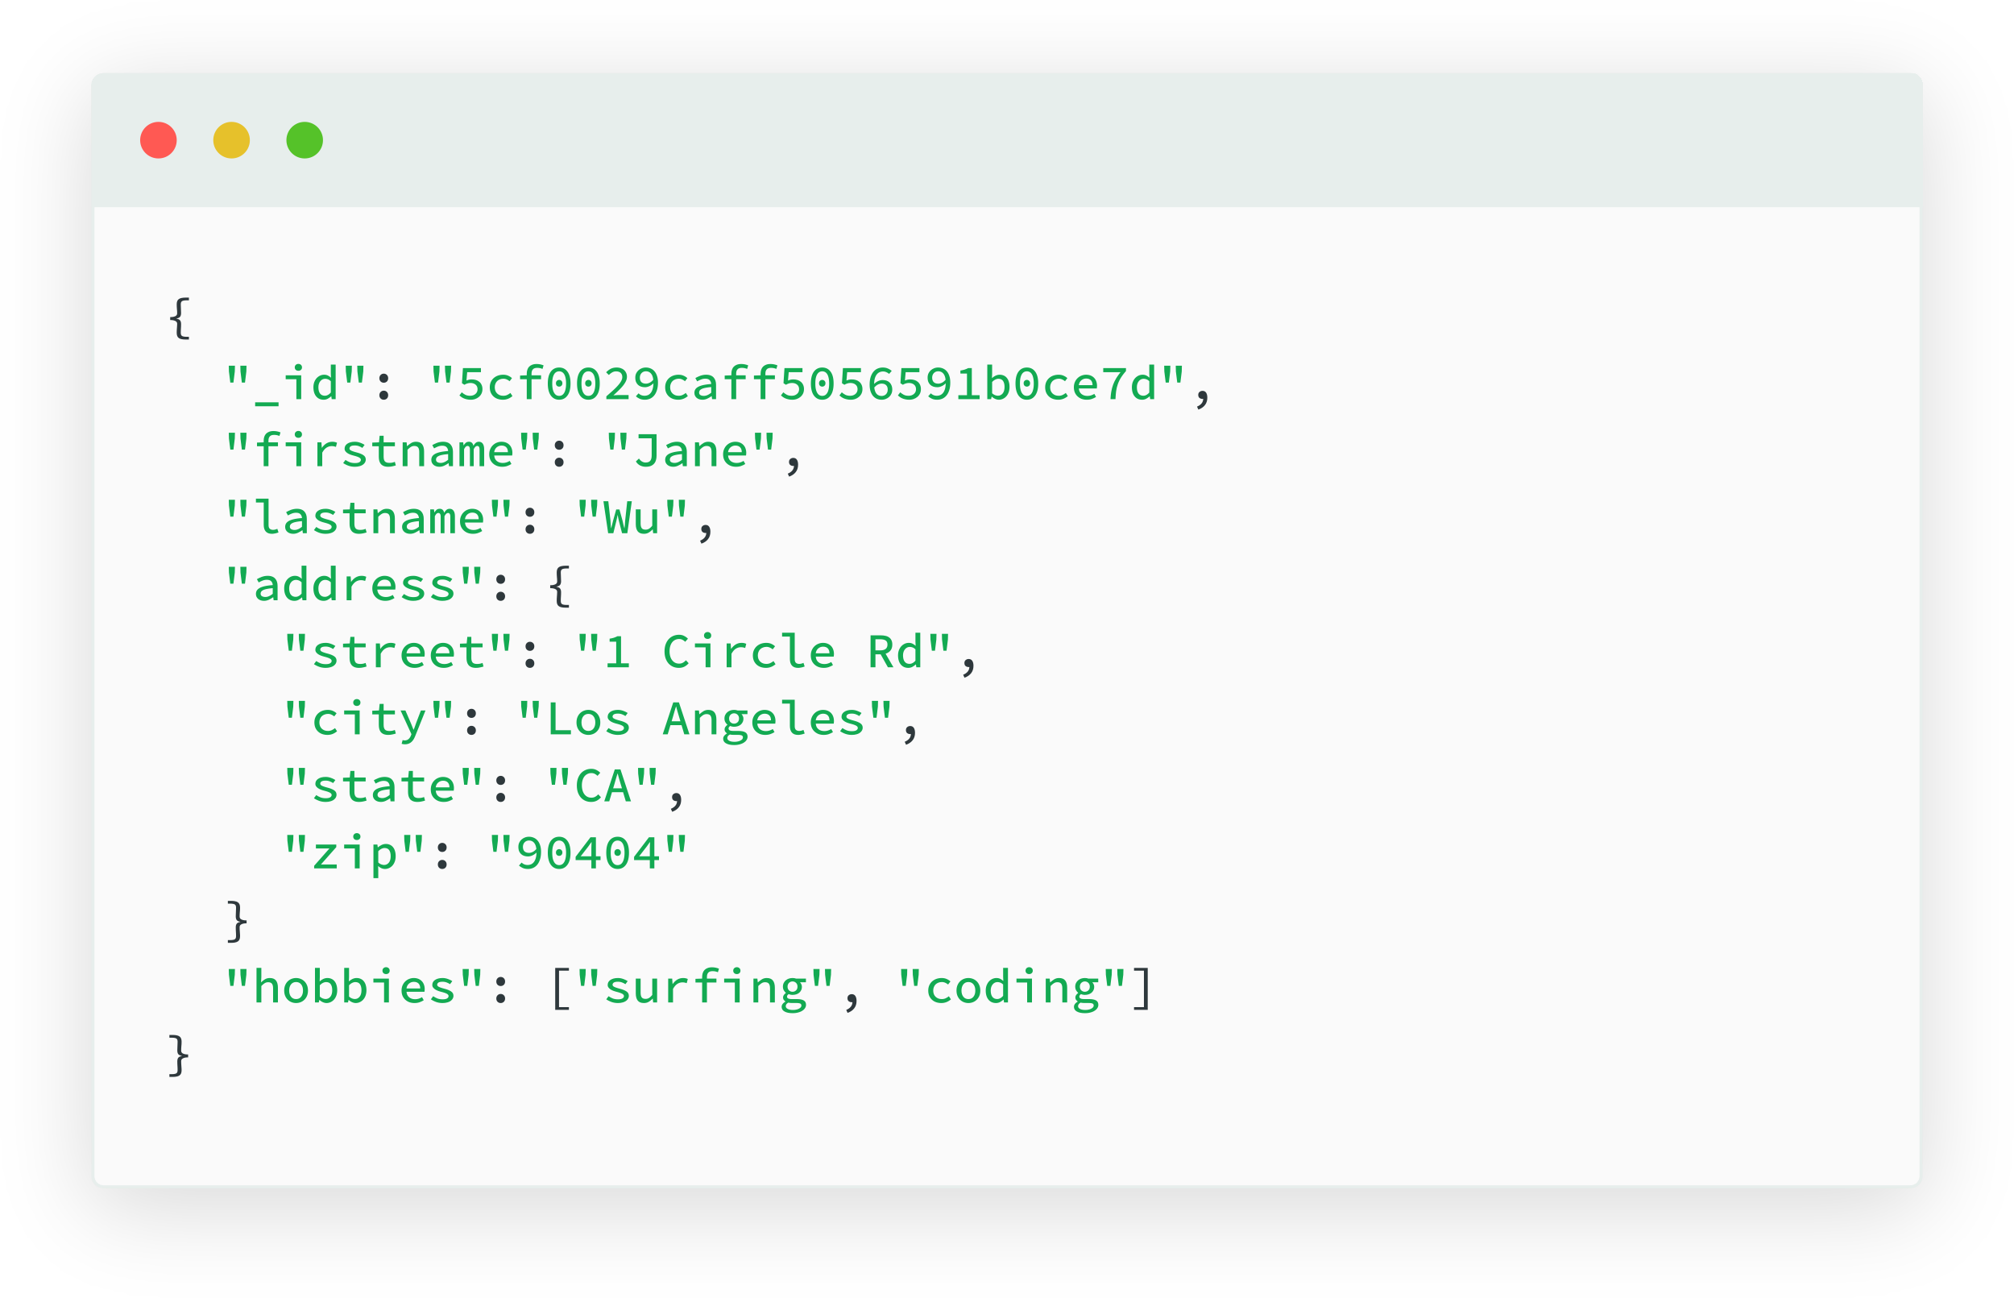
Figure 1: MongoDB - document database example

Comparison with SQL
Document databases store data in ‘records’, relational databases store data in tables with rows and columns. Relational databases utilise strict structuring of datasets, data is stored in pre-defined rows and columns. Each row represents a single record, with each column representing a specific and individual piece of information for that record. Relationships between different tables can be established using primary and foreign keys, which allow data from different tables to be linked together. These keys also act as unique constraints, ensuring unique values are stored within them. This has a second benefit, which is that data can be searched using the primary key values to retrieve an individual or range of records which are unique. Relational databases are well-suited for storing data that can be easily represented in a tabular format, such as customer information or products (books, in the case of Abertawe Entertainment). Document databases represent relationships between data within individual documents by nesting documents, removing the need to link data together from multiple collections. Document databases are generally more scalable than relational databases, organisations can introduce new collections spread across servers to store data as opposed to expanding pre-existing database table storage when the volume of data grows.

As demonstrated by S. Chickerur, et al. there are significant speed advantages when performing Create, Read, Update and Delete operations in document databases with extremely large volumes of data when compared to relational databases [3]. Both document databases and relational databases have their own query languages for accessing and manipulating data. Relational databases use Structured Query Language (SQL) – in the accompanying PostgreSQL example there is a mixture of SQL and PL/pgSQL (used for writing scripts for PostgreSQL queries). Document databases often use a variant of JavaScript or other programming languages.

When considering the use case for Document databases compared to SQL, it’s evident that document databases such as MongoDB provide organisations with the ability to adapt to changing circumstances and requirements for data storage over time. If the models stored by an entity change over time, the addition or subtraction of values in the datasets can be stored with no issue inside a document database.

In terms of Abertawe Entertainment this could prove beneficial if, in the future, the data they currently collect was to change. An example of such change is ISBNs, until December 2016, ISBNs were restricted to 10 digits [4]. Since January 2007, they have consisted of 13 digits – given the continuous release of new books, ISBNs formats could be subject to change in the future. As it currently stands, to ensure that modern ISBNs are correctly stored in an SQL database, constraints on ISBN field lengths would be used. This constraint would be void if ISBN formats were to change again in the future. Another factor worth noting when comparing, in relation to Abertawe Entertainment, is offering digital books in the form of epubs (electronic publications – to be used on e-readers such as Amazon Kindles) and audiobooks. Although epubs and audiobooks can be registered with ISBNs, it is not a requirement – therefore some inventory will lack this field while others will require the appropriate field in the database to be present. Likewise, ISBNs are not granted to a wide range of publications such as newspapers, magazines and collections. If Abertawe Entertainment was to expand their product range into such domains – their inventory table would require adjusting – to allow storage of ISSNs [5].

Graph
Graph databases are designed to hold and display data entities as separate ‘nodes’, with the relationships between them referred to as ‘edges’. Common usages of graph database systems include social networks and fraud detection – where the key value in the dataset is the ability to easily analyse the links between each entity. In the case of social networks this would be the links between individual users. In the case of fraud detection, it would again be the links between individual users, combined with bank details – to easily identify multiple individuals being linked to the same sources of finance. Fraud is often detected using pattern identification, which requires significant computing power for machine learning operations. This approach, accompanied by graph databases’ ability to efficiently map relationships, enhances the process of fraud identification [6]. Figure 2: Neo4j - graph database example displays the layout of data in a graph database.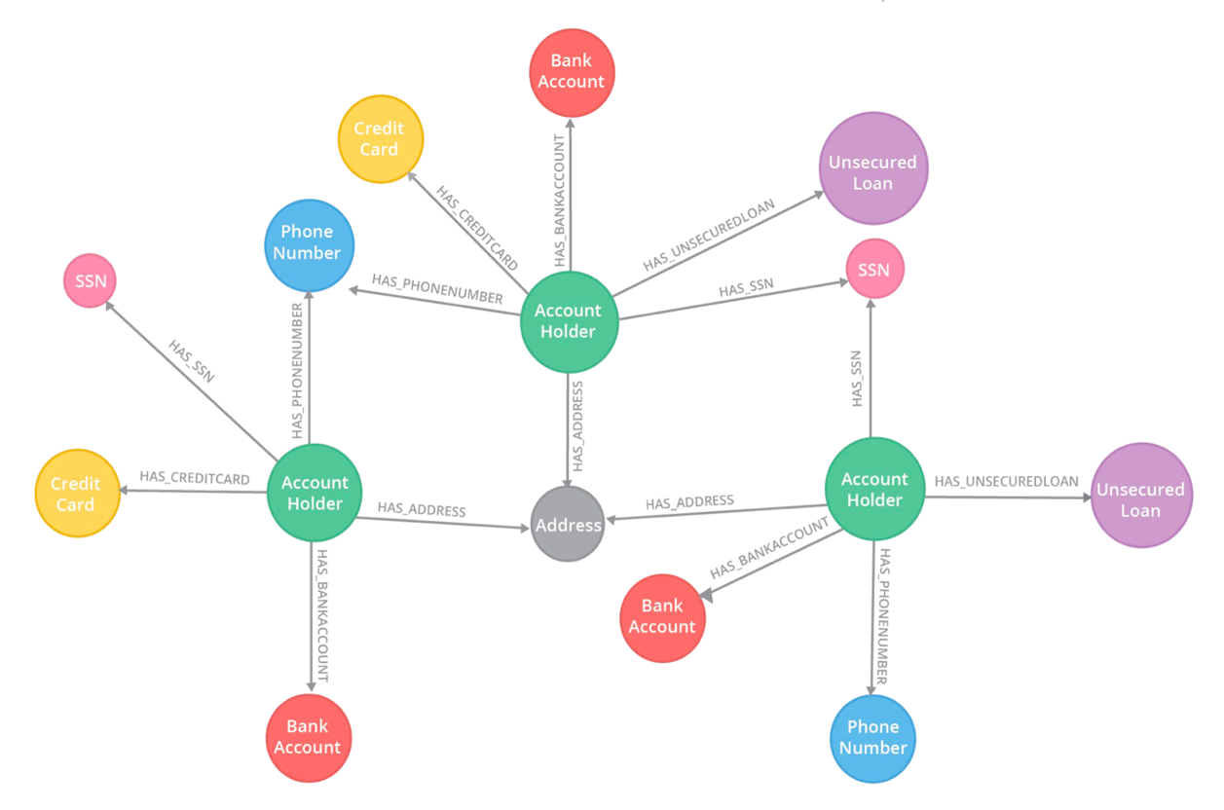
Figure 2: Neo4j - graph database example

Comparison with SQL
Graph databases represent relationships directly with nodes and edges, relational databases represent relationships using primary and foreign keys. In a relational database, relationships are represented using primary and foreign keys, which can make it more difficult to query relationships, especially where there are multiple levels of relationships or where data does not have strictly defined and outline relationships. Graph databases such as Neo4J use declarative query languages, such as Cypher [7]. This allows users to specify the pattern of nodes and edges they want to match in the graph.
The key benefit of graph databases is their ability to rapidly query relationships between nodes, as evidenced by Almabdy, S. there are significant time saving advantages achieved when querying relationships in graph databases in comparison to relational databases [8]. Relational databases use structured query language (SQL), allowing users to specify the tables and columns they want to query, as well as the conditions that rows must meet to be returned. Graph databases are optimal for storing data which is highly connected to many other entities, although Abertawe Entertainment’s data is linked in terms of customers and books/suppliers and purchases – there’s not a widespread interconnection between data as there would be in a dataset for social media users. In relation to Abertawe Entertainment, this database design is not ideal, the focus of the business is not investigating relationships between individual entities.

Key-value
Key-value databases are design to store data in key-value pairs, where values are searched for using their respective key. A common use for Key-value databases is storing user session details in ecommerce stores, with each key-value pair being an item in the shopping cart. This database design is optimised for high-volume, high-speed state changes, as stated by Amazon (AWS) DynamoDB information page [9].
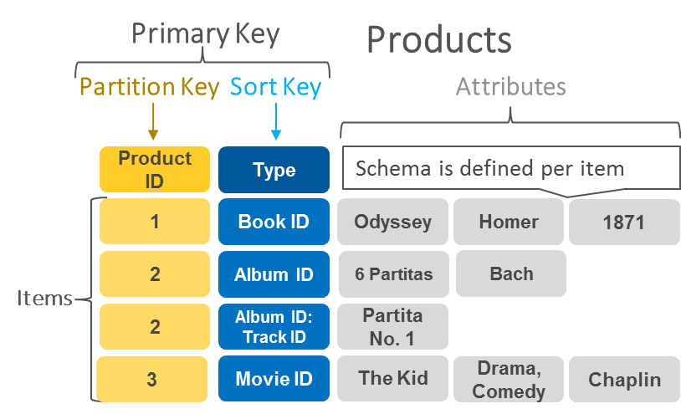
Figure 3: AWS - key-value database example

Comparison with SQL
Key-value databases have comparatively simple data models, which makes them easy to use and scalable, but results in them not being well-suited to handling complex relationships between data entities. Relational databases use SQL to query and manipulate data, and they are well-suited to storing and interrogating large volumes of structured data. They also support more advanced features such as transactions, triggers, and constraints, allowing developers to maintain data integrity and consistency. Key-value databases do not support relationships between data elements, whereas relational databases use primary and foreign keys to represent relationships between tables’ data. This makes it easier to query and manipulate relationships in a relational database. This does, however, make relational databases more complex to design and maintain. Key-value databases use simple lookup operations to retrieve values based on their keys, while relational databases use SQL to specify the tables and columns they want to query, as well as the conditions data must meet in order to be returned.
Overall, key-value databases are well-suited to handling large volumes of simple data, while relational databases are better at handling complex relationships between data elements and supporting advanced data manipulation features.
Key-value databases are optimal for storing real-time related data for collective viewing and processing, as is the case with shopping carts. They aren’t designed for storage of long-term data which is subject to change in the future – as would be needed in the case of Abertawe Entertainment if customers remove books or suppliers change their details.

Abertawe Entertainment could seek to utilise this database design for their online store management for user sessions and purchases. For their backend database storage of the information they require, especially persistent storage of potentially large blobs, key-value databases would not be advisable.

Wide column
Wide-column databases are design for large scale data storage and analysis, due to the intended usage of storing large volumes of data, they are designed to enable dividing of data across database nodes. This means that the databases can continue to expand horizontally onto new servers, as opposed to having to increase the capacity of a single server – which can often prove to be more expensive. Figure 4: Apache Cassandra - wide-column database example provides a visual example of horizonal scaling – the dataset in the first table can be split up and spread across new servers (nodes) and still be accessible as a group.
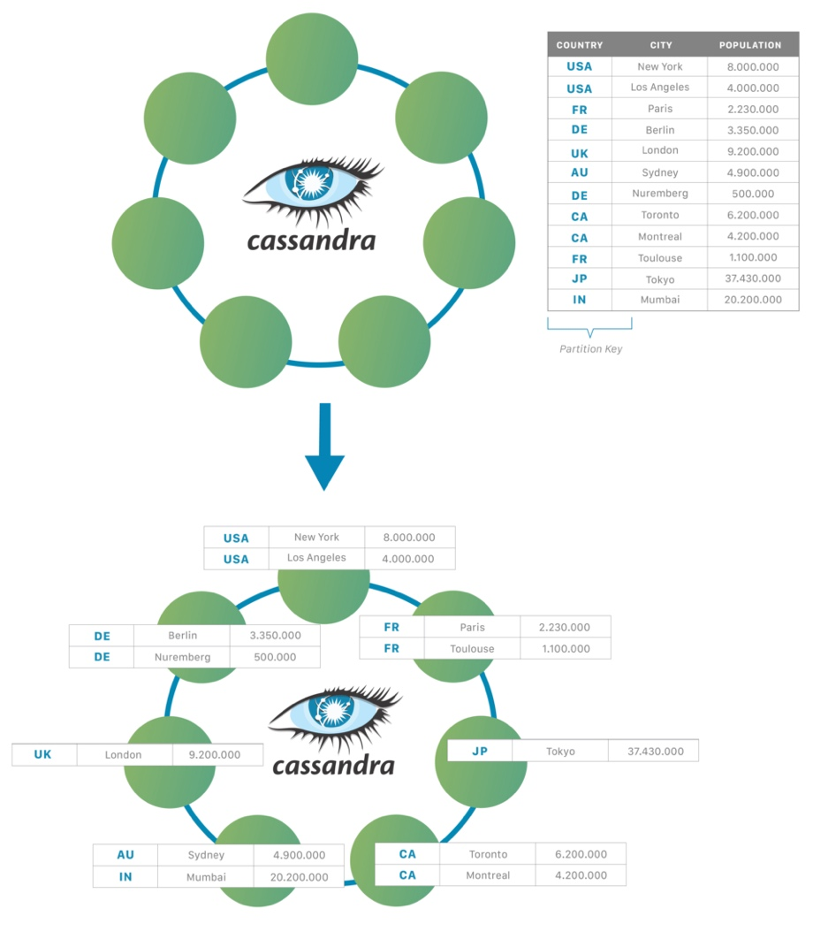
Figure 4: Apache Cassandra - wide-column database example

Comparison with SQL
Wide-column databases and relational SQL databases such as Postgres share similarities in that they both utilise rows, and columns. Wide-column databases, however, store grouped data in columns and allow column names and formats to vary across the data stored. Wide-column databases do not enforce cross-table rules involving primary and foreign key constraints, unlike relational SQL databases. These two factors allow for structured data storage, but with the benefit of flexibility in data content. This can be best imagined as a half-way point between SQL relational databases and NoSQL Document databases. Relational databases implement normalisation, where data is spread amongst tables. In the case of customers for Abertawe Entertainment, this would mean storing data such as a customer’s phone number in a separate table, and their address in yet another separate table. Wide-column databases, however, do not implement normalisation – all related data is stored together. This means that cross-referencing rows is not needed, as explained in the book NoSQL for mere mortals [10].

Relational databases are generally easier to use and maintain, enabling easier data management. However, they may not be as effective when dealing with large volumes of data or high levels of traffic, which is unlikely to be a significant cause for concern for Abertawe Entertainment. On the other hand, wide column databases are generally more flexible and scalable, but may not offer the same level of data integrity or query capabilities as relational databases.

In Abertawe Entertainment’s case, the volume of data stored by the company is unlikely to reach a point at which significant horizontal or vertical expansion is required for the foreseeable future, given their current size. If the company could foresee rapid growth in the future, this database design could be viewed as a viable solution.

When should SQL/NoSQL databases be used?
As outlined previously, there are multiple benefits and drawbacks for both NoSQL and relational databases, the key SQL vs. NoSQL factors to consider can be summarised as follows:

- Data structure: Relational databases have a fixed data structure, while NoSQL databases are more flexible, data structures can change over time without causing conflicts with existing database constraints. If an organisation has a well-defined data structure that is unlikely to change, a relational database would be a good choice. If the structure of data is more likely to vary or is unlikely to fit neatly into a table, a NoSQL database would be a better fit.
- Data scale: NoSQL databases are designed to handle very large volumes of data, making them ideal for organisations which require storing and interrogating very large volumes of data. If an organisation’s data is unlikely to reach large amounts requiring large processing and storage capacity which could span multiple servers, a relational database would be suitable. One of the key reasons originally put forward for implementing third normal form in relational databases was the reduction in data storage expenses [11]. On 17th July 1973, the IBM Model 11 was launched, with storage of 200 million bytes (0.0002 Terabytes) and a data rate of 0.806mb/s, at a price of $74,000 to $87,000 [12]. This, in comparison to modern day storage available to the average consumer, is significantly more expensive. A 1 Terabyte Hard Disk Drive with data rates of 190 mb/s can be purchased for $44.00 [13]. Due to lack of availability of inflation statistics between 1973 and present day, an inflation-adjusted comparison was not possible.
- Data access: Relational databases use SQL to access data, while NoSQL databases often use different query languages. If a company changed from one relational database system to another, for example moving from PostgreSQL to MySQL or Oracle, the transition would be relatively straightforward. Although relational databases often use proprietary variations of SQL, the overarching principles and language will remain consistent enough to make the change easier than learning JavaScript or Python for database administrators who only know one SQL language.
- Performance: NoSQL databases can be faster than relational databases when reading and writing large amounts of data, but they could be slower when performing complex queries. NoSQL database may be a good choice for an organisation focusing on fast read and write performance. Whereas if the organisation needs to perform complex queries on your data, a relational database may be a better option.

ACID vs BASE

ACID
Most NoSQL databases do not possess ACID (Atomicity, Consistency, Isolation, Durability) properties. If an organisation’s data management requires these features, then a relational database system is likely to be the best option.
- Atomicity: All changes to data are performed as if they are a single operation, either all are completed in their entirety, or none are (e.g. transferring of funds between accounts).
- Consistency: Data remains consistent when a transaction starts and when it ends (e.g. if funds are transferred between accounts, the total value of both accounts at the end of the transaction is the same as at the beginning of the transaction)
- Isolation: The activities undertaken by a transaction are not visible to other transactions during the process. Only beginning or end result, exclusively, is visible from external viewpoints.
- Durability: Upon completion of a transaction, the results are immutable and stored securely. They cannot be undone and are not susceptible to reversal or removal in the event of system downtime or errors.

BASE
NoSQL databases, rather than ACID properties, have BASE properties. Which, as explained by T. Hills [14]:
- Basis Availability: Most of the data is available, most of the time.
- Soft State: No guarantee that changes to the database will complete successfully and commit the change. This means that updates/changes could be lost.
- Eventually Consistent: In the event of a system failure, copies of the database will, over time, be in synchronisation with the database. Meaning that they aren’t always up to date.

If, upon consideration of NoSQL and SQL, an organisation decides to implement NoSQL, then further consideration must be given to the various advantages and disadvantages of each type of NoSQL database. N. B. Seghier and O. Kazar’s [15] investigations into Redis (Key-Value), MongoDB (Document) and Cassandra (Wide-Column) databases reveals that each database has performance advantages over the others in specific instances. Redis performed best in read operations, MongoDB performed best in scanning operations (searching the data to identify objects for updates) and inserts.

Conclusion
To conclude, based on the above comparisons and the use-case for Abertawe Entertainment – a document database such as MongoDB is likely to be the best. In the JSON schemas accompanying this report, there are six collections – theoretically the data from PostgreSQL could have been migrated into one all-encompassing collection. The decision to not implement the database in such a way was made to maintain more clearly defined groups of information.

Bibliography

[1] | “Mockaroo,” [Online]. Available: https://www.mockaroo.com/. [Accessed 10 12 2022].
[2] | “MongoDB,” MongoDB, Inc., [Online]. Available: https://www.mongodb.com/. [Accessed 09 01 2023].
[3] | A. G. a. A. K. S. Chickerur, “Comparison of Relational Database with Document-Oriented Database (MongoDB) for Big Data Applications,” in 2015 8th International Conference on Advanced Software Engineering & Its Applications (ASEA), 2015.
[4] | I. I. Agency, “ What is an ISBN?,” 2022. [Online]. Available: https://www.isbn-international.org/content/what-isbn. [Accessed 17 12 2022].
[5] | I. S. S. N. I. Centre, “ What is an ISSN?,” 2022. [Online]. Available: https://www.issn.org/understanding-the-issn/what-is-an-issn/. [Accessed 17 12 2022].
[6] | Oracle, “Graph Database Defined,” [Online]. Available: https://www.oracle.com/uk/autonomous-database/what-is-graph-database/. [Accessed 30 12 2022].
[7] | Neo4J, “Cypher Query Language,” [Online]. Available: https://neo4j.com/developer/cypher/. [Accessed 01 01 2023].
[8] | S. Almabdy, “Comparative Analysis of Relational and Graph Databases for Social Networks,” in 1st International Conference on Computer Applications & Information Security (ICCAIS), 2018.
[9] | A. W. Services, “What Is a Key-Value Database?,” Amazon Web Services, [Online]. Available: https://aws.amazon.com/nosql/key-value/. [Accessed 30 12 2022].
[10] | D. Sullivan, NoSQL for Mere Mortals, Addison-Wesley Professional , 2015.
[11] | E. F. Codd, “A Relational Model of Data for Large Shared Data Banks,” Communications of the ACM, pp. 377-387, 06 1970.
[12] | “IBM 3330 data storage,” IBM, [Online]. Available: https://www.ibm.com/ibm/history/exhibits/storage/storage_3330.html. [Accessed 09 01 2022].
[13] | “Seagate BarraCuda ST1000DM010 1TB 7200 RPM 64MB Cache SATA 6.0Gb/s 3.5" Hard Drive Bare Drive,” [Online]. Available: https://www.newegg.com/seagate-barracuda-st1000dm010-1tb/p/N82E16822179010. [Accessed 09 01 2023].
[14] | T. Hills, NoSQL and SQL Data Modeling: Bringing Together Data, Semantics, and Software, Technics Publications, 2016, p. 306.
[15] | N. B. Seghier and O. Kazar, “Performance Benchmarking and Comparison of NoSQL Databases: Redis vs MongoDB vs Cassandra Using YCSB Tool,” in 2021 International Conference on Recent Advances in Mathematics and Informatics (ICRAMI), 2021.

