

University of Wales Trinity Saint David
UWTSD

BEng Energy and Environmental Engineering

Oliver R D Turner
1805585

Environmental Engineering and Sustainable Energy
Environmental Pollution Control
ACMA6007

March 2024

Contents
Introduction 3
Overview 3
Aims and Objectives 3
Legislation 4
Methodology 5
Risk assessment fundamentals 5
Assessment method selection 6
FMEA 7
Hierarchy of Controls 8
Risk Assessment 9
Manufacturing 9
Grinding Operations 9
Machining 9
Welding 9
Coating 10
Chrome Plating 10
Galvanizing 10
Coating 10
Surface Preparation 10
Other Coating Processes 10
Spraying 11
Spray Solvents 11
Degreasing Solvents 11
Chemical Storage and Disposal 11
Cost analysis 12
Further Assessments 12
References 13
General 13
UK Governmental Acts 14
Appendix 15

Figure 1: Likelihood of Occurrence 7
Figure 2: Risk Matrix 7
Figure 3: CDC Hierarchy of Controls 8
Figure 4: Full FMEA Table 15

Introduction

Overview

An Environmental Pollution Risk Assessment is to be performed for a Manufacturing Plant specialising in Manufacturing of metal Components. These are engineered using Machining, Welding and Grinding processes. Many of these components are then sent for Coating operations. These operations comprise of Spraying, Chrome Plating and Galvanising.
Due to the nature of the operations conducted on site, there is regularly a 25 Tonne supply of both Spray Solvents and Degreasing Solvents on site. Chemical storage Bunds are present. These are an effective way of controlling ground water pollution, providing they are up to regulatory standards and well maintained. There are also both foul and surface water drains on site. The presence of foul drains suggests the company's awareness of regulations concerning groundwater and local water pollution controls. These are another method which work efficiently, provided they are operated and maintained correctly.
These operations all pose environmental pollution risks. This paper will assess these risks for severity and likelihood using FMEA (Failure Mode Effective Analysis) and then apply a Hierarchy of Controls to produce a Mitigation Strategy for the risks posed. For explanations of these methods, see the methodology section.
Once Risks have been assessed and a Mitigation Strategy has been implemented, pollution control equipment will be suggested to mitigate any further pollution risks from the plant. A list of legislation will be complied so the managers know exactly what is at stake should they fail in their responsibilities. The report will show that the cost of compliance (costings for implementing the mitigation strategy and pollution control equipment) shall be outweighed by the cost of non-compliance in the form of government pollution fines, as well as possible personal and institutional liability for not following guidelines.
The following section highlights the specific goals of this report. These are word for word, from the brief of the paper and shall be assessed in the conclusion section.

Aims and Objectives

- Develop a risk survey tool for the site to highlight all pollution risks.
- For all high risks develop a pollution mitigation plan.
- Identify pollution control equipment and related legislation that the site must comply with.
- Prepare a report that highlights costs of compliance, costs of non-compliance and provides appropriate justification for at least a compliance strategy.

Legislation

Legislation is crucial for ensuring Environmental Pollution Risks are dealt with in the appropriate manor. Many failures in the past have mandated the need for governments to stipulate what is allowable and what is not. For the purposes of this report, the relevant legislations are deemed to be as follows:
Legislation
Environmental Protection Act 1990
Pollution Prevention and Control Act 1999
Water Resources Act 1991
Health and Safety at Work Act 1974
Control of Substances Hazardous to Health Regulations 2002 (COSHH)
Environmental Damage (Prevention and Remediation) Regulations 2009
Environmental Permitting (England and Wales) Regulations 2016
Waste Management Licensing Regulations 2018
Control of Major Accident Hazards Regulations 2015 (COMAH)

Methodology

Risk assessment fundamentals

When assessing pollution risk, it is crucial to use a tested and proven strategy. Depending on the aims and objectives of the report, and the nature of the risks involved; a risk assessment and risk mitigation strategy can be customised to the specific requirements of the client or subject of the report.
In order to reduce pollution risk factors, they must first be identified and characterized.
A publication co-written by the Environment Agency and Department for Environment, Food & Rural Affairs, (2016) establishes risk assessment guidelines to be followed in order to obtain an ‘Environmental Permit’. The publication lays out a 6-step guide to do a pollution-oriented risk assessment. They are as follows :
- Identify and consider risks for your site, and the sources of the risks.
- Identify the receptors (people, animals, property and anything else that could be affected by the hazard) at risk from your site.
- Identify the possible pathways from the sources of the risks to the receptors.
- Assess risks relevant to your specific activity and check they are acceptable and can be screened out.
- State what you will do to control risks if they are too high.
- Submit your risk assessment as part of your permit application.
Boral et al., (2020), Ghassemi, (2005) as well as information from the Environment Agency report explain the relevance of these specific terminologies.
- Hazard – Anything that can cause environmental pollution, such as a chemical, particulate or noise.
- Receptor – Anything that can/ would be affected by the release of a hazard.
- Pathway – The means in which a hazard reaches a receptor; such as air or water.
- Risk – The likelihood of a hazard causing harm.
- Source – The place or thing from which something comes.

Assessment method selection

The International Electrotechnical Commission [IEC], (2009), sets the international standard for Engineering Risk Assessments. The document introduced methods for risk assessment which are internationally recognised. Of these, five are “Function Analysis” methods. For Pollution risks of a plant, one of these shall be chosen as they allow for the analysis of the failure modes of an entire plant, allowing for the identification of potential hazards which can pose a risk to the Environment via Pollution.
These are as following:
- FMEA (Failure Mode Effect Analysis)
- Reliability- centred maintenance
- Sneak Analysis (Sneak circuit analysis)
- HAZOP (Hazard and operability studies)
- HACCP (Hazard Analysis and critical control points)
FMEA is to be selected for this report as it is easy to understand while being a thorough assessment of the entire plant. FMEA is used for Engineering operations where failure modes must be effectively highlighted and then managed due to the systematic nature of the method (Boral et al., 2020). When combined with a Hierarchy of controls, FMEA reports are capable of highlighting hazard likelihood and severity and analytically solving for risk priority.

FMEA
In this simplified version of FMEA, it shall be said that Risk = Severity * Likelihood. Extent is often used as a factor; this does however make the process more complicated. As there have been known breaches by the operators of the plant, the report shall be kept as simple as possible, making it easy for the operators and workers to follow. This will allow company procedure to remain clear and concise.
In order to calculate risk, Severity and Likelihood must be highlighted. Building upon the work of Vazdani et al. (2017) and Barends et al., (2012) the following Likelihood and Severity tables have been produced.
Likelihood
Rating | Criterion
1 | Less than once per year
2 | Multiple times per year
3 | Multiple times per month
4 | Multiple times per week
5 | Multiple times per day
Figure 1: Likelihood of Occurrence
Severity
Rating | Criterion
1 | Very little impact
2 | Minor environmental impacts
3 | Average environmental impacts/  Unnecessary consumption of environmental resources
4 | Significant environmental impacts/  Threats to health of local population, flora or fauna.
5 | Extreme environmental impacts/  Threats to life of local population, flora or fauna.
Figure 2: Severity of Occurrence
Risk priority is given a value of 1-25 (Severity* Likelihood). A Risk Matrix is then used to assess whether the risk is negligible (1-3), low (4-9), medium (10-15), high (16-20) or Extreme (21+).
The following risk matrix has been produced in accordance with Dinu et al. (2017) and following the guidance of Relyence Corporation (2020).
Figure 2: Risk Matrix
The higher the Risk number, the higher the priority. Negligible risks may be ignored. Low risks could be addressed to make them negligible. Medium risks should be addressed. Usually, in order to sign off on a medium or higher risk priority, management will need to be involved and justify the reasons that the issue has not been rectified. High and Extreme risks must be rectified as soon as it is possible to do so. The plant may need to cease functioning until remediations have been enacted.
Once the risk has been categorized, a hierarchy of controls is applied, as explained in the next section.

Hierarchy of Controls
When using the FMEA process, a hierarchy of controls must be followed. An example of this, as used by the Centers for Disease Control and Prevention (CDC) (National Institute for Occupational Safety and Health [NIOSH], 2023) is shown and explained in figure 1 below.
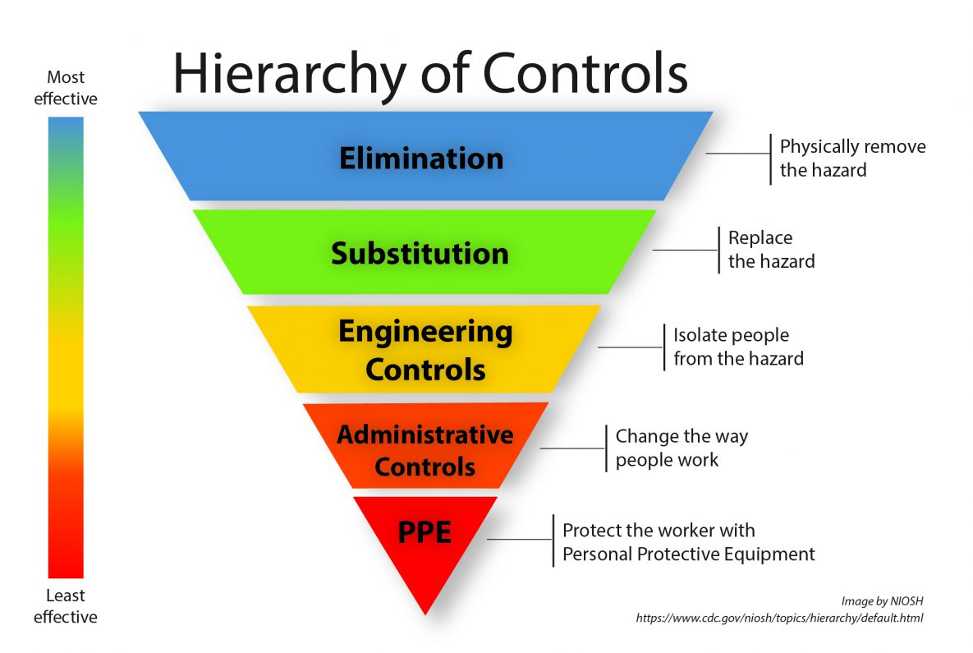
Figure 3: CDC Hierarchy of Controls
When mitigating risks, assessors are to start at the top. If this is not possible to implement, the assessor is to move down and attempt the next step. These steps are explained simply below. These controls are used as an industry standard; however, this version is more relevant to full risk assessments including those relating to health and safety of employees. In this case, in the further work section, a full Health and Safety risk assessment is to be undertaken. Therefore, the PPE section will not be relevant to this report as measures for worker receptors shall be addressed separately.
- Elimination, where the Hazard is removed entirely.
- Substitution, where the hazard is replaced by another which poses less risk. These can be difficult to implement into an existing process so are more effective when implemented in the design stage. For more information, on this, research “Prevention through Design”.
- Engineering Controls, for Environmental Pollution Control, Engineering controls will be the predominant Control Measure. The diagram states “Isolate the people from the hazard”. In this instance, however, Engineering Controls shall be considered to mean “Isolate the hazard from the environment”. This will be through means such as extraction, isolation and treatment facilities.
- Administrative Controls are policies that are put in place by the company which ensure that risk is minimised, and if something does go wrong, everyone knows what to do. This requires that all workers are trained for possible pollution incidents and know how to react. It also teaches pro-active approaches involving company policies that must be followed. Examples include chemical handling and disposal training, regular inspections of equipment, and strict procedures for reporting any possible breaches.
- Maintenance and Inspections. This final process is to replace PPE for the application of this report. Pro-active measures such as preventative maintenance can ensure that pollution opportunities do not occur or are spotted before they are allowed to escalate to an unsuitable level.
In 2005, Ghassemi assembled the Handbook of Pollution Control and Waste Minimisation. From this document, a Hierarchy of controls for Pollution Management are suggested. By following these guidelines, the most effective measures have been implemented into the CDC hierarchy of controls, making them more suitable for the specific environmental pollution aspect of this report.
With these Controls and the Risk identification and classification, the risk shall be identified and entered into a table for remediation. Some may still not meet targets and will therefore need to go through the process again, moving further down the hierarchy.

Risk Assessment

Manufacturing

Grinding Operations

Machining

Welding

Coating

Chrome Plating

Galvanizing

Coating

Surface Preparation

Other Coating Processes

Spraying

Spray Solvents

Degreasing Solvents

Chemical Storage and Disposal

Cost analysis

Due to the amount of information provided, it is not possible to provide accurate costings for this plant. However, using the FMEA analysis it is possible to suggest where spending should be focused.
The number one priority for this company will be training, this is evident when their history is analysed. The only way to ensure that Environmental Pollution Risks are fully minimised, legislation, guidelines and company protocols must be followed to the letter. Any breaches in this must be reported. Any fines due to this are likely to be significant; however, fines for non-compliance may be significantly higher.
The Environmental Damage (Prevention and Remediation) Regulations (2009) allow the British government to pursue negligent business owners who cause environmental pollution instances. There have been countless examples where negligence has resulted in the need for government wide clean up operations which lead to millions of pounds in fines. If it is found that Pollution has occurred due to negligence, the fines will reflect. It is therefore cheaper to install specific pre-emptive measures such as Ventilation/ Extraction equipment with the capability to either collect or purify contaminants from the air. Chemical storage bunds must be well maintained and guidelines for their use must be followed. The Waste Management Licensing Regulations (2018) must be followed when disposing of any chemicals or harmful materials, drains that are incorrectly operated may seem like a cheap way of disposing of materials, however, the sewage plants monitor emissions and hefty fines can result.
Other equipment recommended are enclosed surface preparation facilities, such as vacuum blasting cabs, where the particulates and waste materials are enclosed within the equipment. This also means they can be re-used, and less blasting material is needed. Heavy duty doors will help with dust/ fine particulate matter and noise. Minor chemical spill kits should be purchased and positioned at regular intervals wherever chemicals are used. Fire Suppression systems must be up to code and comply with regulations for the specific materials and operations present.

Further Assessments

- Health and safety at work.
- Fire Safety and suppression.
- Emergency response planning.
- First aid training.
- COSHH
- Maintenance and Monitoring

References

General

Barends, D. M., Oldenhof, M. T., Vredenbregt, M. J., & Nauta, M. J. (2012). Risk analysis of analytical validations by probabilistic modification of FMEA. Journal of Pharmaceutical and Biomedical Analysis.
Boral, S., Howard, I., Chaturvedi, S. K., McKee, K., & Naikan, V. N. A. (2020). A Novel Hybrid Multi-Criteria Group Decision Making Approach for Failure Mode and Effect Analysis: An Essential Requirement for Sustainable Manufacturing.
Dinu, V., Maftei, M., & Mateescu, R. M. (2017). Research on using FMEA as a risk assessment method in order to reduce risk handling costs. Paper presented at BASIQ 2017 conference.
Environment Agency and Department for Environment, Food & Rural Affairs. (2016). Risk assessments for your environmental permit. Retrieved from https://www.gov.uk/guidance/risk-assessments-for-your-environmental-permit.
Ghassemi, A. (2005). Handbook of Pollution Control and Waste Minimization. Taylor & Francis e-Library. New York: MARCEL DEKKER, INC.
International Electrotechnical Commission (IEC). (2009). IEC/FDIS 31010:2009(E) Risk management — Risk assessment techniques. Geneva, Switzerland: IEC Central Office.
OpenAI. (2024). Assistance with identifying potential failure modes, assistance with creating a table and compiling legislation. [Digital assistance]. Retrieved from [ChatGPT].
National Institute for Occupational Safety and Health (NIOSH). (2023). Hierarchy of Controls. Retrieved from https://www.cdc.gov/niosh/topics/hierarchy/default.html
Relyence Corporation. (2020). How to Assess Risk Using FMEA. Retrieved from https://relyence.com/wp-content/uploads/2020/09/FMEA-Risk-Assessment-White-Paper.pdf
Vazdani, S., Sabzghabaei, G. R., Dashti, S., Cheraghi, M., Alizadeh, R., & Hemmati, A. (2017). FMEA techniques used in environmental risk assessment. Environment & Ecosystem Science (EES)

UK Governmental Acts

Climate Change Act 2008:
UK Legislation. (2008). Climate Change Act 2008. Available at: [https://www.legislation.gov.uk/ukpga/2008/27/pdfs/ukpga_20080027_en.pdf] (Accessed: [March 2024]).
Control of Noise at Work Regulations 2005:
UK Legislation. (2005). Control of Noise at Work Regulations 2005. Available at: [https://www.legislation.gov.uk/uksi/2005/1643/pdfs/uksi_20051643_en.pdf] (Accessed: [March 2024]).
Control of Substances Hazardous to Health (COSHH) Regulations 2002:
UK Legislation. (2002). Control of Substances Hazardous to Health (COSHH) Regulations 2002. Available at: [https://www.legislation.gov.uk/uksi/2002/2677/pdfs/uksi_20022677_en.pdf] (Accessed: [March 2024]).
Environmental Protection Act 1990:
UK Legislation. (1990). Environmental Protection Act 1990. Available at: [https://www.legislation.gov.uk/ukpga/1990/43/pdfs/ukpga_19900043_en.pdf] (Accessed: [March 2024]).
Environmental Protection (Controls on Ozone-Depleting Substances) Regulations 2002:
UK Legislation. (2002). Environmental Protection (Controls on Ozone-Depleting Substances) Regulations 2002. Available at: [https://www.legislation.gov.uk/uksi/2002/528/contents/made] (Accessed: [March 2024]).
Regulatory Reform (Fire Safety) Order 2005:
UK Legislation. (2005). Regulatory Reform (Fire Safety) Order 2005. Available at: [https://www.legislation.gov.uk/uksi/2005/1541/pdfs/uksi_20051541_en.pdf] (Accessed: [March 2024]).
Water Industry Act 1991
UK Legislation. (1991). Water Industry Act 1991. Available at: [https://www.legislation.gov.uk/ukpga/1991/56/contents] (Accessed: [March 2024]).
Workplace (Health, Safety and Welfare) Regulations 1992:
UK Legislation. (1992). Workplace (Health, Safety and Welfare) Regulations 1992. Available at: [https://www.legislation.gov.uk/uksi/1992/3004/contents/made] (Accessed: [March 2024]).
Health and Safety at Work Act 1974:
UK Legislation. (1974). Health and Safety at Work etc. Act 1974. Available at: [https://www.legislation.gov.uk/ukpga/1974/37/pdfs/ukpga_19740037_en.pdf] (Accessed: March 2024).
Pollution Prevention and Control Act 1999:
UK Legislation. (1999). Pollution Prevention and Control Act 1999. Available at: [https://www.legislation.gov.uk/ukpga/1999/24/pdfs/ukpga_19990024_en.pdf] (Accessed: March 2024).

Appendix

Figure 4: Full FMEA Table

