

Modelling of Shape charges using Dassault Systems Abaqus CAE software package.
Advanced Physics of OME (ACDB5015)

Stephen McAngus
2113123
January 2024
Lecturer: Kelvin Donne
Abstract
Shape charge design hasn’t changed much since their inception during the second world war, however the technology that supports the design of these munitions has changed drastically over the last century. Scientists and engineers are now able to somewhat predict what happens to a shape charge and model these through sophisticated modelling tools. Using a Lagrangian approach, this report has identified that a shape charge with a circumference of 50mm and cone angle of ~62º will result in the copper jet reaching a velocity of ~6500ms⁻¹. However, this report has also highlighted there are other techniques that could be used that could give greater insight as to what happens during a shape charges explosive event.

Contents
Introduction 3
Method 5
Software setup 5
Figure 1 – Shape charge design 5
Material properties 6
Table 1 - Equation of State figures for Composition B 6
Table 2 - Johnson-Cook Damage models for copper and Tool Steel 6
Table 3 - Isotropic Elastic Properties for Tool Steel & Shear Modulus of Copper. 7
Table 4 – Johnson-Cook Plastic parameters for Tool Steel and Copper. 7
Results 8
Figure 2 - Displays the uninitiated shape charges, the top image represents the two-dimensional axisymmetric model, which has been revolved in the viewport tools, and the bottom image being a true three-dimensional image. 8
Figure 3 - Displays the two-dimensional Axisymmetric model of the shape charge, top uninitiated, and bottom initiated showing the formation of the shape charge’s Jet, where the explosive fill has been removed from the viewport due to clutter. 9
Figure 4 - Displays the true three-dimensional model of the shape charge, top uninitiated, and bottom initiated showing the formation of the shape charge’s Jet, where the explosive fill has been removed from the viewport due to clutter. 10
Figure 5 - Displays the two-dimensional axisymmetric model with a cut away sectional view showing the expansional direction of the gases being formed after the explosive event. Top uninitiated, bottom initiated. 11
Figure 6 - displays the two-dimensional velocity plot of the tip of the Shape charges Jet, where peak velocity reaches a peak of 6700ms⁻¹ 12
Figure 7 - displays the three-dimensional velocity plot of the tip of the Shape charges Jet, where peak velocity reaches a peak of 6300 ms⁻¹ & 6800ms⁻¹ 12
Figure 8 - Displays the strain rate of the Copper liner material as the progression of the explosive event occurs over time. 13
Figure 9 - Displays the pressure profile of the Composition B explosive fill of the shape charge. 13
Discussion 14
References 18

Introduction

Shape charges are explosively driven devices that work on the principle of focusing the energy of the blast to a single localised spot. The ability to use explosives in such as a way was discovered by Charles Munroe in the 1880’s, where he discovered that a conical depression in an explosive material transferred to a target upon initiation. He also noted that this depression focused the explosive force, increasing the materials ability to penetrate hardened targets [1]. The refined design of shape charges that can be seen today first came about during the Second World War, notably where Axis forces refined the technology to a small enough scale to fit to small rocket power munitions, or the panzerfaust [2] [3]. Due to a shape charges effective ability to penetrate armour they have been adopted by various military forces worldwide. To that end, shape charges have also served purposes outside of military applications, such as in the oil and gas industry where these charges are designed to clear passage for pipe laying tools [4].
All shape charges work on the principle of the Munroe effect, which is where a shock wave from the initiation of an explosion propagates through the explosive material and imparts its energy into a liner material. Due to the shape of the liner material and the surrounding explosive fill the liner will begin to collapse under high stress and pressure towards the centre of the munition. Surrounding pressure from the explosion forces the liner material to move towards an area of lower pressure, leading to the formation of high-density jet travelling greater than the speed of sound in air [5] [6]. However, as can be extrapolated, for a shape charge to function there must be valent space for jet formation occur, this is known as standoff distance, an ideal stand off distance is meant to be 3 – 4 cone diameters away from the target [7] [8].
Shape charges are generally constructed out of a rigid outer casing, typically being a steel, with an explosive fill, these can be both cast or moulded from plastic explosive materials which is then lined with a very malleable metal alloy [9]. There is some evidence to suggest that this liner material if made from an electrically conductive material such as copper may form electromagnetic fields and may contribute towards jets direction and flow, although this is thought to be an insignificant impact upon the overall mechanics of shape charge [10] [11]. It is the cone angle of a shape charge that most dramatically impacts the effect of the device, generally shape charges designed to penetrate targets will conserve a cone angle between 30º and 90º there is no standard angle at which a shape charge operates, in some senses making shape charges a bespoke item, as their effective penetrative performance is dependent on many factors such as target material, thickness of material, case hardening of material, sloped angle of target material. To that end, there is another branch of explosively formed munition, regarded as explosively form projectiles (EFP’s). Unlike Shape charges EFP’s tend to have an angle greater than 90º but less than 120º the dynamics of how EFP’s work is significantly different to shape charges. First and foremost, there is no jet formation, but instead EFP’s utilise the Munroe effect to move a large mass at high speed, relying on deformation of the target, somewhat a sledgehammer vs scalpel analogy [12].
To understand how a theoretical shape charge function, engineers can rely on mathematical modelling techniques, these techniques will use material properties and forces to generate graphs and visual representations of a shape charge under an explosive event [13] [14]. The Lagrangian approach that is being demonstrated in this report works on the principle of resultant trajectory equations. To estimate the trajectory and velocity of a shape charge a Lagrangian method will calculate the effect of shock wave propagation through Rankine-Hugonoit equations in relation to material properties to generate a trajectory at which a liner will form. Equations of state will govern the behaviour of the materials undergoing extreme conditions such as temperature and pressure. All of these together will eventually generate effect and resultant forces which can then be plotted in an X,Y,Z environment [15] [16] [17].
The technique selected for this study is a simple Lagrangian approach in both an axisymmetric 2D planner, and 3D model. A Lagrangian approach is a system of where the motion a behaviour of elements is explicitly tracked through space and time, newtons rules of motion and other relevant equations govern the movement of these elements [15] [14] [4]. Furthermore, this method will analyse the individual motions and interactions of each element, and subsequently change the properties of each element through time. This in turn makes a Lagrangian approach an ideal candidate to studying the velocity and explosive performance of the shape charge selected.
The objective of this study is to design a shape charge using an Lagrangian approach and to evaluate the performance of this design. With the objectives of designing a shape charge in Abaqus CAE with an cone angle between 60º and 90º whilst using a realistic explosive fill, and to evaluate the performance between two Lagrangian approaches, one being a full three dimensional approach, and the other being a Axisymmetric approach.

Method

Software setup

Using Dassault System’s Abaqus programme, an axisymmetric cross-sectional view of the shape charge warhead was drawn to a full width of 50mm, and a cone angle of approximately 50º Each part was created by referencing each other and saved as sketches. These sketches were then exploited to make three-dimensional model by using Abaqus’s revolve extrusion function. One all parts were sketched they were opened in the assembly module and aligned concentrically. Whilst in the property module parts were attributed sections, and material properties were assigned to each section respectively. Within the Load module on the axisymmetric model, an encastre boundary condition was applied to the central axis this was removed from the three-dimensional model. The only step that was applied to this model was a general all with self-explicit interaction.

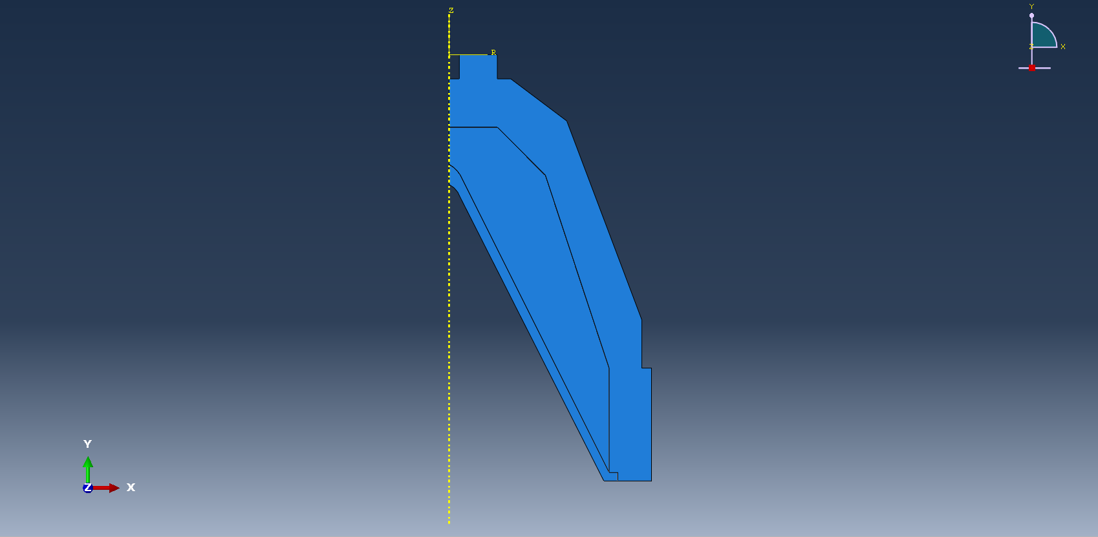

Figure 1: Displays an axisymmetric sketch of the shaped charge design, this design has an approximate cone angle of 50º and a total diameter of 50mm, for a desired stand of 150mm. The detonator well was retained in this design as it may aide towards the structural integrity of the casing. However, this well was faux plugged with the casing to retain the pressure created by the explosion of the Composition B fill. Outermost layer: Casing, Middle Layer: Explosives fill, Innermost layer: Liner. Design is based upon a design previously explored in literature [18].

Mesh densities were conservatively applied to each section respectively, where the finest mesh was on the liner section, with the next level of mesh refinement pertaining to the explosive fill to ensure that the two sections would accurately interact, with the least amount of consideration being made to the casing material. However, when extrapolating this to a three-dimensional model level of mesh refinement had to be reduced significantly due to both lack in computer processing power and limitations to the number of accessible nodes with the software licence to hand.
Liner: approximate global seed size = 3D = 0.0005, 2D = 0.00002
Fill: approximate global seed size = 3D = 0.002, 2D = 0.0001
Casing: approximate global seed size = 3D = 0.003, 2D = 0.0009
In the three-dimensional model there were attempts to locally refine the mesh, however due to the complex geometry of the liner where a steep cone angle tapers to a curved feature caused crashes with the software being used.

Material properties

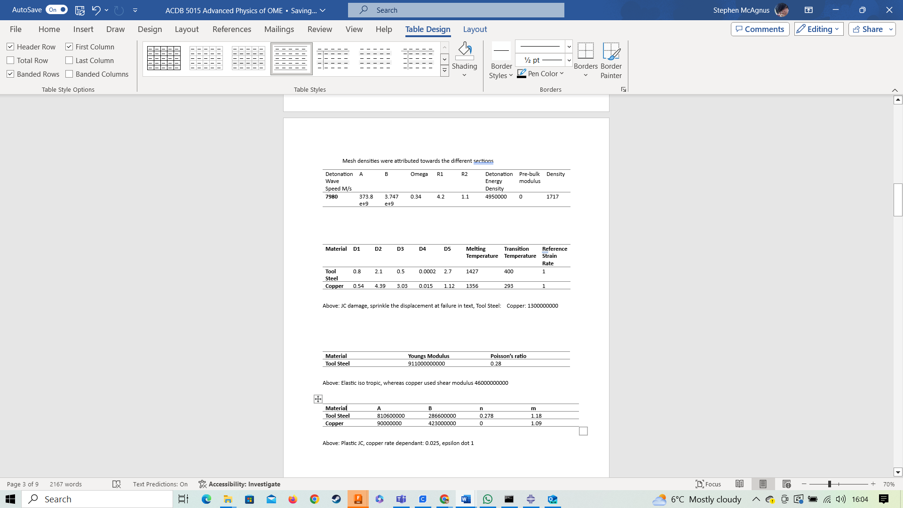

Table 1 - Displays the Equation of State figures for Composition B that were extrapolated from literature [19] [20] [21]. Composition B has a mass density of 1717kg/m³. The detonation point was set at the base of the explosive fill, where there was an interaction with the casing, and in alignment to the faux detonator well.

Table 2 - Displays a table that outlines the Johnson-Cook Damage models for copper [22] and H13 Tool Steel [23] [24].

Table 3 - Displays the isotropic elastic properties for the tool steel used in this model [25], whereas the copper used in this experiment used a shear modulus of 46 mPa [26], shear modulus was selected for this material as the copper liner underwent the most amount of translated force.



Table 4 - Displays the Johnson Cook Plastic parameters for Tool Steel [23] and copper [27]. Note that copper also had a rate dependant of 0.025, and an epsilon dot of 1.

Results

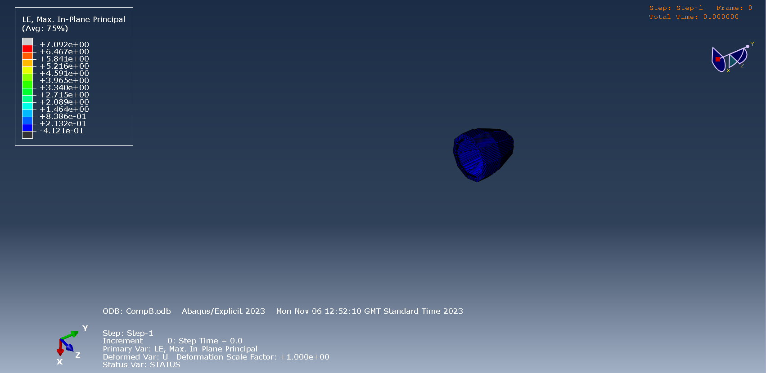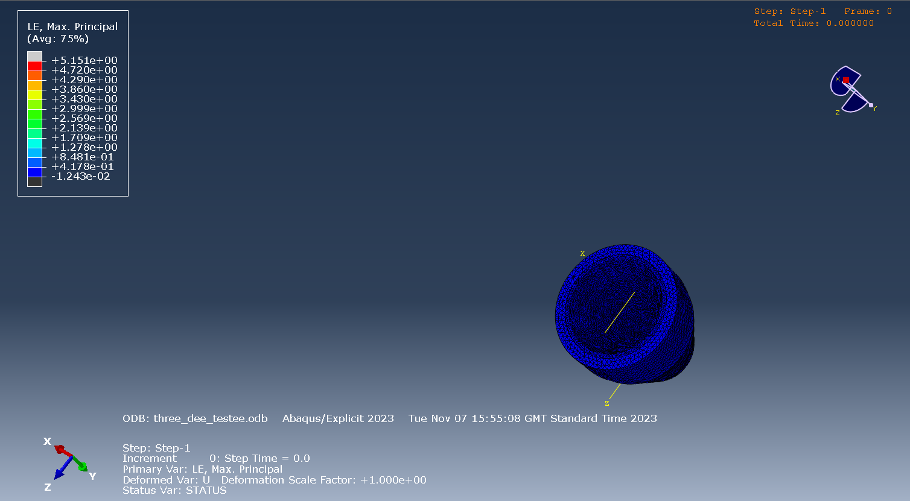

Figure 2 - Displays the uninitiated shape charges, the top image represents the two-dimensional axisymmetric model, which has been revolved in the viewport tools, and the bottom image being a true three-dimensional image.

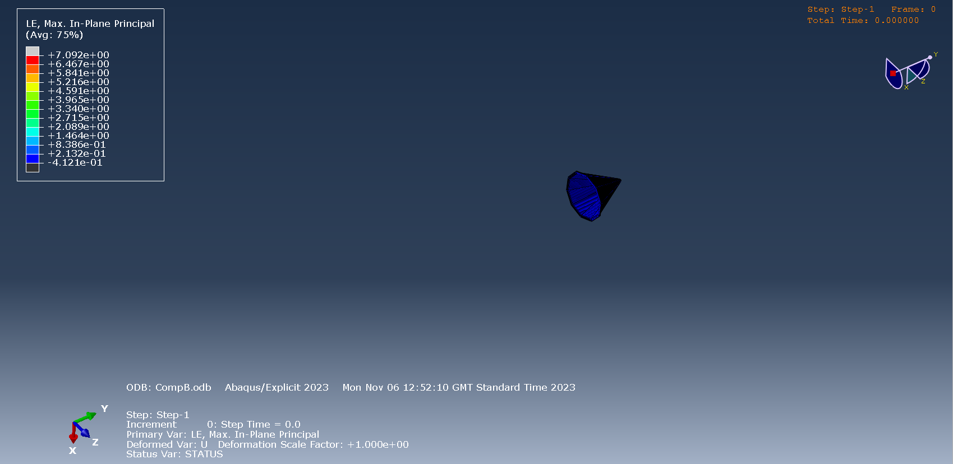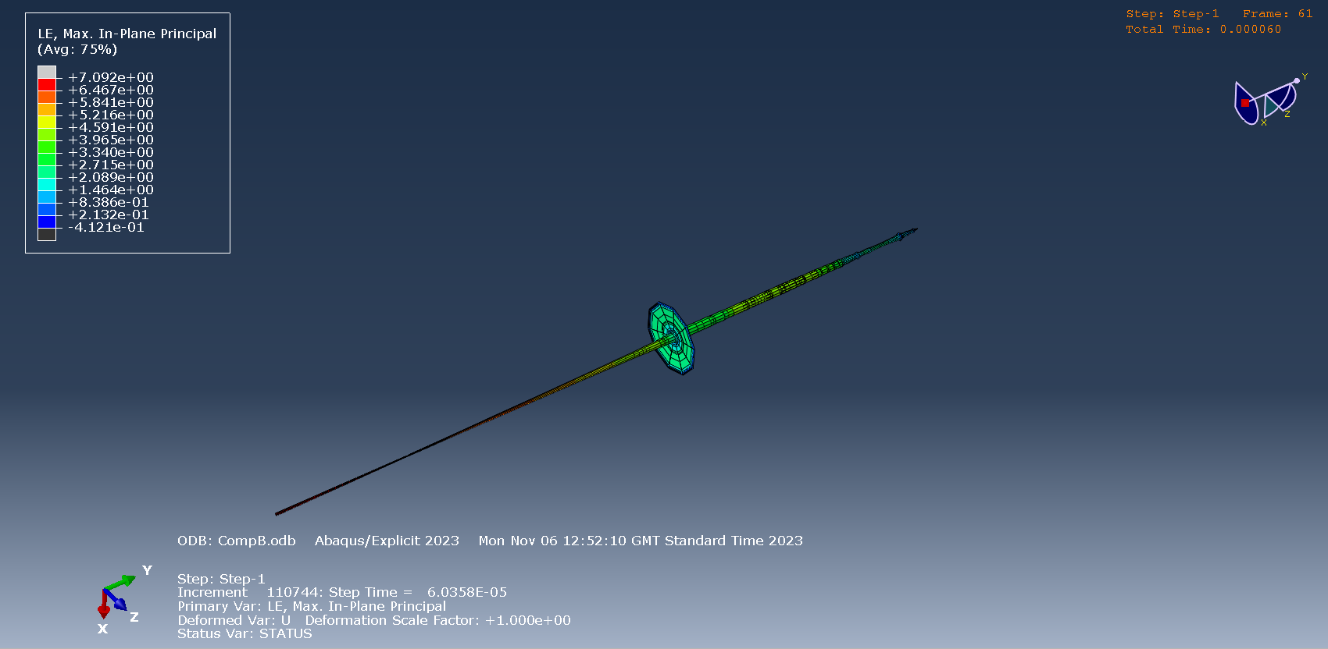

Figure 3 - Displays the two-dimensional Axisymmetric model of the shape charge, top uninitiated, and bottom initiated showing the formation of the shape charge’s Jet, where the explosive fill has been removed from the viewport due to clutter.

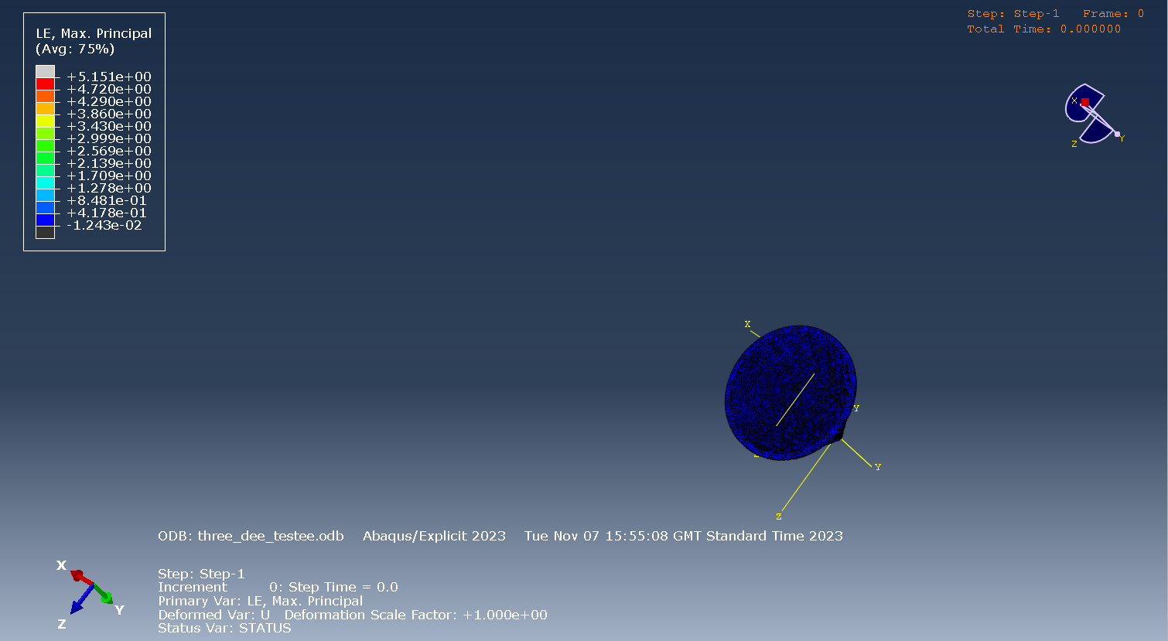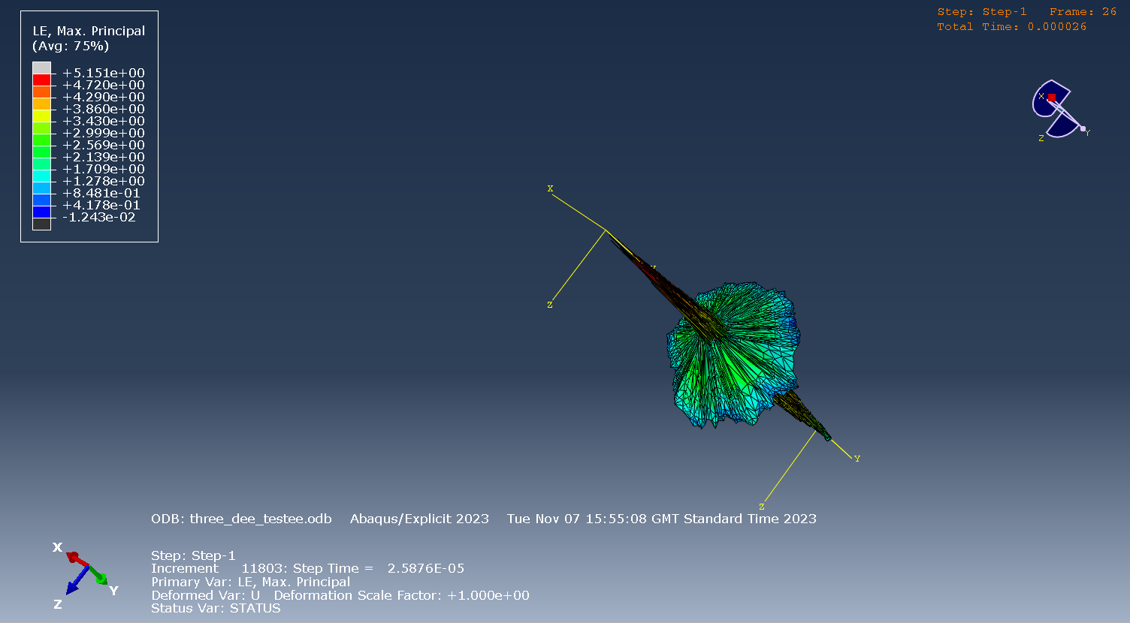

Figure 4 - Displays the true three-dimensional model of the shape charge, top uninitiated, and bottom initiated showing the formation of the shape charge’s Jet, where the explosive fill has been removed from the viewport due to clutter.

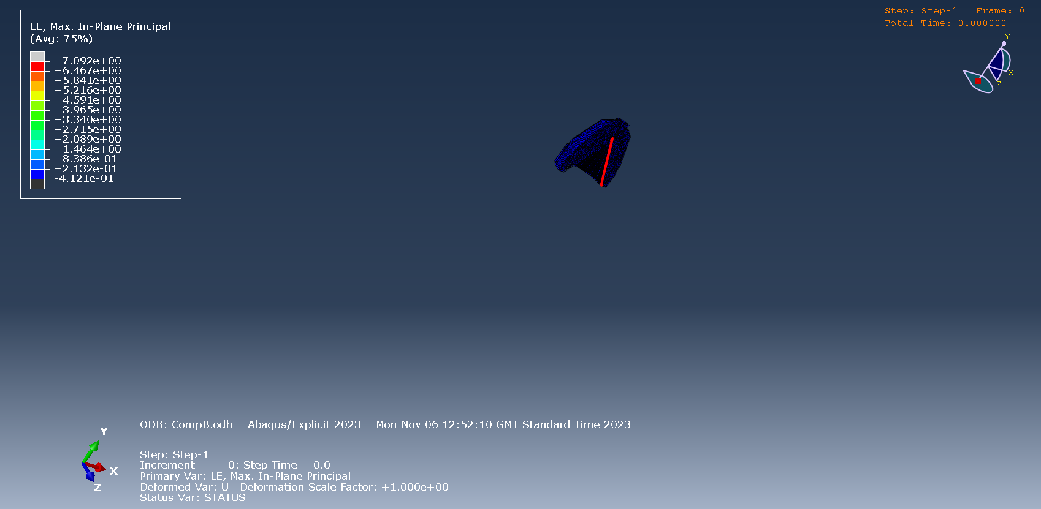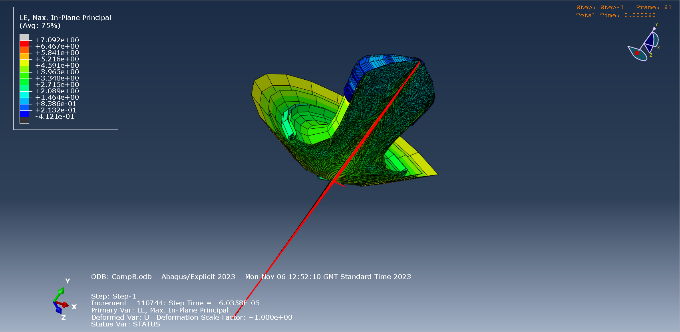

Figure 5 - Displays the two-dimensional axisymmetric model with a cut away sectional view showing the expansional direction of the gases being formed after the explosive event. Top uninitiated, bottom initiated.

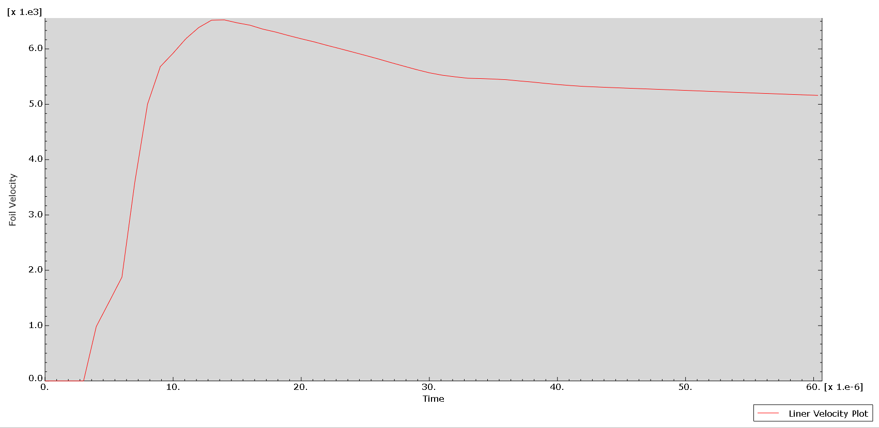

Figure 6 - displays the two-dimensional velocity plot of the tip of the Shape charges Jet, where peak velocity reaches a peak of 6700ms⁻¹

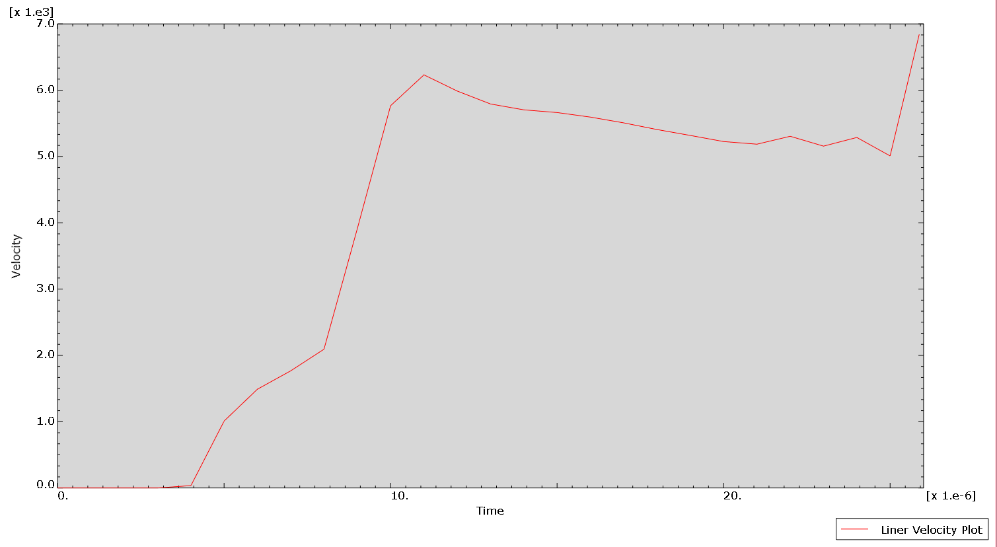

Figure 7 - displays the three-dimensional velocity plot of the tip of the Shape charges Jet, where peak velocity reaches a peak of 6300 ms⁻¹ & 6800ms⁻¹

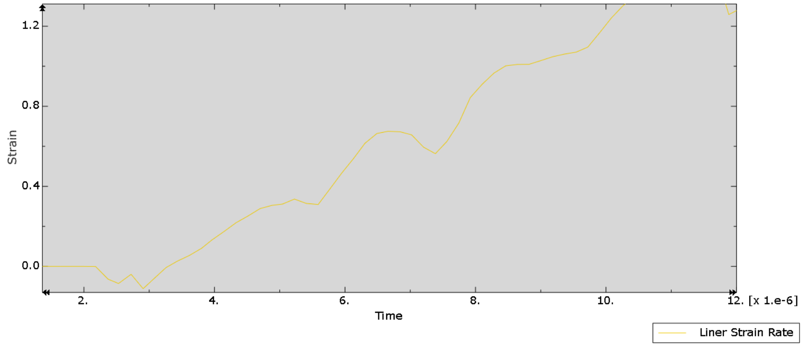

Figure 8 - Displays the strain rate of the Copper liner material as the progression of the explosive event occurs over time.

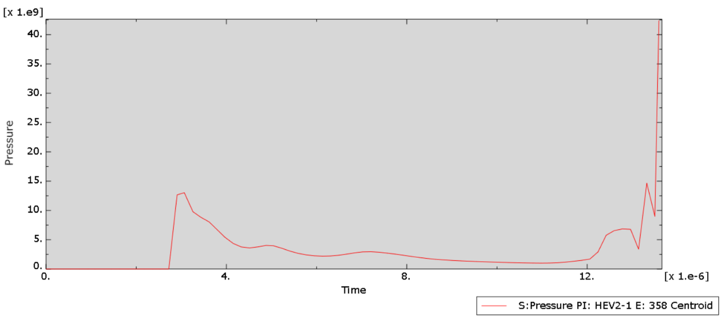

Figure 9 - Displays the pressure profile of the Composition B explosive fill of the shape charge.

Discussion

Comparing both the axisymmetric and the three-dimensional model again one another it can be seen in Figure Six & Figure seven that both shape charge liners when stimulated to the Comp B fill show a conservation of velocities between one another of roughly 6500 Ms⁻¹. However, upon visual inspection of both models there is significantly more clutter in the three-dimensional model. This is because in this model there are no constraints to plane or boundary condition, as would be expected in a true firing of a shaped charge device. However, this has highlighted that using solely a Lagrangian method is not a suitable means of studying the effect of a shape charge in a three-dimensional plane.
The three-dimensional Lagrangian model shows in principle the same as the axisymmetric model, both conserve similar velocities. However, what is important to note is that this three-dimensional simulation may pose more representative results, as nodes are not restricted to a two-dimensional axisymmetric plane. This means that there will be more complex nodal interactions in an unrestricted plane [28]. However, this study identified that due to software licensing limitations, there was a restriction to the total number of nodes in the model, this can be seen by the difference in mesh quality. Furthermore, three-dimensional models are much more computationally taxing, as such the detail from this model was significantly restricted. By Improving the computational power, and the number of accessible nodes, a more realistic three-dimensional model could be produced. As this infrastructure was not in place at the time of producing this report, conclusions as to if a three-dimensional model produces more tenable results cannot be drawn.
To that end, it is important to stress that there should be some restraint when designing any model and assigning nodes for the modelled structure. Whilst an increase in the number of nodes can lead to a more detailed representation and higher accuracy in results it may also prove to be counterproductive as it poses the risk of over representation that doesn’t significantly contribute towards the accuracy of final result [29]. What would be more suitable to improving the results obtained from this study would be using optimization strategies such as editing the mesh density in localised regions, or the use of adaptive meshing techniques. Employing Hierarchical mesh refinement would benefit this study as these techniques are reliant on physical properties of the model. As the liner of a shape charge undergoes high stress, an adaptive meshing technique could be employed to refine detail of the mesh to the areas of the liner that undergo the highest levels of stress [30]. Furthermore, there is scope to hybridise this technique with an error estimation technique. P-Adaptivity uses the compounded errors from an initial simulation and estimates the best mesh refinement based on the error rate. This technique is also repetitive, as such could also be artificially driven over a multitude of runs to refine the mesh detail to an optimal state [31].
The Linear Elastic (LE) Max Plane Principle in both axisymmetric and three-dimensional studies shows that most of the elastic stress seen it within the central regions of the jet under formation. This is somewhat expected behaviour as it is as the centre of the jet region where the pressure is contained, and thus there are a magnitude of different and opposing forces acting against one another. Typically, LE max plane principle is used to show modes of failure, i.e. areas of high stress, however under the terms of this study it is showing the effects of where the conical liner is at maximum compressional deformation and is starting to act like a plasma whilst forming a jet. What is interesting to note is that for the three-dimensional study the magnitude of theses figures are lower than the axisymmetric, it is quite possibly that due to the lack of boundary conditions resultant forces are able to dissipate more efficiently. These results are supported by Figure 8 where a linear trend can be identified between time and stresses observed within the copper liner material of the model.
One pressure profile was obtained from this study, where this shows that as time passes there is as initial peak of pressure, which is timed to the same point of detonation, this is the initial blast formed by the Composition B fill. However later in the graph there is a significantly higher-pressure event, which has been ruled to be an anonymous event, which is most probably caused by nodes continuing acceleration in the time space aspect of an Lagrangian approach. There were additional attempts to obtain pressure data from the three-dimensional model, however only surface elements could be selected in the viewport, the model was set to delete a proportion of elements that underwent catastrophic distortion to assist the simulation run through to completion, subsequently no pressure data was obtainable.
Whilst the Lagrangian technique provides excellent data on the element velocity and trajectory after exposure to multiple mathematical interactions. As an explosive event is not a linear event, a sole Lagrangian approach struggles to compute the behaviour of the explosives and the interaction of the explosive fill with the liner, and the casing, this can be identified by Figure 4 where the sharpness in the charge and morphology of the three dimensional jet is somewhat messy, this was exacerbated on initial runs, where auto deletion wasn’t enabled. However this is where other techniques such as a Eulerian approach may have provided more substantial data to this set. This is because a Eularian approach employs one of two techniques, Finite Volume Method (FVM) or Finite Difference Method (FDM). FVM works on the principe of dividing the model up into volumetric grids and introduces flux states across the faces of these volumes, where properties are updated at each grid point [32]. Whereas FDM works on the principle of approximating derivatives in the equations that are dependent on finite differences globally updating the local grid section’s properties and updating neighbouring grid sections [33]. These two approaches are why the eularian approach is considered a gold standard for evaluating the material flow and fluid dynamics of a material.
By implementing a hybrid Lagrangian-Eulerian approach (particle-in-cell approach) would capture element details and associated macroscopic effects. This technique would have retained the ability to track individual elements and their trajectories whilst also studying the effects of forces, fields and densities that a Eulerian approach offers. Furthermore, the mathematics is constrained to grid-based patterns, making the computational load significantly lower than a Lagrangian approach Examples of this modelling approach are commonly referred to Arbitrary Lagrangian-Eulerian (ALE) methods. ALE techniques are efficient means of modelling interactions that lead to large deformations, through exploitation of the fluid structure interactions [34]. This means that the formation of a penetrative jet from the interactions between the conical liner material and explosive fill can be better modelled. The key benefit of an ALE technique is the adaptive grid system that it employs. This is where the Eulerian grid aspect of this approach moves in respect to the changing geometry of the modelled shape charge during detonation [35]. This dynamic approach aides in maintaining accuracy of results it allows for tracking of evolving boundaries, whilst also reducing excessive node distortion [36]. More importantly dynamic griding allows for focused computational resourcing, enhancing the computer power to localised areas when the system requires it.
Another potential means of studying shape charges and their associated effects would be using Multiphysics simulations. Unlike the aforementioned methods a Multiphysics simulation would better capture the explosive detonation, as this technique excels at estimating the effects of a chemical reaction thus behaviour of the explosive material and gas generated from the explosion [37]. Additionally, to this a Multiphysics also has the capability to study structural mechanics, this the material deformation of the casing, liner and targets could also be captured. The most crucial part of this technique however is that it will extrapolate the material dynamics of jet formation, this in turn means that the Munroe effect would be better captured than using force vs material deformation [38]. More importantly as this technique explores Multiphysics domains, studies pertaining to fluid-structure interaction can be undertaken, this means that the effect of shockwave propagation upon the liner, and the jets effect upon a target can be better understood [39]. One additional feature that a Multiphysics simulation can benefit is through understanding energy conservation and the effect of electromagnetism upon the formation of jets & slugs of EFP’s and shape charges.
It is important to note that none of the techniques mentioned above are mutually exclusive, as such these techniques can be hybridised to benefit the whole system of study. Examples of this would through integrating the adaptive gridding system of an ALE technique with Multiphysics solutions. This approach would reduce the computation tax and reduce mathematical error. However, it can be seen that deformation and velocity are the two strongest results drawn from this study, as such there should be some scope for any future work where a target could also be implemented into these simulation scenarios, then estimation on the penetrative performance could also be assessed.
Whilst each of the aforementioned techniques pose advantages and disadvantages, a best route would be to hybridise multiple techniques into one to produce a more robust means of analysing the design of a shape charge. It was identified in this report that whilst a Lagrangian approach will produce a good level of detail on the velocity and vectors of travel, the approach is somewhat flawed in the context of measurement of gas production, where other approaches such as Eulerian excel. However, it is the authors suggestion that using a Multiphysics software package may be more suitable for this area of study as it provides more robust data on interactions between gases and solids, whilst also incorporating ALE techniques so that the fluid dynamics of a shape charge can be better understood. In conclusion, this study has identified that a Lagrangian approach yielded excellent results on the deformation on the conical liner, and the formation of a jet, and displaying theoretic velocities, however there are some considerable flaws to using a two dimensional approach outside of scoping a design as this approach require too much manipulation by the user for the results be considered accurate, this can be seen in the results between the two velocities and the LE max plane principle where there are significant differences between the two sets of data. To further validate a eularian approach should also be conducted to solidify the results pertaining to pressures and blast waves.

References

[1] | W. Walters, “A Breif history of Shaped Charges,” Defence Technical Information Centre, Aberdeen Prooving Grounds, 2008.
[2] | I. V. Hogg, German Artillery of World War Two, Barnsely: Pen & Sword Books Ltd, 2013.
[3] | G. L. Rottman, Panzerfaust & Panzerschrek, Oxford: Osprey Publishing, 2014.
[4] | L. Wilk, A. Habera, K. Frodyma, P. Hebda and Z. Koslik, “Optimization Testing of Shaped charges used in oil industry with numerical methods,” Oil and Gas Explorartion, vol. 19, no. 1.2, pp. 1031 - 1035, 2019.
[5] | J. J. Milinazzo, “Energey Transfer of Shaped Charges,” U.S. Department of Energy - Office of Scientific and Technical Information, Albuquerque, 2016.
[6] | J. M. J, F. M. P and H. T, “Shaped Charges and Explosively Formed Penetrators: Background for Clinicians,” Journal of the Royal Army Medical Corps, vol. 153, no. 3, pp. 184 - 188, 2007.
[7] | A. M and Q. M. A, “A Review of Works on Shaped Charges,” Engineering Technology & Applied Science Research, vol. 7, no. 5, pp. 2098-2103, 2017.
[8] | V. Bohanek, M. Dobrilović and V. Škrlec, “The Efficiency of Linear Shaped Charges,” Tehnički vjesnik, vol. 21, no. 3, pp. 525 - 531, 2014.
[9] | A. Gustafsson, “Shaped Charge Design: Construction of a minaturised Shape Charge,” Karlstad University Faculty of Health, Science and Technology, Karlstad, 2021.
[10] | V. F. S, V. B. A, V. L. S, A. S. G and D. M. A, “Possibilities of Controlling the Shaped-Charge Effect by Electromagnetic Actions,” Comustion, Explosion, and Shock Waves, vol. 36, pp. 792 - 808, 2000.
[11] | A. S. G, D. M. A, V. F. S, V. L. S and V. B. A, “Effect of External Magnetic fields on Shaped-charge operation,” International Journal of Impact Engineering, vol. 38, no. 6, pp. 521-526, 2011.
[12] | J. Morrison and F. M. Peter, Shaped Charges and Explosively formed Projectiles "Ryan's BAllistic Trauma: A practical guide, London: Springer, 2011.
[13] | D. Novotney and M. Meryl, “Historical Development of linear Shape Charges,” in Joint Propulsion Conference & Exhibit, Cincinnati, 2007.
[14] | D. Pyka, K. Adam, B. Miroslaw, B. Marcin, M. Magier, J. Sliwinski and J. Krzysztof, “Numerical and Experimental studies of the Lk type Shaped Charge,” Applied Sciences, vol. 10, no. 19, p. 6742, 2020.
[15] | F. M. J, “Finite element simulation of shaped charges,” Finite elements in analysis and design, vol. 28, no. 10, pp. 921-936, 2002.
[16] | Q. X. Q, X. H. Z, S. Z. C and D. Z. X, “Calculation of Depth and Crater Diameter for the supersonic penetration of shaped charge into concrete,” Propellants, Explosives, Pyrotechnics, vol. 38, no. 2, pp. 224 - 231, 2013.
[17] | S. H. B and S. D. O, “Finite compressibility in shaped charge jet and log rod penetration - the effect of shocks,” journal of applied physics, vol. 52, no. 8, pp. 5066-5071, 1981.
[18] | T. Elshenawy and A. Elbeih, “A modified Penetration Model for Copper Tungsten Shaped Charge Jet With non-uniformity Density Distrabution,” Central European Journal of Energetic Materials , vol. 13, no. 4, pp. 927 - 943, 2016.
[19] | C. T. Chadd May, “Short Pulse Duration Shock Inititation Experiments plus ignition and growth modeling on Compositon B,” in Journal of Physics: Conference Series , Livermore, 2014.
[20] | J.-Y. Liu, Y.-X. Dong, X.-y. An, P. Ye and Q. G. Qi-Tian Sun, “Reaction Degree of Composition B Explosives with multilayers compound structure protection subjected to detonation loading,” Defence Technology, vol. 17, no. 2, pp. 315-326, 2021.
[21] | L. Aronlea, “Sound Velocity and Elastic Moduli Measurements on Several TNT-Base Explosive compositions,” Naval Ordnance Labortory, Maryland, 1961.
[22] | V. Champagne, D. Helfritch, M. Trexler and B. Gabrial, “The Effect of cold spray impact velocity on deposit hardness,” Modelling and simulation in materials science and engineering, vol. 18, no. 6, 2010.
[23] | H. Ding, N. Shen and Y. Shin, “Experimental Evaluation and Modeling Analysis of Micromilling of Hardened H13 Tool Steels,” Journal of Manufacturing Science and Engineering, vol. 133, 2011.
[24] | Y.-l. Wang, K.-x. Song, Y.-M. Zhang and G.-X. Wang, “Microstructure Evolution and Fracture Mechanism of H13 Steel during high temperature tensile deformation,” Material Science and engineering, vol. 746, pp. 127-133, 2019.
[25] | Azo Materials, “Azo Materials,” 10 July 2013. [Online]. Available: https://www.azom.com/article.aspx?ArticleID=9107. [Accessed 28 11 2023].
[26] | Granta Design, “Azo Materials,” Grantadesign, 20 July 2001. [Online]. Available: https://www.azom.com/properties.aspx?ArticleID=597. [Accessed 29th November 2023].
[27] | M. L. D, “Determination of Johnson-Cook Material constants for Copper ujsing traction tests and inverse identification,” in IOP Conference series: Materials science and engineering , Eforie Nord, 2021.
[28] | N. Xie, F. Battagila and S. Pannala, “Effects of using two-verfus three-dimentional computational modeling on fluidized beds: part one Hydrodynamics,” Powder Technology, vol. 1, no. 13, pp. 1 - 13, 2008.
[29] | D. Strait, Q. Wang, P. Dechow, C. Ross, B. Richmond, M. Spencer and B. Patel, “Modeling Elastic properties in finite-element-analysis: how much precision is needed to produce an accurate model?,” The anatomical record, vol. 283, no. 2, pp. 275-287, 2005.
[30] | Y. You, X. Kou and S. Tan, “Adaptice meshing for Finite element analysis of heterogenous materials,” Computer-aided design, vol. 62, no. 10, pp. 176-189, 2015.
[31] | S. C, O. E and N. S, “A review of the scaled boundary finite element method for two-dimentional linear elastic fracture mechanics,” Engineering Fracture Mechanics, vol. 187, pp. 45-73, 2018.
[32] | L. M. Fadi Moukalled, M. Darwish, F. Moukalled, M. L and D. M, The Finite volume method, Springer International Publishing, 2016.
[33] | N. Perrone and R. Kao, “A general finite difference method for arbitrary meshes,” Computers & Structures, vol. 5, no. 1, pp. 45-57, 1975.
[34] | J. Trajkovski, “Comparison of MM-ALE and SPH methods for modelling blast wave reflections of flat and shaped surfaces,” in Proceedings of the 11th European LS-Dyna Conference, Salzburg, 2017.
[35] | A. Rooz and A. Hamidi, “A numerical model for continous impack pile driving using ALE adaptive mesh method,” Soil dynamics and earthquake engineering, vol. 118, pp. 134-143, 2019.
[36] | G. Compere, F. R. J, J. J and H. J, “A mesh adaptation framework for dealing with large deforming meshes,” International journal for numerical methods in engineering, vol. 82, no. 7, pp. 843 - 867, 2010.
[37] | W. C, X. W and L. T, “Experimental and numerical studies on penetration of shaped charge into concrete and pebble layered targets,” the international jounal of multiphysics , vol. 11, no. 3, pp. 295-314, 2017.
[38] | S. D, G. N, N. F and S. M, “Hydrodynamics computation of jet formation and penetration for micro-shaped charges,” Procedia Engineering, vol. 58, pp. 39-47, 2013.
[39] | F. F, M. R, K. M and S. V, “A parametric study of shock wave simuations with help of COMSOL multiphysics,” in Proceedings of the 2012 COMSOL conference, Milan, 2012.

