BMIH5004

MANAGEMENT & ORGANISATIONAL BEHAVIOUR
Student Name: Dan Andreea-Monica
Student ID: 2127612
Lecture: Maggie Lan Zang
Executive summary
This executive summary encapsulates the findings, recommendations, and conclusions of the audit conducted on Hyatt Hotel Group. Hyatt Hotel Group exhibits a robust organisational structure and a customer-centric culture aligned with its overarching goals. Recent change initiatives, including digital transformation and sustainability efforts, have enhanced operational efficiency and customer satisfaction. Despite challenges like the COVID-19 pandemic, Hyatt demonstrates strategic resilience, effectively navigating market uncertainties. To sustain momentum, Hyatt should focus on continuous improvement in change management processes. Exploring revenue diversification opportunities through market expansion and alternative business models is advised. Prioritising sustainability efforts with ambitious targets for carbon reduction and waste management will strengthen Hyatt's competitive position. Hyatt's strengths lie in its organisational structure, change management, and strategic resilience. However, there's room for improvement, particularly in revenue diversification and sustainability. By implementing the provided recommendations, Hyatt can further solidify its position in the hospitality industry and ensure sustained success in the face of evolving market dynamics.

Table of Contents
Introduction 4
Organisation Structure, Culture, and Goals 5
Analysis of Hyatt's Organisational Structure 5
The Perceived Organisational Culture and Its Alignment with Relevant Theories 6
Overview of Hyatt's Goals, Visions, or Aims: 6
Recent Change Initiatives and Impact 7
Strategic Direction and Current Business Performance 8
Analysis of Hyatt's Strategic Direction 8
Assessment of Current Business Performance Using SWOT Analysis 9
Conclusion 12
References 13

Introduction
The Hyatt Hotel Group is a major player in the global hotel business. It is known for its high-end rooms, excellent service, and dedication to maintaining customer happiness. Through a long and storied past spanning decades, Hyatt has become a major hotel brand with a position in many important markets around the world. In this opening, the organisation is briefly described, the goal and scope of the audit are explained, and the main issues.
Background Information on Hyatt Hotel Group
Founded by Jay Pritzker in 1957, Hyatt Hotel Group has grown from its small beginnings in Los Angeles to become one of the most well-known names in the hotel business. With a collection that now includes luxury, upscale, and select service hotels, Hyatt has grown over the years to serve a wider range of customers. Maintaining its core values of honesty, respect, humanity, and creativity, Hyatt continues to change the way guests experience the hotel while staying true to its commitment to innovation and success.
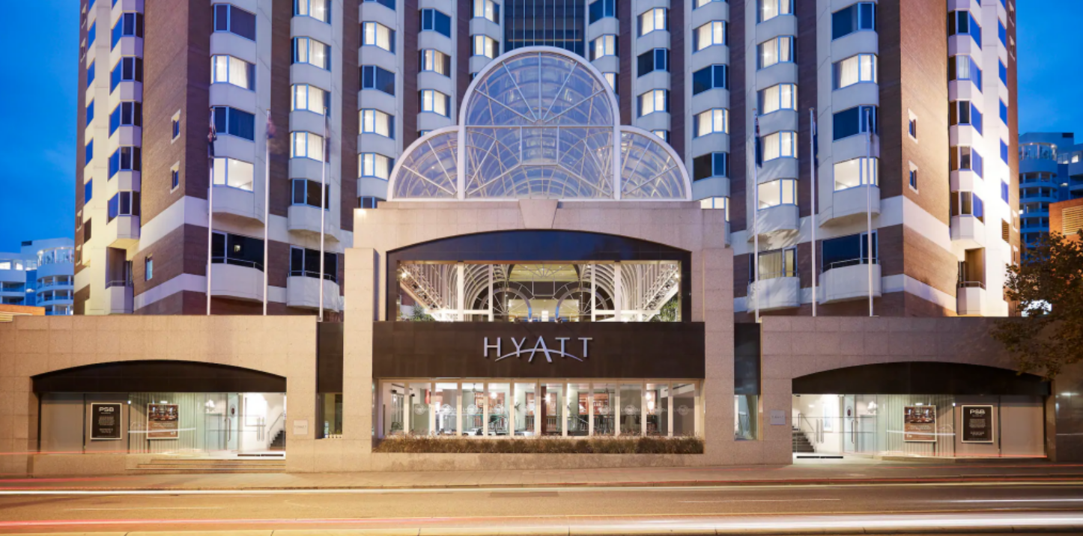
Figure 1: HYATT
(Source: Hyatt)
Purpose and Scope of the Audit
Hyatt Hotel Group will be looked at closely at both the company and unit levels in this audit, with a focus on important organisational aspects. This audit's main goal is to look at Hyatt's organisational structure, culture, goals, recent change efforts, strategic direction, and current business success by providing a thorough examination. Hyatt's strengths, flaws, chances, and dangers can be studied in detail, which will help with making decisions and planning strategies. Overview of Key Topics to be Addressed
This report looks at Hyatt's organisational system, including its goals, cultural ideals, and managerial structure. Analysing Hyatt's change management methods and how well they worked to bring about organisational development. Analyses Hyatt's financial success, market share, and competitors, as well as its strategy standing in the market.

Organisation Structure, Culture, and Goals

Analysis of Hyatt's Organisational Structure
Hiatt Hotel Group has a structured organisational system, which is common for big international companies. A company organisation includes a board of directors, a top leadership team, and different specialised areas like human resources, operations, finance, and marketing. There are clear lines of power and quick decision-making with this centralised system (Miteva and Ackovska, 2017).
To run its hotels, Hyatt uses a decentralised system. Each site has a general manager who is in charge of day-to-day activities. Flexible and independent at the property level, this decentralised system lets managers meet the specific needs of their guests and the changing nature of the local market.
Although Hyatt is set up in a hierarchy, the company encourages partnership and teamwork at all levels. An open and helpful work setting is created with regular feedback and contact routes.

The Perceived Organisational Culture and Its Alignment with Relevant Theories
With a strong focus on service quality, creativity, and giving employees the power to make decisions, Hyatt's organisational culture is characterised by these values. When dealing with guests and coworkers, employees are told to represent the company's core values of honesty, respect, understanding, and creativity.
Multiple related ideas, such as Edgar Schein's model of organisational culture, fit well with Hyatt's culture. Schein says there are three layers of organisational culture: artefacts, stated ideals, and basic beliefs. Customer-centeredness and ongoing growth are two of Hyatt's core values, and the company's goal statement, staff training programmes, and guest service standards all show these values (Arif and Hossin, 2016).
For example, Hyatt uses some ideas from transformational leadership theory, which says that leaders should inspire and drive their workers to do better work. Hyatt's leaders enable innovation and imagination among their employees by promoting a culture of trust, open communication, and freedom.

Overview of Hyatt's Goals, Visions, or Aims:
The overarching goal of Hyatt Hotel Group is to provide genuine service by improving the lives of its owners, workers, and guests. The company's goal statement emphasises making unique events and building long-term connections with stakeholders, which shows its dedication to excellence (Fernandes, 2021).
Consistent with its vision, Hyatt has set clear goals and targets to help it make smart decisions. These goals might include growing the company's reach around the world through organic growth and smart acquisitions, making the brand stand out through creative design and great customer experiences, and achieving business excellence by making updates to technology and processes.
Beyond that, Hyatt's views, goals, and aims show that the company is committed to providing excellent guest experiences while also caring for people and the environment. By coordinating its organisational structure, attitude, and goals, Hyatt sets itself up for long-term success and growth in the fast-paced hotel industry (Catana and Toma, 2021).

Recent Change Initiatives and Impact
Explanation of Recent Change Initiatives Undertaken by Hyatt:
Responding to shifting customer tastes and market conditions, Hyatt Hotel Group has recently started several new programmes to improve business efficiency and guest happiness and attempts to be more environmentally friendly.
Implementing digital transformation tactics is one of Hyatt's big changes. This includes creating mobile apps, online booking systems, and digital personal services to make things easier for guests and run more smoothly.
Furthermore, Hyatt has made environmental programmes a top priority as part of its business duty plan. Energy-efficient lights, water-saving measures, and waste-reduction programmes are some of the eco-friendly practices that have been used recently.
Reasons for Implementing These Changes:
Several things, such as market trends, competition forces, and internal strategic goals, led to the choice to enact these change efforts. Regarding digital change, Hyatt knows that technology is becoming more and more important in shaping the guest experience and keeping the hotel business competitive (Thio and King, 2016).
Additionally, Hyatt's attention to sustainability shows its dedication to both business social duty and environmental management. Consciousness about climate change and resource loss is growing, so customers want businesses to use more eco-friendly methods.

Evaluation of the Impact of These Changes on the Organisation:
With some problems and places for growth, Hyatt's latest efforts to make changes have had a good effect on the organisation. Within operations, digital transformation projects have simplified procedures, eased the work of management, and raised guest happiness levels. With the arrival of digital room keys, mobile check-in/out, and computers in rooms, staff can provide more personalised services while making things easier for guests (Krupskyi et al., 2019).
Additionally, environmental efforts have led to real benefits such as lower costs, better use of resources, and better brand recognition. Investments in waste-reduction and energy-efficient technologies have helped Hyatt lower electricity costs and carbon pollution across all of its sites. Additionally, these efforts have been well received by environmentally aware customers, which has increased customer and company loyalty (Jones and Comfort, 2019).
Noting that change is not always easy is important, though. Hyatt has had problems with resource limitations, workers who don't want to change, and integrating new technology. Effective change management, involving stakeholders.
Generally, Hyatt's recent efforts to make changes have set the company up for long-term success by improving business efficiency, guest happiness, and environmental performance.

Strategic Direction and Current Business Performance

Analysis of Hyatt's Strategic Direction
Its goal to provide genuine service and make a good change in the lives of its guests, workers, and owners guides Hyatt Hotel Group's strategic path. Brand uniqueness, guest experience innovation, global growth, and green leadership are all important parts of Hyatt's strategy path.
Brand Differentiation: Hyatt stands out in the market by having a wide range of hotel names for different types of customers, such as luxury, expensive, and select service options. Hyatt can reach a wider range of customers and successfully target different groups because each brand is tailored to the tastes and lifestyles of a specific group of travellers (Kansakar, Munir, and Shabani, 2019).
Guest Experience Innovation: Hyatt's strategic plan is based on creating new guest experiences and making them better all the time. In order to give guests unique, personalised experiences that go above and beyond their expectations, the company spends money on new technologies, better services, and creative designs. Hyatt wants to anticipate guests' needs, improve service, and turn customers into loyal advocates by using digital tools and data analytics (Walker, 2021).
Global Expansion: Hyatt's growth plan is based on hyper-growth and market penetration in key global places. Hyatt wants to expand its business in both known and new areas by making smart deals and leading internal growth programmes. By opening up more hotels in more places, Hyatt hopes to take advantage of the growing demand for travel and generate more consistent income.
Sustainability Leadership: Hyatt shows a dedication to business social responsibility and environmental leadership as part of its overall strategy. There are eco-friendly practices, community involvement programmes, and responsible buying rules that the company uses to help the earth and society. Integrating sustainability into its business practices, Hyatt not only meets its moral responsibilities but also improves its brand image and draws travellers who care about the environment.

Assessment of Current Business Performance Using SWOT Analysis
Strengths:
- Strong brand portfolio with diverse offerings catering to various market segments.
- Global presence and extensive network of properties in key destinations.
- Commitment to innovation and guest experience excellence (Lin, 2016).
- Robust loyalty program driving customer retention and repeat business.

Weaknesses:
- Exposure to economic downturns and fluctuations in travel demand.
- Reliance on the luxury segment may pose challenges during economic downturns.
- Vulnerability to geopolitical risks and regulatory changes in international markets (Gozgor, et al., 2022).
- Limited presence in certain geographic regions compared to competitors.
Opportunities:
- Expansion into emerging markets with high growth potential, such as Asia-Pacific and the Middle East.
- Innovation in technology and digital solutions to enhance guest experiences and operational efficiency.
- Strategic partnerships and alliances to strengthen brand presence and market share.
- Increasing demand for sustainable and eco-friendly travel experiences.
Threats:
- Intense competition from global hotel chains, boutique hotels, and alternative accommodations.
- Disruption from technological advancements and online travel agencies.
- Economic uncertainties and geopolitical tensions impacting travel patterns.
- Regulatory challenges and compliance requirements in various jurisdictions.
Despite the challenges brought on by the COVID-19 spread and changing market trends, Hyatt has stayed true to its strategy goal, which is to provide great leisure experiences, promote long-term growth, and create value for all stakeholders. By building on its strengths, fixing its weaknesses, seizing opportunities, and lowering its risks, Hyatt is ready to handle the challenges of the hotel business during the pandemic. By responding to changing customer habits, welcoming new ideas, and putting in place strong safety measures, Hyatt hopes to not only weather the current storm but also come out stronger and more adaptable after the pandemic. Hyatt is ready to do well in the changing hospitality market thanks to its dedication to quality and flexibility in its strategic planning. It will provide guests with unmatched experiences while increasing stockholder value (Zuo et al., 2018).

Conclusion
The audit of Hyatt Hotel Group shows that it has a strong organisational structure that values teamwork, creativity, and providing excellent service, all of which are in line with its central focus on customers and overall goals. In recent years, projects like digital transformation and green efforts have been pushed forward by good change management, which has improved business efficiency and customer happiness. Beyond problems like the COVID-19 outbreak, Hyatt shows strategic adaptability by changing its business to deal with unstable market conditions. It is suggested that change management be improved all the time, that income streams be diversified by expanding markets and using different business models, and that sustainable efforts be given top priority. By giving partners important information, this study helps them make smart choices that will help Hyatt succeed and stay in business in the tough hotel industry.

References
Arif, T.M.H. and Hossin, M.Z., (2016). A comparative analysis of internal and external environments between Hotel Hyatt, UK and Hotel The Cox Today, Cox’s Bazar, Bangladesh. IOSR Journal of Humanities and Social Science, 21(6), pp.13-22.
Catana, Ş.A. and Toma, S.G., (2021). Entrepreneurship in the hospitality industry. Case study: Marriott International. SEA-Practical Application of Science, (27), pp.221-225.
Fernandes, F.S.M.S., (2021). Intercontinental hotels group-time to check-in? analysis of one of the biggest hotel players in times of a global pandemic (Doctoral dissertation).
Gozgor, G., Lau, M.C.K., Zeng, Y., Yan, C. and Lin, Z., (2022). The impact of geopolitical risks on tourism supply in developing economies: The moderating role of social globalization. Journal of Travel Research, 61(4), pp.872-886.
Jones, P. and Comfort, D., (2019). Sustainable development goals and the world’s leading hotel groups. Athens Journal of Tourism, 6(1), pp.1-14.
Kansakar, P., Munir, A. and Shabani, N., (2019). Technology in the hospitality industry: Prospects and challenges. IEEE Consumer Electronics Magazine, 8(3), pp.60-65.
Krupskyi, O.P., Dzhusov, O., Meshko, N., Britchenko, I. and Prytykin, A., (2019). Key sources when formulating competitive advantages for hotel chains. Tourism: An International Interdisciplinary Journal, 67(1), pp.34-46.
Lin, X., (2016). Strategy analysis of a boutique and lifestyle hotel: a SWOT analysis.
Miteva, N. and Ackovska, M., (2017), March. The impact of hotel chains on the customer satisfaction and loyalty. In International Scientific Conference on Economics and Management EMAN (pp. 856-861). Association of Economics and Managers of the Balkans, Belgrade, Serbia.
Thio, S. and King, B., (2016). The managerial competencies required by Indonesia’s leading hotel groups: A preliminary investigation. In Heritage, Culture and Society: Research agenda and best practices in the hospitality and tourism industry (pp. 95-100). CRC Press.
Walker, J.R., (2021). Introduction to hospitality. Pearson.
Zuo, L., Xion, S., Wang, Z. and Lida, H., (2018), August. Evaluation of hotel loyalty program with game refinement theory and analytic hierarchy process. In International Conference on Computer, Electronic Information and Communications (CEIC 2018) (pp. 433-441).

