Student name: Alexandra Elena Vlad
Student ID: 2118684
Lecturer name: Christopher Wilkin
Module: BMIH6008

TO INVESTIGATE THE IMPACT OF EMPLOYEE SATISFACTION ON NEGATIVE CUSTOMER EXPERIENCES FOR CUSTOMERS 18-35: A CASE STUDY OF IBIS HOTEL STRATFORD-LONDON

Acknowledgement
I would like to convey my heartfelt gratitude to my mentors and guides who have helped me in the accomplishment of the study on the topic of “TO INVESTIGATE THE IMPACT OF EMPLOYEE SATISFACTION ON NEGATIVE CUSTOMER EXPERIENCES FOR CUSTOMERS 18-35: A CASE STUDY OF IBIS HOTEL STRATFORD-LONDON”. I greatly acknowledge my mentors for helping me throughout the project and guiding me in the right direction. I am also thankful to other teachers for providing me with constant support for the successful completion of the project. I am also thankful to my university for providing me with all the required resources for completion of my studies. Last but not the least I would like to convey my gratitude to my parents for providing me with support throughout the project.

Executive Summary
The research has investigated the impact of employee satisfaction which increases negative customer experiences for the customer between the age group 18-35 years. It has been highlighted that job security, poor management and many more are the reasons for rising employee dissatisfaction which affects the customer experiences in the hotel industry, The aims and objective of the research project help in evaluating in-depth knowledge over the internal and external implications in the hotel.
The literature review of the report has concentrated on the evaluation of existing sources in the context of employee satisfaction and customer experience. The section has further focussed on theoretical perspectives and literature gaps. The case study analysis of the report has highlighted SWOT and PEST analysis in addition to competitor analysis. The generated themes have projected how the Brexit Protocols are responsible for the price rise of services being offered by Ibis. A lack of modern security policy has also been projected. It projected how the company is lagging in the competition even though it has a good brand awareness in the UK. The suggestions recommended ways of mitigation have included the implementation of AI integration and safety enhancement to increase the level of customer satisfaction. The research has included appropriate recommendations which are essential for decreasing the negative impact of employee satisfaction which has been analysed in the IBIS hotel operations.

Table of Contents
Introduction 6
Research Background 6
Overview of the Case Study Hotel 6
Research Aims and Objectives 6
Literature Review 7
Role of employee satisfaction on customer experiences 7
Factors contributing to negative employee satisfaction across hotel businesses 7
Theoretical perspective 7
Literature Gap 9
Methods 10
Research Onion 10
Research Philosophy 10
Research Approaches 10
Data Collection 11
Reflective Writing 11
Case study 11
Background of IBIS Hotel 11
SWOT analysis 12
PEST analysis 14
Competitor Analysis (Price vs Quality) 17
Theme Exploration 19
Customer Behaviour on the services of Ibis Hotel 19
Influences on Customer Services by Ibis Hotel 20
Issues Detected in the Services of Ibis Hotel in London 22
Effective Ways to Curb Problematic Issues and Improving Services 24
Conclusion and Recommendations 25
Conclusion 25
Limitations 26
Recommendations 26
Reflective Account 27
References 31

Introduction

Research Background
The negative side of customer engagement creates a strong bad impression of the company which affects the growth and reputation of the organisation (Do et al., 2020). It has been analysed that the impact of the demotivated staff members leads to an increase in frustrated customers in the service-oriented industries. Different factors include technological integration increased employee lay-off, employee job stability impacts, increased customer traffic increased work pressure and many more increases in negative employee satisfaction levels in the hospitality industries.

Overview of the Case Study Hotel
This report is going to investigate the IBIS hotel Stratford-London over the impact of the employee satisfaction level which affects customer experiences. IBIS Hotel is a France-based budget hotel which is owned by Accor. The brand has been operating since 1974, and the company is able to spread its branches throughout the world. The financial revenue has reached up to 5.056 million euros by the end of 2023, whereas the company has entitled with economic performances which have reached up to 5 billion euros (group.accor.com, 2024).

Research Aims and Objectives
Aims
The study aims to understand the impact of employee satisfaction on negative customer experiences for customers between the age group of 18-35 years.
Objectives
- To analyse the impact of employee satisfaction on customer experiences
- To evaluate factors of employee satisfaction that accumulate negative impact on customer experiences
- To examine the challenges faced by the hotel business in terms of maintaining employee satisfaction
- To recommend a solution to enhance employee satisfaction and customer experiences

Literature Review

Role of employee satisfaction on customer experiences
Employee satisfaction tends to have a massive impact on the parameters of customer experience and involvement. According to Al Kurdi et al. (2020), employee satisfaction is significant, particularly in enhancing the long-term productivity and profitability of businesses. In terms of fostering customer experiences, parameters of employee satisfaction such as loyalty, retention and commitment play a pivotal role in fulfilling the needs and requirements of customers. Additionally, the considerable amount of satisfaction that individuals gain from their workplace directly leads to better customer experiences (Jeon and Choi, 2019). The positive changes that employees make relevant to their attitude and behaviour, considerably contribute to the enhancement of customer satisfaction and engagement.
In contrast, Charni et al. (2019) mentioned that the value and profit chain of business entities depends on attitudes and behaviours showcased by employees. Hence, it can be inferred that employee satisfaction has a massive impact in terms of customer experience (Bahadur et al., 2019).

Factors contributing to negative employee satisfaction across hotel businesses
Several factors such as low net earnings, stress, workload and interpersonal tensions are some of the common factors that generate negative employee satisfaction. According to Heimerl et al. (2020), the hospitality industry witnesses a massive impact on employee turnover in comparison to other domains. On the contrary, Kassim (2019) mentioned that the satisfaction parameters of employees in the hotel business depend on job security, supervision and work environment. In this context, the absence of a positive working culture that caters needs and requirements of employees can hinder the feasibility of their participation and satisfaction.
As postulated by Andrade et al. (2020), poor working conditions in the hotel domain can result in consequences of inadequate staffing. In the words of Coelho and Bartolomeu (2019), the determinants such as failure to recognise the exceptional performance of employees, affect the delivery of hotel business (Yang, 2020). However, the challenges have been significant reasons that deteriorated the experience and engagement of customers in undertaking services of a hotel business.

Theoretical perspective
Herzberg's motivation-hygiene theory
The theory infers that proper management of hygiene factors is essential to prevent employee dissatisfaction. Moreover, based on this parameter of satisfaction can be identified based on which individuals can pursue needs, desires and goals (Alrawahi et al., 2020). The dimensions of Herzberg's theory include achievement, resignation, responsibility, advancement, growth, supervision, relationships, working conditions, salary, security and others.
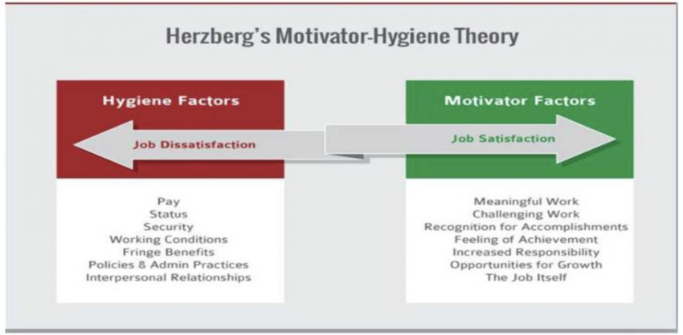
Figure 1: Herzberg's motivation-hygiene theory
(Source: Ahmad et al., 2021)
For the hotel business, this also infers enhancement of opportunities in response to career growth and professional development of employees, thereby empowering them to develop prerequisite skills and knowledge in the area of concern (Ataliç et al., 2019). In addition, leveraging the aspects of Herzberg’s motivation-hygiene, hotel sectors can also drive hygiene factors such as salary, job security, working conditions, company policies, interpersonal relationships and others to enhance productivity and growth of the hotel business.
Social Exchange Theory
The theory of social exchange is concerned with the idea of social behaviour that can lead to the enhancement of the exchange process. The theory determines the potential benefits and concerns of social relationships. Moreover, as per the theory, the exchange can result in the maximisation of benefits, in addition to the minimisation of costs (Ahmad et al., 2023). Concerning organisational satisfaction and experience the theory elaborates on the appropriate use of resources, thereby receiving positive work outcomes.
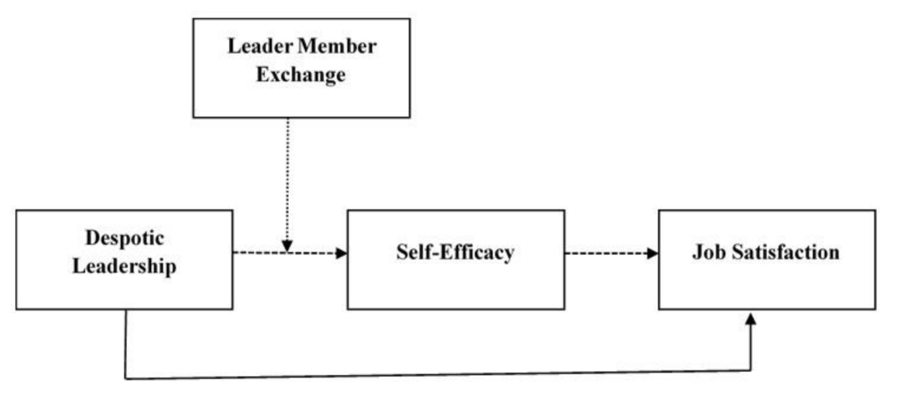
Figure 2: Social Exchange Theory
(Source: Zhou et al., 2021)
Further, in terms of hotel ventures, the theory also suggests that employees can show more engagement and commitment if they perceive that their contributions are valued and reciprocated (Jahan and Kim, 2020). Therefore, the hotel domain of the UK must foster employee satisfaction by providing them with recognition, opportunities for growth and supportive feedback, in an effort to acquire customer loyalty.

Literature Gap
The major gap of the chosen literature can be determined in terms of its failure to focus on the context of employee satisfaction and customer engagement from a hotel domain. Besides, the literature has lacked the efficacy to offer organised and comprehensive information concerning the analysis of the context. Therefore, the gap in the literature has been accumulated in the context of offering credible and organised information.

Methods

Research Onion
The methodologies are going to cultivate the analysis of the impact of employee satisfaction on negative customer experiences. The use of Saunder’s research onion helps in offering effective information about the process followed for the research study.
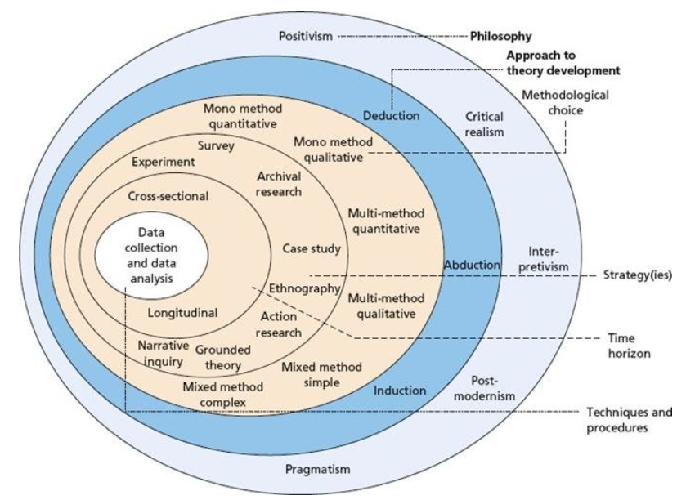
Figure 3: Saunder’s Research Onion
(Source: Saunders et al., 2012)

Research Philosophy
The research philosophy or paradigm refers to the demonstration of the broad overarching framework which has an integrated set of assumptions and scientific processes for continuing the research work (Cottrell, 2014). Furthermore, it helps in analysing constructive information while gathering data for the research support.

Research Approaches
The case study methodologies were included in the research report while investigating the necessity of employee satisfaction for avoiding the rising negative customer satisfaction approaches for the age group 18 to 35. The case study methodologies are part of a research approach that aligns with real-world phenomena while using multiple data sources to gain a comprehensive understanding (Farquhar et al., 2020). Focusing on the limitation of this specific method, as it inherits difficulties in generalising findings from one case study towards the other settings. The reflective writing techniques are been utilised in the research work which supports effective case study methodology. For continuing with the case study methodologies, the inclusion of nethnography method which helps in cultivating large sets of data. Netnography is considered an important aspect of the elaboration of the research work on the case study research method as it helps in formulating effective practices through engaging the particular process (Kopaničová et al., 2022).

Data Collection
The research is going to include a secondary data collection method, which helps in the collection of different reports on the IBIS hotel from the annual reports and case studies of the organisation. Integration of the secondary data collection technique helps in adopting resources from articles, journals, and authentic webpages (Urcia, 2021).

Reflective Writing
The methodologies have been optimised with reflective writing properties as it is essential for enhancing the learning power which can offer a crystallised learning process and present an efficient mindset that helps in arranging different aspects connected with the research topic. Reflective journal writing includes the essence of flexible activities which enable the researcher to choose the appropriate topic, test new ideas and comment on descriptive feelings while working on the research work (Baresh, 2022).

Case study

Background of IBIS Hotel
IBIS Hotel is a French-based hotel subsidiary chain which was founded in the year 1974 with official headquarters in Evry, France. In the initial years, the hotel chain widely operated in over 1,200 locations in 67 countries, including the United States and the United Kingdom, The other significant locations of the hotel business comprise Europe, Asia Pacific and the Middle East (IBIS, 2024). Being a part of Accor Hotel, the hotel chain aims to maintain a consistent and quality experience with the incorporation of modern design and functionality. The hotel is known for offering budget hotels across the globe, in addition to services such as suit rooms, restaurants, tour desks and others (Accor, 2024). In general, IBIS Hotel caters requirements of a wide range of guests, from business travellers to families, in addition to leisure travellers, thereby offering them pleasant and comfortable stays at an affordable price.
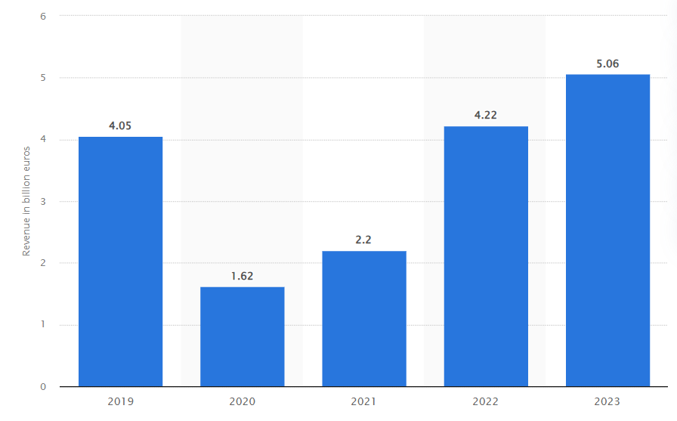
Figure 4: Revenue growth of IBIS Hotel
(Source: Statista, 2024)
The above provided statistical representation infers the growth in global revenue of the IBIS hotel chain in the fiscal year of 2024. In comparison to past trends, the hotel company has witnessed dramatic growth in its revenue by €5.06 billion, in comparison to the 2022 record which was €4.22 billion (Statista, 2024). For the hotel venture, this elaborates on the efficacy that the business has sustained in terms of gaining customer engagement. The rise in this aspect is further imperative for IBIS Hotel to seek significant growth and development in future instances.

SWOT analysis
Strength | Weaknesses
- The hotel chain operates in a wider location of the global domain  - Have a presence of more than 1,200 hotels in 67 countries  - Established economical hotel brand, affordable rate and focuses on consistent quality  - AccorHotels provides resources and expertise (Accor, 2024) | - IBIS primarily depends on the economic segment of the region  - Vulnerable to the impact of parent company performance  - IBIS faces stiff and threatening competition (Similiarweb, 2022)  - Challenges in gaining active participation of employees
Opportunities | Threats
- Growing demands for a budget hotel  - Market expansion opportunities  - Eco-friendly practices to attract environmentally conscious travellers (IBIS, 2024)  - Able to formulate strategic partners and strategic alliance | - Intense competition from major brands such as Premier Inn, Travelodge and others (Similiarweb, 2022)  - Reduction in travel services due to economic vulnerability  - The operation of IBIS is affected by strict laws and regulation  - Shifts towards alternative accommodations
Table 1: SWOT Analysis
(Source: Self-created)
Analysis
The major strength of IBIS Hotel can be determined in terms of its operating and functioning capability across 1,200 locations in 67 countries. Having a robust global presence, the hotel chain is able to maintain strong brand recognition, economical pricing, and standardised services in order to ensure a consistent quality experience for customers. Besides, the hotel venture also gains significant benefits from Accor Hotels. The parent company offers IBIS to utilise effective resources and expertise in terms of commencing services in a credible way.
Moreover, the strength of the company has been feeble in fostering long-term opportunities, particularly in seeking growth in the emerging market. In this aspect, IBIS witnesses’ opportunities in regard to the market expansion process. The precise association of Accor Hotels has enabled IBIS to seek meaningful partnerships and collaborations in terms of imperative service quality and competitiveness.
However, IBIS also demonstrates critical weaknesses, as the higher reliance on the hotel chain of the economy segment limits its growth and development. Besides, dependence on AccorHotels also tends to pose a vulnerable impact on the efficacy of the hotel company as the performance of the parent company significantly impacts its success, thereby posing additional challenges. Further, the IBIS also faces concerns of competition and employee turnover, which inculcates massive weakness in the maintenance of potential customer edge.
Besides, the threats of the hotel chain elaborate the presence of intense competition from popular brands such as Premier Inn, Travelodge and others. The intense threat of economic vulnerability has also posed concern in terms of reducing services operating to hospitality and travel. In addition, IBIS Hotel also faces intense threats due to the presence of strict laws and regulations in nations such as the UK. Apart from this, the potential threats of IBIS can be determined as a result of shifts towards alternate accommodations and services. Hence, this has resulted in lowering the brand quality and efficiency of IBIS hotels in terms of complying with new trends and patterns in the hotel sector.

PEST analysis
Factors | Description | Opportunity/Threat
Political | - The political stability index of the UK as of 2022 is 0.50, this infers the presence of low corruption and political vulnerabilities (The Global Economy, 2023)  - Brexit has widely impacted the labour market of the UK with the decline of around 330,000 labour force (Springford and Portes, 2023) | Threat
Economic | The inflation rate of the UK elaborates a rise of 3.1% as of August 2024 (GOV.UK, 2024)  Gross Domestic Product (GDP) of the UK has grown by 0.5% in 2024 (BBC, 2024) | Opportunity
Socio-cultural | - The overall population of the UK is 69,249,917 (Worldometers, 2024)  - The UK has a presence of multicultural society with the inclusion of cross border workforce  - The literacy rate of the UK depicts seek growth of 99% (UNA-UK, 2023) | Opportunity
Technological | - The UK retains 1st position in Europe in terms of gaining technological resilience  - It has the presence of fast-growing tech companies with the regulation of forward-thinking approach (Government of UK, 2022)  - Encouragement of artificial intelligence applications, quantum technologies and many more (Government of UK, 2023) | Opportunity
Table 2: PEST Analysis
(Source: Self-created)
Analysis
Based on the above evaluation it can be analysed that the political stability of the UK is free from corruption and political vulnerabilities. For hotel ventures such as IBIS, the political scenario of the UK demonstrates possibilities of feasible operation and functioning. However, the event of Brexit has widely affected the labour market of the UK and resulted in a maximum decline in the labour force. In this aspect, the political scenario of the UK offers massive threats to IBIS Hotel in terms of gaining employee engagement. Concerning hotels such as IBIS, the unfavourable environment can reduce occupancy rates and revenue, in addition to a decrease in customer satisfaction due to concerns about safety and security. This also includes a reduction in productivity and performance of IBIS, thereby deteriorating reputation and brand image.
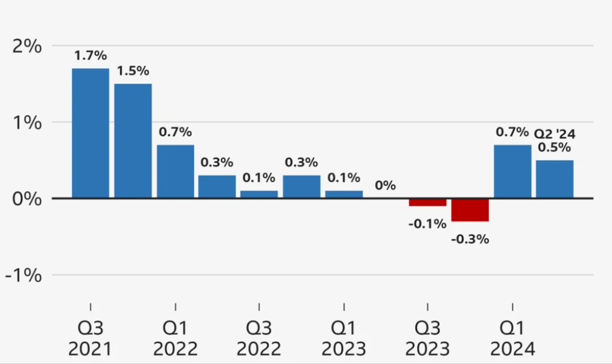
Figure 5: GDP growth of the UK
(Source: BBC, 2024)
The economic situation of the UK demonstrates a rise in the rate of inflation which can hinder the income-earning capability of individuals. From the perspective of IBIS Hotel, the growth in inflation rate trends is insignificant. The inflation growth of IBIS Hotel can significantly impact operations and profitability, resulting in higher staffing expenses due to increased labour costs. In this aspect, the company can witness significant challenges in meeting the satisfaction of employees in terms of offering them rewards and appraisals. This will in turn hinder the quality and efficacy of the firm to meet customer needs and interests pertaining to hotel services. Moreover, in terms of GDP, the nation demonstrates significant growth, which will eventually influence the growth outcomes of IBIS Hotel. The rise of GDP will not only bring feasibility in gaining spending capability but also the firm can focus on satisfaction of employees (Worldometers, 2024). IBIS Hotels can also drive increased demand for travel and hospitality services by enabling consumers to spend more on travel and leisure.
The sociocultural aspects of the UK tend to bring massive opportunities for IBIS in terms of gaining employee engagement. For the hotel venture, the rise in population growth and literacy rate will lead to massive engagement of skilled and potential workforce. However, this venture can also fulfil the needs and requirements of customers by gaining active participation and contribution of employees. Leveraging the growth of literacy rate and population, IBIS can inculcate new changes in its services (The Global Economy, 2023). This also demonstrates the hiring of a skilled workforce who can demonstrate credible contribution to the growth and success of the hotel enterprise. Moreover, the hotel entity can gain access to information that will enable it to foster travel awareness and fuel demand for hospitality services. This trend is particularly pronounced in emerging markets, where IBIS has a strong presence. Hence, IBIS can adopt a demographic shift in increasing occupancy rates and revenue, expanding market share, gaining brand recognition and loyalty and driving business growth and profitability.
Apart from this, in the technological aspect, IBIS acquires potential opportunities. This means since the UK demonstrates greater feasibility in gaining technological resilience, the hotel entity can leverage this to enhance the skills and competencies of employees. The rapid growth of technology significantly transforms IBIS Hotel operations and customer experience. For the venture, this will demonstrate enhancement in employee satisfaction as they will be able to gain opportunities to harness their skills and knowledge. In the wider sense, employees will utilise technological skills to meet and understand the requirements of customers, thereby fostering their experience and satisfaction (Government of UK, 2022). Moreover, the imperative use of technology can help IBIS to acquire a skilled and potential workforce who are able to contribute to the growth and productivity of the business. Therefore, the technological environment of the UK for IBIS Hotel pertains to bring ample opportunities concerning growth and success.

Competitor Analysis (Price vs Quality)
Competitor identification is essential in order to develop effective marketing strategies pertaining to the growth and development of businesses. Moreover, this is essential to illustrate the position of firms within the area of specialisation (Hatzijordanou et al., 2019). In this context, the potential competitors of IBIS Hotel include, Travelodge, Premier Inn, Key Hotels, Lemon Tree Hotel and others (Owler, 2024). In this context, there is a higher possibility for IBIS Hotel to witness competitive challenges and benefits in terms of gaining a credible market position within the hospitality domain.
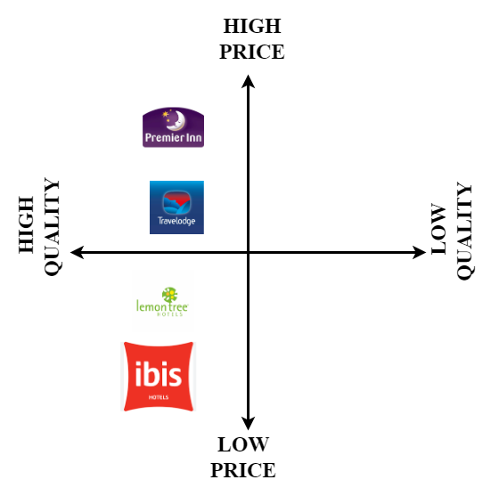
Figure 6: Competitor analysis
(Source: Self-Created)
From the above figure competitor analysis for IBIS Hotel can be determined in terms of quality and price. In this aspect, the major competitor of the hotel chain determines to be Lemon Tree Hotel in relevance to low price and quality. The hotel chain witnesses a significant competitive edge Lemon Tree Hotel in the segment of offering affordable and budget hotel services. Besides, in the case of IBIS Hotel, the company has pertained to major competition in the hospitality sector of the UK. Moreover, this elaborates on the competition position that hotel chains is able to maintain in terms of seeking feasible growth and development. On the other hand, IBIS Hotels faces competition from Premier Inn and Travelodge, in the economy to mid-scale hotel segment. In terms of pricing, IBIS is average, comparable to Travelodge. However, Premier Inn positions itself as a premium option posing a massive threat in the competencies of the IBIS Hotel chain (Globla Data, 2024). Therefore, the competitive strategy of IBIS Hotel demonstrates to focus on the enhancement of quality to match the requirements of customers. For the firm, this elaborates investment in staff training to boost guest satisfaction and experience. Therefore, for IBIS Hotel is essential to seek improvements in its services by inculcating new changes and developments, thereby seeking active participation of the workforce.

Theme Exploration

Customer Behaviour on the services of Ibis Hotel
According to the report presented by Ibis Group in last year’s company gadget the Ibis Hotel of Stratford London has shown a stupendous possession of brand profile in the UK-based hospitality market. It has depicted brand awareness in the region as rising to almost 79% which is undoubtedly a robust portrayal of the increasing popularity of the services offered by Ibis to its guests (statista.com, 2024). It has also made a clear display of the maintained level of popularity for luxury customers in the UK as an estimated 22% of the current market base. It has been seen as mostly a result of the retention of customer satisfaction in recent years.
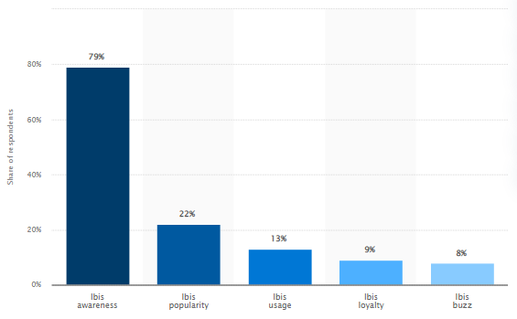
Figure 7: Ibis Hotel Brand Profile
(Source: statista.com, 2024)
This finding from the official report of Ibis Group has provided a deeper insight into the value of maintaining the satisfaction level of loyal customers or guests in a hotel. It also projects the influence of customer satisfaction on the basic contributions of positive customer behaviour in a hotel chain. For example, the implementation of taking feedback from customers on services can be observed as a pivotal strategic step to get a view of improvement criteria in service offerings (Susanto et al., 2022). This feedback also provides valuable insights into the changing preferences of customers while purchasing hospitality service packages or tourism packages from hotels.
On the other hand, the application of employee motivation and loyalty also impacts the circulation of positive customer behaviour in favour of a hotel or resort. In the case of Ibis, the circulation of its popularity in providing debonair services is just a fruit of its relentless striving towards making guests circulate the benefits of its services to others spontaneously. This has worked as a catalytic element in the paradigm of the promotion of services and products through word-of-mouth mode (Tran et al., 2020). This fact has been justified by the piece of evidence provided in the graph containing the figurative imposition of a 22% popularity index (fig 8) in the UK, even though there is a presence of heightened competition among hotel chains.
Apart from this, the detection of customer behaviour plays an essential part in management activities triggered to increase the organisational outputs of business organisations (Tuti and Sulistia, 2022). In this case, the utilisation of reviewing customer suggestions plays a great role in the detection of upcoming trends. For example, in 2022, the post-pandemic period made the hotel company change its CSR to include thorough checking of the biological history of guests as well as employees such as the vaccination certificates and measurement of body temperature while entering the hotel compound in London (Ishraq and Zakaria, 2023).

Influences on Customer Services by Ibis Hotel
The chosen hotel chain, Ibis Group can be seen as making steady progress in the UK in expanding its customer base. The annual report of the company in the 2023 fiscal year has projected that the company has gained almost 2.67 billion GBP as its revenue from sole collection in the UK’s hospitality market (ibisworld.com, 2024). The same report has also shown how the company’s profitability got massively dented sharply in 2020 and 21 due to the prevailing COVID-19 pandemic and that dent has been estimated as amounting to almost 1.6 billion less than the revenue collected in 2023. The projection has provided a fluctuating change scenario in its services from 2011 to 2023 which is a depiction of some remaining improvement areas in its services.
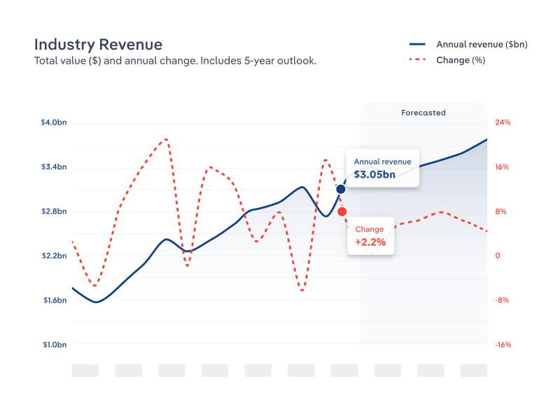
Figure 8: Ibis Hotel Revenue Growth
(Source: ibisworld.com, 2024)
The depiction of this figure is essential in the projection of the popularity of its customer services. The company has been seen as providing a personalised experience in its online booking site and that also provides next-gen end-to-end encryption for local and foreign guests’ booking information (ibisword.com, 2024). It is a projection of the better implementation of automated customer guidance which reduces the formation or the occurrences of human errors by employees in booking suites or packages. However, it has shown a decline of 2.6% in the employability of the brand. Therefore, it is a formative attribute of the service provisions in pre-purchase parameters through digital assistance. Its viability is only usable for online purchasers of its services.
However, Ibis’s media report states that the company has a robust attribution of personalisation suites that are also delivered within a short span of work time after the order is placed (ibisworld.com, 2024). It is also a process of maintaining the satisfaction level of customers. The rationale behind this consideration by the company is rooted in its mission statement which says that it is committed to providing the most affordable debonair dining for guests. Personalisation of suites provides a luxury touch in mid-budget packages and that has contributed to the soaring customer popularity of the Ibis’s service lines.
Apart from this, the application of Ibis’s flexible online checking services for accommodations has also met with a provision for the projection of vacant suites in each category. This depiction is provided to online bookers when they are opening their booking portal through mobiles or other IoT devices. This type of pre-purchase suggestion for services is generally used by employees to implore customers to get a look into the affordable yet useful services as special facilities being provided to them by a business organisation (Ali et al., 2021). As a result, it influences the behavioural pattern of a general customer to get interested in experiencing those suggested services. In this criteria, post-purchase services provide the required loyalty from the end customers. Assistance even after the conclusion of services and seeking suggestive feedback makes customers believe that they are valued by the company (Bi et al., 2020). Their active incorporation helps that company to increase its profitability.

Issues Detected in the Services of Ibis Hotel in London
The selected hotel brand has been seen as facing probably the toughest competition in the UK-based hospitality market due to the strong presence of business rivals. According to a relevant survey report, Ibis has been positioned as 13th in the competition index based on the responses taken from local customers in the UK (statista.com, 2024). Premier Inn has been projected as having the highest approval rate from customers as estimated amounting to almost 78%. Its strongest rivals have been projected as Marriott, Hilton Group, Premier Inn and Holiday Inn in the UK. All of these hotel groups have a robust existence in London which is making the competition very difficult to tackle by Ibis Group.
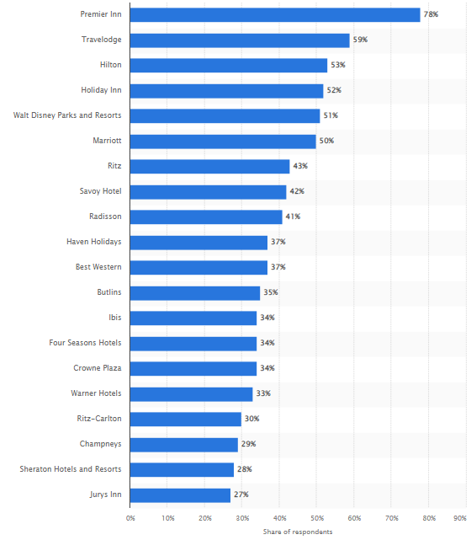
Figure 9: Most Popular Hotels in the UK for 2024 Q2
(Source: statista.com, 2024)
The reason behind this challenging competition is mainly established on the already existing popularity of the business rivals in the current market base of the UK. It is a depiction of the marketing scenario of London in the hospitality industry that is showing a close inclination towards market saturation. Market saturation is always detrimental to the products’ purchasable of new companies in a market and that is evident in the hospitality market in the UK (Dastane, 2020). In this context, the utilisation of practical attributes has also been seen as promoting services using innovative ways and it effectively impacts the visibility of a brand.
As per the official report of Ibis Group, the company is still focused on promoting its services through Well-circulated TV channels in the UK’s urban centres and some esteemed news dailies such as the London Times (Ibisworld.com, 2024). Print media has a very limited viewer base as the broadcasting of news is generally seen as live in news channels available for TVs. Thus, it is evident that the printed advertisements of the services offered by Ibis Hotels get visibility to only the news readers of London and other parts. A sheer ignorance to frequently post promotional content on its pages on social platforms is denting the opportunity for its visibility. Poor or backdated CSR initiatives also affect the volatility of employee engagement and that reflects in promotional attributes.
Another challenge that is being faced by Ibis and some other hotel groups in the UK is seen in the increased price rise of their services. The Brexit protocols have issued extended tariffs for materials being collected from foreign suppliers (Breinlich et al., 2022). As a result, the increased cost of acquiring these raw materials is making it impossible for hotels to maintain stable pricing for their services and products. On the other hand, changing purchase intentions in customers are also affecting the popularity level of Ibis as many customers like modified suiting facilities rather than the traditional ones. This change in customer satisfaction is moving towards better technological assistance and that is why it is challenging for hospitality providers (Dash et al., 2021). Its mitigation is rooted in the implementation of AI integration in customer services.

Effective Ways to Curb Problematic Issues and Improving Services
The press release of Ibis Group has mentioned the risk score of its UK-based hotels as having an average of 5.9 in the risk index currently (ibisworld.com, 2024). It means that its London-based hotel has a moderate risk level in the competitive scenario in the UK-based market of hospitality services and recreation. It is showing a greater level of anomalies in the maintainability of quality of services, especially in the criteria of accommodation for guests. This is one of the most critical causes that is resulting in the declining satisfaction level of its employees despite having a strong brand profile.
To mitigate this issue, the brand should focus more on the utilisation of modern safety modules in the providence of suits as accommodation elements for local and international guests as well as its employees. The rationale behind this suggestion is deeply rooted in the context of making an improved safety incorporation in suits (Anichiti et al., 2021). For example, the offering of secondary drawers to keep personal things during a stay should meet with a technological code-locking system in all rooms. It can be helpful in meeting the security arrangements based on the use of modern technical support for improved privacy by employees. It can improve the satisfaction level of its guests by providing a required level of personal protection. Employees should be trained in meeting these safety protocols.
At the same time, the pricing policy for the service lines and products of Ibis should be checked and revised to meet the affordability criterion present in the hospitality market of the UK. The increased pricing for a service without improving the quality of that is particularly a negative attraction for customers as most customers are focused on getting justified quality while paying a lumpsum amount of money per purchase (Ivanov et al., 2020). A modification of the pricing index for each dining and accommodation service of the hotel may be an effective step to implore more customers to purchase its suits and holiday packages. In this case, issuing festive discounts in the pricing of services can also be an effective step towards the mending of this challenge.
The next issue can be seen as being connected to the utilisation of the local supply chain and prioritising it over the foreign supplier chain (de Bastos, 2023). The rationale behind this consideration is seen as resting in the scope of acquiring affordable raw materials for its food items and other dining services. As a result of this, the pricing of commodities will be checked and this retention of pricing can prove to be effective in managing the satisfaction level of its guests. In this way, the proposed suggestion can curb the challenge faced by Ibis in gaining the desired profitability in the UK.
The implementation of AI integration in customer services provides employees a higher level of accuracy in managing a massive customer base. It basically helps in responding to the queries and grievances as posted by customers. Ibis should look into this suggestion to improve its customer service line. Social platforms have perhaps the largest viewer base which can be applied to promote and circulate the advertisements of services (Infante and Mardikaningsih, 2022). Thus, it is an effective way to promote Ibis’s special hospitality services to a larger mass.

Conclusion and Recommendations

Conclusion
The research report is entitled Analysing the Impact of Employee Satisfaction Level Towards the negative aspects on customer experiences for consumers 18-35 Years. The research has illustrated over IBIS hotel in the Stratford-London location, which has been analysed as a poor working environment, job security issues and improper management approaches lead to increased dissatisfaction levels among the employees. The IBIS hotel has achieved a number of negative feedback which has been provided by the consumers which has optimised due to the not motivated workforce while making mistakes in providing services (Sannindra et al., 2022). The research has also been authorised with effective theoretical framework representation where the research has used the social exchange theory and Herzberg motivational theory in order to motivate the employee for better performances. The research also defines SWOT and PESTLE analysis for understanding the internal and external factors within the company. The research also focuses on the inclusion of the case study analysis which helps in the cultivation of the different information accessed in IBIS hotels which requires for understanding of the internal working culture included which makes the hotel more affordable and budget friendly.

Limitations
The research paper has failed to authorise the primary qualitative and quantitative data collection methods which are essential for gathering in-depth knowledge about the rising employee dissatisfaction within the workplace. The primary data collection presents authentic sources through the application of surveys, experiments, interviews and questionnaires (Taherdoost, 2021). The paper also fails to provide an efficient statistical representation of the internal gap which has been evaluated from the poor working environment, improper management and rising job security.

Recommendations
- In order to reduce the poor working environment in the company, it is essential for the management to introduce a recognition and reward programme which motivates the employees. Intrinsic rewards directly influence the motivation levels of the employees, the evaluation of the employee motivation measures better performance throughout the years which helps in improving the satisfaction levels (Manzoor et al., 2021).
- Embracing technological support measures is one of the main activities in order to improve the working environment. The role of incorporation of new innovative technologies helps in improving competitiveness and efficiency towards the working performances (Na et al., 2022). The UK has been considered as one of the worst work-life balance optimised by companies (statista.com, 2022). It directs that lack of working support increases the concern of rising poor working environment. Hence, the company necessary to employ the support of different innovative technologies which include AI, BigData and many more help support the employees and establish better work performances among the staff.
- An increase in job security among the employees of IBIS hotels increases dissatisfaction towards work. Hence, it is essential for the management to support the employees by providing effective learning and training activities which help in upskilling. The training programme indicates learning new skills from online resources, creation of interactive exercises, online tests and many more (Morandini et al., 2023). The necessity of upskilling the employees helps in achieving personal and professional growth and can able to concentrate towards work while providing efficient performances on providing services to the consumers.

Reflective Account
Description:
During my placement, I have learnt that the motivational criteria for employees in business organisations are also influenced by the level of satisfaction provided to employees. An increased level of physical and financial safety is one of the most effective influential factors that provide boosts to the working spirit of employees (Franzoni et al., 2021). In Ibis Hotel, a certain lack of modern safety protocols for bottom-line workers has made a dent in the retention of skills and talents in the hotel. In the same context, it has been seen that a stagnant salary provision is also detrimental to employee motivation as it does not meet the requirement criterion of living in a society which is facing inflation issues.
Feelings:
I have felt that customer satisfaction level and employee satisfaction level have a parallel relationship in the context of hospitality services. The rationale behind this statement can be seen as deeply rooted in the context of the working spirit of employees which is boosted by the facilities being provided to them by their organisations (Kim, 2020). An increase in the level of motivation by providing financial benefits to employees can make a company improve the working spirit of its employee base to contribute to the productivity of the business. Thus, I have understood that rewards and motivation can motivate employees, which is necessary for fulfilling customer demands. Gathering insights on customer experience development through practical experiences has influenced my feelings of satisfaction with the placement.
Analysis:
The placement has provided me ample scope to analyse the causes behind the company’s poor competitive position in the hospitality market base in the UK. It has been projected that the utilisation of the maintainable aspects of employability in Ibis has shown a decline in employee retention. In this context, it can be seen that the growing competition in the market base of the UK is turning towards a saturation point of hospitality businesses and due to this, the application of the most abstract conceptualisation of competition management should meet with employees’ effective dealing with local suppliers of raw materials (Akbari et al., 2021).
On the contrary, a revised pricing policy is also applicable in the mitigation of price rise issues in services. The descriptions made in the report have shown how Brexit protocols are affecting the pricing of hospitality services and products being offered by most hotel chains in the UK (Gamble, 2021). Ibis has been projected as one of the victims of this challenging situation in the marketing procedure. As per the utilisation of this notorious financial reform in the UK, the prices of most articles are increasing due to its imposition of extended tariffs on internationally acquired items. Thus, there is a need to revise the pricing policy to satisfy customers and increase the scope of profitability. Moreover, the application of AI integration is also relevant in customer services as it can help in reducing human errors (De Andrade and Tumelero, 2022). It can also provide a certain amount of professional boost to the accuracy level of employees who are dealing with customers or guests. Thus, this consideration has also been implied in the case of Ibis.
Evaluation:
I have experienced that my communication skills need a few improvements to cope with the rising demands of direct customer dealing at the placement hotel. Communication skills provide a level of scope to increase the effectiveness of the communication channel through which information can be shared among team members (Jawabreh et al., 2022). In hotels, verbal communication gets the first priority as it needs direct conversations with guests during the service provisioning executions for them (Ratasuk, 2020). An increase in these skills can provide s greater level of collaborative influence in solving a customer issue or demand without facing certain difficulties and this is the cause why it needs good teamwork effort.
Apart from this paradigm, I have also noticed an improvement scope in my research skills. Research skills basically help in detecting problematic issues in a work process. This is the reason why it is also incorporated with the possession of analytical skills. In the hospitality business, most issues are faced in the retention of quality in food items or accommodation providences (Tushar and Sooraksa, 2023). Thus, an active research ability can provide an opportunity to analyse the situational needs in the hospitality sector as presented by customer feedback and comments. In this way, it can help in refining the decision-making ability to handle changing preferences in customer bases.
Moreover, there is also a need to improve my ICT skills and knowledge in handling cases of technological analytics for responding to customer service operations. ICT skills provide a greater level of proficiency in handling software relevant to a particular business (Lee and Song, 2022). In Ibis Hotel, the recommended implementation of AI integration in the customer service criterion can enable the efforts to respond to customer queries and grievances, however, the review of analytical reports being generated by the assistive data solutions is generally done manually. ICT Knowledge can improve the utilisation of these analytical reports.
Conclusion:
It can be concluded from this reflection that there are requirements for improvements in ICT skills, communication skills and research skills. An action plan has also been provided below to incorporate the steps and time to be taken to improve these abilities. Their relevance in business operations has also been projected.
Action Plan:
Specific | Measurable | Accessible | Relevant | Timebound
Communication skills | It can be measured by its use in communicating with customers and employees | Study materials should be perused | It is important to project the usefulness of information-sharing practices | 6 months
Research Skills | It can be measured | Study materials should be perused | Its relevance is rooted in detecting problematic issues | 1 year
ICT Skills | It is measured by its management in handling dynamic analytics | Specific courses should be attended | Its relevance is seen in its utilisation in improving the accuracy of analytics (Falck et al., 2021) | 6 months
Table 3: Action Plan
(Source: Self-developed)

References
Accor 2024. Ibis Hotels - Brand New Ibis, Brand New Comfort | Accor |. [online] all.accor.com. Available at: https://www.accorhotels.com/en/brands/hotels-ibis.shtml [Accessed 9 Oct. 2024].
Ahmad, M., Khan, A. and Arshad, M.Z. 2021. Major theories of Job Satisfaction and their use in the field of Librarianship. [online] ResearchGate. Available at: https://www.researchgate.net/publication/356148118_Major_theories_of_Job_Satisfaction_and_their_use_in_the_field_of_Librarianship [Accessed 9 Oct. 2024].
Ahmad, R., Nawaz, M.R., Ishaq, M.I., Khan, M.M. and Ashraf, H.A. 2023. Social exchange theory: Systematic review and future directions. Frontiers in Psychology, [online] 13(2), pp.1–13. doi:https://doi.org/10.3389/fpsyg.2022.1015921.
Akbari, M., Nazarian, A., Foroudi, P., Seyyed Amiri, N. and Ezatabadipoor, E., 2021. How corporate social responsibility contributes to strengthening brand loyalty, hotel positioning and intention to revisit?. Current Issues in Tourism, 24(13), pp.1897-1917.
Al Kurdi, B., Alshurideh, M. and Alnaser, A. 2020. The impact of employee satisfaction on customer satisfaction: Theoretical and empirical underpinning. Management Science Letters, 10(15), pp.3561–3570.
Ali, B.J., Gardi, B., Othman, B.J., Ahmed, S.A., Ismael, N.B., Hamza, P.A., Aziz, H.M., Sabir, B.Y., Sorguli, S. and Anwar, G., 2021. Hotel service quality: The impact of service quality on customer satisfaction in hospitality. International Journal of Engineering, Business and Management, 5(3), pp.14-28.
Alrawahi, S., Sellgren, S.F., Altouby, S., Alwahaibi, N. and Brommels, M. 2020. The Application of Herzberg’s two-factor Theory of Motivation to Job Satisfaction in Clinical Laboratories in Omani Hospitals. Heliyon, [online] 6(9). doi:https://doi.org/10.1016/j.heliyon.2020.e04829.
Andrade, M.S., Miller, D. and Westover, J.H. 2020. Job satisfaction factors for housekeepers in the hotel industry: a global comparative analysis. International Hospitality Review, ahead-of-print(ahead-of-print). doi:https://doi.org/10.1108/ihr-06-2020-0018.
Anichiti, A., Dragolea, L.L., Tacu Hârșan, G.D., Haller, A.P. and Butnaru, G.I., 2021. Aspects regarding safety and security in hotels: Romanian experience. Information, 12(1), p.44.
Ataliç, H., Can, A. and Cantürk, N. 2019. Herzberg’s Motivation- Hygiene Theory Applied to High School Teachers in Turkey. European Journal of Multidisciplinary Studies, 1(4), p.90. doi:https://doi.org/10.26417/ejms.v1i4.p90-97.
Bahadur, W., Aziz, S. and Zulfiqar, S. 2019. Effect of employee empathy on customer satisfaction and loyalty during employee–customer interactions: The mediating role of customer affective commitment and perceived service quality. Cogent Business & Management, [online] 5(1). doi:https://doi.org/10.1080/23311975.2018.1491780.
Baresh, E.F., 2022. DEVELOPING LIBYAN UNDERGRADUATES’WRITING SKILLS THROUGH REFLECTIVE JOURNALING: A CRITICAL LITERATURE REVIEW. Journal of English Language Teaching and Learning, 3(1), pp.27-35.
BBC 2024. What Is GDP and Why Does It matter? BBC News. [online] 14 Jul. Available at: https://www.bbc.com/news/business-13200758.
Bi, J.W., Liu, Y., Fan, Z.P. and Zhang, J., 2020. Exploring asymmetric effects of attribute performance on customer satisfaction in the hotel industry. Tourism Management, 77, p.104006.
Breinlich, H., Leromain, E., Novy, D. and Sampson, T., 2022. The Brexit vote, inflation and UK living standards. International Economic Review, 63(1), pp.63-93.
Charni, H., Brun, I. and Ricard, L. 2019. Impact of employee job satisfaction and commitment on customer perceived value. International Journal of Bank Marketing, 38(3), pp.737–755. doi:https://doi.org/10.1108/ijbm-03-2019-0097.
Coelho, É.A. and Bartolomeu, T.A. 2019. Determinants of satisfaction and turnover of staff in hotel enterprises. Gestão & Produção, 26(3). doi:https://doi.org/10.1590/0104-530x3242-19.
Cottrell, S. 2014, Dissertation and Project Reports - A step by Step Guide, Palgrave Macmillan: Basingstoke.
Dash, G., Kiefer, K. and Paul, J., 2021. Marketing-to-Millennials: Marketing 4.0, customer satisfaction and purchase intention. Journal of business research, 122, pp.608-620.
Dastane, D.O., 2020. Impact of digital marketing on online purchase intention: Mediation effect of customer relationship management. Journal of Asian Business Strategy, DOI, 10, pp.142-158.
De Andrade, I.M. and Tumelero, C., 2022. Increasing customer service efficiency through artificial intelligence chatbot. Revista de Gestão, 29(3), pp.238-251.
de Bastos, B.P., 2023. Contribution of hotels’ revenue management for supply chain sustainability. Journal of revenue and pricing management, 22(4), pp.294-305.
Do, D.K.X., Rahman, K. and Robinson, L.J., 2020. Determinants of negative customer engagement behaviours. Journal of Services Marketing, 34(2), pp.117-135.
Falck, O., Heimisch-Roecker, A. and Wiederhold, S., 2021. Returns to ICT skills. Research policy, 50(7), p.104064.
Farquhar, J., Michels, N. and Robson, J., 2020. Triangulation in industrial qualitative case study research: Widening the scope. Industrial Marketing Management, 87, pp.160-170.
Franzoni, S., Sarwar, H. and Ishaq, M.I., 2021. The Mediating Role of HRM in the Relationship between CSR and Performance in the Hospitality Industry. Sustainability, 13(24), p.13699.
Gamble, A., 2021. Taking back control: the political implications of Brexit. In The Politics and Economics of Brexit (pp. 127-144). Routledge.
Globla Data 2024. ShieldSquare Captcha. [online] www.globaldata.com. Available at: https://www.globaldata.com/company-profile/accorhotels/competitors/.
GOV.UK 2024. Inflation and Price Indices - Office for National Statistics. [online] ons.gov.uk. Available at: https://www.ons.gov.uk/economy/inflationandpriceindices.
Government of UK 2022. UK tech sector retains #1 spot in Europe and #3 in world as sector resilience brings continued growth. [online] GOV.UK. Available at: https://www.gov.uk/government/news/uk-tech-sector-retains-1-spot-in-europe-and-3-in-world-as-sector-resilience-brings-continued-growth.
Government of UK 2023. Technology - great.gov.uk international. [online] www.great.gov.uk. Available at: https://www.great.gov.uk/international/content/investment/sectors/technology/.
group.accor.com, 2024. Integrated report 2023. Available at: https://group.accor.com/-/media/Corporate/Investors/Documents-de-reference/ACCOR_RI_2023_MEL_UK.pdf (Accessed: 09 October 2024).
Hatzijordanou, N., Bohn, N. and Terzidis, O. 2019. A Systematic Literature Review on Competitor analysis: Status Quo and start-up Specifics. Management Review Quarterly, [online] 69(4). doi:https://doi.org/10.1007/s11301-019-00158-5.
Heimerl, P., Haid, M., Benedikt, L. and Scholl-Grissemann, U. 2020. Factors Influencing Job Satisfaction in Hospitality Industry. SAGE Open, [online] 10(4), p.215824402098299. doi:https://doi.org/10.1177/2158244020982998.
IBIS 2024. IBIS. [online] Accor.com. Available at: https://ibis.accor.com/select-country.html [Accessed 9 Oct. 2024].
ibisworld.com., 2024. “client-success-stories” Available at: https://www.ibisworld.com/client-success-stories/ [Accessed on: 9 Oct 2024]
ibisworld.com., 2024. “company-benchmarking” Available at: https://www.ibisworld.com/products/company-benchmarking/#accounting [Accessed on: 9 Oct 2024]
ibisworld.com., 2024. “press-release” Available at: https://www.ibisworld.com/blog/press-releases/ [Accessed on: 9 Oct 2024]
ibisworld.com., 2024. “products” Available at: https://www.ibisworld.com/products/ [Accessed on: 9 Oct 2024]
ibisworld.com., 2024. “retail-market-sector” Available at: https://www.ibisworld.com/retail-market-sector/ [Accessed on: 9 Oct 2024]
Infante, A. and Mardikaningsih, R., 2022. The Potential of social media as a Means of Online Business Promotion. Journal of Social Science Studies (JOS3), 2(2), pp.45-49.
Ishraq, S. and Zakaria, A.K.M., 2023. IBIS Hotel's Cultural Pragmatics, Marketing Strategies and Critical Discourse Analysis.
Ivanov, S., Seyitoğlu, F. and Markova, M., 2020. Hotel managers’ perceptions towards the use of robots: a mixed-methods approach. Information Technology & Tourism, 22(4), pp.505-535.
Jahan, N. and Kim, S.W. 2020. Understanding online community participation behavior and perceived benefits: a social exchange theory perspective. PSU Research Review, [online] ahead-of-print(ahead-of-print). doi:https://doi.org/10.1108/prr-12-2019-0036.
Jawabreh, O., Al Fayoumi, T. and Bareya, A., 2022. Customer satisfaction towards communication skills of front office staff at the hotel (case study five stars Hotels in Aqaba). Geo Journal of Tourism and Geosites, 44(4), pp.1312-1318.
Jeon, H. and Choi, B. 2019. The relationship between employee satisfaction and customer satisfaction. Journal of Services Marketing, [online] 26(5), pp.332–341. doi:https://doi.org/10.1108/08876041211245236.
Kassim, M. 2019. FACTORS AFFECTING EMPLOYEE JOB SATISFACTION IN THE HOSPITALITY INDUSTRY IN KENYA: A CASE STUDY OF BOMA HOTELS, KENYA A RESEARCH PROJECT SUBMITTED TO THE SCHOOL OF MANAGEMENT AND LEADERSHIP IN PARTIAL FULFILLMENT OF THE REQUIREMENT FOR THE AWARD OF THE DEGREE OF BACHELOR OF MANAGEMENT AND LEADERSHIP OF THE. [online] Available at: https://core.ac.uk/download/pdf/157498272.pdf.
Kim, Y.R., 2020. The impact of spatial clustering on the labour productivity of the UK tourism and hospitality industry (Doctoral dissertation, University of Surrey).
Kopaničová, J., Klepochová, D. and Francová, Z., 2022. USE OF NETNOGRAPHY IN CONTEMPORARY MARKETING RESEARCH. Central European Business Review, 11(4).
Lee, J.W. and Song, E., 2022. Can older workers stay productive? The role of ICT skills and training. Journal of Asian Economics, 79, p.101438.
Lee, W.R., Choi, S.B. and Kang, S.W., 2021. How leaders’ positive feedback influences employees’ innovative behavior: The mediating role of voice behavior and job autonomy. Sustainability, 13(4), p.1901.
Manzoor, F., Wei, L. and Asif, M., 2021. Intrinsic rewards and employee's performance with the mediating mechanism of employee's motivation. Frontiers in psychology, 12, p.563070.
Morandini, S., Fraboni, F., De Angelis, M., Puzzo, G., Giusino, D. and Pietrantoni, L., 2023. The impact of artificial intelligence on workers’ skills: Upskilling and reskilling in organisations. Informing Science, 26, pp.39-68.
Na, S., Heo, S., Han, S., Shin, Y. and Roh, Y., 2022. Acceptance model of artificial intelligence (AI)-based technologies in construction firms: Applying the Technology Acceptance Model (TAM) in combination with the Technology–Organisation–Environment (TOE) framework. Buildings, 12(2), p.90.
Owler 2024. IBIS Top Competitors or Alternatives. [online] Owler Competitors. Available at: https://www.owler.com/company/ibis/competitors [Accessed 9 Oct. 2024].
Ratasuk, A., 2020. Contribution of cultural intelligence to job performance of domestic hotel employees in Thailand: The mediating roles of communication effectiveness and job stress. Thammasat Review, 23(2), pp.170-191.
Sannindra, A.E., Tarigan, E. and Nugraha, R.N., 2022. Analysis of Service Quality To Customer Satisfaction At Ibis Senen Hotel Jakarta. Jurnal Manajemen Pelayanan Hotel, 6(2), pp.358-367.
Saunders, M., Lewis, P. and Thornhill, A. (2012) Research Methodsfor Business Students, FT/Prentice Hall: Harlow
Similiarweb 2022. Similarweb. [online] Similarweb. Available at: https://www.similarweb.com/website/ibis.accor.com/competitors/ [Accessed 9 Oct. 2024].
Springford, J. and Portes, J. 2023. The impact of Brexit on the UK labour market: an early assessment. [online] UK in a changing Europe. Available at: https://ukandeu.ac.uk/the-impact-of-brexit-on-the-uk-labour-market-an-early-assessment/.
Statista 2024. Accor Group: revenue 2005-2018 | Statista. [online] Statista. Available at: https://www.statista.com/statistics/266261/revenue-of-the-accor-group/.
statista.com, 2022. Infographic: Countries with the worst work-life balance (2022) Statista Daily Data. Available at: https://www.statista.com/chart/12997/countries-with-the-worst-work-life-balance/ (Accessed: 09 October 2024).
statista.com., 2024. “Ibis-hotels-brand-profile-in-the-uk” Available at: https://www.statista.com/forecasts/1335566/ibis-hotels-brand-profile-in-the-uk#:~:text=In%20total%2C%2022%25%20of%20UK,of%20people%20like%20the%20brand. [Accessed on: 9 Oct 2024]
statista.com., 2024. “most-popular-hotel-brands-uk” Available at: https://www.statista.com/statistics/951262/most-popular-hotel-brands-uk/ [Accessed on: 9 Oct 2024]
Susanto, S.E., Toto, H.D., Krisnanto, B., Singkeruang, A.W.T.F. and Ramlah, R., 2022. The Influence of Brand Loyalty and Brand Image on Customer Satisfaction. Point of View Research Management, 3(1), pp.70-80.
Taherdoost, H., 2021. Data collection methods and tools for research; a step-by-step guide to choose data collection technique for academic and business research projects. International Journal of Academic Research in Management (IJARM), 10(1), pp.10-38.
The Global Economy 2023. United Kingdom Political stability - data, chart | TheGlobalEconomy.com. [online] TheGlobalEconomy.com. Available at: https://www.theglobaleconomy.com/United-Kingdom/wb_political_stability/.
Tran, V.D., Vo, T.N.L. and Dinh, T.Q., 2020. The relationship between brand authenticity, brand equity and customer satisfaction. The Journal of Asian Finance, Economics and Business, 7(4), pp.213-221.
Tushar, H. and Sooraksa, N., 2023. Global employability skills in the 21st century workplace: A semi-systematic literature review. Heliyon.
Tuti, M. and Sulistia, V., 2022. The customer engagement effect on customer satisfaction and brand trust and its impact on brand loyalty. Jurnal Manajemen Bisnis, 13(1), pp.1-15.
UNA-UK 2023. International Literacy Day - Factsheet. [online] United Nations Association. Available at: https://una.org.uk/international-literacy-day-factsheet.
Urcia, I.A., 2021. Comparisons of adaptations in grounded theory and phenomenology: Selecting the specific qualitative research methodology. International journal of qualitative methods, 20, p.16094069211045474.
Worldometers (2024). U.K. Population 2023 - Worldometer. [online] www.worldometers.info. Available at: https://www.worldometers.info/world-population/uk-population/#google_vignette.
Yang, J.-T. (020. Antecedents and consequences of job satisfaction in the hotel industry. International Journal of Hospitality Management, 29(4), pp.609–619. doi:https://doi.org/10.1016/j.ijhm.2009.11.002.
Zhou, X., Rasool, S.F., Yang, J. and Asghar, M.Z. 2021. Exploring the Relationship between Despotic Leadership and Job Satisfaction: The Role of Self Efficacy and Leader–Member Exchange. International Journal of Environmental Research and Public Health, 18(10), p.5307. doi:https://doi.org/10.3390/ijerph18105307.

