Approaches to Research and Academic Communication
Module Code: SBPD7001
Module Leader: Dr Isaiah Oino
Submitted By: Himanish Kar Purkayastha
Student Number: 1204728



(Section one)
Part -1
A Critical Literature review
Historical review of social media marketing and future prediction
Word count – 4203

(Section Two)
Part -2
Detailed Discussion of a Research Studies
Felix, R., Rauschnabel, P.A. and Hinsch, C., 2017. Elements of strategic social media marketing: A holistic framework. Journal of Business Research, 70, pp.118-126.
Word count – 1719

(Chapter one)
Part -1
A Critical Literature review
Historical review of social media marketing and future prediction

Table of Contents

Introduction: 1
Literature Review: 1
History and Evolution of Social Media Marketing: 1
Review of existing research on SMM: 1
Critical Success Factors: 1
• Factor one: 1
• Factor Two: 1
• Factor three: 1
Future of Social Media Marketing: 1
Conclusion: 1
References: 1

Introduction:
It is very difficult to define marketing in one sentence or from one perspective. Marketing is a very rich field that is itself an independent area of study and work and is also a combination of coordinated activities between other areas (Armstrong et al., 2015). Marketing is basically a mechanism within the business organization which is mainly focused to recognise customers’ needs and deliver service or products accordingly (Yadav, 2017). Mandal (2017) mentioned, marketing techniques are mainly of two types; Traditional marketing and modern marketing. Almost a decade back the main technique that was used by most companies for marketing their products was traditional marketing. This included printing media marking and electronic media marking. However, over the period of time, there is another very powerful marking media evolved other than print and electronic media. This media is called social media marketing (SMM) and it is one of the most powerful and influential platform these days (Alalwan et al., 2017; Mandal, 2017).
Marketing experts suggest, due to the innovation of social media marketing (SMM) or modern marketing, organizations are now more capable to reach their targeted customers, products are more visible to its particular audiences and market is more competitive, faster and remotely accessible (Stephen, 2016). It is often argued that a company that not paying attention to the changing trends of the society or into their social media advertisement, survival of this companies might become difficult in some cases and their chances of being competitive would be very low (Alalwan et al., 2017). Research suggests, while firms do not accept to complying with SMM, they might not have an immediate impact but it will have a long run impact on their business and products (Nath et al., 2014; Paroutis and Saleh, 2009; Cooke and Buckley, 2008).
Incessant growth of social media marketing, as for bringing a bundle of opportunities for organizations, contrarily it also increasing challenges in business operations, especially for the marketing managers (Castronovo and Huang, 2012; Hardey, 2010; Lipsman et al., 2012). Research conducted by Hofacker and Belancheb in 2016 articulated, each and every marketing manager must consider eight major challenges associated with social media marketing before they implementing this new trendy marketing technique for their business. Hofacker and Belancheb’s (2016) research paper is widely accepted by many other researchers (Kaplan & Haenlein, 2010; Lenhart, 2010; Andersen 2009; Brown and Basil, 2010), as along with all other aspects, Hofacker and Belancheb also granted significant attention towards the development of SMM.
In the 21st century for businesses, social media marketing is an integral section, but yet literature review of SMM still remain fractured, as studies that conducted on SMM was isolated and only focused on tactics and techniques of SMM. Therefore, this study is aimed and design to analyse the history and evolution of SMM. However as the context of social media marketing is too broad, thus the main focus of this study will be to identifying the factors that formulated tremendous growth of social media marketing. This current study can be classified as descriptive research in nature and the philosophy that used for this study is Ontology (subjectivism) and Epistemology (Interpretivism). Furthermore, this study would be very useful for any organization that is operating online or academic students with interest in SMM to understand the fundamental and critical success factor of SMM’s growth.
It is also very important that the history of social media sites must be reviewed as it is the basis of social media marketing. Social media is a collection of different websites that are mainly focused on connecting one-to-many and create business and information available worldwide (Yadav, 2017). Down below figure-1 evaluate the history of social media marking through the evaluation of social media;
Evaluation of Social Media
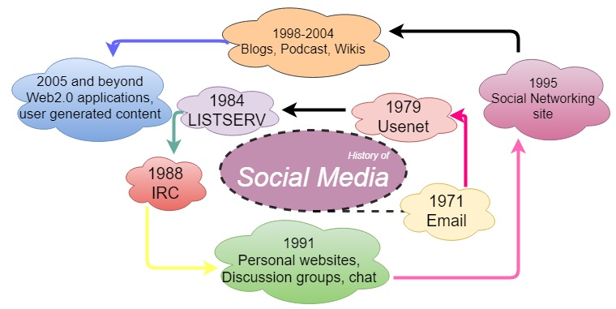
Figure 1, Evaluation of social media (Sajithra and Patil, 2013)
Starting from email, to Facebook and Twitter, LinkedIn and many other such social media sites are now considered as a separate marketplace as SMM for brands and companies (Sajithra and Patil, 2013).
Literature Review:
Marketing via social media allows companies to share and discuss information with their targeted consumers, especially SMM assist companies to identify their actual customer's groups, which allow an organization to keep a close relationship with their existing loyal customers and also helps to attract new consumers with similar interest. The researcher often insists small and medium business should consider SMM as indispensable instruments against big chains and remain competitive, visible and generate more revenue (Zhang, 2017; Hajli, 2014; Jackson, 2011).
Using Facebook, Twitter, email, LinkedIn and such other websites as a medium of marketing to reach out the targeted customers is called social media marketing (Tuten and Solomon, 2017). According to a study conducted by Tsuji et al. in 2009, small brands to big brands, all retail are using the chances of social media marketing (SMM) to increase their sales, profit and brand awareness. It states that low to high brands retailers are embracing social media and utilizing it to boosting sales and brand awareness. This study also outlines that, there is a cost-benefit factor in this marketing technique, SMM is not as expensive as other traditional marketing strategies and tools. Fewer resources are used and more audience is captured.
History and Evolution of Social Media Marketing:
Most of the available studies on social media marketing (SMM) are refers different factors and issues around the topic, but they also studied in isolation (Felix et al., 2017; Iankova et al., 2018; Alalwan et al., 2017; Alves et al., 2016). There is not much research present on how and when exactly all this started. Although, Sajithra and Patil, (2013) mentioned that, SMM is not something that was developed overnight or something that’s starting point can be simply defined and clearly distinguished. It is a process and trend that came into existence over a period of time along with the development of internet and social media websites (Strauss and Frost, 2016; Sajithra and Patil, 2013). Thus it can be assumed that the historical overview of social media marketing is only possible by studying it in a relationship with the development and evolution of social media websites.
In 1960 CompuServe was developed, it was the first and very basic form of the internet with Limited ability of connectivity and networking. But over the period of time, the technology became better and more user-friendly (Sajithra and Patil, 2013). After this period a concept of connecting with friends over internet took place and social media site born. The first website that was developed in 1997 named Six Degree. It was just like Facebook but like a very basic version. Similarly, over the decades, these websites became more advanced and social media websites took over (Sajithra and Patil, 2013). It is believed that Facebook was one of the initial and very popular sites from which brands started social media marketing (Felix et al., 2017). It is one of the websites that actually gave birth to the idea of marketing through social media websites. A company can effectively use this as a tool of marketing. Facebook was just a tool that was used by people in order to connect and comminute but because of the effeteness, nowadays from SME’s to highly ranked companies started to focus on that particular website (Peters et al., 2013; Tuten and Solomon, 2017; Zeng et al., 2010). Facebook is considered as very user-friendly, thus companies can easily reach out to the maximum audience in limited time (Alalwan et al., 2017). A study that was conducted by Sajithra and Patil (2013), compared two very popular social media marketing websites, Facebook and Twitter for their effectiveness and its impact on their customers. Also, the study focused on the types of strategies used by the managers for these websites in hotel industry specifically. Sajithra and Patil’s (2013) research also shows that the strategies used by managers for different websites are different although all these SMM sites produce the same amount of effectiveness. Research conducted by several authors’ shows that SMM is actually more influential than traditional marketing and SMM has a more effective tool in order to capture an audience (Felix et al., 2017; Iankova et al., 2018; Alalwan et al., 2017).
Review of existing research on SMM:
Critical analysing of existing literature on social media marking would help current study to identify and evaluate the factors that generate tremendous growth of social media marketing. As mentioned already social media marketing is very comprehensive, hence this study used the keywords of ‘influencing factors of social media marketing’ to find relevant journals or articles. Searching methods were also defined by excluding the book chapters and not older than 10 years publication. Based on the search, some of the relevant articles are summarised down below:
Research was done by Ramanathan et al. (2017) on consumer behaviour explored the area of customer satisfaction and how it has an impact on spending patterns of customers with a perspective of social media marketing. This research also represents, through SMM how companies can gain a competitive advantage whilst it implemented correctly. The study continued to examine how the interaction of SMM can have an effect on customer satisfaction and the relationship between brands and customers. According to Ramanathan et al. (2017) analysis of consumers behaviours improved the growth of SMM’s performance. Similarly, a study considered by Kim and Park (2013), analysed how SMM has an impact on customer’s behaviours, researchers tried to outline how customers responses towards the brand and how this has an influence on brand equity. Brand equity or creation of brand equity has always been a very important topic for business and marketing managers, thus Kim and Park (2013) paper focus on how online websites and marketing done through these channels is effective in creation and retention of brand equity. In this study, a very important phenomenon word of mouth (WOM) also considered a factor for SMM. Outcomes of this research imply that word of mouth and commitment has a strong impact on brand equity, brand image and brand awareness in the social media world. Many online marketing specialists believe, WOM or eWOM (electronic word of mouth) is one of the most influencing factors behind the development of SMM (Alfonso and Suzanne, 2008; An, 2013; Berthon et al., 2012; Ferguson, 2009).
Usefulness of SMM has been identified by many organizations, as recently business transactions are often concluded through computers or mobile devices, which is one of the major principals of modern shopping, and that characteristics were only achievable because of the mobile technologies and faster internet service (Akman and Mishra, 2017; Bandura, 2009; Chayko, 2014; Gunelius, 2011). According to Kim and Park (2013), social networking makes the business search easier and faster to answer the queries of customers regarding the business context. A perceptual communication generally leads a positive impact towards the products and build a bond between organization and customers, create band loyalty which helps firms to promote their product and service as well as increase brand recognition, brand awareness and brand recall (Kim and Park 2013; Kaplan & Haenlein, 2010; Jackson, 2011). Many studies suggest faster communication and visible on search could be one of the crucial milestones of SMM towards success (Gunelius, 2011; Akar and Topçu, 2011; Armstrong et al., 2015; Stephen, 2016). Organizations also changed their traditional business strategies to e-commerce strategies (Chayko, 2014). Through multiple social media platforms like WhatsApp, Facebook, twitter, snapchat, YouTube, and Instagram’s organizations attract and maintain their potential targeted customers, which also enable organizations to experiment their customers and promote their business accordingly (Lipsman et al., 2012). Most of the organizations have their own websites, Facebook and Instagram pages where they share and update information about their products and receive direct feedback from the customers. Direct communication with the customers helps the organization to build a strong relationship and brand equity.
Dahnil et al. in 2014 published their research on SMM, where researchers prioritize ‘End User’ targeting technique as an important influencing factor behind SMM growth. Statistics show 3.1 billion people worldwide out of 7.7 billion (total population) use social media regularly, thus organization choosing SMM as a route to reach nearly half of the world population at one time and communicate with them directly beyond typical marketing methods. Dahnil et al.’s research in 2014 also flagged that, consumers intended to believe products or service experiences that posted on social media by other users are more likely to be realistic rather than information that was shared by an organization. Dahnil et al.’s research stated, from a consumers prospective product or services that advertised on SMM are more reliable than any other online marketing tools, since examining a genuine reviewer is often impossible in the virtual world to expect social media. Approximately 144 articles on social media marketing have reviewed by Alalwan et al. (2017), the aim of that research was to provide overall themes and trends of social media marketing through the existing literature. Finding of Alalwan et al.’s (2017) research was summarised with few keywords, such as; electronic word of mouth, the role of social media marketing, brand and performance and customer management. However, according to Castronovo and Huang (2012), public relation, marketing strategies, marketing communication and promotion should also be considered as an essential element while operation through SMM.
Critical Success Factors:
As mentioned earlier, this study will pay particular attention to the development of social media marketing, therefore, researcher of this study attempted to evaluate the critical success factors of SMM through literature review. Throughout the inspection writer evaluated that, there are numerous factors that have enormous contribution on the development of SMM (Felix et al., 2017; Iankova et al., 2018; Alalwan et al., 2017; Alves et al., 2016), however during the analysis of existing literature on social media marketing, this research recorded three critical success factors that have comprehensive involvements on the significant growth of SMM, which is listed down below;
- Factor one:
The development of Web.2 and mobile technologies were identified as one of the main success factors of social media marketing development over the last few years (Paroutis and Saleh, 2009). In 2004 an American company called O’Reilly Media Inc. developed “Web.2”. They used it to identify the characteristics of innovative companies and their business traits. Andersen (2009) described Web.2 as a “social software” which has some specific features and provide high importance to the user. Web.2 allows users to participate and contribute, thus customers are able to interact with others in the more easy way regardless of the distance. One of the main features of Web.2 includes allowing users to share and collaborate with other users online (Cooke and Buckley, 2008). Hardey (2010) identified that the success of web.2 as “inherently social so that users are central to both the content and form of all material and resources”. Web.2 firstly facilitates the growth of online desktop as users found it to be easy to use and sharing information with people. Later on the Web. 3 was developed which was named as the “Third decade of the internet” by Nath et al. (2014). When web.2 is concentrated on front-end innovations Web.3 is focused on the development of internet semantic services through the back end.
The relationship between customers, company and Web.2 must need to be considered. Web.2 open the door for the customers to interact with companies online easily, at the same time companies are able to gather more information about their customer and are able to build a strong bond of customer loyalty (An, 2013). Mobile apps were used by companies to rate their services and give comments based on their service to collect feedback from customers. Based on the consumer research by Ferguson (2009), Web.2 gave freedom of choice, switching products where ever they want and Web.2 removed the monopoly that existed in the market among small and big organizations. The “user democracy” made the Web.2 more user-friendly and the effectiveness, which is than considered as one of the critical success factors for SMM and on the other hand, where traditional business tools were decreased (Akar and Topçu, 2011). Reviews or comments from one customer, encourage others to take a purchasing decision regarding a particular product.
Along with Web.2, another succeeding section behind the development of SMM is the introduction of new mobile technologies (Berthon et al., 2012). The researcher often argued saying, the rapid growth in mobile phones are due to the development of the internet (Social media) (Lenhart, 2010). Nowadays accessing the internet is very easy through mobile devices with minimum access requirements. Due to mobile technology users can easily approach in so many Websites, advanced technologies and cloud computing at the same time, which was totally impossible just a generation ago, even 1990 the mobile devices were very small and within twenty years, the growth rate was 36% per annum. Especially over the last ten years, the growth is 64% per annum (Desai, 2012). These increase in mobile phone usage build a new branch of e-commerce, which is called m-commerce to companies. And they have their own app for companies which allow customers to purchase quickly (Desai, 2012).
A triad relational model of socioeconomic lifestyle was proposed by Linda (2010) explaining the mutual connection between social media, e-commerce and Web.2 technologies. The triad relationship demonstrates the actual integration of all those three parties with respect, fulfilment and quality will give benefits to every user.
Socio-Economic Lifestyle
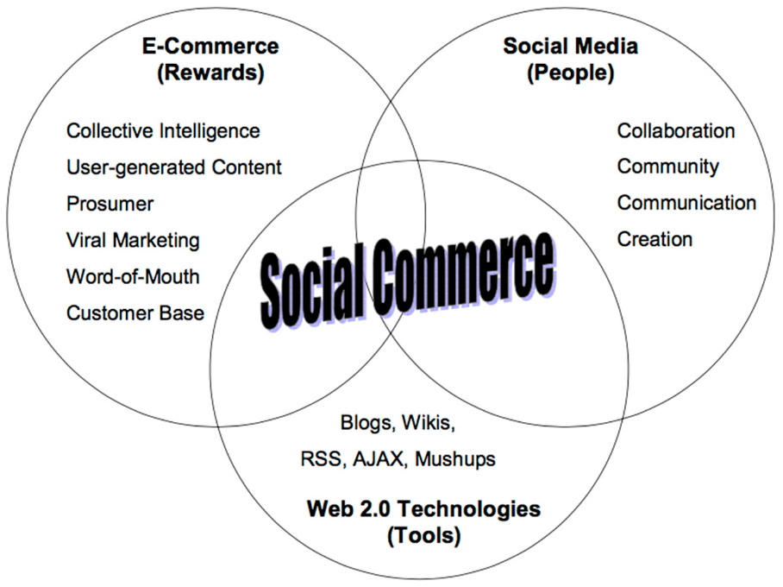
Figure 2, Triad relational model of socioeconomic lifestyle (Linda, 2010)
- Factor Two:
The increasing use of internet leads to highlights facts like social interaction and connectivity of the world. Use of the internet in so much abundance gave rise to the thought of reaching out to customers through the channel. As the brands found it easy to connect with their target customers through SMM, therefore they started searching for keywords (Alves et al., 2016). Along with other traditional social and behavioural trends of human life, the internet also had an impact on businesses and mostly the area that was influenced by this trend was marketing as it is the field that is directly related to customers (Strauss and Frost, 2016). Social media is a platform where everyone is free to express their opinions and thoughts and if a brand is providing good quality products and services, satisfied customers will automatically generate positive word of mouth for that brand. This technique is called electronic word of mouth (eWoM) and marketers thrive to achieve this because it is mostly not in control of the company (Groeger and Buttle, 2014). Below (figure-3) eWOM activities system explains how the eWOM works. Customer-Brand relationship must be very strong if some brand wants to produce its positive word of mouth on social media because if the brand is not delivering a value proposition that it promised that will then take only one click for creating a negative image for that brand. As customers hold all the power in this case, therefore, this factor becomes very popular among the customers (Zhang, 2017).
eWOM Activities System
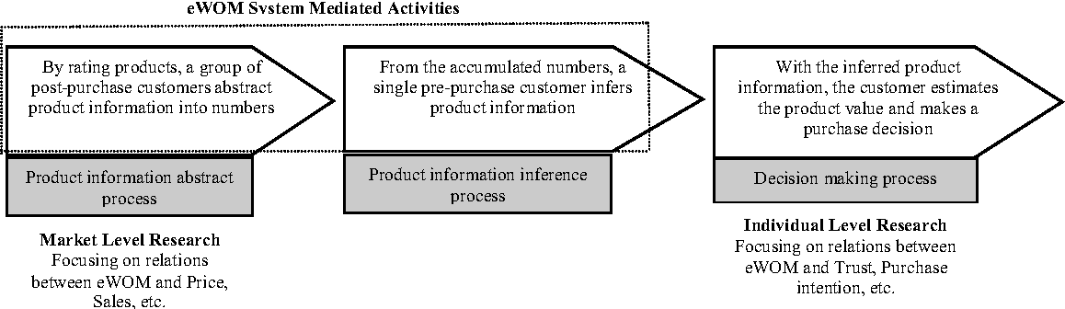
Figure 3, eWOM activities system (Groeger and Buttle, 2014)
Along with many others, Keyword SME’s (small and medium enterprise) has a big contribution to the SMM growth, this keyword help SMM attracts all the small and medium companies around the globe. Many researchers (Dahnil et al., 2014; Akman and Mishra, 2017; Ungerman and Myslivcová, 2014) have been studied the impact of social media marketing on SME’s (Small medium enterprises). Ungerman and Myslivcová (2014) studied the effective consumer communication strategies through social media marketing and developed a new communication model, which gave importance to the quality of content that SMEs published on social media.
- Factor three:
Theories that secure tremendous growth of SMM are parasocial theory and Diffusion of innovation (Labrecque, 2014). These theories are identified as third critical success factors on SMM growth. Parasocial Theory suggests that consumer use social media as a source of connection and they perceive that connection to be real (Brown and Basil, 2010). Marketers are using this model to benefits their business, as when they use social media for advertisement they are creating a consumer-brand relationship. Parasocial relationship helps the brand to fulfil the geographical gap between the company and customers (Labrecque, 2014). On the other hand, the behaviour of the customer towards any new technology is very important; Diffusion of innovation theory explains this behaviour (Bandura, 2009). There are different categories of customers that are present in any market. Social media can play a very important role for marketers in reaching to these customers and to analyse the trends of customer behaviours. Diffusion of innovation theory helped and educates social media marketing managers, how easily target different categories of customers and make them aware about products or services they are offering with specialized strategies for each segment (Zeng et al., 2010).
Future of Social Media Marketing:
Future predictions regarding SMM is given by different social media experts (Asur and Huberman, 2010; Mariani et al., 2014; Zeng et al., 2010). The future of social media marketing is very complex according to some experts, it is predicted that in future social media might get to a point where the lie between the actual world and the world of social media will be blurred and it will be a part of daily life. Also, the competition is increasing day by day which means that only brands that are fittest will survive and will be able to protect their fans and audiences. (Mariani et al., 2014).
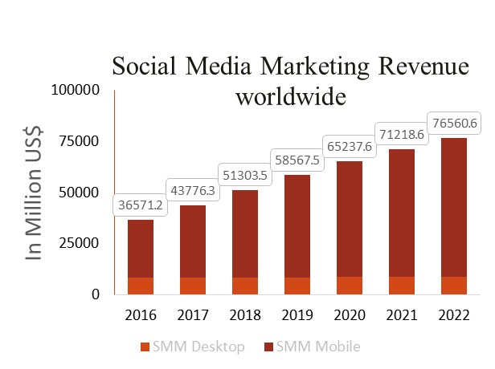
Figure 4, social media marketing revenue worldwide (Statista, 2018)
An online based research company Statista (2018) forecasted that revenue of social media marketing will grow continually and the analytic of this report articulated, mobile technology is the factors that placing social media marketing in this position. Main trends that are going to lead the future social media marketing are predicted by different researchers (Asur and Huberman, 2010).
In order to be more efficient and to reach as many customers and audience as possible, an integrated system must be developed through which the content of a company can be linked to each other (Iankova et al., 2018). This way it will be easier to target audience of all websites or at least most of them and to create an effective marketing strategy. A good example of this is to combine and link email marketing with social media marketing. This way the benefits of email marketing combined with social media marketing can target a wide range of potential customers. Also, the company doesn’t need to putt extra efforts and resources for designing separate and isolated strategies and advertisements for each site. Instead of doing that they can develop hybrid strategies that can fulfil the needs of all types of combined platforms (Alfonso and Suzanne, 2008).
This is not a new concept at all as in traditional marketing endorsements by celebrities like TV stars and sportsmen are very common (Asur and Huberman, 2010). A similar approach needs to adopt by marketers while using social media as a marketing tool because it’s a natural way of attracting people to watch your videos or at least have a look at them because it is being endorsed by a celebrity (Iankova et al., 2018).
No matter how much someone tries to deny this, original content is always more attractive and eye-catching rather than just a copied idea. This is very critical when it comes to social media marketing as the fans are very vigilant and they keep an eye on every move the brands makes. If a brand copied an idea even from a different region it is possible to trace within a few minutes as the networking on social media is so strong that it won’t take too long to realise it’s not an original idea (Hajli, 2014).
It is always said that quality is preferred over quantity but this is not the same in social media marketing. In SMM, if a company only focus on quality and not the frequency and the amount of content they are publishing then organization might lose effectiveness. As the customers are constantly watching so many things willingly and unwillingly that they might forget about your very high-quality content if it is not shown to them enough. Therefore, the companies need to create a balance between quality of content and the frequency with which it will be published (Peters et al., 2013).
Conclusion:
The historical review and to analyse the evolution of social media in isolation is not possible because as mentioned in the analysis it is something that grew eventually with the passage of time. From the examination of facts, it can be concluded that social media marketing is the type of marketing that flourished very quickly in a very short time. And unlike many other trends that come and go, SMM is somehow very consistent and flourishing. Also, the future of social media marketing is very promising as it is going to be playing a very important role in history to be written regarding brands. The social media marketing strategies of a company can make its image and also it can break its image, thus company’s needs to be extra careful when it comes to choosing the type of content they are publishing and the timing of their post.
References:
Akar, E. and Topçu, B., 2011. An examination of the factors influencing consumers' attitudes toward social media marketing. Journal of Internet Commerce, 10(1), pp.35-67.
Akman, I. and Mishra, A., 2017. Factors influencing consumer intention in social commerce adoption. Information Technology & People, 30(2), pp.356-370.
Alalwan, A.A., Rana, N.P., Dwivedi, Y.K. and Algharabat, R., 2017. Social media in marketing: A review and analysis of the existing literature. Telematics and Informatics.
Alfonso, G.H. and Suzanne, S., 2008. Crisis communications management on the web: how internet‐based technologies are changing the way public relations professionals handle business crises. Journal of Contingencies and Crisis Management, 16(3), pp.143-153.
Alves, H., Fernandes, C. and Raposo, M., 2016. Social media marketing: A literature review and implications. Psychology & Marketing, 33(12), pp.1029-1038.
An, U.S., 2013. An effect of social commerce motivations on customer loyalty: Focused on social commerce provider trust and social commerce supplier trust. Journal of Korea Service Management Society, 14(5), pp.201-228.
Andersen, P., 2009. What is Web 2.0?: ideas, technologies and implications for education (Vol. 1, No. 1, pp. 1-64). Bristol: JISC.
Armstrong, G., Kotler, P., Harker, M. and Brennan, R., 2015. Marketing: an introduction. Pearson Education.
Asur, S. and Huberman, B.A., 2010, August. Predicting the future with social media. In Proceedings of the 2010 IEEE/WIC/ACM International Conference on Web Intelligence and Intelligent Agent Technology-Volume 01 (pp. 492-499). IEEE Computer Society.
Bandura, A., 2009. Social cognitive theory of mass communication. In Media effects (pp. 110-140). Routledge.
Berthon, P.R., Pitt, L.F., Plangger, K. and Shapiro, D., 2012. Marketing meets Web 2.0, social media, and creative consumers: Implications for international marketing strategy. Business horizons, 55(3), pp.261-271.
Brown, W.J. and Basil, M.D., 2010. Parasocial interaction and identification: Social change processes for effective health interventions. Health Communication, 25(6-7), pp.601-602.
Castronovo, C. and Huang, L., 2012. Social media in an alternative marketing communication model. Journal of Marketing Development and Competitiveness, 6(1), pp.117-134.
Chayko, M., 2014. Techno‐social Life: The Internet, Digital Technology, and Social Connectedness. Sociology Compass, 8(7), pp.976-991.
Cooke, M. and Buckley, N., 2008. Web 2.0, social networks and the future of market research. International Journal of Market Research, 50(2), p.267.
Dahnil, M.I., Marzuki, K.M., Langgat, J. and Fabeil, N.F., 2014. Factors influencing SMEs adoption of social media marketing. Procedia-social and behavioral sciences, 148, pp.119-126.
Desai, N., Liu, A. and Winikoff, M. eds., 2012. Principles and Practice of Multi-Agent Systems: 13th International Conference, PRIMA 2010, Kolkata, India, November 12-15, 2010, Revised Selected Papers (Vol. 7057). Springer Science & Business Media.
Felix, R., Rauschnabel, P.A. and Hinsch, C., 2017. Elements of strategic social media marketing: A holistic framework. Journal of Business Research, 70, pp.118-126.
Ferguson, R., 2009. The consumer inside: at its heart, all marketing speaks to human beings. Journal of Consumer Marketing, 26(3), pp.214-218.
Groeger, L. and Buttle, F., 2014. Word-of-mouth marketing: Towards an improved understanding of multi-generational campaign reach. European Journal of Marketing, 48(7/8), pp.1186-1208.
Gunelius, S., 30. Minute social media marketing: Step by step techniques to spread the words about your business.
Hajli, M.N., 2014. A study of the impact of social media on consumers. International Journal of Market Research, 56(3), pp.387-404.
Hardey, M., 2010. The city in the age of web 2.0 a new synergistic relationship between place and people. Information, Communication & Society, 10(6), pp.867-884.
Iankova, S., Davies, I., Archer-Brown, C., Marder, B. and Yau, A., 2018. A comparison of social media marketing between B2B, B2C and mixed business models. Industrial Marketing Management.
Jackson, N., 2011. Infographic: Using social media to build brand loyalty. Retrieved from.
Kaplan, A.M. and Haenlein, M., 2010. Users of the world, unite! The challenges and opportunities of Social Media. Business horizons, 53(1), pp.59-68.
Kim, S. and Park, H., 2013. Effects of various characteristics of social commerce (s-commerce) on consumers’ trust and trust performance. International Journal of Information Management, 33(2), pp.318-332.
Labrecque, L.I., 2014. Fostering consumer–brand relationships in social media environments: The role of parasocial interaction. Journal of Interactive Marketing, 28(2), pp.134-148.
Lenhart, A., Purcell, K., Smith, A. and Zickuhr, K., 2010. Social Media & Mobile Internet Use among Teens and Young Adults. Millennials. Pew internet & American life project.
Linda, S.L.A.I., 2010. Social commerce–e-commerce in social media context. World Academy of Science. Engineering and Technology, 72, pp.39-44.
Lipsman, A., Mudd, G., Rich, M. and Bruich, S., 2012. The power of “like”: How brands reach (and influence) fans through social-media marketing. Journal of Advertising research, 52(1), pp.40-52.
Mandal, P.C., 2017. Marketing intelligence: roles in business decision-making. International Journal of Business Forecasting and Marketing Intelligence, 3(4), pp.433-441.
Mariani, M.M., Buhalis, D., Longhi, C. and Vitouladiti, O., 2014. Managing change in tourism destinations: Key issues and current trends. Journal of Destination Marketing & Management, 2(4), pp.269-272.
Nath, K., Dhar, S. and Basishtha, S., 2014, February. Web 1.0 to Web 3.0-Evolution of the Web and its various challenges. In Optimization, Reliabilty, and Information Technology (ICROIT), 2014 International Conference on (pp. 86-89). IEEE.
Paroutis, S. and Al Saleh, A., 2009. Determinants of knowledge sharing using Web 2.0 technologies. Journal of knowledge management, 13(4), pp.52-63.
Peters, K., Chen, Y., Kaplan, A.M., Ognibeni, B. and Pauwels, K., 2013. Social media metrics—A framework and guidelines for managing social media. Journal of interactive marketing, 27(4), pp.281-298.
Ramanathan, U., Nachiappan, S. and Parrott, G., 2017. Social media and successful retail operations in the hyper-customisation era. LSE Business Review.
Sajithra, K. and Patil, R., 2013. Social media–history and components. Journal of Business and Management, 7(1), pp.69-74.
Statista. (2018). Social Media Advertising - worldwide | Statista Market Forecast. [online] Available at: https://www.statista.com/outlook/220/100/social-media-advertising/worldwide# [Accessed 16 Apr. 2018].
Stephen, A.T., 2016. The role of digital and social media marketing in consumer behavior. Current Opinion in Psychology, 10, pp.17-21.
Strauss, J. and Frost, R.D., 2016. E-marketing: Instructor's Review Copy. Routledge.
Tsuji, Y., Bennett, G. and Leigh, J.H., 2009. Investigating factors affecting brand awareness of virtual advertising. Journal of Sport Management, 23(4), pp.511-544.
Tuten, T.L. and Solomon, M.R., 2017. Social media marketing. Sage.
Ungerman, O. and Myslivcova, S., 2014. Model of communication usable for small and medium-sized companies for the consumer communication social media. E+ M Ekonomie a Management, (1), p.167.
Yadav, M., 2017. Social media as a marketing tool: Opportunities and challenges. Indian Journal of Marketing, 47(3), pp.16-28.
Zeng, D., Chen, H., Lusch, R. and Li, S.H., 2010. Social media analytics and intelligence. IEEE Intelligent Systems, 25(6), pp.13-16.
Zhang, T., Abound Omran, B. and Cobanoglu, C., 2017. Generation Y’s positive and negative eWOM: use of social media and mobile technology. International Journal of Contemporary Hospitality Management, 29(2), pp.732-761.
Hofacker, C.F. and Belanche, D., 2016. Eight social media challenges for marketing managers. Spanish Journal of Marketing-ESIC, 20(2), pp.73-80.

(Chapter Two)
Part -2
Detailed Discussion of a Research Studies
Felix, R., Rauschnabel, P.A. and Hinsch, C., 2017. Elements of strategic social media marketing: A holistic framework. Journal of Business Research, 70, pp.118-126.

Table of Contents

Introduction: 1
Brief overview: 1
Research Philosophy: 1
Methodology: 1
Reliability and Validity: 1
Ethics: 1
Limitations: 1
Conclusion: 1
References: 1

Introduction:
This study is designed to critically analyze and evaluate a selected article, and the chosen article for this study is titled as “Elements of Strategic Social Media Marketing: A Holistic Framework”, written by Felix, Rauschnabel and Hinsch (2017) who are linked with the University of Texas, the University of Michigan-Dearborn and Grand Valley State University, USA, respectively. The selected study was conducted in order to explore the strategic social media marketing and its elements by applying a theory-building approach along with qualitative research methods. The researchers have substantially conceptualized and described the strategic media marketing while presenting an integrative framework that is able to go beyond the limits of marketing theory. Throughout this study, critical analysis of research philosophy and theories being used in the selected research article will be evaluated, side by side the literature review, research methodology, data collection and analysis techniques used in that study also will be analysed. Towards the end of this paper, the conclusion of the critical assessment and further recommendations will be suggested.
Brief overview:
Social media marketing has become an integral part of the contemporary business processes, yet this user interaction paradigm remains least addressed in the existing literature despite its importance and usage (Naylor et al., 2012). The researchers in the article under study attempted to fill this research gap with respect to both theoretical and managerial point of views while exploring research questions regarding definition and conceptualization of strategic social media marketing and what elements should be considered when social media marketing strategy of an organization is formulated.
Research Philosophy:
Silverman (2009) states that experienced researcher contributes to the literature by providing the best possible methodologies which further helps the upcoming scholars to identify the potential methodologies along with their possible limitations. Rogers (2012) suggest that the findings and outcomes of research are shaped by the philosophical assumptions and the chosen methodological approach. Thus, it can be deduced that choosing a research philosophy is not only important for the researcher himself who intends to carry out that research but also to the future scholars. Analysis of the research methodology suggests that the selected research paper follow the Interpretivism philosophy as Epistemology and Subjectivism as Ontology (Silverman, 2016). In this study individual social media marking experts though, views and opinion were prioritized via interviews and the level of experience of the various participants can be considered as an accurate source of knowledge. An Interpretive data analysis technique was adopted by the researcher and three steps coding process was used to translate the finding in a meaningful word. Although, the outcome of this study is not empirically demonstrated or generalised, which is one of the most discussed weaknesses of Interpretivism philosophy (Bryman and Bell, 2015). The researchers of the selected article attempted to conceptualize and define the strategic social media marketing while extracting out the factors that are worth considering when strategic social media marketing is developed and the researcher has utilized the interpretivsism research philosophy (Creswell et al., 2011). The main crux of this philosophy is that knowledge of reality is based on social construction by human actors and researchers of the article has also adopted this view that social media is a subjective phenomenon which cannot be studied without considering the human element. Therefore, the selected philosophy for this research is very effective and appropriate for the research (Curry, 2009).
Methodology:
In the selected research paper, the researchers have applied two-stage analysis methods. In the first stage, they selected seven European social media marketing experts as a purposive sample based upon their direct exposure and job position in relevance to social media marketing both at national and international level. They have emphasized on depth rather than the breadth of the sample at stage 1, in order to generate a rich data by audiotaping their responses and then transcribing them into written format. In stage 2, they carried out a qualitative survey, by selecting 265 social media marketing experts from published sources such as, business magazines or managerially focused magazines that were acknowledged as experienced and knowledgeable experts in the field of social media marketing. Qualitative surveys were sent through email out of which only 43 successful responses were used by the researchers for analysis. The selection of interview methods is also aligned with the philosophy of this research. For fulfilling aim and objectives of the present research, rich data was needed and this has been provided through the selected approach. A critical analysis of the above discussion can classify this study as exploratory research in nature (Collis and Hussey, 2009; Bryman and Bell, 2015). Exploratory research is often chosen by a researcher under a situation where the aim of the research is to provide an explanation of a particular phenomenon in details and explore new aspects (Creswell et al., 2011). As the finding of this research was conducted through the thematic analysis and interview were organized for the primary data collection, thus the research is an exploratory in nature and type of the research is pure cross-sectional (Collis and Hussey, 2009).
Throughout the discussion about analysis technique used in the selected article, it has been observed that the researchers have used thematic analysis to examine the response collected from the social media marketing experts. The prevailing patterns in data are recognized, examined and then reported in the technique of thematic analysis in rich details (Clarke and Braun, 2013). The tenets of the content are identified and analysed using coding. The potential benefit of using this type of approach is that it helps in defining the pattern across the qualitative data details (Clarke and Braun, 2013). Saldaña (2015) stated three stages of thematic analysis are; i) pre-analysis, ii) exploration, iii) interpretation and discussion, where the aims and objectives are defined in the pre-analysis stage by choosing, comprehending, and arranging the obtained data in accordance to the aim of the research, after which each and every part of the content is investigated to spot small elements present in the exploration stage. In between the task of identification of codes approaches, which according to Gibbs (2009), is a method of indexing or classifying the content, thus a structure of thematic ideas can be developed that are relevant to the ongoing research. The researcher categorized the data coding process into three stages in order developing a theoretical framework (Saunders et al., 2009). Firstly, they have uncovered the core concepts through open coding, secondly diagnosed second-order themes by means of axial coding. It helped in linking the concepts extracted from stage 1 by using the ‘compare and contrast’ method. In the end, the more frequently occurring trends were materialized from the data at stage 3. This indicates that the rigorous method had been used by the researcher for analysis (Gibbs, 2009).
Reliability and Validity:
There are several techniques to examine the reliability and validity of quantitative research. However, qualitative research is still criticized for lacking such measure that can be used to evaluate its effectiveness and strength (Saunders et al., 2009; Petty, 2012). The description of reliability is quite counter-intuitive and tricky in its epistemological context. To ease up the difficulty, Carcary (2009) linked the reliability of qualitative research with its consistency. Data needs to comprehensive and inclusive in its scope in regards to qualitative aspects as much as possible. The present research has also adopted this approach and the researcher has outlined each step of data collection and analysis in a detailed manner to ensure the transferability of the results. As Curry (2009) says that triangulation is a method which can be used for ensuring reliability and validity in qualitative studies and it can be observed that researcher used extensive secondary data to support the findings of this research with findings from previous studies. This indicates that this research has produced reliable and valid findings.
Ethics:
Ethical considerations are compulsory for every research, and it is a responsibility for every researcher to ensuring that all aspect of ethics is maintained accurately in ordered to achieve the research goal. While research does not comply with the ethical standards than this research can be classified as an invalid research or research bias (Petty, 2012; Saunders et al., 2013). Thus the selected article also considered issues around the research ethical policies throughout the data collection, investigation and articulation. However, in this research, the researcher has not provided sufficient details about the ethical considerations which were followed hence this is a drawback of this research. On the other hand, the analysis shows that appendices of the article are mentioning the name of interviewees which is against the ethics hence this should have had been considered by the author. Data protection policy of this research can be criticized because of the lack of the privacy of participants. Although every secondary data and information that is analysed in this publication is referred precisely, this is essential to acknowledge and respect the authors for their publication. It can be assumed that collected data and information of this research was only used for the particular purpose and none of the sensitive information of responders was gathered during the interview.
Limitations:
The limitations faced by the researchers in this study suggest several avenues for future research. First of all, the only a qualitative technique has been employed to study social media marketing while quantitative technique can be incorporated in future in order to determine the possible effects on firm performance. This framework can also be extrapolated in cross-cultural contexts. Moreover, the role regulatory or self-regulatory bodies can also be incorporated in the framework to identify how they can help the firm in value creation and developing core competencies.
Conclusion:
The research article is well-developed and structures with neatly presented inclusive theoretical background and findings. Using a qualitative approach in collecting the opinions and responses of European social media marketing experts was difficult, but the research optimally justified. Outcome of this research effectively addressed to the research gap in regards to the social media marketing by appropriate philosophical positioning and methodology. A thematic approach was a wise choice for data analysis still the sample size was too small to be generalized in a large context. To conclude, it can be found, this research to be unbiased, valid, reliable and acceptable as a part of literature, only more focus on ethics was needed.
References:
Bryman, A. and Bell, E., 2015. Business research methods. Oxford University Press, USA.
Carcary, M. 2009. The Research Audit Trial--Enhancing Trustworthiness in Qualitative Inquiry. Electronic Journal of Business Research Methods, 7(1).
Clarke, V. and Braun, V., 2013. Teaching thematic analysis: Overcoming challenges and developing strategies for effective learning. The psychologist, 26(2), pp.120-123.
Creswell, J.W., Klassen, A.C., Plano Clark, V.L. and Smith, K.C., 2011. Best practices for mixed methods research in the health sciences. Bethesda (Maryland): National Institutes of Health, 2013, pp.541-545.
Curry, L.A., Nembhard, I.M. and Bradley, E.H., 2009. Qualitative and mixed methods provide unique contributions to outcomes research. Circulation, 119(10), pp.1442-1452.
Felix, R., Rauschnabel, P.A. and Hinsch, C., 2017. Elements of strategic social media marketing: A holistic framework. Journal of Business Research, 70, pp.118-126.
Gibbs, G., 2009. Analysing Qualitative Data, Sage publications, London.
Naylor, R. W., Lamberton, C. P., and West, P. M., 2012. Beyond the “like” button: The impact of mere virtual presence on brand evaluations and purchase intentions in social media settings. Journal of Marketing, 76(6), 105-120.
Petty, N.J., Thomson, O.P. and Stew, G., 2012. Ready for a paradigm shift? Part 2: Introducing qualitative research methodologies and methods. Manual therapy, 17(5), pp.378-384.
Rogers, M., 2012. Contextualizing theories and practices of bricolage research. The qualitative report, 17(48), pp.1-17. Long, T., and Johnson, M, 2000. Rigour, reliability and validity in qualitative research. Clinical effectiveness in nursing, 4(1), 30-37.
Saldaña, J., 2015. The coding manual for qualitative researchers. Sage.
Saunders, M., Lewis, P., Thornhill, A., and Wang, C, 2009. Analysing qualitative data. Research methods for business students. 5th edn. Harlow, Essex, UK: Pearson Education Ltd, 480-525.
Silverman, D. (2009) Doing Qualitative Research, Sage, London.
Collis, J., Hussey, R. (2009) Business Research, A practical Guide for Undergraduate & Postgraduate students, 3rd Edition, Palgrave Macmillan Publishers Ltd., New York, US.

