UNIVERSITY OF WALES TRINITY SAINT DAVID
BIRMINGHAM CAMPUS

Management and Organisational Behaviour
M5X01924
Assignment 2

Student : Florin Amos
Student ID : 1815218
Lector : Olu Adegbite

Table of Contents

Introduction 3
Organisational structure, culture and goals 3
Recent change initiatives of the organisation and impacts and how well they were managed 5
The strategic directions of the organisation and current business performance 6
Conclusions 8
References 9

Introduction
The analysis of the management and organisational behaviours is needed to identity the organisational cultural, structure and different kinds of activities. The assessment of the business performance of the company to the market can be examined in the proper manner by conducting audit of the organisation. The report has been provided as per the secondary audit on Hilton Hotel. The business goals and performance of the company to the market have been analysed in the critical form so that it can be identified and valid conclusions can be made. The change initiatives and its impacts to the organisations are also analysed in the effective manner.

Organisational structure, culture and goals
=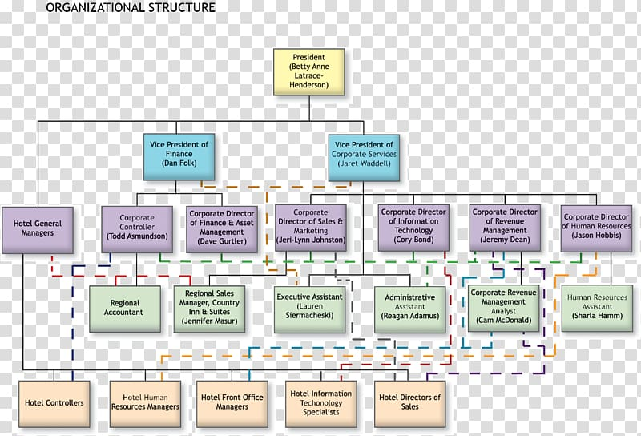
Figure: Organisational structure of Hilton
Source: (Hilton, 2019)
Hilton Hotel is denoted as value added international hotel chain company which has business activities to different countries of the world. Along with business functions to many types of country, the company has effective business operations to United Kingdom. About 59463 hotels rooms are offered to the customers in the hospitality industry by the company to fulfil the customers demand. The matrix structure has been followed to the organisational structure of the company. The president Betty Anne Latrace Henderson is the president of the organisation and he is regarded as the supreme person of the hotel. Along with the president, the business activities of the organisation are operated effectively by 2 vice president. Different kinds of divisional managers are associated with the direct supervision of the vice president (Subba Rao, 2010). The ultimate functions of the company are operated as per the effective approaches of various divisional managers of the company.
Organisational culture: As per making audit of Hilton Hotel, it can be concluded that the share culture is practiced to the management of Hilton Hotel. Hence, the top management of Hilton Hotel is associated with the low level managers and other employees so that the knowledge can be transferred from the high level employees to the low level employees. The top management of Hilton Hotel is associated with ensuring the collaboration among the employees to ensure the shared culture (Robbins, 2018). Apart from this, the flexible working environment is practiced in the effective manner to increase the commitment to its employees. In this context, the flexible approaches from the top management can associate different kinds of employees with the organisational goals so that the superior efforts can be given by all employees to fulfil the organisational goals.
Organisational goal: The goals of Hilton Hotel are something different from other kinds of market giants. The company is determined to build good experience of the tourists and guests by providing its effective hospitality services. the management of the company believes that the good experience of guests can be effective and it affect as promotional tool to the organisation (Rhoden and Cato, 2017). As per this systematic process, the company tend to increase its profit by 20% in next five years. Hilton Hotel wants to ensure the customers satisfaction with the organisation to propose the values for the customers and grab the values in return.

Recent change initiatives of the organisation and impacts and how well they were managed
To increase the presence and capability of the company, different kinds change initiatives have been taken by the company. Though these kinds of change initiatives are risky for the company, they are handled in the effective manner by the direct approach of the managers. The initiatives of change and its impacts to the company are analysed as follows:
Going green: The cut the environmental footprint of the company, the management of Hilton Hotel has decided to go green. In this case, the managers of the company have planned to reduce the waste to the environment. The certification to ISO 50001 has been maintained effective by the organisation to reduce its waste (Wiesner and Millett, 2019). For this reason, the mode of services of the company have been changed to provide the services to the customers. The top management of the organisation is also committed to reduce the organisational waste by half by 2030. Different projects having high level of waste to the society are cut by the managers to go green. This change initiative has been managed effectively by the company so that its social image can be improved (Johnson et al., 2017). The company wants to fulfil its corporate social responsibility as per going green and ensure positive impacts to the society.
More social investment: To increase the social image of the company, the management has been decided to ensure more social investment. The help of the vulnerable people, performing different kinds of social activities, social awareness and many kinds of activities tend to be performed by the organisation to the market to improve the social image. The company has been decided to incur a part of its retained earnings for investing social activities. This change has impacted to the total profit of the organisation (Appannaiah et al., 2010). In this situation, the managers have managed it by allocating the social investment with the fund of social responsibilities. As per the proper supervision of the top management, this change has been managed properly by the company.
Capacity expansion: Hilton Hotel has undertaken the decision to increase the organisational capacity. In the same time, the company has shut about 20 hotels which have inferior services and value addition. The less significant projects have been identified effectively by its management and key decisions have been undertaken to expand the capacity to the emerging market (Mullins and Dossor, 2013). Hence, the market having high extent of demand have been identified by the organisation and different hospitality opportunity are analysed. For this reason, the managers of has been targeted the Asia Pacific region to expand its business activities. This change management decision has increased the organisational capacity to the emerging market and the chance of value addition of the organisation has been increased in the significant manner (Borden and Banta, 2016). It has also been positive extent of impact to the overall profit of the company. This change management can make the company market leader by expanding its activities to the emerging market.

The strategic directions of the organisation and current business performance
The performance of Hilton Hotel has been examined in the effective manner along with its strategic directions. To grab more extent of competitive advantages, the managers of Hilton Hotel tend to formulate different strategic direction of the market. The evaluations of different strategic directions and current business performances are explained as follows:
Focusing on loyal customers: Hilton Hotel has the significant focus on the loyal customers so that their proper satisfaction can increase the organisational values. In this context, the manager of the company has undertaken different discounts and allowances to the loyal customers so that their satisfaction can grab more profit to the company (Grant, 2018). This approach has increased the business performance of Hilton Hotel in the highly competitive hotel industry of the international market.
Quality control: By maintaining the superior quality to the hospitality services, the company tends to add its market values. The quality control can increase the interest of the customers to buy more services from the company. The rate of hotel booking of Hilton Hotel has been increased due to maintaining the superior quality in providing different services to the customers (Fottler et al., 2010). The strategic directions have also secure the base of Hilton Hotel among many kinds of competitors to the market.
Online promotions: To promote the products, Hilton Hotel applied the online promotion. The domestic and international target customers of Hilton Hotel can be associated with the offers and facilities of Hilton Hotel as per the online promotions. Hence, the application of this tool is very effective to secure the strong base of the company (Paauwe et al., 2013). As per the organisational audit, it can be concluded that the social media is also included as the promotional tool of Hilton Hotel to promote its hospitality services.
Targeting emerging market: To target the emerging market to the international marketplace is very effective strategic direction of the company. This strategic approach can increase the market share of Hilton Hotel to the international market (Fottler et al., 2010). The international customers and the brand values of the organisation to the international market can be enhanced in the significant manner due to undertake the business expansion to the emerging market.
Portfolio services: The organisation has ensured the portfolio services to its different kinds of brands. The accommodation, foods, banqueting, conference and many kinds of services are provided by Hilton Hotel to the customers in the international marketplace. The portfolio based strategic direction of Hilton Hotel can add values from the market in the effective manner and secure the organisational base to the international market (Grant, 2018). About 2113-million-pound profit have been grabbed by the organisation through its effective performance to the market.

Conclusions

The analysis of the organisational culture and strategy of Hilton Hotel have been critically analysed within the report. Based on the change management and formulating the business strategy to the market, it can be concluded that the company is in the right tract to increase the values to the market. The values and culture of Hilton Hotel have been analysed in the effective form so that its impact to the organisational value addition can be analysed. The effectiveness of different strategic directions and its business performance have also been analysed within the report.

References

Appannaiah, H., Reddy, P. and Kavitha, B., 2010. Organisational Behaviour. New Delhi: Himalaya Pub. House.
Borden, V. and Banta, T., 2016. Using Performance Indicators To Guide Strategic Decisión Making. San Francisco: Jossey-Bass.
Fottler, M., Khatri, N. and Savage, G., 2010. Strategic Human Resource Management In Health Care. Bingley: Emerald.
Grant, J., 2018. Strategic Management Frontiers. Greenwich, Connecticut: Jai Press.
Johnson, G., Langley, A., Melin, L. and Whittington, R., 2017. Strategy As Practice. Cambridge: Cambridge University Press.
Mullins, L. and Dossor, P., 2013. Hospitality Management And Organisational Behaviour. Harlow: Pearson.
Paauwe, J., Guest, D. and Wright, P., 2013. HRM And Performance. Chichester, West Sussex: Wiley.
Rhoden, M. and Cato, B., 2017. Construction Management And Organisational Behaviour. Malden, MA: Wiley-Blackwell.
Robbins, S., 2018. Organisational Behaviour. Frenchs Forest, N.S.W.: Pearson Education Australia.
Subba Rao, P., 2010. Organisational Behaviour. Mumbai [India]: Himalaya Pub. House.
Wiesner, R. and Millett, B., 2019. Management And Organisational Behaviour. Milton: John Wiley & Sons.

