

Programme: | MSc Public Health and Social Care in Practice
Module: | Population Health and Digital Health Promotion
Module code: | LCHS7009
Lecturer: | Diola Bijlhout`  Dr Ping Wu
Assignment Title: | Component 1  2 Blogs
Student Name: | Smitkumar bharatbhai kachhadiya
Student ID: | 2520164

Table of Contents
Blog 1- Critically discuss the impact of an existing digital technology currently used for a digital health promotion intervention 3
Title: Digital Health for Smoking Prevention: Opportunities and Challenges of Mobile Health Apps. 3
A public health challenge 3
Description of digital technology 4
Impact of digital technology in health promotion (advantages and limitations) 5
How this shortfall can be addressed? 6
References 7
Blog 2- Critically discuss the impact of a digital technology YOU DESIGNED for a digital health promotion intervention 9
Smoking is a leading public health concern 9
Modified version of an existing one 10
How this modified digital technology can address the smoking issue. 11
Impact of the modified digital technology in health promotion 11
How can this shortfall be addressed? 12
References 13

Blog 1- Critically discuss the impact of an existing digital technology currently used for a digital health promotion intervention

Title: Digital Health for Smoking Prevention: Opportunities and Challenges of Mobile Health Apps.

A public health challenge
Smoking is the leading public health challenge in the UK, which significantly contributes to conditions such as heart disease and stroke (Rawat et al., 2023; Fu et al., 2024). The UK has 12.6% of individuals aged 25 to 34 years with the highest smoking prevalence (ONS, 2025).
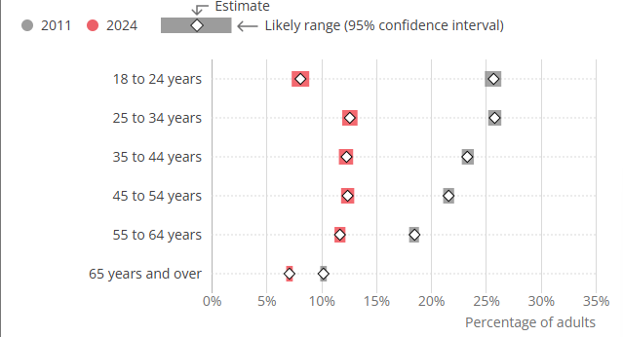
Figure 1: Smoking habits percentage among UK adults
(Source: ONS, 2025)
The British Heart Foundation (2025) states that around 7.6 million people in the UK are suffering from CVD as a consequence of incresing smoking, which accounts for around one in four deaths annually, raising concerns about preventing this public health problem.

Figure 2: Smoking affects quality of life
(Source: Rawat et al., 2023)
Consequently, the NHS's health promotion interventions focus on digitally preventing a public health problem (smoking), facilitating access to health services and promoting a healthy lifestyle (Faizan et al., 2025).

Description of digital technology
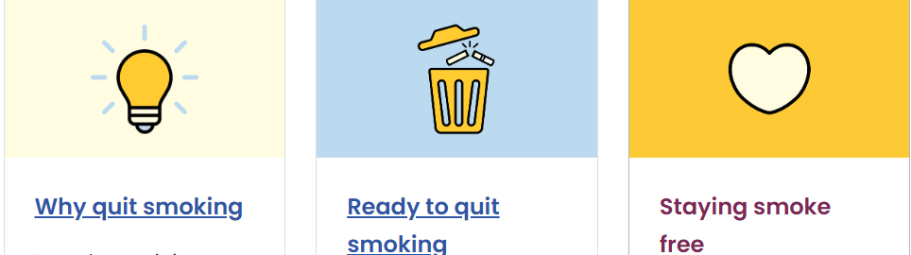
Figure 3: Benefits of using “NHS Smoke Free app”,
(Source: Smokefree Devon, 2026).
Smoking is a major modifiable risk factor for CVD because it damages blood vessels and increases blood pressure, which significantly contributes to increased risks of heart attack and stroke. Hence, one widely used digital health promotion technology is a mobile health (mHealth) application such as the “NHS Smoke Free app”, which is designed through the application of AI to help individuals quit smoking and tracks the time an individual stays smoke-free, monitors daily health improvements, and the money saved by an individual (Smokefree Devon, 2026). According to Lin et al. (2023), through the lens of Social Cognitive Theory (SCT), this app supports smoking cessation through
- Daily motivational messages
- Personalised quit plans
- Financial savings calculators, and
- Craving management tools.
As a result, 500,000 people have already quit smoking by utilising this app, which positively helps them to reduce risk factors of developing CVD (Smokefree Devon, 2026).

Impact of digital technology in health promotion (advantages and limitations)
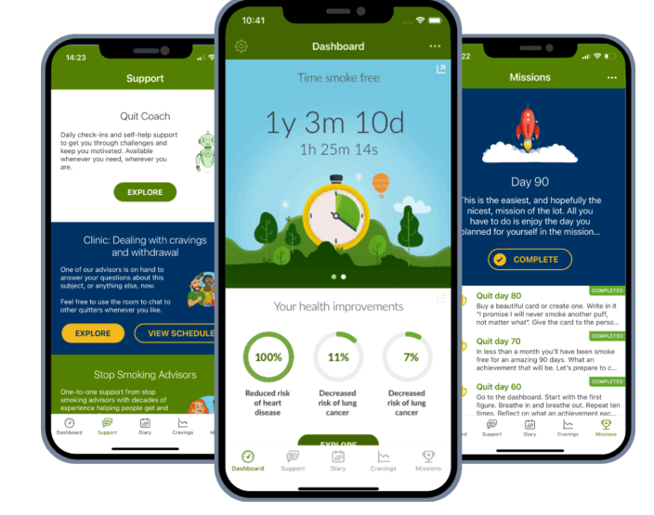
Figure 3: “NHS Smoke Free app”
(Source: Smokefree Devon, 2026).
These digital health promotion interventions can address previous gaps in existing interventions and can help to enhance health benefits of individual, which will be briefly discussed below:

Advantages
- The mHealth “NHS Smoke Free app” provides practical strategies to manage withdrawal symptoms and maintain motivation through the quitting process (NHS.UK, 2026).
- This app is available at any time, which supports users in accessing this app conveniently without frequent visits to healthcare professionals (Smokefree Devon, 2026).
Disadvantages
- Its effectiveness heavily depends on users' motivations and long-term engagement because most users discontinue this app before completely quitting smoking (Jackson et al., 2024).
- Digital literacy is required to access this app, which is a major barrier for the ageing population who lack knowledge regarding digital apps (Xia and Zhu, 2025; Vercruyssen et al., 2023).

How this shortfall can be addressed?
These challenges can be addressed by the NHS Smoke Free app with NHS GP services, which are also utilised by various older adults. Additionally, community-based digital literacy programmes can help the ageing population to enhance their digital skills to easily access this programme that can support them to reduce their smoking, which ultimately contributes to CVD prevention.

References
British Heart Foundation. 2025. Consensus statement on cardiovascular disease. [Online]. Available at: https://www.bhf.org.uk/what-we-do/policy-and-public-affairs/hearts-need-more/bhf-consensus-statement-on-cvd. Accessed 17th July 2026.
Smokefree Devon. 2026. Smoke Free App. [Online]. Available at: https://www.smokefreedevon.org.uk/smoke-free-app/ Accessed 17th July 2026.
Xia, X. and Zhu, M. 2025. The impact of digital literacy on older adults' utilisation of community-based home care services: a cross-sectional study. BMC Health Services Research, 25(1), p.1367. Available at: https://doi.org/10.1186/s12913-025-13427-9 Accessed 17th July 2026.
NHS.UK. 2026. Your quit journey: get support at every stage. [Online]. Available at: https://www.nhs.uk/better-health/quit-smoking/ Accessed 17th July 2026.
Lin, M., Chu, M., Li, X., Ma, H., Fang, Z., Mao, L., Wang, P., Chen, T. and Chiang, Y.C. 2023. Factors influencing adolescent experimental and current smoking behaviors based on social cognitive theory: A cross-sectional study in Xiamen. Frontiers in public health, 11, p.1093264. Available at: https://doi.org/10.3389/fpubh.2023.1093264. Accessed 17th July 2026.
ONS. (2025). Adult smoking habits in the UK: 2024. [Online]. Available at: https://www.ons.gov.uk/peoplepopulationandcommunity/healthandsocialcare/healthandlifeexpectancies/bulletins/adultsmokinghabitsingreatbritain/2024 Accessed 17th July 2026.
Rawat, A., Hivre, M., Sharma, A., Zaidi, S.A., Abedin, M.Z. and Hasan, M.H., 2023. Smoking And Coronary Heart Disease Impact. Journal of Pharmaceutical Negative Results, 2023, pp.1737-1742. Available at: DOI: 10.47750/pnr.2023.14.S02.210. Accessed 17th July 2026.
Fu, M., Mei, A., Min, X., Yang, H., Wu, W., Zhong, J., Li, C. and Chen, J. 2024. Advancements in cardiovascular disease research affected by smoking. Reviews in cardiovascular medicine, 25(8), p.298. Available at: https://doi.org/10.31083/j.rcm2508298 Accessed 17th July 2026.
Vercruyssen, A., Schirmer, W., Geerts, N. and Mortelmans, D. 2023. How “basic” is basic digital literacy for older adults? Insights from digital skills instructors. In Frontiers in Education (Vol. 8, p. 1231701). Frontiers Media SA. Available at: https://doi.org/10.3389/feduc.2023.1231701 Accessed 17th July 2026.
Jackson, S., Kale, D., Beard, E., Perski, O., West, R. and Brown, J. 2024. Effectiveness of the offer of the smoke free smartphone app compared with no intervention for smoking cessation: pragmatic randomized controlled trial. Journal of Medical Internet Research, 26, p.e50963. Available at: https://doi.org/10.2196/50963 Accessed 17th July 2026.
Sivabalah, K., Crane, D., Neville, S., Hancock, M., Ryan, A., Ajay, B., Coyne, J., Benbow, E., Crossfield, A., Bate, S. and Evison, M. 2024. Treating Tobacco Dependency in National Health Service Workers in Greater Manchester: An Evaluation of a Bespoke Digital Service. JTO Clinical and Research Reports, 5(6), p.100674. Available at: https://doi.org/10.1016/j.jtocrr.2024.100674 Accessed 17th July 2026.
Faizan, M., Han, C. and Lee, S.W. 2025, September. Policy-driven digital health interventions for health promotion and disease prevention: a systematic review of clinical and environmental outcomes. In Healthcare (Vol. 13, No. 18, p. 2319). MDPI. Available at: https://doi.org/10.3390/healthcare13182319 Accessed 17th July 2026.

Blog 2- Critically discuss the impact of a digital technology YOU DESIGNED for a digital health promotion intervention
Title: Can your Smartphone help prevent smoking habits?

Smoking is a leading public health concern
Smoking remains one of the leading public health concerns in the UK as it is one of the most modifiable risk factors for CVD, including stroke and heart disease (Raleigh et al., 2022; Zhang et al., 2024).
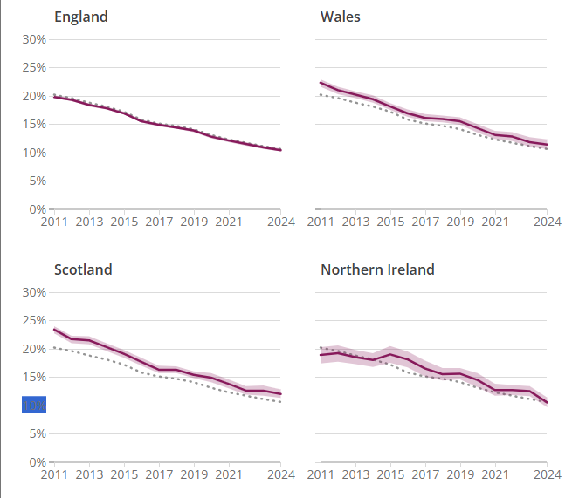
Figure 1: Percentage who were current smokers
(Source: ONS, 2025)
It has been found that in Wales, 10% of adults and 14% of Scots smoked cigarettes between 2024 and 2025 (ONS, 2025), which is leading to severe heart diseases. Even though the NHS launched an NHS Smoke Free app to support smoking cessation, many people struggle to quit smoking due to an ageing population, digital literacy and equitable access to digital health services (Jackson et al., 2024; Liu et al., 2025). Therefore, innovative digital health promotion interventions are required to encourage smoking cessation, reduce the long-term burden of heart disease and improve healthy behaviours.

Modified version of an existing one

Figure 2: Quit Smoking
A modified version of the existing NHS Smoke Free App will be "SmokeFree AI+, which has the potential to overcome the limitations of the current intervention. While previous apps emphasised standardised smoking quit plans (NHS.UK, 2026a), the modified version would integrate NHS GP connectivity, wearable technology, and AI to support personalised support. This app will track smoking patterns of every individual, physical activity, stress levels and their previous quit attempts through wearable devices, which helps to support real-time coping strategies. Through the lens of the Transtheoretical Model (TTM) of Behaviour Change, a personalised smoking cessation plan effectively helps to subsequently reduce smoking consumption among young adults and the ageing population (Cobos-Campos et al., 2023; Bhadania et al., 2025). Similarly, this “SmokeFree AI+ would also include an AI health coach, which provides accessible and easy ways to reduce smoking during craving episodes.

How this modified digital technology can address the smoking issue.
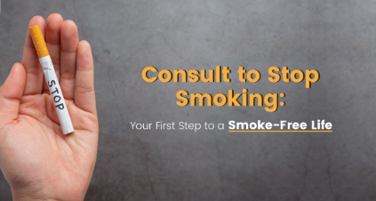
Figure 3: Consult to stop smoking
SmokeFree AI+ will promote smoking cessation through providing continuous and personalised support rather than generic recommendations. According to Krukowski et al. (2024), utilisation of behavioural change techniques including personalised feedback, self-monitoring and realistic goal setting would encourage smokers to consistently maintain smoking-free behaviours. Thus, this SmokeFree AI+ will measure heart rate, blood sugar and physical activity, which will help users to monitor the health benefits of quitting smoking and improve quality of life.

Impact of the modified digital technology in health promotion
Advantages
- SmokeFree AI+ would facilitate AI-driven personalisation, real-time coaching, and continuous monitoring.
- As compared to the previous one, this modified version will provide personalised interventions, which will improve quit rates.
- Wearable devices reduce healthcare costs associated with smoking-related cardiovascular diseases (Di Palo et al. 2026; Qureshi et al. 2023).
Limitations
- The wearable application requires access to large volumes of users' personal data, which might create privacy concerns, and requires compliance with the UK GDPR Act (UK.GOV, 2026).
- AI systems might also generate biased recommendations.

How can this shortfall be addressed?
These limitations can be addressed through implementing strong data encryption, regular algorithm audits, and transparent AI governance to minimise biased information. Additionally, digital literacy training programmes through community groups through GP practices would improve older adults' confidence in using digital health technologies such as SmokeFree AI+.

References
Bhadania, M., Yadav, S., Mathur, A., Acharya, A. and Mehta, V. 2025. Mapping the effectiveness of digital health interventions in promoting electronic cigarette cessation: a systematic review and meta-analysis of randomized controlled trials. BMC Public Health, 25(1), p.3645. Available at: https://doi.org/10.1186/s12889-025-24990-5. Accessed 17th July 2026.
Cobos-Campos, R., Cordero-Guevara, J.A., Apiñaniz, A., de Lafuente, A.S., Ampudia, C.B., Escudero, J.A., Llanos, I.P. and Diez, N.P., 2023. The impact of digital health on smoking cessation. Interactive Journal of Medical Research, 12(1), p.e41182. Available at: https://doi.org/10.2196/41182. Accessed 17th July 2026.
Di Palo, M.P., Amato, M., Vecchione, C., Ciccarelli, M., Garofano, M., Di Spirito, F., Mignogna, M.D., Corallo, F., Pagano, M., Cappadona, I. and Pessolano, C., 2026, July. Wear-Smile: A Multidisciplinary Telemedicine-Based Smoking Cessation Program Assisted by Wearable Monitoring Devices for Persons Who Smoke—Protocol for a Randomized Controlled Trial. In Healthcare (Vol. 14, No. 14, p. 2055). MDPI. Available at: https://doi.org/10.3390/healthcare14142055 Accessed 17th July 2026.
Jackson, S., Kale, D., Beard, E., Perski, O., West, R. and Brown, J. 2024. Effectiveness of the offer of the smoke free smartphone app compared with no intervention for smoking cessation: pragmatic randomized controlled trial. Journal of Medical Internet Research, 26, p.e50963. Available at: https://doi.org/10.2196/50963 Accessed 17th July 2026.
Krukowski, R.A., Denton, A.H. and König, L.M., 2024. Impact of feedback generation and presentation on self-monitoring behaviors, dietary intake, physical activity, and weight: a systematic review and meta-analysis. International Journal of Behavioral Nutrition and Physical Activity, 21(1), p.3. Available at: https://doi.org/10.1186/s12966-023-01555-6 Accessed 17th July 2026.
Liu, X., Zhang, H., Li, H. and Xue, F., 2025. Cardiovascular-kidney-metabolic syndrome modifies smoking-related risk for cardiovascular diseases: findings from an observational cohort study in UK Biobank. BMC Public Health, 25(1), p.1609. Available at: https://doi.org/10.1186/s12889-025-22865-3 Accessed 17th July 2026.
NHS.UK. 2026a. Explore your support options. [Online]. Available at: https://www.nhs.uk/better-health/quit-smoking/ready-to-quit-smoking/explore-your-support-options/ Accessed 17th July 2026.
ONS. (2025). Adult smoking habits in the UK: 2024. [Online]. Available at: https://www.ons.gov.uk/peoplepopulationandcommunity/healthandsocialcare/healthandlifeexpectancies/bulletins/adultsmokinghabitsingreatbritain/2024. Accessed 17th July 2026.
Qureshi, F.M., Golan, R., Ghomeshi, A. and Ramasamy, R., 2023. An update on the use of wearable devices in men’s health. The world journal of men's health, 41(4), p.785. Available at: https://doi.org/10.5534/wjmh.220205. Accessed 17th July 2026.
Raleigh, V., Jefferies, D. and Wellings, D., 2022. Cardiovascular disease in England. Fund TK (ed).
UK.GOV. 2026. The UK's data protection legislation. [Online]. Available at:https://www.gov.uk/data-protection. Accessed 17th July 2026.
Zhang, S., Jiang, Z., Zhang, H., Liu, Y., Qi, J., Yan, Y., Wang, T. and Zeng, P. 2024. Association of cigarette smoking, smoking cessation with the risk of cardiometabolic multimorbidity in the UK Biobank. BMC Public Health, 24(1), p.1910. Available at: https://doi.org/10.1186/s12889-024-19457-y Accessed 17th July 2026.

