MA Criminal Justice and Policing
Dissertation proposal 2026
BMCJ7009D

Student Name: Hossam Rashwan
Student Number: 2518525
__________________________________________________________________
Research Question
How effective are modern security measures in preventing the supply of illicit drugs into prisons in England and Wales?
____________________________________________________________________________________
Research Aim
This research aims to critically examine the effectiveness of modern prison security measures in disrupting the supply of illicit drugs into prisons in England and Wales. It will evaluate current prevention strategies, consider the evolving methods used by offenders to circumvent security, and identify recommendations for improving policy and operational practice.
Research Objectives
- Examine the extent of illicit drug supply within prisons in England and Wales.
- Identify the main methods used to smuggle drugs into prisons.
- Evaluate the effectiveness of current security measures, including body scanners, X-ray scanners, drug detection dogs, drone detection systems, mail screening, intelligence-led searching, and staff training.
- Examine how organised crime groups adapt to overcome prison security measures.
- Recommend improvements to prison security and drug reduction strategies

__________________________________________________________________
Literature Review:

Introduction
The supply and use of illicit drugs within prisons in England and Wales remains a significant challenge for the criminal justice system, undermining prison security, staff safety and the effective rehabilitation of offenders (HM Chief Inspector of Prisons, 2025). Despite the introduction of modern security measures to prevent drug trafficking, illicit substances continue to enter prisons through increasingly sophisticated smuggling methods. This raises important questions regarding the effectiveness of existing security strategies. Consequently, this literature review critically examines the current evidence to evaluate these measures and identify gaps that justify further research.
The Scale of the Problem
Building upon these concerns, the scale of illicit drug use within prisons highlights the complexity of the challenge facing the criminal justice system. New Psychoactive Substances (NPS), particularly synthetic cannabinoids known as Spice, remain highly prevalent within custodial environments (Mason et al., 2022). Their availability is associated with increased violence, prison disorder and reduced rehabilitative opportunities, demonstrating that drug supply represents more than a security issue. Therefore, reducing the availability of illicit substances has become a national priority.
While synthetic cannabinoids such as Spice remain prevalent within prisons in England and Wales, contributing to violence, self-harm, healthcare pressures and wider prison disorder, as Abbott et al,( 2023) highlighting ongoing challenges in effectively identifying and disrupting these substances, a significant gap exists within current responses, as limitations in intelligence-led drug detection and forensic capability may allow emerging substances and evolving trafficking methods to remain undetected, raising questions regarding the effectiveness of existing preventative measures.
Methods of Drug Smuggling
Despite increased efforts to disrupt prison drug markets, existing literature highlights that organized crime groups continue to exploit multiple vulnerabilities within custodial environments. Illicit substances enter prisons through a range of pathways, including visitors, postal systems, perimeter breaches, staff corruption, drones and prisoner movements (Norman, 2022). The diversity and adaptability of these supply routes demonstrate the complexity of preventing drug infiltration and raise important questions regarding whether current security measures are sufficiently responsive to evolving methods of trafficking.
The effectiveness of prison security measures is further challenged by the adaptive nature of organised crime groups, which continually modify their methods in response to enforcement strategies (Gooch and Treadwell, 2024). As traditional supply routes become restricted, criminal networks exploit emerging vulnerabilities and technological developments to maintain drug distribution. This ongoing adaptation creates a persistent challenge for prison authorities, highlighting the need to evaluate whether current security measures can effectively respond to evolving trafficking methods.

Current Security Measures
In response to increasingly sophisticated smuggling methods, prisons in England and Wales have adopted a range of security technologies designed to detect and prevent the supply of illicit drugs (Prison Reform Trust (2023). These include body scanners, X-ray scanners, BOSS chairs, hand-held metal detectors, drug detection dogs and intelligence-led searching. Collectively these measures are reported to have enhanced the identification of concealed contraband, strengthened targeted searching and improved the overall capability of prison authorities to disrupt drug trafficking within custodial environments.
However, the literature questions the long-term effectiveness of these security measures, arguing that organised crime groups rapidly adapt to enforcement strategies. Despite advances in body scanners, mail screening technologies, drug detection dogs and drone detection systems, operational limitations and evolving smuggling techniques continue to undermine their effectiveness (House of Commons, 2026). Criminal networks frequently exploit alternative supply routes, while technological measures require continual updates and consistent implementation to remain effective, highlighting the ongoing challenge of preventing illicit drug supply within prisons.
Given these conflicting findings, further research is required to evaluate the extent to which current security measures remain effective against increasingly adaptive methods of drug trafficking within prisons in England and Wales.
Gaps in Current Research
Existing literature suggests that integrating multiple security measures, including advanced screening technologies, intelligence-led searching and specialist drug reduction units, strengthens prison security by creating complementary layers of protection against illicit drug supply (Leese and Bell, 2019). However, evidence evaluating the collective effectiveness of these measures as an integrated security strategy remains comparatively limited.
Building on this limitation, existing research consistently characterises organised crime groups as highly adaptive, agile and technologically responsive, enabling them to modify their methods in response to evolving enforcement strategies (Synnott, 2026). This suggests that criminal networks may exploit emerging vulnerabilities more rapidly than prison security can adapt. Nevertheless, comparatively little research has critically examined whether the pace of security innovation is sufficient to counter these continually evolving trafficking methods.
Furthermore, while significant investment has been directed towards technological solutions, questions remain regarding whether these interventions achieve sustained reductions in prison
drug supply. The National Audit Office (2026) highlights that although measures such as X-ray body scanners can disrupt traditional smuggling routes, organised crime groups frequently adapt by exploiting alternative methods, including drone-enabled deliveries. This suggests that technological advancement alone may have limited long-term impact without continuous adaptation of wider security strategies.
____________________________________________________________________________________
Methodology
Research Design
This study will adopt a mixed qualitative research design, combining primary empirical research with secondary data analysis. According to Biggam (2026), combining primary and secondary streams provides a comprehensive framework for linking existing policy knowledge with local field realities. This approach is highly appropriate for the current study as it pairs the critical evaluation of academic literature, government reports, and policy documents with first-hand empirical data collected directly from frontline operational practitioners.

Sample and Participants
The primary empirical element of this study will use purposive sampling to recruit active, frontline prison officers serving within the HM Prison Service estate in England and Wales. The targeted sample size will consist of approximately 6 to 8 prison officers to ensure deep, data-rich qualitative insights. Participants will be recruited through open invitations distributed via professional operational networks or direct prison service liaison. Semi-structured interviews will be conducted either remotely via secure digital platforms or face-to-face, focusing explicitly on officers' frontline perspectives regarding drug supply methods, organised crime adaptation, and the real-world operational challenges of deploying modern technological security measures.

Data Sources
This study uses a combination of primary empirical data and authoritative secondary data sources to examine the prison drug crisis. Primary qualitative data will be collected directly through semi-structured interviews with active prison officers, capturing frontline operational perspectives on security measures. Secondary data is drawn primarily from official government publications, statistical releases, and policy documents produced by the Ministry of Justice and HM Prison and Probation Service. To ensure an independent and balanced analysis, these sources are supplemented with field inspection reports and thematic reviews from HM Inspectorate of Prisons, the Independent Monitoring Boards, and the National Audit Office. Relevant academic journal articles are also included to provide theoretical and analytical perspectives. Secondary sources were selected using inclusion criteria requiring publication primarily between 2015 and 2026, direct relevance to prison drug-related issues, and high credibility.

Analysis
This study will employ Braun and Clarke’s (2006) foundational six-phase framework for Thematic Analysis to systematically code and interpret the compiled data corpus. This analytical approach is highly appropriate for a mixed design as its theoretical flexibility allows for the integrated synthesis of both primary data (verbatim qualitative interview transcripts) and secondary data (academic literature, official watchdog inspection reports, and policy documents). The primary transcripts and secondary texts will be structurally coded to identify, cross-examine, and report recurring patterns. The analysis will explicitly focus on synthesising core operational themes, including: frontline drug supply methods, the effectiveness of technological security, organised crime adaptation, institutional challenges, and policy recommendations.

Ethics
Primary qualitative research introduces human participants, requiring first-stage ethical clearance from the University Research Ethics Committee alongside formal operational vetting and approval through the HMPPS National Research Committee (NRC). Officers will receive detailed information sheets, and written informed consent is mandatory prior to any interview. Absolute confidentiality and anonymity are paramount due to prison security sensitivities; no participant names, defining characteristics, or specific establishment locations will be disclosed. Finally, all audio recordings and verbatim transcripts will be safely stored on encrypted, password-protected digital servers in strict compliance with the Data Protection Act 2018.
_____________________________________________________________
Proposed timeline
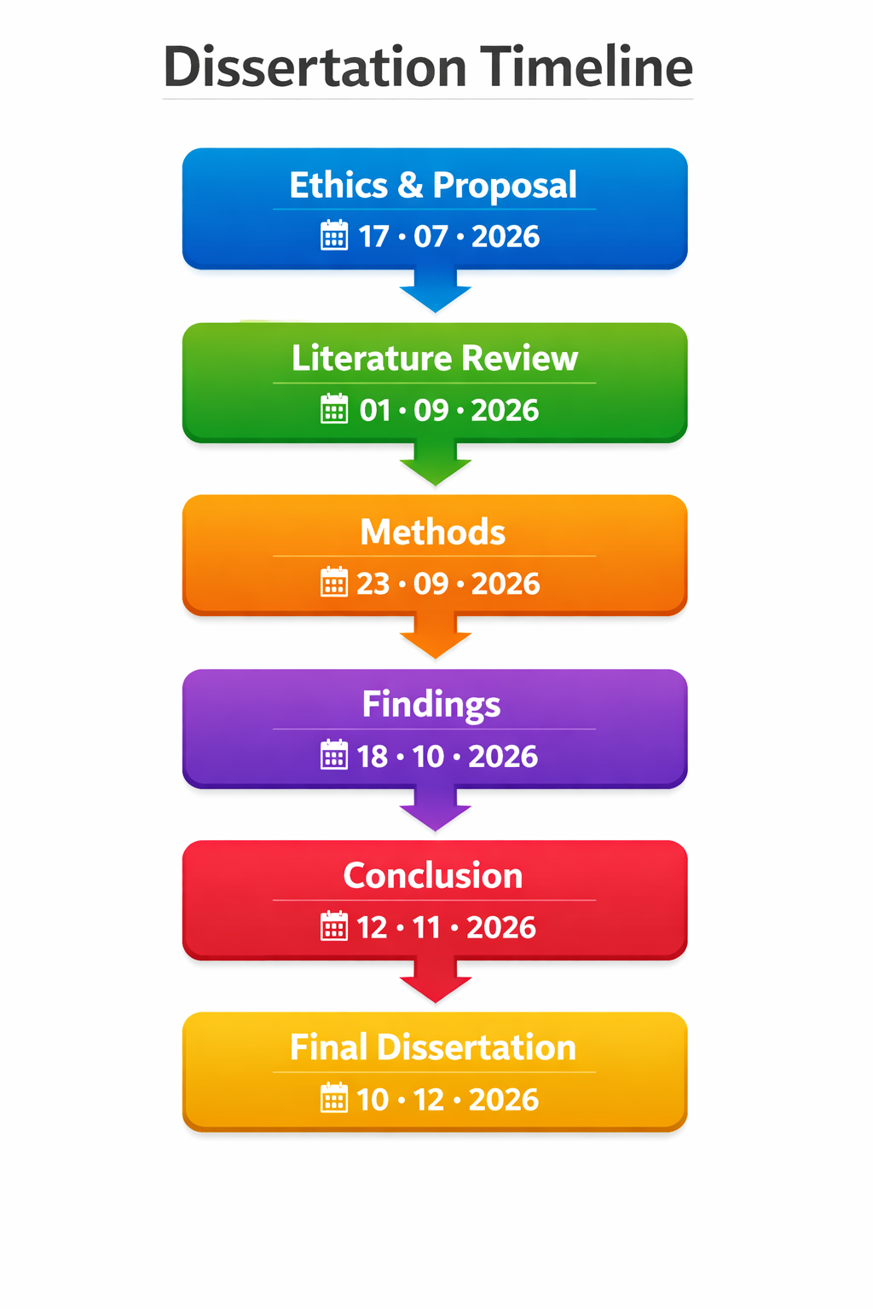

Anticipated Outcomes:
It is anticipated that this research will demonstrate that modern prison security measures have enhanced the detection and disruption of illicit drug supply through improved screening technologies, intelligence-led searching and targeted interventions. However, the findings may also indicate that these measures have not completely eliminated drug availability, as organised crime groups continue to adapt their methods and exploit emerging vulnerabilities. Therefore, the research is expected to suggest that no single technological solution is sufficient in isolation and that effective prevention requires a coordinated approach combining technology, intelligence and operational practice.

The anticipated findings may contribute to prison policy development by identifying areas where security strategies could be strengthened, including investment decisions, staff training and intelligence-led approaches. Ultimately, this study aims to contribute to wider discussions regarding the balance between technological innovation and operational intelligence in reducing the availability of illicit drugs within prisons in England and Wales.

__________________________________________________________________
References
Abbott, Mia Jane, et al. “The Identification of Synthetic Cannabinoids in English Prisons.” Forensic Science International, vol. 348, July 2023, p. 111613, 10.1016/j.forsciint.2023.111613. Accessed 11 July 2026.
Anna. “Braun&Clarke(2006).” Scribd, 2026, https://www.scribd.com/document/825087809/braun-clarke-2006. Accessed 14 July 2026.
Biggam. “Shibboleth Authentication Request.” Oclc.Org, 2026, https://r4-vlebooks-com.uwtsd.idm.oclc.org/reader?ean=9780335253661. Accessed 14 July 2026.
Gooch, Kate, and James Treadwell. “The Prison Firm: The ‘Transportation’ of Organised Crime, the Evolution of Criminal Markets and Contemporary Prisoner Society.” Criminology & Criminal Justice, vol. 25, no. 1, 23 July 2024, 10.1177/17488958241261802.
HM Chief Inspector 2025. “Chief Inspector: Overwhelming Ingress of Illegal Drugs Is Destablising Prisons and Preventing Rehabilitation – HM Inspectorate of Prisons.” Justiceinspectorates.Gov.Uk, HM Chief Inspector, 7 July 2025, https://hmiprisons.justiceinspectorates.gov.uk/news/chief-inspector-overwhelming-ingress-of-illegal-drugs-is-destablising-prisons-and-preventing-rehabilitation/. Accessed 11 July 2026.
House of Commons 2026. “Tackling the Drugs Crisis in Our Prisons.” Parliament.Uk- Justice Committee, 2026, https://committees.parliament.uk/publications/50009/documents/269349/default/. Accessed 12 July 2026.
Leese, M, and V Bell. A Mixed Methods Study of Increased Security Measures in a Drug Recovery Prison. 2019, https://research.tees.ac.uk/en/publications/a-mixed-methods-study-of-increased-security-measures-in-a-drug-re/
Mason, Rachael, et al. “New Psychoactive Substances and Violence Within a UK Prison Setting.” Substance Use & Misuse, vol. 57, no. 14, 21 Oct. 2022, pp. 1–5, 10.1080/10826084.2022.2129999.
National Audit Office. The Costs of Tackling Drug Harms in Prisons. 4 Feb. 20026.
Norman, Caitlyn. “A Global Review of Prison Drug Smuggling Routes and Trends in the Usage of Drugs in Prisons.” WIREs Forensic Science, vol. 5, no. 2, 1 Nov. 2022, https://wires.onlinelibrary.wiley.com/doi/full/10.1002/wfs2.1473. Accessed 11 July 2026.
Prison Reform Trust 2023. Prison Reform Trust Advice and Information Service Searching in Prison Searching of the Person. Aug. 2023, https://prisonreformtrust.org.uk/wp-content/uploads/2020/12/25-Searching-in-prison-info-sheet.pdf. Accessed 12 July 2026.
Synnott, John. Reframing the Response to Serious and Organised Crime: Nationally Developed, Locally Delivered. Apr. 2026, https://pure.hud.ac.uk/ws/portalfiles/portal/141530655/Reframing_the_Response_to_Serious_and_Organised_Crime_.pdf.

