Case study detailing healthcare inequalities faced by Gypsy, Roma, and Traveller communities in Britain

Introduction
This case study aims to gather data in preparation for an essay detailing issues and potential strategies to be employed for social change. The topic in question is health inequalities faced by Gypsy, Roma, and Traveller (GRT) communities, and whether subtle or unsubtle racisms has an impact on their healthcare. Using statistics and data collected by the UK government (Women and Equalities Committee, 2019), the National Health Service (NHS, n.d.), and Traveller specific charities and organisations (The Traveller Movement, 2017), amonst others (Civica, 2018), this piece aims to collate the data to offer an overview of healthcare inequalities faced by the GRT communities and potential causes for those inequalities. This topic is particularly pertinent at the moment due to proposed legislation to criminalise trespass and penalise travelling communities in a disproportionate manner (Rowett, 2021).
Background History
GRT people have been recorded in England from the year 1514, with the term “Gypsy” being used to describe travelling people (UK Parliament, 2019). This is a bastardised term for Egyptian due to a misconception that these nomadic people originated from Egypt though records suggest they arrived from the Indian subcontinent (UK Parliament, 2019). GRT communities have historically faced persecution, including a British law allowing the state to imprison or even execute anyone perceived to be from a travelling community, approximately one quarter of the European Roma population being murdered in the Holocaust, and every modern EU state has had anti-GRT laws at some point in time (UK Parliament, 2019).
Data Sources
Women and Equalities Committee’s report on Tackling Inequalities faced by Gypsy, Roma, and Traveller Communities (2019)
This study set out to explore issues effecting GRT communities, other than issues of accommodation that government policies often focus on (Women and Equalities Committee, 2019). Topics examined within this report include health care, education, employment, hate crime and criminal justice, all of which it is shown that GRT communities have the worst outcomes in (Women and Equalities Committee, 2019). Historic and ongoing discrimination towards GRT communities has led to a huge lever of mistrust between GRT people and public services (Women and Equalities Committee, 2019). Some key points from the report are as follows –
- The 2011 census for Wales and England showed that the number of GRT people who reported their health as “bad” or “very bad” was more than twice as high as those within the white British group (see table 1)
- GRT people are less likely to be satisfied with access to a GP and the service they receive than those within the white British group.
- Life expectancy for GRT people is 10 to 12 years lower than the general population.
- 18% of the general population are affected by long term conditions, within GRT communities this percentage is 42%.
- One in five GRT child bearers will experience child loss, whereas one in a hundred non-GRT child bearers experience this.
Table 1: Overall health variations categorized by ethnicity, in England and Wales 2011
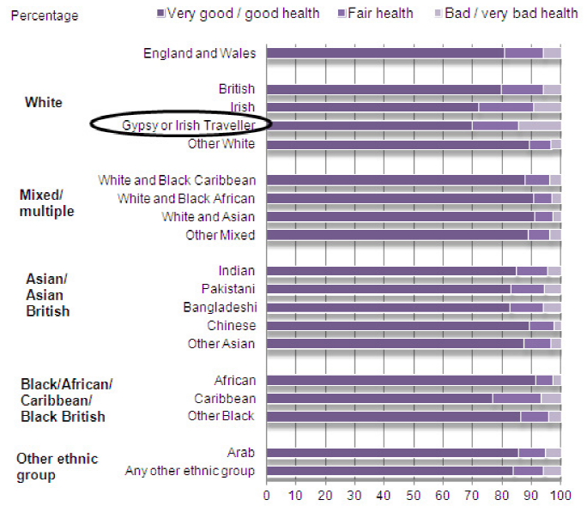
The Traveller Movement “The Last Acceptable Form of Racism?” Report (2017)
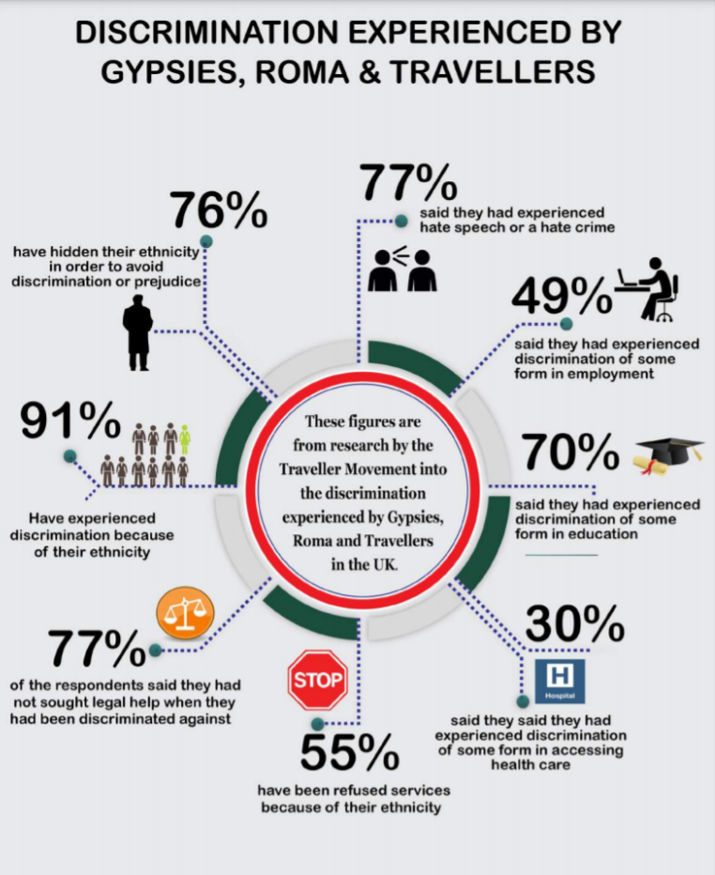
The Traveller Movement (2017) report studies the responses of 214 GRT community members to a survey conducted UK wide. This report details the magnitude of prejudice, injustice and discrimination faced by the GRT community across a range of services and fields. Here are a few key notes from the report –
- 91% of participants have experienced discrimination simply because of their ethnicity.
- 30% of participants have suffered discrimination regarding accessing health care.
- 76% of participants had concealed their ethnicity in the hopes of avoiding prejudice and discrimination.
- Multiple reports of difficulty accessing health care (including vaccinations) due to being of no fixed abode.
- Participants described being ill-treated by staff at GP surgeries due to their ethnicity.
- With regard to seeking help for discrimination they faced, some participants expressed that the treatment they received made them feel worse.
The National Health Service
When searching the NHS website for data on the GRT community and what the NHS is doing about the disproportionate level of health care they receive, very little can be found. There is one relatively short page detailing health inequalities faced by GRT communities and potential actions to be taken to combat this (NHS, n.d.). Here are a few key notes from the web page –
- GRT communities have a significantly lower life expectancy than settled communities, citing a study in Leeds that found that the difference was 28 years.
- There is a higher maternal and infant mortality rate within GRT communities, with a study suggesting that the mortality rate was 4 times higher for GRT people than the general population in Ireland.
- A low level of child immunisations with an increasing risk of vaccine preventable disease.
- Poor dental health within GRT communities with low dental registration.
- Potential actions to combat these issues included: developing minimum standards of courtesy for all health care staff, simplifying registration such as GP and dental (including allowing care of addresses), enhancing GRT people’s health literacy, providing flexible services, and increasing collaborative work with organisations with already trusted relationships with GRT communities.
Civica web page “How can we bridge the gap?” (2018)
This webpage is an overview of what the writer learned after attending the annual conference organised by the Traveller Movement. Key points raised within this piece are –
- The NHS does not include GRT categories in their data dictionary.
- Suicide rates are six times higher within GRT communities and is seven times higher among young GRT men.
- The first step to improvement should be conversation, going to talk to people who need help and support and finding a way to make it happen.
- There has been an increase in mental health issues among GRT communities.
- Cultural awareness training should not be simply a tick box exercise, and special training should not need to be provided simply to gain equality. “Members of these communities are not asking for special treatment, they are seeking equality” (Civica, 2018)

Conclusion
In conclusion, it is unquestionable that GRT communities suffer discrimination and inequality when it comes to health care. Correlations can be made and expanded upon within the essay using this data, such as GRT facing difficulties in accessing vaccinations for their children (The Traveller Movement, 2017) and the NHS suggesting that GRT children are at a higher risk for vaccine preventable diseases (NHS, n.d.). Within the essay further analysis may be explored into whether the racism and discrimination faced by GRT communities directly affects their access to health care and their health overall. All sources collected here offer potential actions to combat these inequalities, more in-depth research within the essay can examine the possible effectiveness of these actions and how effective they may be.

References
Civica, 2018. How Can we Bridge the Gap? - Health Inequalitites for Gypsy, Roma and Irish Travellers. [Online]
Available at: https://www.civica.com/en-gb/container---insights-library/how-can-we-bridge-the-gap--health-inequalities-for-gypsy-roma-and-irish-travellers/
[Accessed 18 April 2021].
NHS, n.d. Improving Uptake and Delivery of Health Services to Reduce Health Inequalities Experienced by Gypsy, Roma, and Traveller People. [Online]
Available at: https://www.england.nhs.uk/ltphimenu/improving-access/improving-uptake-and-delivery-of-health-services-to-reduce-health-inequalities-experienced-by-gypsy-roma-and-traveller-people/
[Accessed 18 April 2021].
Rowett, C., 2021. Criminalising Trespass: Why Should We be Worried?. [Online]
Available at: https://greenworld.org.uk/article/criminalising-trespass-why-should-we-be-worried
[Accessed 05 March 2021].
The Traveller Movement, 2017. The Last Acceptable Form of Racism? The Pervasive Discrimination and Prejudice Experienced by Gypsy, Roma and Traveller Communities, London: The Resource Centre.
UK Parliament, 2019. What we Know About Inequalities Facing Gypsy, Roma and Traveller Communities. [Online]
Available at: https://publications.parliament.uk/pa/cm201719/cmselect/cmwomeq/360/report-files/36005.htm
[Accessed 18 April 2021].
Women and Equalities Committee, 2019. Tackling Inequalities Faced by Gypsy, Roma and Traveller Communities, London: House of Commons.

