

Assessment Component 1: Support Paper

Student Name: Safa Ahmed
Student ID: 2124319
Model Name: Mental Disorders and Psychopathology.
Model code: BMHP6006.
Lecturer Name: Bianca Sanfilippo

Introduction
This report discusses post-traumatic stress disorder (PTSD). PTSD within the ICD-10 manual, its causes, and common causes. Here you will find a description of the symptoms, signs, diagnosis, historical perspectives on PTSD treatments, and current practices for working with people suffering from PTSD. PTSD is a mental health condition characterized by intrusive thoughts, nightmares, and flashbacks. Common causes of PTSD include military combat, accidents, natural disasters, and childhood trauma. Treatment for PTSD typically includes psychotherapy, medication, and lifestyle changes.
Definition
According to the Royal College of Psychiatrists (2021) Post-traumatic stress or PTSD is a mental health condition that can occur after experiencing or witnessing a traumatic event. This might have an adverse effect on someone's mental, physiological, social, and spiritual well-being and be perceived as emotionally or physically damaging or even fatal. Natural catastrophes, catastrophic accidents, terrorist attacks, war and conflict, rape and sexual assault, historical trauma, violence against intimate partners, and bullying are a few examples. For example, people who have gone through a traumatic event such as a natural disaster or war may experience nightmares, flashbacks, intrusive thoughts, difficulty sleeping, difficulty concentrating, and feeling emotionally numb or isolated. PTSD can be classified into several types: Acute Stress Disorder (ASD): While PTSD is typically diagnosed four weeks after a trauma, acute stress disorder can be diagnosed immediately. Complex PTSD: Complex PTSD occurs when there is no co-occurring mental health disorder, such as anxiety or depression. In addition to the psychological effects of childhood abuse or neglect, complex PTSD can also result from interpersonal trauma that has been prolonged. However, 4 in 100 people suffer from PTSD at any one time and a further 1 in 10 people go on to experience PTSD at some point in their lives. PTSD can have long-term effects on an individual's mental health, as well as on their relationships with others. This includes children, women, and men. According to PTSD UK, between 50-70% of people will experience a traumatic event in their lives and 20% of those, will go on to develop the condition (The PROMIS Rehabilitation,2024).
Post-traumatic stress disorder within the ICD-10 Manual
Group: Neurotic, stress-related and somatoform disorders (F40-F48) Classification: F43.1 post-traumatic stress disorder.

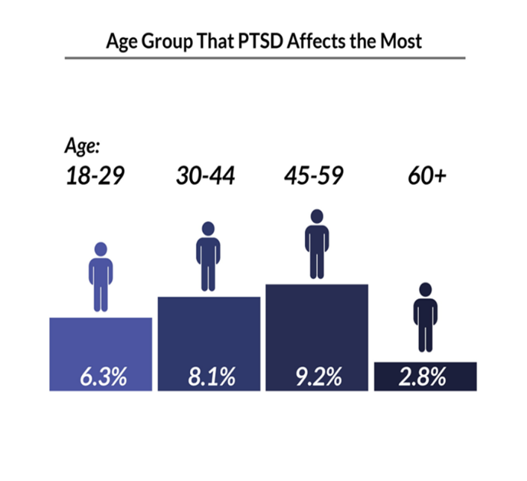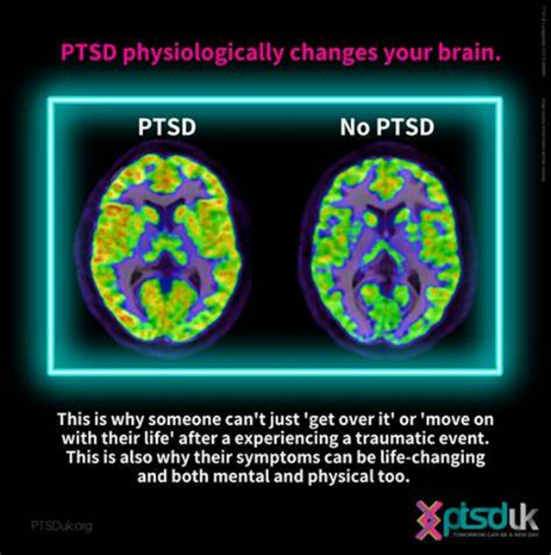

There are varying levels of severity associated with post-traumatic stress disorder (PTSD). In PTSD diagnosis, symptoms are classified as mild, moderate, and severe depending on how they affect the patient. The symptoms of mild PTSD may cause distress, but they do not significantly impair daily functioning. People who suffer from this condition may occasionally experience intrusive thoughts, nightmares, or increased anxiety. Moderate PTSD: Moderate cases involve more pronounced symptoms that interfere with daily life. Severe PTSD: Severe PTSD significantly disrupts a person’s well-being. Symptoms are intense, persistent, and may lead to severe distress, impaired relationships, and challenges in work or social settings (Mind, 2021).
Causes
When someone experiences or is exposed to an extremely stressful event such as death or the threat of death, serious injury, or sexual abuse, they can develop PTSD. PTSD can cause a person to feel anxious, angry, and scared. It can also lead to difficulty sleeping, nightmares, and flashbacks. Treatment for PTSD usually involves a combination of psychotherapy and medication (Krouse, 2023).
Symptoms
After a traumatic event, symptoms of post-traumatic stress disorder may begin within months, but they can appear years later as well. There are four general types of PTSD symptoms: intrusive memories, avoidance, negative changes in thinking and mood, and changes in physical and emotional reactions. For instance, intrusive memories can include flashbacks of the traumatic event, nightmares, and intrusive thoughts.
Clinical interview is one of the ways to diagnose PTSD During a clinical interview for diagnosing PTSD, a mental health professional will typically ask the individual about their traumatic experiences, symptoms, and any related distress. They may also inquire about the duration and intensity of the symptoms, as well as any functional impairments. The purpose of the interview is to gather information and assess whether the individual meets the criteria for a PTSD diagnosis according to the Diagnostic and Statistical Manual of Mental Disorders (DSM-5). Moreover, CT scan: To check for abnormalities in the brain. A blood test can detect any infections or drugs that may be causing the problem. A CT scan can image the brain and show any abnormalities that may be causing the problem (National Institute Health & Care Excellence, 2023).
Helpful Link: https://www.psychiatry.org/patients-families/ptsd/what-is-ptsd#section_5
Historical view and treatments for PTSD
According to the Trauma Dissociation (2024) PTSD was first diagnosed in the early part of the twentieth century by Russian army doctors who labelled it "battle shock". After World War I, American doctors diagnosed the same problem in soldiers and called it "shell shock". As a result of the PTSD concept, a significant change occurred: it stipulated that the etiological agent was external to the individual (i.e., traumatic events) rather than an internal weakness. In addition to veteran, feminist, and Holocaust survivor advocacy groups, PTSD became a diagnosis. For example, the National Women's Health Network, which was founded in 1975, was an early advocate for recognizing PTSD as a diagnosis for women who have experienced trauma, such as rape or domestic violence. The historical treatments for PTSD included psychotherapy, medication, and lifestyle changes. In modern times, a variety of treatment options are available, including cognitive behavioural therapy, exposure therapy, and medication. Also, early treatments included the use of hypnotism, electric shock therapy, and drug therapy. For instance, hypnotism was used to "rewire" the brain to reduce symptoms of PTSD, while electric shock therapy was used to cause unpleasant memories and emotions to reduce anxiety.
Current treatment from NHS
Mild PTSD symptoms or symptoms lasting less than 4 weeks require active monitoring. 2 in 3 individuals recover within weeks post-trauma. Follow-up within a month is important. For PTSD treatment, talk therapies are usually the first recommended option. For severe or persistent PTSD, a combination of therapy and medicine may be suggested. You can consult your GP, who can refer you to an NHS talking therapies service or a specialist clinic. Alternatively, you can refer yourself directly to an NHS service. However, today there are various of Charities such as Combat Stress, Rape Crisis, Victim Support, and CRUSE offer support and advice to individuals with PTSD. Paroxetine and sertraline are two recommended medicines for treating PTSD in adults (National Health Service, 2022).
Principles when working with people with PTSD.
Empathy is crucial in working with people with PTSD, providing a safe environment for healing and building trust. Clear boundaries, patience, and flexibility are also important. The 6Cs approach (care, concern, compassion, courage, communication, and commitment) is also key in providing emotional support to individuals with PTSD. is key in providing emotional support, as each person requires a personalized approach. A safe space for expressing emotions is essential (National Institute for Health and Care Excellence, 2023)
Recommendations and Conclusion
People who have experienced PTSD can benefit from self-care activities like regular exercise, getting enough sleep, and practicing relaxation techniques such as deep breathing or meditation. Establishing a support network and seeking professional help when needed is also important, as managing PTSD can be a challenging journey. It is essential to take proactive steps to maintain mental health. Additionally, creating a safe space for individuals to express their emotions and feelings is crucial.

References
Krouse, L. (2023) What Is Post-Traumatic Stress Disorder (PTSD)? Available At: Https://Www.Verywellhealth.Com/What-Is-Ptsd-5084527#Toc-Types-Of-Ptsd (Accessed: 02 April 2024).
Mind (2021) Post-Traumatic Stress Disorder (PTSD). Available At: Https://Www.Mind.Org.Uk/Information-Support/Types-Of-Mental-Health-Problems/Post-Traumatic-Stress-Disorder-Ptsd-And-Complex-Ptsd/Symptoms/ (Accessed: 21 March 2024).
National Institute Health and Care Excellence (2023) When Should I Suspect Post-Traumatic Stress Disorder (PTSD)? Available At: Https://Cks.Nice.Org.Uk/Topics/Post-Traumatic-Stress-Disorder/Diagnosis/Diagnosis/#Differential-Diagnosis (Accessed: 13 April 2024).
National Health Service (2022) Treatment - Post-Traumatic Stress Disorder. Available At: Https://Www.Nhs.Uk/Mental-Health/Conditions/Post-Traumatic-Stress-Disorder-Ptsd/Treatment/ (Accessed: 23 February 2024).
National Institute for Health And Care Excellence (2023) When Should I Suspect Post-Traumatic Stress Disorder (PTSD)? Available At: Https://Cks.Nice.Org.Uk/Topics/Post-Traumatic-Stress-Disorder/Diagnosis/Diagnosis/#Differential-Diagnosis (Accessed: 02 April 2024).
Royal College of Psychiatrists (2021) Post-Traumatic Stress (PTSD). Available At: Https://Www.Rcpsych.Ac.Uk/Mental-Health/Mental-Illnesses-And-Mental-Health-Problems/Post-Traumatic-Stress-Disorder (Accessed: 25 March 2024).
Trauma Dissociation (2024) History Of PTSD And Trauma Diagnoses. Available At: Http://Traumadissociation.Com/Ptsd/History-Of-Post-Traumatic-Stress-Disorder.Html (Accessed: 25 March 2024).

Appendix: Power Point Presentation


