

Programme: BSc Health and Social Care
Module: Changemakers: Building your Personal Brand for Sustainable Employment
Module Code: BMHP 5015
Lecturer:
Assignment Title: component 1 Online Portfolio of Set Exercises

Student Name: Mina Khorshid
ID: 2122088

Table of Contents

Task 1 – Personal Brand 3

Task 2 - Network Map and Rationale 4

Task 3- Blog 5

Task 4- NHS Equality, Diversity and Inclusion Quiz 6

Task 5 - A Correspondence to myself 8

Task 6 – Gantt Chart 8

Task 7 - Modifications Report 10

Task 8 - Self-Assessment 10

Reference List: 12

Task 1 – Personal Brand
Personal branding is important for individuals to show off their skills, values and professional credentials to understand consumer perceptions of themselves and show what they are able to provide (Borman-Shoap, et.al,.2019).
My current personal brand is based on the skills I believe I exemplify like reliability, team working, problem solving, and determination towards growth. I find I organize myself and adapt to working in groups to a good capacity and having faced many challenges in the past, I find my ability to cope and manage problems to be very developed.
However, I still have areas which I believe I can nurture to be more well-rounded. My communication ability could improve alongside my confidence and leadership qualities. To do this, I need practice and exposure to more public speaking opportunities and feedback from team-based training. This sort of development will be exceedingly more important in a career with social care
Philbrick and Cleveland (2015), notes 6 steps any candidate can take to developing their personal branding, including understanding your brand, crafting your physical and digital footprint and communicating your message, all useful in developing a plan to improve on my shortcomings.
Developing my personal brand will help me become more whole and a stronger candidate for any opportunity in the future and will be crucial in securing any notable job opportunity in the future for long term success.

Task 2 - Network Map and Rationale

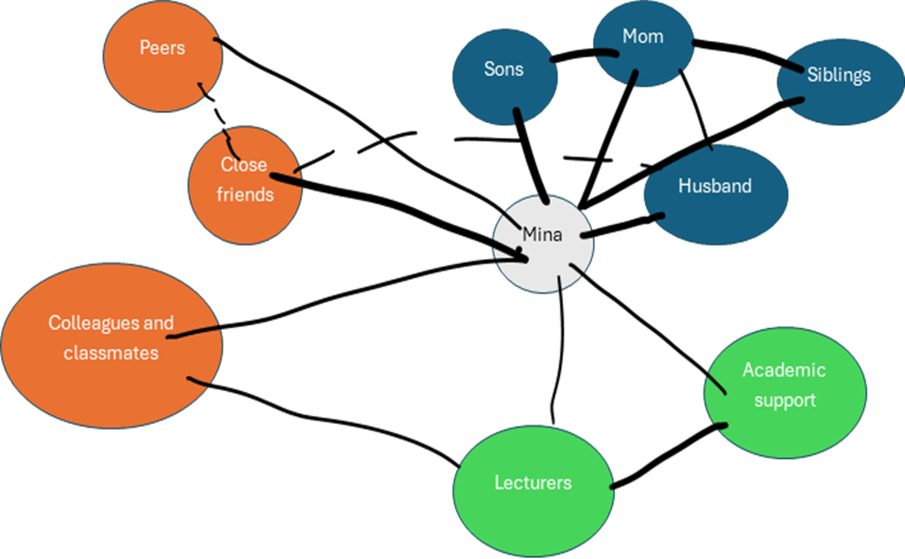
My personal network is built up of the interconnected roles of career, support, social, and community relationships, each giving their own aid in my personal development. My career network, especially my university lecturers and peers are essential for developing my knowledge, receiving feedback and in acquiring access to information for career development. Networking behaviour in this sense is linked to increased fulfilment and employability competency (Jacobs, S., 2019). enhancing future career development and opportunities which becomes incredibly relevant post-graduation.
More personally, my support network including family and close friends offer emotional stability and reliable support that are needed to withstand academic and long-term pressures, and relief from duties. However, while they are necessary for my personal wellbeing, they are limited in terms of professional development and must be balanced to tie into my career.
Social and community networks further create a sense of belonging and identity and develop soft skills like communication and teamwork. Innovation in research and practice oftentimes comes from interconnected academics who help further one another's career development (Ansmann,et,al,.2014). These help to strengthen my personal weaknesses (like my confidence) and further give a stable foundation for growth.

Task 3- Blog

Title: Mental health challenges amongst young adults

Introduction:
Mental health problems are rising amongst young adults, but access to effective and opportune care remains stagnant. Issues like anxiety, depression and other consequences of increased stress reign amongst people aged 18-25, often linked to academic pressure, employment uncertainty, social media, cost of living problems amongst others. Understanding these gaps in mental health services is necessary to drive change in support.

Growing demand:
Over recent years, referral to mental health services for young adults have risen considerably but services are struggling to keep up with the demand.
Many young people are dealing with increased rates of depression, suicidal behaviours, eating disorders, substance abuse, and many psychological problems that remain untreated (Jurewicz, I, 2015).
The rise in these conditions leads to further problems in these services with increased waiting times, limited availability and much more
Barriers to accessing care:
Many young people see barriers that prevent them from seeking help, such as:
-stigma around mental health
-lack of awareness of services
-inconsistent support
Individuals with clinical depressive symptoms report lower intentions to seek help often due to these barriers like stigma, accessibility or familial burdens (Baldofski, S., t, al,.2024).
Digital services like online counselling and mental health apps can improve access but they aren't suitable for all people and shouldn't replace face-to-face counselling.
Conclusion:
Mental health services for young adults need greater investment, accessibility, and awareness of their existence. By raising this awareness and challenging stigma we can help ensure young people receive the care they need when they need it. If this issue matters to you then consider learning more, sharing resources and making a stand for mental health in your community.

Task 4- NHS Equality, Diversity and Inclusion Quiz

1. What is the primary goal of the NHS Equality, Diversity, and Inclusion Improvement Plan?
The principal objective of the strategy is to enhance equality, diversity, and inclusion within the NHS workforce and to fortify staff's sense of belonging, hence improving their workplace experience (NHS England, 2023).32
2. How does the NHS EDI Improvement Plan propose to tackle the gender pay gap? The primary aim of the strategy is to improve equality, diversity, and inclusion within the NHS workforce and to strengthen staff's sense of belonging, hence enhancing their workplace experience (NHS England, 2023).32
3. What is meant by the term ‘intersectionality’ as used in the NHS EDI Improvement Plan? Intersectionality means that people may experience disadvantage in overlapping ways because of more than one part of their identity, such as race, gender, disability or age (NHS England, 2023).29
4. Why is it important for the NHS to create a psychologically safe work environment? A psychologically secure workplace enables employees to express concerns, report issues, and share ideas without fear of retribution or discrimination, hence enhancing wellbeing and care quality (NHS England, 2023).29
5. How does the NHS EDI Improvement Plan suggest improving the experience of internationally recruited staff? It advocates for improved induction, pastoral support, equitable career possibilities, and measures against discrimination to ensure that globally recruited personnel feel appreciated and supported within the workforce (NHS England, 2023).30

6. What role does leadership play in advancing EDI objectives according to the NHS Improvement Plan? It promotes enhanced induction, pastoral assistance, equal career opportunities, and anti-discrimination measures to ensure that globally recruited staff feel valued and supported in the workplace (NHS England, 2023).28
7. Identify one way the NHS EDI Improvement Plan aims to reduce health inequalities within the workforce.
Enhancing access to flexible employment and equitable opportunities facilitates the retention and advancement of employees from diverse backgrounds (NHS England, 2023).21
8. Why does the NHS EDI Improvement Plan emphasise the importance of collecting and analysing data on protected characteristics?
This is significant as data enables organisations to identify disparities, track progress, and direct assistance when prejudice or under-representation occurs (NHS England, 2023).23
9. Explain how flexible working policies can contribute to equality and inclusion in the NHS workforce.
Flexible working accommodates employees with caregiving obligations, disabilities, or health requirements, facilitating a broader spectrum of individuals to remain employed and feel engaged (NHS England, 2023).26
10. What is one strategy mentioned in the NHS EDI Improvement Plan to combat bullying and harassment in the workplace? Flexible working supports employees with caregiving responsibilities, disabilities, or health needs, enabling a wider range of persons to maintain employment and remain engaged (NHS England, 2023).26

Task 5 - A Correspondence to myself
Dear younger me,
I recognise that you are currently experiencing overwhelming emotions and are attempting to cope with pressure without fully comprehending your feelings. You repeatedly urge yourself to proceed, however emotional intelligence would have been more beneficial than feigning contentment. Had you devoted more effort to acknowledging your feelings, accurately labelling them, and comprehending their origins, you might have been less critical of yourself. Emotional intelligence does not entail constant emotional expression. It pertains to self-awareness, self-regulation, and comprehending the influence of emotions on behaviour.
Resilience would have also been impactful. At that time, you likely perceived resilience as the absence of struggle; yet it actually signifies the ability to adapt, recover, and persevere despite challenges. Masten (2001) characterises resilience as a commonplace attribute rather than an extraordinary one, which is significant since it implies that resilience may be cultivated by minor daily practices. Perfection was unnecessary. You required assistance, forbearance, and improved coping mechanisms.
If I may provide counsel, I would recommend engaging with others promptly, embracing assistance without remorse, and refraining from seeing every setback as evidence of failure. Practice pausing prior to responding, contemplate your needs, and extend compassion towards yourself during challenging times. These abilities would not have eliminated all issues, but they would have enabled you to address them with greater confidence and diminished self-doubt.
You possess greater strength than you comprehend; but true strength encompasses the willingness to seek assistance.

Task 6 – Gantt Chart
A Gantt chart has been utilised to outline the essential stages required to attain my future work objective in health and social care. The timeline is organised over a 12-month span, delineating tasks, duration, and advancement.
During the initial two months, the emphasis will be on self-evaluation and career exploration, encompassing the identification of employment positions, requisite qualifications, and essential skills. During months 2 to 4, I will focus on developing my CV and composing my personal statement, ensuring they accurately represent my talents, experiences, and career objectives.
During months 3 to 6, I will concentrate on skill enhancement, namely in communication, teamwork, and confidence, through volunteering, workshops, or online education. Simultaneously, I will initiate a job search and networking efforts, which will involve visiting career events and interacting with professionals.
During months 6 to 9, I will diligently submit job applications and prepare for interviews by practicing responses and enhancing presenting abilities. Ultimately, from months 9 to 12, I will assess feedback, enhance my strategy, and persist in my applications until job is attained.
This planned timeline aids in maintaining order, tracking progress, and sustaining concentration on the attainment of my career objectives.
Self-assessment & career research
████
CV & personal statement development
████
Skills development (training, etc.)
████ ████
Job searching & networking
████ ████ ████
Job applications
████ ████
Interview preparation
████ ████
Review & improvement

████ ████
Month 1-2 Month 3-4 Month 5-6 Month7-8 Month 9-10 Month 11-1

Task 7 - Modifications Report
Modification Report
As the manager of a care home, I would implement a new system for staff communication and handover. Inadequate communication can result in errors, inconsistent care, and staff frustration; hence, enhancing this aspect will advantage both personnel and residents. The objective is to implement a systematic handover template, concise daily briefings, and a more defined procedure for reporting issues
Lewin's change model is pertinent as it delineates change as a process of unfreezing, transitioning, and refreezing (Lewin, 1951). Initially, I would elucidate to the staff the necessity of the change by demonstrating how communication issues impact the quality of service. The unfreezing phase is crucial for fostering awareness and diminishing resistance. I would thereafter implement the new handover process, deliver training, and allocate time for personnel to exercise it. This stage necessitates robust communication, leadership, and problem-solving skills. The new approach will be routinely evaluated and integrated into daily operations to establish it as standard practice.
Kotter (1996) emphasises the significance of establishing urgency, engaging stakeholders, and maintaining change. I would engage senior carers and nurses in the preparation of the new approach to ensure that personnel feel involved rather than subordinated. Potential obstacles may encompass personnel resistance, scheduling constraints, and apprehension regarding the alteration of established behaviours. These could be mitigated by employee consultation, explicit guidance, and continuous assistance. Effective leadership and collaboration are crucial for successful change and enhancement of resident care.

Task 8 - Self-Assessment
Introspection
I utilised Gibbs' reflective cycle to contemplate my learning experiences throughout this module (Gibbs, 2013). I have discerned that I possess valuable personal traits, including determination, reliability, and collaborative skills; yet I also recognise the necessity for improvement in areas such as confidence, communication, and leadership. Prior to this module, I did not consistently contemplate the impact of these abilities on my future employability and professional practice.
This training enhanced my understanding of personal branding, networking, emotional intelligence, resilience, and professional development. I discovered that employment relies not solely on qualifications, but also on self-presentation, relationship-building, and responses to obstacles. This reflection has elucidated the necessity for me to be more deliberate in enhancing my confidence and communication abilities, especially in the health and social care sector where effective communication is paramount.
Upon reflection, I believe this module has enhanced my self-awareness. I now see that professional development necessitates both introspection and action. In the future, I will leverage this understanding to solicit feedback, engage in additional group discussions, and further cultivate resilience in the face of adversities. This will enhance my efficacy as a practitioner, enabling proficient communication, adaptability to change, and the ability to support others in a professional environment. This module has enhanced my self-awareness and preparedness for future practice (Gibbs, 2013).

Reference List:
Ansmann, L., Flickinger, T.E., Barello, S., Kunneman, M., Mantwill, S., Quilligan, S., Zanini, C. and Aelbrecht, K. (2014). Career development for early career academics: Benefits of networking and the role of professional societies. Patient Education and Counseling, [online] 97(1), pp.132–134.
Baldofski, S., Scheider, J., Kohls, E., Klemm, S.-L., Koenig, J., Bauer, S., Moessner, M., Kaess, M., Eschenbeck, H., Lehner, L., Becker, K., Krämer, J., Diestelkamp, S., Rainer Thomasius and Rummel-Kluge, C. (2024). Intentions and barriers to help-seeking in adolescents and young adults differing in depression severity: cross-sectional results from a school-based mental health project. Child and adolescent psychiatry and mental health, 18(1).
Borman-Shoap, E., Li, S.-T.T., St Clair, N.E., Rosenbluth, G., Pitt, S. and Pitt, M.B. (2019). Knowing Your Personal Brand. Academic Medicine, 94(9), pp.1293–1298.
Gibbs, G., 2013. Reflections on the changing nature of educational development. International journal for academic development, 18(1), pp.4-14.
Jacobs, S., De Vos, A., Stuer, D. and Van der Heijden, B.I.J.M. (2019). ‘Knowing me, knowing you’ the importance of networking for freelancers’ careers: Examining the mediating role of need for relatedness fulfillment and employability-enhancing competencies. Frontiers in Psychology, [online] 10(1).
Jurewicz, I. (2015). Mental Health in Young Adults and Adolescents – Supporting General Physicians to Provide Holistic Care. Clinical Medicine, [online] 15(2), pp.151–154.
Kotter, J.P., 1996. Leadership change. Harvard Business School Press: Boston, MA, USA.
Lewin, K., 1951. Field theory in social science: selected theoretical papers (Edited by Dorwin Cartwright.).
Masten, A.S., 2001. Ordinary magic: Resilience processes in development. American psychologist, 56(3), p.227.
NHS England (2023), NHS equality, diversity and inclusion (EDI) improvement plan, Available At: https://www.england.nhs.uk/publication/nhs-edi-improvement-plan/ (Accessed: 17 March 2026).
Philbrick, J.L. and Cleveland, A.D. (2015). Personal Branding: Building Your Pathway to Professional Success. Medical Reference Services Quarterly, 34(2), pp.181–189.

