

University of Wales Trinity Saint David
Systems Engineering ACDA5021

Ordnance, Munitions and Explosives (Beng)
Academic Year 2023- 2028

Joseph Compton
Systems engineering

Supervisor: Dave Holley
April 2026

This thesis is submitted in partial fulfilment of the requirements for the degree of Ordnance, Munitions and Explosives (Beng)
(NB. Remove if the degree award is based solely on examination of the thesis)

© UWTSD 2025. All rights reserved. No part of this publication may be reproduced without the written permission of the copyright owner.

Contents
1. Introduction 3
2. Systems engineering approach to manufacturing 3
3. Manufacturing Requirements & Design Influence 6
3.1 Derivation of Manufacturing Requirements 6
3.2 Translation into Manufacturing Drivers 7
3.3 Influence on design decisions 8
3.4 Process Selection and Trade-Offs (QFD 2 Manufacturing) 9
3.5 Summary of manufacturing strategy 10
4. Manufacturing Process, Risk & Control 10
4.1 Manufacturing Process Strategy 10
4.2 Key Manufacturing Process Steps 11
4.3 Translation of design features into Manufacturing Processes (QFD 3 ) 11
4.4 Failure Mode Analysis (FMA) in Manufacturing 13
4.5 Process Control and Quality Assurance (QFD 4) 13
4.6 “Right First Time” Manufacturing and Risk Reduction 14
5. Manufacturing Constraints, Trade-offs & Limitations 15
6. Conclusion 15
References 17

Table of Figures
Figure 1 - QFD 1 Functional Importances 5
Figure 2 - Design QFD 2 6
Figure 3 - QFD 4 Importances Chart 7
Figure 4 - Requirements set Manufacture 8
Figure 5 - Manufacturing Process Importance Chart 9
Figure 6 - Function Means Analysis 10
Figure 7 - QFD 2 Manufacturing 11
Figure 8 - QFD 3 Matrix 13
Figure 9 - Technique Importances Chart 14
Figure 10 - QFD 4 Process importances chart 15

Introduction
This report examines how systems engineering methodologies were applied to the development of “TruePath” mine clearance system, which is a dual drone platform designed to detect and neutralise landmines, enabling humanitarian convoys to operate safely and pass through contaminated environments.
Within the broader group project, the author took on the manufacturing role, with a particular focus on translating high level system requirements into a production solution that was not only technically viable but safe and scalable. This work drew on a range of systems engineering tools, including requirements analysis, Quality Function Deployment (QFD) and failure mode analysis (FMA), ensuring that manufacturing considerations were not treated as an afterthought but were embedded into the design process from the outset.
An underlying principle running through the report is how stakeholder needs shaped manufacturing requirements and how those requirements in turn drove key design decisions. These included the use of Commercial Off-The-Shelf (COTS) components, the adoption of a modular system architecture and the development of controlled processes for explosive integration. The report also examines the practical challenges encountered during integration alongside the process control measures put in place to maintain safety, reliability and repeatability.
The report concludes with a critical reflection on the value of the systems engineering approach itself, specifically how it contributed to reducing design risk, improving first time manufacturing outcomes and ultimately supporting the system's core objective of safe and efficient mine clearance.

Systems engineering approach to manufacturing
The manufacturing approach for the TruePath system was built around a structured systems engineering methodology, with the deliberate aim of embedding production considerations into the design process from the outset rather than addressing them retrospectively. By linking manufacturing decisions to formal toolsets, it was possible to ensure that stakeholder requirements remained visible and traceable throughout development.
The process began by deriving manufacturing specific requirements from the generic system requirements. Some key constraints emerged from this: the need for low cost production, rapid assembly, minimal reliance on energetic materials and use of COTS components. These constraints together reflect the operational realities of the system, it needs to be deployable, safe and logistically manageable in the field.
Quality Function Deployment (QFD) is a quality tool that helps to translate the Voice of the Customer (VoC) into new products that truly satisfy their needs [1]. It was then used to convert these requirements into tangible manufacturing drivers. QFD 1 established the relative importance of the system level functions with survivability, personnel protection and deployability emerging as the highest priority considerations. Crucially these priorities were not left at the system level they were carried forward into manufacturing ensuring production processes were shaped by what the system most needed to get right.
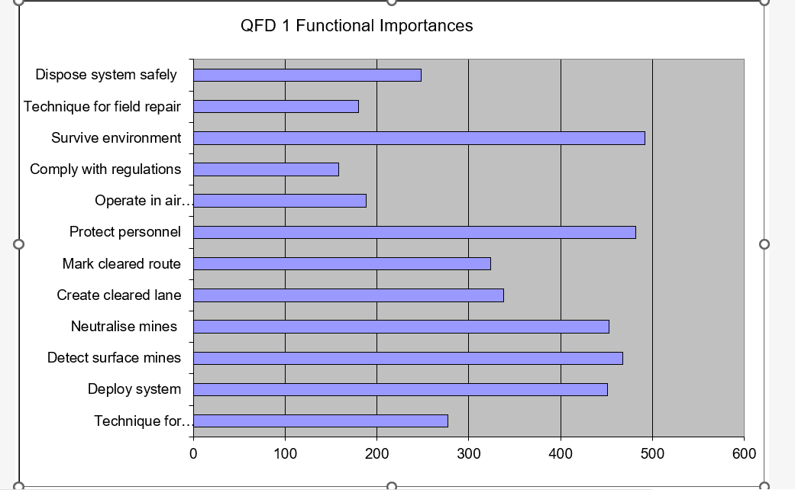
Figure 1 - QFD 1 Functional Importances
The results of QFD 1 made clear that functions tied to safety and operational effectiveness carried the greatest weight. This had a direct bearing on manufacturing priorities most notably in how explosive integration was to be controlled and in the emphasis places on consistent and repeatable assembly throughout.
Building on this foundation QFD 2 evaluated candidate design solutions against the established functional requirements. From a manufacturing standpoint the analysis pointed strongly towards approaches that reduced complexity, supported modular integration and avoided the need for specialised fabrication. The analysis supported the selection of a drone based solution capable of performing both detection and neutralisation functions as these features showed strong correlations with the highest priority system requirements.
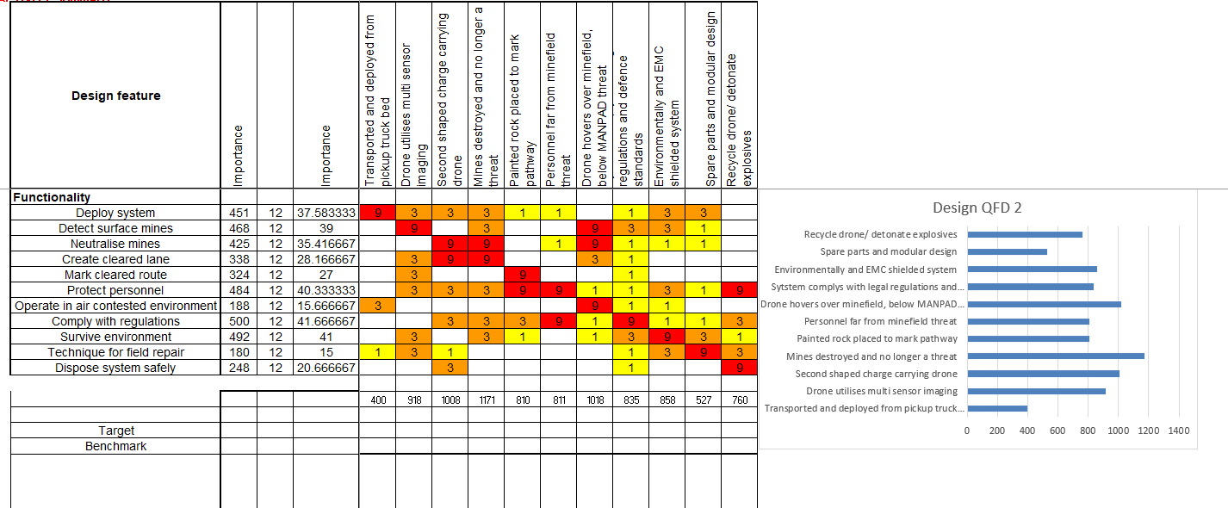
Figure 2 - Design QFD 2
Manufacturing specific trade offs such as the use of XOTS components and modular architecture, were evaluated separately through a dedicated manufacturing QFD process.
The QFD 2 outputs revealed a strong correlation between modular design approaches and the systems highest priority requirements. This gave clear justification for design choices such as lug and play electrical interfaces and simplified mounting systems both of which reduced assembly time and made the system easier to maintain in operational conditions.
Finally, QFD 4 brought the analysis down to the process level, translating design requirements into specific manufacturing controls and identifying the steps carrying the greatest risk. Explosive handling and electronic system integration were flagged as particularly critical, prompting the development of targeted inspection and verification methods to manage the risks effectively.
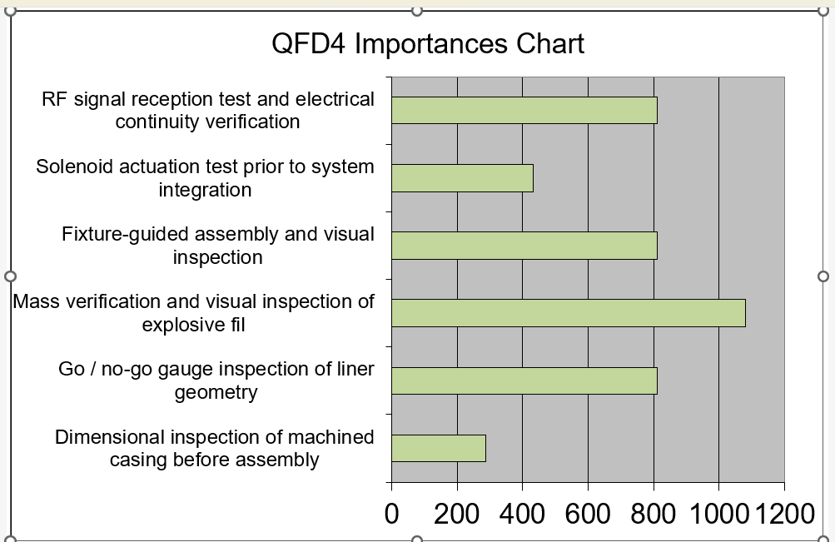Figure 3 - QFD 4 Importances Chart
Together the progression from stakeholder requirements through to process level controls illustrates how systems engineering tools served not just as a means of defining the system but as an active influence on how it would be built. The result was a manufacturing strategy that remained genuinely aligned with system level objectives reducing design risk and laying the groundwork for a reliable and repeatable production outcome.

Manufacturing Requirements & Design Influence

Derivation of Manufacturing Requirements
The manufacturing requirements for the TruePath system were not developed in isolation they were developed from the generic system requirements, ensuring that what was needed on the production floor remained grounded in what was needed in the field. Captured in a structured format they requirements were centred around five themes: cost, manufacturability, scalability, safety and supply chain robustness. This approach aligns with design for manufacture and assembly (DFMA), which emphasises incorporating manufacturing, assembly and supply chain considerations during the early design stages to reduce cost and complexity while ensuring production remains aligned with system level requirements. [2]
In practical terms this translated into a clear set of priorities. One key quantitative requirement was supporting a minimum batch size of 10 units in one working day. The system was to be built from predominantly COTS components, Keeping unit costs low and avoiding delays and risks associated with bespoke fabrication. Assembly of the system was to be achievable within a single working day using basic workshop tooling supporting rapid production without dependence on specialist facilities. Beyond individual units the requirements also looked ahead ensuring quality remained consistent across builds and that the production approach could scale from low rate initial output to full rate manfacture without redesign. Deliberate steps and decisions were also taken to avoid signle source dependencies, strengthening the resilience of the supply chain against disruption.
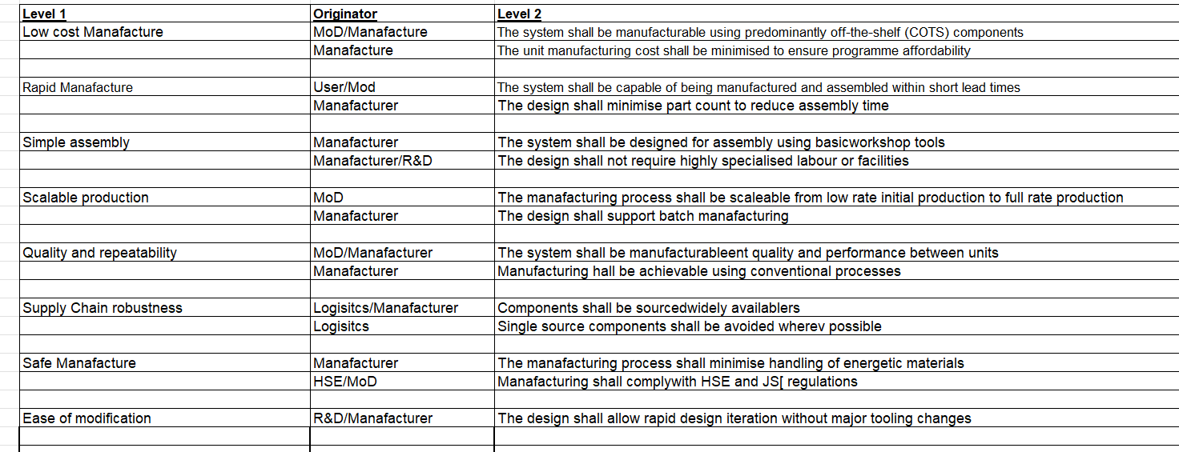
Figure 4 - Requirements set Manufacture
Collectively, these requirements reflect a coherent design philosophy that prioritises affordability, speed of deployment and simplicity of production, consistent with established design for manufacture principles used to reduce lifecycle cost and complexity. [3] For a military engineering system expected to operate under significant time and resource pressure they are fundamental concerns that shape every subsequent manufacturing decision.

Translation into Manufacturing Drivers
To ensure that manufacturing requirements did more than sit in a document, a manufacturing focused QFD analysis was carried out to trace their influence directly through to design decisions. By mapping requirements against key production functions, it became possible to identify which manufacturing activities carried the greatest weight and therefore deserved the closest attention.
The analysis pointed to three dominant processes: system assembly, manufacture at scale and sub system integration. Each of these returned the highest weighting importance scores and the message was consistent reducing assembly complexity and building in scalability from the start were not optimal refinements, but central drivers of the entire manufacturing strategy.
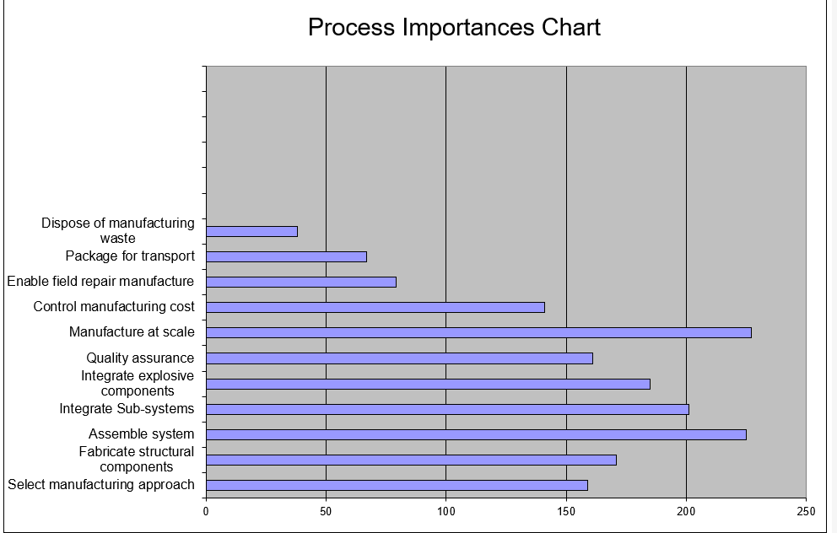
Figure 5 - Manufacturing Process Importance Chart

These findings cemented some decisions that had already begun to take shape like minimising part count, standardising interfaces and adopting modular integration approaches. Rather than emerging from intuition alone, these choices were now backed by a structured analysis that confirmed their importance to production efficiency and overall system performance.

Influence on design decisions
The manufacturing requirements and QFD outputs left a clear and traceable mark on the design decisions that followed.
The choice of a modular drone based system was perhaps the most significant of these. By allowing sub-systems: sensors, payload and control electronics to be developed and tested independently before final integration. The modular approach substantially reduced manufacturing complexity, it also made fault isolation far more straight forward meaning that problems could be identified and resolved at the sub-system level rather than discovered later in the assembly process.
Alongside this, the strong preference for COTS components removed the need for extensive bespoke fabrication, bringing down both cost and production timelines. There was a supply chain benefit here too, sourcing from multiple suppliers rather than relying on a single source introduced a degree of resilience that bespoke components simply cannot offer.
The requirements for rapid, accessible assembly also shaped the choice of fabrication methods. Conventional methods like machining and laser cutting were adopted in favour of advanced composites or specialised processes which while technically capable would have introduced cost and lead time of the system.
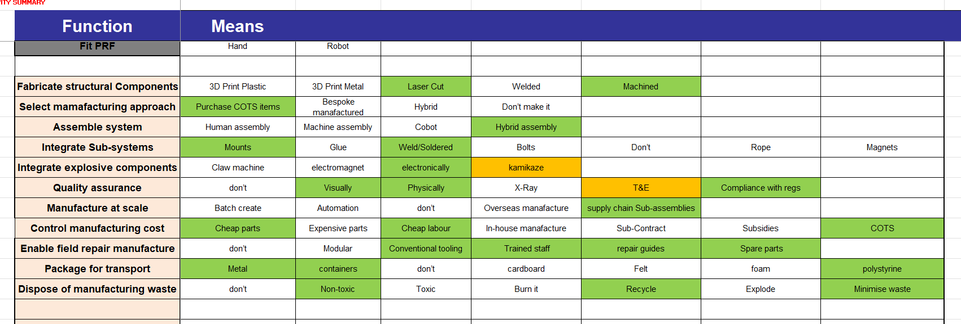
Figure 6 - Function Means Analysis
Finally and perhaps most critically the safety requirements surrounding energetic materials assisted with establishing the processes for controlled integration for explosive components. The underlying principle was straightforward hazardous operations should be limited in scope and carried out only under appropriate conditions reducing exposure and the potential for error at the most consequential stage of assembly.

Process Selection and Trade-Offs (QFD 2 Manufacturing)
A second QFD analysis was conducted to stress test the manufacturing strategy by evaluating competing approaches against the defined requirements. Three broad options were considered fully bespoke, hybrid approaches and COTS based solution. The analysis provided a structured basis for comparison across areas that mattered most cost, scalability and manufacturability.
The results were clear cut, COTS and hybrid approaches consistently offered the most favourable balance across these criteria, while fully bespoke solutions fell away on all three fronts due to there cost, complexity and lead times they would introduce to the programme.
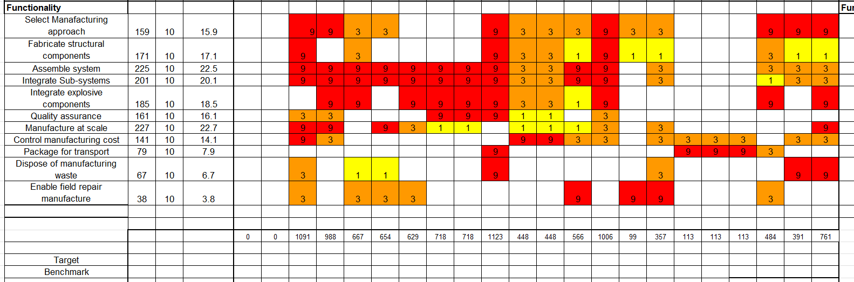
Figure 7 - QFD 2 Manufacturing
The justified final manufacturing strategy, which prioritised:
- Use of standardised components
- Modular system architecture
- Minimal reliance on specialised tooling
These decisions ensured that the system could be produced rapidly and at a scale without compromising performance or safety.

Summary of manufacturing strategy
Overall, the manufacturing strategy for the TruePath system used a systems engineering approach to ensure requirements, design and production processes were aligned.
By using QFD methodology, key manufacturing drivers were identified and used to guide design decisions resulting in a system that is cost effective, scalable and practical to produce. The emphasis on modularity, COTS components and simplified assembly ensures the system can be manufactured quickly while maintaining quality and operational effectiveness.

Manufacturing Process, Risk & Control

Manufacturing Process Strategy
The manufacturing approach for the TruePath system is integration led by design, complex fabrication has been largely designed out of the process. A deliberate and obvious consequence of the decision to build around COTS components and modular subsystems, both of which trade manufacturing complexity for speed and accessibility.
In practice, this means the process centres on bringing pre-manufactured elements together into a complete operational system. The drones and sensor systems arrive as finished components. The manufacturing task is one of assembly and interfacing rather than production from raw material. Where modification of COTS components is required at all it is limited in scope typically to enable mounting, correct balancing or to establish physical and electrical interfaces between sub-systems or integrating the explosive payload.
The benefits of this approach compound across the programme. Lead times are shortened, costs are low and the need for specialised tooling or dedicated facilities is kept to a minimum. Perhaps less obviously the same modularity that simplifies the initial assembly also makes the system easier to maintain and repair which is advantageous beyond the production phase.

Key Manufacturing Process Steps
Based on the manufacturing strategy in place the production process can be broken down into steps:
- Preparation of COTS drone platforms
- Installation of sensor systems and mounting structures
- Integration of communication and control systems
- Installation of payload deployment mechanism
- Integration of modular explosive payload
- System assembly and alignment
- Functional testing and verification
This process is structured so that each sub-system is integrated in a controlled and repeatable way, ensuring no unit-to-unit variance and improves overall system reliability.

Translation of design features into Manufacturing Processes (QFD 3 )
The relationship between design features and Manufacturing process was analyses using QFD 3 which mapped system design features against available manufacturing techniques.
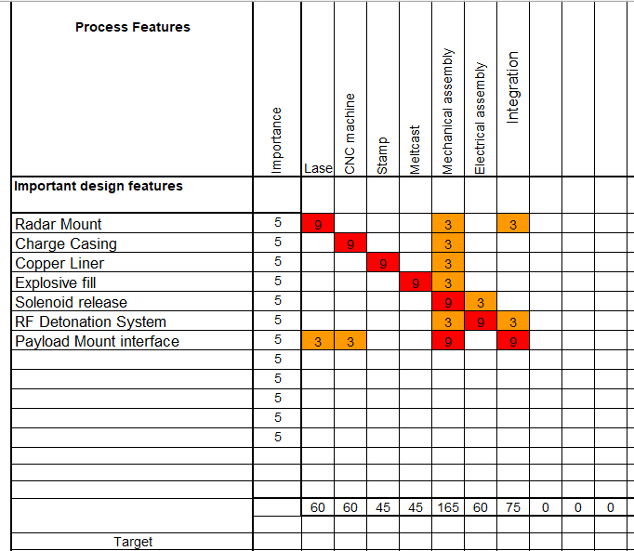
Figure 8 - QFD 3 Matrix
The analysis identified the most appropriate manufacturing processes to achieve the design. Results showed mechanical assembly and integration processes had highest importance reflecting the integration focsed nature of the system. Fabrication processes like CNC machining, stamping and melt casting were required for specific components mostly associated with explosive payload.
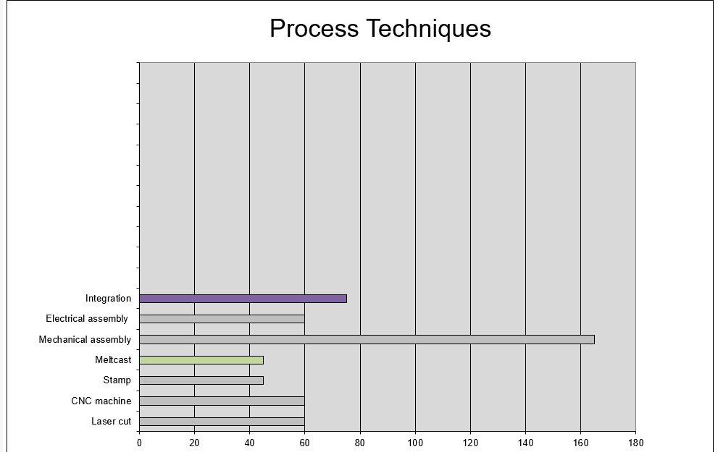
Figure 9 - Technique Importances Chart
This highlights the system relies on integration of pre manufactured components focusing on assembly accuracy and reduction of complexity. The outputs of QFD 3 informed the selection of manufacturing processes ensuring they were appropriate.

Failure Mode Analysis (FMA) in Manufacturing
Failure Mode Analysis (FMA) was used to identify any points of failure within the manufacturing and integration process. This allowed any critical risk to be spotted early and ways to mitigate implemented.[3]
- Key failure modes as follows:
- Incorrect explosive fill or inconsistency in payload preparation
- Failure of RF communication between operator and payload
- Misalignment or incorrect assembly of sub-systems
- Electrical faults within the firing or control systems
These failure modes were prioritised based on their potential impact on system safety and operational effectiveness.
The FMA demonstrates the highest risk failures are linked to explosive components and communication systems. This further cemented the reasoning these areas need and have such strict controls in place.

Process Control and Quality Assurance (QFD 4)
QFD 4 was used to translate manufacturing requirements into specific process control measures, ensuring that critical risks identified in the FMA were mitigated.
The analysis showed three areas where the controls are most essential.
Explosive fill inspection emerged as the most critical process step given its impact on both safetpection emerged as the most critical process step given its impact on both safetand system effectiveness. Inconsistencies in explosive fill have the potential to produce unreliable performance and failure to neutralise mines. This creates safety hazards during handling and deployment so to combat, inspections are done to catch any deviations before they get any further in the process.
RF signal testing addressed a different but equally consequential risk being the integrity of communication between the operator and the payload. It is a safety requirement to have reliable transmission of commands so testing at this point ensures signals are correctly sent and received reducing the potential for misfire or failure to detonate when the system is used operationally.
Finally feature-guided assembly was introduced to take human error out of the integration process as far as possible. By constraining the positioning and alignment of components through physical guides, you don’t depend on individual judgment and the process is more repeatable. This is an important consideration for a system where there cannot be variability between units. (Refer to figure 3)

“Right First Time” Manufacturing and Risk Reduction
The integration of systems engineering tools into the manufacturing process supports a “right first time” approach, where errors are identified and mitigated early in the design process and production lifecycle. This aligns with Systems Engineering principles that emphasise early-stage analysis and decision-making to reduce downstream risk and improve system reliability [4]
By combining QFD analysis with FMA and process controls, critical risks are reduced to minimise the likelihood of defects, re-design or system failure. This is important in a system like this with energetic material, where manufacture errors can have severe safety consequences.

Manufacturing Constraints, Trade-offs & Limitations
The TruePath manufacturing approach still has constraints mainly safety, time and reliance on external components. Manufacturing explosive payload separately to minimse handling of energetic materials so they were individual moduals to be integrated was a sensible safety decision but introduced dependency on a separate process. Also asse,bly within a signle day places a limit on how elaborate manufacturing techniques could be.
The constraints show there is a fundamental trade off between manufacturability and optimisation, Consistent with studies showing that modular designs improve flexibility and cost efficiency bt can limit overall system performance[5]. COTS components kept costs low and timelines short but forclose the possibility of fully tuning system performance. Equally the integration focusd approach confirmed through QFD 3 reduced fabrication complexity but highlights accurate assembly. Less is made but everything must be done precisely.
The modular design has many advantages but also vulnerabilities as each additional interface is a potential point of failure and without adequate controls the risks accumulate quietly. This places considerable weight on inspection and testing particularly in areas the consequences are mot severe like explosive integration and RF communication.

Conclusion
The development of the TruePath system demonstrates the effective integration of manufacturing considerations within a systems engineering approach. By applying QFD methodology and FMA, manufacturing requirements were translated into design decisions, process selection and quality control measures.
The resulting manufacturing strategy is centred on integration rather than fabrication using COTS components and modifying them, enabling rapid assembly, scalability and cost effective production. Key risks associated with explosive handling and system integration were identified and mitigated using inspection and testing processes, supporting a “right first time” manufacturing approach.
While there are limitations like reliance on external components, the overall approach provides a practical and robust solution aligned with the operational requirements that were set out. The application of systems engineering tools has enhanced the manufacturability and reliability of the system, demonstrating their value in managing complex systems within a safety-critical engineering design.

References
[1] E. S. Jaiswal, “A Case Study on Quality Function Deployment (QFD),” IOSR Journal of Mechanical and Civil Engineering, vol. 3, no. 6, pp. 27–35, 2012, doi: https://doi.org/10.9790/1684-0362735.
[2] R. Gagnon and A. Bearman, Design for Manufacture and Assembly. Hosted by PALNI Open Press, 2026. Accessed: Apr. 23, 2026. [Online]. Available: https://pressbooks.palni.org/designmanufactureassembly
[3] “SYSTEMS ENGINEERING.” Available: https://www.nasa.gov/wp-content/uploads/2018/09/nasa_systems_engineering_handbook_0.pdf
[4] B. Jones and M. Ryan, “INCOSE Systems Engineering Handbook—Visual Enhancement to Support Understanding,” ResearchGate, May 02, 2011. https://www.researchgate.net/publication/270219287 (accessed Apr. 27, 2026).
[5] M. Fixson, “Modularity and Commonality Research: Past Developments and Future Opportunities,” Concurrent Engineering, vol. 13, no. 2, pp. 85–111, 2005. [Online]. Available: https://scispace.com/pdf/tradeoff-between-modularity-and-performance-for-engineered-4ko94zw7gl.pdf

‌

‌

