Module Title: BMSW5105 Workplace Culture and its Impact on Organisational Efficiency
Assignment Title: Individual
Report-Task 1
Student ID:2126703
Student Name: Iulia Dunareanu

Table of Contents
Introduction 3
Company Overview 3
Organisational culture, ethos, and values of Google 4
Promoting Sustainability in Google with relevant theories 6
Recommendations for improving Google’s culture & its impact on corporate efficiency 9
Conclusion 12
Reference 13

Figure 1: The logo of Google 3
Figure 2: The Mission Statement of Google 5
Figure 3: Triple Bottom Line (TBL) Framework 7
Figure 4: Circular Economic Model at Google 9

Introduction
Google is a well-known brand around the world because of its innovative products and services, but the company is also admired for its refreshing approach to business. This article will analyze Google's culture, ethos, and values to determine how much they contribute to the development of sustainable workplace practices. This study also explores potential avenues for improvement and provides recommendations to strengthen the company's cultural norms. This research aims to better understand Google's corporate culture by analyzing how it corresponds with sustainability structure, analyzing its various characteristics, and looking into its potential for expansion. Finally, it offers several approaches that Google could employ as a global giant for boosting its corporate settings while maintaining its operational excellence and sustainability.

Company Overview

Figure 1: The logo of Google
Source: (Google, 2023)
Google, one of the renowned brands, began operations in 1998 by Larry Page and Sergey Brin as a global information technology corporation with headquarters in Mountain View, California. The firm focuses largely on machine learning and AI, while it includes an array of services and goods, including cloud-based computing through Google Cloud, Android software, hardware like the Google Pixel smartphones, and YouTube (Google, 2023). In fiscal year 2023, it has earned about $74.6 billion in revenues with more than 50 products and solutions operated by nearly 1 lakh employees globally. Google has become one of the best-known technology firms in the globe due to its creative atmosphere, devotion to direct interaction, and dedication to equality and inclusion ranking 2nd in Forbes and 4th in Interbrand’s most influential brand all over the world.

Organisational culture, ethos, and values of Google
Google's prosperity and image might be ascribed in large part to the firm's distinctive and specified culture, principles, and ideals.
The corporate culture of Google includes:
- Innovation: Google supports a work environment that fosters and stimulates innovative ideas and risk-taking among its employees. The practice often referred to as "20% time" offers personnel the freedom to spend just a percentage of their allocated work hours towards individual pursuits (Mosley, 2017). This generates a setting that fosters creativity and continual development.
- Interaction: Google lays high importance on the tenets of cooperation and collegiality. The adoption of an open-plan workspace arrangement, the availability of common areas, and the exclusion of private desks promote and foster social involvement as well as cooperation among personnel. Additionally, the organisation promotes a range of internal endeavours and initiatives intended for strengthening staff solidarity and collaboration.
- Transparency: Google is famous for its devotion to openness, which involves efficient interaction and accurate decision-making practices (Murphy and Stott, 2021). The organisation performs regular group discussions every week, during which key personnel communicate pertinent knowledge to the employees. The enactment of open communication encourages the growth of cooperation and active participation.
- Equality & diversity: Google displays a strong devotion to fostering equality and encouraging inclusivity within their company. The organisation regularly promotes the growth of worker diversity and has launched numerous campaigns focused on promoting a more welcoming workplace.
- Data-oriented decision-making: The culture of Google prioritises data and analytics-driven decision-making (Perron et al., 2016). This process is highly connected to its fundamental principles and serves as a pivotal catalyst for its growth across diversified pursuits, including the domains of research and marketing.
- Flat hierarchical structure: The organisational layout of Google, defined by its fairly flat hierarchy, may be attributed to the philosophical framework of "organisational planning." A flat organisational layout allows the self-determination of people, supports freedom, and allows expedited decision-making procedures, all of these are vital for an agile and dynamic firm such as Google.
The organisational ethos of Google: The fundamental tenets directing Google's operations are firmly planted in its core objective, which focuses on its aim of organising global data and maintaining its wide availability and usability. This vision assertion indicates an obligation to treat clients effectively while delivering technologies that better simplify the lives of individuals (Rana and Brandt, 2016). Google's corporate ethos involves a firm conviction in the efficacy of innovation to deal with complicated challenges and encourage constructive transformations. Furthermore, Google focuses a major priority on the responsible and moral utilisation of innovation. The organisation has introduced procedures for addressing challenges about user confidentiality, data safety, and deception, displaying its devotion to ethical innovation and the management of technologies.
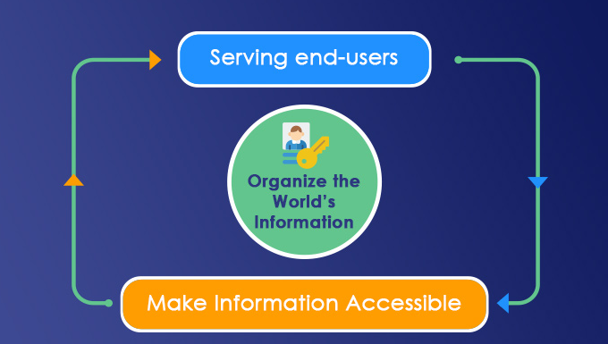
Figure 2: The Mission Statement of Google
Source: (Singh and Misra, 2022)
The organizational values of Google include:
- Integrity & ethics: Google's devotion to sustaining integrity and conforming to moral values aligns with the core notion of corporate ethics. The preservation of respect with consumers, personnel, and other stakeholders demands a commitment to moral principles and an example of truthfulness (Rauch et al., 2018).
- Customer orientation: Google's prioritisation of satisfying its client's requirements is by the principle of customer service. The introduction of a customer-oriented approach promises that goods and amenities are carefully developed with a primary focus on the end consumer, hence boosting user excitement and fostering commitment.
- Long-term focus: The determination of Google on future goals and long-term viability is in accordance with the fundamentals of strategic management (Smith and Drudy, 2022). The firm's profitable growth and viability are reliant upon its execution of prospective strategies and environmental measures.
- Agility & high speed: Google prioritises rapidity and adaptability in making choices and manufacturing procedures. The business's attention to providing swift and efficient services is representative of this ethic.
- Web democracy: Google embraces the principles of an open and transparent internet, where data is easy to access for everyone without limitations (Tóth, 2019). This organization's value is shown through its approval of internet freedom and devotion to free web ideals.
Overall, the organisational environment, principles, and core beliefs of Google play an integral part in developing its brand while adding to its success. The firm's achievements have reinforced its position as an innovative and unique technology firm, which has an important focus on consumer advantage, moral utilisation of technological advances, and the psychological well-being of its employees. The moral and philosophical aspects of Google constantly shape its direction and response to growing challenges within the technology sector.

Promoting Sustainability in Google with relevant theories
The corporate cultural behaviours employed by Google efficiently foster sustainability within the company. The organization has shown an intense devotion to sustaining ecological stewardship, minimising waste production, and fostering green work settings (Sultan and Van De Bunt-Kokhuis, 2012). Yet, it is vital to point out that there is still an opportunity for growth, and Google will continue to concentrate on decreasing its ecological footprint, retaining supplies, and broadening its sustainability activities.

Triple Bottom Line (TBL) Framework: The TBL framework examines the efficacy of an organisation by analysing three distinct aspects including the firm's financial profitability, its influence on people and society, and its commitment to sustainability. The three pillars of Triple bottom model include:
- Economic: The robust economic growth and long-term viability of Google permit the firm to invest resources into sustainable endeavours without forfeiting its revenue. The business's dedication to utilising 100% green power sources is in accordance with economic sustainability principles (Yunis et al., 2018).
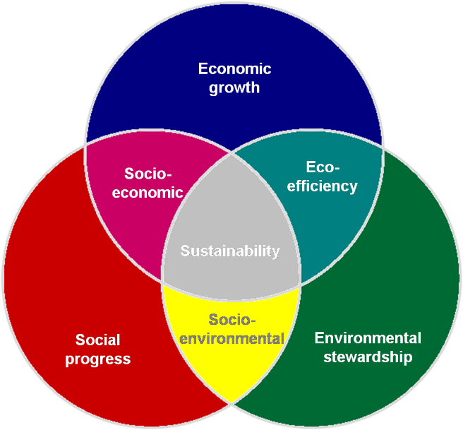
Figure 3: Triple Bottom Line (TBL) Framework
Source: (Towers, 2016)
- Social: The employee-centric ethos of Google, characterised by its provision of amenities such as health care and work-life balance, encourages a sustainable society. Personnel who have high levels of contentment and receive sufficient help are prone to exhibit dedication and efficiency, delivering beneficial results for both the organisation and the wider community.
- Environmental: Google's devotion to mitigating its ecological influence by implementing energy-efficient methods, investing in green power sources, and actively lowering pollution illustrates its devotion to the ecological facet of sustainability (Tran, 2017). The TBL (Triple Bottom Line) paradigm asserts that an in-depth perspective on sustainability is crucial, and Google's cultural habits aim to support this notion.
Corporate Social Responsibility (CSR) Model: Corporate Social Responsibility (CSR) places a high priority on the social and legal duties of companies to make positive contributions to the community. Google's devotion to sustainability reflects a robust corporate social responsibility (CSR) mentality.
- Google is involved in the financing of green energy initiatives, advocates for waste minimization and recycling tasks, and aims to lower its environmental impact (Mosley, 2017). These strategies both contribute positively to the ecology and also accord with its moral commitments to mitigate its negative environmental influence.
- Google's devotion to promoting diverse and inclusivity programs is in alignment with the societal aspect of corporate social responsibility (CSR). This highlights the business's commitment to developing a favourable and holistic workplace ambience, promoting the welfare of its staff members and society as a whole.
Sustainable Development Goals (SDGs): The strategies adopted by Google might be attributed to the 2030 Sustainable Development Goals established by the United Nations. The firm's endeavours to design innovations and products which handle global difficulties like data availability, medical services, and protecting the environment, are by various Sustainable Development Goals (SDGs), among which are of reducing inequality, wellness, and energy efficiency (Murphy and Stott, 2021). The business's goal is to achieve carbon neutrality throughout all of its product lines and subsidiaries by the year 2030. By 2025, Google promises to have over half of the plastics employed for its buyer's hardware offerings to be sourced from recycled or sustainable resources.
Green Building Framework: Google has adopted environmentally conscious layout and construction fundamentals throughout its corporate locations. The support of Google for sustainable structures and energy-efficient gadgets illustrates its devotion to mitigating its adverse environmental effects. This, therefore, assists in the establishment of an equitable work culture (Perron et al., 2016). The purpose of the organization is to become more eco-friendly by creating goods and innovations that aid society in becoming greener, collaborating with associates and non-profits worldwide to facilitate the switch to flexible, low-carbon networks, and conducting business more sustainably.
Resource Conversion Model: The concept lays a high priority on the improvement of the utilization of resources and lowering of wastage. The business's actions aimed at lowering waste and advocacy of recycling show its dedication to ecological efficiency. This practice increases the long-term sustainability of an organization by limiting the adverse ecological impacts linked to garbage management.
Stakeholders Theory: The stakeholder model centres on the premise that firms have to take into account the requirements of all interested parties, instead of merely addressing the concerns of stakeholders. Google's corporate governance initiative targets its web service and technology users. For example, Alphabet has an energy-efficiency initiative centred on climate change. Yet, prior to an internal transformation that created Alphabet Inc., Google had long been actively engaged in corporate governance (Freeman, 2023). This approach incorporates programs like Google's storage facility energy programs. Therefore, Google's endeavours serve as the core foundation for Alphabet's social obligation plan and methods, but its affiliates take advantage of them as well. Personnel receive benefits from an employment context that values their mental health and the equilibrium between their professional and private lives, which encourages social sustainability. Users receive rewards from taking advantage of cutting-edge and user-oriented offerings and amenities that better their standards of life while improving their connection to data, thereby harmonizing with principles of social and financial sustainability (Rana and Brandt, 2016. Google's devotion to mitigating its greenhouse gas emissions and dedicating resources towards sources of clean electricity has a beneficial effect on our planet, hence promoting a green economy.
Circular Economy: Google's work environment aligns with the tenets of the circular economy, which point out the most effective use of assets and the reduction of wastage. Google manufactures goods with sustainability in mind from the get-go, reprocessing waste into fresh substances. This assists in a happier planet and a more prosperous future (Rauch et al., 2018). In order to extract most of all the materials that were spent generating a good or material, Google preserves them for future utilization for as long as feasible while also guaranteeing their confidentiality.
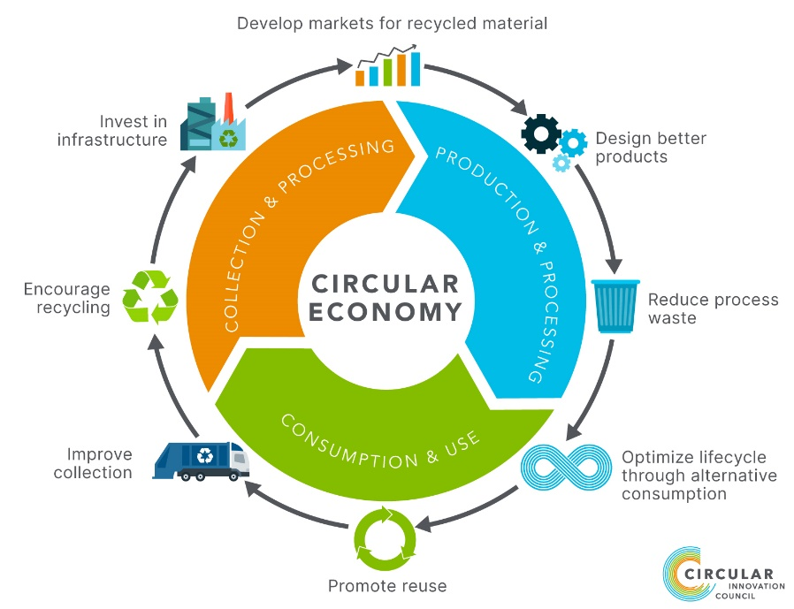
Figure 4: Circular Economic Model at Google
Source: (Singh and Misra, 2022)
It allows for safeguarding leftover supplies and decreases pollution. Google crafts solutions with resources which are sustainable for both humans and the surroundings, understanding that these resources could be consumed and repurposed far into the future as well. The storage facilities of Google construct and function for powering its solutions, its offices where Google employees collaborate on building the next generation of innovative gadgets, and the end-user gadgets that individuals employ on a regular schedule all influence the circular economy (Smith and Drudy, 2022).
However, Google's commitment to sustainability provides insight into the company's internal culture and reveals that it follows established sustainability frameworks and ideas. The Triple Bottom Line paradigm emphasizes a company's all-encompassing approach to sustainability, which takes into account not just financial but also social and environmental factors. In addition, Google's emphasis on resource conservation, green building standards funding, and general commitment to CSR all lend credence to the claim that the company appreciates and practices sustainability at work. Google's current practices show a strong agreement with the ideals of sustainability, and there is growth or further improvement.

Recommendations for improving Google’s culture & its impact on corporate efficiency
The recommendations that Google could incorporate in its culture to enhance its productivity and efficiency level include:
Promote mental well-being: Google needs to offer its employees substantial psychological treatment programs. Proposed requirements could consist of therapy services, tools for managing stress, and projects that promote consciousness about mental health (Hult et al., 2014). Better provision of psychological attention has a chance to result in lower rates of tardiness, heightened efficiency, and stronger staff engagement. Personnel who possess a chance to avail themselves of mental wellness services are inclined to display greater quantities of engagement, attention, and inspiration, resulting in better performance at work.
Better employee engagement initiatives: Google could enhance the approach its employees can voice comments on its internal processes and policies by implementing more formal processes including regular focus group discussions or surveys. Organized evaluation processes have been able to supply substantial data pertaining to staff complaints, choices, and aspects that require development (James et al., 2015). Google may employ the information to reach well-informed judgments and proactive alterations, hence boosting productivity through rapid and efficient resolution of difficulties.
Concentration on work-life harmony: Google must recognize the significance of a comprehensive and balanced routine for its workforce, comprising the offering of proper time off and the enforcement of limitations on exorbitant weekly work hours. The adoption of a healthier work-life harmony has a chance to mitigate exhaustion while improving staff satisfaction within the context of the company (Freeman, 2023). Thus, there is an advancement in profitability, a boost in worker continuation, and an overall productivity improvement.
Promoting inclusion & diversity at work: Google has the option to develop stronger diversity plans, carry out periodic reviews of diversity, and dedicate more resources to assisting minority communities. A culture of diversity and inclusivity in the workforce fosters inventiveness and originality by carrying forth an extensive variety of ideas and perspectives. Furthermore, it augments the firm's present, recruiting professionals while enhancing the technique of decision-making processes, thus supporting higher efficiency in operations.
Social involvement and participation: By establishing charitable initiatives, fundraising efforts, and offering aid to nearby enterprises and non-profits, Google could grow a greater presence in the neighbourhoods where its headquarters is situated (Lewandowski, 2016). The firm's reputation and connections with nearby stakeholders may benefit from its direct involvement in community affairs. The efficiency of an organization is improved when personnel develop an awareness of responsibility in the beneficial contributions their company brings to society.
Flexible work culture: Google might broaden its options for working arrangements, offering employees to pick from telecommuting, time flexibility, or reduced weekdays. Agility in work schedules might encourage a work-life equilibrium, minimize travelling periods, and satisfy distinctive employee needs. This may contribute to better staff retention, fewer layoffs, and maybe improved output, all of which promote effectiveness at work.
Employee growth and development opportunities: Google may accomplish more to support its employees in advancing their personal and professional lives by giving them the opportunity for a wide range of educational and vocational facilities (Perron et al., 2016). A workforce that contains higher-level abilities is more adept at managing varying difficulties and developments in technology. Better team efficiency and expertise could be accomplished through staff growth, which serves the organization.
Promote transparency: The work environment leans strongly on direct interaction. Google might become more transparent about how it operates, its decisions, and its outcomes when it releases further details about those domains. Respect between staff, customers, and other participants might be fostered through transparent interaction (Towers, 2016). Google might become more productive as a company when it adopts a more democratic philosophy.
Technological advancement & innovation: The philosophy of innovation is fundamental at Google. Yet, the organization may do better to foster inventiveness. Google may promote a climate that is more welcoming to development by facilitating risk-taking, increasing utilization of resources, and cultivating a culture that values fresh perspectives. Google must continually innovate in order to keep up with its rivals and boost morale within the company.

Conclusion
Google's culture is characterized by the inclusion, innovative mindset, and transparency of its staff. The culture sets an emphasis on its staff's overall well-being and rewards uniqueness, taking chances, and collaboration as ways to encourage creativity. To foster a green work setting, Google has invested major expenses in waste minimization programs, green power, and multicultural assistance. Google's actions in that field are consistent with sustainability concepts like Corporate Social Responsibility and the Triple Bottom Line, which identify the infinite scope for betterment.
Google's dedication to staff happiness, conservation, and creativity might be strengthened by enacting the suggested reforms to its corporate culture. Those modifications include funding for mental health services, improved work-life harmony, and more proactive inclusion goals. Google is a market leader in corporate culture since it regularly puts its core beliefs and works for growth. Google's devotion to fostering a friendly, broad, and inventive work atmosphere has been an important aspect of its ongoing prosperity while it has evolved and expanded.

Reference
Freeman, R.E., 2023. Managing for stakeholders: Trade-offs or value creation. In R. Edward Freeman’s Selected Works on Stakeholder Theory and Business Ethics (pp. 295-299). Cham: Springer International Publishing.
Google, 2023. Google - about Google, Our Culture & Company News. [online] about.google. Available at: https://about.google/intl/ALL_us/.
Hult, G.T.M., Hurley, R.F. and Knight, G.A., 2014. Innovativeness: Its antecedents and impact on business performance. Industrial marketing management, 33(5), pp.429-438.
James, B., Katie, G., Jitendra, M. and Bharat, M., 2015. 'The Big Idea'The Sustainable Economy and the TBL (triple bottom line). Advances in Management, 8(1), p.1.
Lewandowski, M., 2016. Designing the business models for circular economy—Towards the conceptual framework. Sustainability, 8(1), p.43.
Mosley, R.W., 2017. Customer experience, organisational culture and the employer brand. Journal of brand management, 15(2), pp.123-134.
Murphy, D.F. and Stott, L., 2021. Partnerships for the sustainable development goals (SDGs). Sustainability, 13(2), p.658.
Perron, G.M., Côté, R.P. and Duffy, J.F., 2016. Improving environmental awareness training in business. Journal of Cleaner Production, 14(6-7), pp.551-562.
Rana, S. and Brandt, K., 2016. Circular economy at work in Google data centers. Google & the Ellen MacArthur Foundation.
Rauch, A., Wiklund, J., Lumpkin, G.T. and Frese, M., 2018. Entrepreneurial orientation and business performance: An assessment of past research and suggestions for the future. Entrepreneurship theory and practice, 33(3), pp.761-787.
Singh, K. and Misra, M., 2022. The evolving path of CSR: toward business and society relationship. Journal of Economic and Administrative Sciences, 38(2), pp.304-332.
Smith, D. and Drudy, L., 2022. Corporate culture and organisational ethics. In Leadership and business ethics (pp. 231-243). Dordrecht: Springer Netherlands.
Sultan, N. and Van De Bunt-Kokhuis, S., 2012. Organisational culture and cloud computing: coping with a disruptive innovation. Technology Analysis & Strategic Management, 24(2), pp.167-179.
Tóth, G., 2019. Circular economy and its comparison with 14 other business sustainability movements. Resources, 8(4), p.159.
Towers, D., 2016. An investigation into whether organisational culture is directly linked to motivation and performance through looking at Google Inc. British Journal of Social of Psychology, 42, pp.87-106.
Tran, S.K., 2017. GOOGLE: a reflection of culture, leader, and management. International Journal of Corporate Social Responsibility, 2, pp.1-14.
Yunis, M., Tarhini, A. and Kassar, A., 2018. The role of ICT and innovation in enhancing organizational performance: The catalysing effect of corporate entrepreneurship. Journal of Business Research, 88, pp.344-356.

