Assignment feedback

Student Name: Karen Davies
Student University Email: 1703046@student.uwtsd.ac.uk
Module code: AHHE4001  Module title: Heritage & the Heritage Industry | Student ID number:  1703046 |  | Educational support needs:  No
Assignment title: Drawing on a particular example of your choice, discuss how communities may engage with their heritage.

Assignment due date: 23.1.2018
Assignment Number: 2
(i.e. 1,2,3)
Marker’s signature: |  | Date:
Provisional.
NB. All marks are provisional until confirmed by the final examination board.

SELF-REFLECTION SHEET.

PLEASE COMPLETE BEFORE SUBMISSION AND ATTACH TO YOUR WORK

Date: Module: Name:

Guidance: You might consider the following elements:

- Argument: does it have one/ is it backed by sufficient evidence/ how lucid is it?
- Structure: how clear is it / is my essay easy to follow/ does it help my argument?
- Analysis: is more/less analytical than narrative/ does it address the question?
- Reading: was this sufficiently broad/ have I referenced properly?
- How might I improve my performance in future?

Strengths

Tried to define community and heritage. Example of community successfully engaging with their heritage.

Weaknesses:

Bit lightweight; not academic enough?

General Comments:

Please give a mark for your work: 59

(for eg: 1st = 70+: 2/1 = 69-60: 2/2 = 59-50: 3rd = 45-49: pass = 40-44: fail = 39- )

Drawing on a particular example of your choice, discuss how communities may engage with their heritage.

Before we can discuss how communities may engage with their heritage, we ought to define our language – what is heritage, and what do we mean by community? Although heritage and community seem straightforward terms, when we try to pin down what we mean, things become more complicated.
Initially, one thinks of heritage as ‘what makes you, you’, or identity; it can be tradition, culture, something that defines you, usually old and of value. However, there is also living heritage, where people with a common background continue to live today the traditions from the past that tie them together; for instance, using food, music, crafts, language and other cultural traditions to keep alive their customs. Heritage can be tangible and intangible – objects ranging from buildings to archives to types of jewellery, and encompassing music, dance and drama. Watson and Waterton (2011) posit that heritage is a leisure activity in the West, with the engagement by communities occurring in non-work time. They describe the cultural heritage of archaeological sites as being the significance accorded the sites by the people who live with them. Greer (2011) states that local interests in heritage are often considered less important than national interests, with particular reference to Indigenous cultural heritage in Australia. These latter points seem to imply that heritage can become a commodity, to be used for a commercial purpose, and this commodification changes the emphasis of heritage from being something personal to something global. Waterton and Smith (2011) feel that, where there is an official definition of heritage, social inclusion policies tend to try and force the excluded to conform to the standard, rather than redefining heritage to encompass different cultural and historical experiences.
What makes a community? There are many communities with different definitions: a particular type of communal activity – a business community; sexuality – the gay community; ethnicity – the black community; age – the third age community; religion – the Catholic community. Hence, a community may be defined by location, ethnicity, age, sexuality, religion, language, history, shared customs. Terms used to describe community include homogenous, unity, cohesion, integration and multi-culturalism. Community is usually described using positive terms and is seen as something aspirational, and often has political implications as government policies use the idea of communities to promote civic engagement and renewal, sustainable communities, social inclusion and regeneration. (Waterton & Smith 2011) Bruce-Lockhard (2006) states “The creation of strong, vital and cohesive communities is one of the most important issues that we face ….. to create strong communities, in which the fear of difference can be broken down and everyone feels valued and safe, has an equal place and feels a shared responsibility for their community.” Community activities promote civic pride in the local environment. However, community can also be a politically charged term; for instance, in Northern Ireland, there are very strictly defined, and divided, communities where every action has a possible political impact and where great sensitivity and tact is required to navigate between the two communities. Both communities have strong political elements. There have been many attempts to bring the communities together, one project being the Community History Project which was a state-backed project from which funding was available dependent on the project objectives. Another project is run by The Bloody Sunday Trust and is an exhibition of Bloody Sunday. This project received no state funding and is an example of a heritage or history being seen differently depending on the community viewing it. Policy goals aimed at forming a cohesive, integrated, regenerated society are commendable but government must beware of using culture as a social management tool. (Crooke 2011)
It seems to me that heritage and community are both terms covering a broad range of definitions which are fluid and not static, which change according to the type of heritage associated or the viewpoint of the particular community involved.
A lot of museums are increasing their engagement with the community as a result of the changing rationale for museums, and this demonstration of community heritage is a way to display community histories, communicate their culture, convey an identity and perhaps increase cultural relevance. (Crooke 2011) The idea of community engagement seems laudable, but care is needed to use an inclusive approach, utilising the whole community, and not just aiming at members of the community who might be seen to be intellectuals, or middle-class. In Africa, the legacy of colonialism begets its own problems, where people could be seen to be disenfranchised from their culture. (Chirikure 2011) Chirikure (2011) suggests that heritage should be used as an economic resource, putting back the profits into the community involved. Thus, the communities benefit financially but also intellectually as involvement with their heritage will become an educational process in itself. This enables the communities to see the value of the heritage and increases their desire to protect it, but also ensures the heritage is managed sustainably. In some countries, heritage management can be an important element of a poverty alleviation programme, employing and educating the community. Unless there is a demand for community engagement, imposing it from above could result in unsustainable projects, lacking in support and being tokenistic. A community engagement project resulting from grass-roots campaigning is more likely to be successful with continuing collaboration from those involved. (Perkin 2011)
So, I suggest a successful community heritage project is one which is supported strongly at a grass-roots level, involving the whole community, and providing some sort of benefit to that community.
The heritage I want to look at is Shetland, with particular reference to Shetland knitting. This may seem an unlikely topic for a heritage project providing benefit to the local community, but I hope to illustrate a successful project which has beneficial consequences throughout the Shetland community.
Knitting in Shetland has a long history. The Shetland Islands are found north-east of Scotland, west of Norway, where the Atlantic and the North Sea join, so they are remote, wind-swept islands on which it is hard to make a living. Shetland was originally part of Norway, becoming Scottish in 1469. The economy was based on fishing, the sea, and crofting. The breed of sheep native to Shetland produces a distinctive type of wool, very fine, with a short staple and feeling soft and silky. There are variations in fleece colour using local dialect as names for the different colours, eg moorit for red-brown and shaela for grey-black. The sheep are small and consequently their fleeces weigh less than mainland breeds. As there was an abundance of fine-quality wool, and as the activity of knitting fitted well into the rhythm of life on a croft, knitting became an important element of the economic life of the crofting families. In the fifteenth century, Shetland had sea links with the Hanseatic ports of Hamburg, Bremen, and Lubeck, as well as England and Scotland, and retained strong links with Scandinavia, and it is thought that the craft of knitting came from these links, perhaps from England as a lot of the local knitting vocabulary uses English words, although the Shetland dialect word for knitting – makkin – comes from the Norn verb ‘mak’. (Fryer 1995) In 1695, the Shetlanders knitted stockings and hose to barter with merchants from Hamburg and Bremen who visited in May and with the Dutch visiting in June for herring fishing. The earliest dated items of Shetland knitting date from around this time, being two caps, a pair of gloves, a pair of stockings and a purse found in 1951 in a peat bog on Gunnister Man. His purse contained coins dating from 1680-90. Knitting continued in the 18th century, with trade affected by the burning of the Dutch fleet in 1703 by the French and the imposition of a tax on foreign salt in 1712, with the latter reducing the visiting foreign fishermen and traders. Local landowners took over the Shetland trade, and the combination of lack of expertise and failures of harvests led to unpaid rents and debts accumulating, all of which contributed to the Truck System, which lasted until the latter part of the nineteenth century. The Truck System was where wages were paid in kind rather than using money, which became in Shetland an exchange of produce for shop goods and resulted in crofters having to ‘pay’ their landlords via barter, accepting the landlords’ value of goods bought and sold. Knitting hosiery remained an important part of the barter system.
Wool was hand spun and a range of quality was produced, with a very fine yarn being developed, particularly on Unst, one of the northern Shetland islands. This led to the practice of fine lace knitting, known as Shetland lace, which became popular during the 1800s, particularly in the form of shawls and from this emerged the wedding-ring shawl, a hand spun shawl so fine that it could be pulled through a wedding ring. (Rutt 1989) The other type of knitting linked to Shetland is Fair Isle knitting using distinctive patterns and colours in jumpers, and a double layer hat with a tassel called a fisherman’s kep.

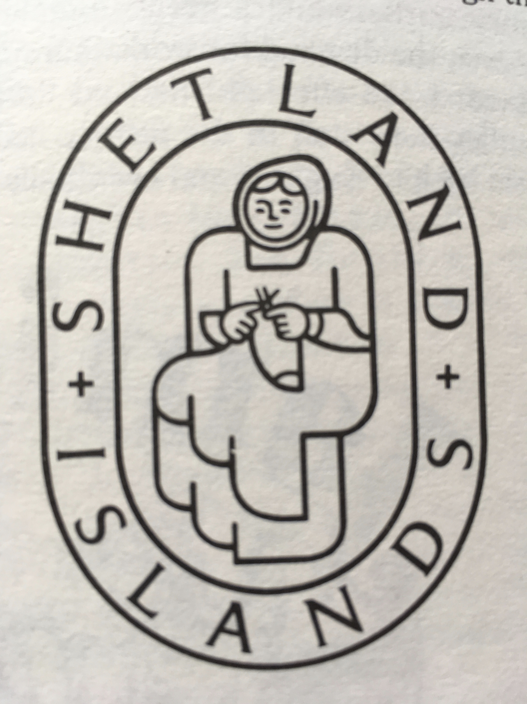
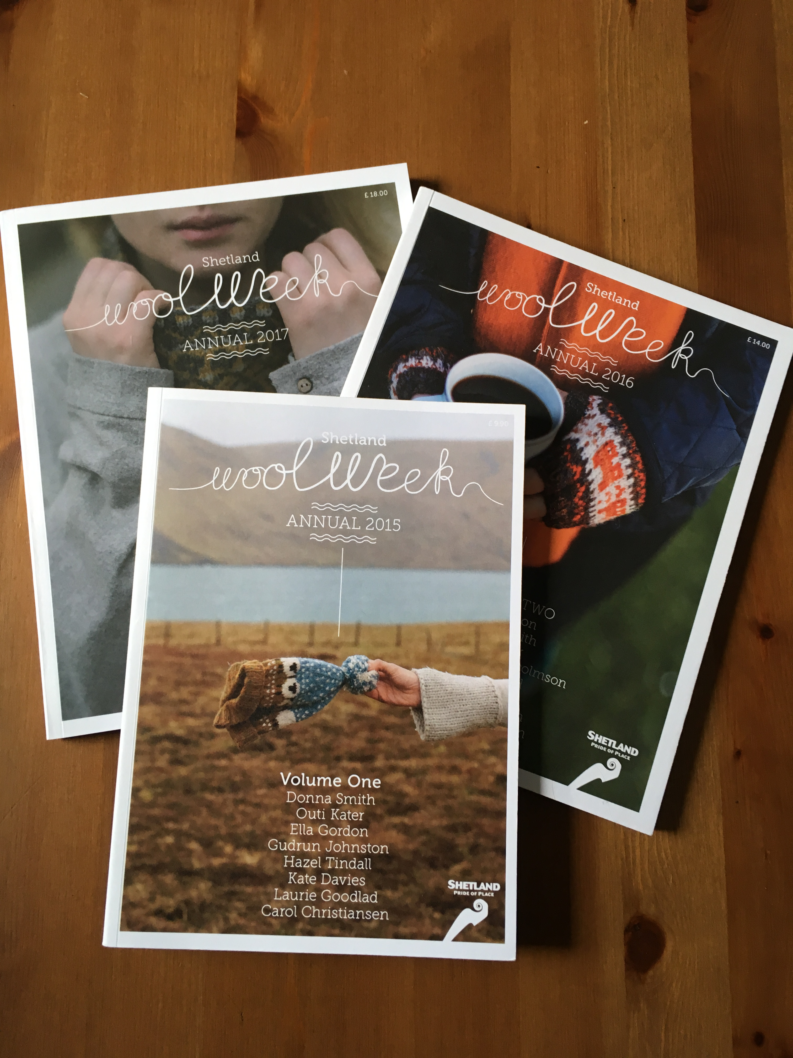
These colours were produced by natural dyes and the provenance of the patterns and use of colour has been much discussed. One romantic story was that these patterns were brought by Spanish Armada sailors being shipwrecked on Fair Isle. It is felt this story is unlikely, with a more likely Scandinavian influence being the origin. (Rutt 1989) After the Truck System became discredited, Shetlanders were able to sell their hand knitted items for ready cash, which was very important for them economically. The start of Fair Isle jumpers becoming fashionable is thought to date from 1922, when the Prince of Wales wore a Fair Isle jumper when playing golf at St Andrews, and the bright colours were popular in the Jazz Age. As commerce developed, wool merchants continued to trade hand knitted Shetland garments. In an attempt to fight off competition, particularly from machine-made garments, and enhance their ‘brand’ - their USP - the Shetland Woollen Industries Association were granted a trademark in 1925 to be used for Shetland hand knits and Fair Isle knitting made in Fair Isle. Eventually, however, machine-made articles and lack of demand for Shetland lace saw the decline of the industry in the post-second world war period. Hand- nitting at home continued, with families using favourite patterns, and, in the 1980s, books were published containing traditional patterns gathered from the Islands as there was concern that the North Sea Oil boom and the resultant change in the local economy would result in the loss of the traditional patterns and crafts. (McGregor 1981) Also in the 1980s, a mill was set up in Sandness - Jamieson’s - to spin Shetland wool produced only from local farmers. As hand knitting fashions ebbed and flowed in the decades following the 1950s, traditional Shetland patterns were recorded by enthusiasts with those enthusiasts continuing to be interested in the history and designs of Shetland knitting, but there was no significant economic effect on the islands. In 1983, the Shetland Knitwear Trades Association was formed to promote Shetland knitwear produced on the islands. (Fryer 1995) Their Shetland lady logo shows a woman knitting, dressed in an outfit that seems to hark back to a Viking era. Although there was a desire to maintain the tradition of the distinctive Shetland style of hand knitting, there didn’t seem to be a coherent strategy to enable this or to produce any economic benefit for the local people. In 2010, Jamieson & Smith Shetland Wool Brokers started Shetland Wool Week, a week-long celebration of Shetland wool and knitting. J&S obviously had a commercial interest in promoting Shetland wool, but this event has grown each year, becoming a very popular festival where like-minded people gather to attend lectures, visit sites of interest, travel around the Shetland Islands, buy locally produced products, and knit. In 2011, native Shetland wool achieved PDO status under the European Union, the UK’s first non-food and drink product to be registered. The Wool Week has strong grass-roots support, with partners including the Shetland Amenity Trust, an organisation set up to promote, protect and develop Shetland; Loganair, a Scottish airline; Jamieson & Smith Shetland Brokers, who buy Shetland wool from Shetland’s crofters and farmers; Jamieson’s, a mill spinning the Shetland wool; the Shetland Museum and Archives, a local museum about Shetland life; the Shetland Textile Museum, which is a community museum specialising in everything to do with the textiles of Shetland; Shetland Organics, the local organic producers’ group; the Shetland Guild of Spinners, Weavers and Dyers, the local guild of a national association with an obvious interest in Shetland wool; the Shetland Livestock Marketing Group, a co-operative representing Shetland crofters and farmers; and Shetland College, the local educational institution. The 2017 Wool Week had visitors from as far as Australia, Canada, the USA, and all over Europe, with over 600 people arriving on the Islands. The event comprises a week-long series of classes and workshops run by tutors, both local and foreign specialists, evening meet-ups to promote Shetland food and other produce and music, tours of the Islands, crofting visits, visits to wool mills and wool brokers, with open days, demonstrations and exhibitions being held in the local community halls and museums. (Shetland Wool Week 2018) A lot of the inhabitants of the Islands sell hand knitted items and other Shetland-related items to the visitors. In 2017, the event brought in over £700,000 of economic benefit to the Islands, which is a significant amount. An annual is produced for sale, including patterns and articles about Shetland, they produce products specifically for sale during the Wool Week, and there is a strong online presence including Facebook, Pinterest, Twitter as well as their own website. There is also a knock-on effect of this tourism on hotels and other accommodation, car hire and local transport providers, restaurants and pubs, and other entertainment. On Fair Isle, funds are raised for the George Waterston Memorial Museum by the sale of a pattern for a Fair Isle kep. (Shetland Wood Week 2018)
From relatively small beginnings, almost as a means to market products, this event has grown organically. It covers many areas of Shetland Island life, promoting the Islands worldwide and enhancing, promoting, and consolidating their brand, increasing their profile, and, very importantly, involving the local communities. Without the support of the grass-roots community, it would not be so successful, and I believe this partnership between manufacturers, craftspeople, local people, and visitors is an example of a successful engagement by a community with its heritage.

Reference List

Bruce-Lockhard, S. 2006. Leading cohesive communities: a guide for local authority leaders and chief executives. London. Local Government Association.

Chirikure, S., Manyanga, M., Ndoro, W., and Pwiti, G. 2011. Unfulfilled promises? Heritage management and community participation at some of Africa’s cultural heritage sites, in Waterton, E. and Watson, S. Heritage and Community Engagement. Collaboration or Contestation? 38-53. Oxford. Routledge.

Crooke, E. 2011. The politics of community heritage: motivations, authority and control, in Waterton, E. and Watson, S. Heritage and Community Engagement. Collaboration or Contestation? 24-38. Oxford. Routledge.

Fryer, L. G. 1995. “Knitting by the fireside and on the hillside” A History of the Shetland Hand Knitting Industry c. 1600-1950. Lerwick. The Shetland Times Ltd.

Greer, S. 2011. Heritage and empowerment: community-based Indigenous cultural heritage in northern Australia, in Waterton, E. and Watson, S. Heritage and Community Engagement. Collaboration or Contestation? 53-67. Oxford. Routledge.

McGregor, S. 1981. The Complete Book of Traditional Fair Isle Knitting. London. B T Batsford Ltd.

Rutt, R. Bishop of Leicester. 1987. A History of Hand Knitting. London. B T Batsford Ltd.

Shetland Wool Week. 2018. A website dedicated to the promotion and recording of Shetland Wool Week. http://www.shetlandwoolweek.com.

Waterton, E. and Smith, L. 2011. The recognition and misrecognition of community heritage, in Waterton, E. and Watson, S. Heritage and Community Engagement. Collaboration or Contestation? 12-24. Oxford. Routledge.

Watson, S. and Waterton, E. 2011. Heritage and community engagement: finding a new agenda, in Waterton, E. and Watson, S. Heritage and Community Engagement. Collaboration or Contestation? 1-12. Oxford. Routledge.

Bibliography

Amedro, G. 1993. Shetland Lace. Lerwick. The Shetland Times Ltd.

Bruce-Lockhard, S. 2006. Leading cohesive communities: a guide for local authority leaders and chief executives. London. Local Government Association.

Chirikure, S., Manyanga, M., Ndoro, W., and Pwiti, G. 2011. Unfulfilled promises? Heritage management and community participation at some of Africa’s cultural heritage sites, in Waterton, E. and Watson, S. Heritage and Community Engagement. Collaboration or Contestation? 38-53. Oxford. Routledge.

Crooke, E. 2011. The politics of community heritage: motivations, authority and control, in Waterton, E. and Watson, S. Heritage and Community Engagement. Collaboration or Contestation? 24-38. Oxford. Routledge.

Dicks, B. 2000. Heritage, Place and Community. Cardiff. University of Wales Press.

Fryer, L. G. 1995. “Knitting by the fireside and on the hillside” A History of the Shetland Hand Knitting Industry c. 1600-1950. Lerwick. The Shetland Times Ltd.

Greer, S. 2011. Heritage and empowerment: community-based Indigenous cultural heritage in northern Australia, in Waterton, E. and Watson, S. Heritage and Community Engagement. Collaboration or Contestation? 53-67. Oxford. Routledge.

Hodder, I. 2010. Cultural Heritage Rights: from ownership and descent to justice and well-being. Anthropological Quarterly 83(4): 861-882.

Jones, C. and Munday, M. n.d. Blaenavon and United Nations World Heritage Site Status: Is conservation of industrial heritage a road to local economic development? Policy Review Section, Welsh Economy Research Unit 585-590.

Lilley, I. 2016. Cultural heritage, community engagement, and environmental impact assessment in Australia. Environmental Practice 18(3): 205-208

McGregor, S. 1981. The Complete Book of Traditional Fair Isle Knitting. London. B T Batsford Ltd.

Rutt, R. Bishop of Leicester. 1987. A History of Hand Knitting. London. B T Batsford Ltd.

Shetland Wool Week. 2018. A website dedicated to the promotion and recording of Shetland Wool Week. http://www.shetlandwoolweek.com. [Accessed 18 January 2018]

Smith, M. and Bunyan, C. 1991. A Shetland Knitter’s Notebook. Lerwick. The Shetland Times Ltd.

Smith, M. and Liddle, M. 1992. A Shetland Pattern Book. Lerwick. The Shetland Times Ltd.

Waterton, E. and Smith, L. 2011. The recognition and misrecognition of community heritage, in Waterton, E. and Watson, S. Heritage and Community Engagement. Collaboration or Contestation? 12-24. Oxford. Routledge.

Watson, S. and Waterton, E. 2011. Heritage and community engagement: finding a new agenda, in Waterton, E. and Watson, S. Heritage and Community Engagement. Collaboration or Contestation? 1-12. Oxford. Routledge.

